Online Form for Adding a New Record – Screenshots
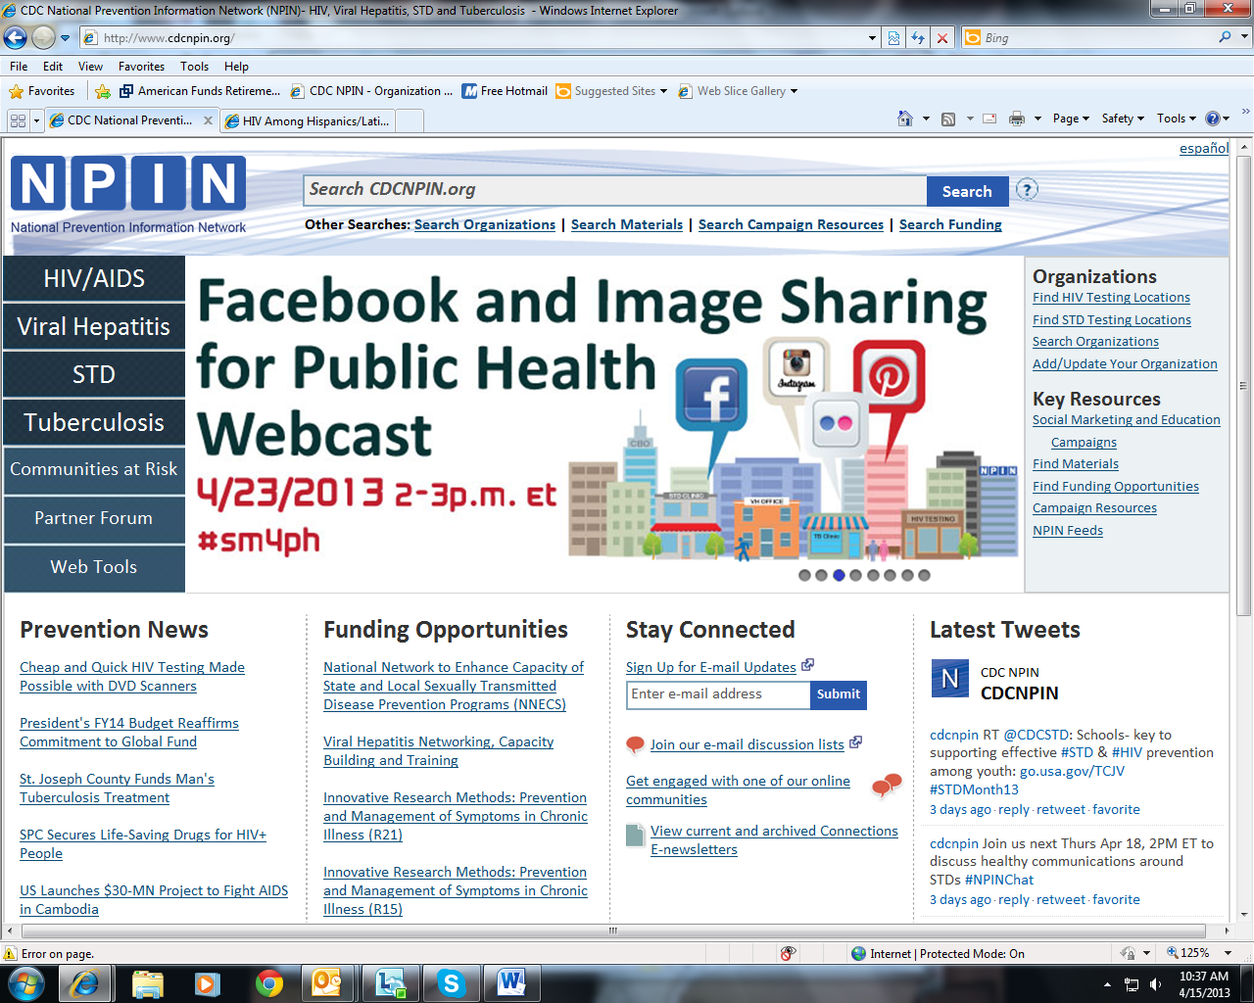
User clicks the “Add/Update Your Organization” link on the home page of the NPIN Web site to access the online form.
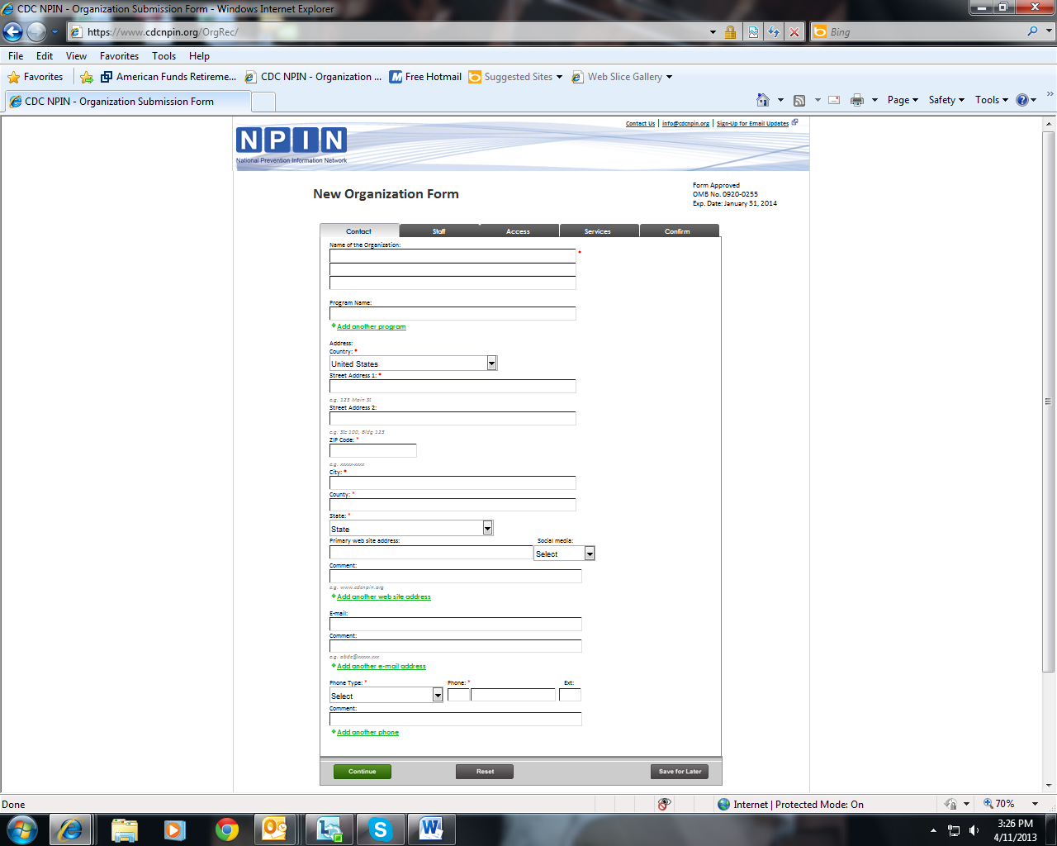
The form is divided into five sections (see the tabs across the top).
The first screen of the form is for entering contact information for the organization.

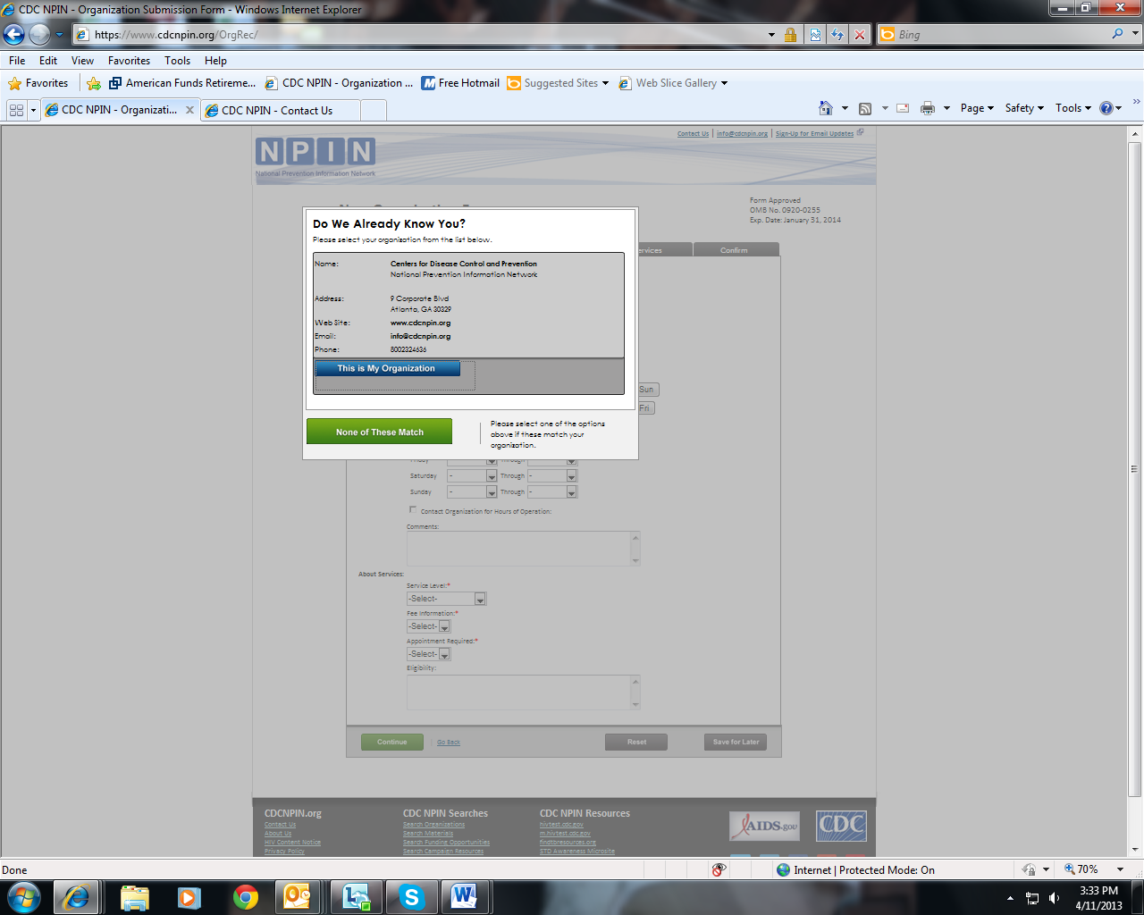
After the contact information for the organization has been entered, the system will check the database to determine if the organization is already listed. Potential matches will be displayed. If a match is found, users can select that record, review it, and make edits if needed. If no match exists, user continues with the add process.
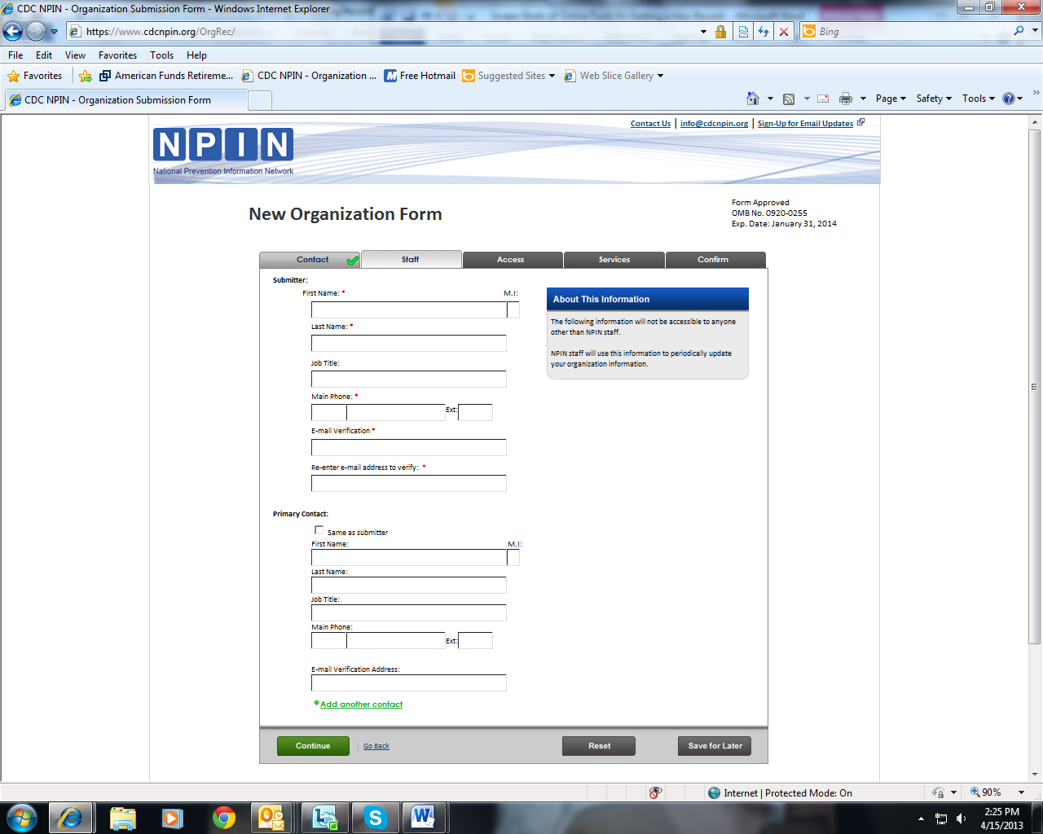
The second tab, Staff, is used to enter information about the form submitter and the person who will be the primary contact for this organization.

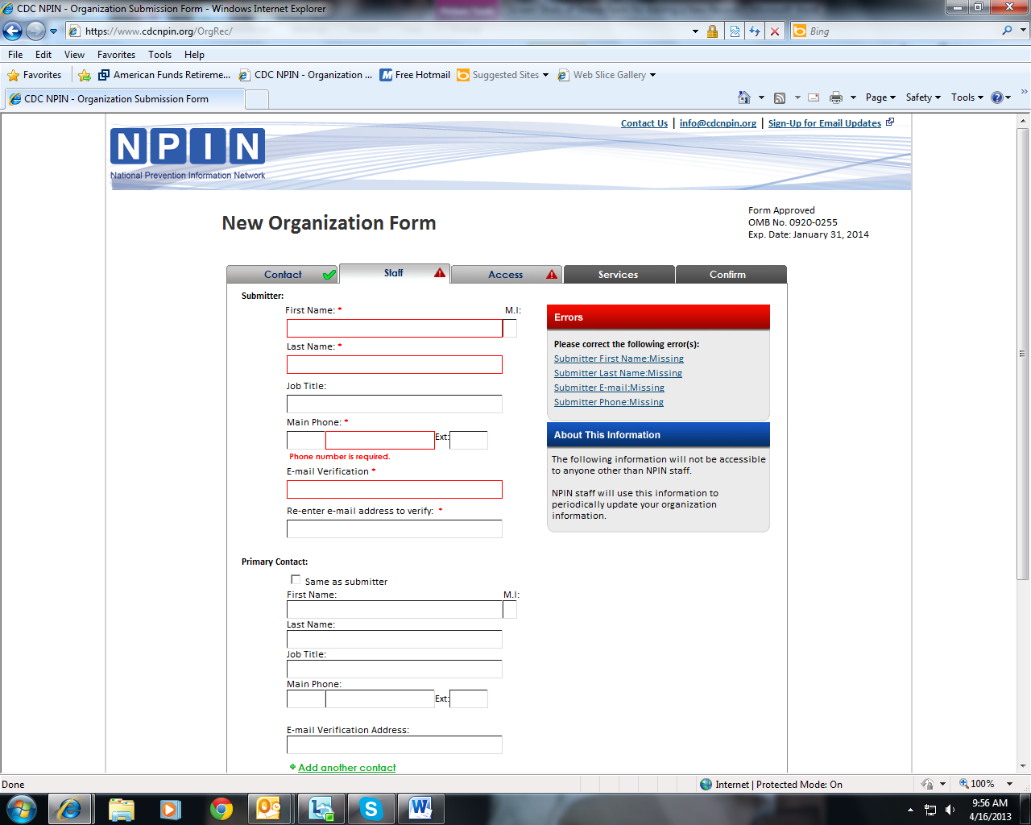
Check marks will appear on the tab to indicate to user that all required information is entered, and triangles are used to indicate that information is missing.
Error messaging is provided to assist users in proper completion of the form.

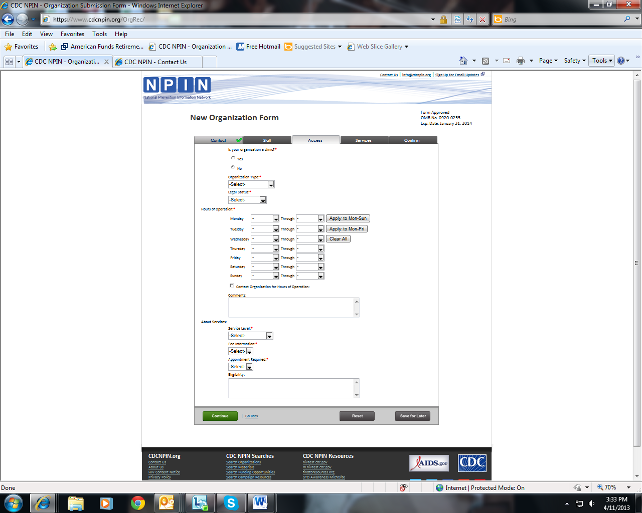
The third tab, Access, contains information about the organization type, hours of operation, and fees.

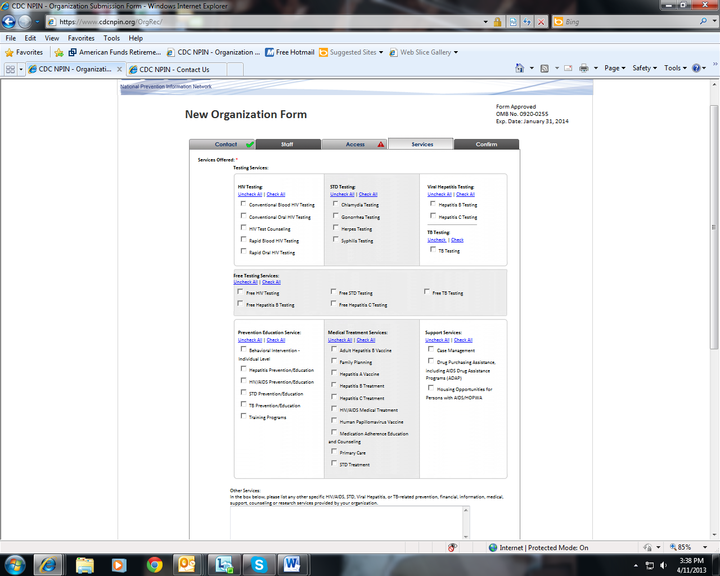
The fourth tab, Services, enables users to indicate the services offered by their organization.

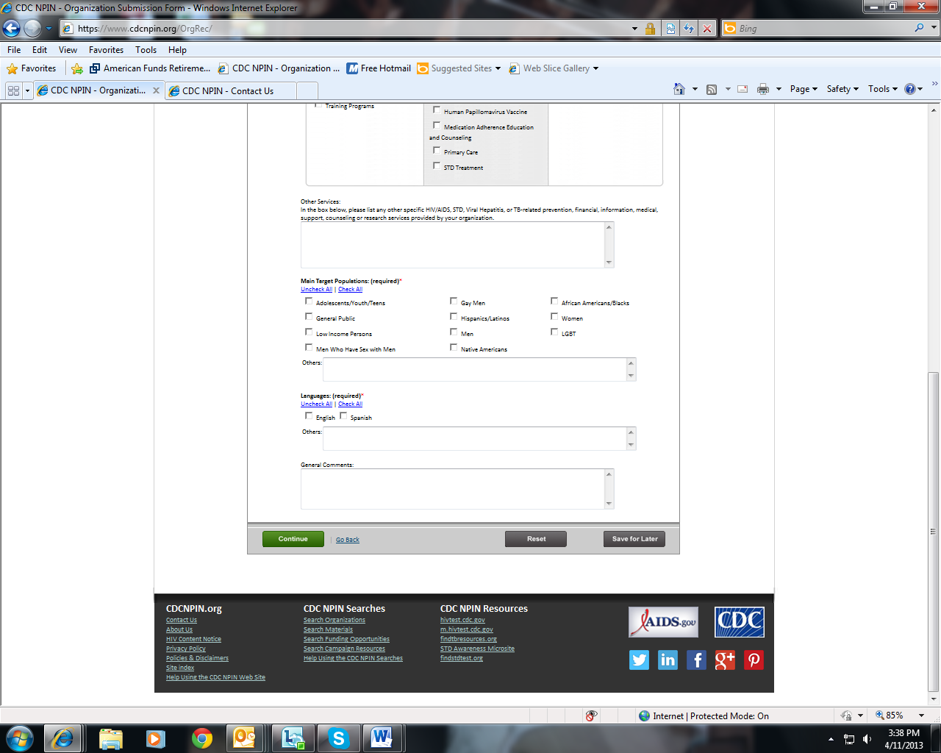
The Services tab also captures information about the audiences served by the organization and the language services that they provide.

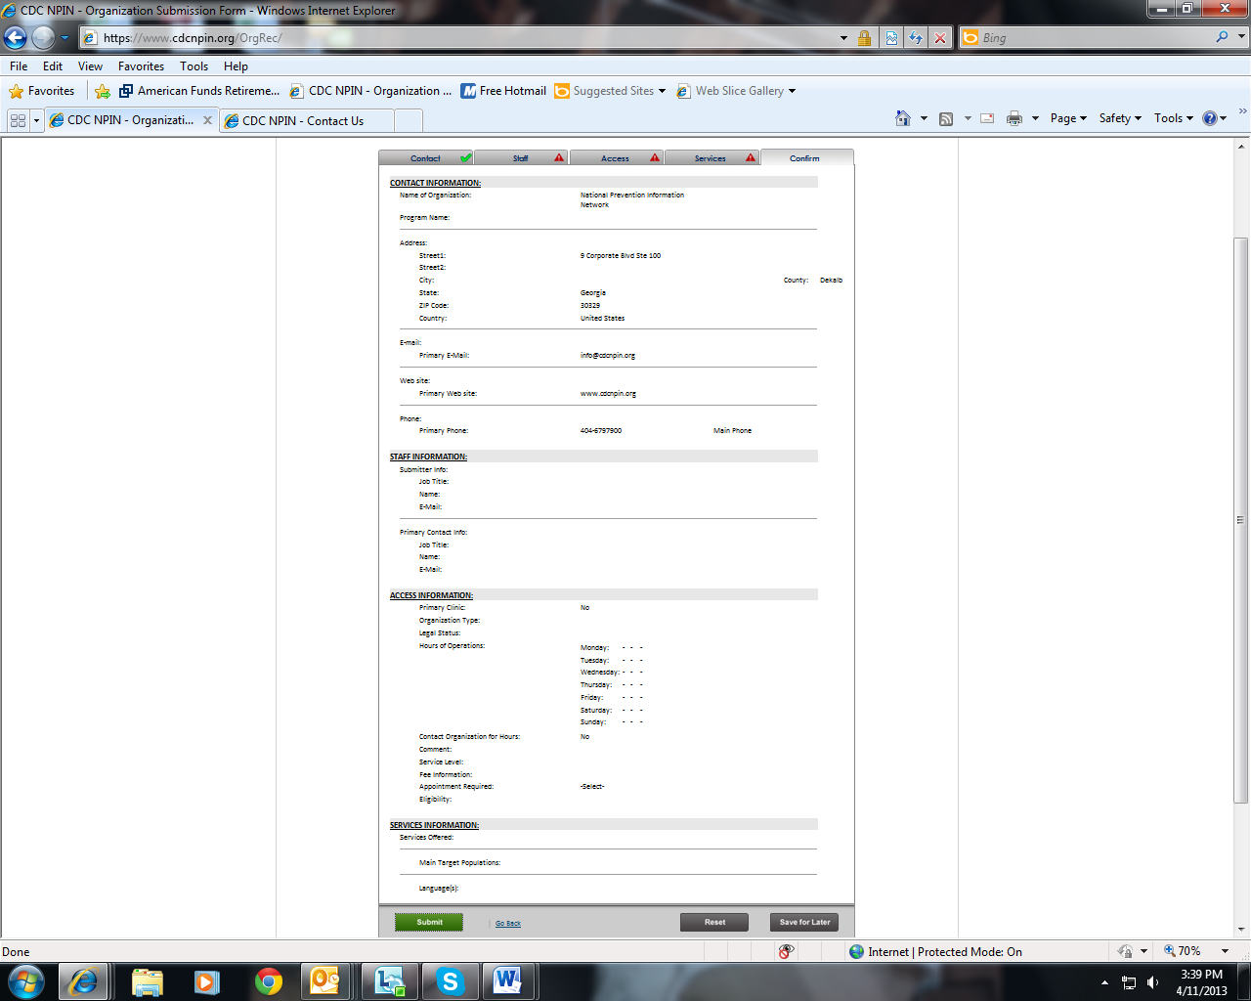
The final tab, Confirm, displays all of the information as entered by the submitter so that it can be reviewed for accuracy.

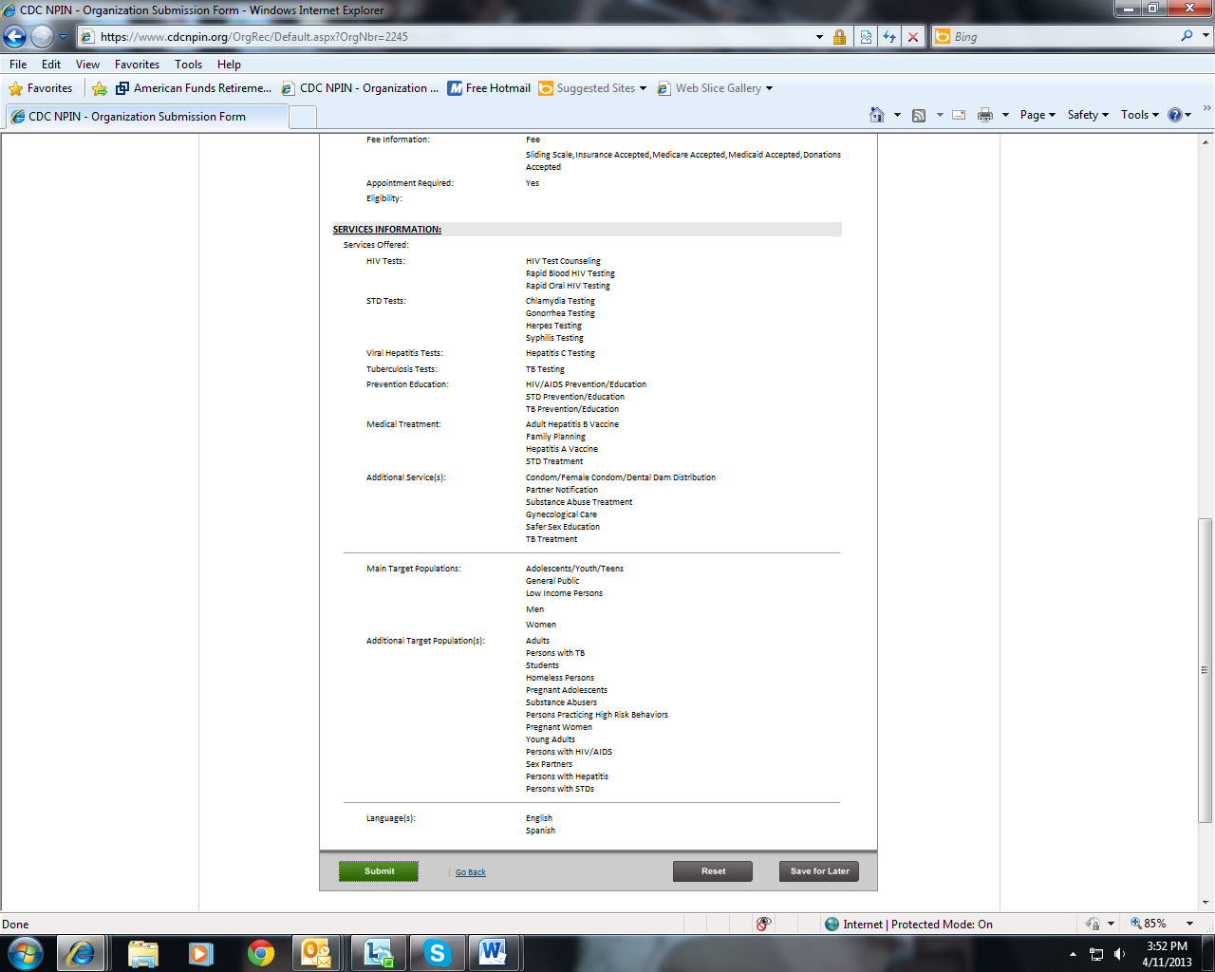
If the user needs to stop before completing the form, they can click the Save for Later button, which saves the information already entered, and go back to the form when they are able.

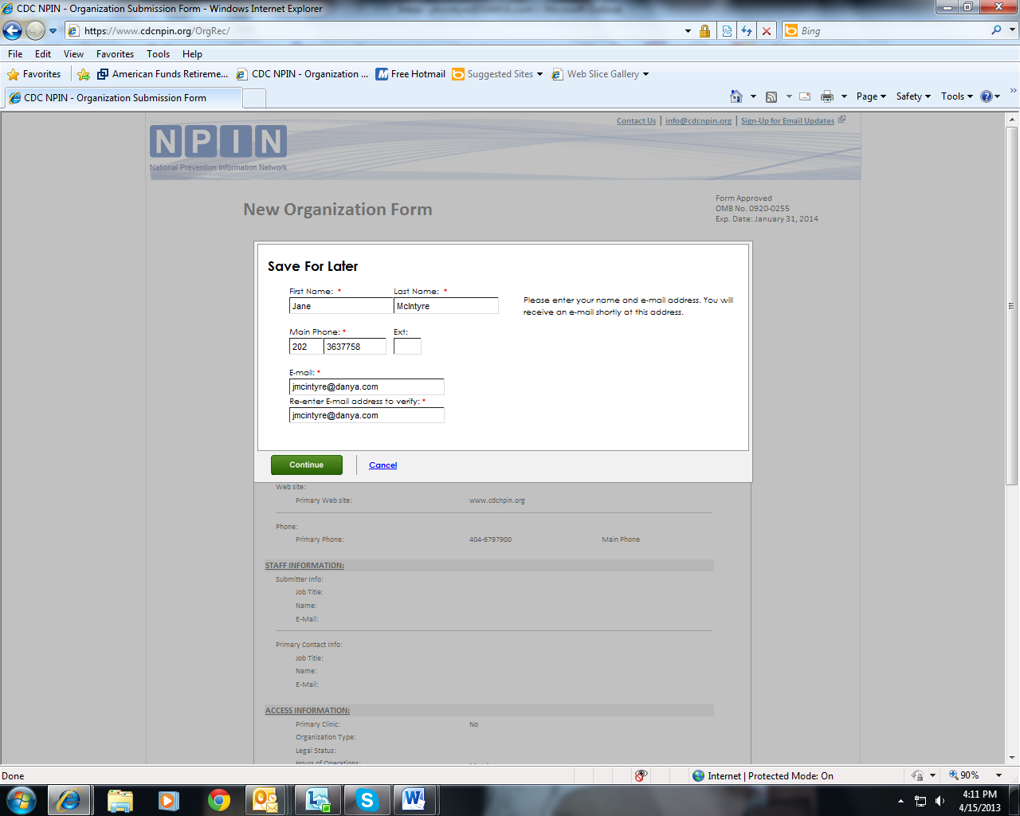
If Save for Later is clicked, the user will be prompted to enter their contact information. If this information has already been entered, it will be pre-populated here.

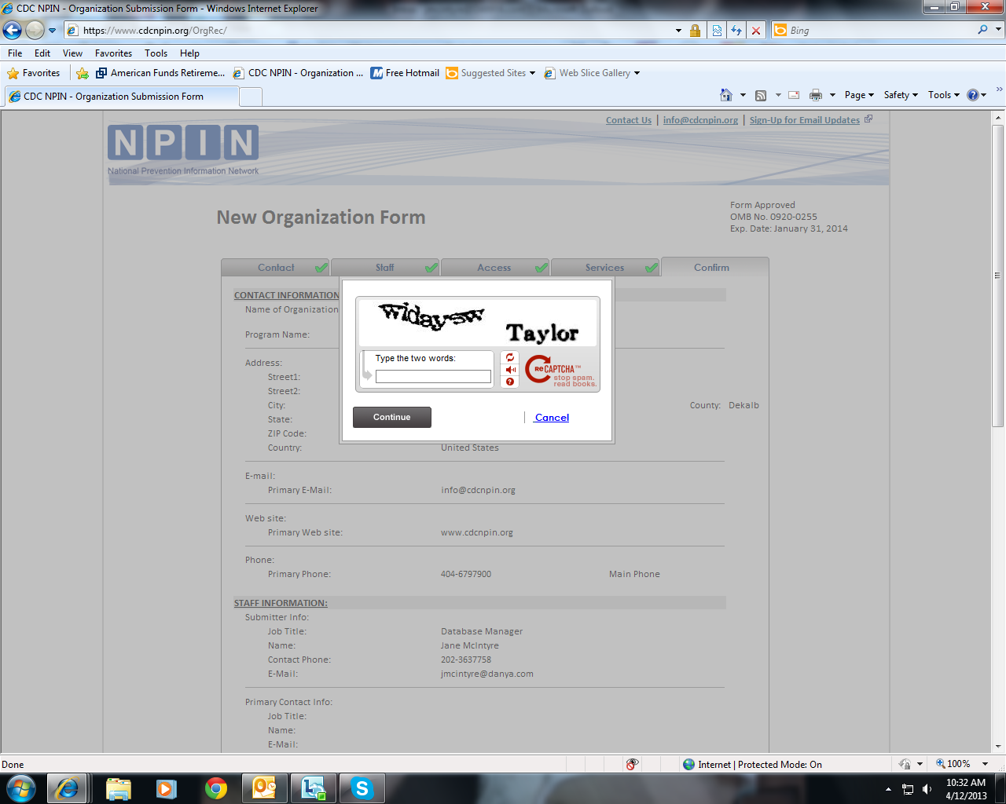
Recaptcha is used as a security precaution. Users must enter the displayed terms.

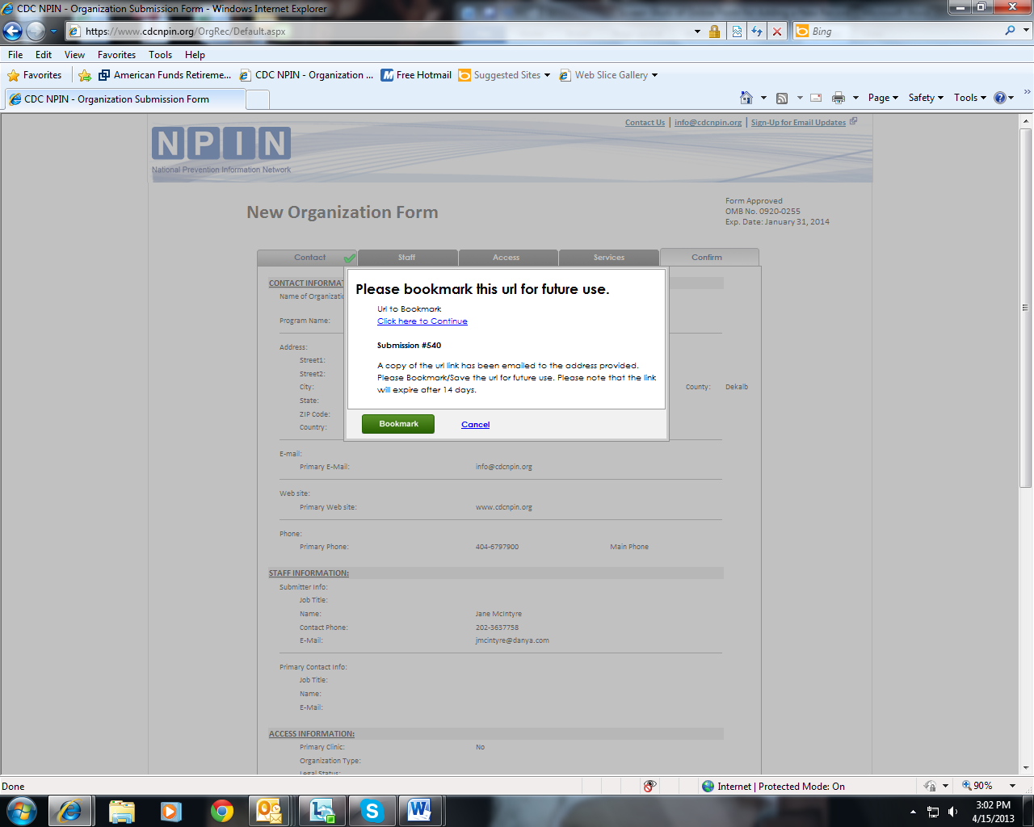
When a submission is Saved for Later, users receive a url to bookmark. This url will take them back to their incomplete form. They have 14 days to finish the submission form.

Once all information is correct, the user then clicks the Submit button to send the form to NPIN.

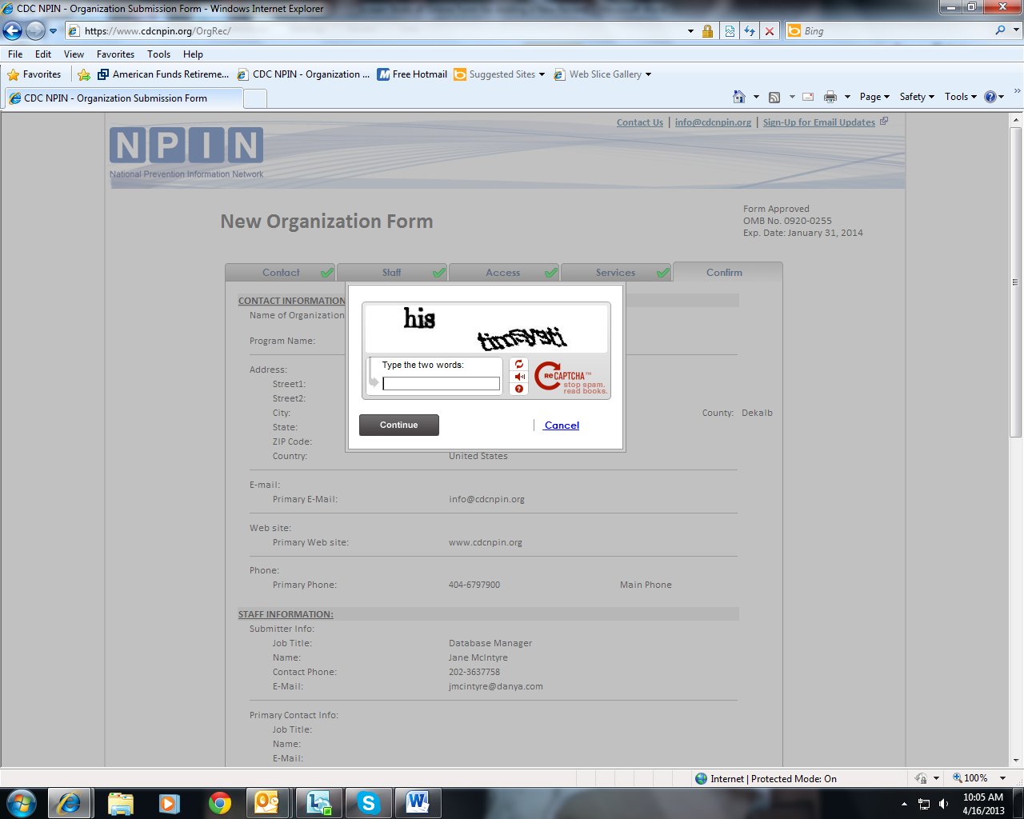
Again, Recaptcha is used as a security precaution before submission.

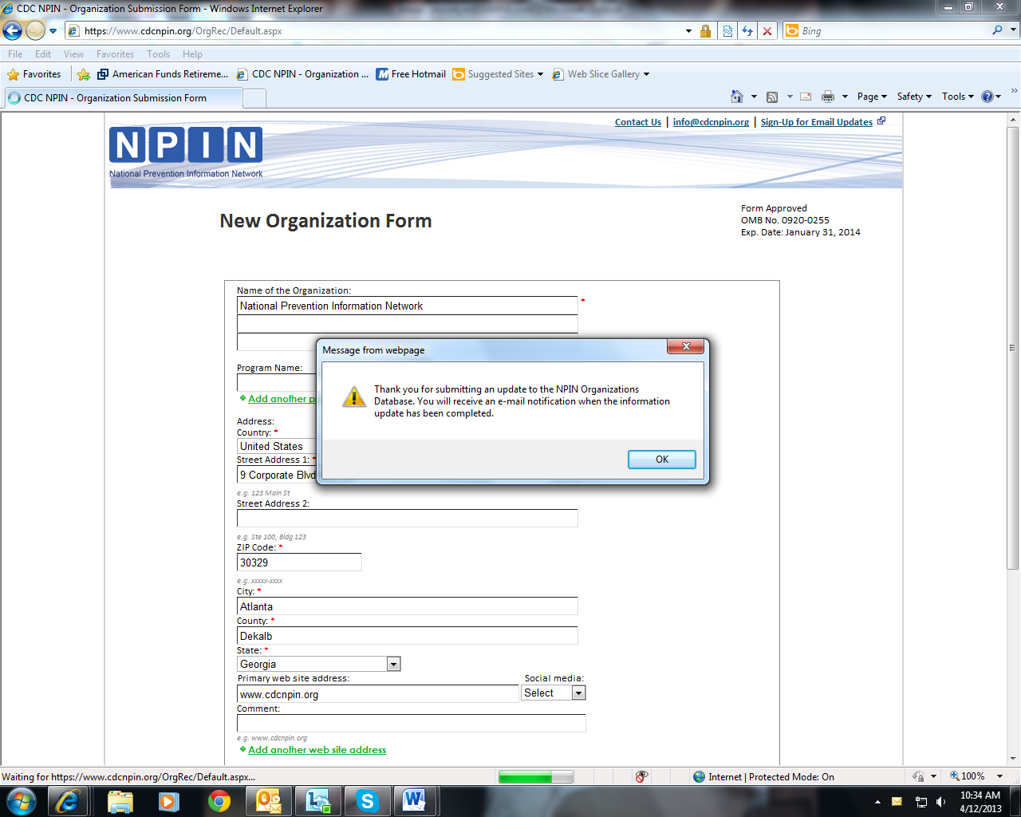
After the form is submitted, the user sees a message confirming the receipt of the form. Additionally, an e-mail notification is sent to the submitter confirming submission.

