Appendix 13

IRB Approval Letters From the Six Participating Sites

Baylor College of Medicine

Human Approval Letter
July 23, 2013

THOMAS PETER GIORDANO
BAYLOR COLLEGE OF MEDICINE
MEDICINE: INFECTIOUS DISEASE
BCM Saylor College of Medicine
Baylor College of Medicine
Office of Research
One Baylor Plaza, 6000
Houston, Texas 77030
Phone: (713) 798-6970
Fax: (713)798-6990
Email: irb@bcm.tmc.edu
H·32781 • COMPREHENSIVE HIV CLINIC·BASED INTERVENTION TO IMPROVE PATIENTS' HEALTH AND REDUCE TRANSMISSION RISK

APPROVAL VALID FROM 7/23/2013 TO 6/25/2014

Dear Dr. GIORDANO

The Institutional Review Board for Human Subject Research for Baylor College of Medicine and Affiliated
Hospitals (BCM IRB) is pleased to inform you that the research protocol named above was approved.
The study may not continue after the approval period without additionallRB review and approval for continuation.

You will receive an email renewal reminder notice prior to study expiration; however, it is your responsibility to assure that this study is not conducted beyond the expiration date.

Please be aware that only IRB-approved informed consent forms may be used when written informed consent is required.

Any changes in study or informed consent procedure must receive review and approval prior to implementation unless the change is necessary for the safety of subjects. In addition, you must inform the IRB of adverse events encountered during the study or of any new and Significant information that may impact a research participants' safety or willingness to continue in your study.

The BCM IRB is organized, operates, and is registered with the United States Office for Human Research
Protections according to the regulations codified in the United States Code of Federal Regulations at 45 CFR 46 and 21 CFR 56. The BCM IRB operates under the BCM Federal Wide Assurance No. 00000286, as well as thoseof hospitals and institutions affiliated with the College.

Sincerely yours,
VERNON R SUTTON, M.D., B.S.
Institutional Review Board for Baylor College of Medicine and Affiliated Hospitals

Boston Medical Center



Title of Study: Comprehensive HIV Clinic-Based Intervention to Promote Patients' Health and Reduce Transmission Risk
Protocol Number: H-32301

RE: New Protocol
Review Type: Full Board
Action: Approved

Date of Action: 05/23/2013
Date Revisions Were Accepted: July 26, 2013
Date of Expiration: 05/22/2014

Funding Source: Center for Disease Control and Prevention (CDC), NIH/National Institute of Mental Health (NIMH)
Award #: 6003158,

Protocol Version #: 1.2
Consent Form(s): PwP Informed Consent Version 1.3

Dear Dr. Mari-Lynn Drainoni, PhD:

At the 05/23/2013th Panel Blue Institutional Review Board (IRB) meeting, chaired by James Feldman, the above referenced protocol was reviewed. It has been determined that this study meets the requirements set forth by the IRB and is hereby approved. This protocol is valid through the expiration date indicated above.

This approval corresponds with the versions of the protocol and consent form(s) indicated above.

Protocol Specific Determinations and Findings

- The board made pregnancy findings in accordance with 45 CFR 46.204.
- The board approved a Waiver of Consent (45 CFR 116 (d)) and HIPAA Waiver.
- The board determined the study is minimal risk and can be expedited in the future

Requirements

The study may not continue after the approval period without additional IRB review and approval for continuation. You will receive an email renewal reminder notice prior to study expiration; however, it is your responsibility to assure that this study is not conducted beyond the expiration date.

Please be aware that only IRB-approved informed consent forms, validated with current approval dates generated by the INSPIR system, may be used when informed consent is required.

Any changes to the approved protocol or informed consent documents must be reviewed and approved prior to implementation unless the change is necessary for the safety of subjects.

You must report to the IRB unanticipated problems involving risk to subjects or others according to the process posted on the IRB website (www.bumc.bu.edu/irb ). The IRB must also be informed of any new or significant information that might impact a research participant's safety or willingness to continue in your study.

Investigators are required to ensure that all HIPAA requirements have been met prior to initiating this study. Once approved, validated HIPAA forms may be found within INSPIR under Study Documents.
It is the responsibility of the PI to ensure that all required institutional approvals have been obtained prior to initiating any research activities.

Sincerely yours,

Signature applied by Jamie Merrill on 07/26/2013 04:12:18 PM EDT

Senior IRB Analyst, Panel Blue

University of California at San Diego

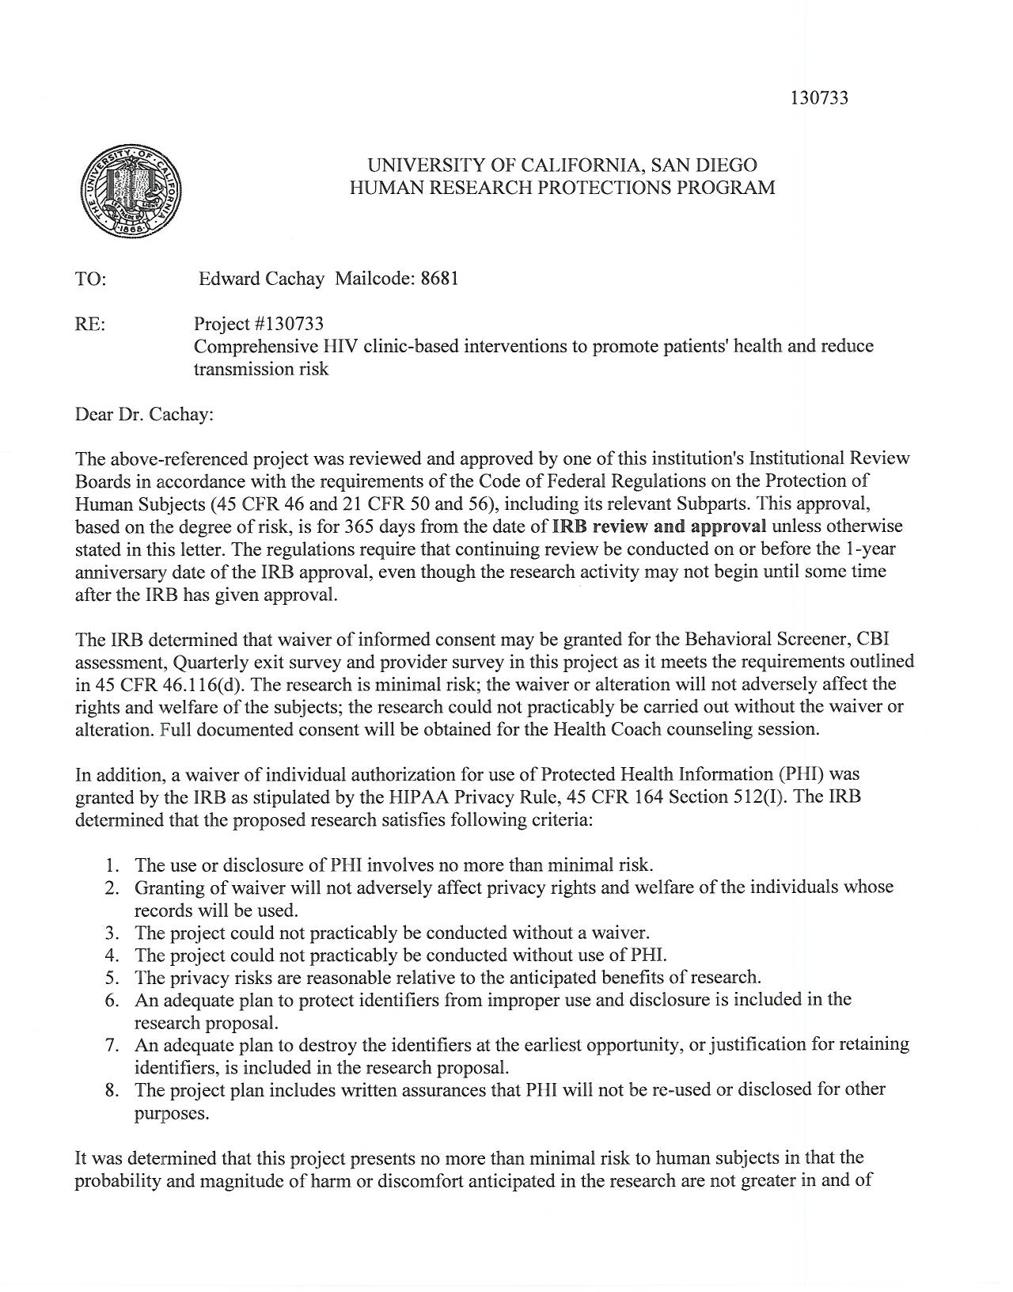
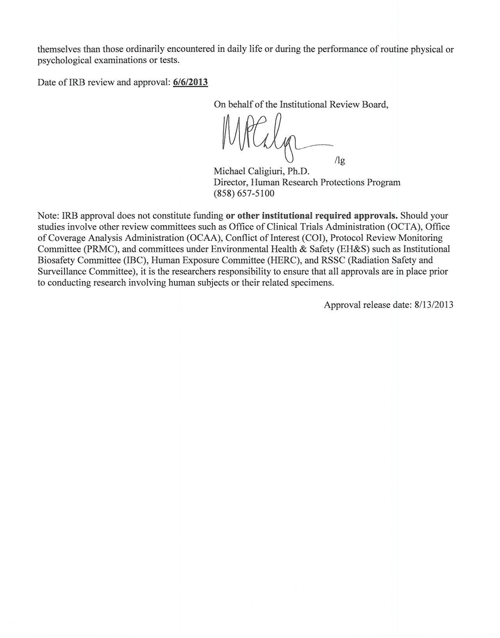
University of Miami
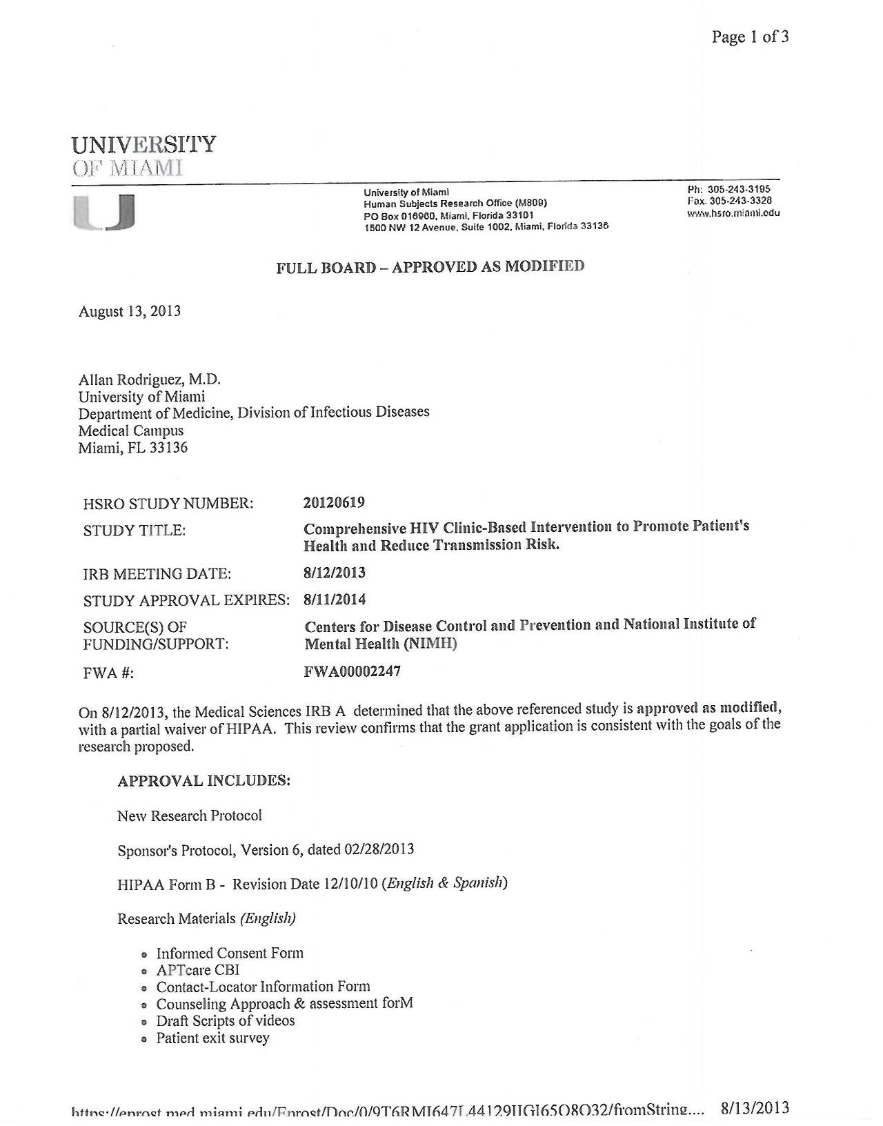
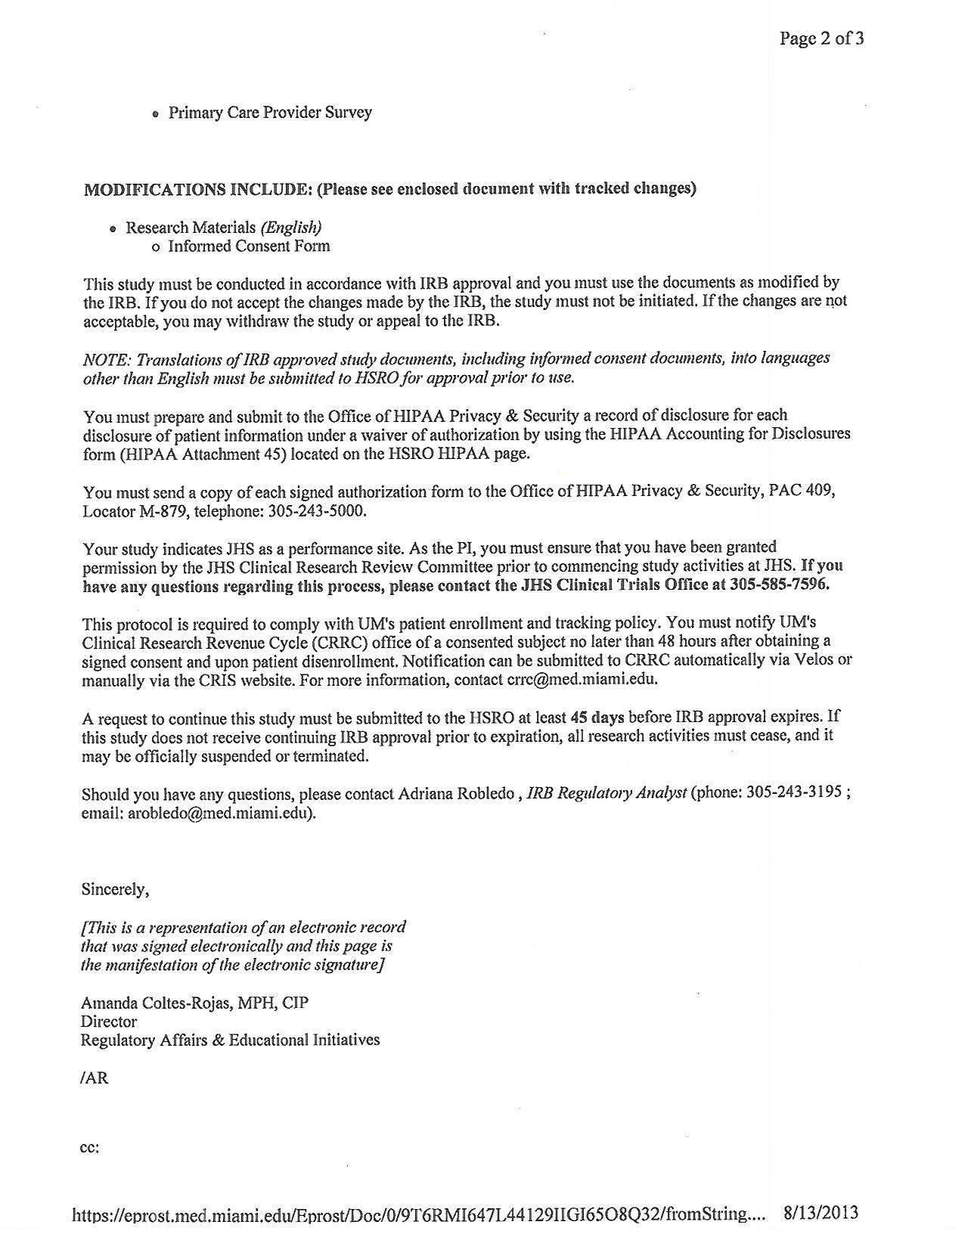
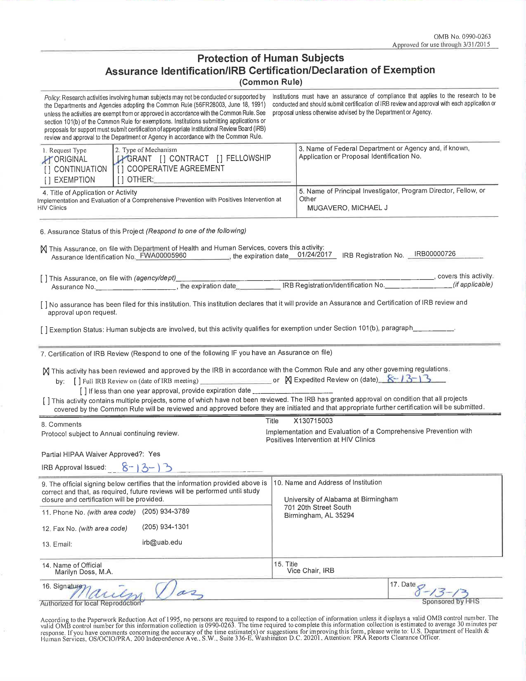
University of Alabama, Birmingham

