Appendix B-1:
Map of Parks Requiring Air Tour Management Plans

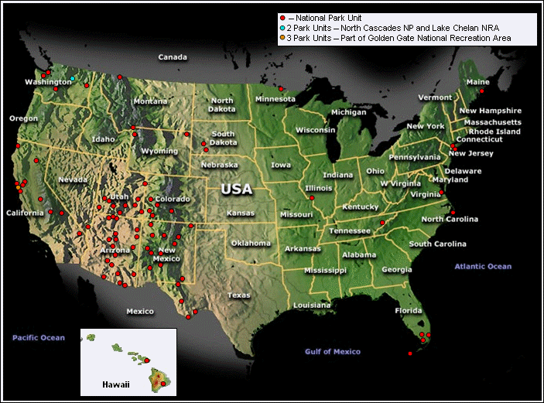

Appendix B-2:
Parks Averaging At Least 365 Air Tour Operations per Year

