SUPPORTING STATEMENT
NOAA Constituent Engagement Survey
OMB CONTROL NO. 0648-0615

A. JUSTIFICATION

1. Explain the circumstances that make the collection of information necessary.

This supporting statement is for a request to revise and extend an existing NOAA engagement survey. The revision is a request by the NOAA National Sea Grant College Program , created by the Sea Grant Act, to extend the existing engagement survey (OMB Control No.0648-0615) for its use, focusing on Sea Grant engagement. The current engagement survey was developed because NOAA services, products and sciences are important to both the nation as a whole, and to the daily lives of US citizens. NOAA’s Science Advisory Board (SAB) identified a need for more effective two-way communication between its programs and the customers and clients it serves. NOAA’s National Sea Grant College Program invests in sustaining a two-way communication channel between its sponsored research and its customers through a robust constituent engagement program. The goal of Sea Grant’s engagement program is to solve problems through university-based research, extension, outreach and education programs. Sea Grant regularly analyzes the way it engages with its constituents and the results of the engagement survey will provide information to form recommendations on ways to continually improve its two-way communication with customers. To achieve this goal, extension, outreach and education staff will use the previously approved engagement survey to assess Sea Grant’s success in engaging with a cross section of its constituents. The survey instrument assesses NOAA Sea Grant’s accessibility, responsiveness and respect for partners. The three engagement characteristics were identified by NOAA’s SAB as three of seven engagement characteristics defined in the Kellogg Engagement Test (an activity of the Kellogg Commission).

2. Explain how, by whom, how frequently, and for what purpose the information will be used. If the information collected will be disseminated to the public or used to support information that will be disseminated to the public, then explain how the collection complies with all applicable Information Quality Guidelines.

The information will be collected by Sea Grant programs to assess how well NOAA Sea Grant is meeting the needs of customers in terms of accessibility, responsiveness and respect for its partners. The survey instrument will be a tool available to Sea Grant for measuring how effectively Sea Grant engages its constituents. The survey instrument is flexible in design and could be used by other NOAA programs submitting similar requests to OMB. Results of the administered survey will provide NOAA Sea Grant with valuable information and feedback from its constituents that can lead to:

- Techniques to improve NOAA Sea Grant’s products, services, and information.
- Improved accessibility and responsiveness throughout NOAA.
- Greater emphasis on engagement with NOAA partners.
- Improved reputation among the public
The survey focuses on three of the seven characteristics of engagement as defined by the Kellogg’s foundation work on university engagement. The three defining categories are accessibility, responsiveness and respect for partners. Volunteer participants who complete the survey are asked to respond to 24 questions divided unevenly among the three categories (Sections 2, 3 and 4) and 9 additional demographic questions. In the current survey, “Sea Grant” is appended after each reference to NOAA.

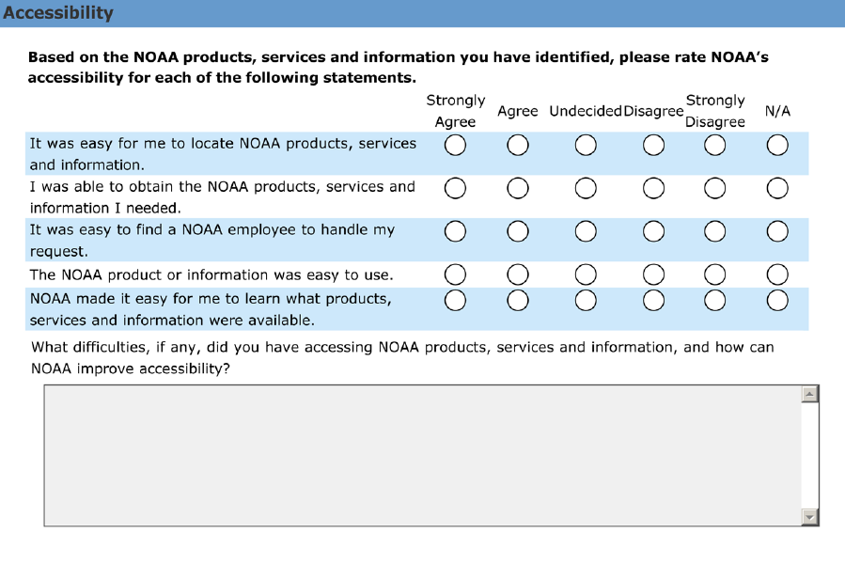
Figure 1. A screen capture of the 6 accessibility survey questions.
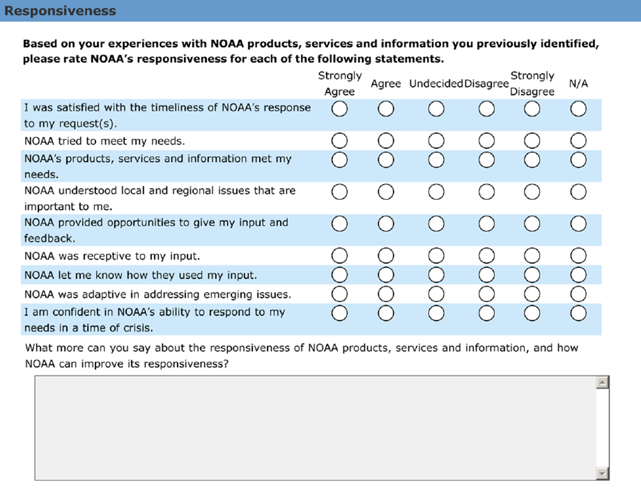
Figure 2. A screen capture of the 10 responsiveness survey questions. The revised questions append Sea Grant after each reference to NOAA in the survey.

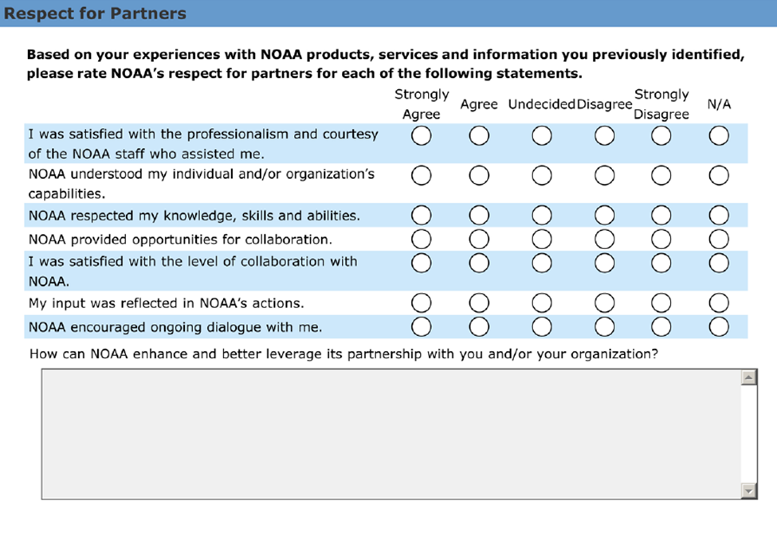
Figure 3. A screen capture of the 8 respect for partners survey questions. The revised questions append Sea Grant after each reference to NOAA in the survey.

NOAA’s National Sea Grant College Program will retain control over the information and safeguard it from improper access, modification and destruction, consistent with NOAA standards for confidentiality, privacy and electronic information. See response to Question10 of this Supporting Statement for more information on confidentiality and privacy. The information collected is designed to yield data that meet all applicable information quality guidelines. Individual responses will not be disseminated; summary results may be used in scientific, management, technical or general informational publications. Should NOAA Sea Grant College Program decide to disseminate the information, it will be subject to the quality control measures and pre-dissemination review pursuant to Section 515 of Public Law 106-554.

3. Describe whether, and to what extent, the collection of information involves the use of automated, electronic, mechanical, or other technological techniques or other forms of information technology.

Primarily, respondents will be asked to complete the survey online through the web-based survey tool “Survey Monkey” (www.surveymonkey.com). Alternatively, a print version of the survey will be made available upon request, which can be returned by mail or facsimile.

4. Describe efforts to identify duplication.

Through research, consultation with NOAA line offices and personal/professional experiences, it appears that there are no other efforts that duplicate the proposed questions. Guiding OMB approved survey documents were obtained and used as a reference in creating the survey instrument:

- Office of Management and Budget (OMB Control No.0648-0342) approved Quantitative Questions were used as a guideline for a table of specifications.
- A 2009 Office of Education survey regarding the Teacher at Sea Program was used as a guideline for questions pertaining to regions. This collection targeted the measurement of professional development programs, and is not a duplicate of the proposed collection.
- We are aware of a collection entitled the NOAA Awareness Study, OMB Control No. 0648-0574, conducted from 2008-11. The proposed collection herein differs in that he NOAA Awareness Study is focused on collecting information to assess the general public’s understanding and awareness of NOAA and its programs. The proposed NOAA Engagement survey is designed to specifically measure NOAA accessibility, responsiveness and respect for partners in terms of two-way communications with customers.
5. If the collection of information involves small businesses or other small entities, describe the methods used to minimize burden.

The survey instrument will create minimal burden on small business owners because the survey is brief, taking 15minutes to complete. There are also no required questions to answer before going to the next question. The brevity of the survey is purposeful since NOAA Sea Grant College Programs seeks to repeat the survey over time to assess change.

6. Describe the consequences to the Federal program or policy activities if the collection is not conducted or is conducted less frequently.

If the collection were not conducted, NOAA’s two-way communications with its constituents would remain unchanged or improve incrementally because of the lack of quantifiable input from constituents for the three constructs of this survey. Collection of constituent input as frequently as annually will allow NOAA to monitor improvements in constituent engagement through time.

7. Explain any special circumstances that require the collection to be conducted in a manner inconsistent with OMB guidelines.

N/A.

8. Provide information on the PRA Federal Register Notice that solicited public comments on the information collection prior to this submission. Summarize the public comments received in response to that notice and describe the actions taken by the agency in response to those comments. Describe the efforts to consult with persons outside the agency to obtain their views on the availability of data, frequency of collection, the clarity of instructions and recordkeeping, disclosure, or reporting format (if any), and on the data elements to be recorded, disclosed, or reported.

A Federal Register Notice published on August 12, 2013 (78 FR 48859) solicited public comments. None were received.

Since this survey was not implemented during the first three-year period – due to staff being unexpectedly occupied addressing Deepwater Horizon issues – we were not able to collect feedback from respondents, but we recently received feedback from three Sea Grant constituents (university scientist, representative of the tourism industry and county employee). Each person said the estimated response time was accurate and that they were pleased that Sea Grant plans to use the survey to improve how it engages with its customers.

9. Explain any decisions to provide payments or gifts to respondents, other than
remuneration of contractors or grantees.

N/A.

10. Describe any assurance of confidentiality provided to respondents and the basis for assurance in statute, regulation, or agency policy.

There will be no assurance of confidentiality; Summaries of responses will be used in as part of professional development programs for Sea Grant staff and on Sea Grant web sites.

11. Provide additional justification for any questions of a sensitive nature, such as sexual behavior and attitudes, religious beliefs, and other matters that are commonly considered private.

N/A.
12. Provide an estimate in hours of the burden of the collection of information.

An estimated 325 respondents will spend 15 minutes answering the survey annually: 325 x 15 minutes/60 minutes, which is a total of 81.25 (81) burden hours/year to obtain the information from NOAA Sea Grant constituents.

13. Provide an estimate of the total annual cost burden to the respondents or record-keepers resulting from the collection (excluding the value of the burden hours in Question 12 above).

There will be no reporting/recordkeeping costs to respondents. For those respondents replying by mail, postage-paid envelopes will be supplied.

14. Provide estimates of annualized cost to the Federal government.

The estimated annualized cost to the federal government to administer the survey and summarize the requests is $3,250 or $10 per completed survey.

15. Explain the reasons for any program changes or adjustments.

Program change: The responses and hourly burden have been changed to reflect current plans. This removes 325 respondents and responses, and 109 hours.

Adjustment: The response time has been changed from 20 minutes to 15 minutes, to be more accurate. This removes 27 hours.

16. For collections whose results will be published, outline the plans for tabulation and publication.

N/A. Individual results will not be published. Summary statistics will be made available to the Sea Grant network and NOAA to monitor changes in Sea Grant engagement.

17. If seeking approval to not display the expiration date for OMB approval of the information collection, explain the reasons why display would be inappropriate.

N/A.

18. Explain each exception to the certification statement.

N/A.

The commission was charged not only with defining and bringing to public attention the kinds of changes occurring at public universities today, but with analyzing necessary reforms and suggesting ways to accomplish them and monitor the results. A series of reports document the commission's findings (http://www.aplu.org/page.aspx?pid=305).

