ATTACHMENT N:

CORRESPONDENCE RELATED TO ENROLLMENT, SCREENSHOTS OF THE FLASHE WEBSITE, AND FAQS

Introductory Email to Parent
Dear [parent name]:
I am pleased to tell you about the Family Life, Activity, Sun, Health, and Eating (FLASHE) Study. This is an important study about daily lifestyle practices that may affect your health and this study is sponsored by the US Department of Health and Human Services (HHS). The study will involve you and your teenager each completing two surveys – one focused on diet and one focused on physical activity. We have contracted with a private research firm, Westat, to help us with this study. Westat will be sending you information regarding the FLASHE Study in all future communications.
The parent surveys are intended for [parent name], and only [parent name] should fill them out. As a thank you, you will receive $5 for each survey you complete. Similarly, your teenager, [teen name], will also complete two surveys. The teenager surveys are intended for [teen name], and only [teen name] should fill them out. As a thank you, [teen name] will also receive $5 for each survey.
Before you can complete the surveys, we need to obtain consent for your participation, as well as permission for your teenager’s participation.
To get started and let us know whether or not you will participate in the FLASHE Study, please use the following information to log in to the study website. We ask that you log in and get started within five days of receiving this email.
URL
Pin
Feel free to contact the Westat FLASHE Research Team at 1-800-XXX-XXXX or at XXXXX@Westat.com, if you have any questions.
If you choose to participate, your responses will help inform research and efforts at HHS to promote healthier lifestyles and behaviors among teenagers and their families in the US. Thank you for your consideration in participating in this important study!

Sincerely,
Linda Nebeling, PhD, MPH, RD, FADA
FLASHE Project Officer
National Institutes of Health
U.S. Department of Health and Human Services

Introductory Email for Adolescent

Dear [teen name]:
I am pleased to tell you about the Family Life, Activity, Sun, Health, and Eating (FLASHE) Study, for which your [relationship], [parent name] has given permission for you to participate. This is an important study about daily lifestyle practices that may affect your health and this study is sponsored by the US Department of Health and Human Services (HHS). The study will involve you and your [relationship], each completing two surveys – one focused on diet and one focused on physical activity. We are working with a private company, Westat, to help us with this study. Westat will be sending you information about the FLASHE Study in all future communications.
The teen surveys are intended for you and only you should fill them out. As a thank you, you will receive $5 for each survey you complete.
Even though your [relationship] has already given permission for you to participate, we need to obtain your permission as well.
To get started and let us know whether or not you will participate in the FLASHE Study, please use the following information to log in to the study website. We ask that you log in and get started within five days of receiving this email.
URL
Pin
Feel free to contact the Westat FLASHE Research Team at 1-800-XXX-XXXX or at XXXXX@Westat.com, if you have any questions.
If you choose to participate, your responses will help inform research and efforts at HHS to promote healthier lifestyles and behaviors among teenagers and their families in the US. Thank you for your consideration in participating in this important study!

Sincerely,
Linda Nebeling, PhD, MPH, RD, FADA
FLASHE Project Officer
National Institutes of Health
U.S. Department of Health and Human Services

Website Pages

Home Page – the adult will click the link on the “Enrollment” side of the screen to begin.

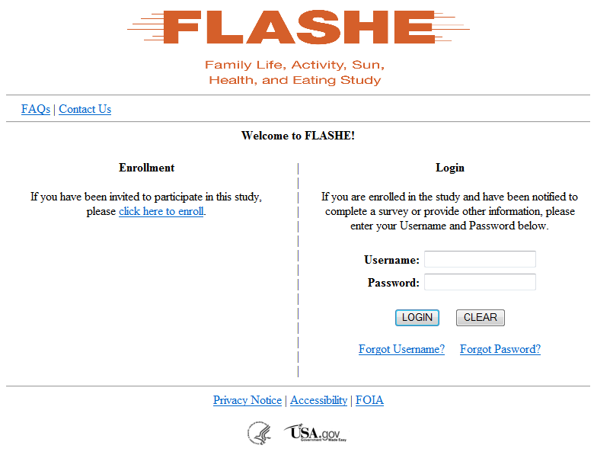

PIN Screen – the adult will enter a PIN sent to them via email and their First and Last Name to begin the process.

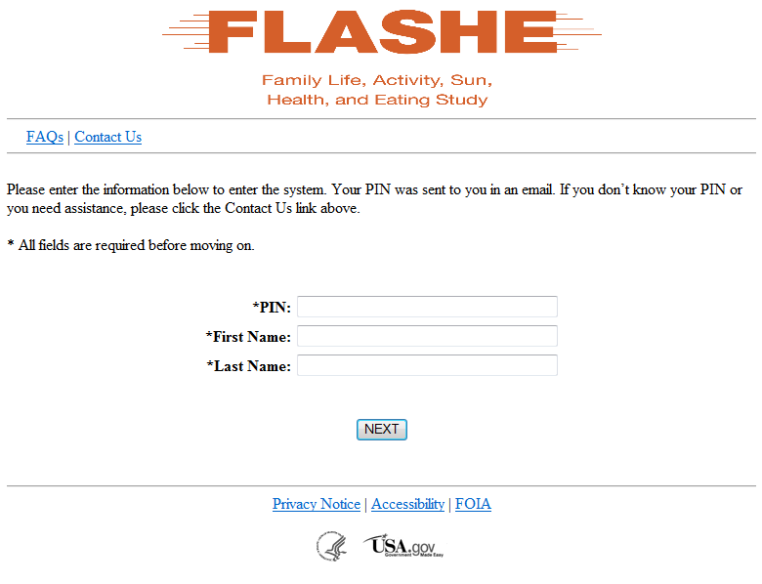

Adult Welcome – provides some basic information about the study.

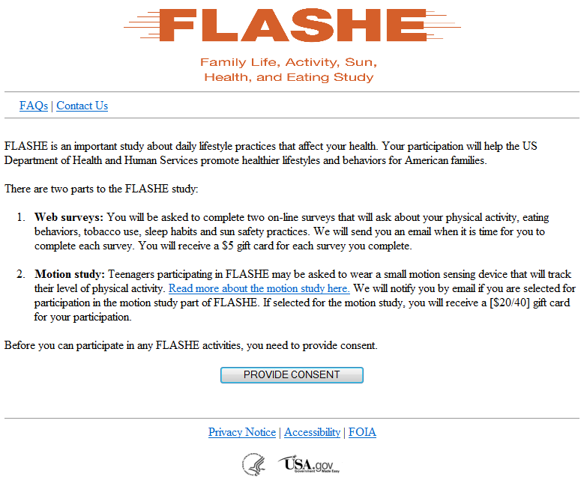

Username/Password Screen – adult creates their username/password

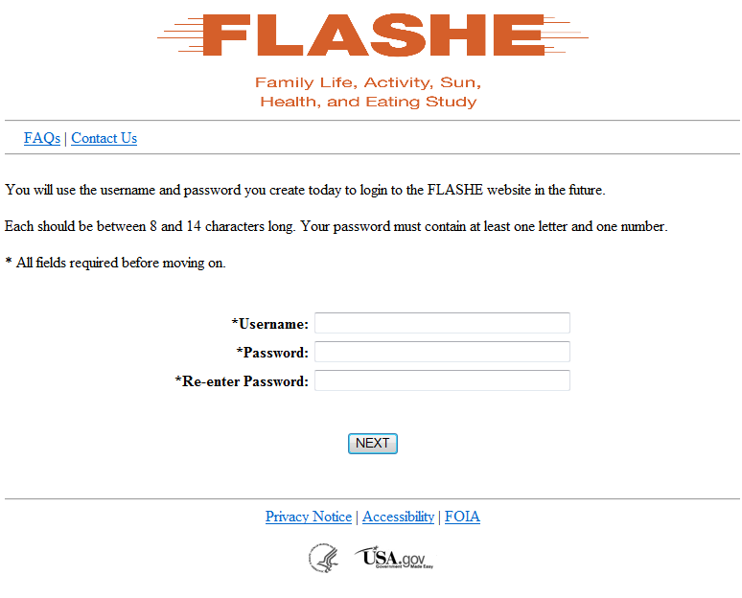

Adult Thank You Screen – final screen verifying the adult completed enrollment

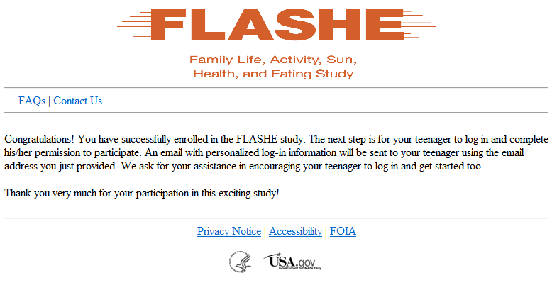

Adult “Sorry” Screen – If the adult chooses not to consent to the study, this screen is displayed

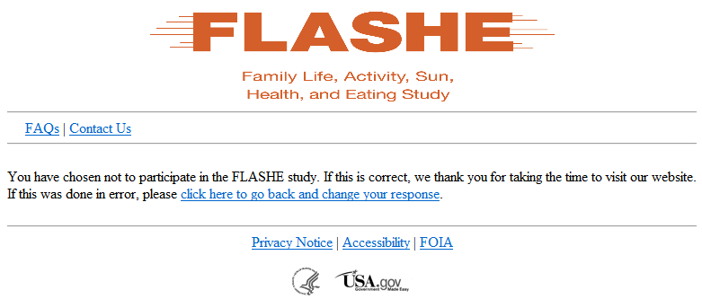

Adult No Permission for Teen – If the adult does not provide permission for the teen to participate, this screen is displayed

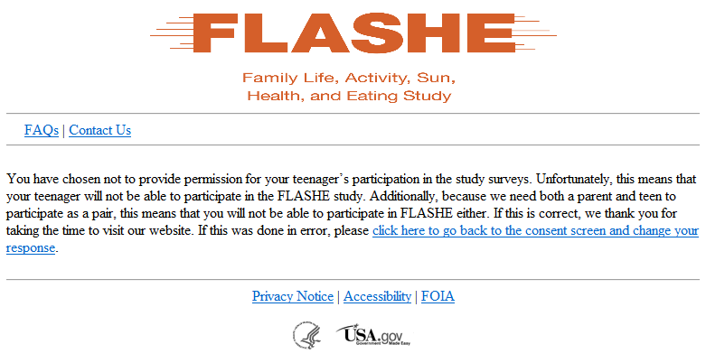

Teen Enrollment Screens/Process

The following screens detail the process for an invited adult to enroll in the study. The teen will be notified once the adult has completed enrollment and if the adult has provided permission for the teen to enroll:

Home Page – the teen will click the link on the “Enrollment” side of the screen to begin.

PIN Screen – the teen will enter a PIN sent to them via email and their First and Last Name to begin the process.

Teen Welcome – provides some basic information about the study.

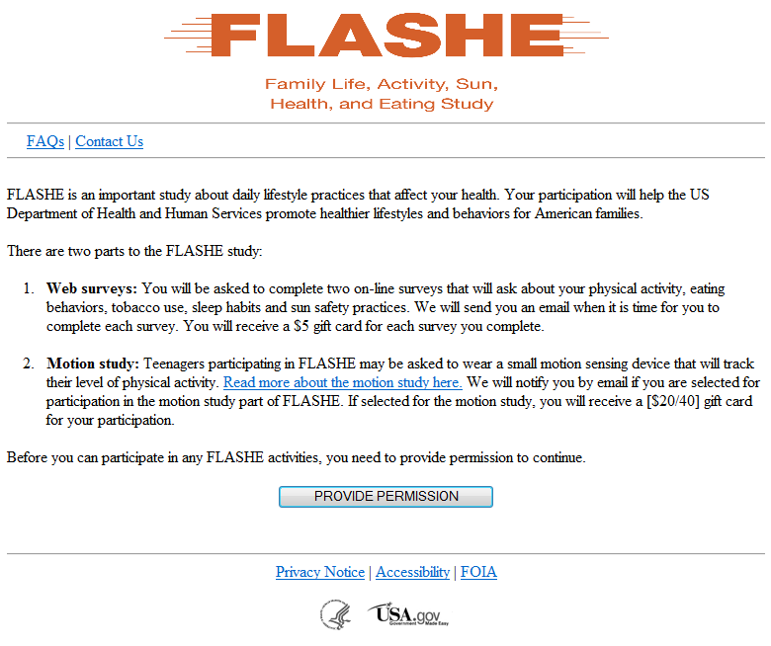

Username/Password Screen – adolescent will create personal username/password.

Thank You Screen – Once here, the system will create the first assignments for both the adult and the adolescent and the adolescent can begin immediately.

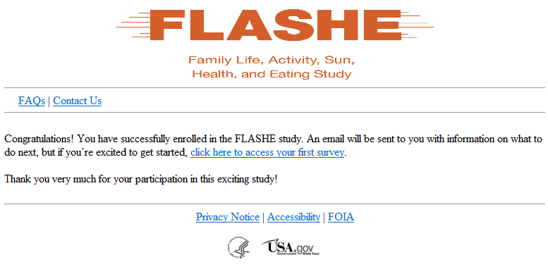

Adolescent “Sorry” Screen – if the adolescent does not agree to participate, this screen is displayed

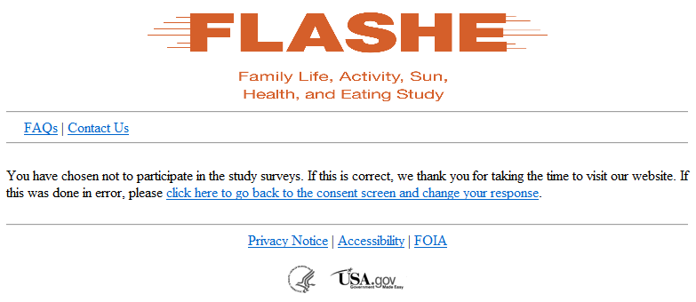

Study Participation Screens

Once both the adolescent and the adult are enrolled, they can follow the process below to login and begin their assignments.

Home Page – participant will login on the right side of the screen. If they forget their username or password, they can retrieve them through email. If password is retrieved, the system will send a “temporary” password and force the participant to change it.

Forgot Username Screen – simple screen to retrieve their username

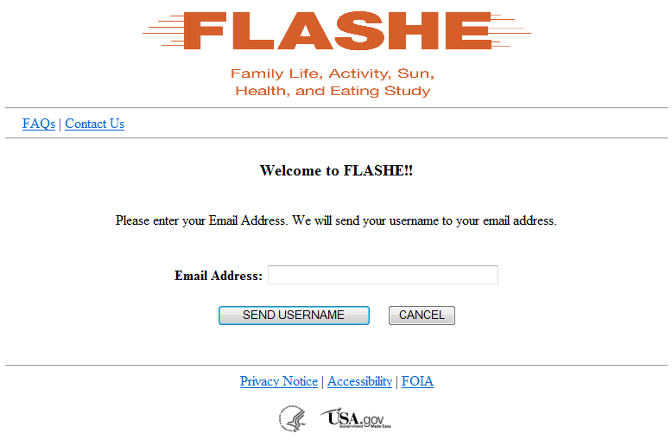
Forgot Password Screen – simple screen to retrieve their password

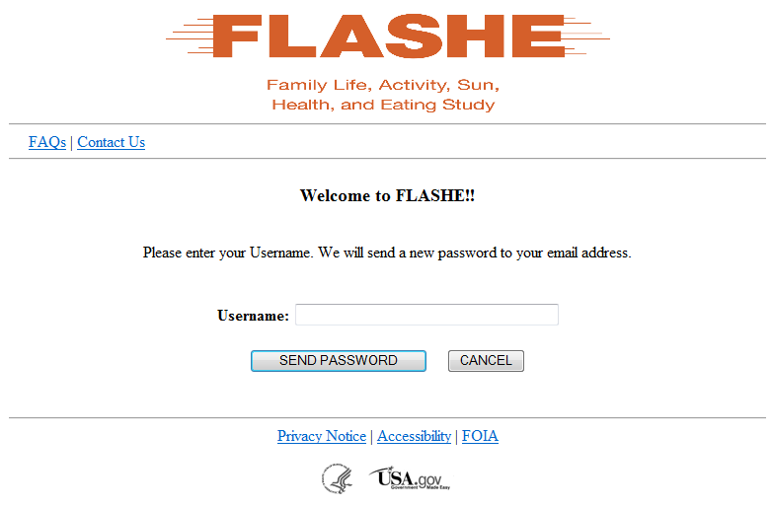

Study Dashboard/Assignments – main screen from which participants can begin their assignments.

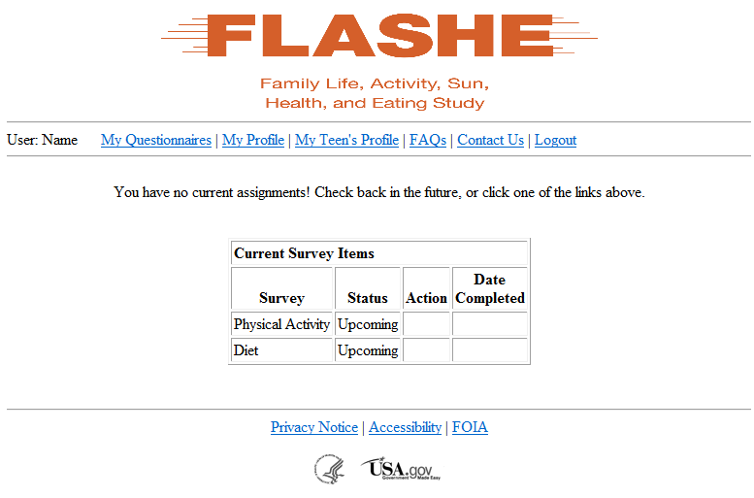

Accessibility Statement

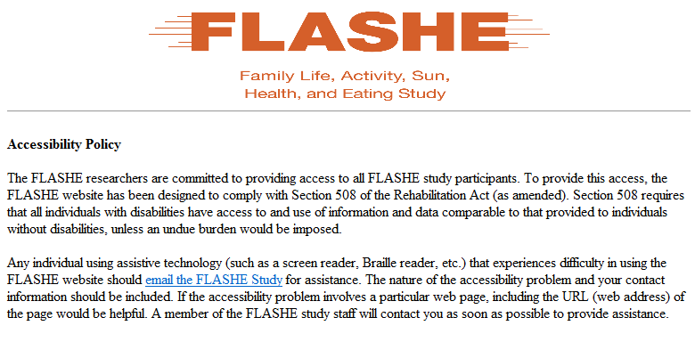

- FOIA

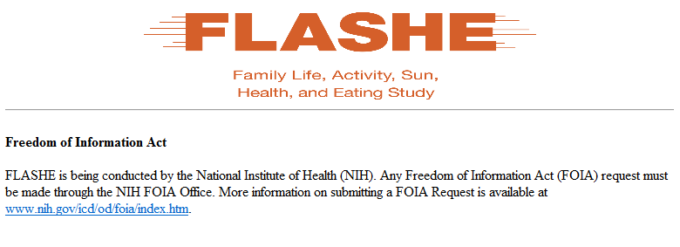

Privacy/Security Statement

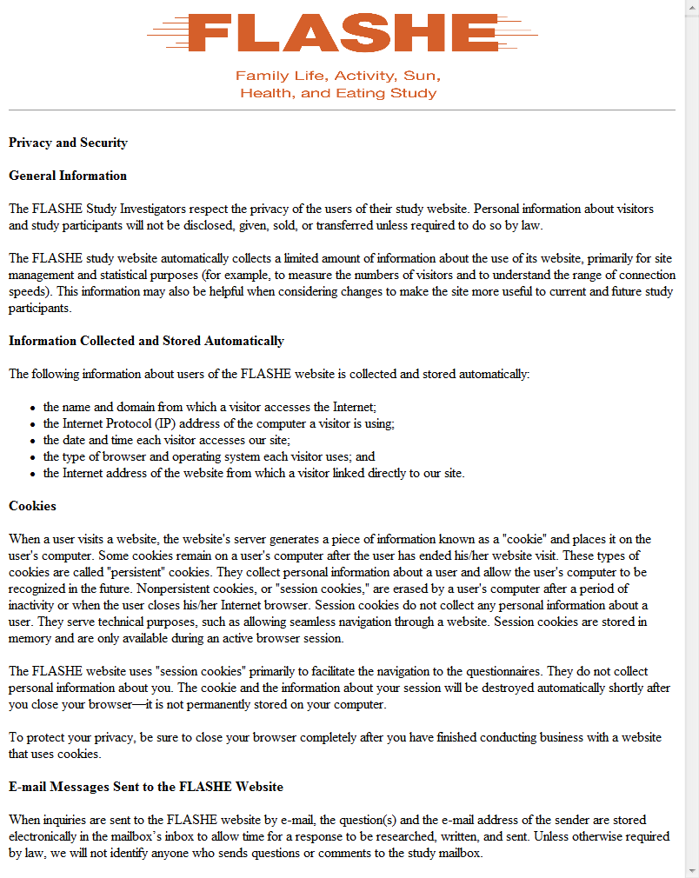

The FAQs will come up as a PDF when then FAQ link is clicked on. This link can be found at the top of each screen.

Frequently Asked Questions about the
Family Life, Activity, Sun, Health, and Eating (FLASHE) Study

Q: What is the study about? What kind of questions do you ask?
A: The FLASHE Study is interested in finding out about lifestyle practices that affect your health. The FLASHE surveys will ask questions about your physical activity, eating behaviors, tobacco use, sleep habits, and sun safety practices. Since parents and their teenagers are both being surveyed, the researchers hope to gain an understanding about practices that may contribute to health from one generation to the next.

Q: How will the study results be used? What will be done with my information?
A: Findings will help the U.S. Department of Health and Human Services gather information that can be used in developing programs that can help teenagers and their parents adopt healthy habits and ultimately help promote good health. You will not be personally identified in any of the results.

Q: How did you get my contact information?
A: You previously provided your contact information to Ipsos, a company which you are registered with. You and your teenager were specifically chosen from this registry based on sampling procedures.

Q: Why should I take part in this study? Do I have to do this?
A: Your participation is voluntary and you may refuse to answer any questions or withdraw from the study at any time. However, your answers are very important to the success of this study. Getting as many responses as possible is the best way to make sure the study results reflect the thoughts and opinions of people across the US.

Q: Will my answers to the survey be kept private?
A: Yes. Your answers will be kept private under the Federal Privacy Act. Your answers cannot be connected to your name or any other information that could identify you or your household, to the extent provided by law. The questionnaire responses will be stored in a file with restricted access. The identification information you provide will be destroyed shortly after the research is finalized.

Q: How long will it take to answer the questions?
A: Each survey should take about 15-20 minutes to complete.

Q: Will I be asked to do anything other than answer survey questions?
A: This is a possibility. Based on random sampling your teenager may be selected to take part in an additional study where he/she will be asked to wear a motion sensing device for seven days to get more information about his/her physical activity levels.

Q: Can I refuse to do any of the study activities?
A: Yes. Your participation in the surveys is separate from your participation in the motion study. Not wishing to take part in the motion study does not affect your ability to respond to the surveys.

Q: Who is sponsoring the study? Is this study approved by the Federal Government?
A: The study is sponsored by the U.S. Department of Health and Human Services. The study has been approved by the Office of Management and Budget (OMB), the office that reviews all federally-sponsored surveys. The OMB approval number assigned to this study is XXXX.

Q: Who is Westat?
A: Westat is a research company located in Rockville, Maryland. Westat is conducting this study under contract to the U.S. Department of Health and Human Services.

Q: What if I have questions?
A: If you have any questions or concerns, please feel free to call the Westat FLASHE study team toll free at 1-800-XXX-XXXX or email them at XXXX@westat.com.

Device Information: The following will come up as a PDF when the motion study link is clicked.

PHYSICAL ACTIVITY MONITOR DESCRIPTION AND PHOTO

The Family Life, Activity, Sun, Health and Eating (FLASHE) study is being conducted by the US Department of Health and Human Services to understand lifestyle factors and how they affect health. As part of this study, a group of survey participants will wear a physical activity monitor on the wrist. A picture of the monitor is shown below. The activity monitor records body movements during normal daily activities such as walking or jogging. The activity monitor records no other information except time of day. Its battery life is 10 days.

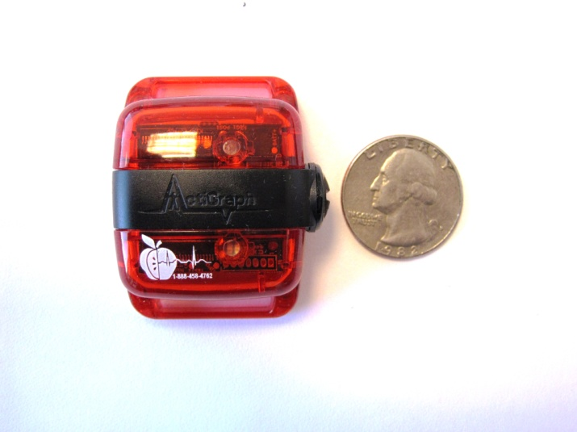
Photograph of the FLASHE Physical Activity Monitor
The monitor is manufactured by ActiGraph of Pensacola, Florida. The monitor is safe, durable, and comfortable to wear. A single polymer lithium ion (4 Volt) battery powers the monitors.
Study participants will wear the activity monitor 24 hours a day for 7 days while sleeping and awake, including activities related to school, camp, or work whenever possible. The monitor should be removed when bathing or when swimming.

Feel free to contact the Westat FLASHE Research Team at 1-800-XXX-XXXX or at XXXXXX@westat.com if you have any questions.

Frequently Asked Questions about the FLASHE Motion Study

- For how many days should I wear the activity monitor?
You should wear the monitor every day for seven days.

- When should I take the activity monitor off?
Take the monitor off only when showering, bathing, or swimming.

- Is the activity monitor waterproof?
The monitor is NOT waterproof. Please take the monitor off when you take a bath, shower, or go swimming.

- What does the blinking red light mean?
If the red light flashes it means that the battery is low. Please ignore this and keep wearing the monitor. During normal use the monitor gets approximately 10 days of battery life.

- Does the monitor track my location?
No, the monitor only records information about physical activity. It is not a GPS device and it is not able to track and/or record your location.

- What do I do if I can’t wear the monitor on days of religious observance?
If you cannot wear the monitor because of religious observances record the information on the activity log for those days that the monitor is not worn.
- What does this monitor tell the researchers?
The monitor provides an indication of the frequency, duration, and intensity of physical activity.

- How does this monitor work?
The monitor has sensors that measure general movement and allows us to get a better idea of your overall activity level. The sensors measures posture, step frequency, and acceleration. The monitor is powered by rechargeable lithium ion batteries.

- Can I wear this on an airplane?
Yes the monitor can be worn on an airplane.

10. What if I get questioned about the monitor?
A separate document, the Physical Activity Monitor Description, is available for download from the FLASHE website in case you need to provide schools, camps, or places of employment with information about the monitor. If questioned about the monitor when passing through metal detectors at an airport, please show the description to security personnel. If a security guard insists that you remove the monitor, simply reattach it to the same wrist after passing through the security checkpoint.
11. Who do I contact if I have questions?
If you have any questions about the monitor or the motion study, you may call the FLASHE study team toll free at 1-800-xxx-xxxx or email them at xxxx@westat.com.

