SUPPORTING STATEMENT
CALIFORNIA RECREATIONAL GROUNDFISH SURVEY
OMB CONTROL NO. 0648-XXXX

B. COLLECTIONS OF INFORMATION EMPLOYING STATISTICAL METHODS

1. Describe (including a numerical estimate) the potential respondent universe and any sampling or other respondent selection method to be used. Data on the number of entities (e.g., establishments, State and local governmental units, households, or persons) in the universe and the corresponding sample are to be provided in tabular form. The tabulation must also include expected response rates for the collection as a whole. If the collection has been conducted before, provide the actual response rate achieved.

Potential respondent universe

The potential respondent universe includes all saltwater recreational fishermen (anglers) who target Pacific Coast groundfish from the state of California and within California waters. Of these individuals, those who are 18 years and older and who participated in California groundfish fishing at least once in the previous 12 months are eligible to be selected for this data collection.

An average annual 927,500 groundfish trips were made in California in 2011-12. The number of groundfish anglers is unknown and will be determined as part of this survey effort.

Sample frame

Prospective respondents to this survey will be drawn from the following sample frames:

- The California Department of Fish and Wildlife (CDFW) manages an Automated License Data System (ALDS) that includes names, addresses and telephone numbers of all resident and non-resident anglers who purchase fishing licenses in California. Every two months, the Pacific States Marine Fisheries Commission (PSMFC) draws a random sample of ALDS anglers, whom they contact and screen via phone to determine whether they are saltwater (as opposed to freshwater) anglers. Saltwater anglers thus identified are then interviewed to determine the nature and extent of their saltwater fishing effort (angler trips) in California.

- CDFW conducts year-round random dockside sampling at 500 fishing sites along the California coast for purposes of collecting data on the intercepted trip (e.g., date of intercept, location, fishing mode, target species, numbers and species of fish caught).

The sampling frame for the proposed survey includes license holders in the ALDS and the pool of anglers intercepted by CDFW dockside samplers. Specifically, PSMFC will provide names and addresses of individuals, 18 years and older, sampled in the ALDS phone survey who targeted groundfish in California in the past 12 months. The ALDS will be supplemented (as needed) with names and addresses of groundfish anglers intercepted by CDFW dockside samplers. The ALDS survey and dockside sampling are ongoing programs, and obtaining names and addresses of groundfish anglers from those sources will not impose additional burden on the general public.

Sampling or other respondent selection methods

The sample selection method is stratified random sampling, with strata corresponding to the five groundfish management areas designated by CDFW: Northern, Mendocino, San Francisco, Central, and Southern (CDFW 2011). Stratification was deemed necessary, as a major purpose of the survey is to obtain information on species preferences and attitudes/preferences regarding groundfish regulations. Because species distributions and groundfish regulations vary by management area, proper interpretation of survey results will require area-specific analysis of survey data.

Anglers who participate in the ALDS telephone survey are randomly selected from the population of license holders. As a result, most ALDS respondents are drawn from California’s most populous areas (Southern, Central, and San Francisco management areas); many fewer anglers are drawn from the sparsely populated Mendocino and Northern management areas. To achieve the target sample size in these latter areas, the ALDS will be supplemented with names and addresses of groundfish anglers randomly intercepted by CDFW dockside samplers in the Mendocino and Northern areas.

Expected response rate and comparison with previous studies

A 35% response rate is anticipated, based on response rates to two previous nationwide angler surveys sponsored by NMFS in 2006 and 2011 (Gentner and Steinback 2008, CIC Research 2012). Like the proposed survey, these previous surveys focused on saltwater anglers and were conducted using a mail questionnaire. The response rate achieved for the California portion of those surveys was 36% for the 2006 survey and 35% for the 2011 survey.

Another survey that also includes saltwater anglers is the National Survey of Fishing, Hunting, and Wildlife-Associated Recreation (FHWAR), sponsored by the U.S. Fish and Wildlife Service. The FHWAR collected some information about saltwater anglers in California (USDOI 2011). However, the response rates to FHWAR are likely not applicable to this survey, as FHWAR covers a much broader range of recreation than saltwater fishing and FHWAR data are collected via in-person interviews rather than mail.

Number of entities to be sampled

As indicated in Part A, Question 12 of this Supporting Statement, 1,500 completed responses are targeted for this data collection. A target sample size of 4,285 is needed to yield these responses, assuming a 35% response rate. This sample will be distributed among the five management areas with the goal of achieving 300 completed responses for each area. Table B-1 describes the number of surveys to be mailed and the number of completed surveys, by area.

Table B-1. Sample size by management area
Management area | # surveys, by source |  |  | # completed surveys*
Management area | ALDS phone survey | CDFW dockside sampling | Total | # completed surveys*
Northern | 357 | 500 | 857 | 300
Mendocino | 357 | 500 | 857 | 300
San Francisco | 857 | 0 | 857 | 300
Central | 857 | 0 | 857 | 300
Southern | 857 | 0 | 857 | 300
TOTAL | 3,285 | 1,000 | 4,285 | 1,500
*Based on 35% response rate.

2. Describe the procedures for the collection, including: the statistical methodology for stratification and sample selection; the estimation procedure; the degree of accuracy needed for the purpose described in the justification; any unusual problems requiring specialized sampling procedures; and any use of periodic (less frequent than annual) data collection cycles to reduce burden.

Statistical methodology for stratification and sample selection

Stratification was deemed necessary, not to reduce variance in population estimates but rather to address a major purpose of the survey – e.g., to evaluate angler species preferences and attitudes/preferences regarding groundfish regulations. As indicated above, species distributions and groundfish regulations vary widely across the state. Thus proper interpretation of survey results will require sufficient sample in each area to conduct area-specific analysis of survey data.

Estimation procedure

Because the ALDS telephone survey involves random selection of anglers from the license frame, these individuals are expected to be representative of the angling population. The dockside sampling program is expected to provide a representative sample of angler trips but not a representative sample of anglers, by virtue of the fact that more frequent anglers are more likely to be encountered dockside. Survey data provided by anglers recruited dockside will be corrected for avidity bias, using a weighting method described in Thomson (1991). After correcting for avidity bias, survey data will be analyzed on an area-specific basis using statistics such as means, standard deviations, and ranges.

Degree of accuracy - precision analysis

Key data to be collected in the survey include (a) information regarding fishing behavior, species preferences, and attitudes/preferences regarding groundfish regulations, and (b) expenditures per angler trip. Sample sizes needed to achieve the desired level of precision for (a) and (b) were estimated as follows.

- Categorical responses

Many of the questions in the survey are asked in a categorical format (e.g., Questions A4, B2, C1-C6, D1, D2, D6, D8-D9, E1-E4, E6; see Attachment 1). Given the diversity of these questions and limited prior knowledge regarding how anglers will respond to them, sample size determinations were based on a wide range of possible outcomes regarding the proportion of anglers responding positively to each possible response to the categorical questions.

Figure 1 describes sample sizes needed to estimate proportions in the range 0.10 ≤ ρ ≤ 0.90 with 95% confidence for three different levels of precision: ±0.05, ±0.055 and ±0.06. As indicated in Figure 1, n=300 is adequate to achieve ±0.05 precision for proportions at the lower and higher ends of the range (0.10 ≤ ρ ≤ 0.25, 0.75 ≤ ρ ≤ 0.90) but is not adequate for estimating proportions in the intermediate range (0.30 ≤ρ ≤ 0.70). However, n=300 is more than adequate to achieve ±0.06 precision for all potential proportions 0.10 ≤ ρ ≤ 0.90, and is adequate to achieve ±0.055 precision for most proportions. Based on the sample sizes need to achieve precision ±0.055 and ±0.06, n=300 was deemed to be an appropriate target sample size for each management area.

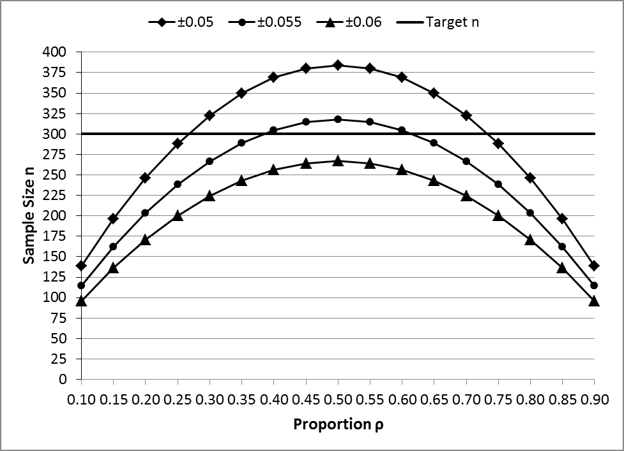
Figure 1. Sample sizes needed to estimate proportions 0.10 ≤ ρ ≤ 0.90 at three different levels of precision d ±0.05, ±0.055 and ±0.06 and 95% confidence. Sample sizes calculated as n = 1.96*ρ*(1- ρ)/d².

- Trip expenditures

Trip expenditure data collected in the proposed survey (Question D4, Attachment 1) will be used to estimate regional economic impacts (jobs, income) generated by the recreational groundfish fishery. Given that boat anglers account for 80% of groundfish effort and over 98% of groundfish catch, a goal of the proposed survey is to provide separate estimates of expenditures per angler day for party/charter and private boat modes.

Estimates of expenditures per angler day for boat-based groundfish trips in California – derived from the 2011 Marine Recreational Fishing Expenditure Survey – are shown in Table B-2.

Table B-2. Expenditures per angler day for boat-based groundfish trips in California, by fishing mode*
Fishing mode | Mean trip expenditures | Standard  deviation | n
Party/charter boat | $172.19 | 107.80 | 196
Private boat | $134.94 | 107.22 | 84
*Source: 2011 NMFS Marine Recreational Fishing Expenditure Survey.

Table B-3 shows the sample sizes needed to ensure that the proposed survey provides 95% confidence interval estimates of expenditures per angler day with a ±10% margin of error (±17 for party/charter boat, ±13 for private boat, based on the mean trip expenditure estimates in Table B-2). Applying the standard deviations from Table B-2 to the proposed survey, sample sizes that yield a ±10% margin of error are n=161 for party/charter mode and n=262 for private boat mode.

Table B-3. Sample sizes needed to estimate expenditures per angler day by fishing mode (required n) and sample sizes likely to be obtained from the survey (likely n)
Fishing mode | Confidence level | Tolerable error | Required n | 2011-12 share of angler trips | Likely n
Party/charter | 95% | ±17 | 161 | 50% | 750
Private boat | 95% | ±13 | 272 | 30% | 450
Required n = 4*StandardDeviation²/(Tolerable error²)
Likely n (party/charter) = 750 = 1500*50%
Likely n (private boat) = 450 = 1500*30%

Effort estimates from Pacific RecFIN (www.recfin.org) indicate that about 50% of total groundfish angler trips in California in 2011-12 occurred in party/charter mode and 30% occurred in private boat mode. Given the target sample of 1,500 completed surveys (Table B-1) and assuming that the survey will yield party/charter and private boat trip data in proportion to their occurrence in the population, expenditure data should be available for 750 (1500*50%) party/charter boat trips and 450 (1500*30%) private boat trips (Table B-3). Thus the sample size of n=1500 is expected to be more than adequate for estimating mean trip expenditures at the desired level of precision.

3. Describe the methods used to maximize response rates and to deal with nonresponse. The accuracy and reliability of the information collected must be shown to be adequate for the intended uses. For collections based on sampling, a special justification must be provided if they will not yield "reliable" data that can be generalized to the universe studied.

Several steps will be taken to maximize response rates and address nonresponse bias.

Maximizing response rates

Developing an appealing and understandable survey instrument is important for achieving high response rates. Economists and fishery biologists provided extensive feedback on the design of the survey. These experts include biologists at the National Marine Fisheries Service (NMFS) Southwest Fisheries Science Center (Santa Cruz), CDFW (Belmont and Monterey, CA), and the University of California Santa Barbara (UCSB) Marine Science Institute, as well as economists at the NMFS Office of Science & Technology (Silver Spring, MD). The NMFS biologist and two of the CDFW biologists consulted – as well as the two economists responsible for this data collection – currently serve or have served on Pacific Fishery Management Council advisory bodies (Groundfish Management Team, Scientific and Statistical Committee); these individuals are very knowledgeable about groundfish regulations and information regarding groundfish behavior and preferences that is needed to improve management. One of the UCSB consultants is also a former charter boat captain who has extensive first-hand experience with groundfish anglers. Focus groups were conducted in different areas of California and were crucial for ensuring that key concepts and terms were correctly used and understood, and for evaluating the overall design, format, and length of the survey questionnaire. More detailed information regarding these focus groups is provided in Appendix A. In addition, CDFW has agreed to help with outreach efforts to ‘get the word out’ about the importance of this data collection. CDFW dockside samplers will be given a copy of the survey and informed when the survey is implemented, so they will be prepared to encourage anglers who receive a questionnaire to complete it.

The implementation protocol that will be employed is based on methods suggested by Dillman et al. (2009):

- A stratified random sample will be drawn from the CDFW sample frame.
- Once selected, an advance notice letter will be mailed to notify respondents that a survey will be sent to them in the next few days. This letter will identify the survey as a NMFS-sponsored study, will emphasize the voluntary nature of the survey, and the importance of their participation.
- A few days following the advance notice letter, the survey questionnaire will be mailed to respondents. The survey will include an introductory letter that will explain the purpose of the survey, the sponsor, that participation is voluntary, and the importance of their participation. Surveys will be self-administered.
- A thank you postcard will be mailed one week after the survey questionnaire. This postcard will thank respondents who have completed the survey and urge respondents who have completed but not yet mailed it to please do so soon.
- A replacement survey will be mailed to nonrespondents 3 to 4 weeks after the initial survey was mailed. This mailing will indicate that the initial survey was not received and will urge the respondent to please complete the replacement.
- A final postcard will be mailed approximately 2 to 4 weeks after the replacement survey mailing. Similar to the thank you postcard above, it will thank respondents who have completed the survey, and urge those who have not to please do so and mail it in soon.

Nonresponse bias

As indicated in Item B1 above, the sample will be drawn from two sources: (a) anglers who are interviewed in PSMFC’s telephone survey of license holders, and (b) anglers who are interviewed in CDFW’s dockside sampling program. Anglers contacted via (a) are asked questions regarding the number of saltwater fishing trips made in the past two months and details of each trip (e.g., fishing mode, target species). Anglers contacted via (b) are asked about the number of saltwater fishing trips they made in the past 12 months and also details of the intercepted trip (e.g., fishing mode, target species, date, location). The data collected by PSMFC and CDFW will be available for both respondents and non-respondents and thus can be used to determine whether statistically significant differences exist between the two groups. These data will also be used to devise weighting schemes (as needed) to correct for non-response bias.

4. Describe any tests of procedures or methods to be undertaken. Tests are encouraged as effective means to refine collections, but if ten or more test respondents are involved OMB must give prior approval under the Paperwork Reduction Act.

As indicated in Part B, Question 3, focus groups were conducted to improve the design of the survey instrument and to evaluate the information presented in each iteration of the survey. The material covered in each focus group varied, depending on feedback received from the previous group. No more than nine members of the general public were included in each focus group. A summary of the notes taken from each of the focus groups is included as a supplementary document.

5. Provide the name and telephone number of individuals consulted on the statistical aspects of the design, and the name of the agency unit, contractor(s), grantee(s), or other person(s) who will actually collect and/or analyze the information for the agency.

The following individuals were consulted on the statistical aspects of the design and will be responsible for analyzing the data collected:

Rosemary Kosaka
Economist
NOAA Fisheries
Southwest Fisheries Science Center
831-420-3988
Rosemary.Kosaka@noaa.gov

Cindy Thomson
Economist
NOAA Fisheries
Southwest Fisheries Science Center
831-420-3911
Cindy.Thomson@noaa.gov

The following grant administrator is responsible for survey implementation:

Russell Porter
Pacific States Marine Fisheries Commission
205 SE Spokane St., Suite 100
Portland, OR 97202
503-595-3100
rporter@psmfc.org

The following sub-award recipient has been identified by the PSMFC and is responsible for data collection:

Ernie Brazier
CIC Research, Inc.
8361 Vickers St., Suite 200
San Diego, CA 92111
858-637-4000
ebrazier@cicresearch.com

References

California Department of Fish and Wildlife (CDFW). 2011. “California Ocean Sport Fishing Regulations Map,” available at: http://www.dfg.ca.gov/marine/fishing_map.asp (accessed 5/7/13).

CIC Research, Inc. 2012. 2011 National Marine Recreational Fishing Expenditure Survey – West Coast Data Collection Final Report, Volume I. Prepared for Pacific States Marine Fisheries Commission, Portland, Oregon.

Dillman, D.A., Smyth, J.D., and L.M. Christian. 2009. Internet, Mail, and Mixed-Mode Surveys: The Tailored Design Method, third edition. John Wiley & Sons, Inc.: Hoboken, New Jersey, 499p.

Gentner, B. and S. Steinback. November 2008. The Economic Contribution of Marine Angler Expenditures in the United States, 2006. U.S. Department of Commerce, NOAA Tech. Memo. NMFS-F/SPO-94, 301 p.

Magnuson-Stevens Fishery Conservation and Management Act (P.L. 94-265), as amended through January 12, 2007 (P.L. 109-479). May 2007. Available at: http://www.nmfs.noaa.gov/msa2007/details.html

National Marine Fisheries Service. 2012. Fisheries Economics of the United States, 2011. U.S. Dept. of Commerce, NOAA Tech. Memo. NMFS-F/SPO-118, 175 p. Available at: http://www.st.nmfs.noaa.gov/st5/publication/index.html.

Thomson, C.J. 1991. Effects of avidity bias on survey estimates of fishing effort and economic value. In: Guthrie, Dan et al. Creel and Angler Surveys in Fishery Management. American Fisheries Society Symposium 12. Bethesda: American Fisheries Society.

