Attachment 12
ICF Macro IRB Approval



Institutional Review Board Findings Form

Name of Project Director(s): Michelle Revels

Title of Project: Impact Evaluation of CDC’s Colorectal Cancer Control Program-annual review

ICF Project Number: 635243.0.007.00.000
Type of Review:

New

X Renewal
Findings of the Board:

Project is exempt from IRB review (Please see IRB exemption form)

X Project complies with all of the requirements of 45 CFR 46, "Protection of Human
Subjects"

Project does not comply with all of the requirements of 45 CFR 46
Project Approved Until: September 30, 2015

Next Annual Review Date: November 22, 2013
October 30, 2012

Chair, Institutional Review Board Date
(Revised-06/26/12)

9300 Lee Highway • Fairfax, VA 22031 • 703-934-3000 • 703.934.3740 fax • icfi.com

IN llfiN,\T!ONAL
ICF

Institutional Review Board

Agreement to Comply with Human Subject Protection Requirements

The following project has been found by the Institutional Review Board (IRB) to be in compliance with the human subject protection requirements as specified in 45 CFR 46.

Project Title: Impact Evaluation of CDC's Colorectal Cancer Control
Program-annual review.

PrincipalInstigator/Project Dlrector(s): Michelle Revels

ICF Project Number: 635243.0.007.00.000

Approval Date:

Next Continuous Review Date:
October 30, 2012

November 22, 2013

As the responsible principal investigator/Project Director for this project, I agree to adhere to the human subject protection procedures that were approved by the IRB and to inform the chair of the IRB when any changes are made in the approved procedures. The approved procedures include all of the following:

• Subject selection and recruitment procedures
• Data collection procedures
• Informed consent procedures
• Protection of privacy and confidentiality procedures
• Data security procedures
• Additional safeguards specified by the IRB.

If you have any questions regarding changes in procedures that are subject to IRB review, please contact the
IRB Chair, Janet D. Griffith (Janet.Griffith@icfi.com), to discuss your concerns.

Also, as the responsible principal investigator or project director, I agree to cooperate with the IRB continuous annual review(s) of this project. Several weeks prior to the next annual review date listed above, the IRB Administrator will send the IRB Project Continuous Review Form or identify where to obtain the form, to complete and submit to the IRB before the annual review date. The purposes of the IRB Project Continuous Review Form are 1) to provide the IRB with updated information on the procedures used to protect the human subjects who are involved in this project, and 2) to help the IRB determine if the project is in compliance with the
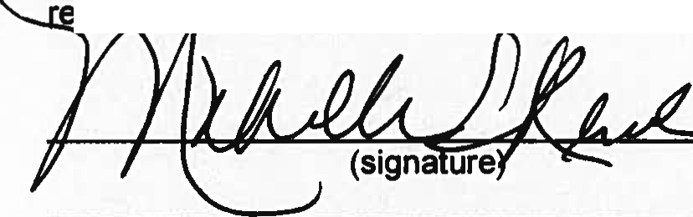quirem ts in 45 CFR 46.
ttl
Please email an original signed copy of this form to the IRB at IRB@icfi.com. A copy of the signed form should
also be maintained with your study files.
(Revtsed-()6/26112)

9300 Lee Highway • Fairfax,VA 22031• 703-934-3000 • 703.934.3740 fax • icfi.com

