WHAM: Women’s Health and Mindfulness Study

Note: Core questions across study sites are indicated with an * at their start.

To be completed by the interviewer.

1.1 PARTICIPANT ID: _____ _____

1.2 INTERVIEWER ID: _____

1.3 DATE OF INTERVIEW: _____ _____ / _____ _____ / 2 0 _____ _____ (MM/DD/YY)

1.4 INTERVIEW BEGIN TIME: _____ _____ : _____ _____ AM / PM

1.5 INTERVIEW END TIME: _____ _____ : _____ _____ AM / PM

1.6 STUDY VISIT NUMBER (CIRCLE ONE): 1 2 3

Read introduction:
We are ready to begin the interview. Please remember that your answers will not be shared with anyone outside the study team. Your answers will be put together with all the other participants’ answers to help us learn more about lesbian and bisexual women's health. For this reason, your honest answers are very important.

Remember that you are not being judged based on your answers and there are no right or wrong answers. Some of the questions ask about personal topics about your health and you may feel uncomfortable answering some of them. You can skip questions, end the interview, or ask me to repeat or explain anything at any time. If you have any questions or want to talk about certain things that come up during the interview, let me know and I will make a note of it to talk to you when we finish. Do you have any questions before we begin?

CODING NOTE TO INTERVIEWERS: DON’T KNOW=-8; DECLINED=-9.

II. Sociodemographics

These questions are about your background and self-identification.

- *What is your date of birth? _____ _____(MM)/_____ _____(DD)/ 19 _____ _____(YY)

- What is your zip code of residence? _____ _____ _____ _____ _____

- *Are you of Hispanic or Latino origin?
_____1 Yes
_____2 No
_____3 Don’t know/not sure

- *Which one or more of the following would you say is your race?
_____1 White
_____1 Black or African American
_____1 Asian
_____1 Native Hawaiian or Other Pacific Islander
_____1 American Indian or Alaska Native

- *What is the highest level of education you have completed?
_____1 Less than high school
_____2 High school or GED
_____3 Technical school -- no degree
_____4 Some college -- no degree
_____5 2-year college degree/technical school degree
_____6 4-year college degree
_____7 Post-graduate work or degree

- *What is your current employment status?
_____1 Working part-time (less than 32 hours/week)
_____2 Working full-time (32 or more hours/week)
_____3 Unemployed, laid off, on strike
_____4 Retired
_____5 Disabled or unable to work
_____6 In school full time and not working
_____7 Full-time homemaker
- What is your household income per year? Please choose one option from this list. Household members include those persons living in the same home who are related by birth, marriage, registered domestic partnership or adoption.

- 1 < $10,000
- 2 $10,000 - 29,999
- 3 $30,000 – 49,999
- 4 $50,000 – 69,999
- 5 $70,000 – 89,999
- 6 $90,000 – 109,999
- 7 $110,00 – 149,999
- 8 $150,000 or more

- What is your gender identity?
_____1 Cisgender (Your sex at birth matches your current gender identity)
_____2 Transgender (Your sex at birth does not match your current gender identity)
_____3 Genderqueer (You do not identify as either male or female)
_____4 Other (please tell us) ___________________

- *Which of the following best represents how you think of yourself? [Response Card B].
_____1 Lesbian or gay SKIP TO 2.10
_____2 Straight, (heterosexual) that is, not lesbian, gay or bisexual SKIP TO 2.10
_____3 Bisexual SKIP TO 2.10
_____4 Something else SKIP TO 2.9a
_____5 I don't know the answer SKIP TO 2.9b

2.9a *What do you mean by something else?
_____1 You are not straight, but identify with another label such as queer, trisexual, omnisexual or pansexual
_____2 You are transgender, transsexual or gender variant
_____3 You have not figured out or are in the process of figuring out your sexuality
_____4 You do not think of yourself as having sexuality
_____5 You do not use labels to identify yourself
_____6 You mean something else

- *How “out” are you about your sexuality with your health care providers (doctors, nurses, nutritionists, mental health professionals, personal trainers, etc.)
_____1 Out to all
_____2 Out to some
_____3 Out to a few
_____4 Out to None

- *Do you have a long term physical or mental impairment that substantially limits one or more major life activities?
_____1 Yes
_____2 No

2.11a *In which activities are you limited? You may choose more than one.
_____1 Caring for myself
_____2 Performing manual tasks
_____3 Walking or standing
_____4 Lifting or reaching
_____5 Seeing
_____6 Hearing, speaking or communicating
_____7 Learning, thinking or concentrating
_____8 Working

- *Do you have any kind of health care coverage, including health insurance, prepaid plans such as HMOs or PPOs, or government plans such as Medicare or MediCal?
_____1 Yes
_____2 No
_____3 Don’t know/Not sure

*Quality of Life (VR-12 Survey): I would like to start the next part of our questionnaire by asking you some general questions about how you see your health.
2.13 In general, would you say your health is:
_____1 Excellent
_____2 Very good
_____3 Good
_____4 Fair
_____5 Poor

2.14 The following questions are about activities you might do during a typical day. Does your health now limit you in these activities? If so, how much?

2.14A. Moderate activities, such as moving a table, pushing a vacuum cleaner, bowling or playing golf?

_____1 Yes, limited a lot
_____2 Yes, limited a little
_____3 No, not limited at all

2.14B. Climbing several flights of stairs?

_____1 Yes, limited a lot
_____2 Yes, limited a little
_____3 No, not limited at all

  - During the past 4 weeks, have you had any of the following problems with your work or other regular daily activities as a result of your physical health?

2.15A. Accomplished less than you would like.
_____1 No, none of the time
_____2 Yes, a little of the time
_____3 Yes, some of the time
_____4 Yes, most of the time
_____5 Yes, all of the time

2.15B. Were limited in the kind of work or other activities.
_____1 No, none of the time
_____2 Yes, a little of the time
_____3 Yes, some of the time
_____4 Yes, most of the time
_____5 Yes, all of the time

2.16 During the past 4 weeks, have you had any of the following problems with your work or other regular daily activities as a result of any emotional problems (such as feeling depressed or anxious)?

2.16A. Accomplished less than you would like.
_____1 No, none of the time
_____2 Yes, a little of the time
_____3 Yes, some of the time
_____4 Yes, most of the time
_____5 Yes, all of the time

2.16B. Didn’t do work or other activities as carefully as usual
.
_____1 No, none of the time
_____2 Yes, a little of the time
_____3 Yes, some of the time
_____4 Yes, most of the time
_____5 Yes, all of the time

  - During the past 4 weeks, how much did pain interfere with your normal work (including both work outside the home and housework)?
_____1 Not at all
_____2 A little bit
_____3 Moderately
_____4 Quite a bit
_____5 Extremely

These questions are about how you feel and how things have been with you during the past 4 weeks. For each question, please give the one answer that comes closest to the way you have been feeling.

2.18 How much of the time during the past 4 weeks:

Have you felt calm and peaceful?
_____1 All of the time
_____2 Most of the time
_____3 A good bit of the time
_____4 Some of the time
_____5 A little bit of the time
_____6 None of the time
2.19 How much of the time during the past 4 weeks:

Did you have a lot of energy?
_____1 All of the time
_____2 Most of the time
_____3 A good bit of the time
_____4 Some of the time
_____5 A little bit of the time
_____6 None of the time

2.19 How much of the time during the past 4 weeks:

Have you felt downhearted and blue?
_____1 All of the time
_____2 Most of the time
_____3 A good bit of the time
_____4 Some of the time
_____5 A little bit of the time
_____6 None of the time
2.20. During the past 4 weeks, how much of the time has your physical health or emotional problems interfered with your social activities (like visiting with friends, relatives, etc.)?
_____1 All of the time
_____2 Most of the time
_____3 Some of the time
_____4 A little of the time
_____5 None of the time

Now, we’d like to ask you some questions about how your health may have changed.

2.21. Compared to one year ago, how would you rate your physical health in general now?
_____1 Much better
_____2 Slightly better
_____3 About the same
_____4 Slightly worse
_____5 Much worse

2.22. Compared to one year ago, how would you rate your emotional problems (such as feeling anxious, depressed or irritable) now?
_____1 Much better
_____2 Slightly better
_____3 About the same
_____4 Slightly worse
_____5 Much worse

III. Health Behaviors
We are interested in finding out about the kinds of physical activities that people do as part of their everyday lives. The questions will ask you about the time you spent being physically active in the last 7 days. Please answer each question even if you do not consider yourself to be an active person. Please think about the activities you do at work, as part of your house and yard work, to get from place to place, and in your spare time for recreation, exercise or sport.
SHOW PARTICIPANT PHYSICAL ACTIVITY IMAGE CARD.
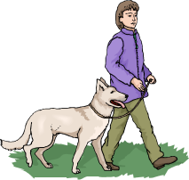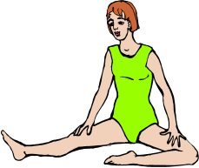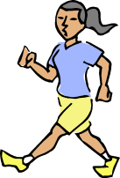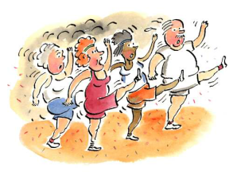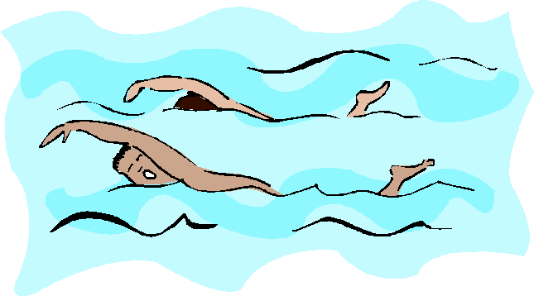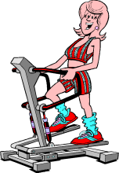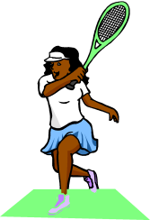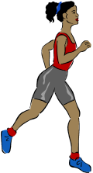

Light activities
- Your heart beats slightly faster than normal
- You can talk and sing
Moderate activities
- Your heart beats faster than normal
- You can talk but not sing
Vigorous activities
- Your heart rate increases a lot
- You can’t talk or your talking is broken up by large breaths
Walking
leisurely
Stretching
Vacuuming
or light yard
work
Fast walking
Aerobics class
Strength training
Swimming gently
Stair machine
Jogging or running
Tennis, racquetball, or badminton
Think about all the vigorous activities that you did in the last 7 days. Vigorous physical activities take hard physical effort and make you breathe much harder than normal. Think only about those physical activities that you did for at least 10 minutes at a time.
- *During the last 7 days, on how many days did you do vigorous physical activities like heavy lifting, digging, aerobics, or fast bicycling?

_____ days in the last week if 0, skip to 3.3
- *How much time did you usually spend doing vigorous physical activities on one of those days?

_____1 Hour(s) per day
_____2 Minutes per day
_____3 Don’t know/not sure

Think about all the moderate activities that you did in the last 7 days. Moderate activities take moderate physical effort and make you breathe somewhat harder than normal. Think only about those physical activities that you did for at least 10 minutes at a time.
- *During the last 7 days, on how many days did you do moderate physical activities like carrying light loads, bicycling at a regular pace, or doubles tennis? Do not include walking.

_____ days in the last week if 0, skip to 3.5

- *How much time did you usually spend doing moderate physical activities on one of those days?

_____1 Hour(s) per day
_____2 Minutes per day
_____3 Don’t know/not sure
Now, think about the time you spent walking in the last 7 days. This includes at work and at home, walking to travel from place to place, and any other walking that you might do solely for recreation, sport, exercise, or leisure.
- *During the last 7 days, on how many days did you walk for at least 10 minutes at a time?
_____ days in the last week if 0, skip to 3.7
- *How much time did you usually spend walking on one of those days?

_____1 Hour(s) per day
_____2 Minutes per day
_____3 Don’t know/not sure

The last question is about the time you spent sitting on weekdays during the last 7 days. Include time spent at work, at home, while doing course work and during leisure time. This may include time spent sitting at a desk, visiting friends, reading, or sitting or lying down to watch television.

- *During the last 7 days, how much time did you spend sitting on a week day?

_____1 Hour(s) per day
_____2 Minutes per day
_____3 Don’t know/not sure

The next section is about the foods you ate or drank during the past 30 days, including meals and snacks. Remember to include any sweetened beverages used as a mixer for cocktails.
- *During the past 30 days, how often did you drink regular soda or pop that contains sugar? Do not include diet soda.

_____1 Times per day
_____2 Times per week
_____3 Times per month
_____4 Never

- *During the past 30 days, how often did you drink diet soda or pop that contains artificial sweeteners?

_____1 Times per day
_____2 Times per week
_____3 Times per month
_____4 Never

- *During the past 30 days, how often did you drink sports or energy drinks such as Gatorade, Red Bull or Vitamin Water. Remember to use include sports or energy drinks used as a mixer? Do not include diet or sugar-free kinds.

_____1 Times per day
_____2 Times per week
_____3 Times per month
_____4 Never

- *During the past 30 days, how often did you drink sweetened fruit drinks such as Kool-aid, cranberry drink or lemonade? Include fruit drinks you made at home and added sugar to. Do not include 100% fruit juices and drinks with things like Splenda or Equal.

_____1 Times per day
_____2 Times per week
_____3 Times per month
_____4 Never

- *During the past 30 days, how often did you drink coffee or tea with sugar or honey added? Do not include drinks with things like Splenda or Equal. Include pre-sweetened tea and coffee drinks such as Arizona Iced Tea and Frappuccino.
_____1 Times per day
_____2 Times per week
_____3 Times per month
_____4 Never

- *During the past 30 days, how often did you drink water (including tap, bottled, and carbonated water)?

_____1 Times per day
_____2 Times per week
_____3 Times per month
_____4 Never

- *Each time you drank water, how much did you usually drink?

_____1 Less than 6 fl oz (3/4 oz)
_____2 8 fl oz (1 cup)
_____3 12 fl oz (1-1/2 cups)
_____4 16 fl oz (2 cups)
_____5 More than 20 fl oz (2-1/2 cups)

- *During the past 30 days, how many times per day, week or month did you drink 100% PURE fruit juices? Do not include fruit-flavored drinks with added sugar or fruit juice you made at home and added sugar to. Only include 100% juice.

_____1 Times per day
_____2 Times per week
_____3 Times per month
_____4 Never

- *During the past 30 days, not counting juice, how many times per day, week or month did you eat fruit? Count fresh, frozen or canned fruit.

_____1 Times per day
_____2 Times per week
_____3 Times per month
_____4 Never

- *During the past 30 days, how many times per day, week or month did you eat cooked or canned beans, such as refried, black, garbanzo beans, beans in soup, soybeans, edamame, tofu or lentils. Do NOT include long green beans.

_____1 Times per day
_____2 Times per week
_____3 Times per month
_____4 Never

- *During the past 30 days, how many times per day, week or month did you eat dark green vegetables for example broccoli or dark leafy greens including romaine, chard, collard greens or spinach?
_____1 Times per day
_____2 Times per week
_____3 Times per month
_____4 Never
- *During the past 30 days, how many times per day, week or month did you eat orange colored vegetables such as sweet potatoes, pumpkin, winter squash or carrots?

_____1 Times per day
_____2 Times per week
_____3 Times per month
_____4 Never

- *Not counting these last questions on fruits and vegetables, during the past 30 days, about how many times per day, week or month did you eat OTHER vegetables? Examples of other vegetables include tomatoes, tomato juice or V-8 juice, corn, eggplant, lettuce, cabbage and white potatoes that are not fried such as baked or mashed potatoes.
_____1 Times per day
_____2 Times per week
_____3 Times per month
_____4 Never

- *How many servings of fruits and vegetables do you usually have per day? (1 serving = 1 medium piece of fruit; ½ cup fresh, frozen or canned fruits/vegetables; ¾ cup fruit/vegetable juice; 1 cup salad greens; or ¼ cup dried fruit).
____0 servings per day
____1-2 servings per day
____3-4 servings per day
____5 or more servings per day

The next questions are about alcohol use and smoking.

- *During the 30 days, how often did you usually have any kind of drink containing alcohol?
By a drink we mean half an ounce of absolute alcohol (e.g. a 12 ounce can or glass of beer or cooler, a 5 ounce glass of wine, or a drink containing 1 shot of liquor).
_____1 Every day
_____2 5 to 6 times a week
_____3 3 to 4 times a week
_____4 twice a week
_____5 once a week
_____6 2 to 3 times a month
_____7 once a month
_____8 I did not drink any alcohol in the past 30 days, but I did drink in the past
SKIP TO 3.25
_____9 I never drank any alcohol in my life SKIP TO 3.25

- During the last 30 days, how many alcoholic drinks did you have on a typical day when you drank alcohol?
_____1 25 or more drinks
_____2 19 to 24 drinks
_____3 16 to 18 drinks
_____4 12 to 15 drinks
_____5 9 to 11 drinks
_____6 7 to 8 drinks
_____7 5 to 6 drinks
_____8 3 to 4 drinks
_____9 2 drinks
_____10 1 drink

- *During the last 30 days, how often did you have 4 or more drinks containing any kind of alcohol in within a two-hour period?
_____1 Every day
_____2 5 to 6 days a week
_____3 3 to 4 days a week
_____4 two days a week
_____5 one day a week
_____6 2 to 3 days a month
_____7 one day a month
_____8 Never
- *Do you NOW smoke cigarettes every day, some days or not at all?
_____1 Every day
_____2 Some days
_____3 Not at all

- *Have you smoked at least 100 cigarettes in your lifetime?
_____1 Yes
_____2 No
- Do you NOW use marijuana?
_____1 Yes
_____2 No
- If yes, how often do you use marijuana?
_____1 Every day
_____2 5 to 6 days a week
_____3 3 to 4 days a week
_____4 two days a week
_____5 one day a week
_____6 2 to 3 days a month
_____7 one day a month

IV. Psychosocial Assessments

The next questions ask about what things you may or may not think about when it comes to food and eating. I will give you a card so you can show me which number describes your experiences with each question I read out loud to you. [HAND RESPONSE CARD C].

 | Almost Never | Some-  times | Fairly Often | Very Often
Factor 1: Disinhibition
- I stop eating when I’m full even when eating something I love. | 1 | 2 | 3 | 4
- When a restaurant portion is too large, I stop eating when I’m full. | 1 | 2 | 3 | 4
- When I eat at “all you can eat” buffets, I tend to overeat. | 1 | 2 | 3 | 4
- If there are leftovers that I like, I take a second helping even though I’m full. | 1 | 2 | 3 | 4
- If there’s good food at a party, I’ll continue eating even after I’m full. | 1 | 2 | 3 | 4
- When I’m eating one of my favorite foods, I don’t recognize when I’ve had enough. | 1 | 2 | 3 | 4
- When I’m at a restaurant, I can tell when the portion I’ve been served is too large for me. | 1 | 2 | 3 | 4
- If it doesn’t cost much more, I get the larger size food or drink regardless of how hungry I feel. | 1 | 2 | 3 | 4
Factor 4: Emotional Response
- When I’m sad I eat to feel better. | 1 | 2 | 3 | 4
- When I’m feeling stressed at work I’ll go ﬁnd something to eat. | 1 | 2 | 3 | 4
- I have trouble not eating ice cream, cookies, or chips if they’re around the house. | 1 | 2 | 3 | 4
- I snack without noticing that I am eating. | 1 | 2 | 3 | 4
Factor 5: Distraction
- My thoughts tend to wander while I am eating. | 1 | 2 | 3 | 4
- I think about things I need to do while I am eating. | 1 | 2 | 3 | 4
- I eat so quickly that I don’t taste what I’m eating. | 1 | 2 | 3 | 4

Below is a collection of statements about your everyday experience. Using the 1-6 scale I have given you on the chart, please indicate how frequently or infrequently you currently have each experience. Please answer according to what really reflects your experience rather than what you think your experience should be. Please treat each item separately from every other item. (SHOW RESPONSE CARD D) [reverse score]
 | Never | Very Infrequently | Somewhat Infrequently | Somewhat Frequently | Very Frequently | Almost Always
- I could be experiencing some emotion and not be conscious of it until some time later. | 1 | 2 | 3 | 4 | 5 | 6
- I break or spill things because of carelessness, not paying attention, or thinking of something else. | 1 | 2 | 3 | 4 | 5 | 6
- I find it difficult to stay focused on what's happening in the present. | 1 | 2 | 3 | 4 | 5 | 6
- I tend to walk quickly to get where I'm going without paying attention to what I experience along the way. | 1 | 2 | 3 | 4 | 5 | 6
- I tend not to notice feelings of physical tension or discomfort until they really grab my attention. | 1 | 2 | 3 | 4 | 5 | 6
- I forget a person's name almost as soon as I've been told it for the first time. | 1 | 2 | 3 | 4 | 5 | 6
- It seems I am "running on automatic," without much awareness of what I'm doing. | 1 | 2 | 3 | 4 | 5 | 6
- I rush through activities without being really attentive to them. | 1 | 2 | 3 | 4 | 5 | 6
- I get so focused on the goal I want to achieve that I lose touch with what I'm doing right now to get there. | 1 | 2 | 3 | 4 | 5 | 6
- I do jobs or tasks automatically, without being aware of what I'm doing. | 1 | 2 | 3 | 4 | 5 | 6
- I find myself listening to someone with one ear, doing something else at the same time. | 1 | 2 | 3 | 4 | 5 | 6
- I drive places on "automatic pilot" and then wonder why I went there. | 1 | 2 | 3 | 4 | 5 | 6
- I find myself preoccupied with the future or the past. | 1 | 2 | 3 | 4 | 5 | 6
- I find myself doing things without paying attention. | 1 | 2 | 3 | 4 | 5 | 6
- I snack without being aware that I'm eating. | 1 | 2 | 3 | 4 | 5 | 6

The next questions ask you about your feelings and thoughts during the last month. Again, that includes all time from MONTH/YEAR until today. In each case, you will be asked to say how often you felt or thought a certain way. You can answer by choosing one of these responses from “Never” to “Very Often” [SHOW RESPONSE CARD E].
 | Never | Almost Never | Sometimes | Fairly Often | Very Often
- In the last month, how often have you been upset because of something that happened unexpectedly? | 0 | 1 | 2 | 3 | 4
- In the last month, how often have you felt that you were unable to control the important things in your life? | 0 | 1 | 2 | 3 | 4
- In the last month, how often have you felt nervous and “stressed”? | 0 | 1 | 2 | 3 | 4
- In the last month, how often have you felt confident about your ability to handle your personal problems? | 0 | 1 | 2 | 3 | 4
- In the last month, how often have you felt that things were going your way? | 0 | 1 | 2 | 3 | 4
- In the last month, how often have you found that you could not cope with all the things that you had to do? | 0 | 1 | 2 | 3 | 4
- In the last month, how often have you been able to control irritations in your life? | 0 | 1 | 2 | 3 | 4
- In the last month, how often have you felt that you were on top of things? | 0 | 1 | 2 | 3 | 4
- In the last month, how often have you been angered because of things that were outside of your control? | 0 | 1 | 2 | 3 | 4
- In the last month, how often have you felt difficulties were piling up so high that you could not overcome them? | 0 | 1 | 2 | 3 | 4

Section V. Partners and Social Support
- * Which of the following best describes your present relationship?

_____1 In a committed relationship with a woman (for example, cohabitating, domestic partnership, or legally married)
_____2 In a committed relationship with a man (for example, cohabitating, domestic partnership or legally married)
_____3 Single, but somewhat involved with a woman, man or both – SKIP TO 5.2
_____4 Single, and not involved with anyone – SKIP to 5.2

5. IA If in a committed relationship, do you currently live with your partner:
_____1 All or most of the time
_____2 Some of the time
_____3 None of the time
In this last section I will ask you about your connections with friends, any partner you might have and the community.
- How satisfied are you with your current relationship status?
- Very satisfied
- Somewhat satisfied
- Somewhat dissatisfied
- Very dissatisfied
- How would you rate the health of your current partner?
- Excellent
- Very good
- Good
- Fair
- Poor
- No partner (or N/A)
- *What is the number that best depicts the approximate outline of your primary partner?
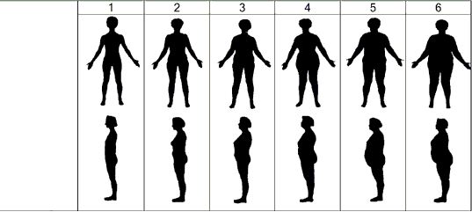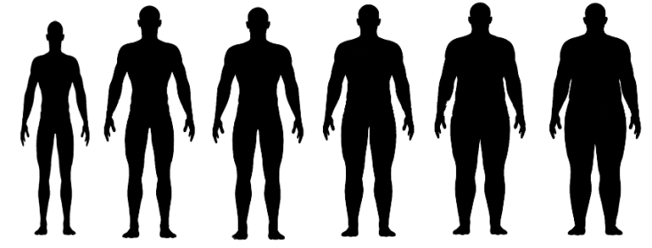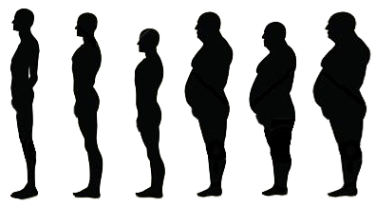
1
1
2
3
4
5
6
2
3
4
5
6
RECORD RESPONSE: _____ _____ [NO PARTNER=7]

- How satisfied are you with the support you receive from your current social network of friends?
- Very satisfied
- Somewhat satisfied
- Not satisfied nor unsatisfied
- Somewhat dissatisfied
- Very dissatisfied
- Is your current social network
- Mostly other lesbian and bisexual women
- A mix of LGBT people
- A mix of women, LB and straight
- A mix of heterosexual men and women and LGBT people
- Mostly heterosexual people
Social Isolation: Family
*5.7 How many relatives do you see or hear from at least once a month? | 0 = none  1 = one  2 = two  3 = three or four  4 = five thru eight  5 = nine or more
*5.8 How many relatives do you feel at ease with that you can talk about private matters? | 0 = none  1 = one  2 = two  3 = three or four  4 = five thru eight  5 = nine or more
*5.9 How many relatives do you feel close to such that you could call on them for help? | 0 = none  1 = one  2 = two  3 = three or four  4 = five thru eight  5 = nine or more
Social Isolation: Friendships
*5.10 How many of your friends do you see or hear from at least once a month? | 0 = none  1 = one  2 = two  3 = three or four  4 = five thru eight  5 = nine or more
*5.11 How many friends do you feel at ease with that you can talk about private matters? | 0 = none  1 = one  2 = two  3 = three or four  4 = five thru eight  5 = nine or more
*5.12 How many friends do you feel close to such that you could call on them for help? | 0 = none  1 = one  2 = two  3 = three or four  4 = five thru eight  5 = nine or more

VI. Health Assessment
Read introduction: These questions are basic health questions. It will include me taking down your height, weight and measuring your waist circumference with a measuring tape. Is it okay for me to measure your waist? A clinic staff member will take your blood pressure as well.

6.1. What is your current height? ________ ft _______inches
6.2. Record current weight ________ pounds

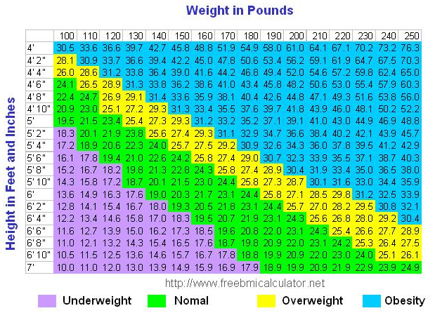

6.3. BMI = __________________ (filled in by staff)

6.4. Waist circumference _____________ inches

6.5. Blood pressure ______________

6.6. Have you had at least one menstrual period in the past 12 months? (Please do not include bleedings caused by medical conditions, hormone therapy, or surgeries).
_____1 Yes
_____2 No SKIP TO 6.6C

6.6A. Is your period:
_____1 Regular (approximately once a month)
_____2 Irregular

6.2B Why do you think your period is irregular? _____________________________

SKIP TO 6.7.

6.6C How long has it been since your last period? ____________ months (calculate years into months)

6.6D. What are you doing to manage your menopause symptoms?

- Hormone treatment
- Nutritional treatment
- Herbal treatment
- Other prescription medications
- Meditation
- Other ________________

6.7. Do you currently have or have you ever had any of the following health concerns or chronic conditions?
- Heart attack
- Stroke
- High blood pressure
- High cholesterol (hyperlipidemia, high triglycerides)
- Asthma
- Emphysema, COPD, chronic bronchitis or other lung disease
- Prediabetes
- Diabetes
- Arthritis
- Chronic pain

WHAM Study Laboratory Test Results

Participant ID: _____ _____

Testing Date [MM/DD/YY]: _____ _____ / ______ ______ / ______ _____

Laboratory: _____1 LMHS
_____2 Other SF location
_____3 East Bay location

STUDY VISIT NUMBER (CIRCLE ONE): 1 2 3

TRANSCRIBE LABORATORY TEST RESULTS BELOW FOR DATA ENTRY.

  - Total cholesterol _________
  - LDL ___________
  - HDL __________
  - Triglycerides ___________

  - Hemoglobin A1C ________

