The following screenshot was pulled from the FitBit website. To create a pedometer-related profile, respondents must complete the following information.
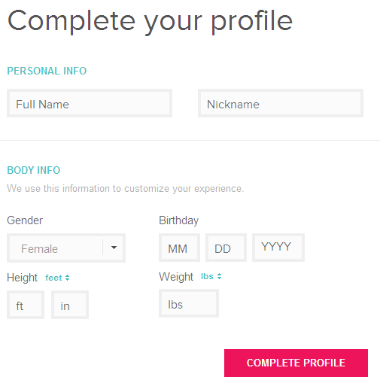
After completing a profile, we will activate each users’ pedometer and respondents will have no additional burden. Data will be pulled manually by our research team using the FitBit Leaderboard function, which will be viewable only to those individuals included in our intervention. The following screenshot shows an example Leaderboard currently published on the FitBit website. Note that the example below is a public Leaderboard; thus, names are pictures are available. For our intervention, however, this information will be private and identities will be protected.
Steps data can be pulled in 7-day or 30-day increments.

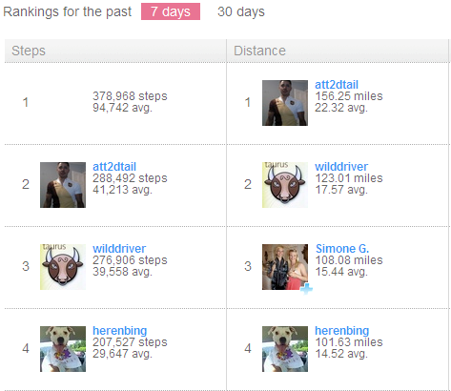
USER NAME
USER NAME
USER NAME
USER NAME
USER NAME
USER NAME
USER NAME
USER NAME

