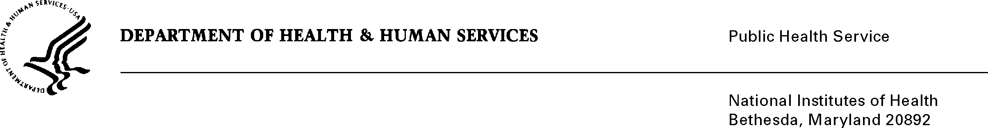

DATE: June 24, 2013

TO: Dorothy F. Farrell, Ph.D.,
Nanotechnology Development Projects Manager
Office of Cancer Nanotechnology Research
National Cancer Institute

FROM: NIH Privacy Act Officer

SUBJECT: Applicability of the Privacy Act: “Cancer Nanotechnology Platform Partnerships (CNPP) Scientific Program Reports”

I have reviewed the NCI submission to OMB. The purpose of the study is to monitor the effectiveness of the NCI Alliance for Nanotechnology in Cancer Program and the performance and progress of individual awardees to ensure that the intent and requirements of the CNPP award are met.

The respondents will be Principal Investigators of funded grant awards and Institutional Business Officials. They will be asked to submit personally identifiable information about their key achievements, education and training activities, publications and patents, etc.

The respondents will enter information or upload files using an interface that is part of the National Institutes of Health (NIH) eRA Commons system. Electronic copies of PHS Form 2590 will collect detailed budget information, personnel and progress reports and will be stored on the NIH e-Grants system. Much of the information is specific to the requirements of the program (e.g., progress on milestones). Interim and annual progress reports will be reviewed by NCI Alliance program staff who will reach back to the investigators with questions or comments regarding scientific details or programmatic matters.
The data collection is covered by NIH Privacy Act Systems of Record 09-25-0036, “Extramural Awards and Chartered Advisory Committees (IMPAC 2), Contract Information (DCIS), and Cooperative Agreement Information, HHS/NIH”.
If you have any questions, please contact my office at (301) 402-6201.

Karen M. Plá

cc: Vivian Horovitch-Kelley, NCI PRA Liaison

