Revised: 05/09/2013 OMB Control No. 0648-0393 Expiration Date: 08/31/2013
 | APPLICATION FOR  AMERICAN FISHERIES ACT (AFA) PERMIT  FOR  REPLACEMENT VESSEL | U.S. Dept. of Commerce/NOAA  National Marine Fisheries Service (NMFS)  Restricted Access Management (RAM)  P.O. Box 21668  Juneau, AK 99802-1668  (800) 304-4846 toll free / 586-7202 in Juneau  (907) 586-7354 fax | 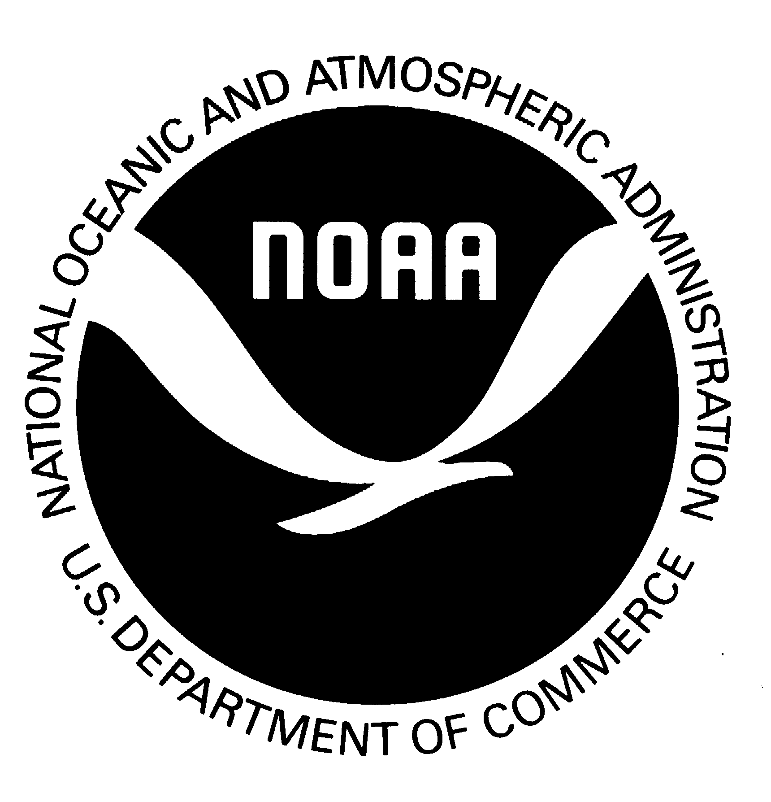
Provide information as of the time of the actual or constructive loss of the vessel.
BLOCK A - IDENTIFICATION OF LOST AFA ELIGIBLE VESSEL
Attach USCG form 2692 or insurance papers to verify the loss.
1. Vessel Name: |  | 2. ADF&G Vessel Registration Number:
 |  | 3. USCG Documentation Number:
 |  | 4. AFA Permit Number:
5. Gross Tons: | 6. Shaft Horsepower: |  | 7. Registered Length (feet):
8. Owner Name:

9. Business Mailing Address: |  | 10. Business Telephone Number:
 |  | 11. Business FAX Number:
 |  | 12. Business E-mail Address:
13. What was the last year in which this vessel harvested or processed pollock in a
BSAI directed pollock fishery?
14. Describe how the vessel was lost or destroyed:

BLOCK B - IDENTIFICATION & OWNERSHIP OF REPLACEMENT VESSEL
(Attach USCG documentation for this vessel)
1. Vessel Name: |  |  |  | 2. ADF&G Vessel Registration Number:
 |  |  |  | 3. USCG Documentation Number:
 |  |  |  | 4. Federal Fisheries Permit Number:
5. Gross Tons: | 6. Net Tons (U.S, tons): |  |  |  | 7. Shaft Horsepower:
8. Registered Length (feet): |  |  | 9. Current Length Overall (feet):
10. Owner Name:

11. Business Mailing Address: |  |  |  | 12. Business Telephone Number:
 |  |  |  | 13. Business Fax Number:
 |  |  |  | 14. Business E-mail Address:
15. Was the vessel built in the United States?  YES [ ] NO [ ] |  | 16. Has the vessel ever been rebuilt?  YES [ ] NO [ ] |  |  |  | 17. If YES, was it rebuilt in the United States?  YES [ ] NO [ ]

BLOCK C - CERTIFICATION OF APPLICANT
Under penalties of perjury, I declare that I have examined this application, and to the best of my knowledge and belief, the information presented here is true, correct and complete.
1. Signature of Owner |  | 2. Date:
3. Printed Name of owner

Instructions

APPLICATION FOR AFA PERMIT FOR REPLACEMENT VESSEL

Provide information as of the time of the actual or constructive loss of the vessel.

GENERAL INFORMATION

Use this application to request replacement of an AFA qualified catcher vessel, catcher/processor, or mothership in the event of total or constructive loss of the qualified vessel. Replacement of AFA qualified vessels is authorized at Section 208(g) of the AFA and 50 CFR 679.4(l).

Attach USCG form 2692 or insurance papers for this vessel to verify the loss

Type or print legibly in ink; retain a copy of completed application for your records.

When completed, submit application to:

By mail to: NMFS Alaska Region
Restricted Access Management (RAM)
P.O. Box 21668
Juneau, Alaska 99802-1668

or fax to: (907) 586-7354

or deliver to: 709 West 9th Street, Room 713
Juneau, AK 99801

Items will be sent to you by first class mail, unless you provide alternate instructions and include a prepaid mailer with appropriate postage or corporate account number for express delivery.

If you have any questions, or if you need any assistance in completing the application, please contact RAM as follows:

Telephone (toll Free): 1-800-304-4846 (press “2") or
(Juneau): 907-586-7202

E-Mail Address: RAM.Alaska@noaa.gov

Web Site: www.alaskafisheries.noaa.gov

Please allow at least 10 working days for your application to be processed. Items will be sent by first class mail, unless you provide alternate instructions and include a prepaid mailer with appropriate postage or a corporate account number for express delivery.

COMPLETING THE APPLICATION

BLOCK A - IDENTIFICATION & OWNERSHIP OF LOST AFA ELIGIBLE VESSEL

1. Vessel Name as displayed in official documentation.

2. ADF&G Vessel Registration Number (example: 51233)l.

3. USCG Documentation Number (example: 566722).

4. AFA Permit Number.

5. Gross tons from USCG documentation/registration.

6. Shaft horsepower from USCG documentation/registration.

7. Registered length (in feet) from USCG documentation/registration.

8. Owner Name - If there is more than one owner, list the principal owner first; the permit will be issued to the first owner listed, with an et al. notation. The permit MUST be issued to the owner of the vessel, not operators or lessees.

9. Business Mailing Address – enter complete, PERMANENT business mailing address, including state and zip code. Your permit will be sent to this address. If you need to have your permit sent to a different address, please enter your PERMANENT business address on the application and attach a note with your alternate address.

10. Business Telephone Number used by the vessel or processor owner, including area code. It is very important that you provide a telephone number where we can contact you, or where we can leave messages for you; if questions arise concerning your application and we cannot contact you by telephone, issuance of your permit will be delayed.

11. Business fax Number used by the vessel owner, including area code.

12. Business E-mail address used by the vessel owner.

13. Indicate the last year in which this vessel harvested or processed pollock in a BSAI directed pollock fishery

14. Describe how the vessel was lost or destroyed

BLOCK B - IDENTIFICATION & OWNERSHIP OF REPLACEMENT VESSEL
(Attach USCG Documentation for this vessel)

1. Vessel Name as displayed in official documentation.

2. ADF&G Vessel Registration Number (example: 51233).

3. USCG documentation number (example: 566722).

4. Federal Fisheries Permit number.

5. Gross tons from USCG documentation.

6. Net tons (U.S. tons) as stated in official documentation.

7. Shaft horsepower from USCG documentation.

8. Registered length (in feet) from USCG documentation.
9. Current length overall (in feet).

10. Enter the full name(s) of the vessel owner(s). If there is more than one owner, list the principal owner first; the permit will be issued to the first owner listed, with an et al. notation. The permit MUST be issued to the owner of the vessel, not operators or lessees.

11. Enter complete PERMANENT business mailing address of owner, including state and zip code. Your permit will be sent to this address. If you need to have your permit sent to a different address, please enter your PERMANENT business address on the application and attach a note with your alternate address.

12. Enter business telephone number used by the vessel owner, including area code. It is very important that you provide a telephone number to avoid delays in permit processing.

13. Enter business fax number used by the vessel owner, including area code.

14. Enter business e-mail used by the vessel owner

15. Indicate whether the vessel was built in the United States.

16. Indicate whether the vessel was ever rebuilt.

17. If YES, indicate whether it was rebuilt in the United States.

BLOCK C - CERTIFICATION OF APPLICANT
Signature and printed name of the owner and date application was signed.

______________________________________________________________________________________________________

PUBLIC REPORTING BURDEN STATEMENT
Public reporting burden for this collection of information is estimated to average 30 minutes per response, including the time for reviewing the instructions, searching existing data sources, gathering and maintaining the data needed, and completing and reviewing the collection of information. Send comments regarding this burden estimate or any other aspect of this collection of information, including suggestions for reducing the burden, to Assistant Regional Administrator, Sustainable Fisheries, NMFS, P.O. Box 21668, Juneau, AK 99802.

ADDITIONAL INFORMATION
Before completing this form please note the following: 1) The NMFS may not conduct or sponsor this information request, and you are not required to respond to this information request, unless the form displays a currently valid OMB control number;
2) This information is used to manage regulations under the American Fisheries Act (AFA); 3) Submission of this information is required of persons seeking to participate in the groundfish fisheries under authority of the AFA; 4) This information is mandatory and is required to manage the AFA Limited Access Programs under 50 CFR part 679 and under section 402(a) of the Magnuson-Stevens Act (16 U.S.C. 1801, et seq.); 5) Responses to this information request are confidential under section 402(b) of the Magnuson-Stevens Act as amended in 2006. They are also confidential under NOAA Administrative Order 216-100, which sets forth procedures to protect confidentiality of fishery statistics.
__________________________________________________________________________________________________

