MySocialSecurity / Direct Deposit: Screen Package
Table of Contents

1. Provide Information 2
2. Provide Information (Multiple Payment Info) 3
3. Provide Information (Yes Expanded) 4
4. We're sorry... (Owner/Co-owner: No Selected) 5
5. Review Information 6
6. Confirmation (Update) 7
7. Confirmation (Enroll) 8
8. Help (Where can I find this?) 9
9. Help (What if this isn't correct?) 10
10. Definition (Owner or co-owner) 11
11. PopUp (Privacy Act Statement) 12
12. PopUp (Paperwork Reduction Act) 13

- Provide Information
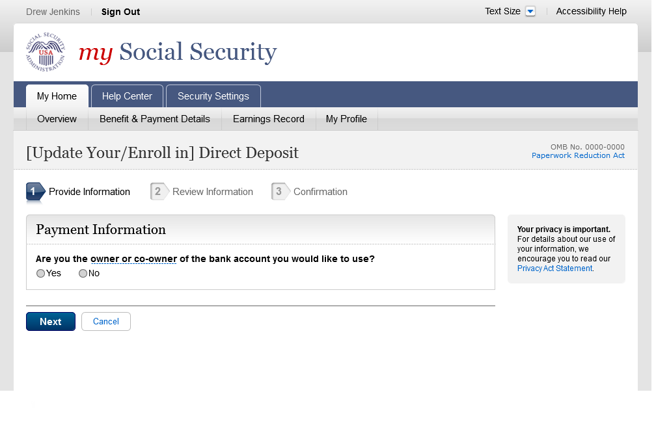
- Provide Information (Multiple Payment Info)
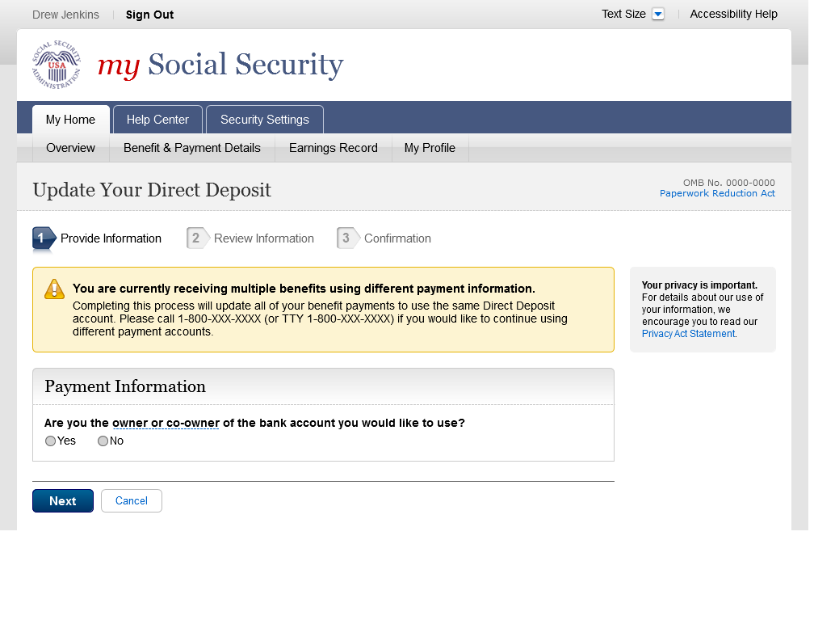
- Provide Information (Yes Expanded)
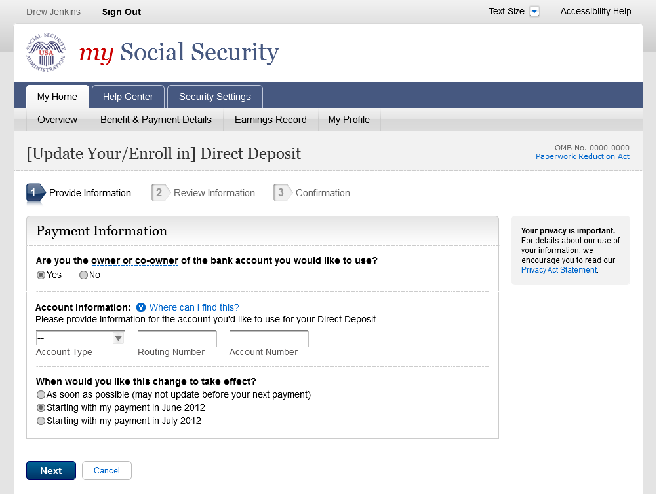
- We're sorry... (Owner/Co-owner: No Selected)
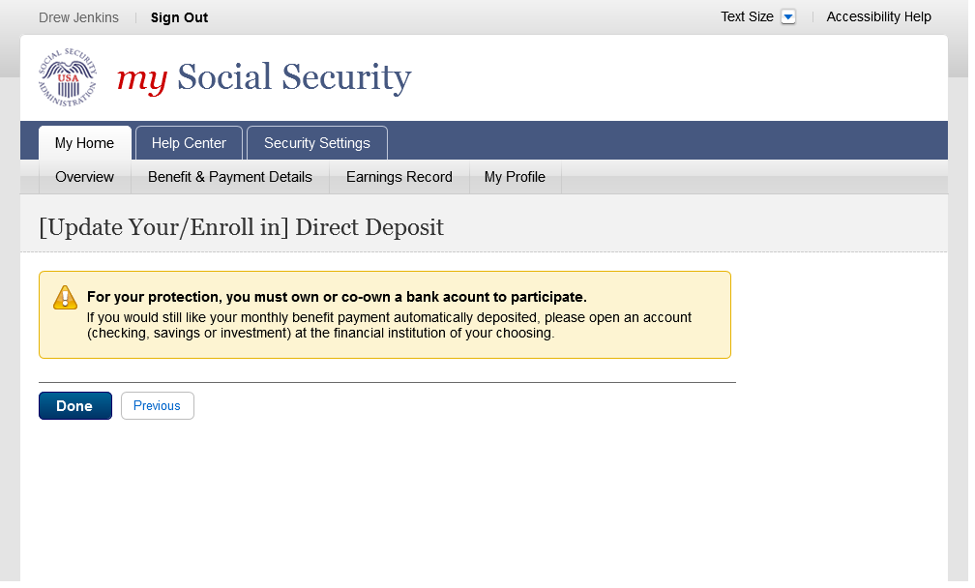
- Review Information
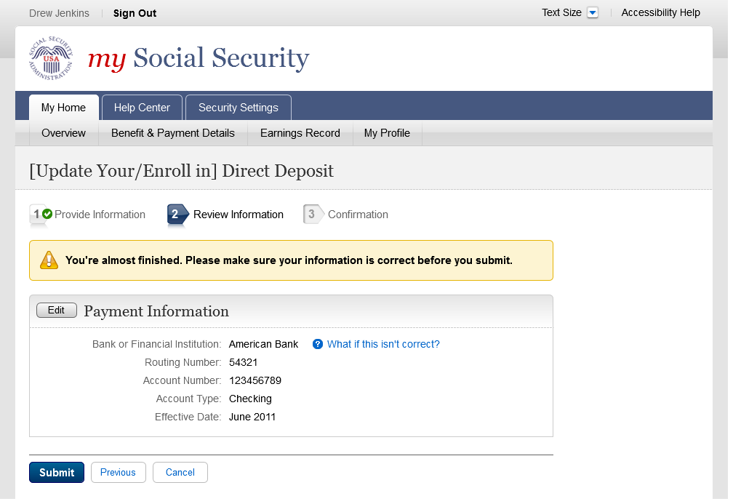
- Confirmation (Update)
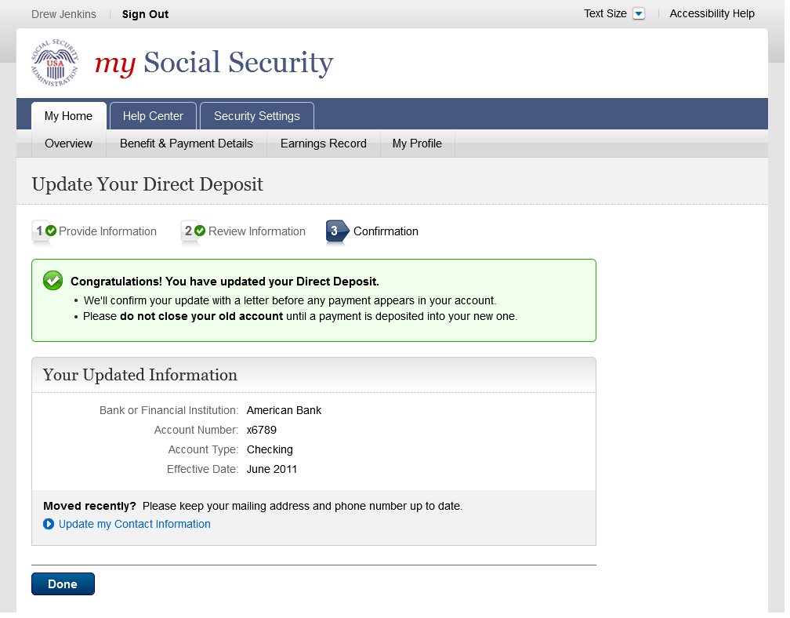
- Confirmation (Enroll)
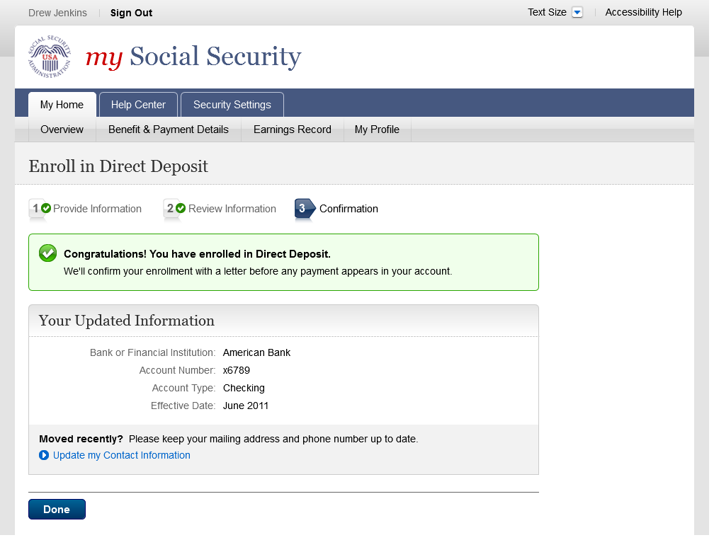
- Help (Where can I find this?)
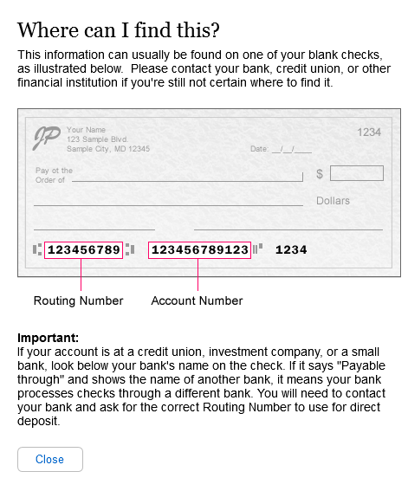

This page will be created and maintained by OCOMM.

- Help (What if this isn't correct?)
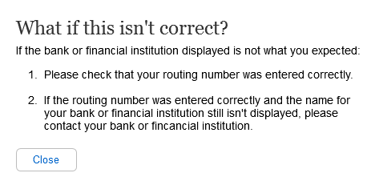

This page will be created and maintained by OCOMM.

- Definition (Owner or co-owner)
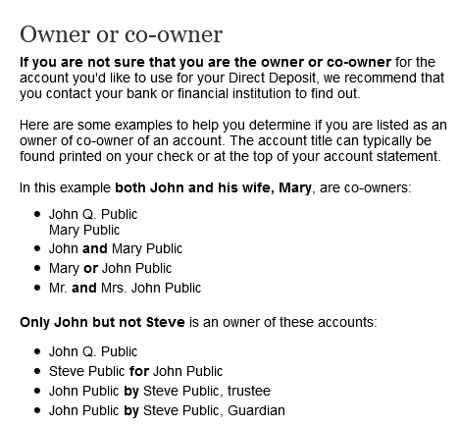

This page will be created and maintained by OCOMM.

- PopUp (Privacy Act Statement)
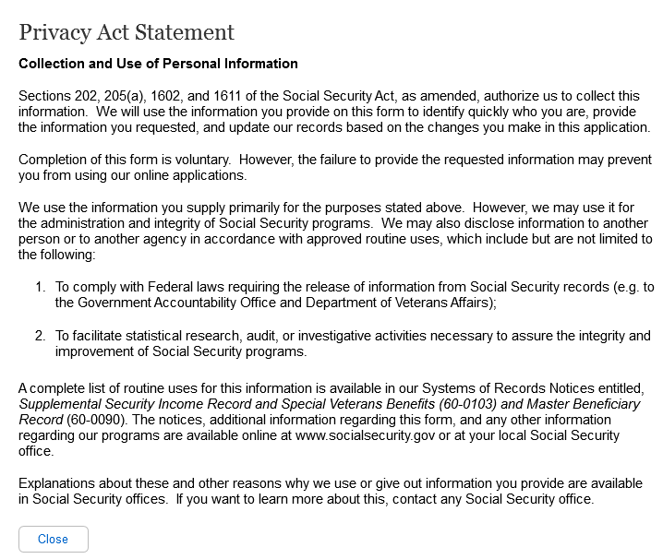

This page will be created and maintained by OCOMM.

- PopUp (Paperwork Reduction Act)
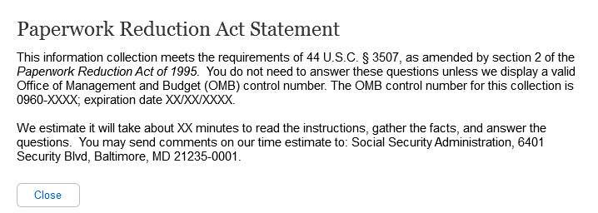

This page will be created and maintained by OCOMM.

