Customer Satisfaction Survey

OMB No.: 0925-0046
Expiration Date: 05/31/2016
Collection of this information is authorized by The Public Health Service Act, Section 410 (285) and Section 412 (285a-1). Participation is voluntary, and there are no penalties for not participating or withdrawing from the study at any time. Refusal to participate will not affect your benefits in any way. The information collected in this study will be kept private under the Privacy Act of 1974, as amended, 5 U.S.C. 552a (SORN #09-25-0156). Names and other identifiers will not appear in any report of the study. Information provided will be combined for all study participants and reported as summaries. You are being contacted by the National Cancer Institute to provide feedback on its tobacco cessation website.

Public reporting burden for this collection of information is estimated to average 10 minutes per response, including the time for reviewing instructions, searching existing data sources, gathering and maintaining the data needed, and completing and reviewing the collection of information. An agency may not conduct or sponsor, and a person is not required to respond to, a collection of information unless it displays a currently valid OMB control number. Send comments regarding this burden estimate or any other aspect of this collection of information, including suggestions for reducing this burden to: NIH, Project Clearance Branch, 6705 Rockledge Drive, MSC 7974, Bethesda, MD 20892-7974, ATTN: PRA (0925-0046). Do not return the completed form to this address.

We’re interested in your feedback on the Smokefree Women website and online community (Facebook page and any other Smokefree Women branded webpages). This customer satisfaction survey should take about 20 minutes. Completion of the survey is voluntary. Your responses will be kept secure to the extent provided by the law. No personal identifiers will be attached to your responses (see www.nih/gov/about/privacy.htm for more information).

After you submit this survey you will be entered into a lottery to receive a $20 in Amazon e-gift card as a thank you for participating.

- In the past 30 days, how many days have you smoked? Enter a number 0-30: ____. If you’re not sure, give your best guess. [input box, capable of capturing 4 digits]

- During the past 30 days, on the days you smoked, how many cigarettes did you smoke per day? If you’re not sure, give your best guess. Type in number of cigarettes per day: ___. [input box capable of capturing 3 digits]

- Overall, how interested are you in stopping smoking in the next 30 days?
  - Not at all interested
  - Mildly interested
  - Moderately interested
  - Very interested
  - Extremely interested

- Using the scale below, please indicate how much each statement about stopping smoking is true for you:

1 2 3 4 5
Not at all Neutral Very true
True

  - I don't want to stop smoking.
  - I would stop smoking because others want me to stop smoking.
  - I would stop smoking because I would feel bad about myself if I did not.
  - I would stop smoking because I have carefully thought about it and I believe it is very important for me to stop smoking
  - I would stop smoking because stopping smoking is consistent with other goals and things that are important in my life.

- How many times during the past month have you stopped smoking for one day or longer because you were trying to quit smoking?
  - I have not smoked in the past month
  - I have not tried to quit
  - 1 time
  - 2 times
  - 3 to 5 times
  - 6 to 9 times
  - 10 or more times

- About how much do you weigh without shoes? ___ pounds

- About how many cups of fruit (including 100% pure fruit juice) do you eat or drink each day?
  - None
1 cup of fruit could be:
- 1 small apple
- 1 large banana
- 1 large orange
- 8 large strawberries
- 1 medium pear
- 2 large plums
- 32 seedless grapes
- 1 cup (8 oz.) fruit juice
- ½ cup dried fruit
- 1 inch-thick wedge of watermelon
  - ½ cup or less
  - ½ cup to 1 cup
  - 1 to 2 cups
  - 2 to 3 cups
  - 3 to 4 cups
  - 4 cups or more

- About how many cups of vegetables (including 100% pure vegetable juice) do you eat or drink each day?
1 cup of vegetables could be:
- 3 broccoli spears
- 1 cup cooked leafy greens
- 2 cups lettuce or raw greens
- 12 baby carrots
- 1 medium potato
- 1 large sweet potato
- 1 large ear of corn
- 1 large raw tomato
- 2 large celery sticks
- 1 cup of cooked beans
  - None
  - ½ cup or less
  - ½ cup to 1 cup
  - 1 to 2 cups
  - 2 to 3 cups
  - 3 to 4 cups
  - 4 cups or more

- Using the scale below, please indicate how much each statement about eating fruits and vegetables is true for you:

1 2 3 4 5
Not at all Neutral Very true
True

  - I don't want to eat more fruits and vegetables.
  - I would eat more fruits and vegetables because others want me to.
  - I would eat more fruits and vegetables because I would feel bad about myself if I did not.
  - I would eat more fruits and vegetables because I have carefully thought about it and I believe it is very important for me to eat more fruits and vegetables.
  - I would eat more fruits and vegetables because eating more fruits and vegetables is consistent with other goals and things that are important in my life.

- In a typical week, how many days do you do any physical activity or exercise of at least moderate intensity, such as brisk walking, bicycling at a regular pace, and swimming at a regular pace?
  - None
  - 1 Day
  - 2 Days
  - 3 Days
  - 4 Days
  - 5 Days
  - 6 Days
  - 7 Days

- On the days that you do any physical activity or exercise of at least moderate intensity, how long do you typically do these activities?

__________ Minutes _____________ Hours

- In a typical week, outside of your job or work around the house, how many days do you do leisure-time physical activities specifically designed to strengthen your muscles such as lifting weights or circuit training (do not include cardio exercise such as walking, biking, or swimming)?
  - None
  - 1 Day
  - 2 Days
  - 3 Days
  - 4 Days
  - 5 Days
  - 6 Days
  - 7 Days

- Using the scale below, please indicate how much each statement about physical activity is true for you:

1 2 3 4 5
Not at all Neutral Very true
True

  - I don't want to be physically active (exercise) on a regular basis.
  - I would be physically active (exercise) on a regular basis because others want me to.
  - I would be physically active (exercise) on a regular basis because I would feel bad about myself if I did not.
  - I would be physically active (exercise) on a regular basis because I have carefully thought about it and I believe it is very important for me to be physically active (exercise).
  - I would be physically active (exercise) on a regular basis because being physically active (exercising) is consistent with other goals and things that are important in my life.

- Think about the Smokefree Women online community and resources, and rate your level of agreement with the statements below.
- Strongly agree
- Agree
- Neither agree nor disagree
- Disagree
- Strongly Disagree

  - I turn to Smokefree Women for guidance on living an overall healthy life.
  - I turn to Smokefree Women for guidance on quitting smoking.
  - I would tell other women to visit Smokefree Women’s website and social media pages.
  - There are better online smoking cessation programs than Smokefree Women.
  - Smokefree Women’s messages and resources are better than other healthy lifestyle programs or websites.
  - There are many online programs like Smokefree Women.
  - Smokefree Women is for women like me.

- Think about the Smokefree Women online community and resources, and rate your level of agreement with the statements below.
- Strongly agree
- Agree
- Neither agree nor disagree
- Disagree
- Strongly Disagree

  - I feel comfortable using and participating in the Smokefree Women program.
  - Smokefree Women is for women who are seeking a healthier lifestyle.
  - Smokefree Women is an empowering community for women who are trying to quit smoking.
  - I’d like to actively help promote or get the word out about the Smokefree Women program.
  - I’d post a question or comment to the Smokefree Women’s Facebook page.
  - I’d put a Smokefree Women banner or cover photo on my social media page.
  - I am aware that Smokefree Women is a product of the National Cancer Institute, which is a part of the United States Federal Government.
  - I trust Smokefree Women because it is made by the National Cancer Institute.

- Think about the Smokefree Women online community and resources, and rate your level of agreement with the statements below.
- Strongly agree
- Agree
- Neither agree nor disagree
- Disagree
- Strongly Disagree

  - Maintaining a smokefree lifestyle is easier with a supportive community.
  - Smokefree Women is here to help me improve my whole self.
  - I am part of a movement; I help myself and someone else.
  - Smokefree Women understands that I have unique needs for quitting smoking, and it has ways to help me meet those needs.
  - Smokefree Women is my virtual best friend.
  - Smokefree Women understands that I am on the go, and it’s on the go with me.
  - Feeling pride in my smokefree accomplishments is an important part of quitting.

- In the last 30 days, how often have your visited the Smokefree Women study site sent to you by email?
  - Never
  - 1 to 3 times
  - 4 to 6 times
  - 7 o 9 times
  - 10 or more times

- In the last 30 days, how often have you visited the SmokefreeWomen Facebook page (https://www.facebook.com/smokefree.women)?
  - Never
  - 1 to 3 times
  - 4 to 6 times
  - 7 o 9 times
  - 10 or more times

- In the last 30 days, how often have you interacted with the Smokefree Women Facebook page? Interactions include liking comments, posts or images; sharing posts or images; tagging people in images or comments; or posting your own comments or updates.
  - Never
  - 1 to 3 times
  - 4 to 6 times
  - 7 o 9 times
  - 10 or more times

- Select the statement(s) that best describe you. Choose all that apply.
  - I use Smokefree Women to help me live an overall healthier lifestyle.
  - I use Smokefree Women to support friends/family who are trying to quit or have quit smoking.
  - I use Smokefree Women to support the online community of women who are trying to quit smoking or have quit smoking, even if I do not know them personally.
  - Other [text box for detail]

- Please share any suggestions or comments you have for Smokefree Women in the box below. [1000 character text box]
When you’re finished, click the “Submit” button below to complete this survey.
[Submit button]
Completion Message [will be shown as a pop-up or new page]
For individuals who answered questions.

Thank you for completing this survey. An Amazon gift card will be sent to your email, as a thank you for finishing the survey. Check your email.
You have now completed the Smokefree Women Customer Satisfaction Study. If you have questions, please contact the study team at:
- Email: XXXX@nih.gov
- Phone: XXX-XXX-XXXX

Customer Satisfaction Survey Screenshots

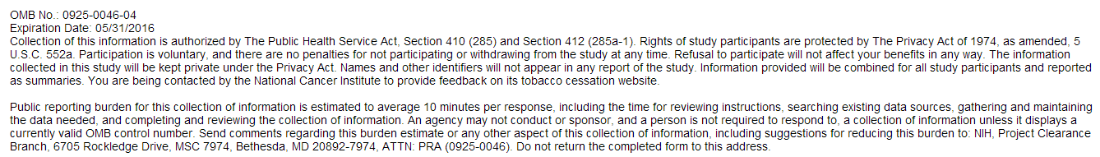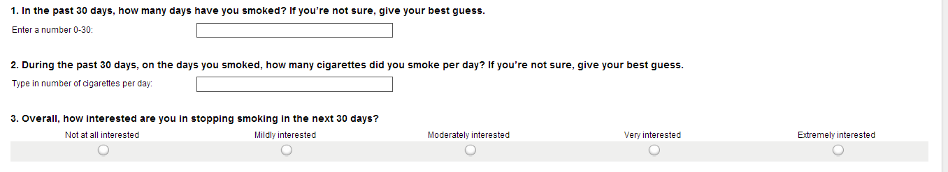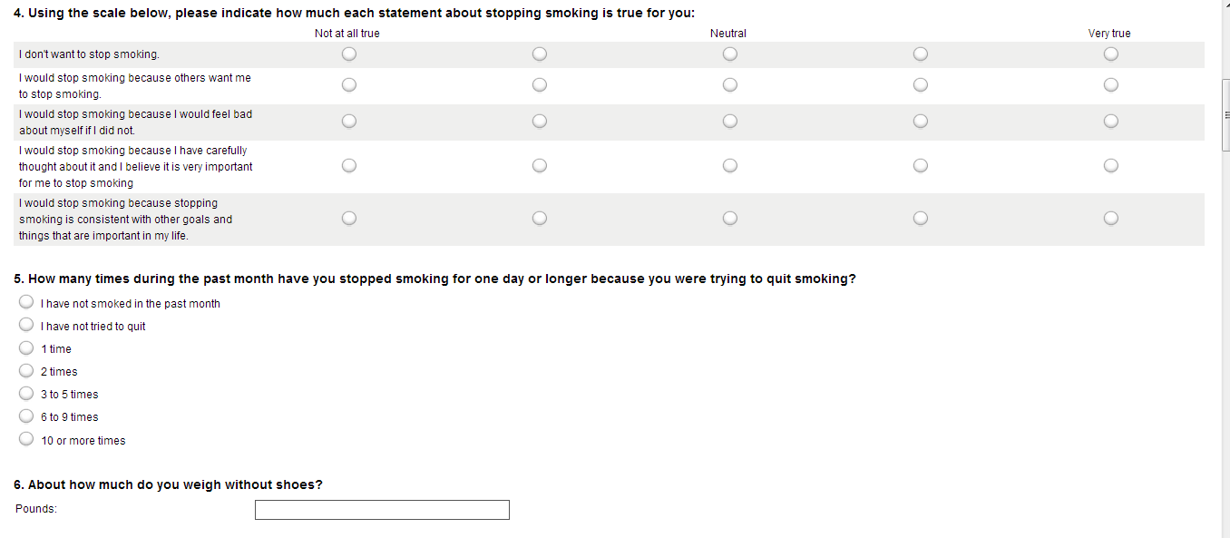

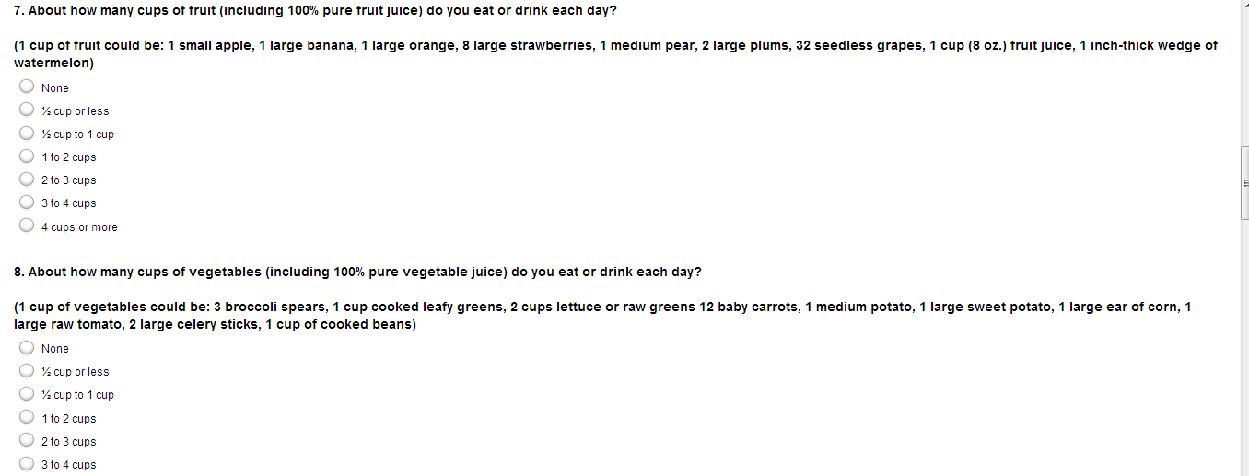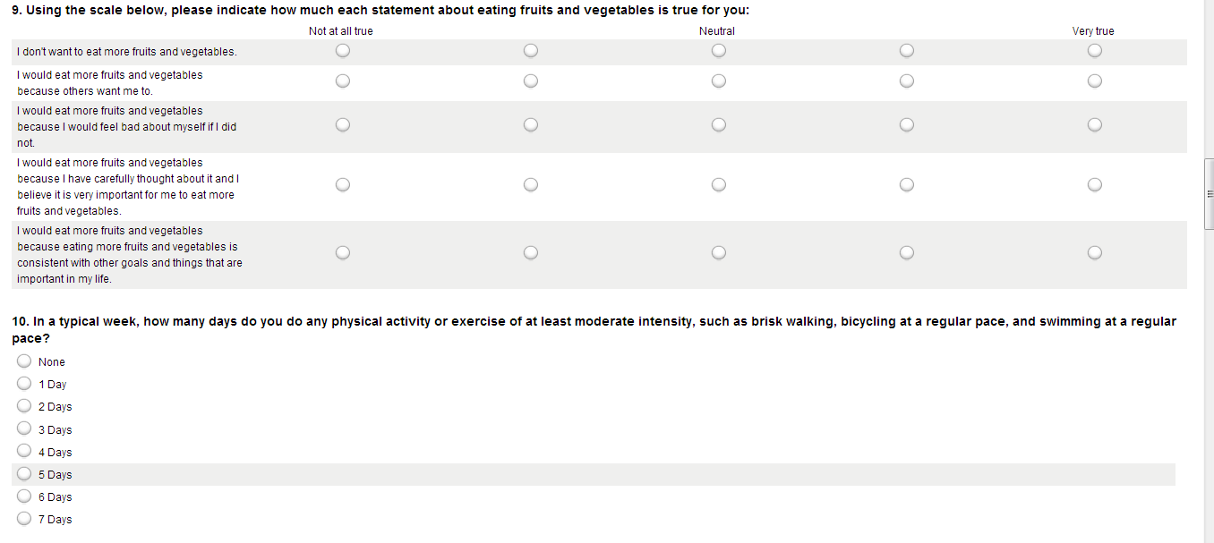
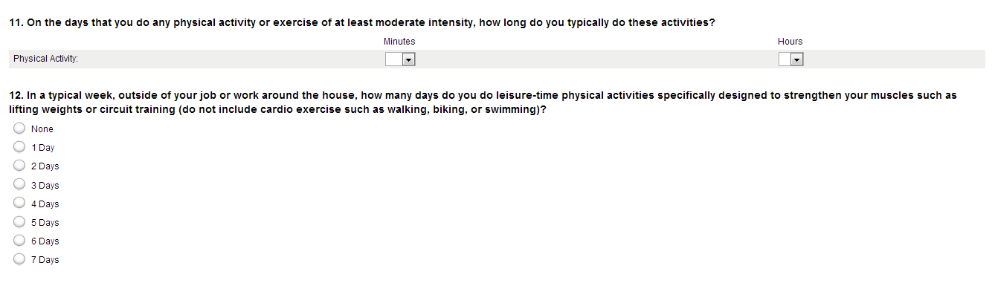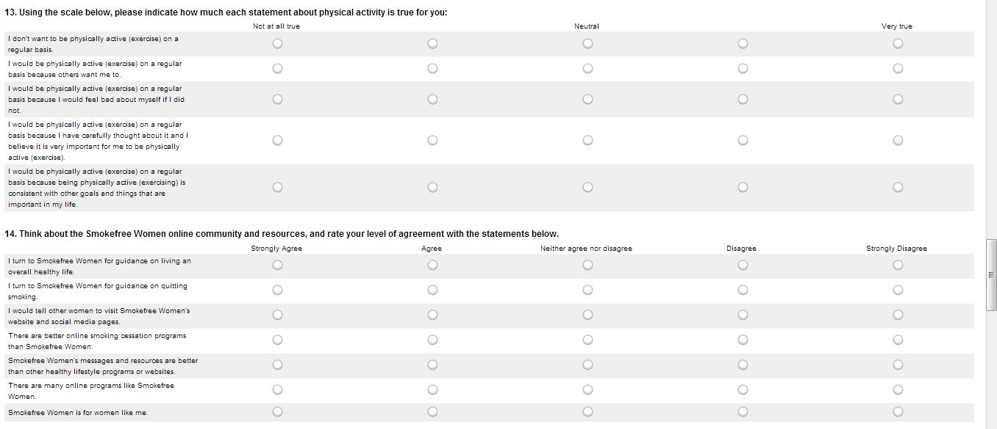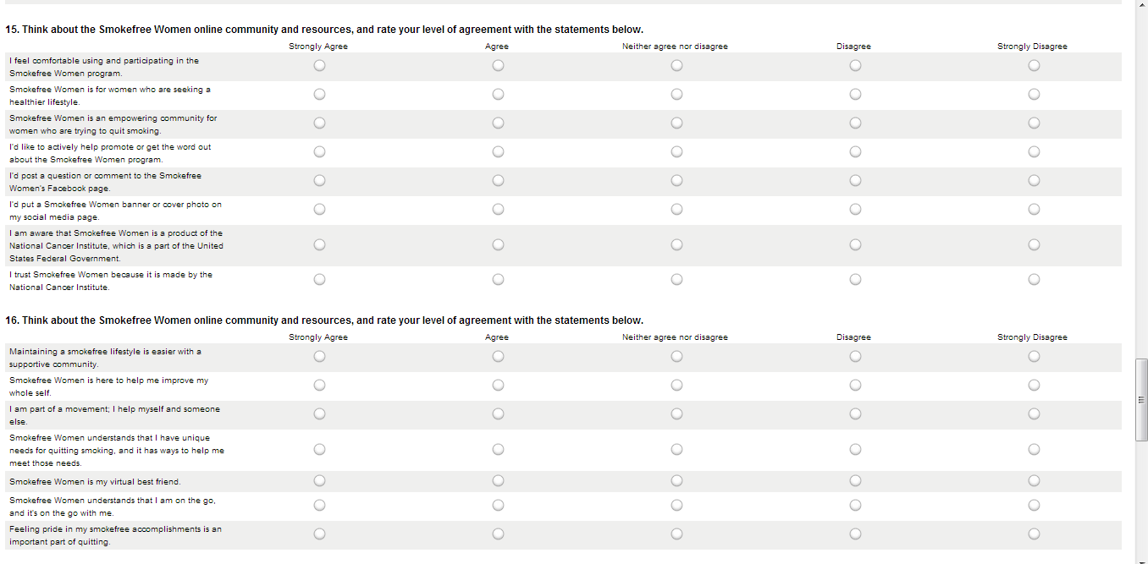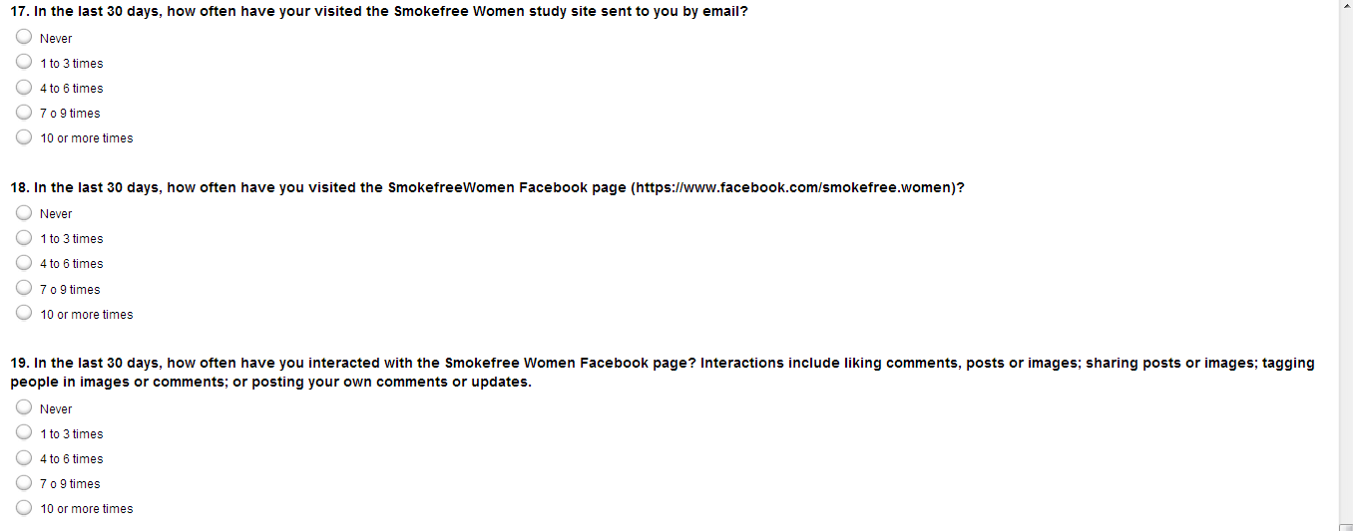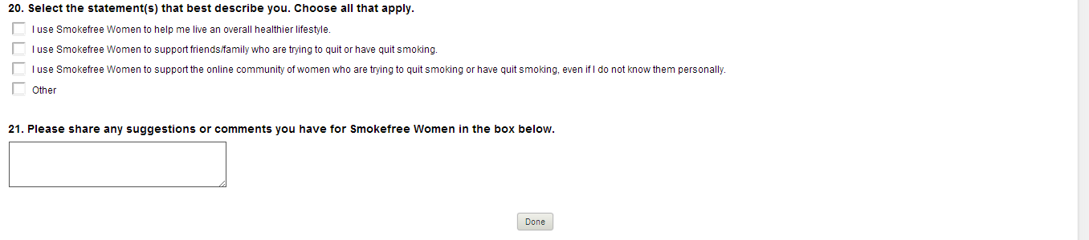

You already spent 20 minutes over the course of 4 weeks returning to the website, so 40 minutes is the total between the website viewing and the time it will take you to complete this survey.

