National Marine Fisheries Service Endangered Species and Marine Mammals

Scientific Research and Enhancement Permits

OMB No. 0648-0084
Expires: xx/xx/xxxx

National Marine Fisheries Service Endangered Species and Marine Mammals: Scientific Research and Enhancement Permits

TABLE OF CONTENTS

Background 3
Overview 4
When to Apply 4
Processing 4
Pre-application Guide (PAG) 5
General Guidance for Filling out an Application 5
Application Layout 6
Completing an Application using APPS 7
Give Complete Information 7
Project Information Page 8
Project Description Page 10
Project Supplemental Information Page 14
Captive Information Pages 18
Project Locations and Take Information Pages 19
Take Information Pages 22
National Environmental Policy Act (NEPA) Considerations Page 28
Project Contacts Page 30
Submit Application Page 33
Authentication and Certification 34
Project Status 35
Requesting a Modification 37
Modification Request Questions 38
Modification Types 40
Submitting Your Modification Request 42
Additional Information 43
Paperwork Reduction Act Statement 43

Background

This chapter describes how to use APPS to apply on-line for Marine Mammal Protection Act and Endangered Species Act scientific research and enhancement permits for National Marine Fisheries Service (NMFS) protected species, including:
- Cetaceans;
- Pinnipeds (excluding walrus);
- Sea turtles (in water);
- Shortnose sturgeon;
- Atlantic sturgeon;
- Smalltooth and largetooth sawfish; and
- White and black abalone.

Under section 104 of the Marine Mammal Protection Act of 1972 (MMPA) and section 10(a)(1)(A) of the Endangered Species Act of 1973 (ESA), NMFS may issue permits for scientific research purposes or to enhance the propagation, survival, or recovery of protected marine species. Under the Fur Seal Act of 1966 (FSA), NMFS may issue permits for research on fur seals of the North Pacific.

Additional federal and state laws or regulations more restrictive than the MMPA or ESA may also apply to your activities and you are responsible for securing any other necessary permits or authorizations.

Possession of a permit is a privilege. NMFS must evaluate issuance of permits in consideration of its duties to protect and recover listed species.

Permits may be valid for up to five years after issuance and will include conditions necessary to mitigate and monitor the impacts of the proposed activities.

Please note, not all MMPA and ESA permit applications are currently available on APPS. You will need to use separate application instructions and apply by mail if you require the following permits/authorizations:
- MMPA Commercial/Educational Photography Permit
- MMPA Public Display Permit
- MMPA Incidental Harassment Authorization (IHA)
- MMPA Incidental Take Letter of Authorization (LOA)
- MMPA Pre-Act Parts Authorization
- ESA Section 10(a)(1)(B) Incidental Take Permit

For more information on applying for these permits, click the “Permit Types” link in the APPS Features box, use the Pre-Application Guide in APPS (see below), or visit http://www.nmfs.noaa.gov/pr/permits/types.htm.

Section A: Scientific Research and Enhancement Permits

Overview

When to Apply

Target Species | Non-target species | When to apply
Non-ESA listed marine mammals | No ESA-listed species or designated critical habitat will be adversely affected by the research activities | At least 6 months prior to when you want to begin research/enhancement activities
Non-ESA listed marine mammals | ESA-listed species or designated critical habitat may be adversely affected by the research activities | At least one year prior to when you want to begin research/enhancement activities
ESA-listed species (marine mammals and other taxa) |  | At least one year prior to when you want to begin research/enhancement activities

Processing

Once we receive a complete permit application, it is subject to a mandatory 30-day public comment period. We concurrently send the application to the appropriate NMFS Regional and Science Center Offices, subject matter experts, and the Marine Mammal Commission for review and comment as applicable.

All permit decisions must be analyzed under the National Environmental Policy Act (NEPA).

An environmental assessment (EA) or environmental impact statement (EIS) may be necessary if proposed research or enhancement activities:
- are the subject of public controversy based on potential environmental consequences,
- have uncertain environmental impacts or unknown risks,
- may result in cumulatively significant impacts, or
- may have an adverse effect upon endangered or threatened species or their habitats.

If an application does not contain sufficient information on the environmental impact of the proposed activity to determine whether an EA/EIS is necessary, or if the information is insufficient to complete such analyses, the application may be returned to the applicant or processing will be prolonged.

Consultations

As applicable, NMFS must request consultation with the following agencies on the potential effects of certain proposed activities, as listed below:

Agency | Subject of Consultation
NMFS Endangered Species Act Interagency Cooperation Division | ESA-listed species and designated critical habitat
NMFS Office of Habitat Conservation | Essential Fish Habitat (EFH)
NOAA National Ocean Service | National Marine Sanctuaries
U.S. Fish and Wildlife Service | ESA-listed species and designated critical habitat

Issues that arise during these consultations will lengthen the permit process.

Pre-application Guide (PAG)

Refer to Chapter 1 for guidance on filling out the PAG, which is required prior to applying for a permit using APPS. Upon completing the PAG, the “Results” page will indicate the type of NMFS permit required. Please note the Questionnaire No. for future reference.

You have the option at this point to start an application or cancel. If you select cancel, you will have to complete another PAG before starting your application. If you are satisfied with the results of the PAG, click the link to start an application.

If you have questions about the results of the PAG or about completing your application, please call the Permits Division at 301-427-8401.

General Guidance for Filling out an Application

Refer to Chapter 2 (“How to Use the System”) for basic instructions for using APPS, including system requirements, creating a new account, using the “portfolio” page, detailed navigation guidance, and information on saving and submitting your application.

APPS will assign your application a file number. Please reference this file number in correspondence about your project (e.g., in email subject headings). When starting from your portfolio, clicking on the link of your application file number under the “File Number” column will take you to the application.

General guidelines

- Data is not saved automatically. APPS will display a warning message and will time out after 20 minutes without any activity. To avoid loss of data, save the application before the system times out. Save frequently using the “Save” link at the top of your application. You will also be prompted to save each page when you click on the navigation links. Select “Save” to save new data, or “Cancel” to continue on to the next screen without saving.

- You do not have to complete an application in one session. You may save the application as a draft as long as you save before logging off or before the system “times out” and logs you off due to inactivity. The draft application may be accessed later from your portfolio and will remain in draft mode until you complete the required fields and submit the application.

- An asterisk (*) marks a field that is required.

- Some text boxes have character limits, which includes spaces.

- You may cut and paste from other documents (e.g., Word), but special characters and formatting will be lost.

Navigation guidelines

- Do not use your web browser’s navigation buttons. Doing so may cause you to lose information. Use the navigation links “< Previous” or “Next >” or the breadcrumbs at the top of the APPS screen, as described below and in Chapter 2.

- Two options are available to navigate through the application sections:
  - Breadcrumb links (represented by the title of each major section of the application) allow you to jump to other pages in the application without having to complete the required information prior to leaving a page (i.e., you can skip a section and come back to it later).

- APPS navigation links (“< Previous,” “Reset,” or “Next >”) on the right side of the pages require you to go to each screen in a sequential order, and you are required to enter all information prior to leaving a page.

Application Layout

- New applications will open in draft or editing mode. You will navigate through a series of screens to enter information in the following sections of the application:

1) Project Information, Project Description, and Project Supplemental Information – this section requires specific information about your project, such as the duration and timing of your work, hypothesis/justification, description of methods, and other information.

2) Location and Take Information – this section requires information about the places you are requesting to work, the numbers and types of protected species you expect to take or import, and the methodologies you will use to conduct your research or enhancement activities.

3) NEPA – this section requires information about how your activities would result in impacts on the environment, including the physical and biological aspects of the environment.

4) Project Contacts – this section requires information on the Applicant/Permit Holder, Principal Investigator, Co-investigators, or others that will be working under the permit.

5) Submit – this section allows you to view your completed application and submit it to the Permits Division for review and processing. APPS will run checks before you can “Submit” an application to ensure you have completed all required screens or data fields. You will go through steps to authenticate your identity and certify the contents of your application prior to submitting it, which requires you to provide a signature to the Permits Division.

Completing an Application using APPS

Give Complete Information

Please provide complete and specific information according to the instructions in this document. APPS will not allow you to submit an application if one of the required fields is not filled out. The Permits Division cannot process applications that do not include all of the required information. We will return incomplete applications with explanation or request additional information. If we request additional information and do not receive it within 60 days, we will withdraw your application. Please note the following:

- Your application must be a stand-alone document and must clearly describe all proposed activities even when you reference published literature.

- When a question does not apply, please indicate “Not Applicable” or “N/A” and provide a brief explanation as to why the question is not applicable.

- Please avoid the use of technical jargon when possible because your application will be available to the public for review.

- You are encouraged to contact the Permits Division at 301-427-8401 with questions in advance of submitting your application.

Project Information Page

File Number

This number is automatically generated by APPS and cannot be changed. Use this number in correspondence about your application.

*Project Title (enter up to 255 characters)

Describe the project as concisely and descriptively as possible. Include the species (or taxa if multiple species), the study’s geographic range, and purpose. For example:

- “Characterizing the Population Structure, Forging Ecology, and Movement Patterns of Green Sea Turtles in the Gulf of Mexico.”

Note: If working on a draft application, we strongly recommend you enter a project title before logging out of the system.

*Project Status

Project status (“New” or “Renewal”) is automatically selected based on your answers in the pre-application guide (PAG). Do not change this field.

Previous Federal or state permit #

If applicable, please enter your most recent NMFS permit number. If you have/had more than one permit, enter the permit most closely related to this application.

Note: State permit numbers are only applicable for Pacific marine and anadromous fish applications.

*Permits Requested

One or more items will be listed based on your answers in the PAG. If the options listed are incorrect, please call the Permits Division at 301-427-8401 for assistance.

*Where will the activities occur?

One or more general locations will be listed based on your answers in the PAG. If a location is incorrect, please call the Permits Division at 301-427-8401 for assistance.

Note: You will have the opportunity to provide more specific location information on subsequent pages.

*Research Timeframe

Enter the proposed start and end dates of the entire project in the following format: MM/DD/YYYY. Please review the “When to Apply” section above and provide realistic dates based on processing time.

- The start date must not be prior to the date you successfully submit the application.

- The end date must be within five years of the start date.

- You may enter more specifics on your project dates/field seasons under “Sampling Season/Project Duration” (see below).

*Sampling Season/Project Duration (enter up to 1,000 characters)

Describe the annual sampling season(s) and the duration of the project. Include the months of the year and frequency of fieldwork/sampling (e.g., how many times per year and how frequently will you sample?).

If your research extends beyond five years, or is a continuation of previously authorized research, enter information here about when the research began and when you expect it to end.

*Abstract (enter up to 2,000 characters)

Provide a brief summary (approximately 200 words) of the proposed research and/or enhancement project. We will publish this summary in the Federal Register Notice of Receipt that initiates the 30-day public comment period. The summary should include concise statements of the following information:

- Purpose of the research or enhancement activity;

- Target species (common and scientific names);

- Type of take activities (e.g., capture, biopsy sampling), import and/or export;

- Numbers of animals to be taken for each activity or number of animals from which specimens will be imported and/or exported, by species or taxa (over a specified time, e.g., per year);

- Numbers and kinds of non-target species, including those listed under the ESA, that may be taken incidentally;

- Specific geographic location(s), including locations from which animals or specimens will be imported or to which they will be exported, if applicable; and

- Requested duration of the permit (e.g., five years).

After you have completed this page, save and click “Next >” or click the “Description” breadcrumb at the top of the APPS page to move to the next page.

Project Description Page

*Project Purpose: Hypothesis/Objectives and Justification (no text limit)

Answer the following questions:

- What are your objectives?

- What is the expected significance of your proposed activities?

- For research, what is the hypothesis being tested?

- For enhancement, how will your activities enhance the survival or recovery of the species in the wild?

Include background information discussing relevant published literature on the subject of your proposal, with citations. Describe how your proposed work is different from, builds upon, or duplicates past research or enhancement activities. Some aspects to include:

- Established knowledge and ideas related to your proposed research/enhancement.

- Whether the activities you are proposing are different from or build upon the proposed studies.

- How your proposed work would not be unnecessarily duplicative.

- If you have previously held or worked under a permit, discuss how your past findings have contributed to the body of knowledge on the subject and how they relate to your proposed objectives.

Describe why your work cannot be accomplished without taking marine mammals or protected species.

Justify your sample size. Include a power analysis or other sample size estimation to determine whether the sample size is sufficient to provide statistically significant or otherwise robust results appropriate for your research study.

Justify your need to sample specific sex, age class, sub-populations, etc., particularly if you are requesting to sample dependent young or other particularly vulnerable groups.

For each species, demonstrate how your research activity would contribute to the basic knowledge of the biology or ecology of the species, or how your activity will identify, evaluate or resolve conservation problems.

As applicable, also address the following:

For ESA-listed and MMPA-depleted species:

- Why must your study involve ESA-listed or depleted species? Discuss the use of possible alternatives (e.g., surrogate non-ESA listed species).

- How will your project contribute to the objectives identified in the species’ recovery or conservation plan? Please be sure to identify specific priorities of these plans.

- Does your project have broader significance than your individual goals? For example, does your project respond to recommendations (other than those listed in a recovery or conservation plan) of a scientific body charged with management of the species? If so, describe.

- If there is no recovery or conservation plan, how and to what degree will your project otherwise contribute to conservation and/or recovery of the species?

- How will your research directly benefit the species or fulfill a critically important research need?

- How will your enhancement activities contribute to maintaining or increasing distribution or abundance, enhance the health or welfare of the species, or ensure the survival or recovery of the species in the wild?

- Will captive maintenance for enhancement maintain a viable gene pool, increase productivity, provide necessary biological information, or establish animal reserves?
  - How does the benefit of removing animals from the wild into captivity outweigh alternatives that do not require removal from the wild?
  - What plans are in place for returning animals and any offspring to the wild? If animals are going to remain in permanent captivity, additional justification is required.

*Project Description (no text limit)

This section should clearly describe the methods you will use, the number of animals you will take, and the locations in which you will take them. This section should provide the reader with a clear picture of what will systematically happen during a typical day/field season of research or enhancement activities.

Describe the number of individuals, by species, sex, age class, manner, and location in which you will take animals and animal parts/specimens over a specified period (annually or per field season if less than one year).

If you will take the same animals in more than one manner, list the number of animals and all procedures that you would conduct.

- Example: capture, blood sample, biopsy, and flipper tag 25 adult male and 25 adult female (non-pregnant and non-lactating) individuals annually during non-breeding season.

If individuals will be taken more than once (e.g., recapture for instrument retrieval or multiple tagging attempts), indicate the frequency and type of take activity per individual per year or per field season if less than one year.

Provide detailed methods for each take activity, including but not limited to descriptions of the following:
- Platform types (vessel or aircraft description)
- Aerial and vessel survey type and routes (attach figure if possible)
- Approach distances (by aerial, vessel, or ground)
- Approach techniques (speed, direction in relation to animals)
- Photo-identification (techniques and analysis)
- Capture techniques (hand, net [type and mesh size], cage [type and dimensions])
- Handling/restraint (methods and number of persons to restrain, maximum time)
- Sedation/anesthesia (type, route/site, dosage, duration, reversal/other drugs)
- Marking (flipper and PIT tagging, branding, bleach/other temporary marking)
- Instrumentation (attachment method, types of sensors, dimensions, weight, battery life, duration of attachment)
- Biological sampling (type, volume/size, site, analysis, shipment, storage)
- Acoustic sampling (passive recording or auditory evoked potential) or acoustic playbacks (frequency, source level, signal duration, duty cycle, and energy output).

Please make sure your methods are detailed enough for us to evaluate potential effects. Refer to Appendix VIII for guidance on what level of detail is required.

Cite references for the methods where applicable, but do not substitute a literature citation in lieu of a complete description of the methods.

On the “Supplemental Information” page, you may attach files containing figures or photographs to illustrate your methods (e.g., tags and instrument attachment devices, nets and net deployment). See below for instructions on attaching files.

Include the purpose of each take activity (including the purpose of specific samples taken). How do each of these take activities relate to meeting your objectives?

Indicate the estimated number and type of non-target species that you may affect each year, and the manner in which you may affect them during your research. This includes but is not limited to marine mammals, ESA-listed species, sea birds, sharks, plants, etc.
If you were to encounter a non-target species in the same area of your study but you do not expect to affect them in any way, please describe why and any actions you will take to prevent impacts (e.g., not in area during time of study; would not approach closer than 100 meters; would halt operations until non-target species moved out of study area).

Describe how your proposed activities coincide with or avoid sensitive biological periods such as reproductive seasons and maternal care of both target and non-target species.

For import and export activities, answer in detail the following:

- What methods will be used to take samples from animals (live or dead) in foreign countries?

- If samples will be obtained from dead animals, describe how the animals died or the method in which they were killed.

- What is the authorizing government agency for the legal collection of animals or specimens in the country of origin? Be prepared to provide documentation regarding the legality of the take in the country of origin for your annual reports.

- What are the shipment/transport methods, including safe handling protocols?

- What are the methods for sample preservation, analysis, and curation (for samples not destroyed in analyses), including safety protocols for laboratory work?

- If an import would be necessary for the protection or welfare of a live marine mammal, discuss the circumstances involved and any alternatives considered.

For exports of living marine mammals from the U.S., the appropriate agency of the foreign government must certify that:

  - The information in the application is accurate;

  - The laws and regulations of the foreign government involved allow enforcement of the terms and conditions of the permit; and

  - The foreign government involved will afford comity to any permit amendment, modification, suspension, or revocation decisions.

After you have completed this page, save and click “Next >” or click the “Supplemental” breadcrumb at the top of the APPS page to move to the next page.

Project Supplemental Information Page

Attach a Supplemental Information File

If you do not have enough room to answer any of the questions in this or the other sections, you may attach files to complete a section or sections. There are additional areas in the application to attach maps, grant proposals, etc.

- To attach a file, use the “click here to attach a supplemental file” link.

- An MS Word file is the preferred format, but formats such as PDF, MS Excel, Word Perfect, and ZIP files are also acceptable.

- An attachment may not be larger than 10 MB and you may attach up to 10 files. If you have a larger document, reduce the size by removing material that is not essential for the review of your application.

- Once you have attached a file, the screen will display text indicating that a file is attached. You may need to refresh the screen to see this after hitting “save.”

*Status of the Affected Species (enter up to 2,000 characters)

As applicable, indicate the status of each target species or stock as follows:

- ESA - threatened or endangered
- MMPA - depleted or strategic
- Convention on International Trade in Endangered Species of Wild Fauna and Flora (CITES) - Appendix I, I, or III

Species information is available at the following web sites:

http://www.nmfs.noaa.gov/pr/species/
http://www.fws.gov/
http://www.cites.org/

*Lethal Take (enter up to 800 characters)

If you do not expect to kill or seriously injure any animals, intentionally or unintentionally, click the “Not Applicable” check box and leave the larger text box blank.

If intentional lethal take is involved, provide an explanation of why a non-lethal method is not feasible or why lethal take is unavoidable. For ESA-listed or MMPA depleted species, also describe how the results will directly benefit the species or fulfill a critically important research need.

- Provide methods of lethal take, number of animals to be taken per year, and protocols for tissue collection, analysis, and carcass disposal if not previously described in the “Project Description” section.

Note: Requests to euthanize animals are considered intentional lethal takes.

If unintentional mortality or serious injury is possible incidental to, or as a result of, the proposed activities, indicate the following if not previously described in the “Project Description” section:

- Maximum number of animals from each species that could die or be seriously injured per year and how you arrived at that number;

- Potential ways that animals may die incidental to the proposed activities; and

- Protocols for tissue collection, analysis, and carcass disposal.

Note: Unintentional mortality refers not only to a death during research, but also to those that succumb at a later time (e.g., death due to effects of stress from handling, adverse reactions to drugs, complications from a pre-existing condition, or abandonment of dependent young).

*Anticipated Effects on Animals (no text limit; refer to Appendix VIII for guidance on what level of detail is required)

- What are the anticipated effects of each of the activities alone or cumulatively on the behavior and physiology of the target animals? How will animals react to your actions and what are the consequences of those reactions? Identify both short- and long-term potential effects.

Note: If you have conducted this work previously, please clearly describe and quantitatively summarize the types of reactions of animals from past research. Include citations for any relevant references and be prepared to provide copies if requested. Annual permit reports and other non-published works are acceptable citations.

- What are the anticipated effects on the population as a whole? On what is your determination based?

- Summarize any mortalities that have occurred during the previous five years of research or enhancement activities conducted by you using the same or similar techniques, including circumstances involved and cause of death.

- Describe how conspecifics or non-target species in the study area may react to or otherwise be affected by your activities (e.g., will you encounter them on your way to or from the study site? How will you avoid harassment?).

*Measures to Minimize Negative Effects (no text limit; refer to Appendix VIII for guidance on what level of detail is required)

- For each activity, what measures will you take to minimize impacts to wildlife? Provide information for both target and non-target species (e.g., plants, fish, coral). Describe measures you will implement to ensure your activities are conducted in a humane manner, with minimal disturbance, stress, and harm to the subject animals. Explain how you determined your methods are those that will have the least potential for pain and stress (e.g., summarize your alternatives search).

- Indicate what short- and long-term post-procedure monitoring you would conduct to evaluate the effects of your activities and/or to ensure animals have recovered.

- What efforts will you make to collaborate or coordinate research with others in your study area? Explain how this will occur and how it will minimize impacts. For example, will it involve sharing resources, samples or data; timing surveys, etc.?

- If the proposed activities may cause stress, discomfort, pain, suffering, injury, or mortality, you must explain why there are no feasible alternative methods to obtain the desired data.

Note: Where an IACUC (Institutional Animal Care and Use Committee) review is required, include a copy of the protocols submitted to the IACUC, and the signed approval and comments. If the protocols have not been approved, indicate the status.

For applications involving captive care of marine mammals, there is a separate place to attach your IACUC documents (question ‘e’ of the captive screens – see page 18)

Attach a References File

If your application contains citations to published work, you must include a list of references. References contain bibliographic information that would allow a reader to obtain a copy of the referenced work.

Note: Referenced materials must be made available to the Permits Division upon request, as needed for evaluation of the application, or preparation of any necessary ESA and/or NEPA analyses. Note that all documents referenced in support of your application must be available to the public upon request. Do not reference confidential documents, or other information you are not willing to provide to the public at the time your application is submitted.

*Resources Needed to Accomplish Objectives (enter up to 800 characters and attach file if necessary)

Explain how your expertise, facilities, and resources are adequate to successfully accomplish the objectives and activities stated in your application.

- Include the name and address of sponsors, cooperating institutions/researchers, or contractors, if not listed as Co-investigators on the application, and clearly indicate their role.

If the proposed take activities will be conducted by a contractor, provide a statement as to whether a qualified member of your staff (include name(s) and qualifications) will supervise or observe the taking. Attach copies of any relevant formal research proposals, contracts, or letters of agreement that would demonstrate the financial or logistical resources available to you to conduct and complete the proposed activities.

Indicate whether you have applied for, secured, or will apply for other federal, local, or state permission to conduct your proposed work, and what those approvals include.

Note: You may add an attachment here for funding proposals, letters of agreements, lists of cooperators and their roles, etc.

*Disposition of Tissue Samples (enter up to 800 characters)

If you will not collect, receive, possess, transport, or import/export tissue samples, click the “Not Applicable” check box and leave the text box blank.

This section is applicable if you will collect, receive, possess, transport, or import/export tissue samples. Provide a description of the disposition of any parts or samples remaining after the research or enhancement activities are complete. If you have made arrangements with a museum or other institutional collection to ensure that remaining tissues will be available for scientific research or enhancement purposes, include information on where the samples will be stored, transferred, and how/when/where they will be disposed. Include contact information for each of researchers, laboratories, museums, and/or institutional collections that would receive these tissue samples or specimens. If you will not retain or transfer samples, state whether samples will be consumed in analysis or will be destroyed after analysis.

*Public Availability of Product/Publications (enter up to 800 characters)

Describe the end product(s) of your proposed research and how they will be made available to the public.

After you have completed this page, save and click “Next >” or click the “Location/Take” breadcrumb at the top of the APPS page to move to the next page.

Captive Information Pages

Based on your responses to the PAG, you may be required to provide additional information on animals in captivity (permanent or temporary), including removing animals from the wild into captivity and research or enhancement on captive or rehabilitating animals. As applicable, address the following:

- Explain why removal from the wild is necessary and why you cannot obtain suitable animals from captive or rehabilitated stock. (Enter up to 2,000 characters.)

- If the source stock is to be beached/stranded marine mammals undergoing rehabilitation, indicate the name and location of the rehabilitation facility. (Enter up to 1,000 characters.)

- If the source stock is from animals already in captivity (other than animals in rehabilitation) indicate the name and location of the facility and, where possible, identify the specific animals (by NOAA ID number if applicable) to be involved in the proposed activity. (Enter up to 1,000 characters.)

- Include a copy of any license or registration issued by the Animal and Plant Health Inspection Service (APHIS) of the U.S. Department of Agriculture, any outstanding variances granted, and the most recent APHIS inspection report. (You must attach a file here.)

- Include the proposal submitted to the appropriate Institutional Animal Care and Use Committee (IACUC) established under the Animal Welfare Act (AWA), the IACUC approval, and any comments and recommendations of the IACUC. (You may attach a file here.)

- Provide a written statement from the responsible veterinarian or expert certifying that the facilities, methods of care and maintenance, and methods of transport will be adequate to ensure the well-being of the animals and, for marine mammals, will comply with all care and transport standards established under the AWA. (You must attach a file here.)

- For ESA-listed species: Describe the care and maintenance of the animals, including a complete description of the facilities where they will be maintained. This includes the dimensions of the pools or other holding facilities; the number, sex, and age of animals by species to be held in each; the water supply, amount, and quality; the diet, amount and type; sanitation practices; and qualifications and experience of the husbandry staff.

- Indicate whether a captive breeding program will be established and, if so, provide justification in accordance with the species conservation or recovery plan as applicable for enhancement activities. For ESA-listed species, indicate if you are willing to participate in a captive breeding program if requested by NMFS. (You may enter up to 1,800 characters.)

- Indicate the disposition of captive animals at the termination of research or enhancement activities. (You may enter up to 1,800 characters.)

- If release of captive animals to the wild is proposed, state the length of time the animals will be held, no matter how temporary, and describe the protocols for the release, including post-release monitoring protocols. Include in the release protocol mitigation for the following:
      - Disease transmission between released animals and the wild population;
      - Potential genetic exchanges between introduced and endemic stocks;
      - Ability of the released animals to forage and protect themselves from predators; and
      - Elimination of behavioral patterns acquired during captivity that could prove detrimental to the released animals or the social structure of local populations.

Project Locations and Take Information Pages

Overview

On the main “Project Locations and Take Information” page, you can describe your location, add new locations, edit or delete existing locations, add or edit take information, and view your defined locations.

The “Project Locations and Take Information” page will first prompt you to “Add New Location” and this will allow you to provide more information about where you will be working, based on the results of your PAG.

Once you have entered one or more locations, the lower part of the “Project Location and Take Information” page will display them. You will then have the option of adding another location, editing or deleting a location, or adding/editing the take information for a location. You will use the “Take Information” page to describe the species you will encounter and the procedures you will conduct at each location.

How to Add a New Location

Follow these steps to add location information:

- : Click on this button to add a location and enter that location information. This will take you to a “Project Location Information” page.
Add New Location
 You must enter multiple locations if you will be working in different places (e.g., multiple oceans or rivers). You will enter each location separately and each will have an affiliated take table.

- *Select the general area: Next, use the drop-down menu to choose a general area where you will be working (this may be automatically populated based on information in the PAG). You can only enter one general area at a time.

Note: If you are requesting to receive or import/export parts of animals, select the “Parts” option as your location. On the Location Details page (see step 4), enter the country of import/location of sample origin, and to where samples will be shipped/exported in the Location Description box.

If you are requesting to work with captive animals, including those in rehabilitation, select the “Captivity” option as your location. On the Location Details page (see step 4), enter names of captive facilities in the Location Description box. You will provide more details in the “Captive Information” section, described above.

Please note that NMFS does not have jurisdiction in the territorial waters of another country and therefore cannot authorize the take of protected species in those waters. For U.S. citizens, activities beyond territorial waters are considered to occur on the high seas and need coverage by a NMFS permit.

- *Select the state(s): If applicable, this second drop down menu will be visible. Choose all applicable states for the general area by holding down the Control key and clicking on all applicable states.
If the correct geographic choices do not show up, please contact the Permits Division at 301-427-8401.
- : Click this button. Enter information on this page as it applies (disregard any non-applicable fields). Use the “Location Description” box (up to 255 characters) to briefly describe your study for each take table. Information on this page includes:
Enter Location Details
- Under “Waterbody,” enter names of rivers, estuaries, bays, etc.
- Latitude and longitude of your study area
- River miles (“Begin Mile” and “End Mile”)
- Limits of your study area (e.g., to the U.S. EEZ, to the edge of the continental shelf, to 50m depth)
- Names of land masses where research will occur (e.g., islands, rookeries)

- Attach File: Click on this link to attach maps or other information to provide detailed descriptions about the locations where you will be working. If you have multiple study areas and species, identify species locations on a map. Formats such as PDF files, MS Excel, MS Word, and Word Perfect are acceptable. The attachment may not be larger than 10 MB. If you have a larger document and cannot reduce the size, please fax this document to the Permits Division at 301-713-0376.

- You may enter all the locations where you are requesting to work at one time, and then go back to enter the takes associated with those locations; or, you can enter a location and go straight to entering the takes for that location.

How to Edit or Delete a “currently defined” Location

- : From the “Project Locations and Take Information” main page, click on this button to edit location information you entered or to delete a location.
Edit/Delete Location

- This will take you to the “Project Location Information” page. Here you can edit any information previously entered on this page. Select “save” to save your changes.

- : Clicking on this button will delete the location specified on the “Project Location Information” page. A pop up box will ask if you want to delete. Click “OK” to delete and “Cancel” to cancel the deletion.
Delete Location
- Deleting a location will also delete all associated takes (if entered) with that location. You will get a warning message to confirm that you want to delete a location.

Take Information Pages

Overview

- : You may access this button from the “Project Locations and Take Information” main page or from the “Project Location Information” page. Click on this button to go to the “Take Information” page. You may also click on the “Next >” link from the “Project Location Information” page to get to the “Take Information” page.
Edit/Add Take

- On this page you will enter the species to be taken, by age and sex class, the number of individuals, methods (e.g., capture, intrusive procedures), and sample dates (See Entering Take Information section below).

Note: All data fields in the take table require entries and the information must be specific to the location listed at the top of the page. If you have more than one location, each location will have a separate take table. Save your data often so that information is not lost.

- The “Take Information” page has three parts:
- The top of the page identifies which location you are working on;
- The middle has editing tools (buttons) that allow you to add, edit, delete, copy, and re-organize take records in the take table; and
- The bottom has the take table.

- You will create a separate record row for each unique combination of species, production type (wild or captive), life stage, take action, capture method, and procedures.

- The take table is a large landscape format. Depending on the size of your screen you may need to use the right and left scroll arrows to complete the table.

Take Table Editing Tools (Buttons)

Editing buttons above the take table appear in the following order:

- : Clicking this button allows you to add more lines (rows) to the take table. You can only add more lines if at least one row contains data.
Add More Lines

- : Use this to “unlock” or “unfreeze” selected rows in the take table so that you can edit information you have previously entered and saved. You must first put a check in (click on) the “Select” box at the far left of each row you want to edit. Click on the button to save your edits.
Edit Selected Records

Save

- : Clicking on this button allows you to delete selected take rows from this location. You must first put a check in (click on) the “Select” box at the far left of each row you want to delete. Click on the button to save your edits.
Delete Selected Records
Save

- : This tool allows you to copy selected take records to the current location, another location within the same general area, or a location in a different general area. You must first put a check in (click on) the “Select” box at the far left of each row you want to copy.
Copy Selected Records

Note: The “Copy Selected Records” function is useful if you are conducting the same activities on multiple species (e.g., enter all the procedure information for one species, copy that row, and then edit the record as needed).

- Clicking on the button will open a new window. You may choose to go to a new location (i.e., a separate take table) after you copy the records or stay at the location you are in by selecting those radio button options in the “Copy Take Records” pop up window.
Copy Selected Records

  - If you copy the takes within the current location, you will make duplicate copies of the selected rows. The copied records will appear at the bottom of the take table. You must make some changes to the copied rows or you will receive a “duplicate records” error message.

  - If you copy the takes to a new location (e.g., a state) within the same general area (e.g., Atlantic Ocean), the information you have entered will be saved, you will be taken to a new location information page, and all the take information from the previous location will already be entered. In order to distinguish the new location from other locations, you must make sure that at least one of the location descriptors is unique.

  - If you copy the takes to a new location in a new general area (e.g. Atlantic Ocean to Pacific Ocean), you will be taken to a blank location page. Once you enter the location information and click the button, you will go to the “Take Information” page and you will see all the takes you copied from the previous location.
Edit/Add Take

  - If you copy the takes to another location you have already created, you will be taken to that location page and all the take information you copied from the previous location will already be entered. The records will appear at the bottom of the take table.

- : This function allows you to copy all take records to the current location, a new location within the same area, a new location outside the area, or to another location you already created. See the information in the “Copy Selected Records” section above for more details about the options.
Copy All Records

Note: You may choose to go to the new location after you copy the records or stay at the location you are in by selecting those radio button options in the “Copy Take Records” pop up window.

7) : Each line in the take table is numbered. If you delete one or more records, click this button to re-number the remaining lines consecutively. This tool also re-orders the rows alphabetically by species’ common name and population name.
Re-number lines

8) : Clicking on this will take you back to the “Location Information” screen for editing (effectively “unlocking” the location in the top portion of the page).
Edit Location

      - : This button saves all edited or updated take information. Save often in case of interruption or computer problems, and save before navigating to another page.
Save

      - : This button allows you to export your take table to Microsoft Excel.
Export to Excel

Entering Take Information

The take table represents annual takes for the duration of your project. The takes you enter for this location are displayed in a table in the lower part of the page. If you have not entered any take information, the table is blank (except for automatically entered begin and end dates). You must enter at least one row for every location. Enter the following information to add takes for each location in the application.

Note: The options that appear in the dropdown menus in the take table are based on the species group (e.g., marine mammals) you indicated in the PAG, the location that you have selected, and the individual species that you select. If you are having difficulties, please first check that the previous fields were entered correctly. See Appendix VII for a list of the options that appear in the take table drop down menus.

Columns in the take table appear in the following order:

- Select: Leave this box blank unless you need to copy, move, or delete the line following the instructions above.

- Line: Each line in the Take Information section is automatically numbered. If you make changes to the take table (e.g., delete a line), you may renumber the lines in consecutive and alphabetical order following the instructions above.

- Species: Use the drop down list to select one species. Species are listed alphabetically by common name and/or category (e.g., whale, sperm). If the species you are looking for is not on the drop-down menu, double check your location (species are populated based on location). If you are still having problems, contact the Permits Division at 301-427-8401.

Note: For a complete list of species, click on the “Species Lists” link on the left side of the “Project Location” page (you will have to navigate back to the “Project Location” page).

- Listing Unit/Stock: Depending on the species selected in the previous field, this field will display those listing units or stocks that are in the location in which you are working. Use the drop-down list to select a “Listing Unit/Stock.” Choose “Range-wide” if, for example, your location has multiple stocks of the same species and you cannot distinguish between them while in the field; or, for example, if you are importing specimens from locations worldwide. Do not select “Range-wide” for ESA-listed species whenever possible.

- Production/Origin: Use the drop-down list to select a “Production/Origin.” Available categories include “wild” and “captive,” and for marine mammals, “rehabilitation facility.” If you will be entering take information for more than one type of Production/Origin, you will need to enter a separate row for each one.

- Life Stage: Use the drop-down list to select the applicable life stage. You may enter take information for more than one life stage (e.g., adult versus juvenile) on separate rows or select a combination of life stages for one take category.

- Sex: Use the drop-down list to select a sex. If your activity targets only one sex, indicate which. If it targets both and they can be targeted separately, enter separate rows for male and female; otherwise select “Male and Female.”

- Expected Take: This represents the number of animals you expect to take or import, annually. Enter the number of animals you expect to capture, observe, etc. for the “Take Action” you select. For actions where a number is difficult to determine (e.g., abalone spawning, import/export of parts), contact the Permits Division at 301-427-8401.

- Indirect Mortality: This column is inactive. You may enter indirect mortality numbers associated with all take actions by choosing “Unintentional Mortality” as a separate “Take Action” on a separate row in the take table.

- Takes Per Animal: Indicate the maximum number of times an individual will be subject to the take actions, etc., annually. For surveys or incidental disturbance, if the same animals may be present on more than one occasion, but not individually identifiable, use the maximum number of times the survey or disturbance event would occur in a year.

- Take Action: Use the drop-down list to select the type of action. The “Take Action” is a generalized overview of how animals will be taken. Select only one action. If more than one action is proposed, you must enter the takes on separate rows.

- Observe/Collect Method: Use the drop-down list to select the method of observation (e.g., survey, vessel) or capture (e.g., net). Select only one observe/collect method per row. If various methods will be used, you must provide take information in separate rows for each observe/capture method.

Note: You can use the button to duplicate takes within this location (see above for directions).
Copy Selected Records

- Procedures: This field is where you provide specific information on the research or enhancement activities that will be conducted. A separate pop-up window will appear with a species-specific list of activities. Hold down the Control key to select all activities to be performed concurrently. Choose “Other” if your proposed activity is not listed. In the “Details” box (see below), briefly describe what the “Other” means.

Note: The procedures list includes both intrusive activities such as “insert ingestible telemeter pill” and non-intrusive activities such as “observations, behavioral,” “photo-id,” and “acoustics, passive recording.”
Refer to Appendix VII for a complete listing of “Take Actions,” “Observe/Collect Methods” and “Procedures” by species groups.

- Run: For fish species, use the drop-down menu list to select an appropriate run, as applicable. Otherwise, select N/A.

- : If you will be transporting live animals during your research or enhancement activities and chose “transport” as a “Procedure,” clicking on this button will allow you to enter information about the transport. Click on this button to enter or edit the information.
Transport

In the “Transport Information” window, you have the option to select a transport location from information you previously entered. If you have not previously entered transport information or you need to enter a new transport record, click on the “click here” link to go to the “Transport Information” window. All of the fields on this page are required.

a) *Mode(s) of transportation: Describe the mode of transportation. Include a description of the vehicle or other platform used to transport animals.

b) *The name of the transportation company, if applicable, and the qualifications of the common carrier to transport live animals: If a contractor or other entity will do the transportation, enter information in the box. Otherwise, click on N/A.

c) *Maximum length of time from capture to arrival at destination: How long will the animal(s) be in transport?

d) *Description of the container (e.g., cage, tank) used to hold the animal during transit: Include the material of the container and its dimensions.

e) *Any special care procedures (e.g., moisture, medicines, aeration) to be administered during transport: How will the animals be cared for during transport?

f) *A statement as to whether the animals will be accompanied by a veterinarian or some similarly qualified person: If so, give the name, affiliation, contact information for each person.

g) *Destination: Use the drop down list to select the species destination. If your destination is not on the list, click on the “New Facility” button to add it. If the animals will be taken to a laboratory, classroom, or aquarium, provide details of the location. If the animals will be released in another waterbody, provide details of the location.

h) *How will the animals be contained at the destination facility?: Describe the containment system for the animals, quarantine procedures, and effluent treatment.

i) *The final disposition of the animals: Describe, for example, whether the fish will be released, sacrificed, or deposited in a museum collection (e.g., “Retain alive for six months, then release”; “Sacrifice for tissue analysis.”).

j) When you have completed all nine fields, click the button to save the information and go back to the “Transport Information” box. When you have entered all the transport information for your application, save and return to the “Take Information” page.
Save

- Begin Date: This field is populated with the “Begin Date” you entered on the “Project Information” page. The take table represents annual takes within the overall project duration. You may change the date to coincide with a specific project time shorter than the overall duration of the project. You cannot enter a date that is earlier than the “Begin Date” you entered on the “Project Information” page.

- End Date: This field is populated with the “End Date” you entered on the “Project Information” page. The take table represents annual takes within the overall project duration. You may change the date to coincide with a specific project time shorter than the overall duration of the project. You cannot enter a date that is later than the “End Date” you entered on the “Project Information” page.

- Details: Enter up to 255 characters in this text box to provide details on each take table row. For example, if you chose “instrumentation, external” as a procedure, use this box to describe what type of instrument you will be deploying (e.g., satellite tags).

- When finished entering and saving take information, either click on “Next >” to take you back to the location page for any final location editing or adding new location and take information; OR, go to the breadcrumbs on top of the page and click on “NEPA.”

National Environmental Policy Act (NEPA) Considerations Page

You are required to respond to all five environmental impact consideration criteria on this page. Please answer each question completely. “Yes” or “no” or “not applicable” are not sufficient answers and your application will be considered incomplete. When you are finished, click the “Next >” link.

- If your activities will involve equipment (e.g., scientific instruments) or techniques that are new, untested, or otherwise have unknown or uncertain impacts on the biological or physical environment, please discuss the degree to which they are likely to be adopted by others for similar activities or applied more broadly.

- If your activities involve collecting, handling, or transporting potentially infectious agents or pathogens (e.g., biological specimens such as live animals or blood), or using or transporting hazardous substances (e.g., toxic chemicals), provide a description of the protocols you will use to ensure public health and human safety are not adversely affected, such as by spread of zoonotic diseases or contamination of food or water supplies.

- Describe the physical characteristics of your project location, including whether you will be working in or near unique geographic areas such as state or National Marine Sanctuaries, Marine Protected Areas, Parks or Wilderness Areas, Wildlife Refuges, Wild and Scenic Rivers, designated Critical Habitat for endangered or threatened species, Essential Fish Habitat, etc. Discuss how your activities could impact the physical environment, such as by direct alteration of substrate during use of bottom trawls, setting nets, anchoring vessels or buoys, erecting blinds or other structures, or ingress and egress of researchers, and measures you will take to minimize these impacts.

- Briefly describe important scientific, cultural, or historic resources (e.g., archeological resources, animals used for subsistence, sites listed in or eligible for listing in the National Register of Historic Places) in your project area and discuss measures you will take to ensure your work does not cause loss or destruction of such resources. If your activity will target animals in Alaska or Washington, discuss measures you will take to ensure your project does not adversely affect the availability (e.g., distribution, abundance) or suitability (e.g., food safety) of these animals for subsistence uses.

- Discuss whether your project involves activities known or suspected of introducing or spreading invasive species, intentionally or not, (e.g., transporting animals or tissues, discharging ballast water, use of equipment at multiple sites). Describe measures you would take to prevent the possible introduction or spread of non-indigenous or invasive species, including plants, animals, microbes, or other biological agents.

Project Contacts Page

On this page you will enter information about the people who will be responsible for overseeing the project and others who will be working under the permit. As the person entering the application, you will automatically be assigned the following roles: Applicant/Permit Holder, Principal Investigator, and Primary Contact. See the directions below for how to change who is assigned to these roles. The following table and Appendix II explain the differences between the personnel roles. The Applicant, Principal Investigator, and Primary Contact can be the same person.

 | Able to make changes to application | Must be named in the permit application | CV, resume, or list of qualifications required | Receive automatic emails from APPS | Can request modifications and submit annual reports
Applicant/Holder | Yes | Yes | Yes | Yes | Yes
Responsible Party | Yes | Yes (only if Holder is an entity) | No (If they are participating in the research they should also be listed as a  Co-investigator) | Yes | Yes
Principal Investigator | Yes | Yes | Yes | Yes | Yes
Primary Contact | Yes | Yes | No | Yes | Yes
Co-Investigator | No | Yes | Yes | No | No
Other personnel (e.g., Research Assistants) | No | No | No | No | No

To change the person assigned to the Applicant/Permit Holder, Principal Investigator, Responsible Party, and Primary Contact roles, click the button next to the name. This action will open the “Contact Search” window.
Change
To prevent duplicate entries, you MUST ALWAYS search the database for the person before entering a new contact.

To search:

1) Enter the person’s last name.
2) Click .
Search for Contact
3) If the person is listed in the search results, click the button to add them to your application.
Select

4) If too many entries are returned, you may enter additional information about the person, and click again.
Search for Contact
5) If the search did not find the person you want to add, click .
Create New Contact
- 6) You will be prompted to enter the person’s contact information. Enter all required information and save when you are finished.

Note: If you remove yourself as a contact you will no longer have access to the application.

A project must have a Responsible Party when the Applicant/Permit Holder is an organization, institution, or agency. The Responsible Party is an official who has the legal authority to bind the organization, institution, or agency and is ultimately responsible for all activities of any individual operating under the authority of the permit.

Note: The Responsible Party is most often used when there is a likelihood of staff changes. For example, permits cannot be transferred from one individual to another. If the Permit Holder changes, NMFS has to issue a new permit. However, the Responsible Party role can be transferred to another individual. Long-term research projects held by public agencies tend to encounter staff changes and in many cases, NMFS has assigned the Permit Holder role to the agency. It is up to the applicant to decide if this is appropriate for their project. To add a Responsible Party, follow the steps above.

In addition to the roles described above, you must add Co-investigators to the application if the Principal Investigator will not always be present during the permitted activities. Co-investigators are individuals who are qualified and authorized to conduct or directly supervise activities conducted under a permit issued for scientific research or enhancement purposes without the on-site supervision of the Principal Investigator.

To add a Co-investigator:

1) Click on the button.
Add Personnel
2) The Contact Search box will open
3) Follow the instructions above for searching and adding a new contact.
4) Once you select a person, click on the button before adding another Co-investigator.
Save Personnel
5) Repeat this process until you have added all Co-investigators.

Qualifications and Experience

You are required to submit the following information about the qualifications and experience of the Principal Investigator and all Co-investigators.

Note: All documentation submitted will be publicly available. DO NOT include personal information in your documentation.
Contact Information
- Full Name (as it appears on driver’s license, passport, etc.)
- Email address
- Business mailing address, phone, and fax

Education & Training
- Degree, year, major, name of institution
- Certificates or Licenses, relevant dates (year received, expiration date)
- Other training or certification relevant to the permitted activity, date (e.g., dive certification, animal handling course)

Experience
- Current position title, name of employer
- Relationship to Applicant/Principal Investigator
- List of duties to be performed under the permit
- Brief description of when and how you obtained expertise in the proposed methods you will be conducting and supervising, whether you have performed them without supervision and when you supervised others performance

Annotated Publication History
- Authors, Date, Title, Journal (or book, etc.), applicable permit number

To attach qualification documentation, such as a resume:

1) Click the button next to the person’s name.
Add CV
2) A pop-up window will appear that allows you to attach a file.

Note: If the person’s CV is already in the APPS system, you will see a file name under “Selected File;” however, we ask that you still attach your version because it may be more recent than the one we have on file.

3) Click and locate the file.
Browse
4) Click and wait for the file to upload.
Attach
5) When finished, click the button to close the pop-up window.
Cancel

Resumes and CVs are considered part of an application’s public record and are available to reviewers and the public. Refer to the Additional Information at the end of this chapter. Please do not include personal information such as:
- Home address/phone number
- Date of birth
- Social security number
- Nationality
- Marital status
- Salary

As the Applicant, it is your responsibility to notify your Co-investigators that their names and resumes may be available to the public.

You may also add personnel who perform other roles (Research Assistants, Veterinarians, Tissue Sample Disposition) to the application.

To add other personnel:

1) Click on the button.
Add Personnel
2) The Contact Search box will open.
3) Follow the instructions above for searching and adding a new contact.
4) Once a person is added, APPS defaults the “role” to Co-investigator.
5) To change the role, click on “Co-Investigator.”
6) Another window will open with a list of roles. Choose the role you want.
7) Click Save.
8) Once the role has been assigned, click on the button before adding other personnel.
Save Personnel

When you are finished, click the “Next >” link to go to the Submit Application page.

Submit Application Page

Before you can submit your application, you must authenticate your identity and certify that all information in the application is correct. After you click the button, an authentication screen will appear.
Click Here to Submit Application

Authentication and Certification

1) Print the following screen and have the Applicant/Permit Holder or Responsible Party sign and date the page (for personnel definitions refer to Appendix II). If the Principal Investigator (PI) differs from the Applicant/Permit Holder or Responsible Party then the PI must also sign and date the page. Signatures will remain on file in the Permits Division for five years or until you apply for a new permit, whichever comes first.

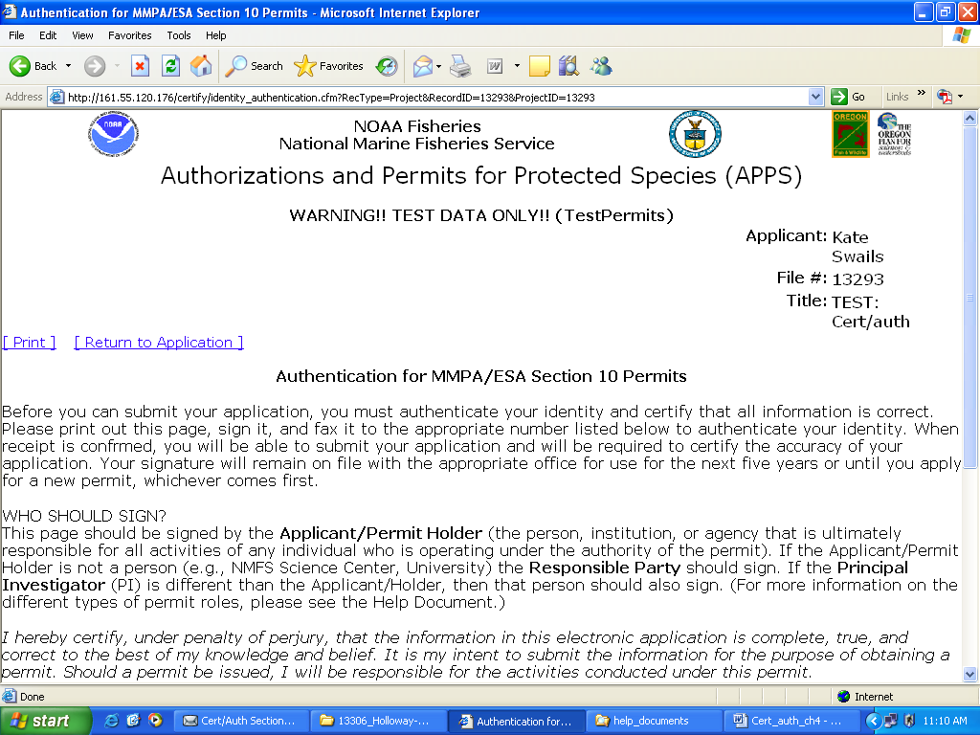
To print on one page make sure your text size is set to “smaller.” In Internet Explorer go to “View” then “Text Size” and choose “smaller.”

2) After you have signed and dated the page, please fax it to the Permits Division at
301-713-0376.

3) Once you have faxed your authentication page, save your application and log off APPS.

4) A permit analyst will email you to confirm receipt of the signature page within 1-2 business days.

- 5) After you are notified that your signature was received by the appropriate office, you may log into APPS and submit your application by clicking on the button. The following certification screen will appear:
Click Here to Submit Application

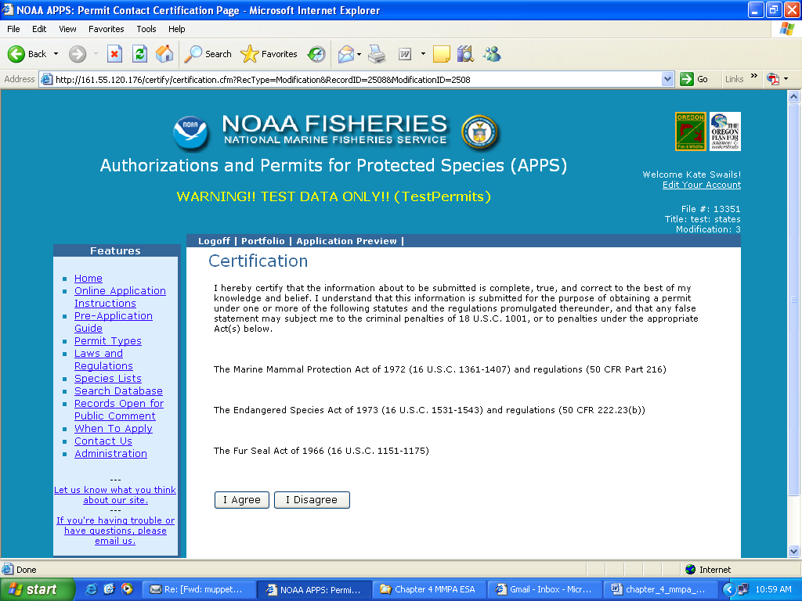

6) You must read and accept the certification statement before your application can be submitted. If you choose not to accept the statement, your application will not be submitted and your request cannot be processed.

- 7) Once submitted, you will receive an automatic email saying that you have successfully submitted your application.

Project Status

Once an application has been submitted, the “Project Status” page will track the progress of the application. This screen will display which analysts have been assigned your application and where your application is in the review process. From the “Project Overview” page, click on the “Application Preview” link. From this page you can access the “Status” page. Click on the “+” next to “Status” to open that page (see below).

Application Preview Screen

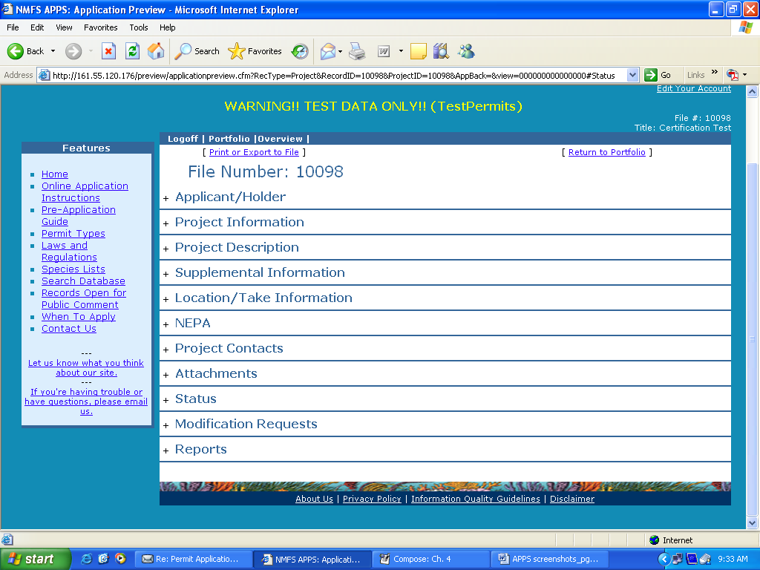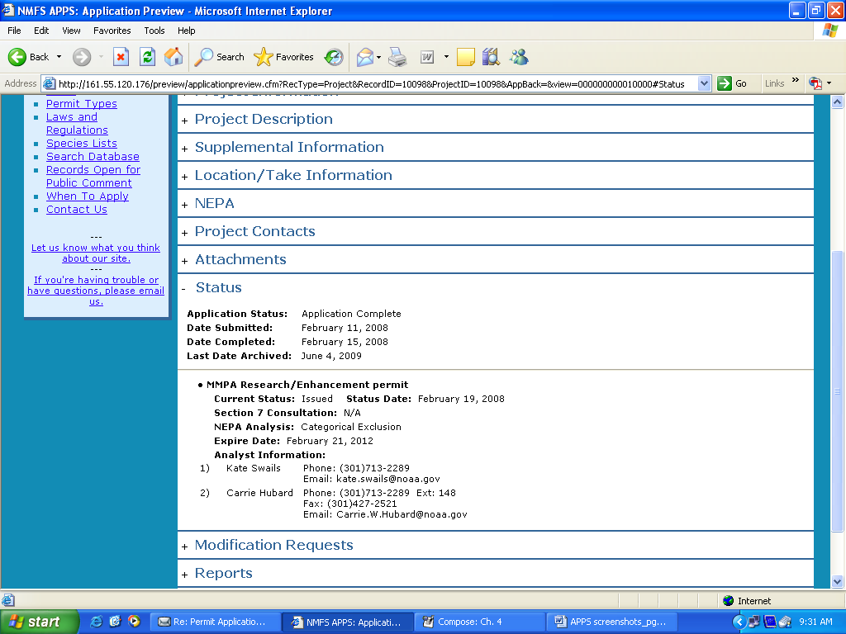

Requesting a Modification

This section of APPS allows the Applicant, Principal Investigator, and Primary Contact to request changes to the issued permit.

Note: The Director, Office of Protected Resources, may amend or modify scientific research and enhancement permits in response to or independent of a request from the Permit Holder. Amendments and modifications are subject to additional analyses under NEPA and the ESA.

Requests to modify the following permit specific conditions may require a new 30-day public review and comment period:

- changing the species to be taken or imported/exported;
- increasing the number of animals to be taken or imported/exported;
- changing or adding locations;
- changing methods; and
- extending the expiration date.

Other requests such as changing personnel or allowing a film crew to accompany the researchers may be authorized without public review.

To begin, log in to your portfolio and open the issued permit that you would like to modify by clicking on the “file number” link. At the top of the page, you will see a series of links including “Request a Modification.” Click on this link to open the “New Modification Request” page (see below).

New Modification Request Page

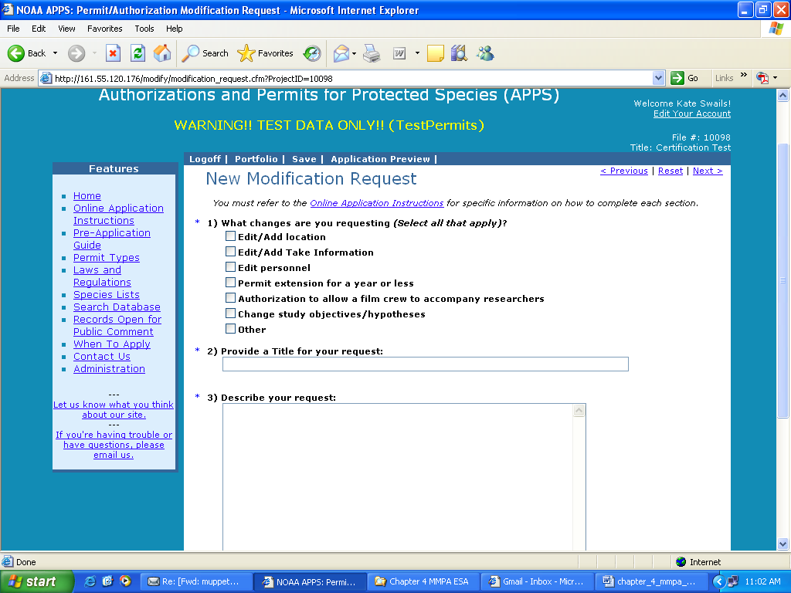

Modification Request Questions

- What changes are you requesting? (Select all that apply)

On the first page of the “New Modification Request” window, you must check the type(s) of modification(s) you are requesting. See “Modification Types” below for a description of each of these options. You have the following list of options:
- Edit/Add Location
- Edit/Add Take Information
- Edit Personnel
- Permit Extension for a year or less
- Authorization to allow a film crew to accompany researchers
- Change Study Objectives/Hypotheses
- Other

Your selections will dictate which fields are available for you to edit on the screens that follow. For example, if you select “Edit/Add Take Information” you will only be able to modify the take table. If you decide that you need to change other sections of the permit, you will have to return to this screen and check those options.

- Provide a Title for your request (up to 255 characters)

Describe the modification as concisely and descriptively as possible. Be sure to enter a modification title before logging out of the system.

- Describe your request (no text limit)

A request to modify an issued permit should address the pertinent sections of these instructions relevant to the requested change. Your request should include the following information, as applicable. See corresponding sections of application above for information required under each category below. Disregard those that do not apply to your modification request.

  - Brief narrative summary of the changes requested
  - Research timeframe and sampling season/project duration
  - Purpose: hypothesis/objectives and justification (also include a report of takes used annually to date when requesting a take increase)
  - Project description (include specifications for changes in methods or gear, such as tags)
  - Captive information
  - Status of the affected species (if requesting a change in species)
  - Lethal take (intentional or unintentional)
  - Anticipated effects on animals
  - Measures to minimize negative effects
  - Resources needed to accomplish objectives
  - NEPA information, especially for changes in methods or locations
  - References
  - For personnel changes, include qualifications/experience in each take activity
  - For filming authorizations, include who (names and roles of crew), what, when, where, why, how, and products that will be developed.

Notes: If requesting a change in authorized take, please make sure to select “Edit/Add Take Information” and edit your take table within APPS. Do not provide a separate take table when attaching a file.

For changes in field equipment or study areas, we highly recommend that you attach figures, maps or illustrations drawn to scale.

- Attach a file (Optional):

If you need to attach figures, maps, or other supporting documents please attach a file. To open the attachments window, click on the “Select File” button. Within the attachments window, you will click on the “Browse” button, and then navigate to the directory containing the file you wish to attach. After locating the file, click the “Attach” button. You can attach more than one document from this window. When you have finished attaching files, click the “Cancel” button to return to the modification request form. If you are making substantial or complex changes to your permit, your attachment should contain enough detail for reviewers to understand your request.

Click “Next >” to proceed.

Modification Types

Edit/Add Location

If you selected this option, you will see the “Modification Locations and Take Information” screen. Currently defined locations are displayed in the lower half of the screen. For instructions on adding locations and take information, see the “Project Locations and Take Information” section above. There is no limit to how many locations you can add.

To increase your action area by adding states to your action area, click on the “Change area or state” button.

To add a new location, click on the “Add new location” button.

To edit or delete an existing location, select the location and click on the “Edit/Delete location” button.

When you have completed changes to the location information, and if you have no other edits, you can submit your modification request. Click the “Next>” link at the top right of the screen. You should now see the “Submit Modification Request” screen. You are encouraged to preview your modification before submitting.

Edit Take Information

This option allows applicants to request a modification to the take table. Some of the typical types of modification requests include the addition of new methods, an increase in the number of animals taken, and the addition of new species. You may edit any part of the take table. See the “Take Table” section above for instructions on required information in the table.

When requesting an increase in the number of animals to be taken, make sure that you request the total number of animals to be taken (i.e., the number of takes you are currently authorized plus your proposed increase). Please note that requests for increases in take of species/stocks currently authorized by the permit must demonstrate valid justification, including a reporting of how many authorized takes you have used. Requests that do not provide this information may be considered incomplete. Provide justification in the “Describe your request” text box or by attaching a supporting document.

To request to remove/delete existing take records, first check the “Select” box to the left of the record you wish to delete, then click the “Delete selected records” button near the top of the page. A pop-up notice box will appear that indicates that the record will still appear in the table but is marked for deletion.

To request to modify existing take records, first check the “Select” box to the left of the record you wish to modify, then click the “Edit selected records” button near the top of the page. The take table should refresh with an editable copy of the original record with the next consecutive version number. For example, if you selected line number 2 to edit, the copied record should be line number 2, version A. Then, make the changes you would like to the record.

When you have finished entering the edits, additions, and deletions you want to request, click the “Save” button and then the “Next>” link. You will be taken to the “Location” page where you can then proceed to another location for which modifications are needed or submit your application.

Edit Personnel

Refer to the “Project Contacts” section above for instructions on editing personnel information. The process for searching and adding contacts for modifications is the same. When using the search function, be sure to exhaust your search (i.e., start out with a generic search before getting too specific so that duplicate contacts are not created).
To request removal of a contact, check the box labeled “remove” to the right of the contact’s role.

Note: To add personnel you must attach a CV or resume for each person. See instructions in application above on what information is required.

Resumes and CVs are considered part of an application’s public record and are available to reviewers and the public. Refer to the Additional Information at the end of this chapter. Please do not include personal information such as:
- Home address/phone number
- Date of birth
- Social security number
- Nationality
- Marital status
- Salary

As the Applicant, it is your responsibility to notify your Co-investigators that their names and resumes will be available to the public. When you submit your modification, all Co-investigators will receive an automatic email saying that they have been named on your application.

Permit Extension for a year or less

If you wish to apply for a permit extension, check this box and include your proposed extended expiration date and justification in the description of your request.

Authorization to allow a film crew to accompany researchers

If you wish to apply for an authorization to allow a film crew to accompany you during research, check this box and provide information on who will accompany you (i.e., production company, names and roles of the crew), where and when filming would occur, and the purpose of the filming (e.g., documentary on humpback whales).

Change Study Objectives/Hypotheses

If you wish to modify the study objectives/hypotheses, check this box and include the new objectives/hypotheses the description of your request.

Other

If you check this box, please explain the modification in the description of your request.

Submitting Your Modification Request

- After moving through all of the applicable windows, you may submit your request using the “Next >” links or click the “Submit” link near the top of the page. A window should appear that suggests you review your request before submitting. IMPORTANT: You must click the button on this page to submit your application. Once submitted, you will receive an automatic email saying that you have successfully submitted your application. A permit analyst will contact you regarding your submitted application.
Click Here to Submit Modification

Call the Permits Division at 310-427-8401 if you need assistance.

Additional Information

Under section 104(c) of the MMPA and section 10(a)(1)(A) of the ESA, persons may be authorized to take marine mammals and threatened and endangered species, respectively, for purposes of scientific research or enhancing the survival of the species. Interested persons are required to submit an application in accordance with the Acts and the implementing regulations at 50 CFR part 216, subpart D, and 50 CFR part 222. These instructions for applying for a research or enhancement permit are drawn from, but do not substitute for, ESA regulations and MMPA regulations. These regulations are available at the following web site: http://www.gpo.gov/. MMPA section 104 is available at: http://www.nmfs.noaa.gov/pr/pdfs/laws/mmpa104.pdf. ESA section 10(a)(1)(A) is available at: http://www.nmfs.noaa.gov/pr/pdfs/laws/esa_section10.pdf.

Paperwork Reduction Act Statement

The information requested in this application is required and is used to determine whether the activities described in the application are consistent with the purposes and policies of the Acts and their implementing regulations.

Public reporting burden for this collection of information is estimated to average 50 hours per response, including the time for reviewing instructions, searching existing data sources, gathering and maintaining the data needed, and completing and reviewing the collection of information. Send comments regarding this burden estimate or any other aspect of this collection of information, including suggestions for reducing this burden, to the Chief, Permits and Conservation Division, Office of Protected Resources, F/PR1, NOAA/National Marine Fisheries Service, 1315 East-West Highway, Silver Spring, MD 20910.

All permit documentation, including the application, permit and amendments, reports, inventory information, and any other associated documents are considered public information and as such, are subject to the Freedom of Information Act.
Notwithstanding any other provision of the law, no person is required to respond to, nor shall any person be subject to a penalty for failure to comply with, a collection of information subject to the requirements of the Paperwork Reduction Act, unless that collection of information displays a currently valid OMB Control Number.

OMB No. 0648-0084
Expires: June 30, 2013

A take under the MMPA means to harass, hunt, capture, collect, or kill, or attempt to harass, hunt, capture, collect, or kill any marine mammal. This includes, without limitation, any of the following: the collection of dead animals, or parts thereof; the restraint or detention of a marine mammal, no matter how temporary; tagging a marine mammal; the negligent or intentional operation of an aircraft or vessel, or the doing of any other negligent or intentional act which results in disturbing or molesting a marine mammal; and feeding or attempting to feed a marine mammal in the wild. Under the ESA, a take means to harass, harm, pursue, hunt, shoot, wound, kill, trap, capture, or collect, or attempt to do any of the preceding.
For marine mammals, serious injury is defined by regulation as any injury that will likely result in mortality.
DO NOT include social security number, date of birth, nationality, marital status, home phone or address (unless it is also the business address), salaries, or other personal information.
Address how you are qualified to perform the proposed activities and to supervise the performance of others acting under the permit (e.g., research assistants, vessel operators).
This does not need to be exhaustive. The intent is to show that the individual has or is reasonably likely to publish in peer reviewed journals or otherwise make results of permitted research available.

