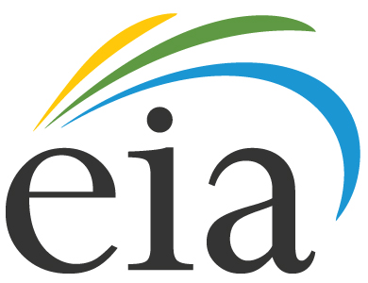
U.S. Energy Information Administration
Office of Energy Statistics
Office of Oil, Gas, and Coal Supply Statistics

Supporting Statement for Survey Clearance
U.S. Energy Information Administration’s (EIA) Financial Reporting System:
Form EIA-28
OMB No. 1905-0149

Part B:
Statistical Methods

March 2013

B. COLLECTIONS OF INFORMATION EMPLOYING STATISTICAL METHODS

1. Universe and Respondent Selection
The information gathered during this evaluation will be used primarily to inform the future redesign of the Form EIA-28 to measure oil and gas operating costs for exploration and production for U.S. companies’ foreign and domestic operations. It will not be used to produce estimates about upstream oil and gas costs for exploration and production for U.S. companies’ foreign and domestic operations. The small-scale testing activities undertaken as part of this clearance will involve respondents selected to represent a broad range of subgroups with expertise in specific characteristics related to measuring upstream oil and gas costs for exploration and production for U.S. companies’ foreign and domestic operations.
More specifically, the testing activities are expected to examine several aspects of the redesign process. Field testing will be used to clarify particular issues with the present form and with the new types of data that should be collected on the redesigned form. Pilot surveys will examine some aspects of the initial redesign of the form. Respondents will be debriefed to examine potential data quality problems and more accurately determine the filing burden of the new form. Cognitive interviews of the respondents will be conducted to identify areas and sources of ambiguity in the present form.
Finally, focus groups will be held to identify and explore issues of interest to stakeholders. Members of the initial focus groups are expected to include various stakeholders such as members or representatives of trade associations, industry groups, research groups, and academics. In addition to gaining an understanding of the needs and interests of the initial set of stakeholders, the focus groups should identify additional stakeholders, which will be invited to participate in subsequent focus groups.

2. Procedures for Collecting Information
Data collection procedures for the testing conducted under this clearance will be varied and may include in-person or web-based interviews, and telephone and web-based surveys. EIA staff members, including both energy subject matter experts and survey statisticians, will conduct these activities.

3. Methods to Maximize Response Rates
In general, telephone callbacks will be used to maximize response rates for in-person, telephone, or web-based interviews. Reminder telephone calls and emails to respondents will be used to encourage them to keep their appointments. We may also contact nonrespondents via email to improve response rates.

4. Tests or Procedures
This request for clearance covers qualitative analyses of the data collected via the interviews, pilot questions, and other means. These analyses will help in the development of the instruments and survey procedures during future redesign of the EIA-28. EIA expects that all tests conducted under this clearance will result in improved data quality and reduced or minimized respondent burden on the future redesign of the EIA-28. In addition, the data collection procedures under this OMB clearance package may identify third party data sources of upstream oil and gas costs for exploration and production for U.S. companies’ foreign and domestic operations. These third party sources may be used to supplement the future redesign of the EIA-28. In addition, these third-party sources and other portions of the activities that are part of this OMB clearance package may assist EIA in verifying the validity of these data sources.

5. Name and Telephone Number of Individual
Staff from the EIA Office of Oil, Gas and Coal Supply Statistics (OGCSS) will have primary responsibility for information gathering efforts; they will be assisted by staff from the EIA Office of Survey Development and Statistical Integration (SDSI). Questions concerning testing conducted as part of this clearance should be directed to Neal Davis (OGCSS) on 202-586-6581.

