Screen Shots for Training Course Feedback Forms-Take from the National Explosives Detection Canine Team Program web page referred to as the Canine Web Site or CWS. Note: This information is does not reflect current questions, will be corrected as soon as the forms resubmission process is complete.
Online Forms Page – Initial page for students to complete form online. Selection can be made for several forms.
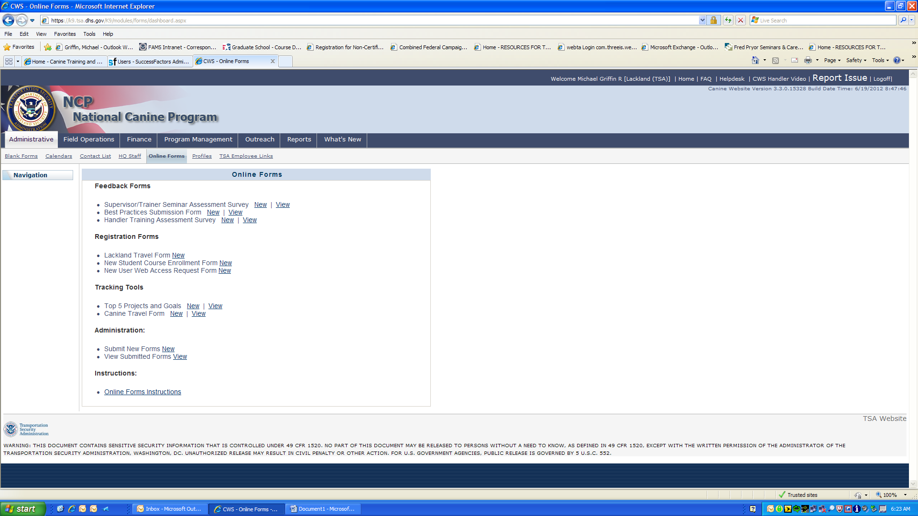

1st FORM-Handler Training Assessment Survey [NEW]-form students will complete.
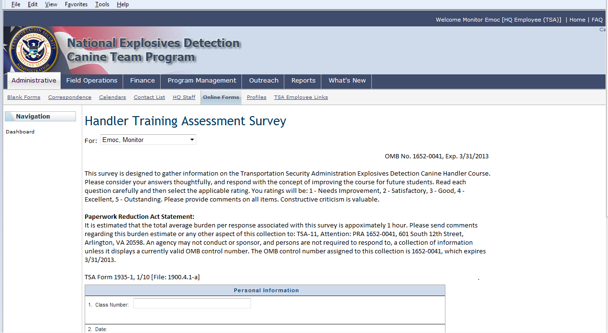

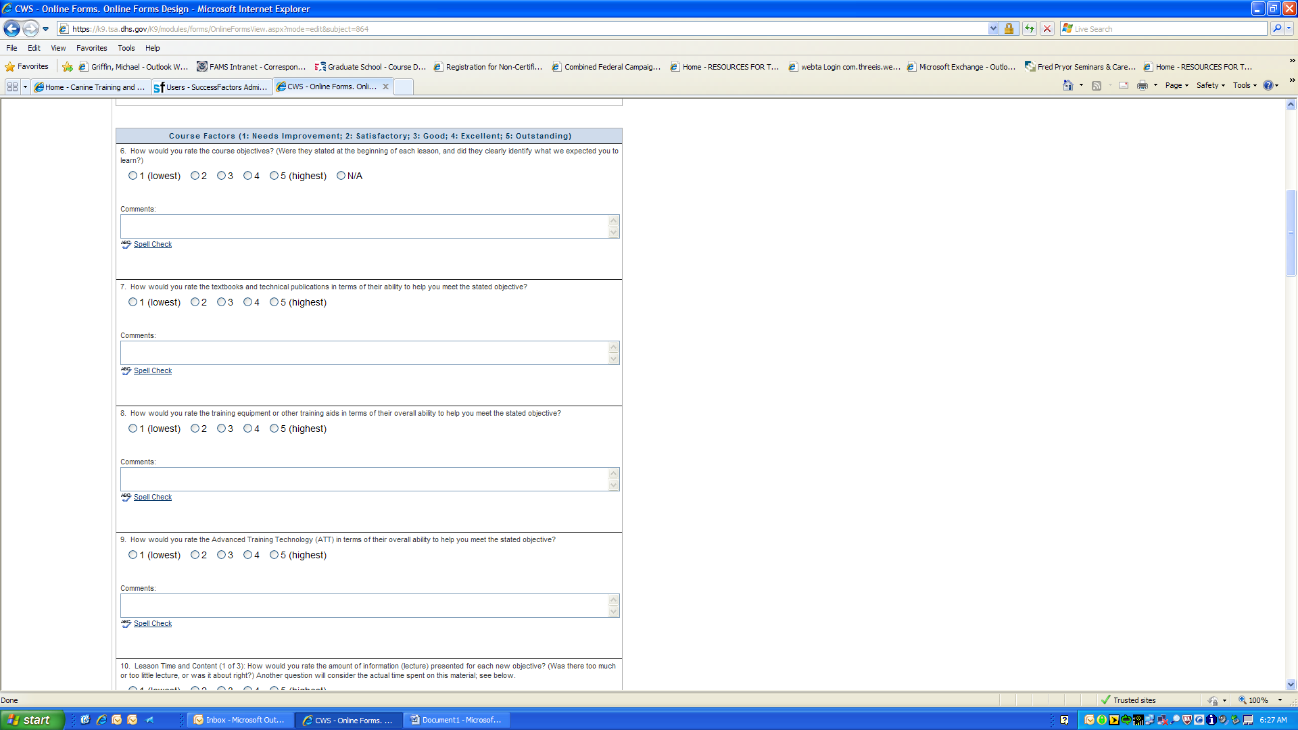

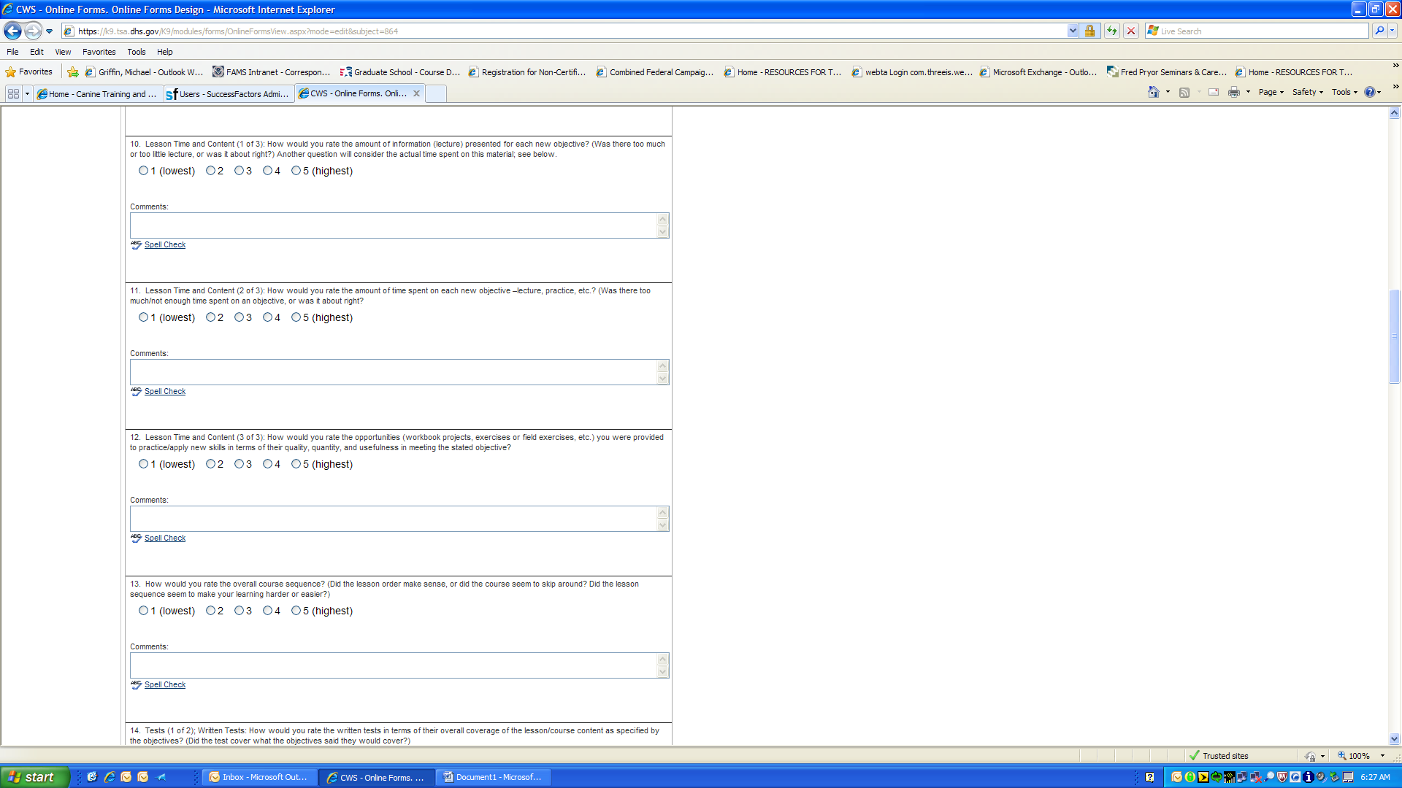

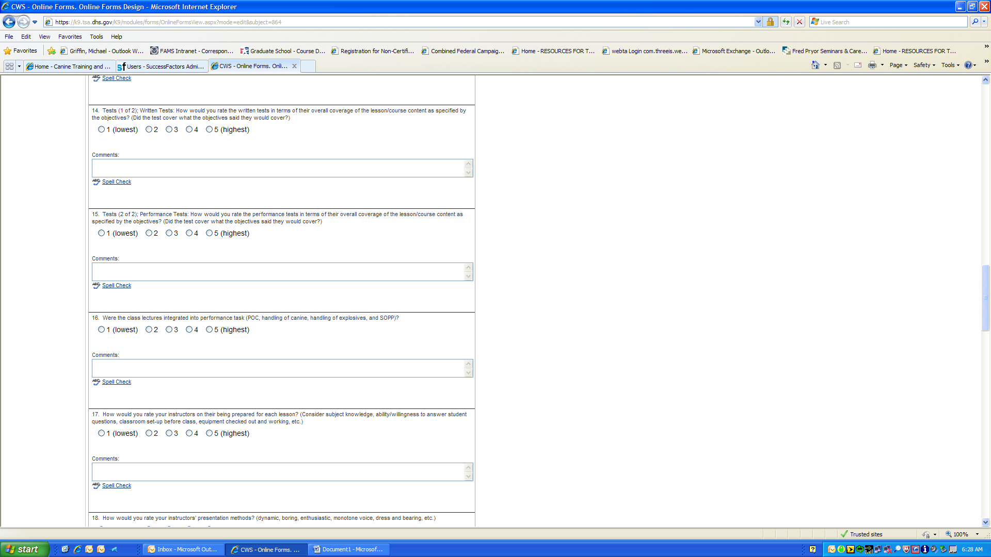

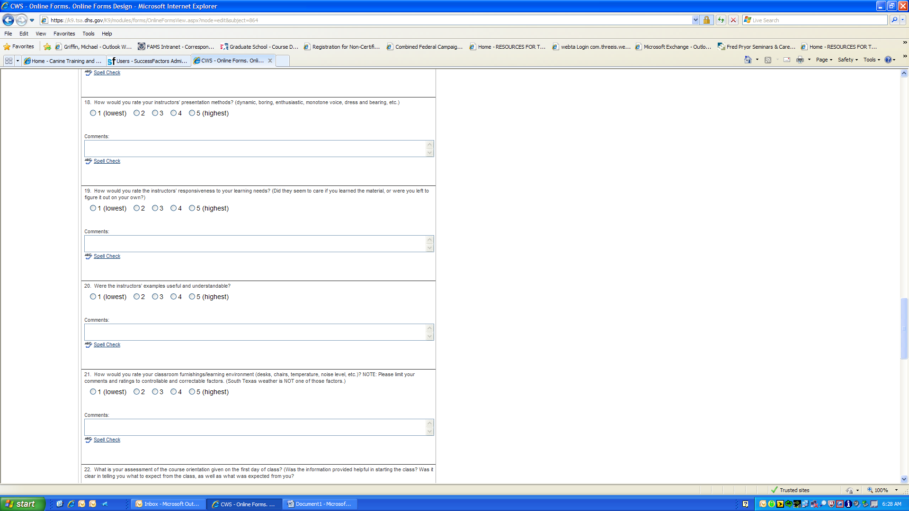

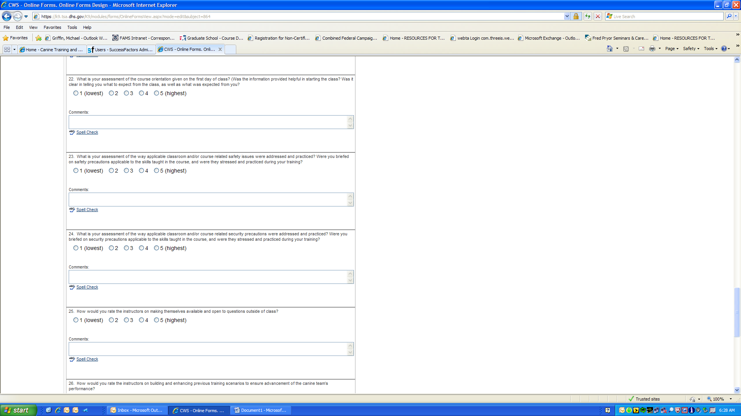

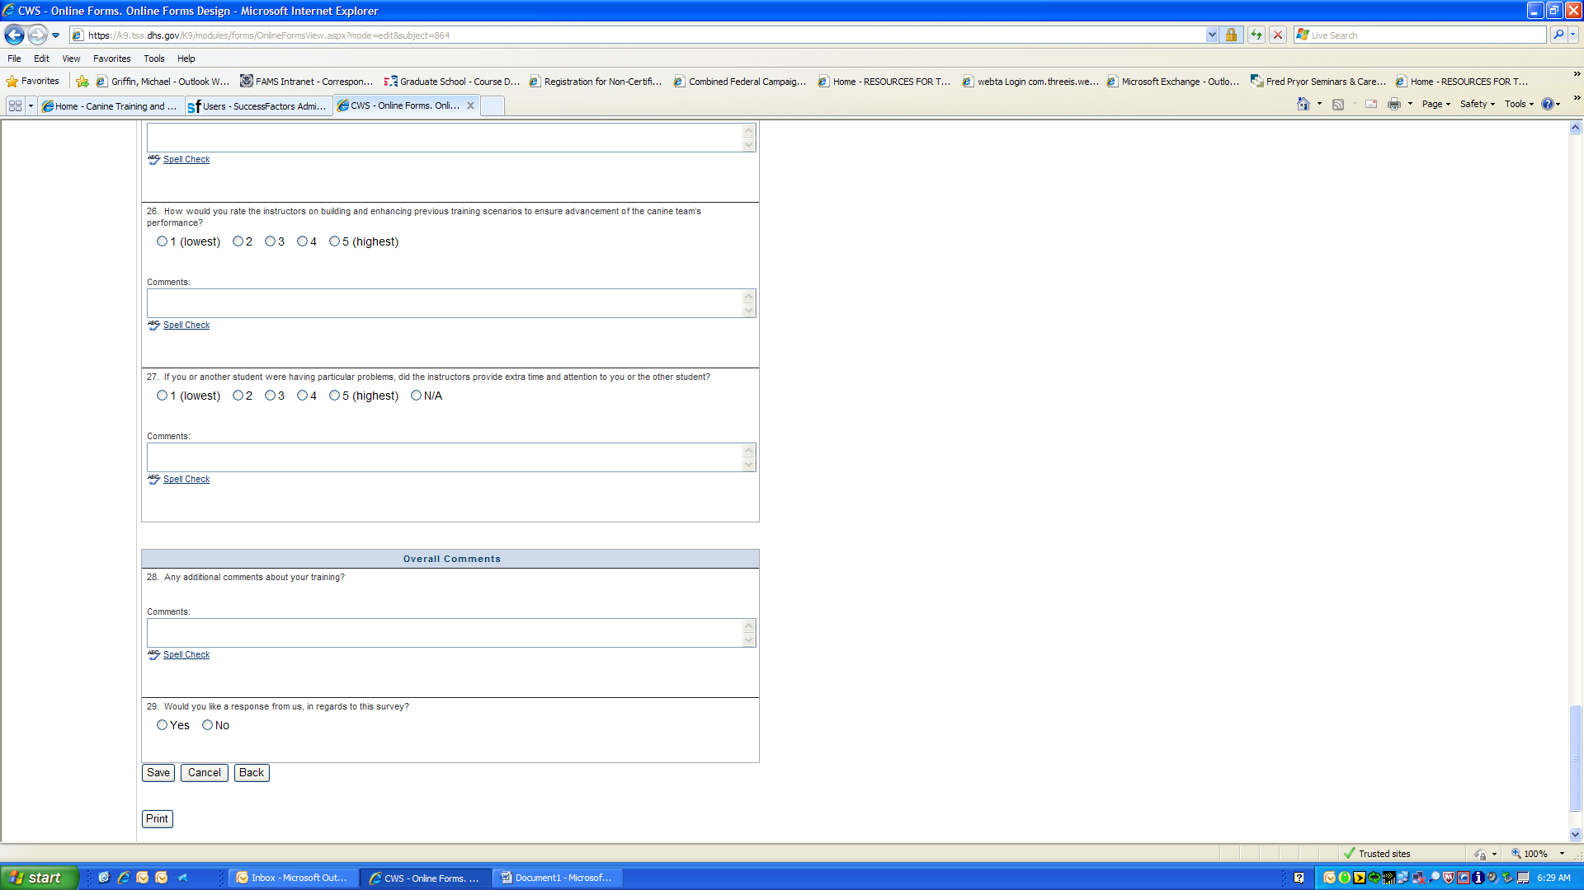

Handler Training [VIEW]-This area the Training Development personnel can view all the surveys completed to date for assessments.
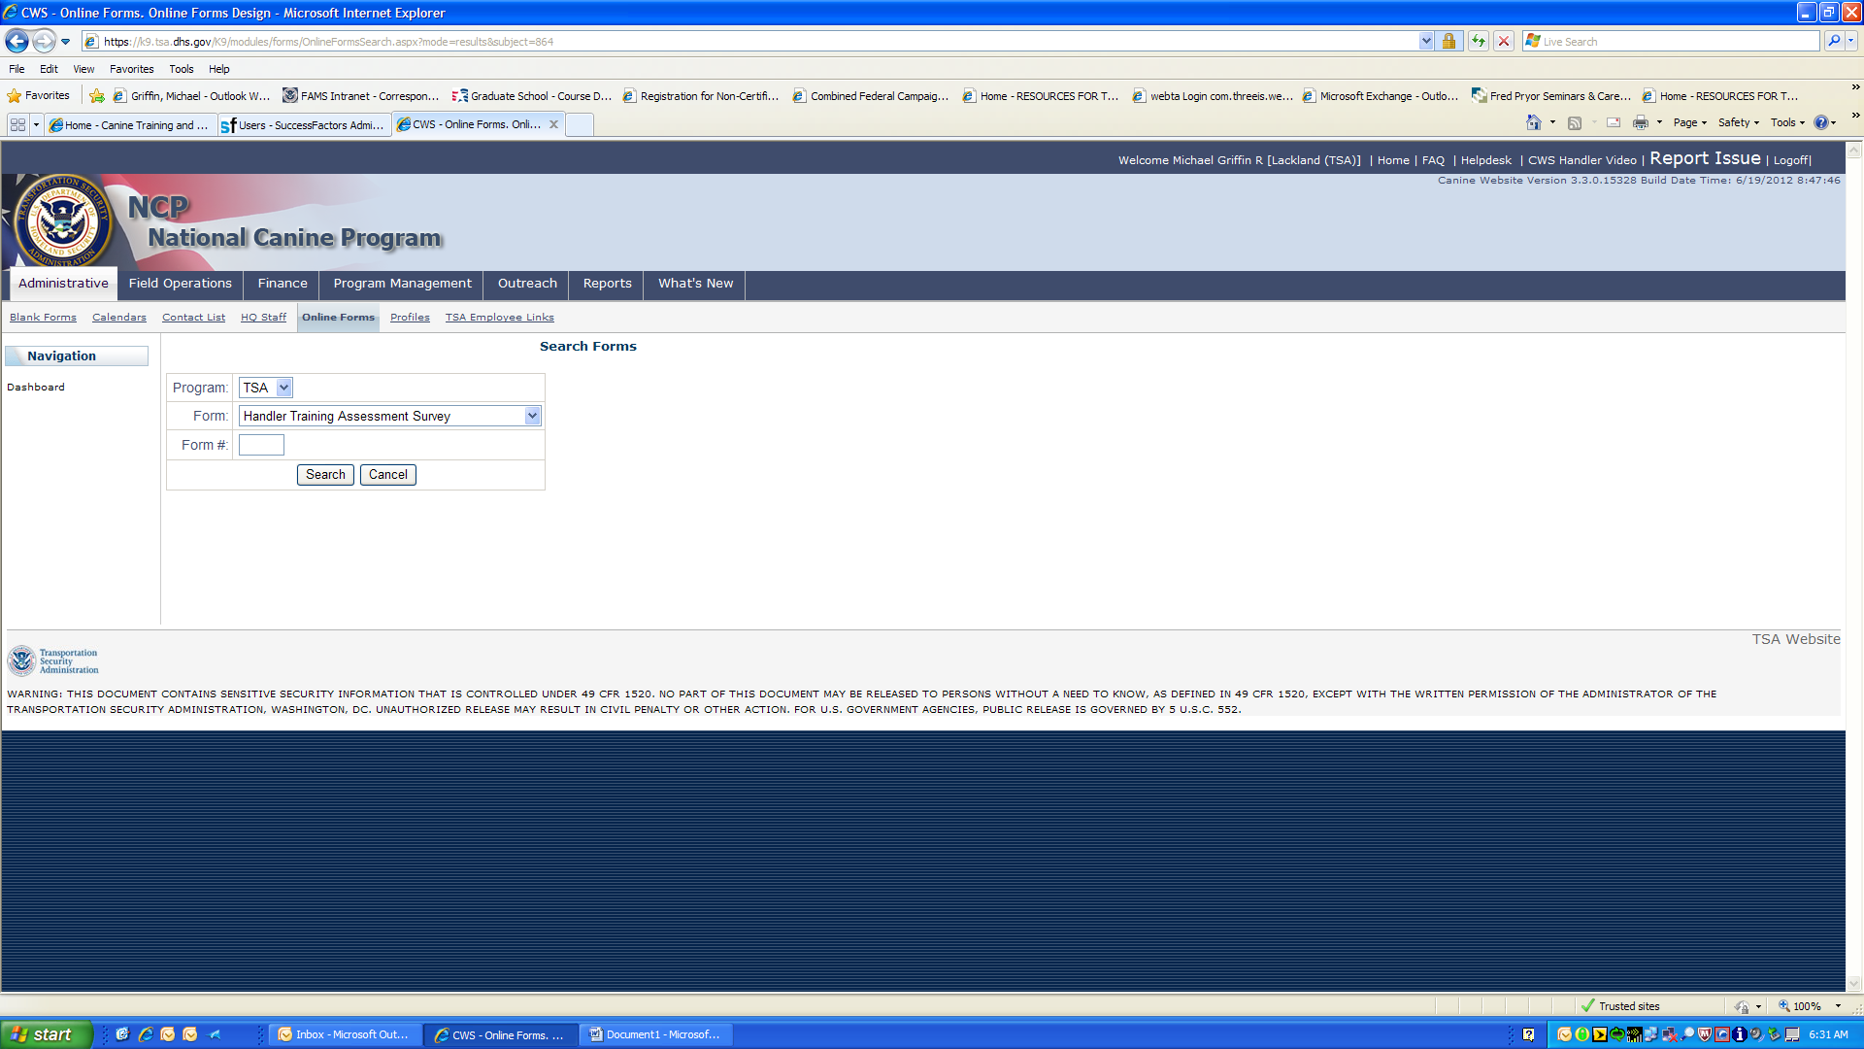

Handler Training (Search Forms)- Sample of a data query to find surveys.
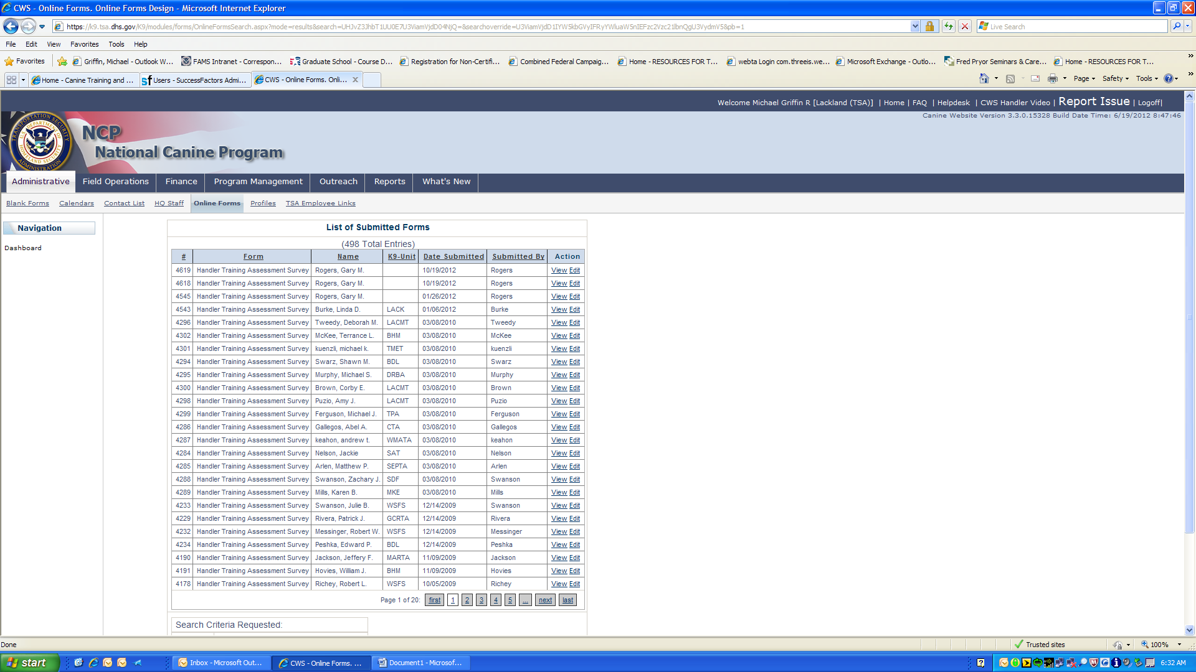
2nd FORM-Supervisor/Trainer Seminar Assessment Survey [NEW]- form students will complete.
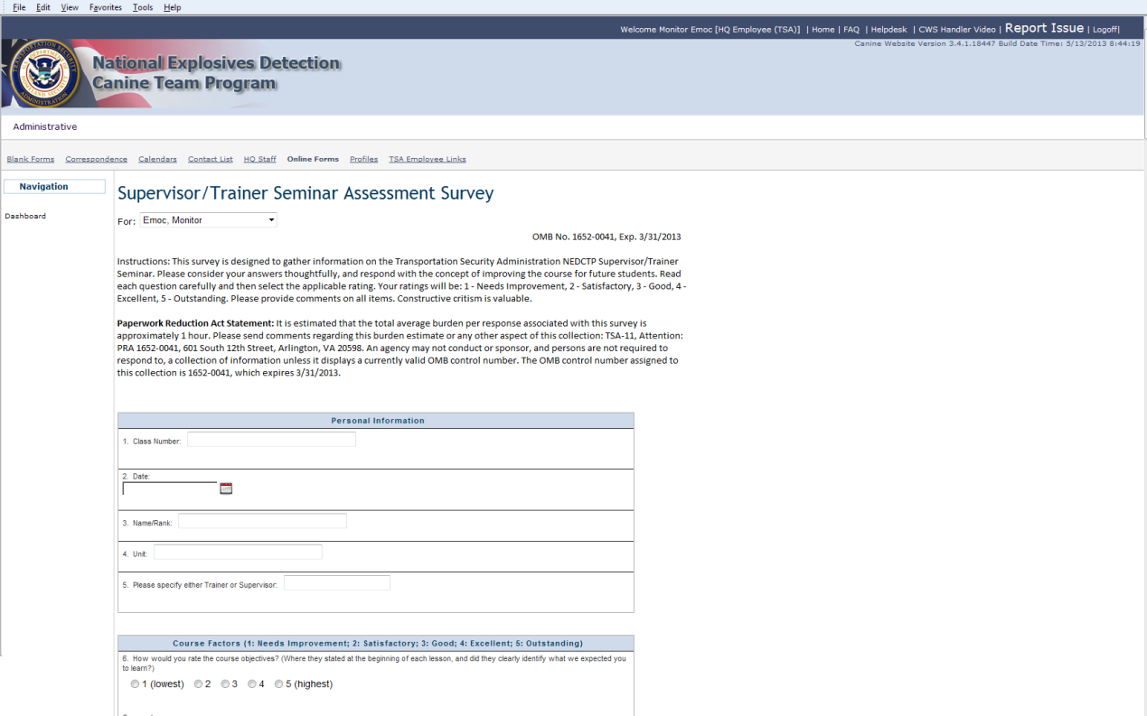

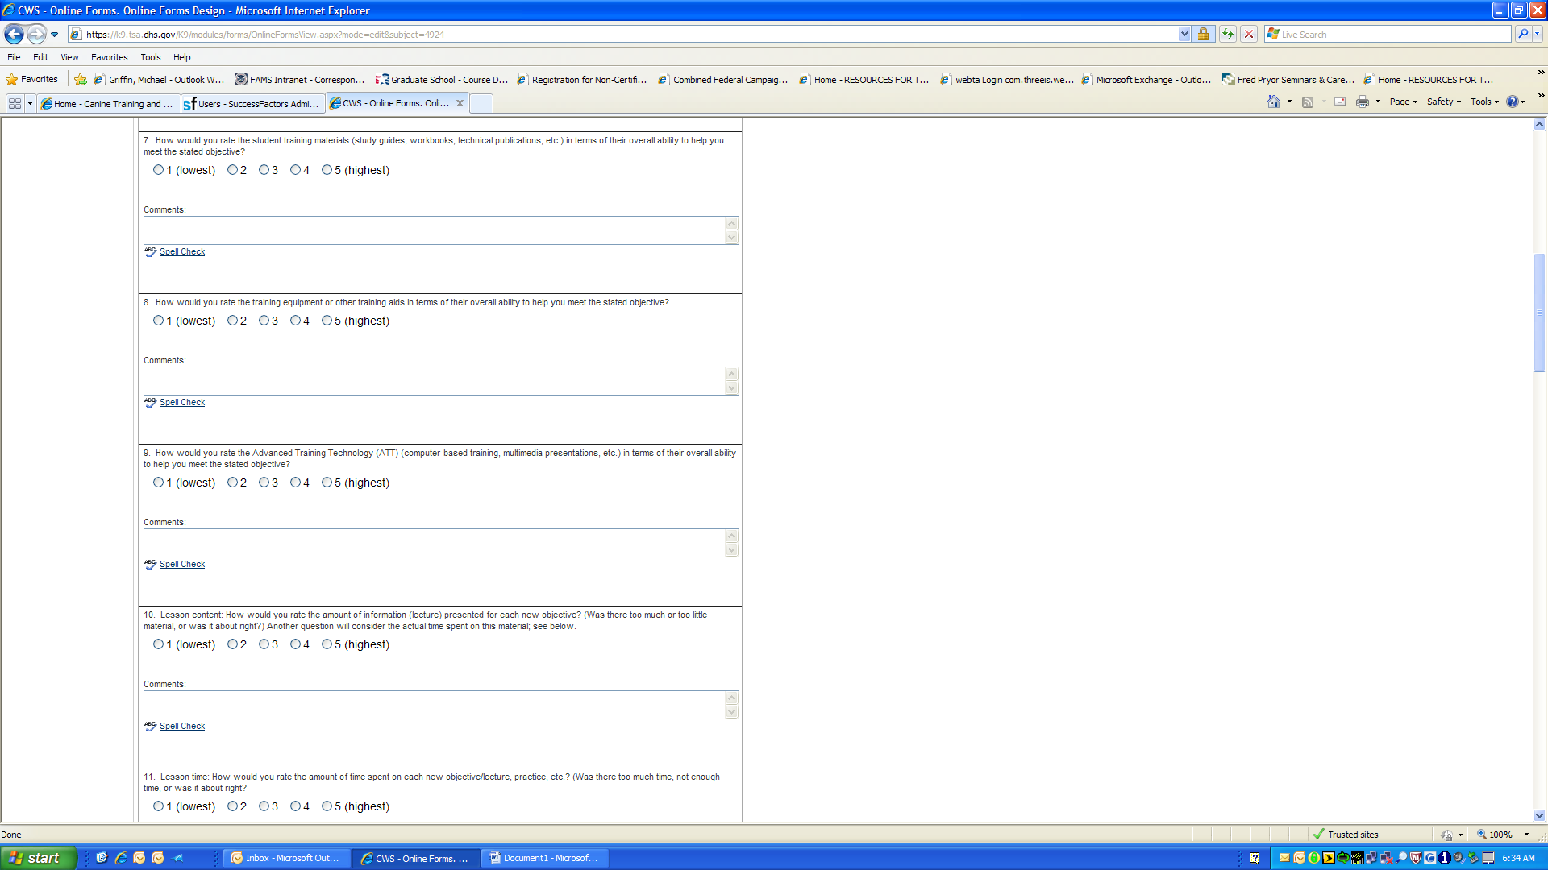
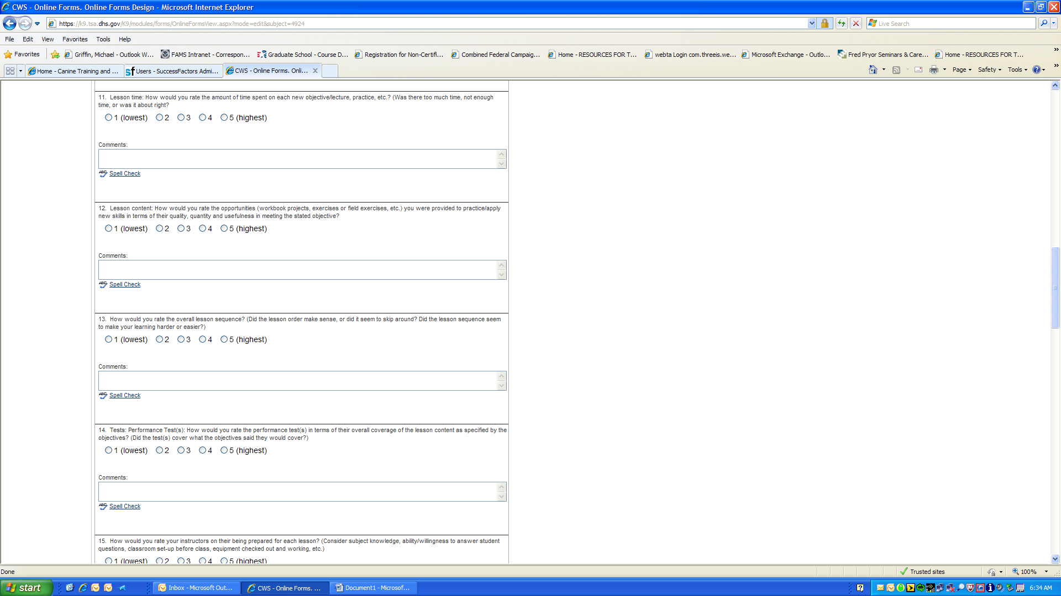

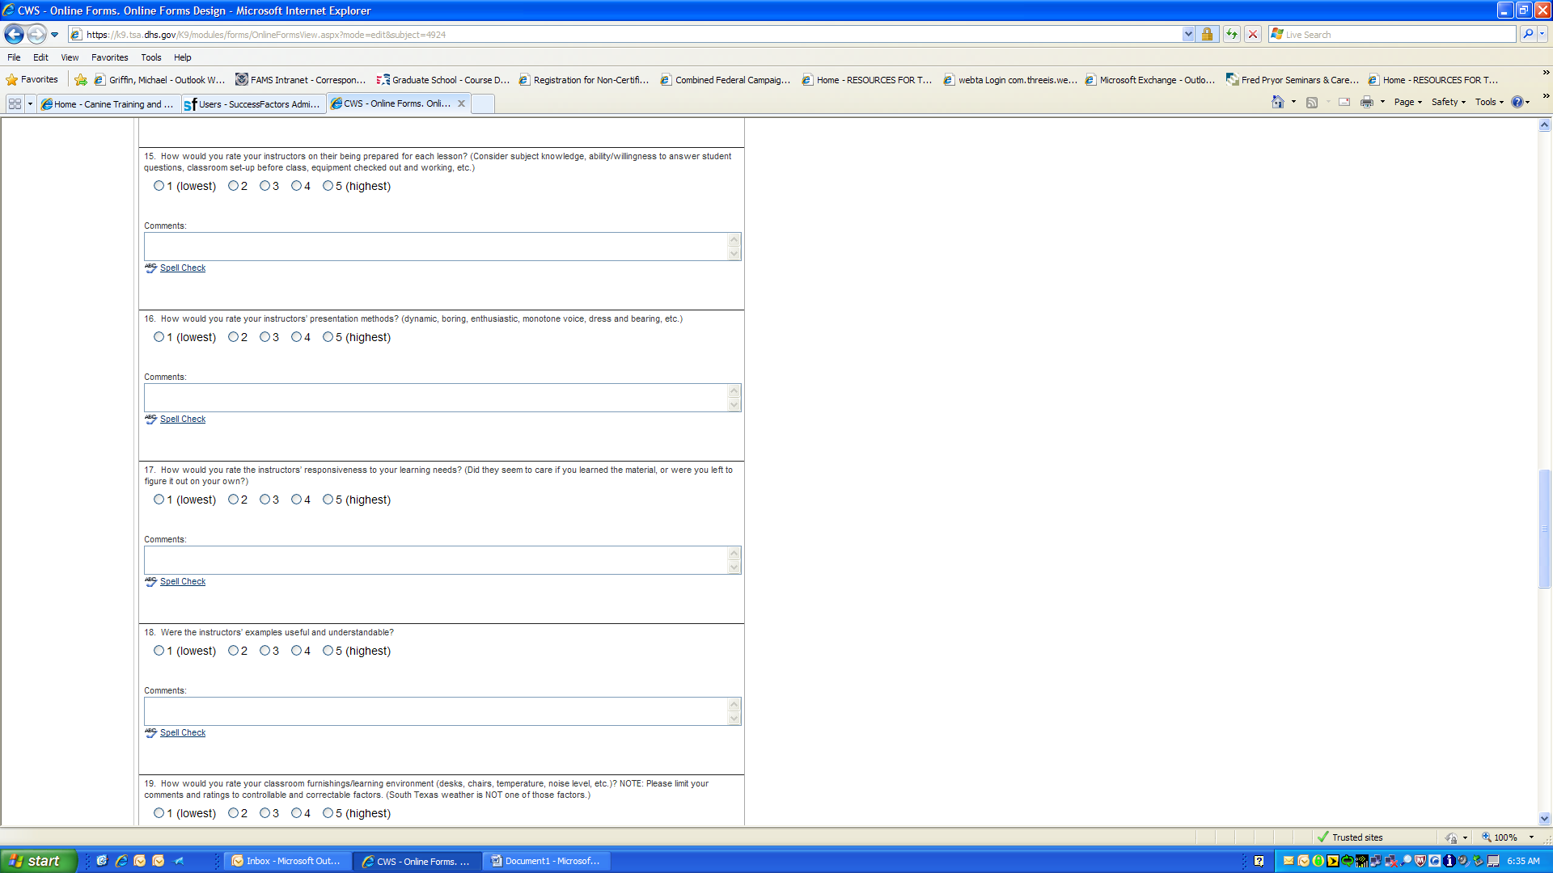

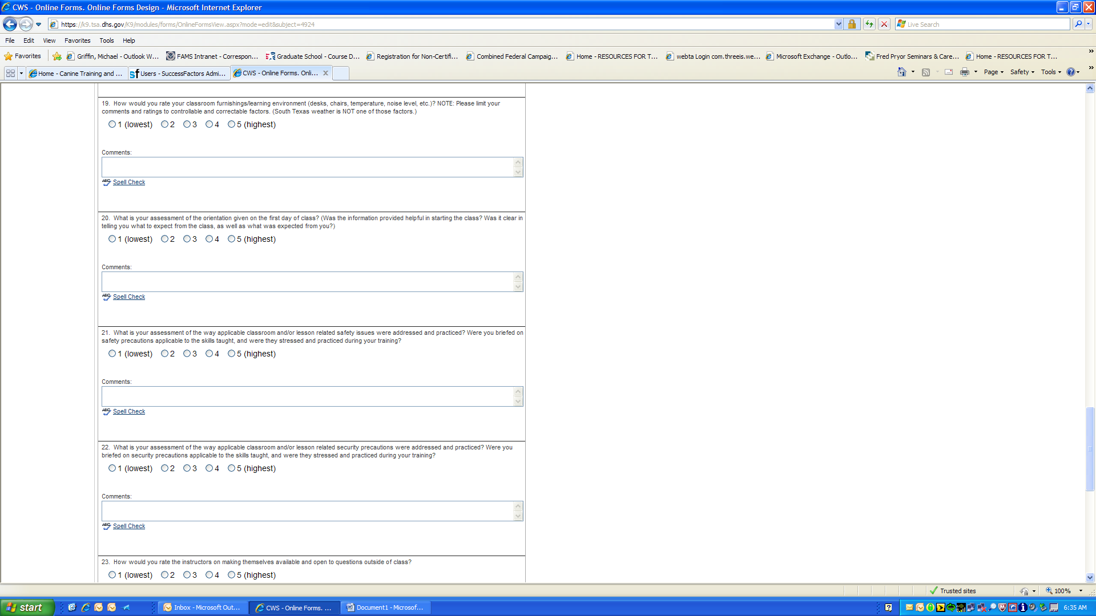

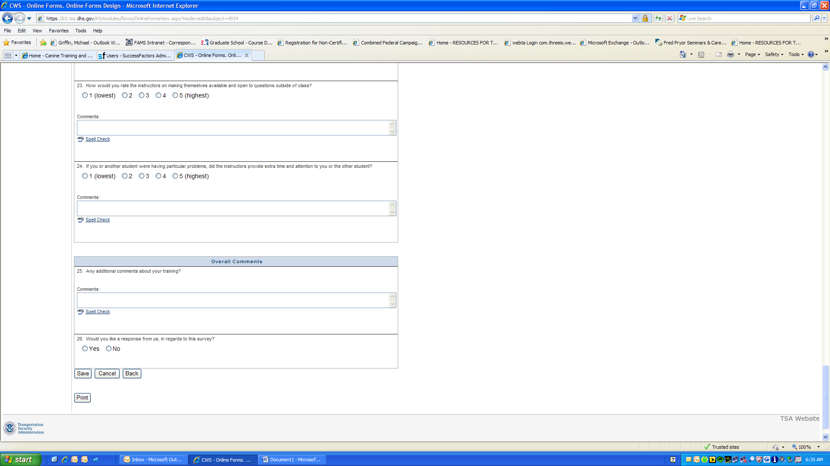

Supervisor/Trainer Seminar Assessment Survey [VIEW]- This area the Training Development personnel can view all the surveys completed to date for assessments.
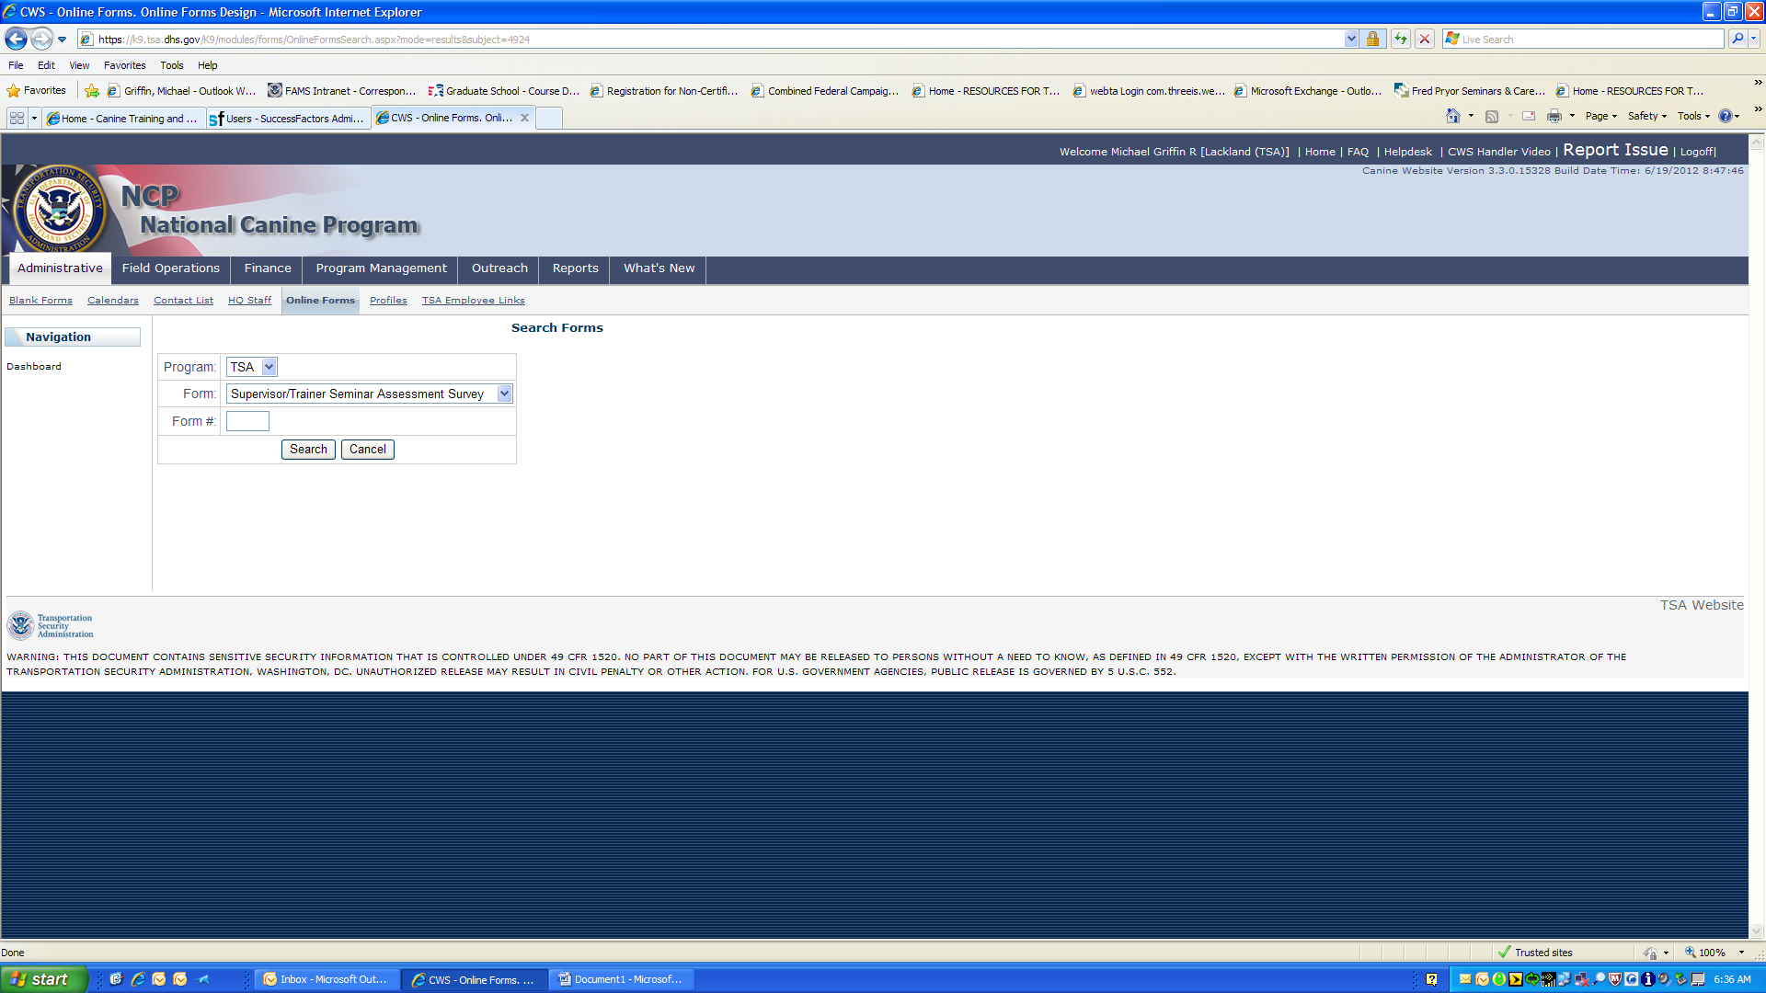
Supervisor/Trainer Seminar Assessment Survey (Search Forms)- Sample of a data query to find surveys.
