Note to the Reviewer: The text in the shaded boxes below will not be included in the survey (the visitors will not read this as a part of the survey process). This text is used to annotate the questions in response to Part A question 2 of the PRA Supporting Statement. The text boxes will be removed and will not be printed on the final version of the approved questionnaire.

NPS Study of Value of Natural Sounds: A Pilot Study
On-site Visitor Survey
Focus Group Exercise

OMB Control Number 1024-0XXX
Expiration Date: XX/XX/XXXX

Thank you for agreeing to take this survey. We are asking for your help to improve this version of the survey that we will use in the future to measure visitor perception of sounds in National Parks. Your participation will help us to make sure that other visitors like you will be able to complete the questions in our survey. We are going to ask you to answer a series of questions and then we will ask you to listen to some recorded sounds. After that we would like to spend some time as a group to debrief with you about your experience taking the survey. In total this should take about 90 minutes to complete. Are you ready to get started?

The participants will be asked to read the text below as it will be the same that precede the questions in the questionnaire. Sounds of Nature at [insert park name]

Sounds of Nature at [insert park name]
Wildlife at national parks can be affected by sound conditions. Predators rely on sounds to detect prey and likewise sound often alerts prey to the presence of predators. Some species use sound to locate and attract mates. Man-made sounds such as talking, road vehicles, and aircraft have the potential to cover up the sounds of nature that wildlife use to survive.
Man-made sounds may also affect a visitor’s experience at a national park. The man-made sounds heard in the front country at national parks (scenic overlooks, trail heads, portions of hiking trails close to trail heads and developed campsites) are generally louder and more prevalent than the man-made sounds heard in the back country. However, man-made sounds heard in the back country can disturb a visitor’s feeling of solitude.
Instructions for Exercises
On the following pages you will find a series of exercises that will ask you to choose between three possible experiences at [insert name of park]. In all the exercises, the first option (Trip A) represents the current typical summer visit to [insert park name]. While the conditions you have experienced during your visit might be different, the conditions listed under Trip A are the usual conditions you would expect to experience. The other two trip experiences are hypothetical.
The trip experiences have different sound conditions described using the phrase “the percent of time you would hear only the sounds of nature.” This means that there are no man-made sounds during that time. The rest of the time some amount of man-made sounds could be heard. The man-made sounds would be like those that are currently heard at [insert park name]
The sound conditions are described separately for front country and back country. On the map on the following page, the green shaded area marks the front country. The front country includes scenic overlooks, trail heads, hiking trails within a half mile of trail head, and developed campsites. The backcountry is the rest of the park, including hiking trails farther than a half mile from trail heads and primitive campsites.
The trip experiences are also described by a change in the per person trip costs for trips B and C. Assume that all other characteristics of the park visit would be exactly as you experienced them on your current visit to [insert park name].
Please keep in mind your financial situation and that you may prefer to use that money for other purposes. Also keep in mind that there are other natural areas (for example: other national parks, national forests, and state parks) where the sounds of nature may be heard.

Please carefully consider each exercise separately. There are no right or wrong answers; we are interested in learning what characteristics of [insert park name] are important to you.

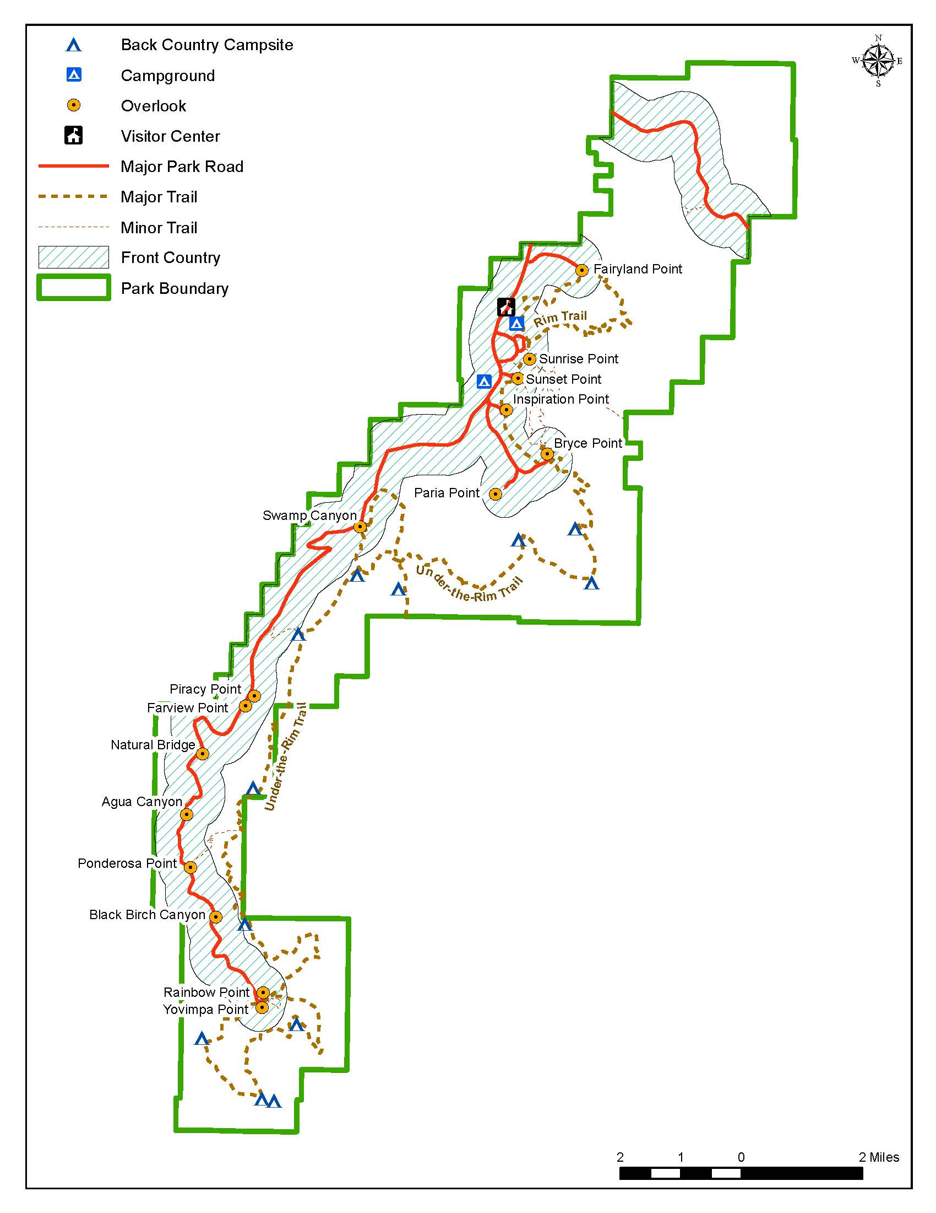
Bryce Canyon National Park

Method 1: Text only
Exercise 1 will use only text to describe sound conditions using the description “the percent of time you would hear only the sounds of nature.” The text only method is the central portion of the study because it will be used by both the general population survey and a version of the visitor survey.
Exercise 2 In addition to the text used to describe sound conditions in Exercise 1, this exercise includes contingent valuation (CV) with payment card method to determine the respondent’s willingness to pay to improve sound conditions at the park.
Method 2: Text and audio clips
Exercise 3 will use text to describe percent of time that only the sounds of nature are heard and an audio clip to demonstrate the maximum volume of the human caused sounds (e.g., overflight or passing road vehicle) and will be calibrated to represent the specified decibel level.
Method 3: Audio clip only
Exercise 4 will use an audio clip to describe the percent of time that only the sounds of nature are heard and the maximum volume of the human caused sounds.
A note about experimental design
The values for percent of time audible, maximum sound level and change in per person trip costs used in these exercises are examples for testing purposes only. The final survey will use a variety of combinations of these attributes for different versions of the study. The experimental design will be constructed to maximize efficiency of the choice exercises.
The volume levels for the soundclips will be programmed so that one alternative is not clearly better or worse than the others (i.e., “dominated”). For example, in Exercise 3, Trip B has lower percent of time only sounds of nature are heard and has a $15 increase in cost over Trip A which make it a “worse” alternative than Trip A. However, the sound clip will present a lower maximum sound level than the sound level for Trip A which would be an improvement over Trip A for that characteristic. For the eventual full-scale study, the responses to the three exercises below will be used for estimating a logit choice model.

The following questions are an example of one of the options we will use in the survey. The values in each cell are examples. The values for the cells in the final survey will be determined from an experimental design which will maximize the efficiency of the choice options. The responses to the three exercises below from the full survey will be used for estimating a logit choice model.
Exercise 1: Please read all the information in the table below and then select the [insert name of park] trip you would prefer.
I would prefer (choose only one)
- Trip A
- Trip B
- Trip C
 |  | Trip A  No change from current typical summer conditions | Trip B  Hypothetical change from current typical summer conditions | Trip C  Hypothetical change from current typical summer conditions
 |  | Below is the percent of time you would hear only the sounds of nature (during a 12 hour period)
If you were in the Front Country at one of the following locations:  - scenic overlooks  - trail heads  - hiking trails within 1/2 miles of trail head  - developed campsites | Daytime   | 60% | 50% | 40%
 | Nighttime   | 75% | 75% | 75%
If you were in the Back Country at one of the following locations:  - hiking trails further than 1/2 miles from trail heads  - primitive campsites | Daytime | 80% | 90% | 70%
 | Nighttime | 85% | 85% | 85%
The change in per person trip cost would be |  | No change | $15 increase | $5 decrease

The range of values in this question is taken from a study of visibility conditions at national parks. The inclusion of this question was suggested by a member of our expert review panel as a follow-up question in the event that the choice experiment questions do not yield usable results.
Exercise 2: Currently at [insert name of park] only natural sounds are heard 60% of the time during the day in the front country. What would you pay (in higher per person trip costs) to improve conditions so that only natural sounds are heard 75% of the time during the day in the front country? Circle the one amount that best represents your answer:
$0.00 | $2 | $8 | $25 | $60 | $150 | $400
$0.50 | $3 | $10 | $30 | $75 | $200 | $500
$1.00 | $4 | $15 | $40 | $100 | $250 | $750
$1.50 | $5 | $20 | $50 | $125 | $300 | $1,000
 |  |  |  |  | Don’t know | More than $1,000

If you selected $0.00 above, please briefly explain why.
_________________________________________________________________________________________________________________________________________________________________________________________________________________________________________________________
Exercise 3: Please read all the information in the table below and then select the [insert name of park] trip you would prefer.
I would prefer (choose only one)
- Trip A
- Trip B
- Trip C
 |  | Trip A  No change from current typical summer conditions | Trip B  Hypothetical change from current typical summer conditions |  | Trip C  Hypothetical change from current typical summer conditions
If you were in the Front Country at one of the following locations:  - scenic overlooks  - trail heads  - hiking trails within 1/2 miles of trail head  - developed campsites | Daytime | Below is the percent of time you would hear only the sounds of nature (during a 12 hour period)
 |  | 60% | 50% |  | 40%
These audio clips play an example of the maximum sound level for man-made sound events

NOTE: Trip A max level will be medium, Trip B will be Lower (better), Trip C will be Higher (worse).
 |  | Trip A  (click to play)   | Trip B  (click to play) |  | Trip C  (click to play)
 | Nighttime | Trips A, B, and C have the same sound conditions
If you were in the Back Country at one of the following locations:  - hiking trails further than 1/2 miles from trail heads  - primitive campsites | Daytime | Trips A, B, and C have the same sound conditions
 | Nighttime | Trips A, B, and C have the same sound conditions
Change in per person trip cost |  | No change |  | $15 increase |  | $5 decrease

Exercise 4: Please read all the information in the table below and then select the [insert name of park] trip you would prefer.
I would prefer (choose only one)
- Trip A
- Trip B
- Trip C
 |  | Trip A  No change from current typical summer conditions | Trip B  Hypothetical change from current typical summer conditions |  | Trip C  Hypothetical change from current typical summer conditions
These audio clips play an example of the typical sound conditions

NOTE: Trip A max level will be medium, Trip B will be medium, Trip C will be Higher (worse)
If you were in the Front Country at one of the following locations:  - scenic overlooks  - trail heads  - hiking trails within 1/2 miles of trail head  - developed campsites | Daytime | Trip A  (click to play) | Trip B  (click to play) |  | Trip C  (click to play)
 | Nighttime | Trips A, B, and C have the same sound conditions
If you were in the Back Country at one of the following locations:  - hiking trails further than 1/2 miles from trail heads  - primitive campsites | Daytime | Trips A, B, and C have the same sound conditions
 | Nighttime | Trips A, B, and C have the same sound conditions
Change in per person trip cost |  | No Change |  | $15 increase |  | $5 decrease

PAPERWORK REDUCTION ACT STATEMENT: The National Park Service is authorized by 6 U.S.C. 1a-7 to collect this information. This information will be used by park managers to understand visitor perception of sound in [insert park name]. Response to this request is voluntary. No action may be taken against you for refusing to supply the information requested. The permanent data connected with this collection will be anonymous. Please do not put your name or that of any member of your household on the questionnaire. An agency may not conduct or sponsor, and a person is not required to respond to, a collection of information unless it displays a currently valid OMB control number.
BURDEN ESTIMATE: The public reporting for this collection is estimated to be 60 minutes per respondent. This includes the time to complete the questionnaire and to participate in the follow-up interview process. Direct comments regarding the burden estimate or any other aspect of this form to: Catherine Taylor, Volpe National Transportation Systems Center, 55 Broadway, Cambridge, MA 02142, catherine.taylor@dot.gov (email).

Anne E. Smith, Michael A. Kemp, Timothy H. Savage & Catherine L. Taylor (2005): Methods and Results from a New Survey of Values for Eastern Regional Haze Improvements, Journal of the Air & Waste Management Association, 55:11, 1767-1779

