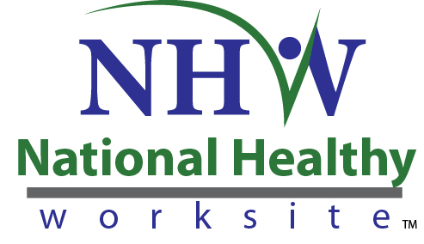
Form Approved
OMB No. 0920-XXXX
Exp. Date XX-XX-XXXX

National Healthy Worksite Program (NHWP)
Health Screening Site Interview Form

Public reporting of this collection of information is estimated to average 30 minutes per response, including the time for reviewing instructions, searching existing data sources, gathering and maintaining the data needed, and completing and reviewing the collection of information. An agency may not conduct or sponsor, and a person is not required to respond to a collection of information unless it displays a currently valid OMB control number. Send comments regarding this burden estimate or any other aspect of this collection of information, including suggestions for reducing this burden to CDC/ATSDR Reports Clearance Officer, 1600 Clifton Road NE, MS D-74, Atlanta, Georgia 30333; ATTN: PRA (0920-XXXX).
Informed Consent
Before you get started, we’d like need to give you some more information to help you decide whether or not you would like to participate.
- This project is funded by the Centers for Disease Control and Prevention. Many parts of the project are being managed by Viridian Health Management (Viridian). Viridian is a private health and wellness company based in Phoenix, AZ. Viridian provides customized solutions to building comprehensive healthy worksite programs. They are helping CDC implement the National Healthy Worksite (NHW) program.
- You were asked to participate because your worksite is participating in the National Healthy Worksite (NHW) program as a benefit to employees. All employers in the NHW program will be asked to complete this questionnaire at the beginning of the NHW program.
- Your participation in completing this form is voluntary. In the course of completing this form, you may refuse to answer specific questions.
- Completing this form is designed to take about 30 minutes.
- All of the information you provide will be maintained in a secure manner. We will not disclose your responses or anything about you unless we are compelled by law. Your responses will be combined with other information we receive and reported in the aggregate as feedback from the group. In our project reports, your name will not be linked to the comments you provide in this discussion.
- CDC is authorized to collect information for this project under the Public Health Services Act.
- There are no personal risks or personal benefits to you for participating in this discussion.
- We are interested in your comments so that we can improve the NHW program for future participants. Please feel free to contact [INSERT WORKSITE NHWP PROGRAM MANAGER]. [HIS/HER] number is [INSERT TEL #]. You can also call Viridian Health Management toll-free at 1-877-486-0140.

Instructions
This form is used in planning for your On-site Health Screening. It is a checklist of information applicable to your site(s) to assist your Viridian Health Coach in successfully managing your biometric screening event.
You will receive the Health Screening Site Interview Form from your Viridian Health Coach in advance to pre-populate the required information. Your Viridian Health Coach will subsequently schedule a meeting to review your information.
The Health Screening Site Interview Form will be retained by Viridian Health Management. An action plan will be generated to implement your On-site Health Screening.
Employer Name
Street Address 1
Street Address 2
City
State
Zip
Site Contact
Phone 1 (preferred)
Phone 2
Email
Alternate Contact
Phone 1 (preferred)
Phone 2
Email
Actual number of Employee's working in facility?
Projected # of screening participants?
Days of operation
Hours of operation
Can the facility be accessed before/after operational hours?
What are those hours?
What is the preferred point of entry to the facility?
Who will grant our team access to the facility on the day of the event?
What is that person's phone number the day of the event?
Do you have the ability to securely store our health screening supplies until the day of the event?

Would an online or paper appointment scheduling tool be more appropriate for your location?
Do we need to provide bi-lingual resources for your location? If so, language and quantity?
Screening Room/Location
What are the approximate dimensions of the room?
How many entry points are there for the room?
What immovable objects are present (i.e. conference table, desks, etc)?
Are electrical outlets available?
Describe the floor surface (i.e. carpet, tile, etc).
Does the facility have the ability to supply chairs/6' tables? If yes, how many?
Does the facility have the ability to supply trash cans (i.e. one per screener)? If yes, how many?
What privacy challenges does the facility have (i.e. windows, no private rooms, etc)?
Does the facility have an overflow/waiting area that will not impede daily operations (i.e. registration)?
Health Screening Date(s)
Health Screening Time(s)
Additional Comments

