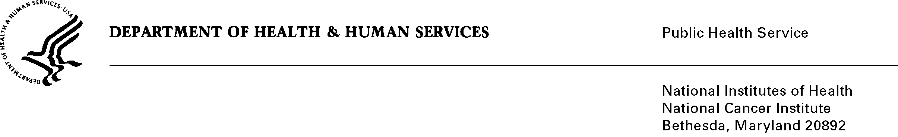
Date: December 13, 2012

To: Office of Management and Budget (OMB)

Through: Keith Tucker, Report Clearance Officer, HHS
Seleda Perryman, Report Clearance Officer, NIH
Vivian Horovitch-Kelley, PRA Project Clearance Liaison, NCI

From: Jane Hoppin, ScD, National Institute of Environmental Health Studies (NIEHS)

Subject: Revision of “The Agricultural Health Study: A Prospective Cohort Study of
Cancer and Other Diseases among Men and Women in Agriculture”
OMB#: 0925-0406, current expiry: 5/30/2013

This is a request for OMB to approve the revision request of “The Agricultural Health Study: A Prospective Cohort Study of Cancer and Other Diseases among Men and Women in Agriculture." We request that OMB consider a compressed timeline for this submission. Our goal is to field the Phase IV follow up in late February 2013 before planting season begins for this agriculture cohort. Our years of experience have shown a dramatic decrease in response rates when the cohort members are approached for study-related activities March – June (planting season) and again during harvest in the fall. In addition, because some cohort members have not been contacted since 2005, the problem of loss to follow up becomes greater in general, and we want to maximize our operations to achieve the highest response rates as possible. Thank you for your thoughtful consideration of this issue.

The Agricultural Health Study (AHS) is a cohort study of 89,568 licensed private and commercial applicators pesticide applicators and the spouses of the private applicators in Iowa and North Carolina that is to be followed for 25 years or more. The stimulus for this prospective investigation comes from the growing evidence that, despite a low mortality overall, farmers experience an excess of several cancers, including lymphatic and hematopoietic system, connective tissue, skin, brain, prostate, stomach and lips. These excesses have been observed in retrospective epidemiological studies among agricultural workers in several countries, and some (brain, NHL, multiple myeloma, and prostate) are also increasing in the general populations of these countries. This suggests a common set of exposures which may explain the high rates in farmers and rising rates in the general population. The design of the study was developed at the NCI with subsequent collaboration with the National Institute of Environmental Health Sciences (NIEHS), the Environmental Protection Agency (EPA), and the National Institute for Occupational Safety and Health (NIOSH). NCI is primarily interested in cancer outcomes and NIEHS is interested in other disease outcomes. EPA and NIOSH are providing support for a limited exposure assessment effort.

This revision is to initiate and complete the phase IV follow-up interview (2013-2015) as well as to continue and complete the ongoing Study of Biomarkers of Exposures Effects in Agriculture (BEEA) and buccal cell collections. The primary objective of the AHS study remains to be determination of the health effects resulting from occupational and environmental exposures in agriculture. We are using a similar questionnaire to ones that have been employed in previous AHS interviews to obtain information on non-cancer outcomes. New for phase IV, questionnaire data will be collected by using one of three methods of the cohort member’s choosing: self-administered computer assisted web survey; self-administered paper-and-pen; or an interviewer administered computer assisted telephone interview. Additionally, because loss to follow up of diseased individuals is a critical issue, we have added proxy interviews for those deceased or too ill to complete themselves will be completed by using one of the three methods.

