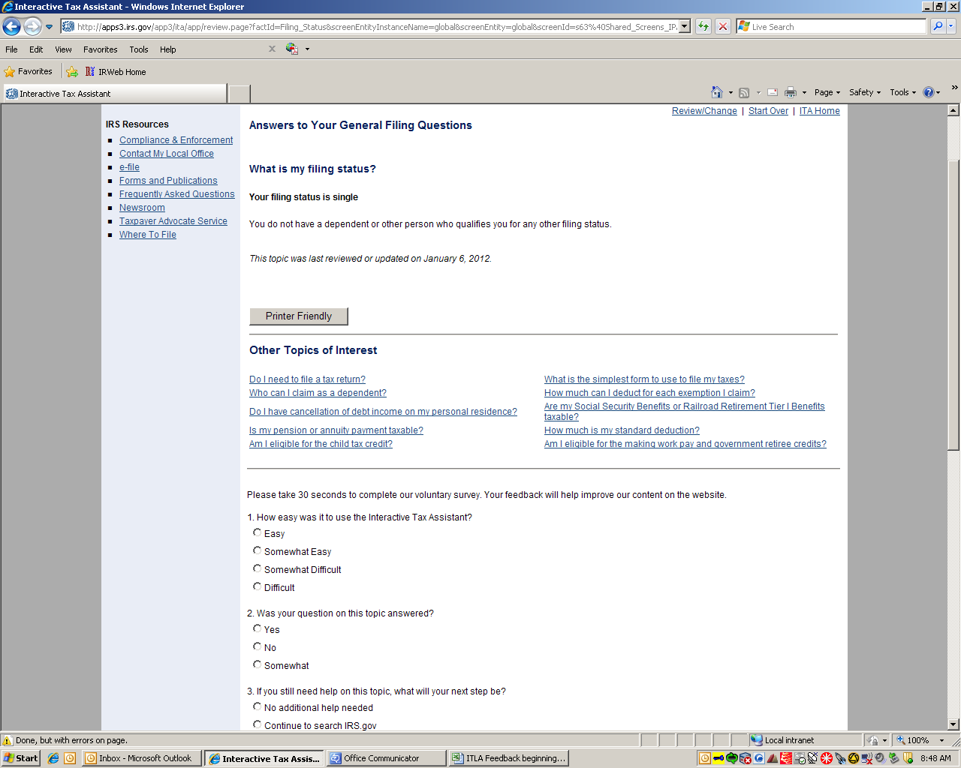
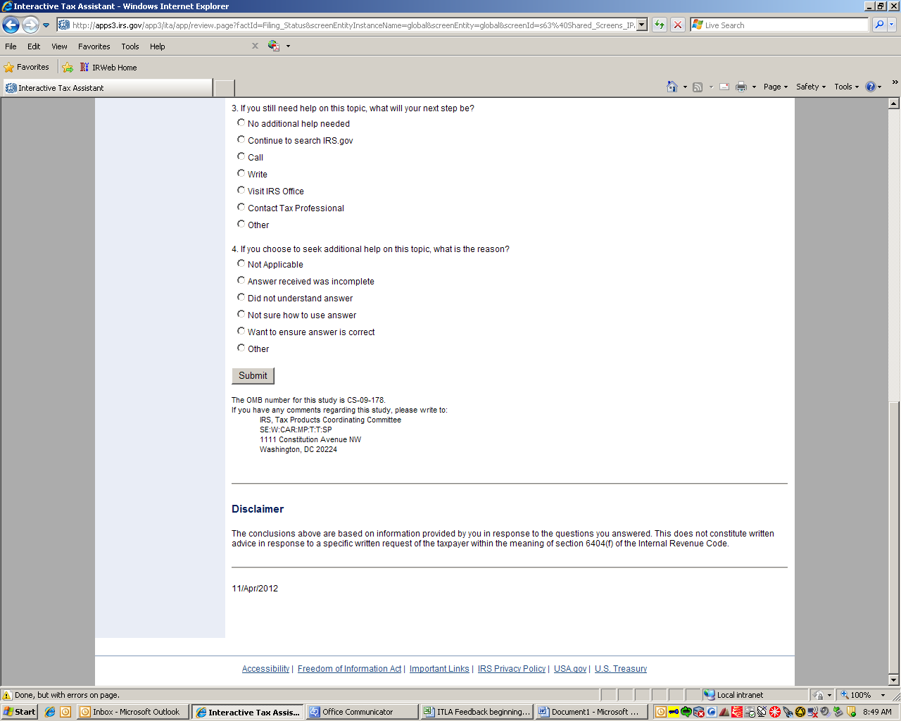

Place this statement just below the “Submit” button:
The Paperwork Reduction Act requires that the IRS display an OMB control number on all public information requests. The OMB Control Number for this study is 1545-1432. The time estimated for participation is less than a minute. If you have any comments regarding the time estimates associated with this study or suggestions on making this process simpler, please write to the, Internal Revenue Service, Tax Products Coordinating Committee, SE:W:CAR:MP:T:T:SP, 1111 Constitution Ave. NW, Washington, DC 20224.

