Dear

I need your help with an important initiative I am undertaking to improve our service to America's taxpayers. I want to get feedback from taxpayers like you who have recently received a notice informing you of a balance due or return delinquency on your tax return.

In a few days, you will receive a questionnaire asking your opinions about the collection process with the IRS. Please direct it to the person who had the most contact with the IRS on this matter. The questionnaire should take less than 5 minutes to complete. Your answers will be combined with others to give us an evaluation of customer satisfaction with IRS service.

The primary purpose for requesting this information is to help the IRS improve its service to taxpayers. Our authority for requesting the information is 5 USC and 26 USC 7801.

Providing information is voluntary. However, if you do not answer all or part of the survey questions, the IRS may lack information it could use to improve taxpayer service. The information you provide may be disclosed to an IRS contractor when authorized by law. The contractor is required to follow protections required by the Privacy Act and/or Internal Revenue Code section 6103.

I am committed to improving IRS service to every taxpayer. Please help me in this effort by completing and returning the questionnaire as soon as possible. If you do not receive a questionnaire, please contact the Survey Helpline at 1-866-960-7897.

Sincerely,

Denice D. Vaughan
Director, Campus Compliance Services

L1_13257-A

Dear

A few days ago, you received a letter from Denice D. Vaughan, Director, Campus Compliance Services, asking for your help with an important research project.

We are administering a nationwide survey among people who have had contact with the Internal Revenue Service (IRS). We want to know your opinions about the collection process you went through which began with a notice informing you of a balance due or a return delinquency. Your responses are critical to the accuracy of this research.

We are sending questionnaires to a random sample of taxpayers who have gone through the collection process on a recent tax return. All responses will be anonymous to the IRS, and your participation is voluntary. We will group your responses with others, so that no individual reply can be traced back to any one person.

You may complete this survey either by mail or online. To complete it online, type the following link into your browser: http://www.surveytracker.org/survey/irscscosurvey. Then enter your password.

Password:

Providing your password ensures that only those invited to take the survey can access it. We will not share your password with the IRS at any time during or after this study.

The questionnaire is quite brief and should take less than 5 minutes to complete. Please use the postage-paid reply envelope to return your completed questionnaire. If you have any questions about this survey, please feel free to call the Survey Helpline at 1-866-960-7897.

The IRS is committed to improving its performance and service to the American public. A first step in this process is to gather reliable information from those who have had contact with IRS services and employees. Your honest opinions will help bring about this improvement.

Sincerely,

Dr. Peter Webb
Project Director
Pacific Consulting Group

L2_13257-A

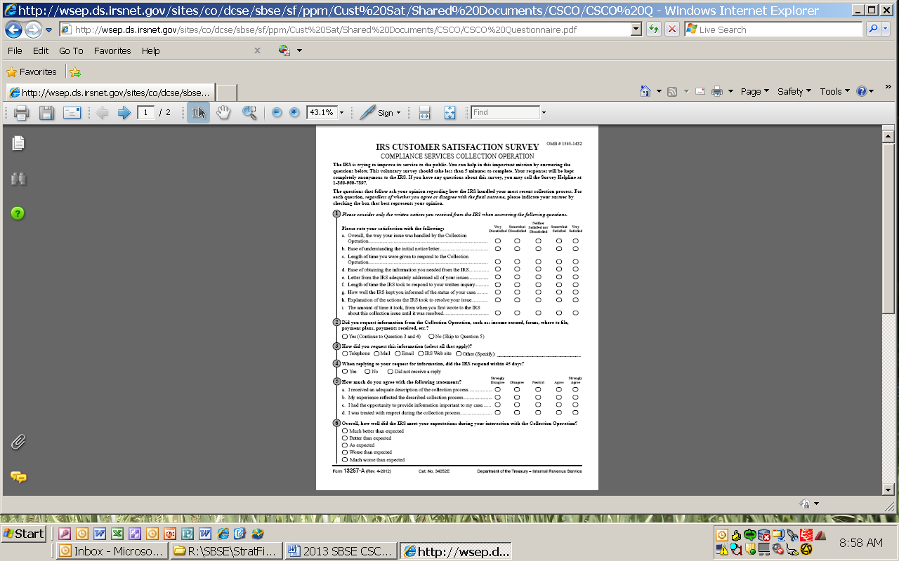

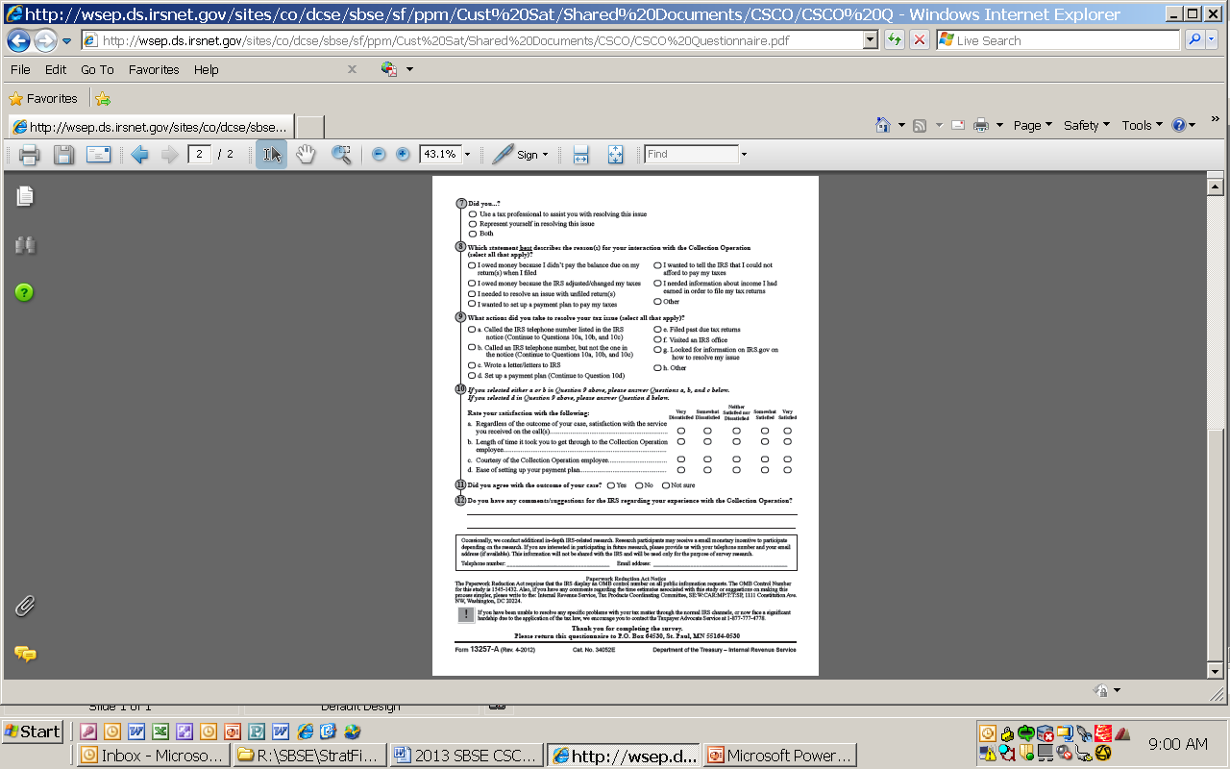

Do We Have Your Input Yet?

Recently, you received a questionnaire asking your opinions about the service
you received from the IRS in a recent contact. If you have already completed
and returned the questionnaire, please accept our sincere thanks. If not, please
take a few minutes to complete it and return it today. We want to be sure we
have your opinions and suggestions.

If you did not receive the questionnaire, or it got misplaced, please call us
at 1-866-960-7897.

Dr. Peter Webb
Project Director
Pacific Consulting Group

L3_13257-A

Dear

A few days ago, you received a survey from Denice D. Vaughan, Director, Campus Compliance Services, asking for your help with an important research project. If you have already completed the survey, thank you. If you have not already done so, please take a few minutes to fill in your responses.

We are administering a nationwide survey among people who have had contact with the Internal Revenue Service (IRS). We want to know your opinions about the collection process you went through which began with a notice informing you of a balance due or a return delinquency. Your responses are critical to the accuracy of this research.

We are sending questionnaires to a random sample of taxpayers who have gone through the collection process on a recent tax return. All responses will be anonymous to the IRS, and your participation is voluntary. We will group your responses with others, so that no individual reply can be traced back to any one person.

You may complete this survey either by mail or online. To complete it online, type the following link into your browser: http://www.surveytracker.org/survey/irscscosurvey. Then enter your password.

Password:

Providing your password ensures that only those invited to take the survey can access it. We will not share your password with the IRS at any time during or after this study.

The questionnaire is quite brief and should take less than 5 minutes to complete. Please use the postage-paid reply envelope to return your completed questionnaire. If you have any questions about this survey, please feel free to call the Survey Helpline at 1-866-960-7897.

The IRS is committed to improving its performance and service to the American public. A first step in this process is to gather reliable information from those who have had contact with IRS services and employees. Your honest opinions will help bring about this improvement.

Thank you in advance for your cooperation.

Sincerely,

Dr. Peter Webb
Project Director
Pacific Consulting Group

L4_13257-A

