Form Approved
OMB No. 0920-0840
Exp. Date: 2/29/2016

Attachment 10
Landing Page and Banner Ad

____________________________________________________________________________________________________________________
Public reporting burden of this collection of information is estimated to average 15 minutes per response, including the time for reviewing instructions, searching existing data sources, gathering and maintaining the data needed, and completing and reviewing the collection of information. An agency may not conduct or sponsor, and a person is not required to respond to a collection of information unless it displays a currently valid OMB control number. Send comments regarding this burden estimate or any other aspect of this collection of information, including suggestions for reducing this burden to: CDC, Project Clearance Officer, 1600 Clifton Road, MS D-74, Atlanta, GA 30333, ATTN: PRA (0920-0840). Do not send the completed form to this address.
_____________________________________________________________________________________________________________________

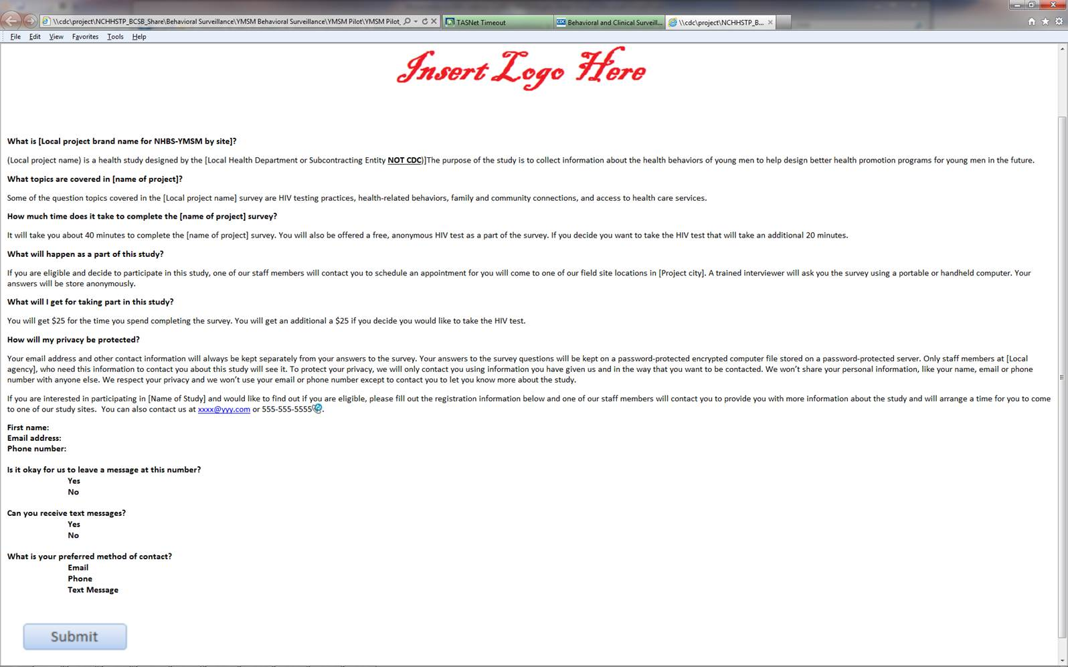
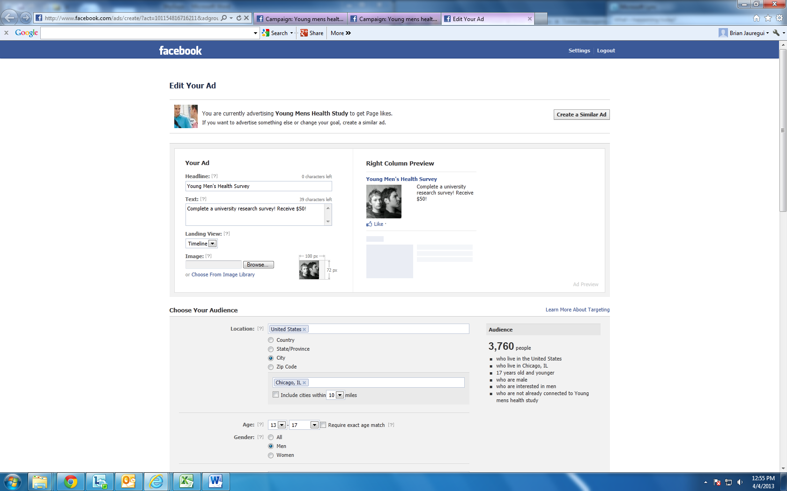
#1: How to set parameters on who sees the ad
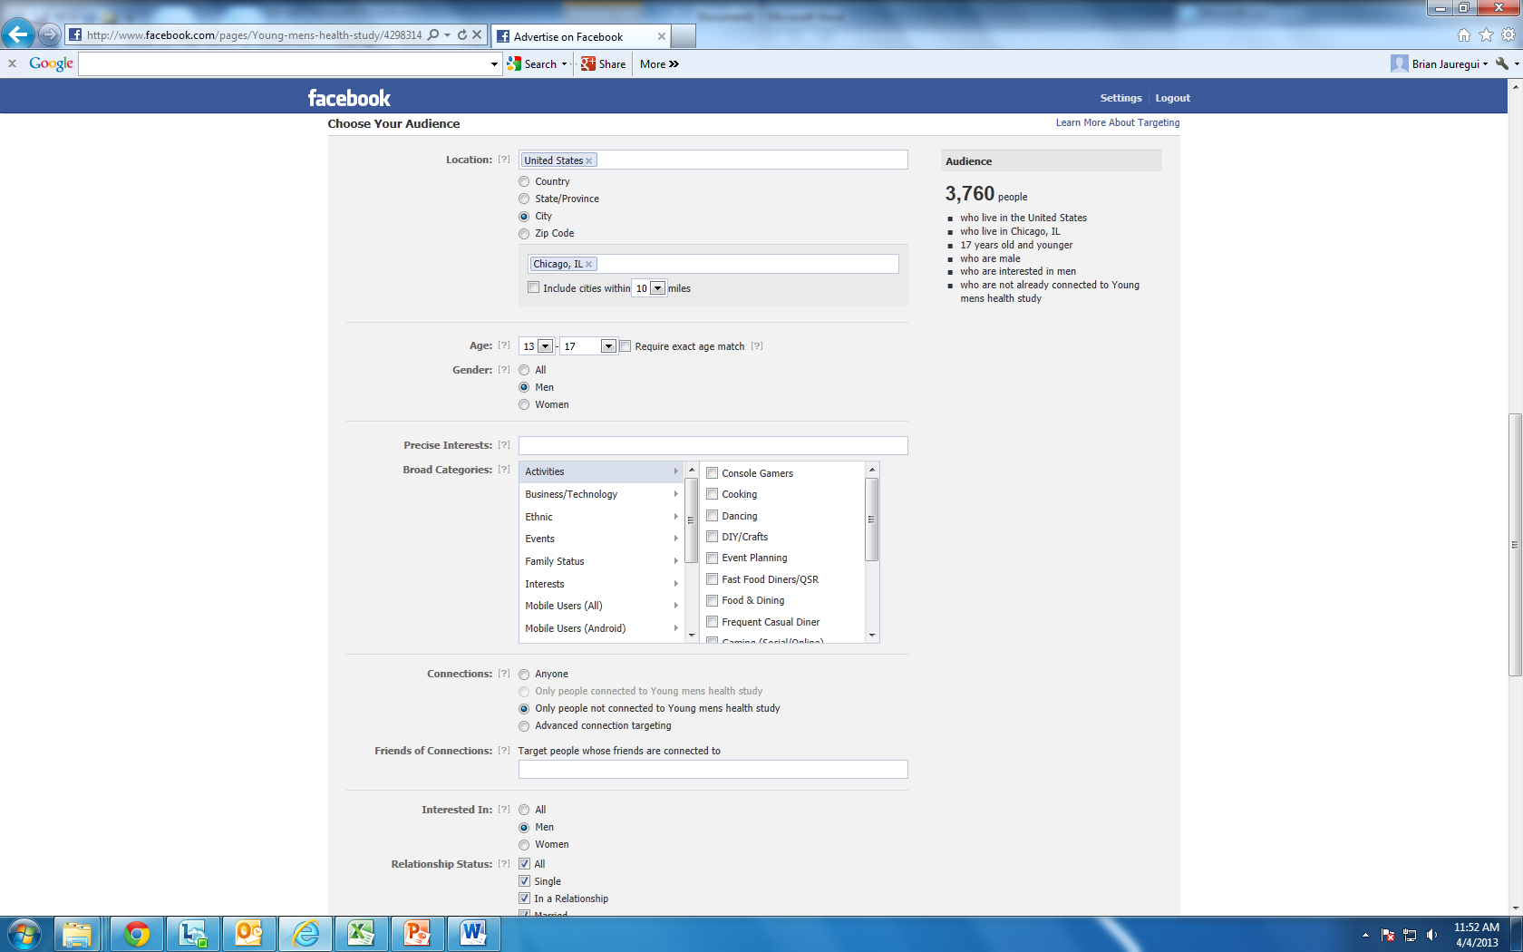
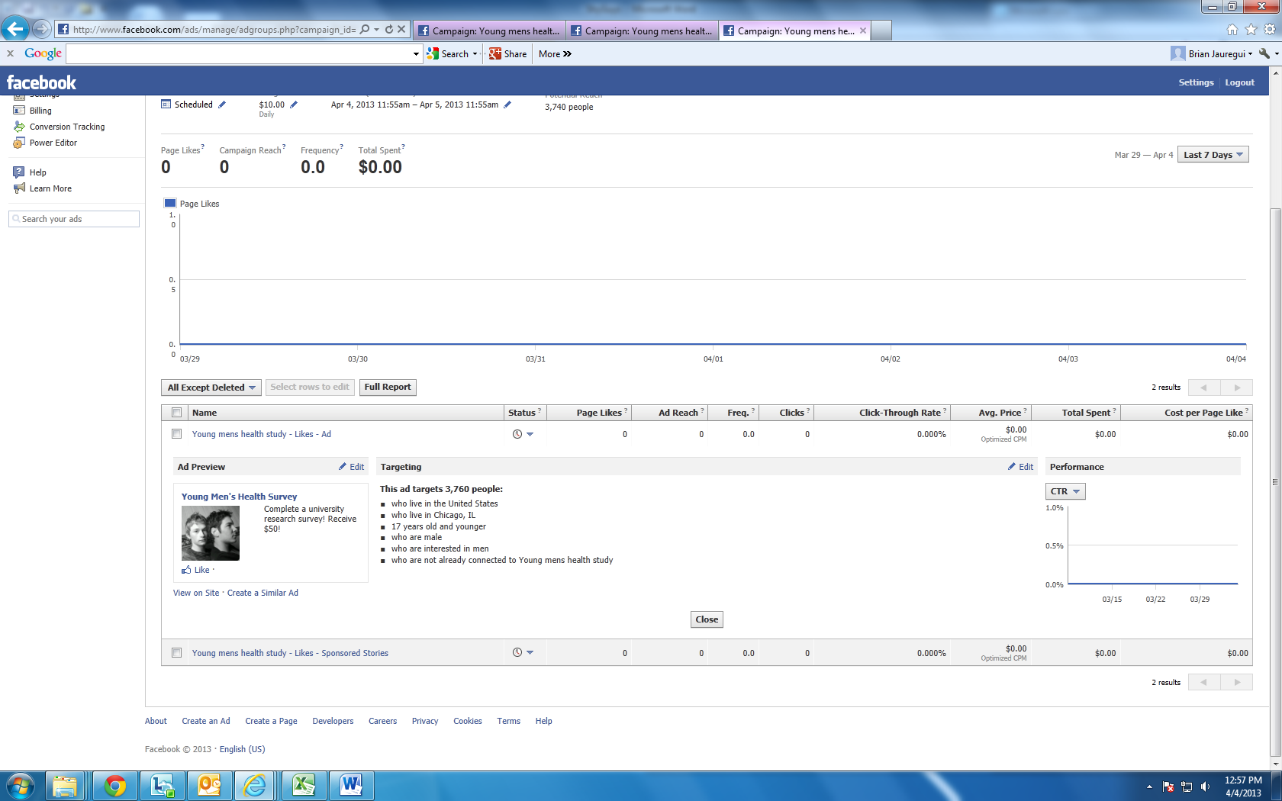
#2: Reports on number of potential participants who click on the ad
This page will provide data on the number of banner ads that are “clicked”.

