Effectiveness of Child Passenger Safety Messages
Human Subjects Study Protocol
NHTSA Contract DTNH22-11-C-00435

Background and Significance

Recent research has provided new information regarding relative risks, common mistakes, as well as low compliance rates for a variety of occupant protection recommendations. Thus, this is an ideal time to re-examine the National Highway Traffic Safety Administration’s (NHTSA) approach when presenting child passenger safety (CPS) recommendations and assess various methods of framing the information, as well as the scope of the information provided. Age-appropriate restraints and rear seating dramatically reduce injury in a collision (Arbogast, Jermakian, Kallan, & Durbin, 2009; Durbin, Chen, Smith, Elliott, & Winston, 2005; National Highway Traffic Safety Administration, 2010; Rice & Anderson, 2009). Yet, at every step in the recommendations, advocates struggle with a “hard sell”—keeping children maximally protected for the longest time possible. Indeed, the primary reasons for injuries to children who are restrained at the time of motor vehicle crashes relate to prematurely turning a child forward, premature graduation from harnessed safety seats to booster seats, premature graduation from booster seats to adult safety belts, misuse of safety restraints and seat belts, and children seated in the front seat of the vehicle (Arbogast et al., 2009; Durbin et al., 2005; Henary et al., 2007; Lennon, Siskind, & Haworth, 2008; Rice & Anderson, 2009). Compared to appropriately restrained children, unrestrained children are greater than 3 times more likely to sustain injury in a crash, and children traveling in inappropriate restraints for their size are at 2 times the risk of injury (Durbin et al., 2005). Rear seating offers independent and additive safety protections in a crash (Durbin et al., 2005; Lennon et al., 2008).

In March 2011, NHTSA revised its CPS recommendations. The new guidelines are categorized by age rather than by type of child seat in order to keep pace with the latest scientific and medical research and the development of new child restraint technologies. The recommendations are supported by many new products which accommodate higher weights for children in each type of child restraint (rear-facing only, convertible, booster). For example, research supports that infants are safer travelling rear-facing versus forward facing (Durbin et al., 2005). The new guidelines are also consistent with the latest advice from the American Academy of Pediatrics. Both organizations’ recommendations highlight that there is no need to hurry to transition a child to the next restraint type.

A possible modification to presenting the recommendations includes the addition of information regarding installation tips. Misuse of safety restraints is common (at least 73%) and is not limited to traditional safety seats (Arbogast & Jermakian, 2007; Decina & Lococo, 2005; Dukehart, Walker, Lococo, Decina, & Staplin, 2007; Garcia-Espana & Durbin, 2008; O'Neil, Daniels, Talty, & Bull, 2009). Proper use of a restraint is vital for maximum protection, yet the added effectiveness of providing installation tips with the recommendations is not known and should be evaluated.

From a risk communication perspective, it is also rather striking that the current recommendations do not explain the safety rationale behind the advice. Parental understanding of the reasons for each recommendation is central to communicating the vulnerabilities of children and the additional risk exposure that comes with inappropriate restraint. Perceptions of risk and recognition of personal (or familial) vulnerability are key determinants of behavior change and can override parents’ comfort level with following the (often unsafe) societal norm (Bandura, 1986; Slovic, 1991; Weinstein, 1988). Societal norms and their influence are also worth examining. Normative feedback interventions (often used in alcohol research) capitalize on the consistent finding that members of the public adjust their own levels of risk exposure to match the societal norm (Walters & Neighbors, 2005). Social norms feedback approaches are typically used when the base percent safe rate in the population is high (Marlatt et al., 1998; Miller, Rollnick, & Conforti, 2002). Normative information about CPS misuse and noncompliance is often communicated to parents, yet it may be contraindicated because in many cases the societal norm is one of low compliance. Thus, in addition to modifications to posing/presenting the CPS recommendations to ensure they evolve with the state of the science and evidence from the field, this study provides an important opportunity to empirically examine the relative benefits or detriments of additional information provided with the recommendations.

Research Overview

The purpose of this research is to assess various methods of framing NHTSA’s CPS recommendations, as well as the scope of the information provided. This project will conduct two experimental studies. Data will be collected from parent participants in two large metropolitan statistical areas on the east coast of the United States. In the first study, participants (N= 300) will be randomized into one of five groups to examine relative effectiveness of, and parent preferences for, different methods of framing CPS recommendations. That is, the goal of the first study is to determine HOW to best communicate the recommendations to parents (e.g., should we include information regarding risk- reduction/rationale, should we emphasize the “hardest sell” for advocates over all other information, etc.). In the second study, participants (N= 240) will be randomized into one of four groups to examine the relative effectiveness of CPS recommendations delivered in combination with other types of information. That is, the goal of the second study is to determine the type and amount of EXTRA information to include in the recommendations without losing the clarity and power of the key recommendations (e.g., normative information is often included but theoretically is contra-indicated, installation information is not included but theoretically may be necessary, etc.). It is hoped that the findings of this research inform the development of more effective ways to communicate messages for child passenger safety. These studies and their methods are explained in detail in the sections that follow.

Study 1 Methods

Study Design
For Study 1, a 5 (CPS Recommendation Version) X 2 (Time) experiment will use a randomized controlled trial design to examine relative effectiveness of and parent preferences for different methods of framing child passenger safety recommendations. As described in more detail below, parent participants will be electronically randomized to one of five groups (including four experimental conditions and one control group), and will respond to pre-post surveys.

Sampling Plan
The geographic regions in which the study will take place include two large Metropolitan Statistical Areas (MSAs): Philadelphia – Camden – Wilmington (Delaware Valley) and Virginia Beach – Norfolk – Newport News (Hampton Roads). The Delaware Valley MSA includes 13 counties in four States with a population of over 5.9 million people. The Hampton Roads MSA includes 10 cities and six counties in two States (VA-NC), with a population of over 1.6 million. These are two socio-economical and culturally diverse areas that range from the rural areas of VA’s Eastern Shore and PA’s farming communities, to large concentrations of people living in urban and suburban settings.

The sample will include 300 parents of children ages 0-12 years. Although expected to be a convenience sample, efforts will be made during recruitment and screening of participants to ensure that the sample under study is representative of the larger population, and that the study includes a variety of income levels, education levels, and racial/ethnic groups (at least Black, White, Latino) across the study conditions.

Power analysis indicated that a sample of 196 participants is adequate to detect small effect sizes above Cohen’s d = 0.25 with a statistical power of 0.80 at the standard significance level of α = .05. Equal variance between groups is expected due to random assignment. Effect sizes for similar studies of intervention messages with smaller sample sizes and fewer experimental groups have been in the medium to large range (Cohen’s d = .50 to 1.68) (Will, Sabo, & Porter, 2009). Therefore, the sample size of 300 participants will be ample to detect group differences in this study.

Recruitment
The study team will work with a variety of colleagues in each geographic locale to disseminate the study recruitment announcement (see recruitment flyer) through their email listserves, social media, office flyer postings, and personal contacts. Colleagues assisting with recruitment represent agencies such as Safe Kids USA, Places and Programs for Children, Consortium for Infant and Child Health, etc. Through these contacts, we anticipate reaching vast networks of agencies and professionals that directly serve a diverse parent community. The team has used similar methods in the past for successful recruitment activities.

Interested participants will call the phone number on the recruitment materials (an email address will also be an option), at which point a member of the study team will briefly describe what is involved in participation, will ask some demographic questions, and will ask whether or not the participant is comfortable reading English-language text displayed on a computer screen (see phone script). For qualifying participants, a study appointment will be scheduled. Preliminary demographic questions (e.g., age, age of children, etc.) will be asked to ensure the participant is appropriate for the study and help the study team ensure equitable assignment within the randomization schedule across conditions. Enrolled participants will receive compensation (e.g., retail store gift card) following participation in this study, which is expected to take approximately 60 to 75 minutes.

Procedure for Participation
Enrolled participants will be asked to arrive at a designated computer lab/center (university lab or commercial learning center) at their appointment time to participate in the study. This study will use a secure web-based study protocol in which participants will view a series of user-friendly screens that will automatically lead them through the informed consent document (detailing the logistics of the study, the study’s duration, their rights as a participant, and remuneration for their participation), pretest measures, study materials specific to condition assignment (described separately below), and post-test measures at the participant’s pace. (See Flow Diagram for Study 1.)

Contrary to past decades, computerized surveys and study presentations are now a valid and reliable means of collecting representative research data, as 79% of US adults under age 65 use the internet (Pew Research Center, 2011). Moreover, a study assistant will be present at the computer center to assign participants to a computer station, help participants log into the study using a secure code, orient them to the process of completing study materials, and answer any questions as they arise. Participants will complete study materials individually, but we are expecting to be able to run as many as 25 subjects simultaneously at different computers in the computer lab/center.

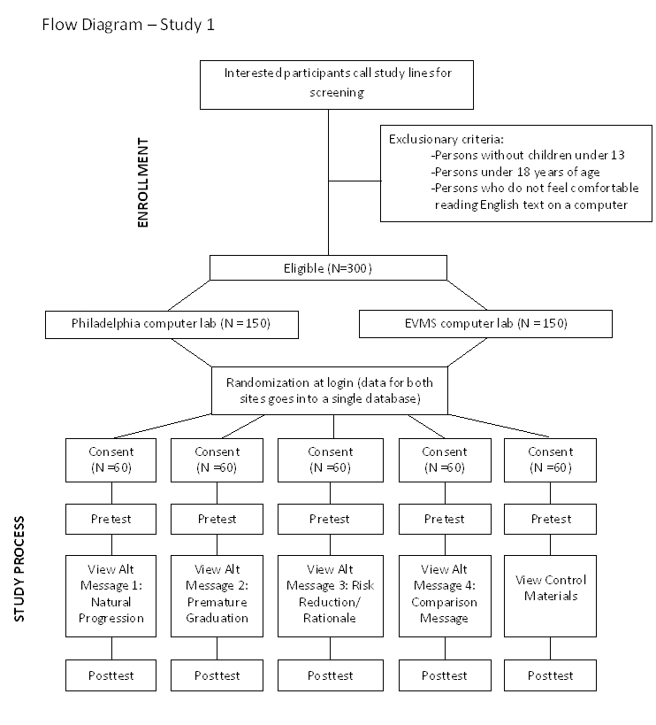
As participants respond to survey questions, they will simply check off their desired response(s) in the same manner as they would on paper. Manipulation checks (e.g., page and survey view times) will be electronically embedded to ensure that participants attend to the messages and read questions versus randomly choosing answer choices; data from participants who forwarded through screens too quickly to have read them will be excluded from the dataset. The data collected from all participants will be anonymous, and no person’s name or other personal identifier will be stored with the data (a coding process will be used to link pre-post data that does not identify the participant). The software package used to collect the web-based survey data (e.g., Inquisite) will automatically send the survey responses to a securely housed and password-protected statistical database (with individual cases for participants and separate variables for each data element) for later analysis with SPSS statistical software. The test messages and survey instruments will be developed on a Windows 2008 Server. The user interface will be designed to provide ease of use and data integrity. Coding will be done in ASP.Net and Java Script. The data will be stored securely on a Microsoft SQL database. Biweekly quality controls will be conducted to ensure that data are being collected and coded appropriately. Once all data have been collected, the Eastern Virginia Medical School (EVMS) research team will perform data analysis and archival tasks.

Study Conditions
Participants will be electronically randomized into one of five groups to examine relative effectiveness of and parent preferences for different methods of framing child passenger safety (CPS) recommendations. The five study conditions (four versions of CPS recommendations and one control group) are described below and are included in the attachments.

CPS Message Alternate 1: CPS Recommendations that Focus on Natural Progression. Participants assigned to this condition will view an alternate version of the NHTSA CPS recommendations in which both text and pictures will highlight the natural progression of seat types from birth to teen years. This version of recommendations removes almost all references to age and all mention of upper limits for common seats as a factor for determining transitions. Recommendations for transitioning from rear-facing to forward-facing will push toward later transition. To quell the perception that age 8 is the maximum, it is mentioned that it can take up to 12 years or longer for a child to be big enough to use a safety belt alone. Recommendations for this condition will focus on best practice for determining transitions to the next stage, which include child size and fit of the restraint. For instance, transition to safety belts will focus on fit of the belt on the seated child (using the fit test), with usual maximum height for a booster seat (4’9”) given as additional guides. Pictures will be used to emphasize the upper transition norms for each stage. The need for back seat positioning will also be more fully integrated and highlighted throughout the recommendations. (See Appendix E; Illustration 1)

CPS Message Alternate 2: CPS Recommendations that Draw Attention to Premature Graduation. Participants assigned to this condition will view an alternate version of the NHTSA CPS recommendations in which both text and pictures draw attention to premature graduation. Therefore, in addition to specifying recommendations for each stage, this version of recommendations specifically emphasizes the message that counters premature graduation to the next stage. For instance, “Stage 2: Forward-facing seats” is changed to “Keep Kids in Harnesses as long as Possible” to emphasize the need to use harnesses throughout this stage. Parents are encouraged to keep children in harnessed seats for as long as the harness weight and height limit will allow. Accompanying pictures provide additional emphasis. Similar to alternate one, this version of recommendations also removes almost all references to age and upper limits for common seats, and fully integrates and highlights the need for back seat positioning at all stages. (Appendix E; Illustration 2)

CPS Message Alternate 3: CPS Recommendations that Explain Risk Reduction/Rationale. In order to be consistent with the risk communication literature and maximize behavior change, this version of the CPS recommendations communicates the risk reduction and rationale (in a lay-friendly, succinct manner avoiding statistics) behind each stage’s recommended restraint configuration, starting first with the basic rationale for occupant restraints, and moving into rationale for specific restraint configurations for the various child sizes. For example, many parents lack the understanding that an object in motion remains in motion when the vehicle crashes, unless restrained. They also fail to grasp that given the abrupt changes in momentum and velocity that occur in mere fractions of a second, crash forces are quite powerful and can result in a child propelling forward with the force of thousands of pounds. Similar to alternate one, this version of recommendations also includes pictures to illustrate stages of restraints, removes almost all references to age and upper limits for common seats, and fully integrates and highlights the need for back seat positioning at all stages. (Appendix E; Illustration 3)

Comparison: Current CPS Recommendations. Participants assigned to this condition will view NHTSA’s current CPS recommendations as depicted in the “Car Seat Recommendations for Children” flyer released March 2011 (NHTSA, 2011). (Appendix E; Illustration 4)

Control Group. Participants assigned to this condition will not receive any instructional materials related to CPS during their participation. Rather, these participants will be taken through a computerized pictorial display of various child safety seats and motor vehicles currently on the market and asked to rate their preferences based on style, color, and other characteristics (See Appendix F). This subterfuge will allow for elapsed time between their pretest and posttest measures as in the other study conditions. To avoid a missed opportunity to educate, control group participants (and all participants) will be given a handout on child passenger safety to take home for reference once they have completed participation in the study (see post-study information handout in Appendix M).

Measures
Several measurement scales will be used to assess appropriateness of restraint selection, knowledge of restraints, perceived efficacy and threat, attitudes and intentions, judgments of relevance and acceptability of the CPS information, and sample demographics. To accurately assess changes in knowledge and perceptions after exposure to the independent variable, most measures will be asked both at pretest and posttest. The exceptions are the demographics questions and judgments of relevance and acceptability, which will be asked only at posttest (see survey attachment in Appendix H).

Restraint Selection Task. A key dependent variable for Study 1 is proper child restraint selection; thus, a Restraint Selection Task was developed that provides participants with a series of specific scenarios that ask the participants to select an appropriate restraint, direction to face, and/or vehicle row, given specific age/weight/height information for a hypothetical child. This 8- item knowledge measure uses a multiple choice response format (providing an item score of correct/incorrect and a total number correct score for each participant). This measure was adapted from a similar existing field-tested measure (Snowden et al., 2008).

Knowledge of Restraint. To gauge immediate changes in knowledge of child passenger safety, as well as differences in knowledge among the groups, a 15-item assessment of parental knowledge will be conducted at both pretest and posttest. This measure uses a Likert-type response format and was tailored for this study from existing field-tested and validated measures used in past research by Snowden and colleagues (2008, 2009), and Will and colleagues (2009). Many questions originated from the Co-Investigators Kids in Kars Survey which has excellent internal consistency (α = .92) and measures parents’ knowledge of and attitudes toward recommended guidelines for restraint use (Will, Sabo, & Porter, 2009).

Perceptions of Efficacy and Risk. The Risk Behavior Diagnosis Scale (RBDS) (Witte, Cameron, McKeon, & Berkowitz, 1996) will be used to assess perceived efficacy and risk. The RBDS is a 12-item template survey designed to be tailored for assessment of any health or safety message. The efficacy subscale (internal consistency α = .79, 6 items) assesses participants' perceptions of response efficacy (i.e., confidence that the recommended actions/restraints will work to prevent injuries) and self-efficacy (i.e., confidence in one’s ability to follow child passenger safety recommendations). The threat subscale (internal consistency α = .82, 6 items) assesses participants’ perceived risk by measuring susceptibility to and severity of negative consequences from inappropriate child occupant protection. Four additional “severity” items were added to properly assess perceptions of severity of the threat at each of the four stages of occupant protection. This, the final RBDS contains 16 items, all of which use a 5-point Likert- type response scale (1 = strongly disagree to 5 = strongly agree).

Attitudes and Intentions. Participant’s more general attitudes and intentions regarding child passenger safety will be assessed via an 8-item attitudes subscale, adapted from the previously mentioned Kids in Kars survey (Will, Sabo, & Porter, 2009), and a 9-item stated intentions subscale. Stated intentions and attitudes will be assessed to gauge participants’ disposition regarding what is recommended for child occupant protection irrespective of their knowledge. Both subscales use a Likert-type response format (1 = strongly disagree to 5 = strongly agree).

Judgments of Relevance and Acceptability. At posttest, parents in each condition will be asked their opinions about the CPS materials. A 10-item questionnaire was developed that uses a 4-point Likert-type response format to assess participants’ judgments of quality and acceptability of the CPS information presented. Specifically, they will be asked to rate the CPS information on a variety of factors, including but not limited to style, amount of information, clarity, and likelihood for motivating behavior change.

Demographics and Other Participant Information. Demographic information will also be collected at the posttest, including but not limited to participant’s age, sex, race, ethnicity, education level, income level, and number of and ages/sizes of children. Information specific to child passenger safety will also be assessed, including types of child restraints being used currently (by child), sources of information about safely transporting children, whether or not they have had their child restraints inspected by a CPS technician, and their preferred communication channels (e.g., print, television, radio, electronic) for receiving child passenger safety information.

Data Analysis Plan
Data analysis will determine which CPS recommendation version produces the maximum
desired outcome (e.g., correct CPS restraint selection, increased knowledge of restraints, enhanced perceptions of efficacy and risk). Data analysis will begin with data cleaning such as checking for missing data and outliers and ensuring normality and linearity of all dependent variables. Next, bivariate correlations will be conducted on all dependent variables to assess their relation to each other and to determine the type of inferential statistics to conduct. Specifically, if dependent variables are moderately inter-correlated, then a 2 (Time) x 5 (CPS Recommendation Version) MANOVA with follow-ups, post-hoc test for group, and simple effects analyses (if the interaction is significant) will be conducted. If dependent variables exhibit inter-correlations near zero or are highly inter-correlated, then multiple 2 (Time) x 5 (CPS Recommendation Version) ANOVAs with post-hoc test for group and simple effects analyses (if the interaction is significant) will be conducted. In the event that the data are found to violate the assumptions of normality that are necessary for parametric tests, data transformations to improve normality or appropriate nonparametric tests, such as the Friedman test and follow-up Multiple Comparison Tests, will be performed instead. Additionally, the study team may conduct several secondary analyses, including a multiple regression for CPS restraint selection to determine which CPS recommendation version best predicts correct restraint selection. Also, variables such as perceived relevance and accuracy of CPS information, age, sex, race, education, income, number of children, and ages of children may be used as covariates to eliminate potential confounding variables and better explain variance in the analyses. The results of Study 1 will be written into a brief research report for NHTSA. No reports or presentations will identify individual participants.

Study 2 Methods

Study Design
For Study 2, a 4 (CPS Information Combination) X 2 (Time) experiment will use a randomized design to examine the effectiveness of NHTSA’s CPS recommendations in combination with other types of CPS information (i.e., normative and/or installation information). As described in detail below, parent participants will be electronically randomized to one of four experimental groups, and will respond to pre-post surveys.

Sampling Plan
Participants for Study 2 will be drawn from the same two broad geographic regions (Delaware Valley MSA and Hampton Roads MSA) as Study 1, with the same procedures followed for assurance of representativeness of the convenience sample. The sample will include 240 parents of children ages 0-12 years. An added exclusion criterion for Study 2 will be that the participants cannot have participated in Study 1.

Power analysis indicated that a sample of 179 participants is adequate to detect small effect sizes above Cohen’s d = 0.25 with a statistical power of 0.80 at the standard significance level of α = .05. Equal variance between groups is expected due to random assignment. Effect sizes for similar studies of intervention messages with smaller sample sizes and fewer experimental groups have been in the medium to large range (Cohen’s d = .50 to 1.68) (Will, Sabo, & Porter, 2009). Therefore, the sample size of 240 participants will be ample to detect group differences in this study.
Recruitment
Recruitment procedures and incentives will be identical to Study 1. That is, the study
team will work with colleagues in each geographic locale to disseminate study recruitment announcements through their networks; interested participants will be screened for inclusion/exclusion criteria and qualifying participants will be assigned an appointment to participate. Enrolled participants will receive $50 compensation (e.g. retail store gift card) following participation in Study 2, which is expected to take approximately 60 to 75 minutes.

Procedure for Participation
Study 2 will follow the same general procedure for participation as in Study 1. Enrolled participants will arrive at a designated computer lab/center, at which point the study assistant will help them log into a secure web-based study protocol to view a series of user-friendly screens that will automatically lead them through the informed consent document, pretest measures, study materials specific to condition assignment (described separately below), and post-test measures at the participant’s pace. (See Flow Diagram of Study 2.) Procedures similar to those used in Study 1 will be used regarding orienting participants to the study materials, obtaining informed consent, de- identifying data, performing manipulation checks of data, and for data management and security of data.

Study Conditions
Participants will be electronically randomized into one of four groups to examine the effectiveness of NHTSA’s CPS recommendations in combination with two other types of CPS information: normative information and/or installation tips. The four conditions are described below and are included in the attachments.

Condition 1: CPS Recommendations Alone (No Additional Information). Participants assigned to this condition will view CPS recommendations presented alone, with no additional information about installation or safety norms. (Appendix G; Illustration 1)

Condition 2: CPS Recommendations Combined with Installation/Proper Use Tips. Participants assigned to this condition will view CPS recommendations as depicted in Condition 1, presented in combination with succinctly summarized installation/proper use tips for each stage of occupant restraint. For instance, installation tips for Step 2 convey that the safety restraint should be installed (a) with the safety belt or child restraint anchors locked tightly in position so that the seat will not move more than an inch; (b) with a snugly positioned top-tether; (c) with the harness straps positioned snugly according to instructions; (d) with the retainer (chest) clip positioned at armpit level; and (e) with harness straps routed at or above shoulders. (Appendix G; Illustration 2)

Condition 3: CPS Recommendations Combined with Normative Information. Participants assigned to this condition will view CPS recommendations as depicted in Condition 1, presented in combination with an additional section that includes normative information regarding compliance with the recommendations. Research on normative feedback interventions (particularly regarding alcohol abuse) has shown that by presenting the public with actual rates and attitudes, members of the public adjust their own levels of risk exposure to match the
societal norm (National Institute on Alcohol and Alcoholism, 2002, 2007; Walters & Neighbors,
2005). As detailed in the introduction, information regarding societal norms may be contraindicated for child passenger safety interventions because in many cases the societal norm is one of low compliance (e.g., three out of four safety restraints are misused; only 45% of 4-7 year-olds travel in age-appropriate child restraints). The impact of normative information will be empirically tested in this condition by specifying relevant societal norms for each stage of occupant restraints and rear seat use. (Appendix G; Illustration 3)

Condition 4: CPS Recommendations Combined with Installation Tips and Normative Information. Participants assigned to this condition will view CPS recommendations as depicted in Condition 1, presented in combination with additional sections that include succinct tips for installation/correct use and normative information regarding each stage of occupant restraint and rear seat use. Thus, this condition will present the information included in the previous two conditions combined. (Appendix G; Illustration 4)

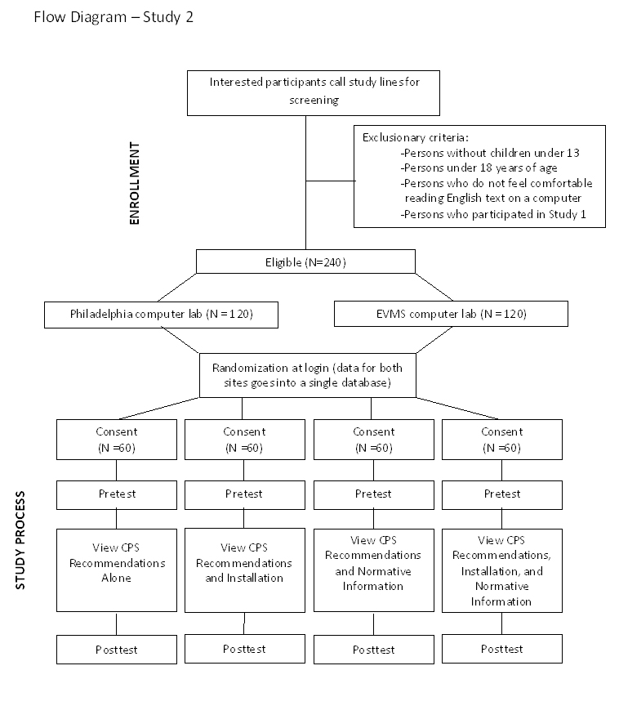

Measures
Several instruments will be used to measure various constructs in Study 2, many of which are identical to assessments developed for Study 1. Specifically, measures from Study 1 that will be used to evaluate Study 2 include the Restraint Selection Task, the Knowledge of Restraints measure, Witte and colleagues (1996) Risk Behavior Diagnosis Scale (measuring self efficacy, response efficacy, and risk perception specific to child passenger safety), the questionnaires assessing Attitudes and Intentions and Judgments of Relevance and Acceptability, and the survey of Demographics and Other Participant Information (refer to Study 1 for descriptions of these measures). An additional Installation Questions subscale was added to assess parents’ knowledge of correct and incorrect installation configurations. As in study 1, participants’ Time Spent on different kinds of information will be measured by the electronically embedded manipulation checks monitoring page and survey viewing times. Also, most measures will be administered both at pretest and posttest. The exceptions are the demographics questions and judgments of relevance and acceptability, which will be asked only once (at post-test). (See Appendix H for Survey Questions)

Data Analysis Plan
Analyses will determine which CPS information combination produces the maximum desired outcome (e.g., correct CPS restraint selection, increased knowledge of restraints, increased perceptions of efficacy and risk, increased knowledge of common mistakes). This will initially consist of data cleaning such as checking for missing data and outliers and ensuring normality and linearity of all dependent variables. Next, bivariate correlations will be conducted on all dependent variables to assess their relation to each other and to determine the type of inferential statistics to conduct. Specifically, if dependent variables are moderately correlated, then a 2 (Time) x 4 (CPS Information Combination) MANOVA with follow-ups, post-hoc test for group, and simple effects analyses if the interaction is significant will be conducted. If dependent variables exhibit correlations near zero or are highly correlated, then multiple 2 (Time) x 4 (CPS Information Combination) ANOVAs with post-hoc test for group and simple effects analyses if the interaction is significant will be conducted. In the event that the data are found to violate the assumptions of normality that are necessary for parametric tests, data transformations to improve normality or appropriate nonparametric tests, such as the Friedman test and follow-up Multiple Comparison Tests, will be performed instead. Additionally, the study team may conduct several secondary analyses, including a multiple regression for CPS restraint selection to determine which CPS information combination best predicts correct restraint selection. Also, variables such as perceived relevance and accuracy of CPS information, age, sex, race, education, income, number of children, and ages of children may be used as covariates to eliminate potential confounding variables and better explain variance in the analyses.

Data Security

All data collection and analysis will be computerized and the security of the database will be maintained by password-only access. The test messages and survey instruments will be developed on a secure Windows 2008 Server. The user interface will be designed to provide ease of use by participants and data integrity. Coding will be done in ASP.Net and Java Script. The data will be stored securely on a Microsoft SQL database. Data analysis will be conducted by members of the EVMS research team. No names or other identifiers will be entered with the data; rather a computer-generated code will link pre and post survey data. Only the research team will have access to the password-protected data files. The project director will perform comparative checks to verify accuracy and maintain adherence to the protocol. All data collected will be kept strictly anonymous in accordance with the study protocol and protected within the limits of the law. Non-personal information learned from the study may be used in reports, presentations, and publications but no subject will be personally identified. The results of Study 1 and 2 will be written into technical report(s) for NHTSA. The research team will also prepare and submit an article about this research to a peer-reviewed journal.

Tentative Timeline
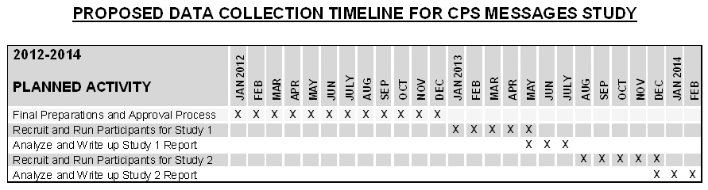

References

Arbogast, K., & Jermakian, J. S. (2007). Field use patterns and performance of child restraints secured by lower anchors and tethers for children (LATCH). Accident Analysis and Prevention, 39, 530-535.

Arbogast, K., Jermakian, J. S., Kallan, M. J., & Durbin, D. R. (2009). Effectiveness of belt positioning booster seats: An updated assessment. Pediatrics, 124(5), 1281-1286.

Bandura, A. (1986). Social Foundation of Thought and Action: A Social Cognitive Theory. Englewood Cliffs, NJ: Prentice Hall.

Decina, L. E., & Lococo, K. H. (2005). Child restraint system use and misuse in six states. Accident Analysis & Prevention, 37(3), 583-590.

Dukehart, J. G., Walker, L., Lococo, K. H., Decina, L. E., & Staplin, L. (2007). Safe Kids Checkup Events: A National Study. Washingotn, D.C.: Safe Kids Worldwide.

Durbin, D., Chen, I., Smith, R., Elliott, M., & Winston, F. (2005). Effects of seating position and appropriate restraint use on the risk of injury to children in motor vehicle crashes. Pediatrics, 115(3), e305-e309.

Garcia-Espana, J. F., & Durbin, D. R. (2008). Injuries to belted older children in motor vehicle crashes. Accident Analysis & Prevention, 40(6), 2024-2028.

Henary, B., Sherwood, C. P., Crandall, J. R., Kent, R. W., Vaca, F. E., Arbogast, K. B., et al. (2007). Car safety seats for children: Rear facing for best protection. Injury Prevention, 13, 398-402.

Lennon, A., Siskind, V., & Haworth, N. (2008). Rear seat safer: Seating position, restraint use and injuries in children in traffic crashes in Victoria, Australia. Accident Analysis and Prevention, 40, 829-834.

Marlatt, G. A., Baer, J. S., Kivlahan, D. R., Dimeff, L. A., Larimer, M. E., Quigley, L. A., et al. (1998). Screening and Brief Intervention for High-Risk College Student Drinkers: Results From a 2-Year Follow-Up Assessment. Journal of Consulting and Clinical Psychology, 66(4), 604–615.

Miller, W. R., Rollnick, S., & Conforti, K. (2002). Motivational Interviewing: Preparing People for Change (2nd ed.). New York: Guilford.

National Institute on Alcohol Abuse and Alcoholism. (2002). A call to action: Changing the culture of drinking at U.S. Colleges. Rockville: U.S. Department of Health and Human Services.
National Institute on Alcohol Abuse and Alcoholism. (2007). What Colleges Need to Know Now: An Update on College Drinking Research. 2007.
National Highway Traffic Safety Administration. (2010). Traffic Safety Facts: Children (No. DOT HS 811 387). Washington, D.C.: Author.

National Highway Traffic Safety Administration. (2011). Car Seat Recommendations for Children. Available:http://www.nhtsa.gov/DOT/NHTSA/Traffic_Injury_Control/Articles/Associated_Files/4StepsFlyer.pdf.

O'Neil, J., Daniels, D. M., Talty, J. L., & Bull, M. J. (2009). Seat belt misuse among children transported in belt-positioning booster seats. Accident Analysis & Prevention, 41(3), 425-429.

Rice, T. M., & Anderson, C. L. (2009). The effectiveness of child restraint systems for children aged 3 years or younger during motor vehicle collisions: 1996 to 2005. American Journal of Public Health, 99(2), 252-257.

Slovic, P. (1991). Beyond numbers: A broader perspective on risk perception and risk communication. In D. G. Mayo & R. D. Hollander (Eds.), Deceptable evidence: Science and values in risk management (pp. 48-65). New York, NY: Oxford University Press.

Snowden, A. W., Hussein, A., High, L., Stamler, L., Millar-Polgar, J., Patrick, L., & Ahmed, E. (2008). The effectiveness of a multimedia intervention on parents’ knowledge and use of vehicle safety systems for children. Journal of Pediatric Nursing, 23, 126-139.
Snowden, A. W., Hussein, A., Purc-Stevenson, R., Follo, G., & Ahmed, E. (2009). A longitudinal study of the effectiveness of a multi-media intervention on parents’ knowledge and use of vehicle safety systems for children. Accident Analysis and Prevention, 41, 498-505.
Walters ST, Neighbors C. (2005). Feedback interventions for college alcohol misuse: what, why and for whom? Addictive Behaviors, 30:1168-1182.

Weinstein, N. D. (1988). The precaution adoption process. Health Psychology, 7(4), 355-386.

Will, K. E., Sabo, C. S., & Porter, B. E. (2009). Evaluation of the Boost ‘em in the Back Seat program: Using fear and efficacy to increase booster seat use. Accident Analysis and Prevention, 41, 57-65.

Witte K, Cameron K, McKeon J, & Berkowitz J. (1996). Predicting risk behaviors: Development and validation of a diagnostic scale. Journal of Health Communication, 1, 317-341.

