Attachment 2: Summer Genetics Institute Alumni Survey Screen Shots
- Login prompt immediately upon navigating to https://public.od.nih.gov/NINR-SGI

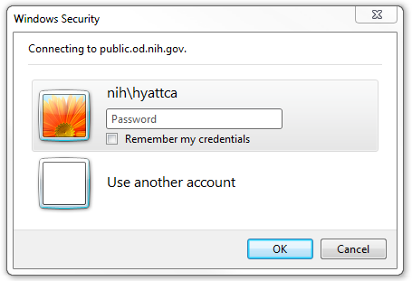

Site entry page after successful login


OMB# 0925-XXX Exp: XX-XXXX

- Help page pop-up after choosing Survey – HELP from left navigation menu

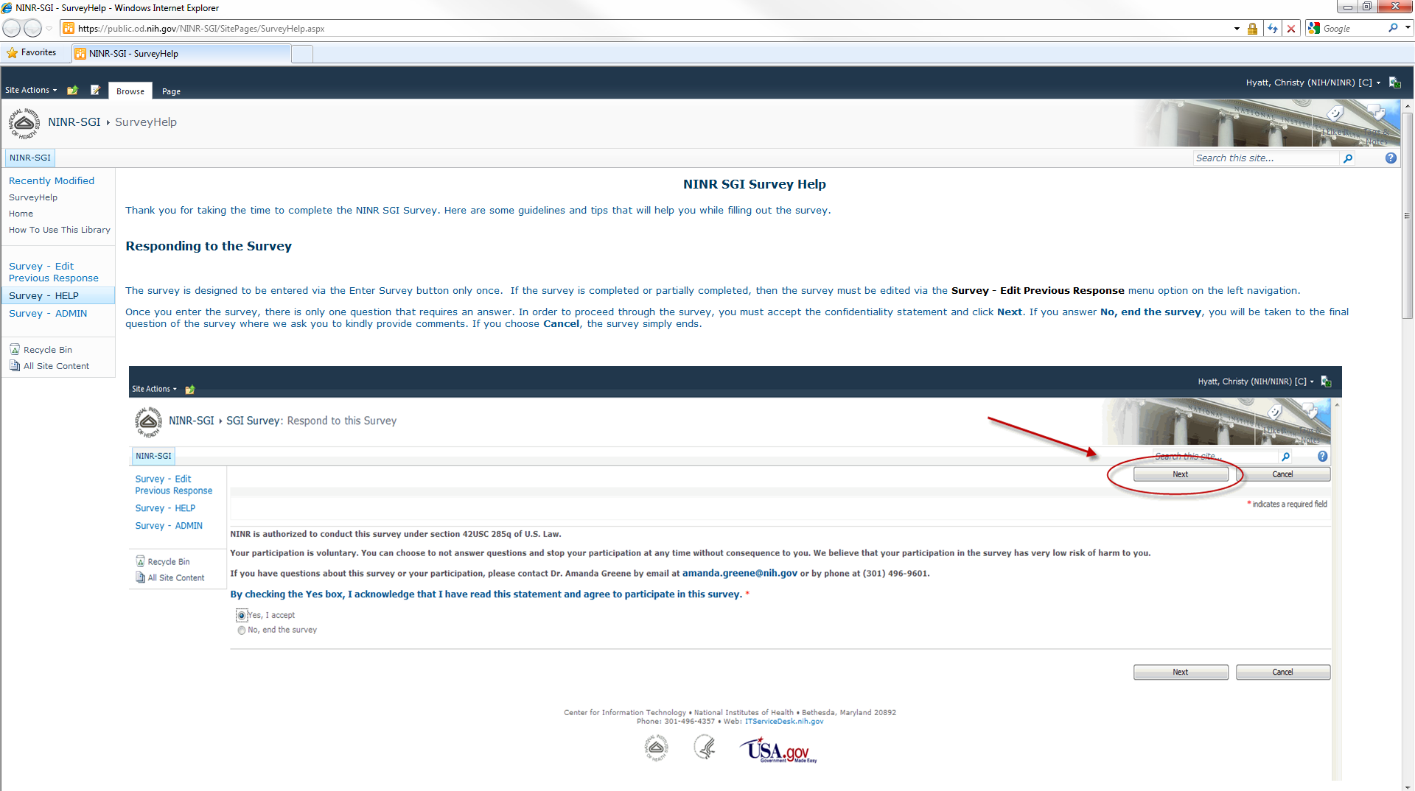

- Enter survey after choosing Enter Survey button on site entry page
- First step is to agree to participate in the survey
- If Yes is chosen, the first page of questions is displayed
- If No is chosen, participant is directed to the last question of the survey asking for additional comments

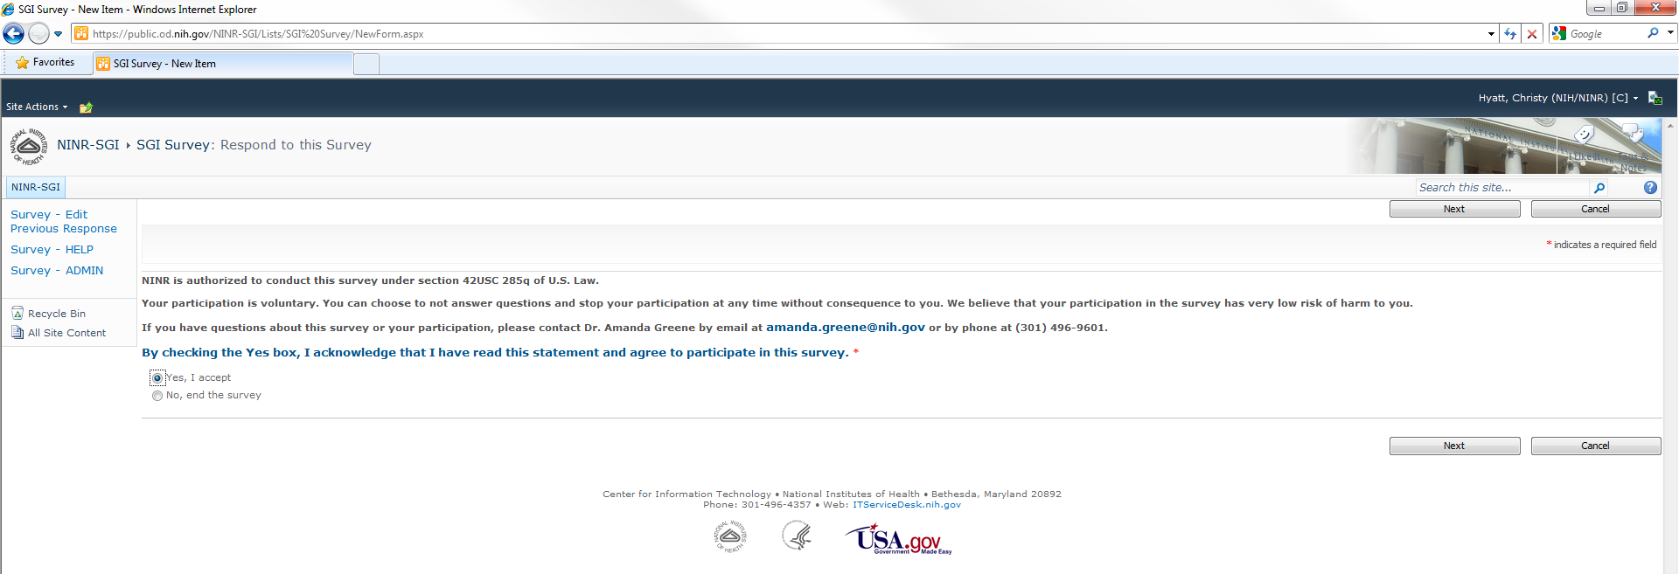
OMB# 0925-XXX Exp: XX-XXXX

- If participant chooses Cancel at any time during the survey, a pop-up message is displayed
- If participant chooses OK, the responses are deleted and the participant is take to the survey thank you and completion page
- If participant chooses Cancel, the responses are saved and the participant is take to the survey thank you and completion page with a partially completed survey that can be completed at a later time

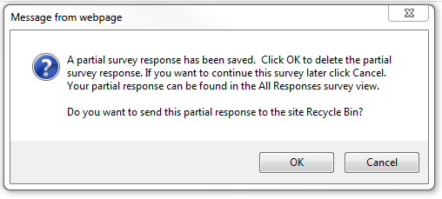

- First page of questions, choose Next button when ready to continue with survey

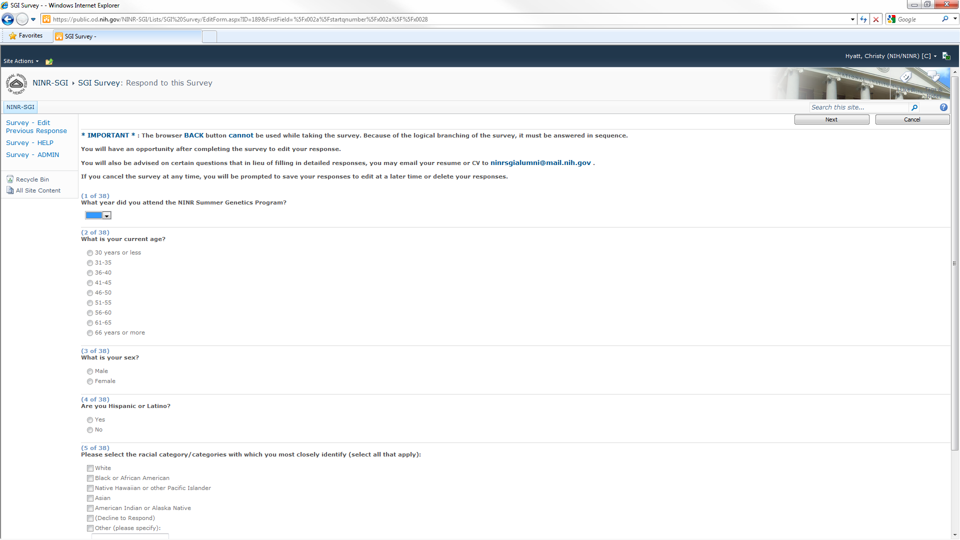

- Next page of questions, choose Next button when ready to continue with survey

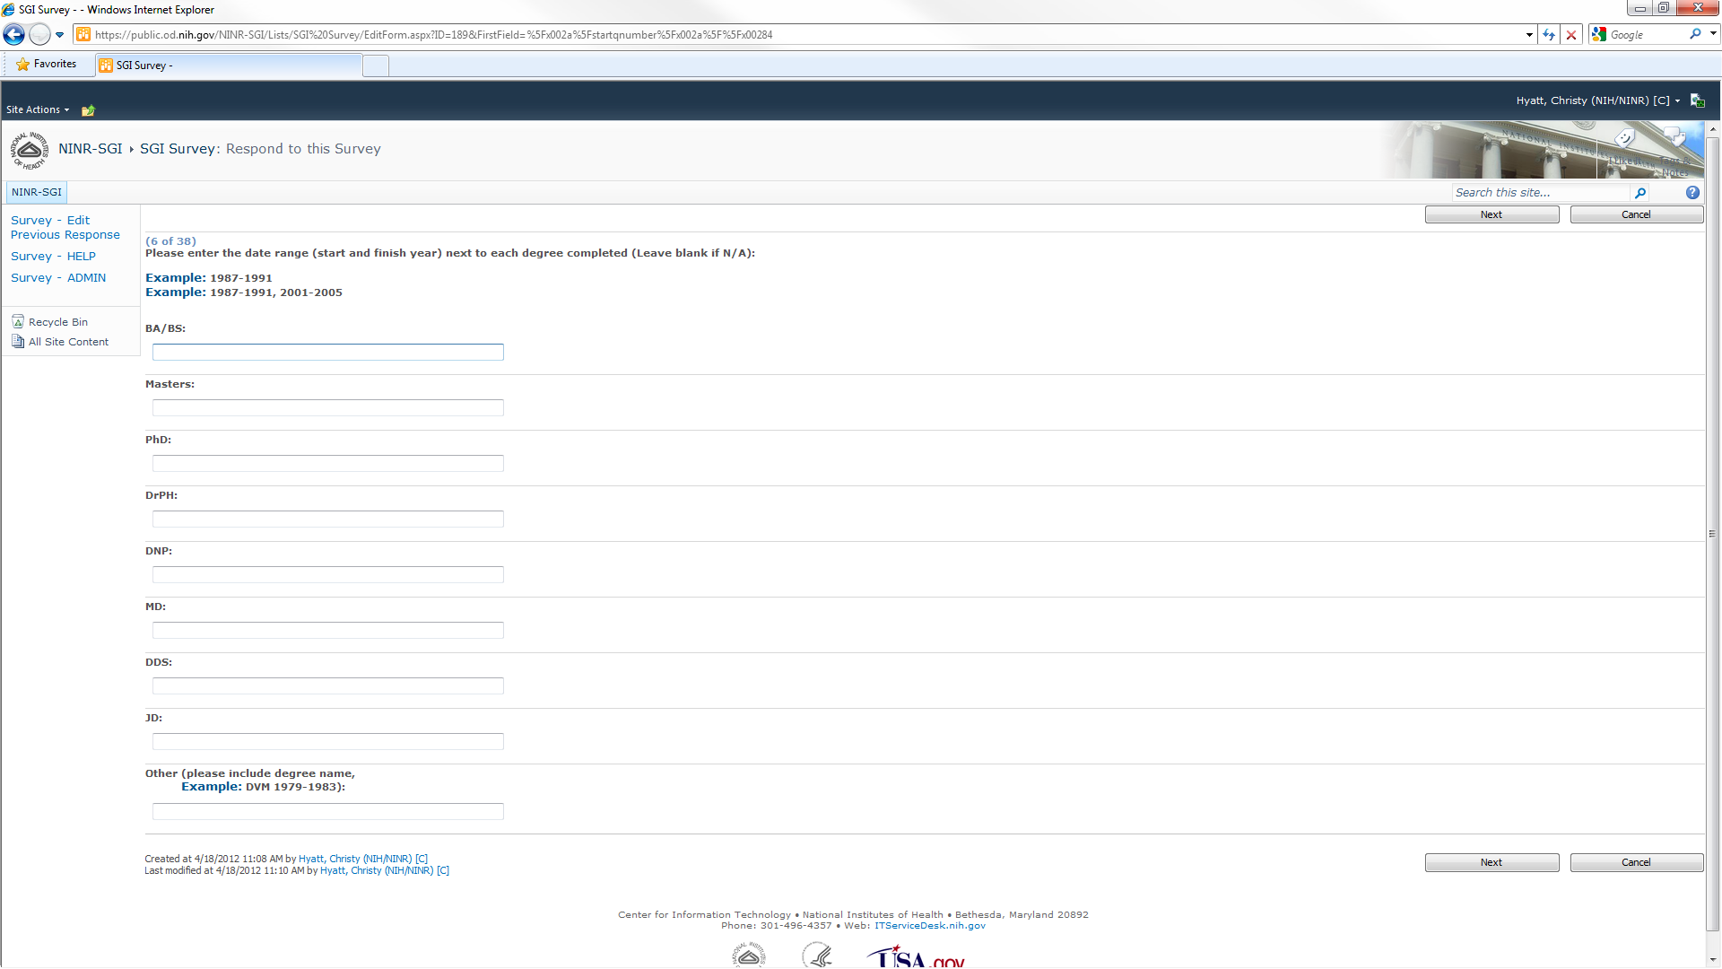

- Next page of questions, choose Next button when ready to continue with survey

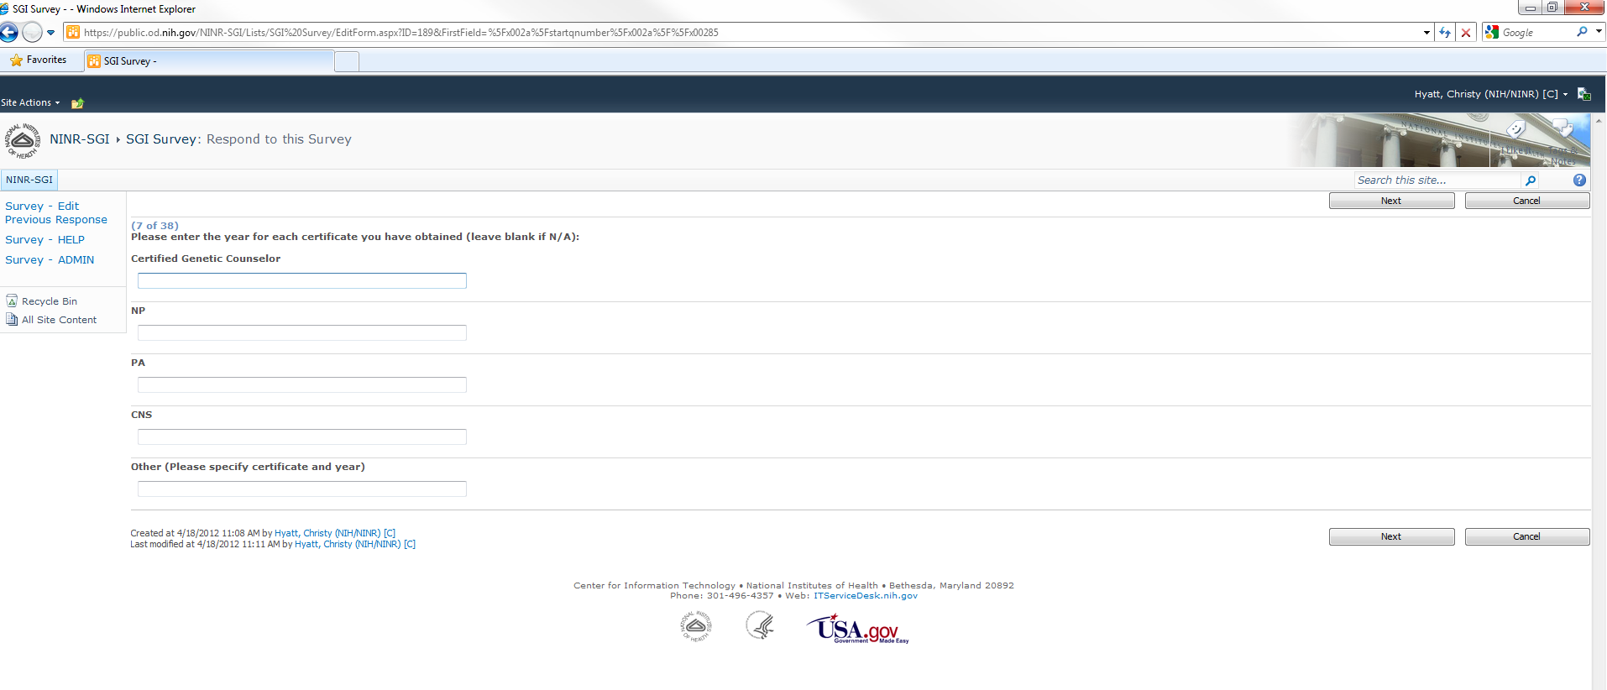

- Next page of questions, choose Next button when ready to continue with survey

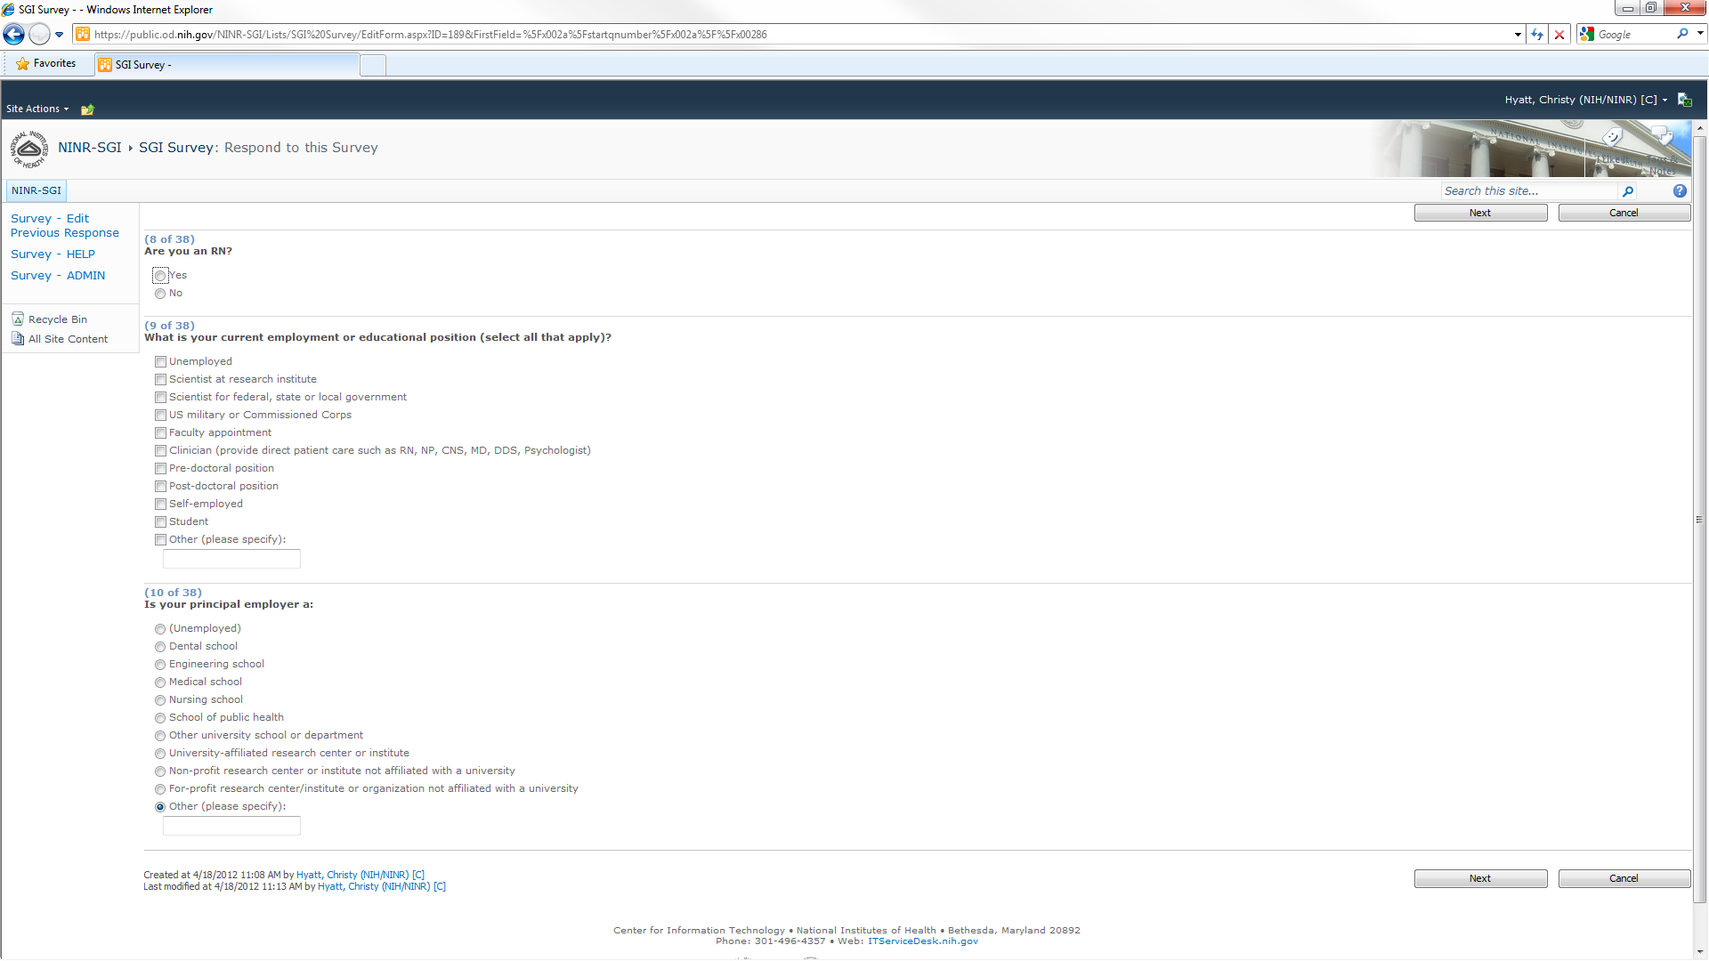

- Next page of questions, choose Next button when ready to continue with survey

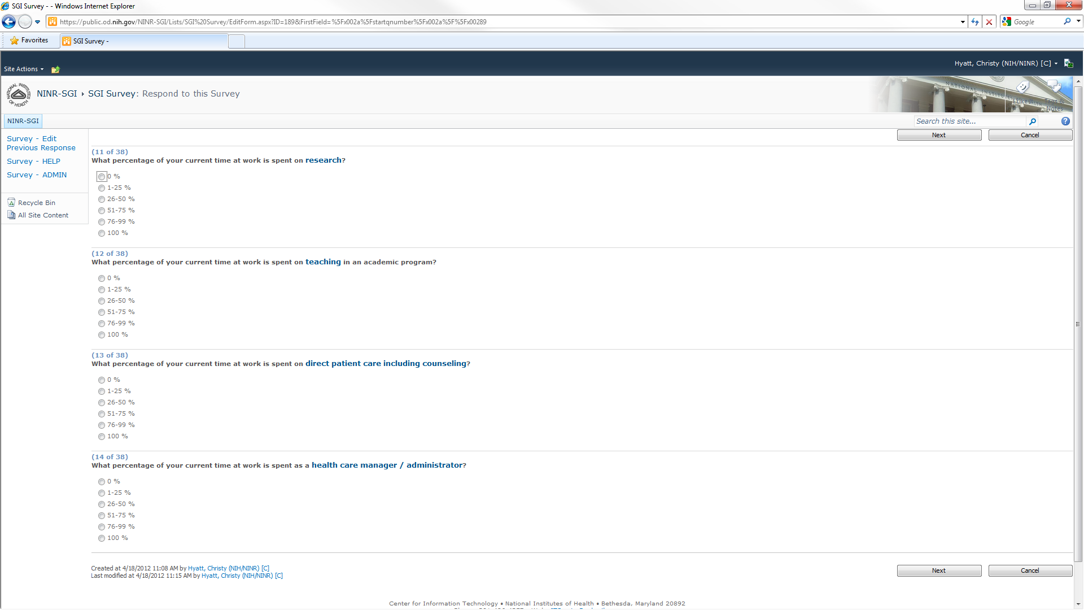

- Next page of questions, choose Next button when ready to continue with survey

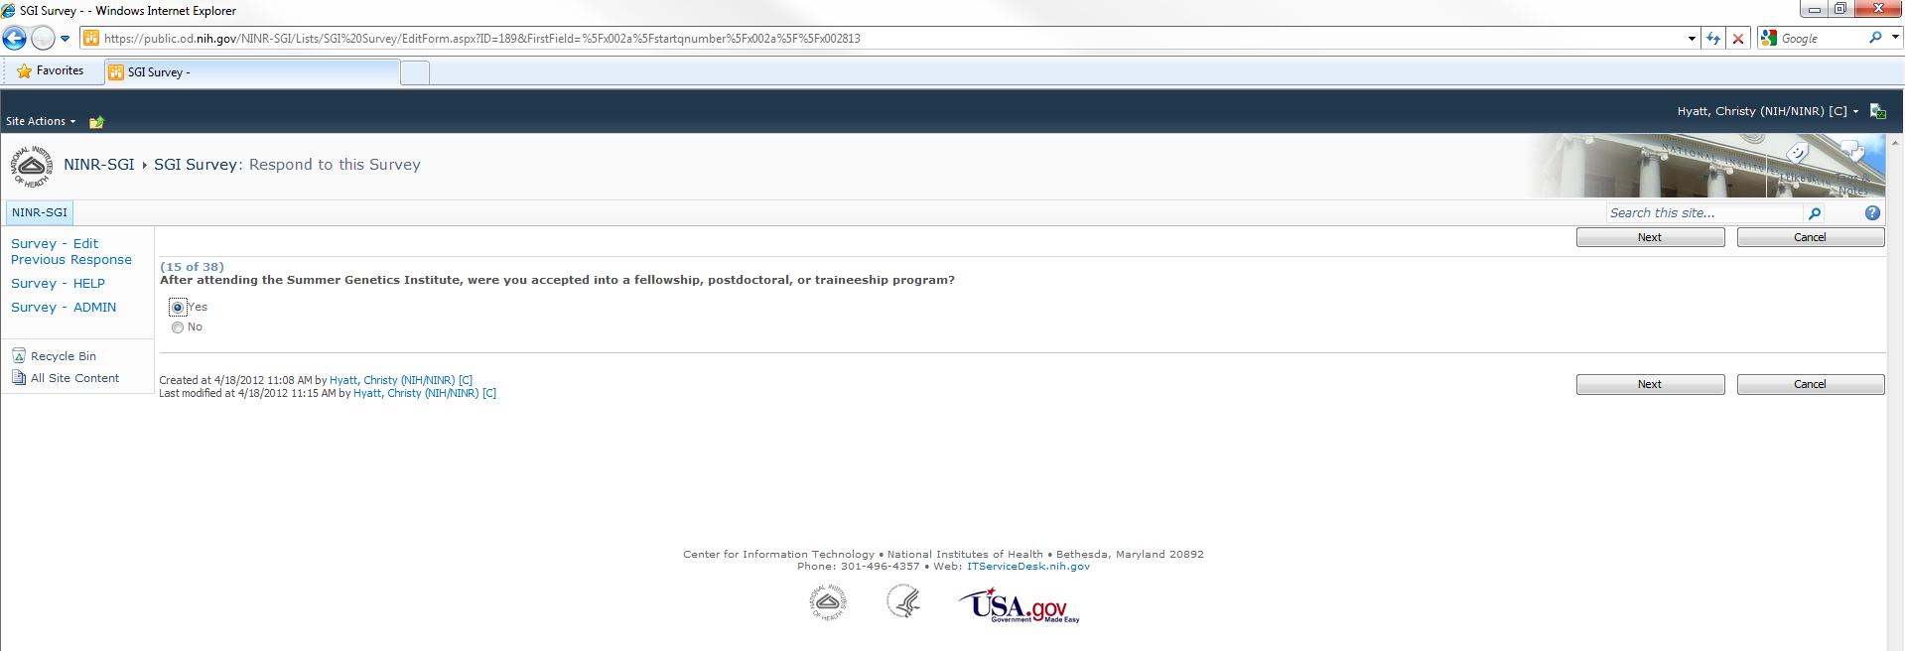

- Next page of questions, choose Next button when ready to continue with survey
- This page of questions is reached as a result of branching logic if the answer to question 15 on the previous screen was Yes
- If the answer to question 15 on the previous screen was No, these questions would be skipped and questions starting at number 16 would be displayed

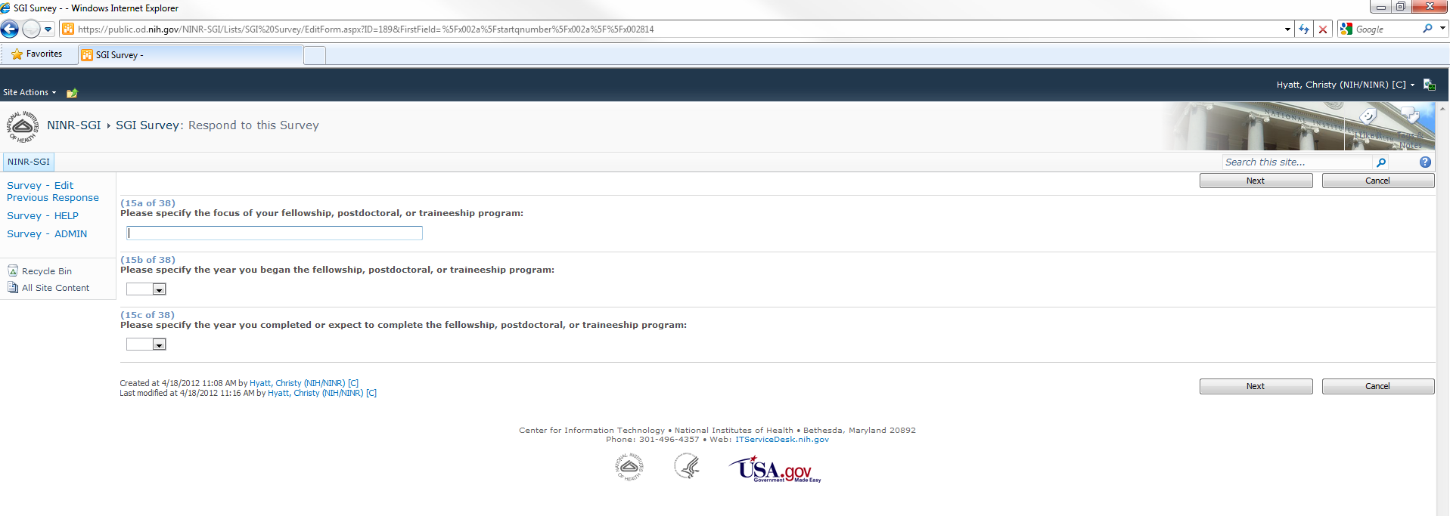

- Next page of questions, choose Next button when ready to continue with survey

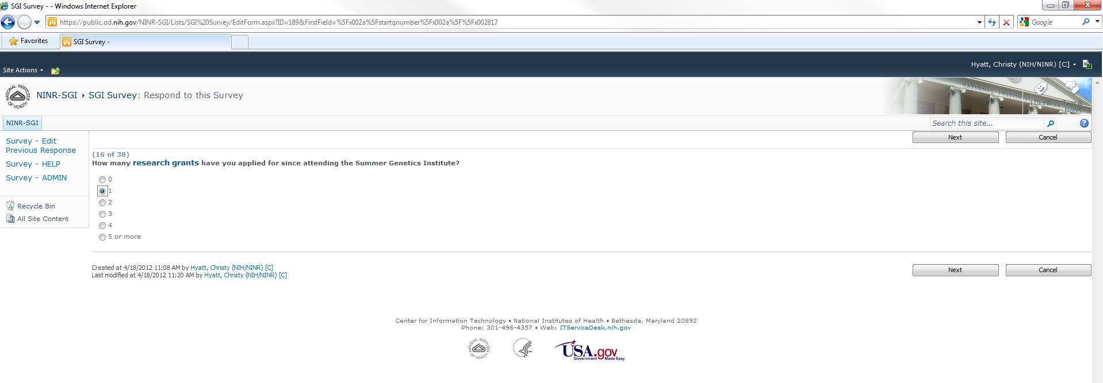

- Next page of questions, choose Next button when ready to continue with survey
- This page of questions is reached as a result of branching logic if the answer to question 16 on the previous screen was any value greater than zero
- If the answer to question 16 on the previous screen was zero, this question would be skipped and questions starting at number 17 would be displayed

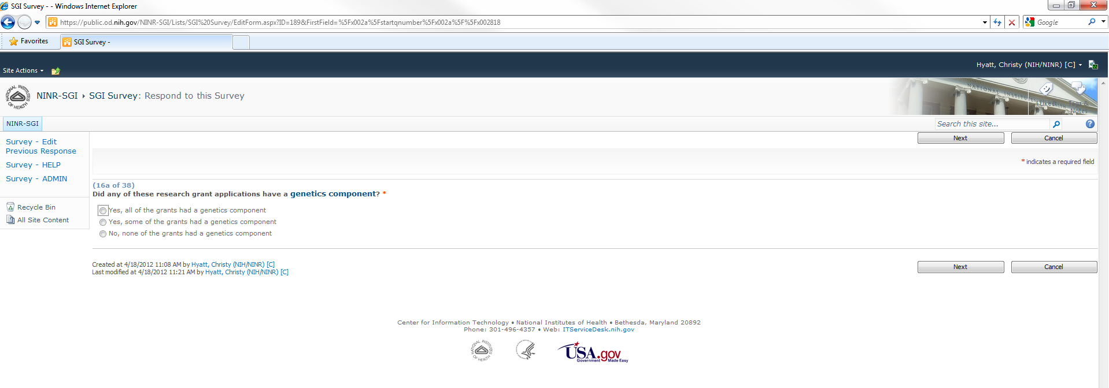

- Next page of questions, choose Next button when ready to continue with survey

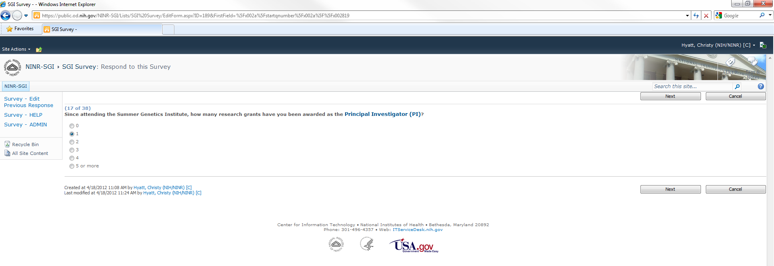

- Next page of questions, choose Next button when ready to continue with survey
- This page of questions is reached as a result of branching logic if the answer to question 17 on the previous screen was any value greater than zero
- If the answer to question 17 on the previous screen was zero, these questions would be skipped and questions starting at number 18 would be displayed

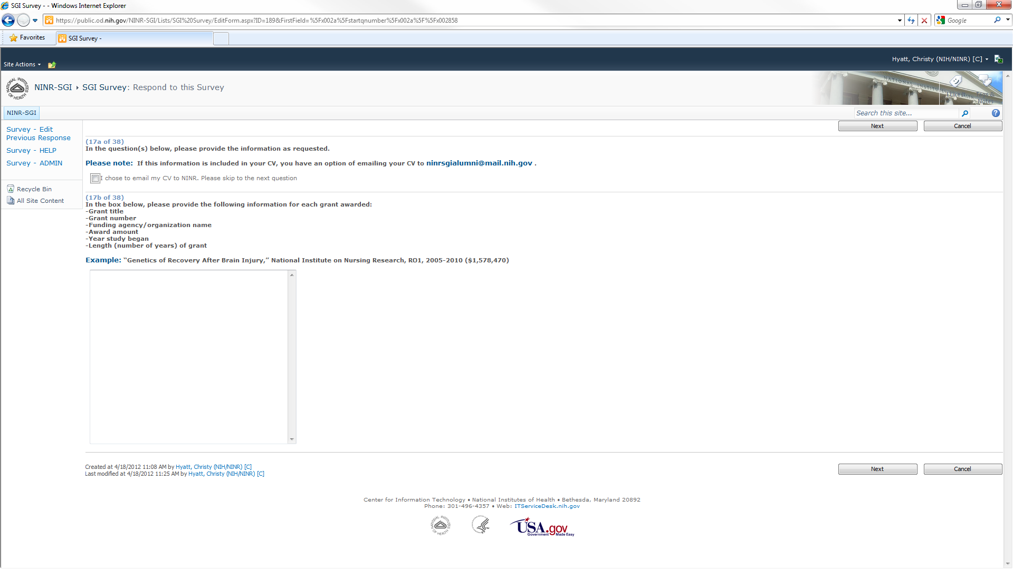
- Next page of questions, choose Next button when ready to continue with survey

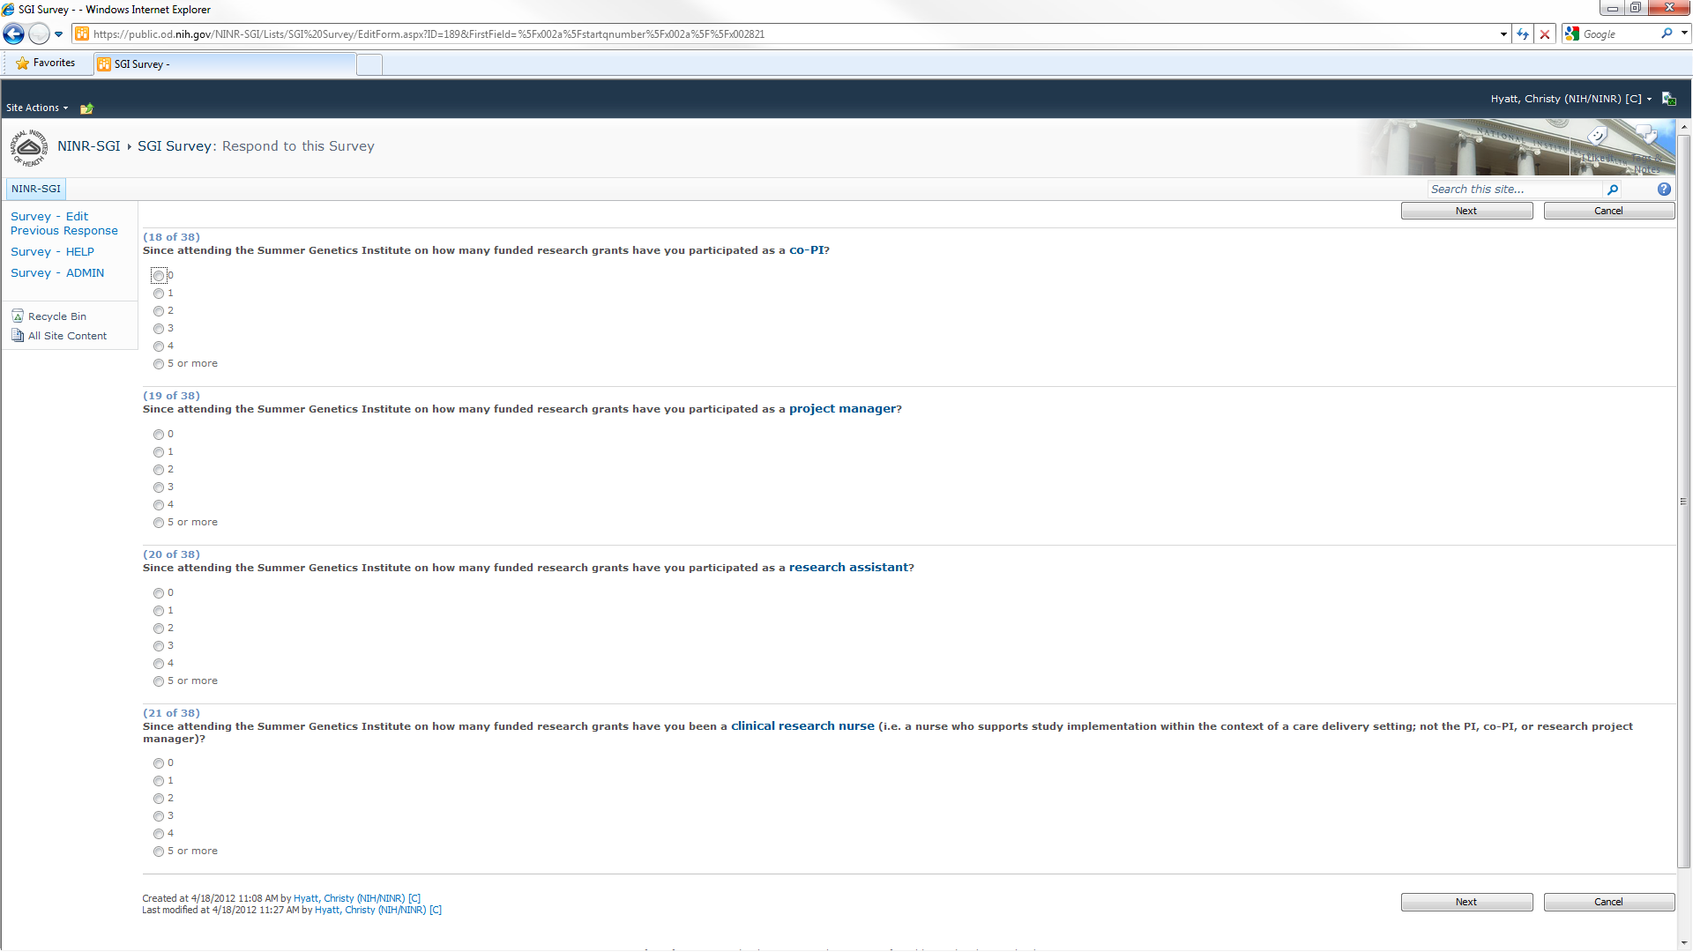

- Next page of questions, choose Next button when ready to continue with survey

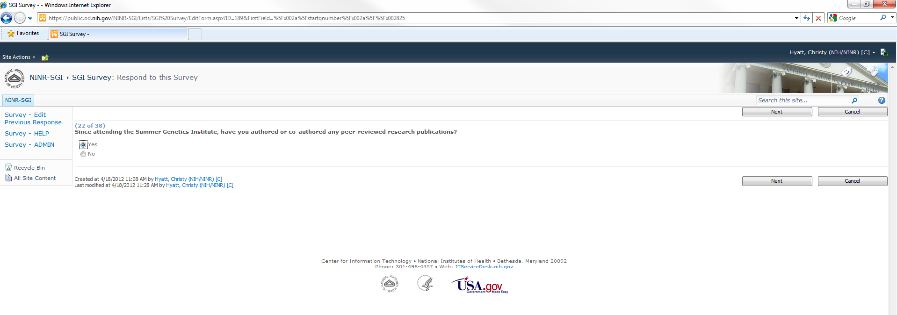

- Next page of questions, choose Next button when ready to continue with survey
- This page of questions is reached as a result of branching logic if the answer to question 22 on the previous screen was Yes
- If the answer to question 22 on the previous screen was No, these questions would be skipped and questions starting at number 23 would be displayed

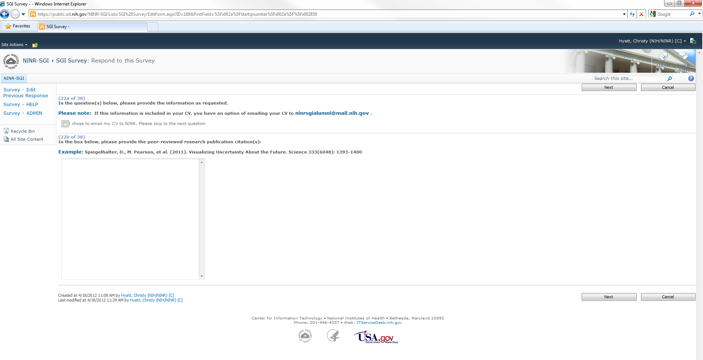

- Next page of questions, choose Next button when ready to continue with survey

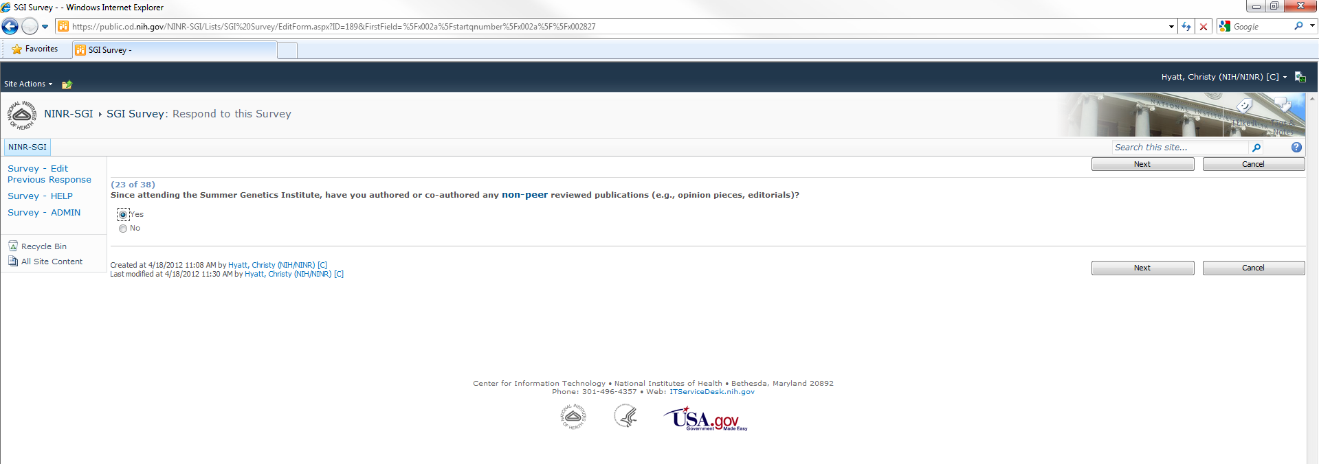

- Next page of questions, choose Next button when ready to continue with survey
- This page of questions is reached as a result of branching logic if the answer to question 23 on the previous screen was Yes
- If the answer to question 23 on the previous screen was No, these questions would be skipped and questions starting at number 24 would be displayed

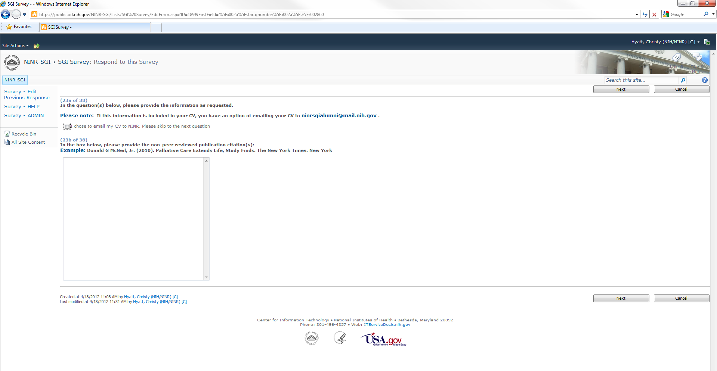

- Next page of questions, choose Next button when ready to continue with survey

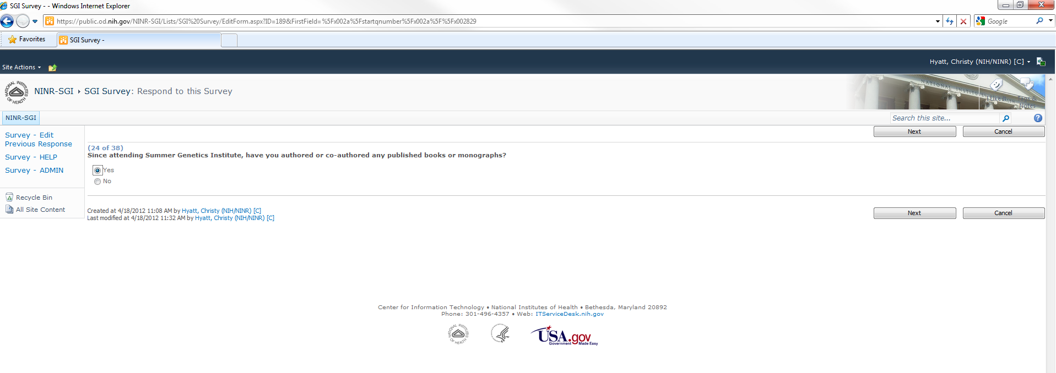

- Next page of questions, choose Next button when ready to continue with survey
- This page of questions is reached as a result of branching logic if the answer to question 24 on the previous screen was Yes
- If the answer to question 24 on the previous screen was No, these questions would be skipped and questions starting at number 25 would be displayed

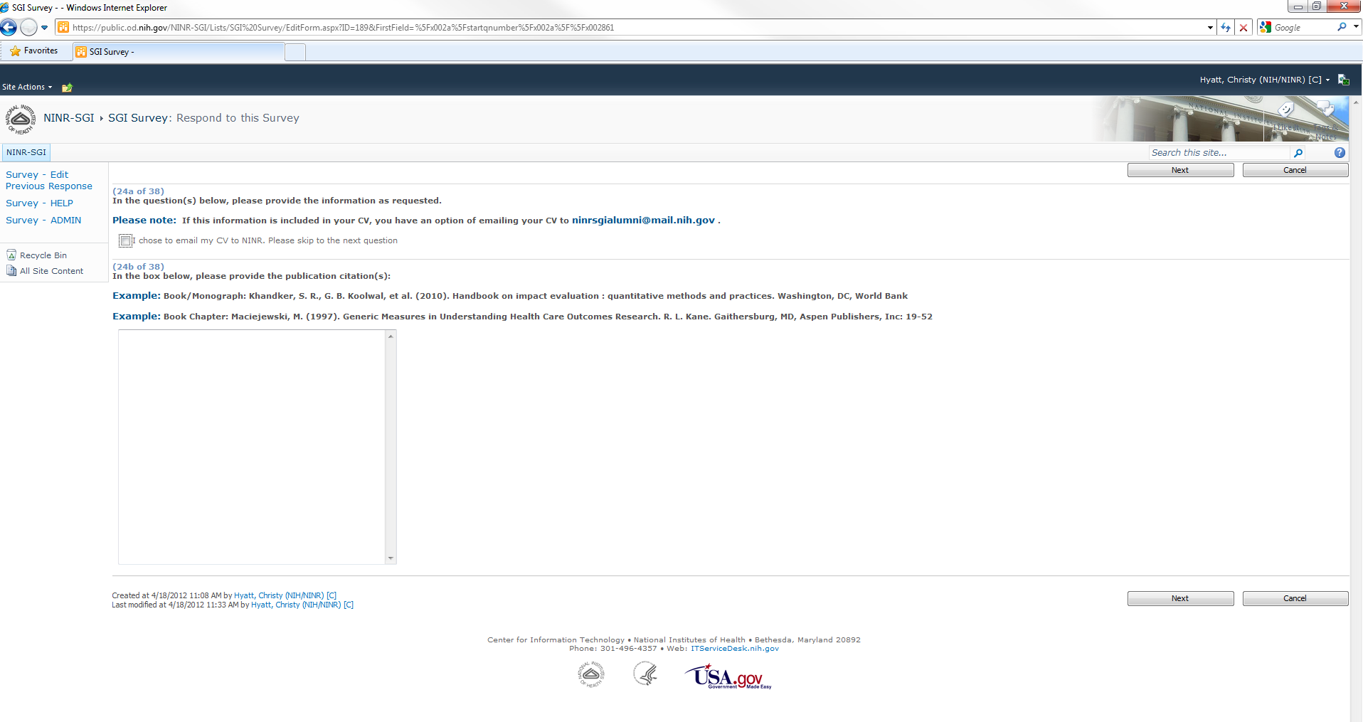

- Next page of questions, choose Next button when ready to continue with survey

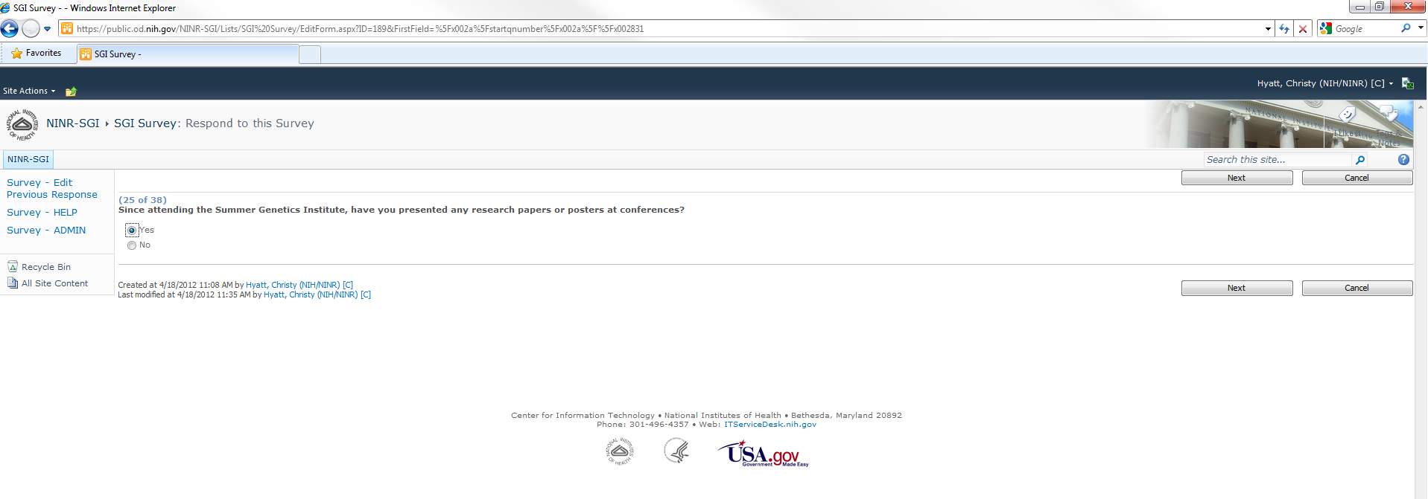

- Next page of questions, choose Next button when ready to continue with survey
- This page of questions is reached as a result of branching logic if the answer to question 25 on the previous screen was Yes
- If the answer to question 25 on the previous screen was No, these questions would be skipped and questions starting at number 26 would be displayed

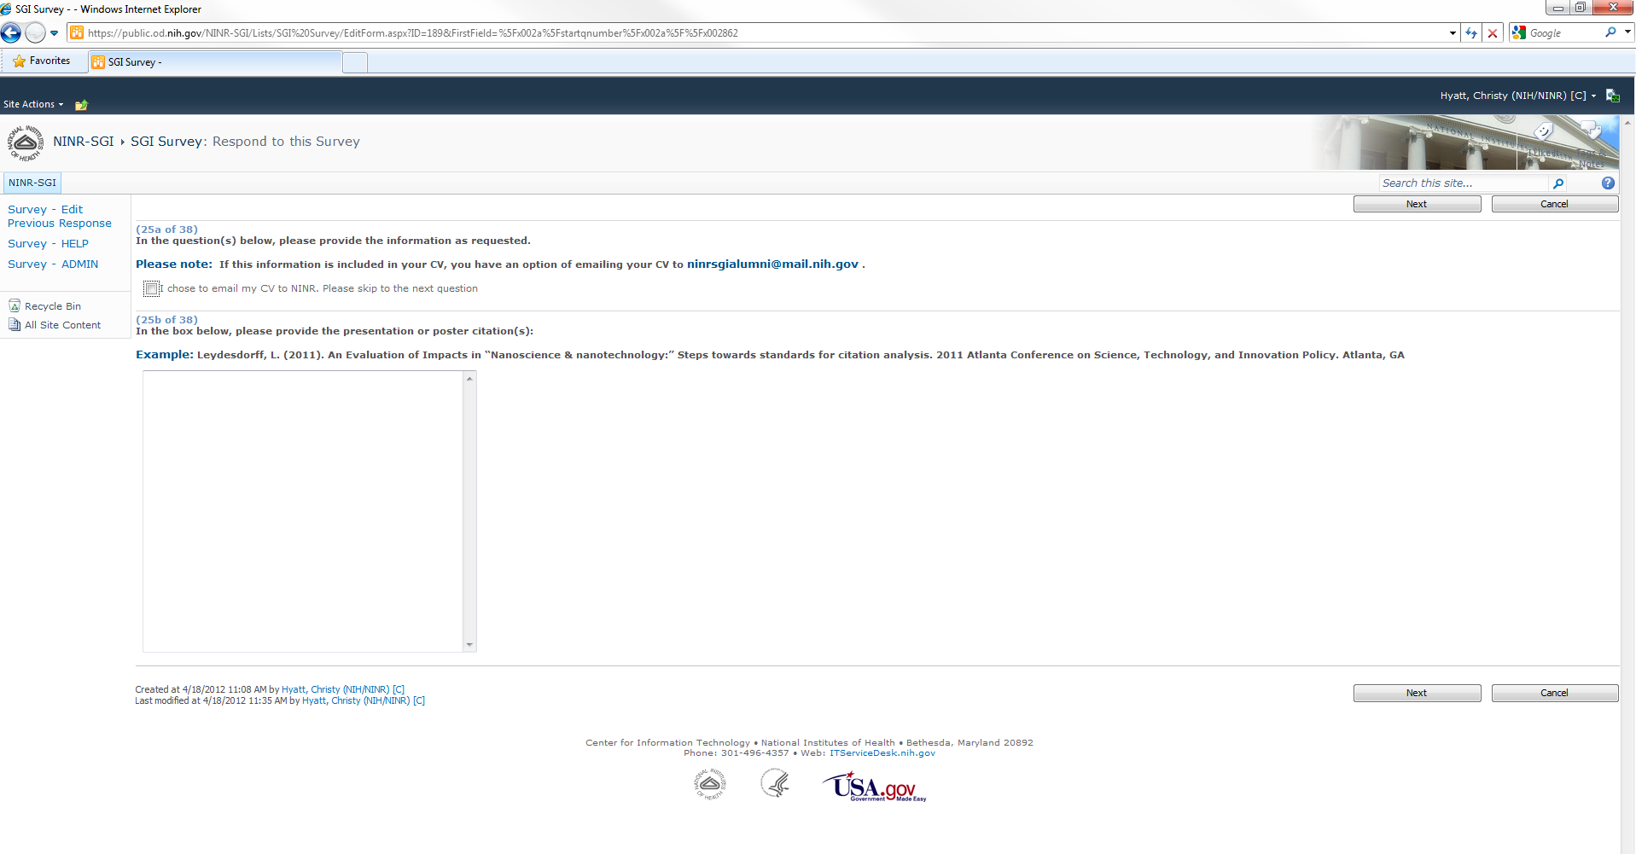

- Next page of questions, choose Next button when ready to continue with survey

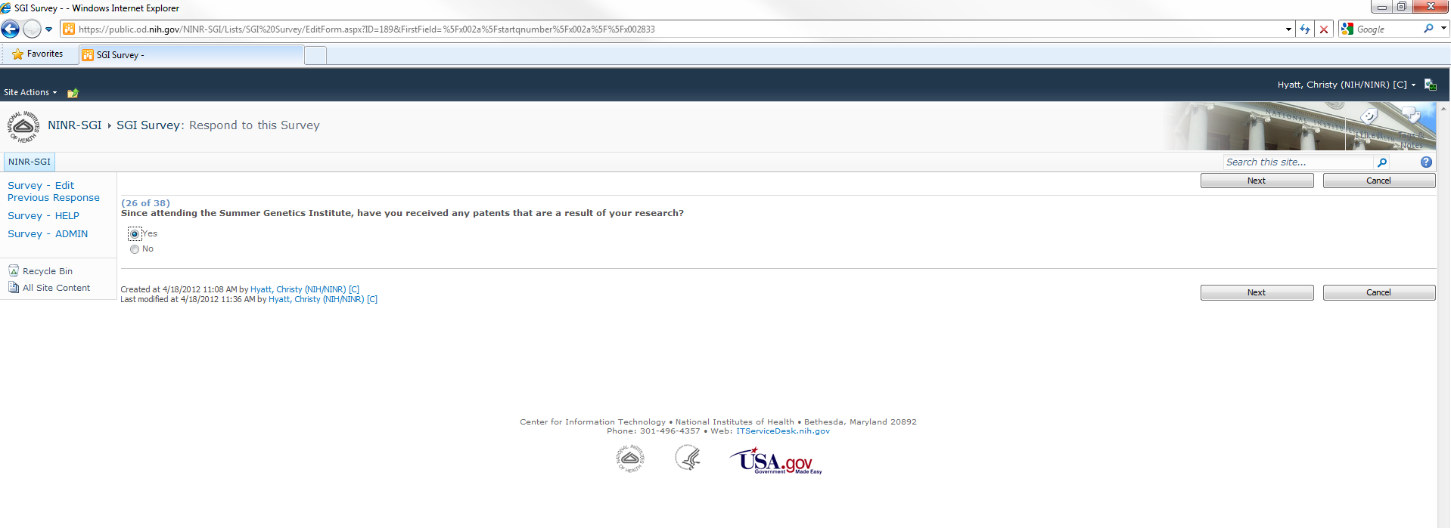

- Next page of questions, choose Next button when ready to continue with survey
- This page of questions is reached as a result of branching logic if the answer to question 26 on the previous screen was Yes
- If the answer to question 26 on the previous screen was No, these questions would be skipped and questions starting at number 27 would be displayed

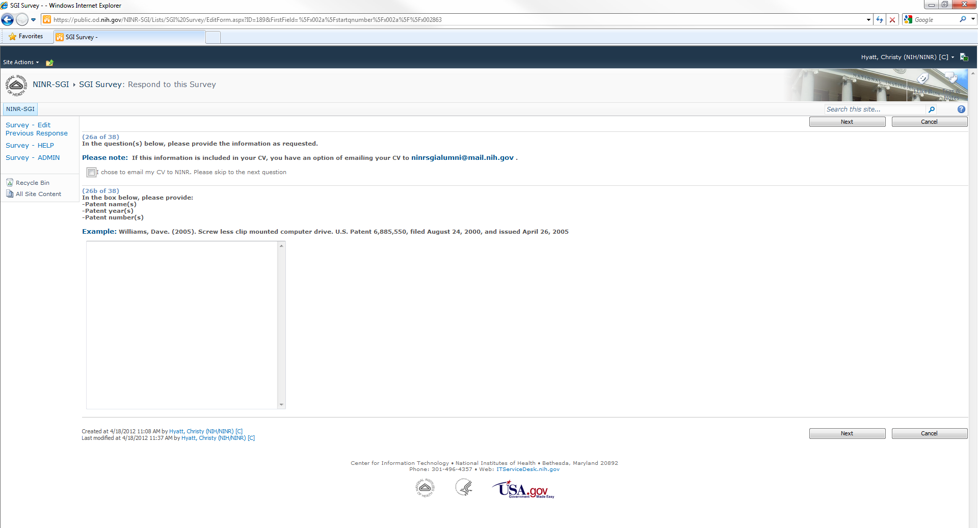

- Next page of questions, choose Next button when ready to continue with survey

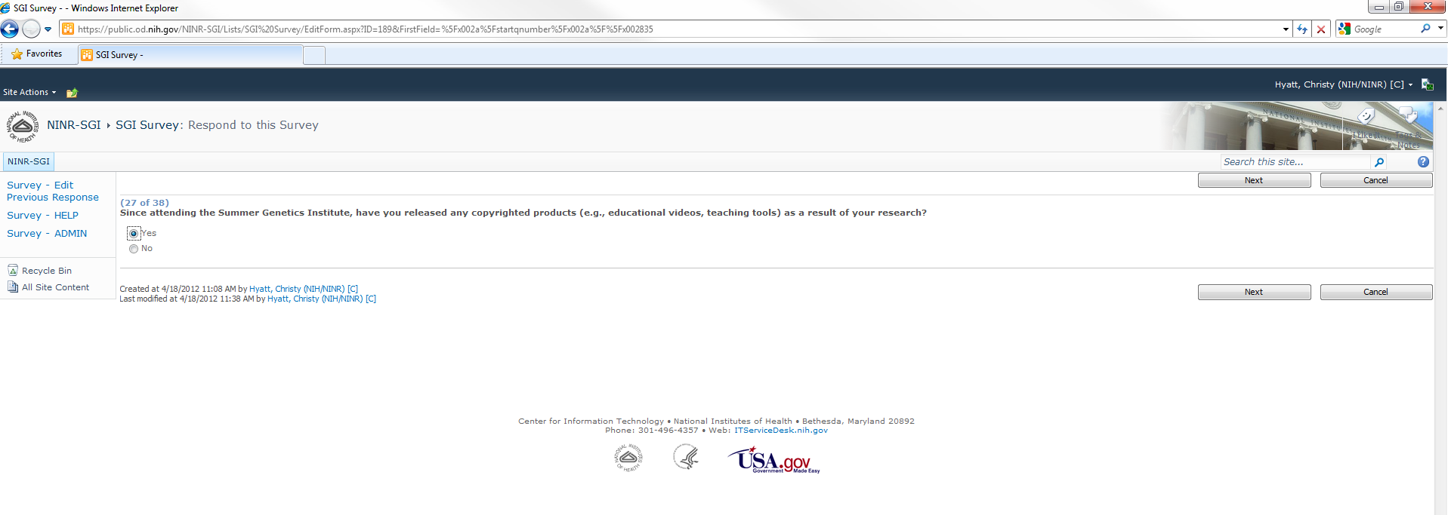

- Next page of questions, choose Next button when ready to continue with survey
- This page of questions is reached as a result of branching logic if the answer to question 27 on the previous screen was Yes
- If the answer to question 27 on the previous screen was No, these questions would be skipped and questions starting at number 28 would be displayed

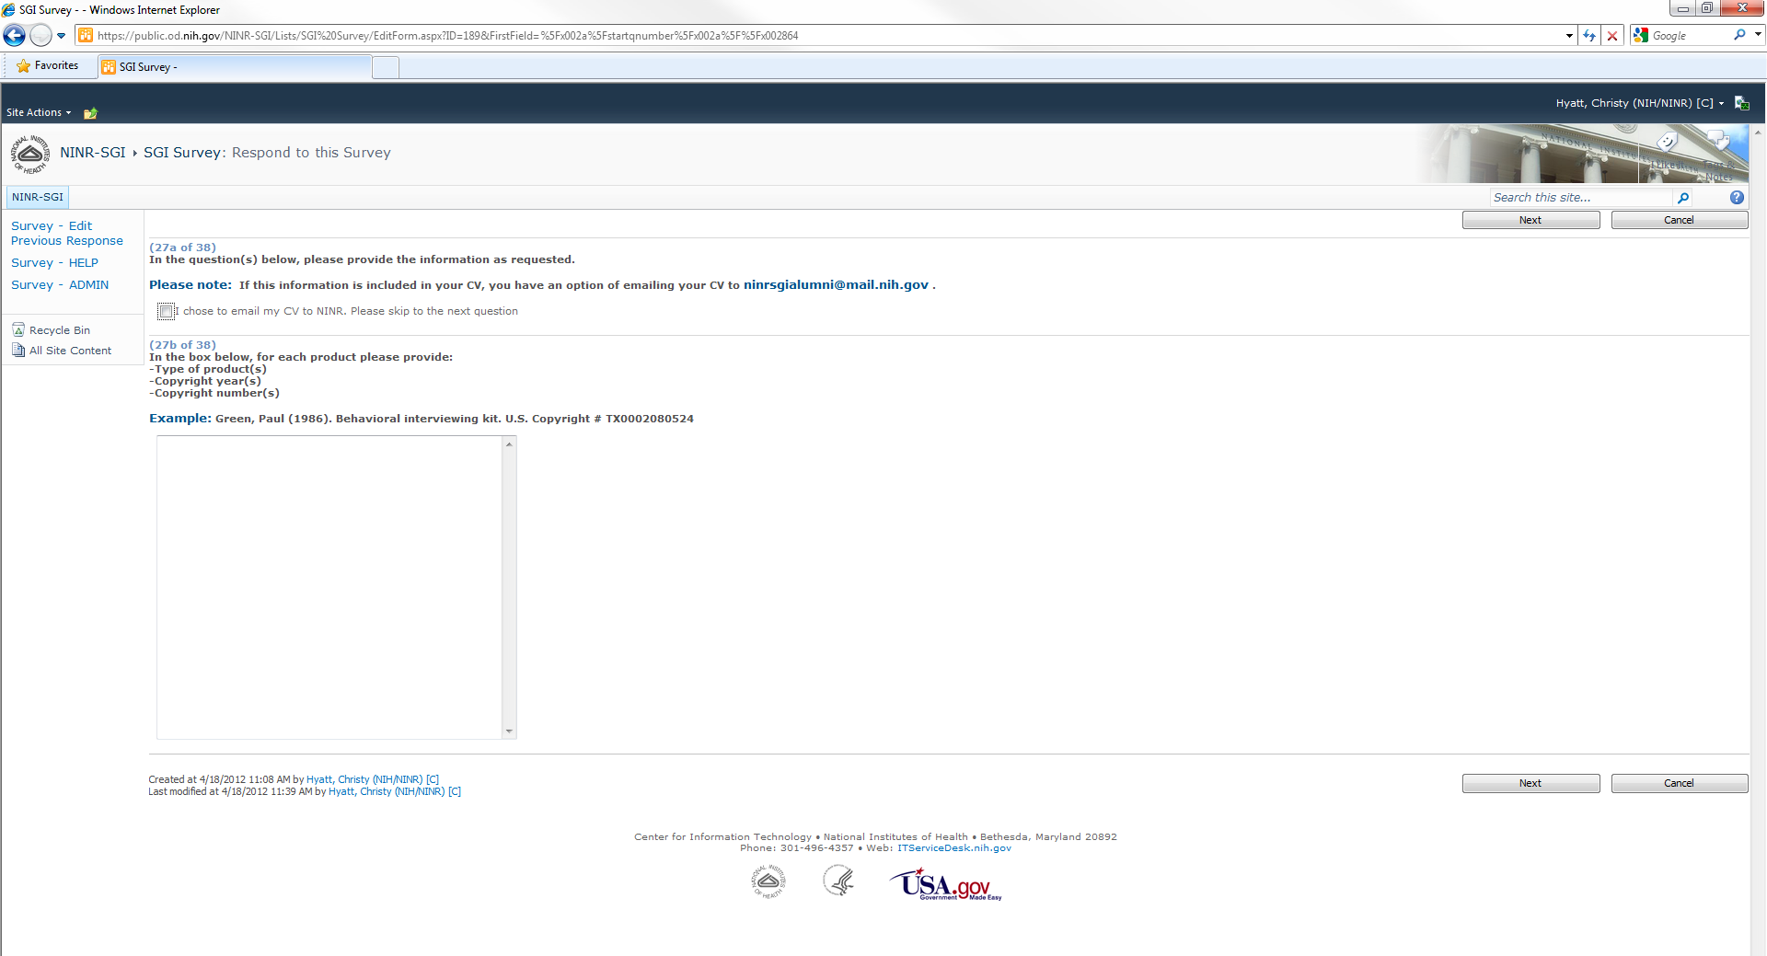

- Next page of questions, choose Next button when ready to continue with survey

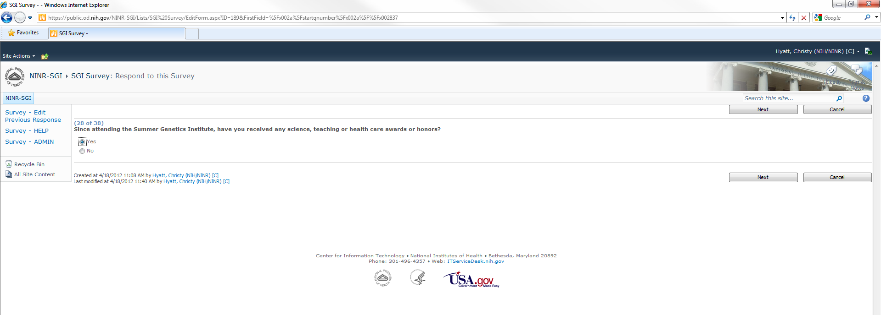

- Next page of questions, choose Next button when ready to continue with survey
- This page of questions is reached as a result of branching logic if the answer to question 28 on the previous screen was Yes
- If the answer to question 28 on the previous screen was No, these questions would be skipped and questions starting at number 29 would be displayed

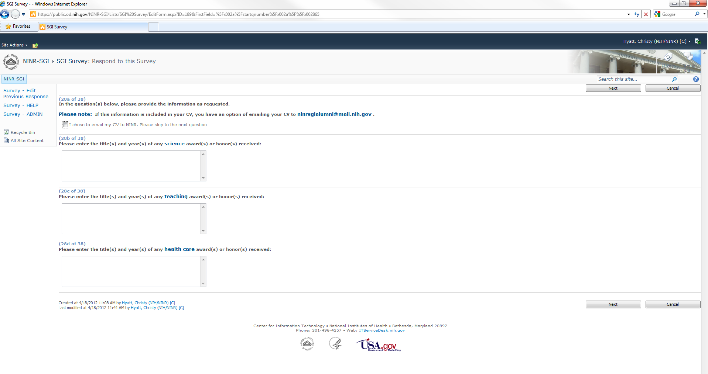

- Next page of questions, choose Next button when ready to continue with survey

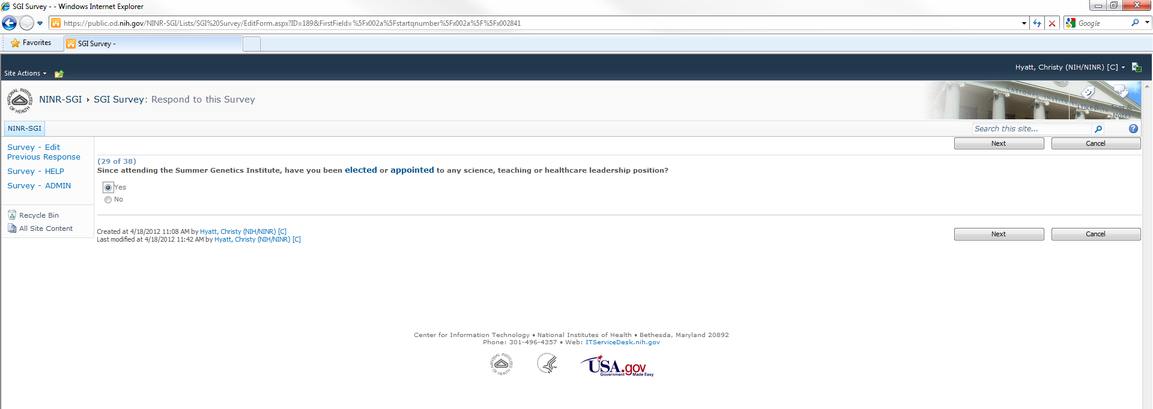

- Next page of questions, choose Next button when ready to continue with survey
- This page of questions is reached as a result of branching logic if the answer to question 29 on the previous screen was Yes
- If the answer to question 29 on the previous screen was No, these questions would be skipped and questions starting at number 30 would be displayed

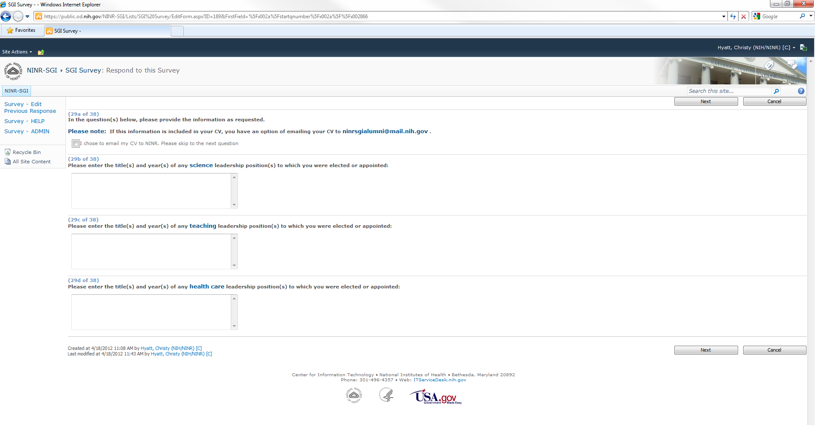

- Next page of questions, choose Next button when ready to continue with survey

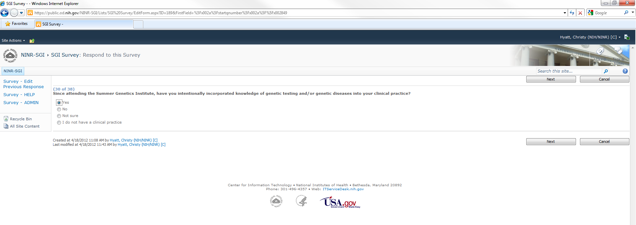

- Next page of questions, choose Next button when ready to continue with survey
- This page of questions is reached as a result of branching logic if the answer to question 30 on the previous screen was anything but “I do not have a clinical practice”
- If the answer to question 30 on the previous screen was “I do not have a clinical practice”, this question would be skipped and questions starting at number 31 would be displayed

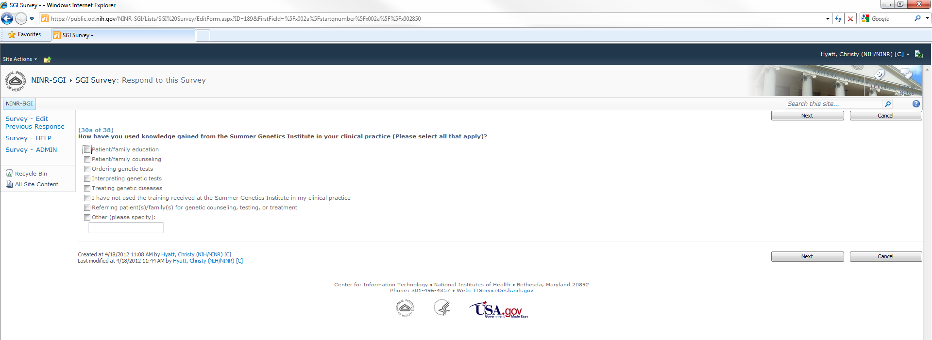

- Next page of questions, choose Next button when ready to continue with survey

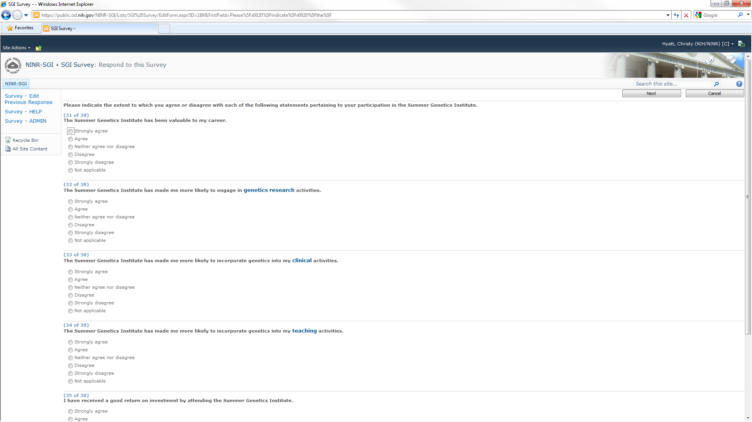

- Next page of questions, choose Next button when ready to continue with survey

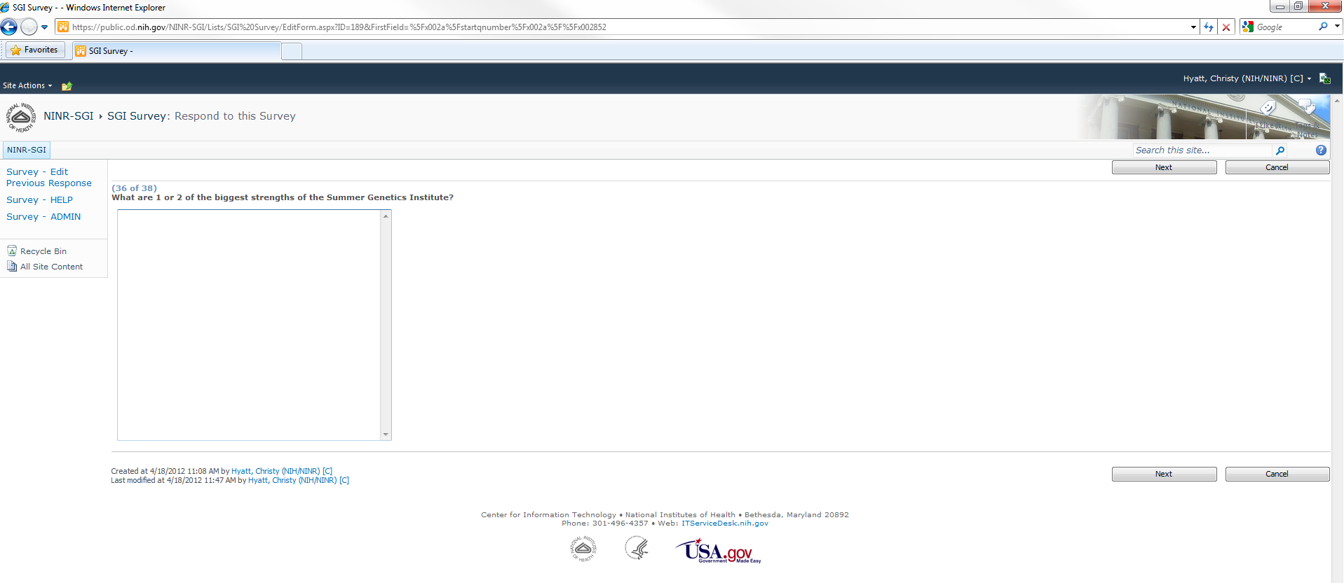

- Next page of questions, choose Next button when ready to continue with survey

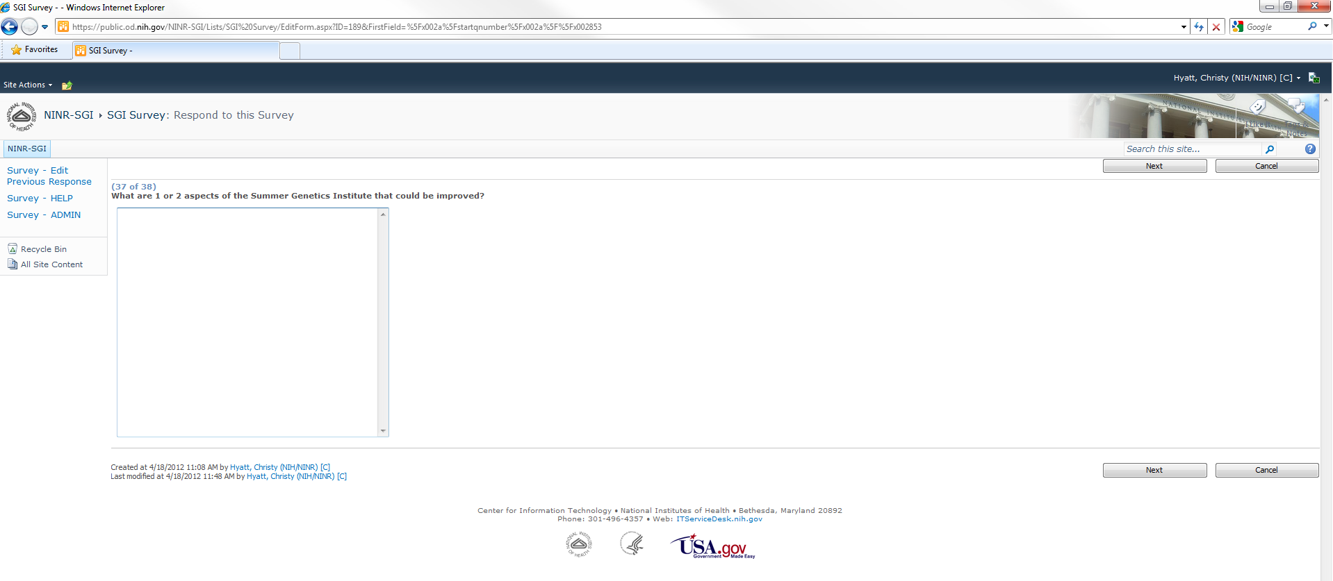

- Final page of questions, choose Finish button when ready to submit survey

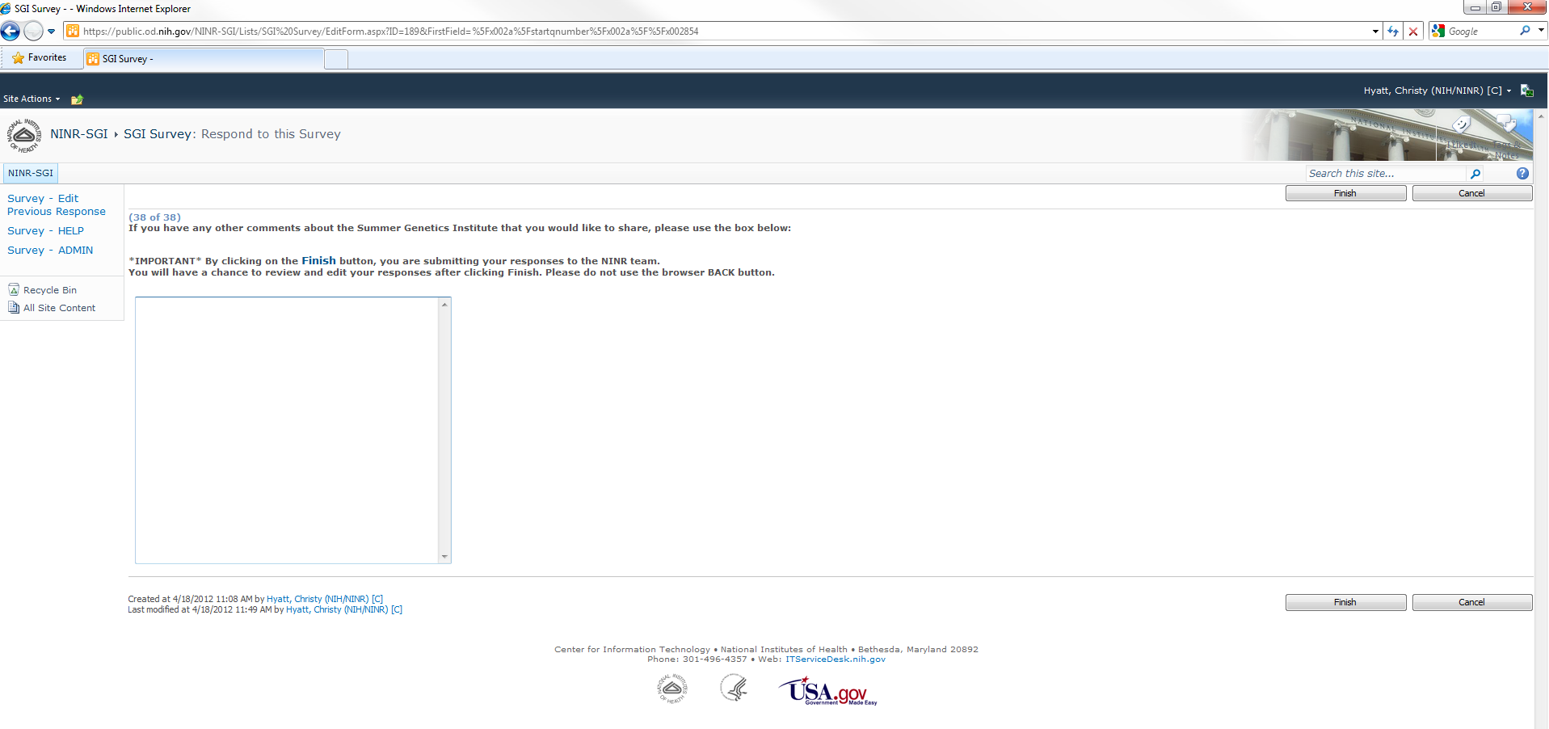

- Survey thank you and completion page
- Also page after choosing Survey – Edit Previous Response from left navigation menu
- Participant may choose to edit the response

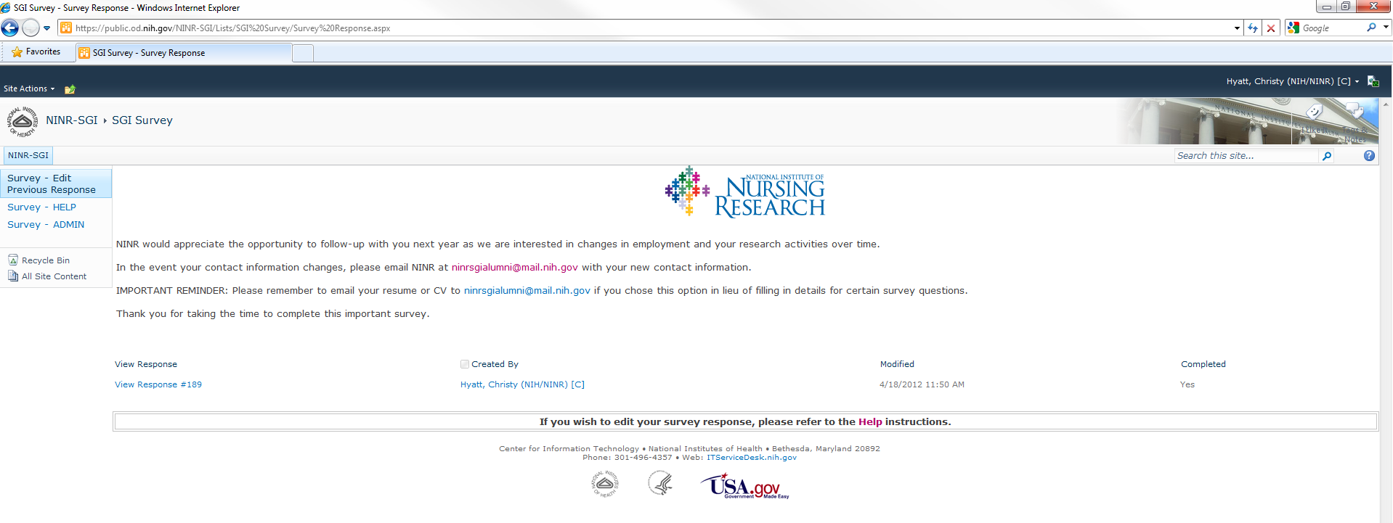

- Survey view response page
- Page after clicking on View Response on previous page
- Clicking on Edit Response will take the participant through the survey pages again

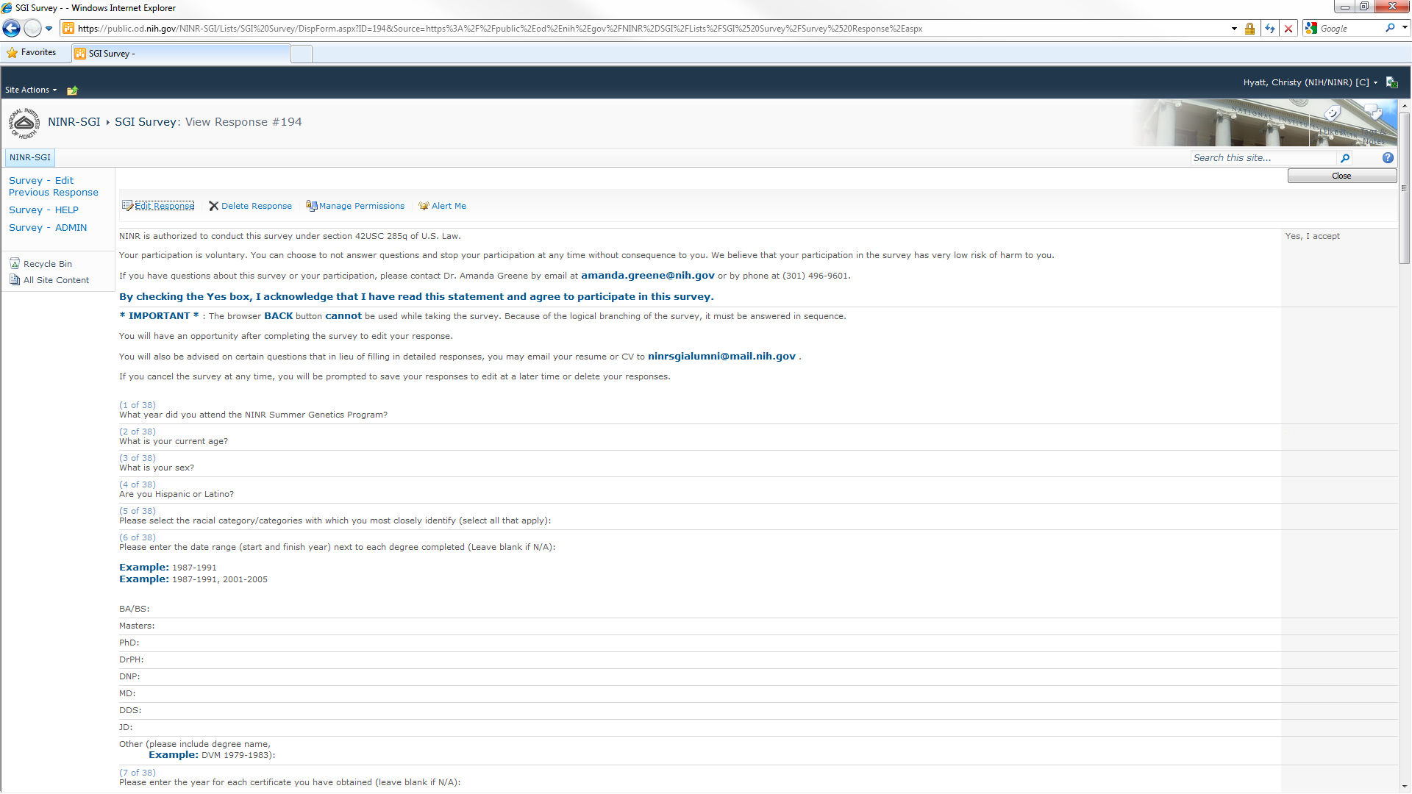
- Survey admin page
- Page and left navigation menu option is only visible/accessible by SharePoint owners and Designers
- Clicking on Export Data allows the NINR admin to export all survey responses to an Excel spreadsheet
- Clicking on Settings/Survey Settings allows the NINR admin to edit the survey structure and questions

