Provider-Based Sampling Frame Questionnaire Refusal Letter for Providers, Phase 2f
Energy
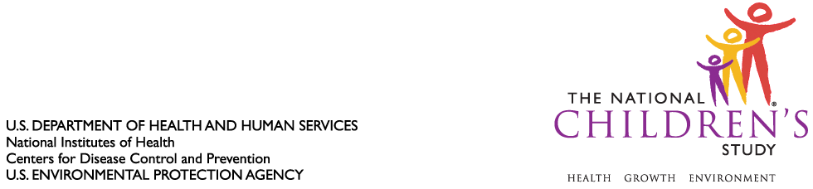Washington, DC 20585

From the Director of the National Children’s Study:

We recently contacted your office on behalf of the National Children’s Study (NCS), a longitudinal study funded by the National Institutes of Health (NIH). I am writing to provide additional information about the importance of this landmark Study and to ask for your assistance.

The purpose of the NCS is to learn how the environment, including factors such as air, water, diet, and neighborhood safety, can affect children’s health. Unlike other cohort studies, we will follow children from before birth to age 21 and hope to answer questions such as why some children are more likely than others to develop certain conditions. The NCS will be the most comprehensive study of children’s health to date and our goal is to enroll 100,000 children.

Currently, we are contacting prenatal care providers in your area to help gather demographic information, in aggregate, about each provider office and the women they serve. Upon completion of the initial data collection, NCS statisticians will select a sample of provider offices that we will engage as NCS recruitment locations. We need the participation of your provider office in order to learn about the characteristics of provider locations in the area. We request that you fill out a short survey about your provider office. We hope that you will reconsider your decision about providing information to help with this important research endeavor.

You and your staff can obtain general information about the Study at our website at www.nationalchildrensstudy.gov I also invite you to contact me directly at 301-594-9147 or ContactNCS@mail.nih.gov to discuss any of your questions or concerns.

Thank you for your consideration.

Sincerely,

Steven Hirschfeld, MD, PhD
Captain, U.S. Public Health Service
Associate Director for Clinical Research
Eunice Kennedy Shriver National Institute of
Child Health and Human Development

Director
National Children's Study

Operations Chief and Chief Medical Officer
USPHS Rapid Deployment Force-1

