Appendix I
Katrina and Rita Exposures Registry:
Feasibility Sample Selection
This document describes the sampling plan for the Katrina and Rita Exposures (KARE) Registry Pilot feasibility study. It contains the following sections: (1) sampling frame development, (2) stratification, (3) sample allocation, (4) applicant selection, (5) snowball sampling, and (6) de-duplication of final data file.
- Sampling Frame Development
The sample will be based on the Federal Emergency Management Agency (FEMA) database provided by Centers for Disease Control and Prevention. The FEMA database is a list of adult applicants for temporary housing units (THU), where each adult represents a household that lived in a THU. Each applicant has a unique registration identification number. For registration identification numbers that had multiple observations in the database, one observation was selected at random so that each observation in the database represented a unique registration identification number. This resulted in a database that contained 118,684 observations. See Appendix A: Distribution of Applicants for a map that shows the density of applicants across counties/parishes. For the feasibility study, sample selection will occur in Alabama, Louisiana, Mississippi, and Texas. The database has 114,292 observations with a geocoded address in Alabama (2,447), Louisiana (70,832), Mississippi (34,482), and Texas (6,531).
- Stratification
For the KARE feasibility study, the explicit stratification will consists of designated counties/parishes. That is, designated counties/parishes will be the sampling strata. There is one county in Alabama, three parishes in Louisiana, three counties in Mississippi, and six counties in Texas designated to be in the feasibility study. In each state the counties/parishes are contiguous. Table 1: Feasibility Study Counties/Parishes lists the counties/parishes that will be included in the feasibility study and the number of applicants in each county/parish.
Table 1. Feasibility Study Counties/Parishes
State | County, State | Applicants
Alabama | Mobile, AL | 1,788
Louisiana | Orleans, LA | 24,239
Louisiana | Jefferson, LA | 19,504
Louisiana | St. Tammany, LA | 11,889
Mississippi | Harrison, MS | 11,577
Mississippi | Jackson, MS | 8,928
Mississippi | Hancock, MS | 7,451
Texas | Jefferson, TX | 1,604
Texas | Orange, TX | 953
Texas | Hardin, TX | 522
Texas | Jasper, TX | 435
Texas | Tyler, TX | 245
Texas | Newton, TX | 175

The counties/parishes represent a mix of rural and urban parishes/counties. See Appendix B: Study Counties/Parishes for a map of study counties/parishes. Within each of these counties/parishes, we will use implicit stratification by Census tract to allocate the sample within the explicit sampling strata.
- Sample Allocation
The sample size for the feasibility study was set at 10,000 applicants. The sample will be allocated proportionally based on the number of applicants across Alabama, Louisiana, Mississippi, and Texas. About 2% of the sample will be allocated to Alabama, about 62% to Louisiana, about 31% to Mississippi, and about 4% to Texas. These percentages represent the approximate population proportions of the applicants based on the applicant counts for Alabama (2%), Louisiana (62%), Mississippi (30%), and Texas (6%). Within each of the states, the sample will be allocated proportionally to the designated counties/parishes within the state. Within each of the designated counties, the sample will be proportionally allocated to the Census tracts. Appendix C: Feasibility Study Counties/Parishes Sample Allocation has a list of feasibility study counties/parishes and the sample allocation for these counties/parishes.
- Applicant Selection
In general, sample selection will be stratified simple random sampling with proportional allocation. The probability of selection for the applicant will be the number of applicants selected for the sample in a sampling stratum divided by the total number of applicants in the sampling stratum. That is, the probability of selection for the i^{th} applicant in the h^{th} sampling stratum is, p_{hi}, will be
$p_{hi}=\frac{n_{h}}{N_{h}}$,
where n_{h} is the number of applicants selected for the sample in the h^{th} sampling stratum and N_{h} is the total number of applicants in the h^{th} sampling stratum. The design weight for an applicant will be the inverse of the applicant probability of selection. That is, the design weight for the for the i^{th} applicant in the h^{th} sampling stratum, d_{hi}, will be
$d_{hi}=\frac{1}{p_{hi}}$.
Appendix A: Distribution of Applicants
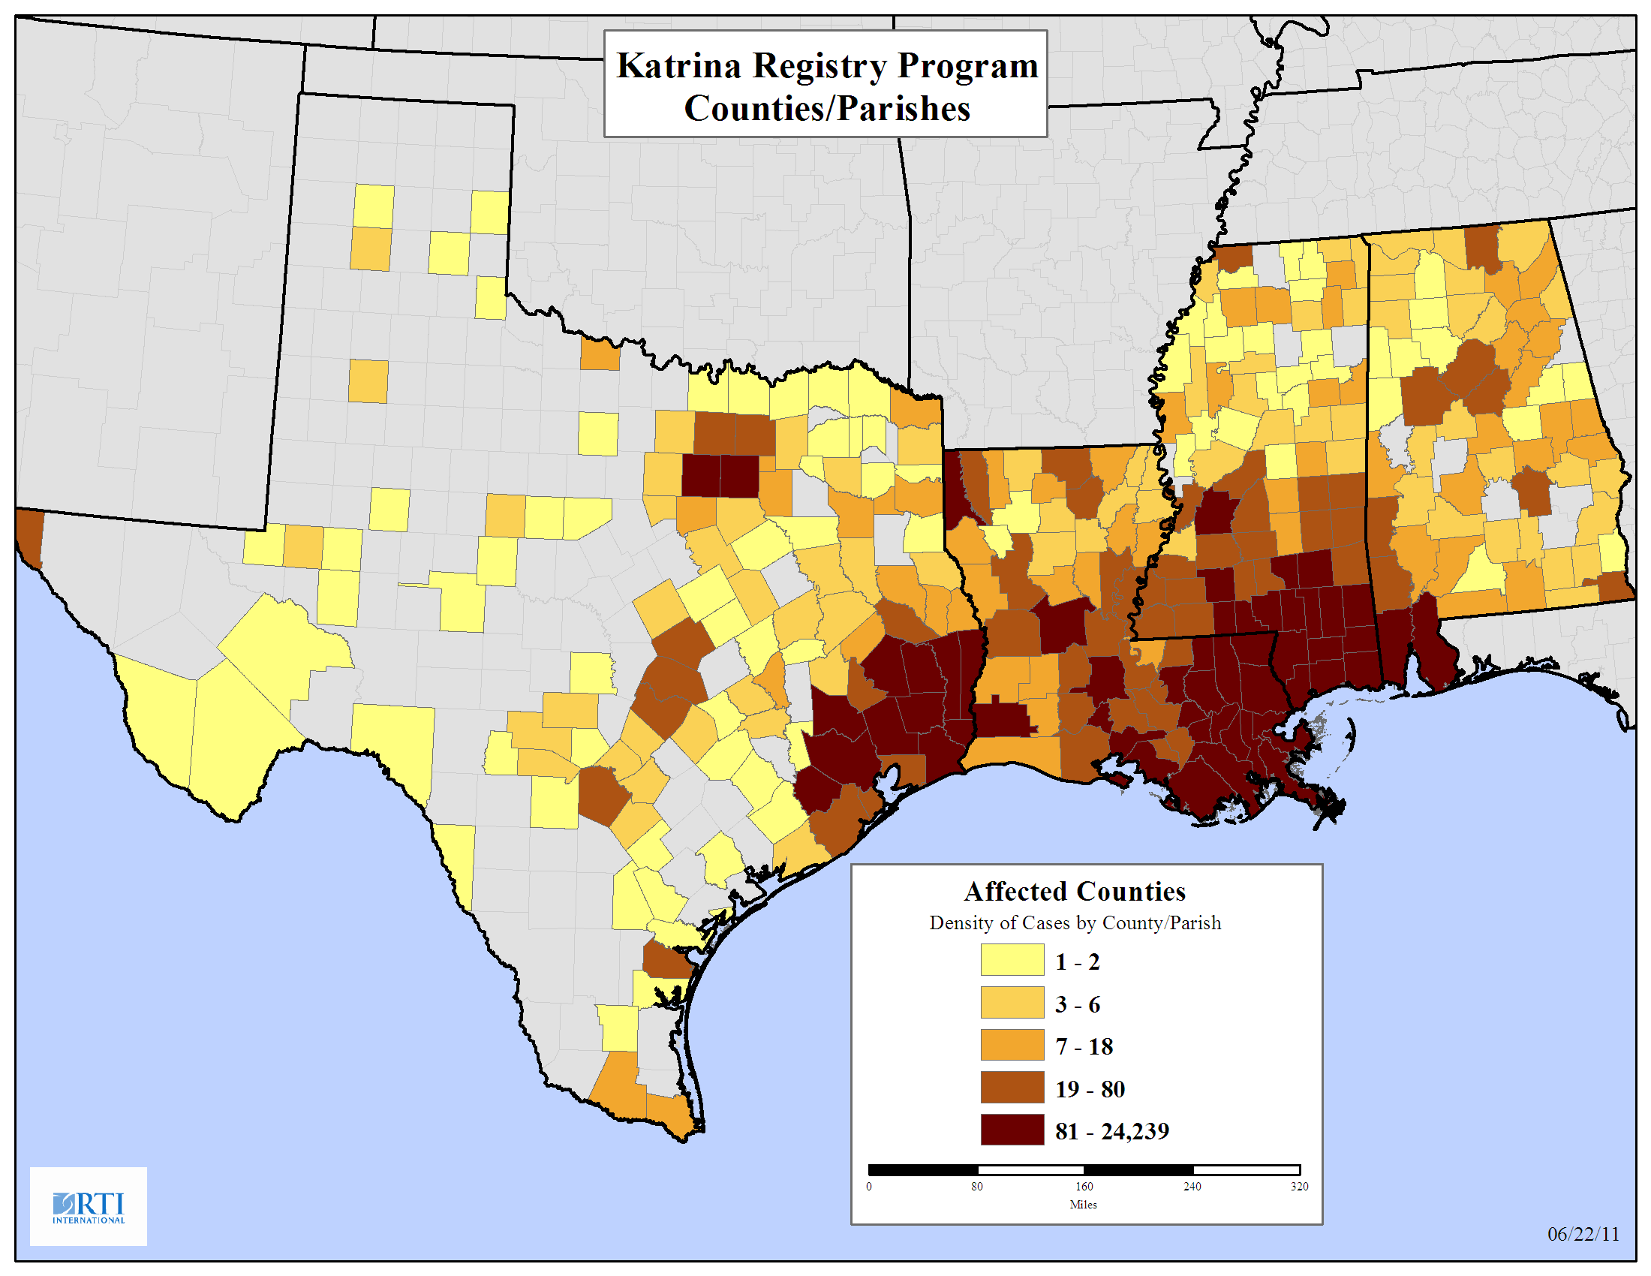
Appendix B: Study Counties/Parishes
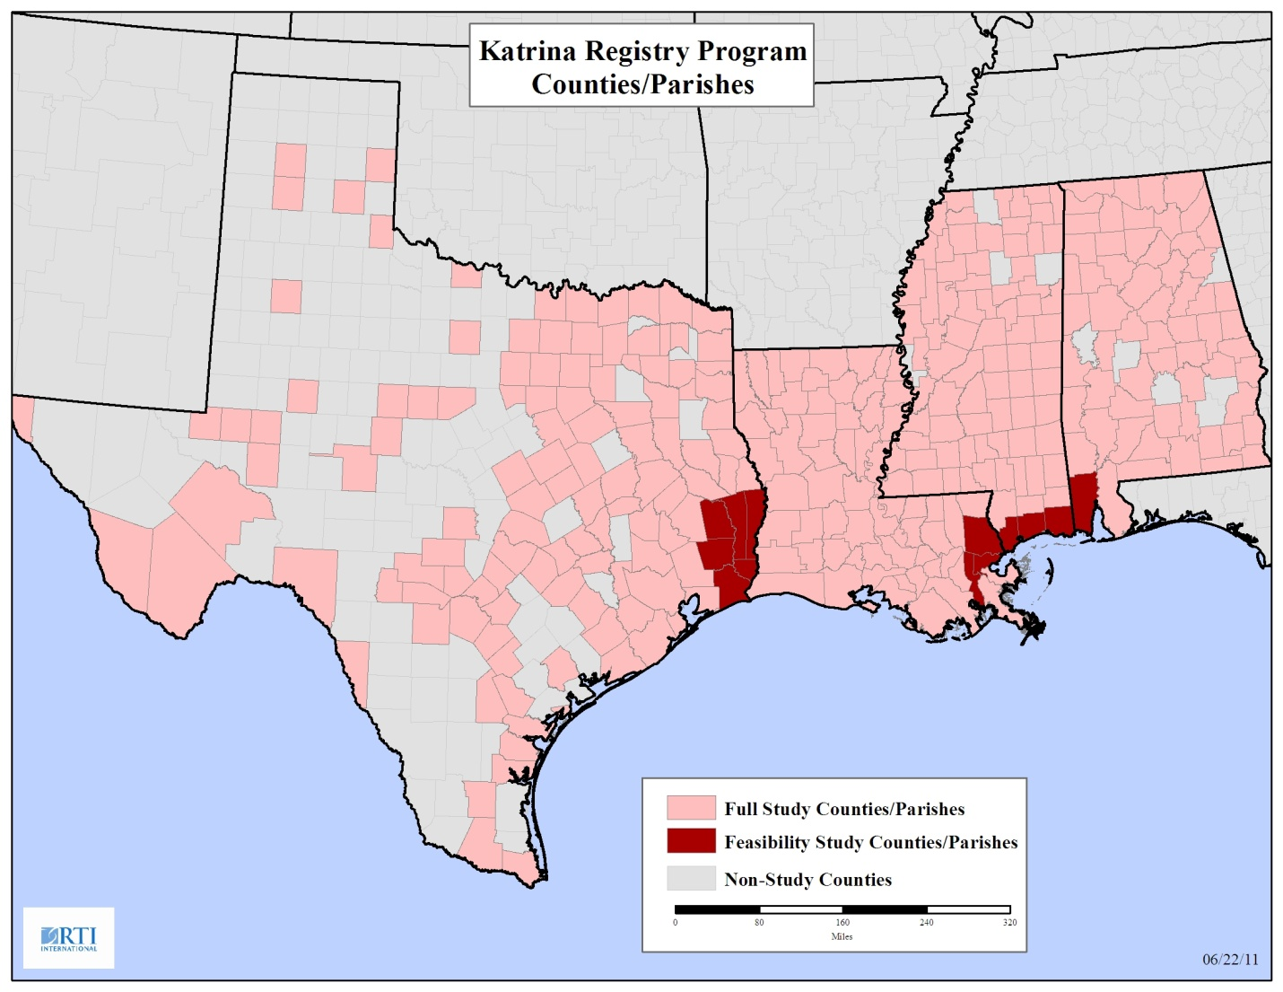
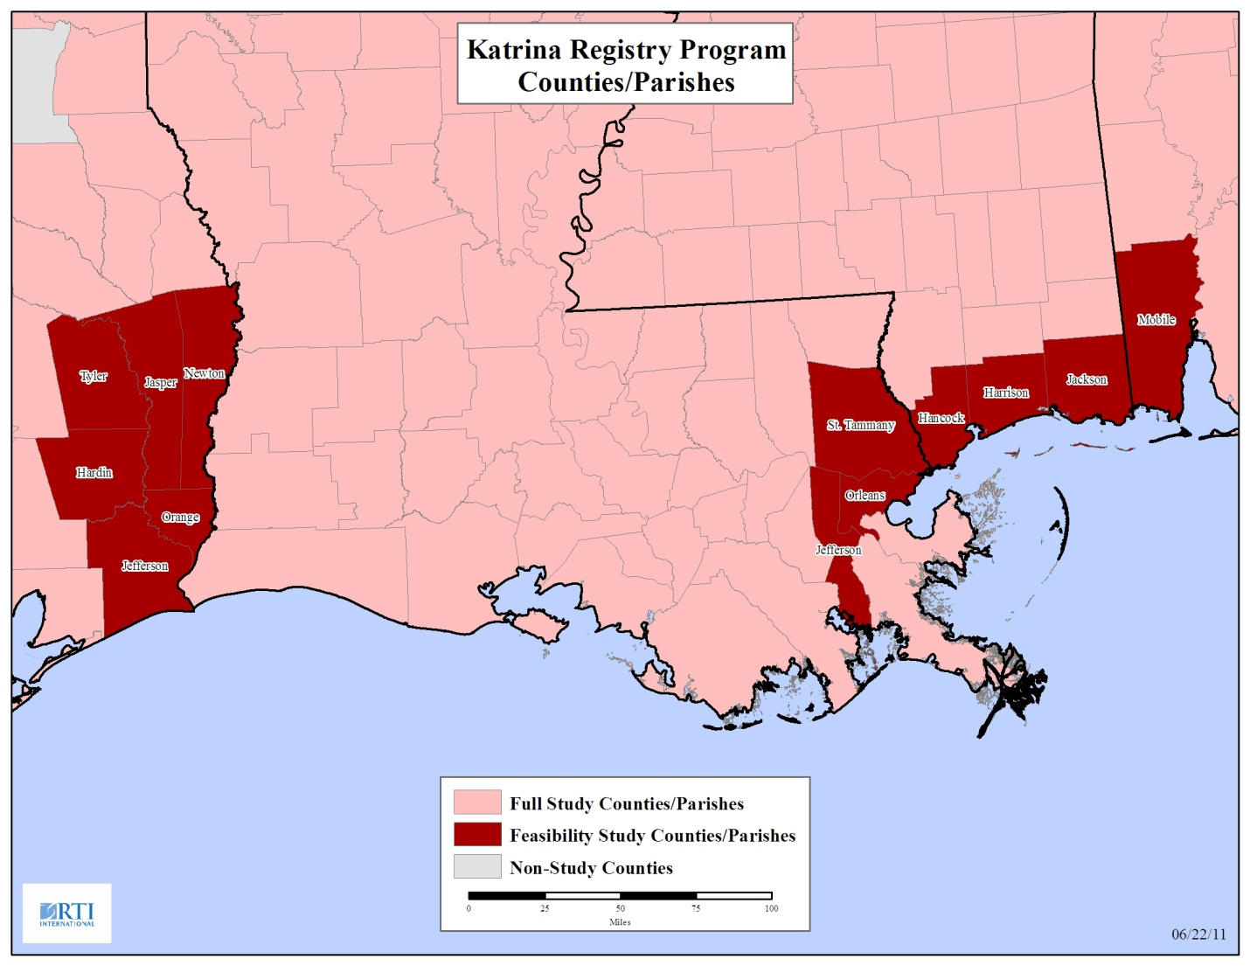

Appendix C: Feasibility Study Counties/Parishes Sample Allocation (POS is the probability of selection and DW is the design weight.)
stateAlphaCode | County, State | Population  Count |  |  |  | Sample  Count |  | POS | DW
AL | Mobile, AL | 1,788 |  |  |  | 200 |  | 0.1119 | 8.9400
AL | Total | 1,788 |  | % Sample | 0.02002 | 200
 |  |  |  | Sample Count | 200
TX | Jefferson, TX | 1,604 |  |  |  | 179 |  | 0.1118 | 8.9409
TX | Orange, TX | 953 |  |  |  | 107 |  | 0.1118 | 8.9409
TX | Hardin, TX | 522 |  |  |  | 58 |  | 0.1118 | 8.9409
TX | Jasper, TX | 435 |  |  |  | 49 |  | 0.1118 | 8.9409
TX | Tyler, TX | 245 |  |  |  | 27 |  | 0.1118 | 8.9409
TX | Newton, TX | 175 |  |  |  | 20 |  | 0.1118 | 8.9409
TX | Total | 3,934 |  | % Sample | 0.0440 | 440
 |  |  |  | Sample Count | 440
LA | Orleans, LA | 24,239 |  |  |  | 2,714 |  | 0.1120 | 8.9310
LA | Jefferson, LA | 19,504 |  |  |  | 2,184 |  | 0.1120 | 8.9310
LA | St. Tammany, LA | 11,889 |  |  |  | 1,331 |  | 0.1120 | 8.9310
LA | Total | 55,632 |  | % Sample | 0.6229 | 6,229
 |  |  |  | Sample Count | 6,229
MS | Harrison, MS | 11,577 |  |  |  | 1,296 |  | 0.1120 | 8.9310
MS | Jackson, MS | 8,928 |  |  |  | 1,000 |  | 0.1120 | 8.9310
MS | Hancock, MS | 7,451 |  |  |  | 834 |  | 0.1120 | 8.9310
MS | Total | 27,956 |  | % Sample | 0.3130 | 3,130
 |  |  |  | Sample Count | 3,130
All States | Total | 89,310 |  | Sample Size | 10,000 | 9,999
Target Actual

