Survey of Post-Graduate Outcomes for International Education Fellowship Recipients
Authorizing Legislation
Website: http://www.gpo.gov/fdsys/pkg/PLAW-110publ315/pdf/PLAW-110publ315.pdf
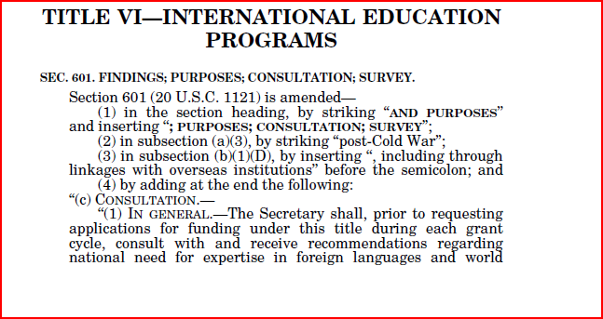
Website - http://www.gpo.gov/fdsys/pkg/PLAW-110publ315/pdf/PLAW-110publ315.pdf
