Revised CareerTrac Screenshots – Trainees Not in Xtrain = FIC/NCI/SRP

Fogarty International Center Tenant
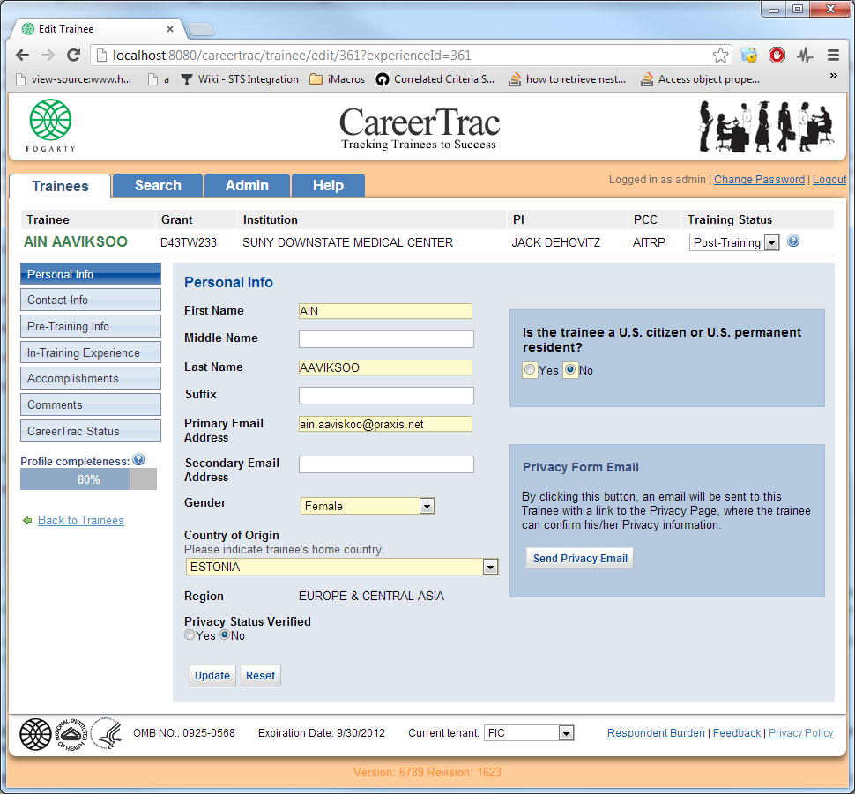
Main screen showing new required question
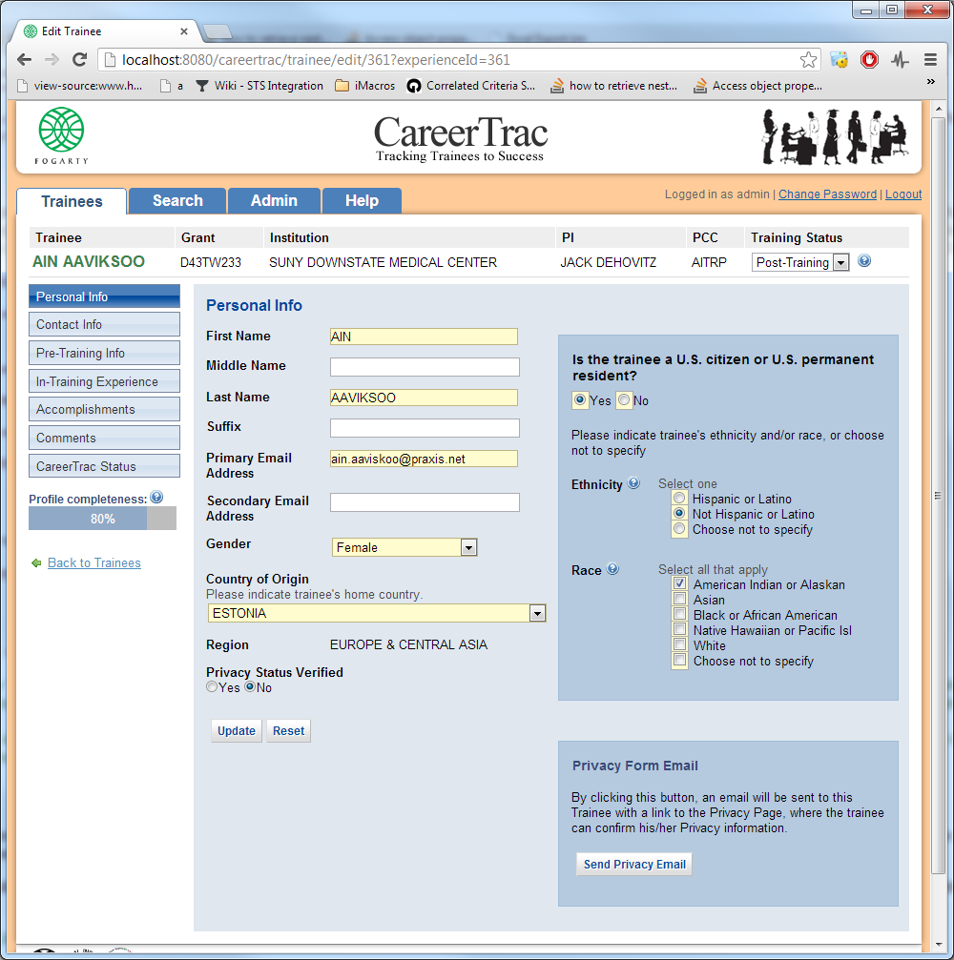

If select yes.. new required questions on ethnicity and race, revised responses per request

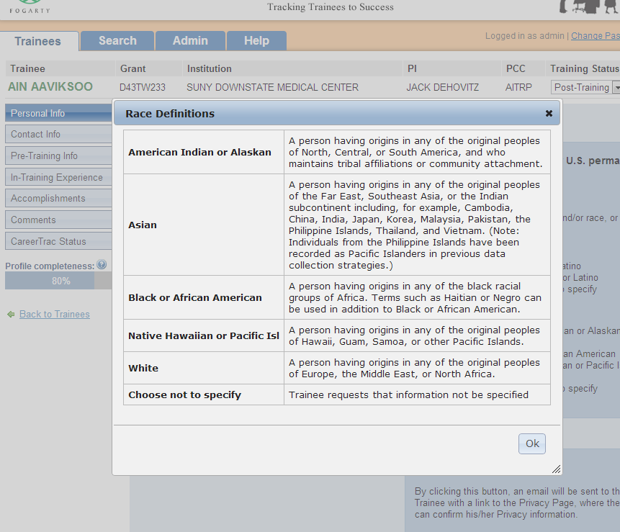
Definitions showing in a tool tip

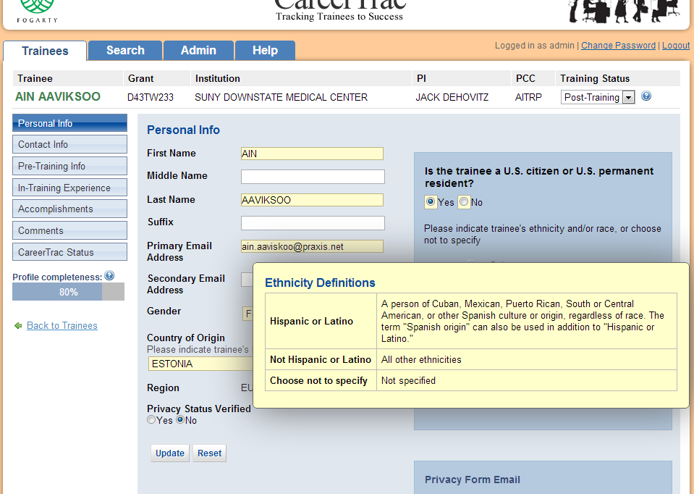
Tool tip with ethnicity definitions. This is the same for all tenants.

Superfund Tenant

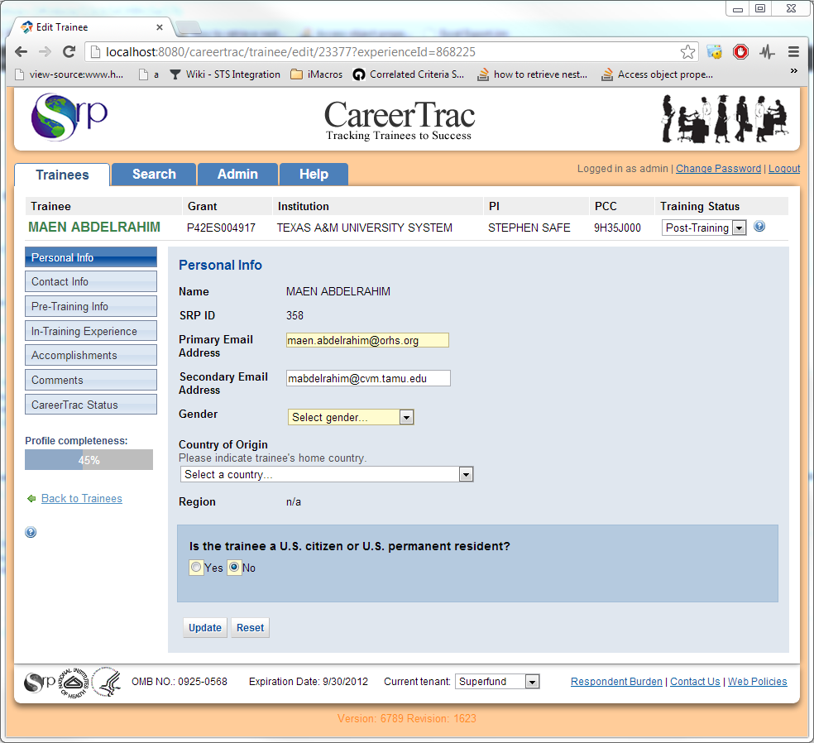

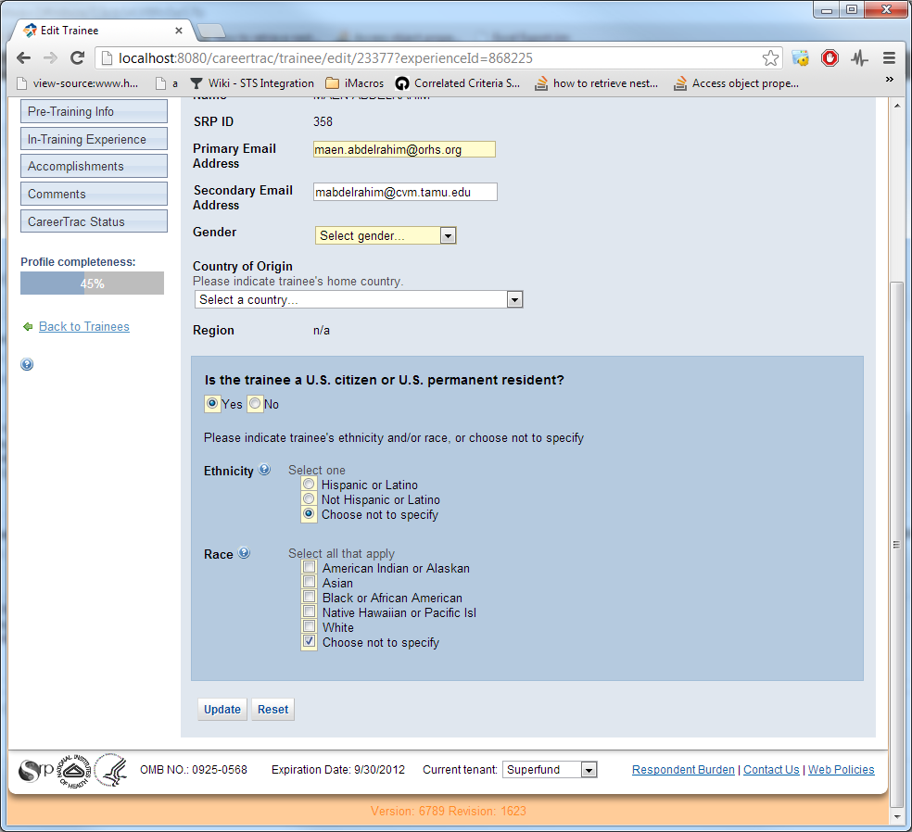

NCI Tenant:

