Revised CareerTrac Screenshots – Trainees who are in Xtrain = NIEHS
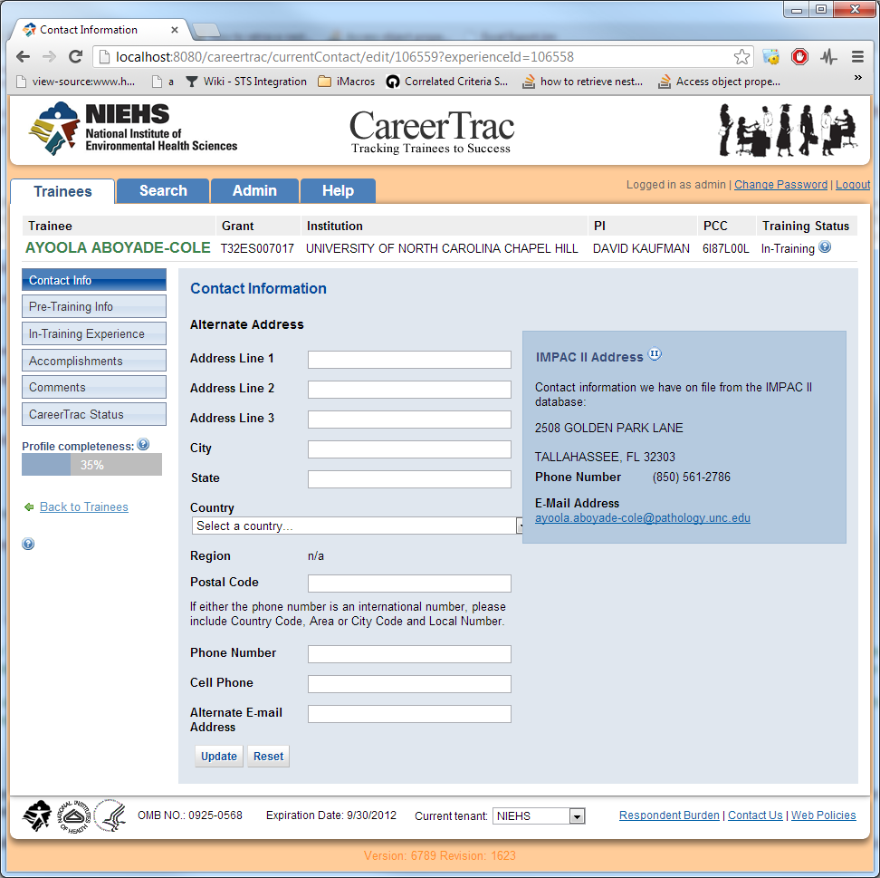

Combined personal info and contact info tabs. Removed gender and ethnicity questions

