Population Assessment of Tobacco and Health (PATH) Study
Wave 4 Cognitive Testing Protocol

Screening Module Images

Cigarettes

Electronic Nicotine Products
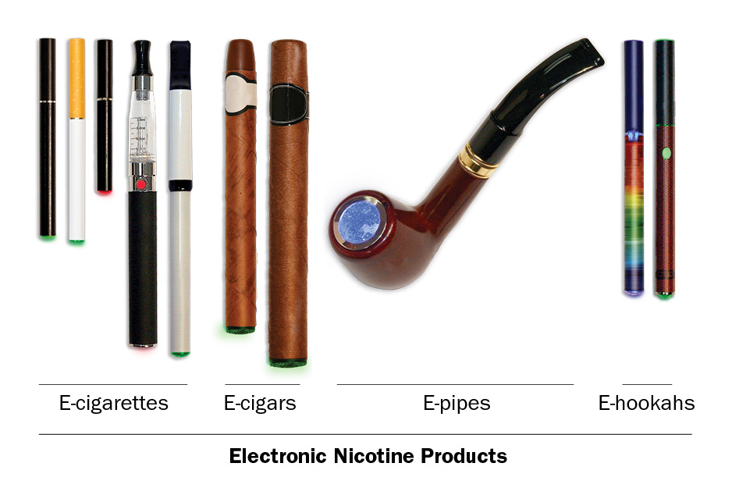

Electronic nicotine products include products such as e-cigarettes, vape pens, hookah pens, personal vaporizers and mods, e-cigars, e-pipes, and e-hookahs. These products are battery-powered and produce vapor instead of smoke. They typically use a nicotine liquid, although the amount of nicotine can vary and some may not contain any nicotine at all. Some common brands include Fin, NJOY, Blu, e-Go and Vuse.

Traditional Cigars, Cigarillos, and Filtered Cigars
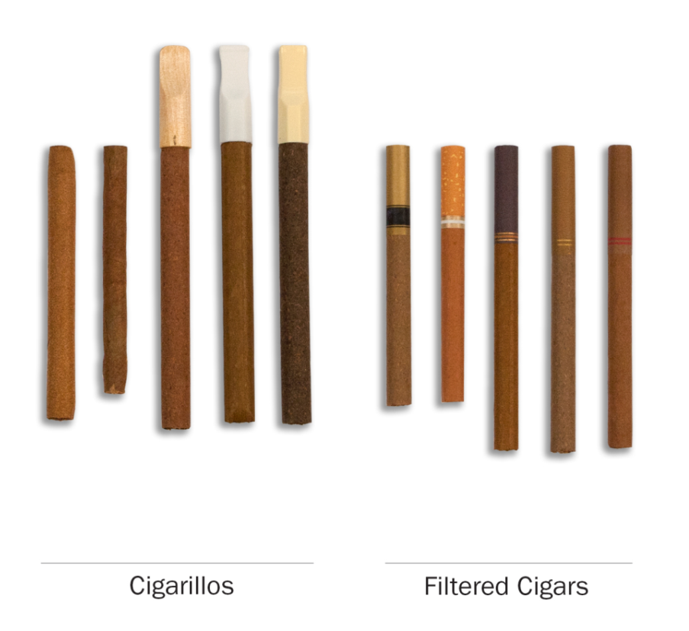

Traditional cigars contain tightly rolled tobacco that is wrapped in a tobacco leaf. Some common brands of cigars include Macanudo, Romeo y Julieta, and Arturo Fuente, but there are many others.
Cigarillos and filtered cigars are smaller than traditional cigars. They are usually brown. Some are the same size as cigarettes, and some come with filters or with plastic or wooden tips. Some common brands are Black & Mild, Swisher Sweets, Dutch Masters, Phillies Blunts, Prime Time, and Winchester.

Pipes
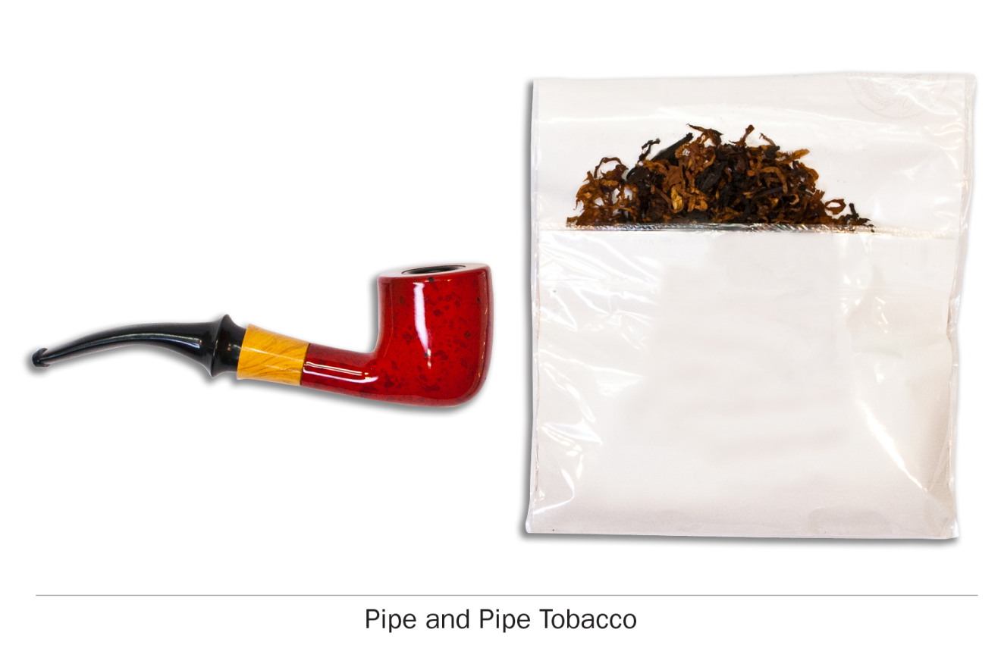

There are many different types of pipes. They all have a bowl that holds the tobacco and a stem.

Hookah
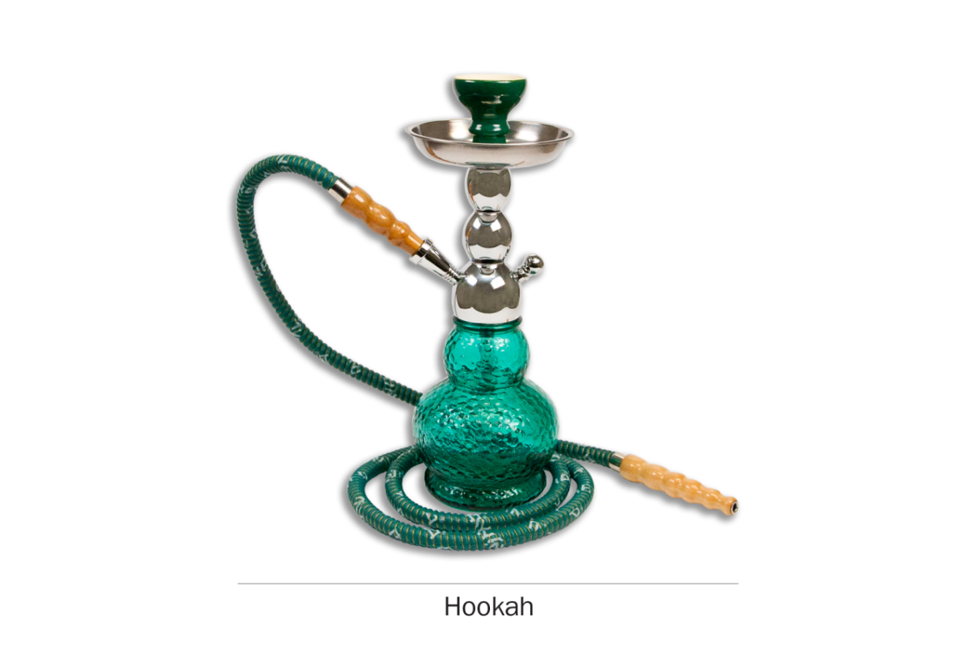

A hookah is a type of water pipe. It is sometimes also called a “narghile” pipe. From now on, we will use “hookah” to refer to a water pipe or narghile pipe.
There are many types of hookahs. People often smoke tobacco in hookahs in groups at cafes or in hookah bars.

Smokeless Tobacco
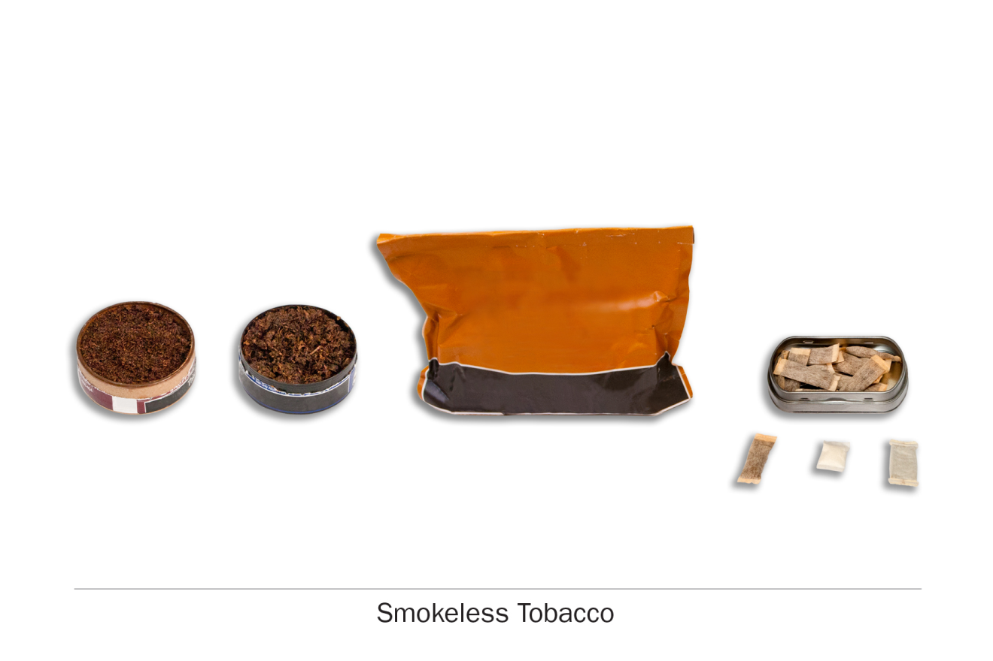

Smokeless tobacco is tobacco which you put in your mouth. Frequently you chew, suck or spit while using smokeless tobacco, although there is no need to do so for some types. Snus, for instance, is a type of smokeless tobacco that comes in a small pouch that you put inside your lip.
There are many kinds of smokeless tobacco, such as snus pouches, loose snus, moist snuff, dip, spit, and chewing tobacco. Common brands include Redman, Levi Garrett, Beechnut, Skoal, Grizzly, Nordic Ice and Copenhagen.

