Population Assessment of Tobacco and Health (PATH) Study

Spanish-Language Protocol

PLEASE NOTE:
All cognitive testing probes will be administered in Spanish. Probes are provided in English for review purposes only.

Spanish Tobacco Use Module
all respondents

Cigarettes
PATH ID: AC1002
- ¿Alguna vez ha fumado un cigarrillo, incluso si solo fueron una o dos probaditas?
- Sí
- No GO TO Q9
ASK: All respondents
PATH ID: AC1003
- ¿Fuma ahora cigarrillos...?
- Todos los días
- Algunos días
- Nunca GO TO Q6
ASK: Respondents who have ever smoked a cigarette (AC1002 = 1)

RESEARCH QUESTION
From a culturaI perspective, it is unclear if respondents will easily differentiate between “two days ago” and “three days ago or more”.
PATH ID: AC0100
- ¿Cuándo fue la última vez que fumó un cigarrillo?
- Hace menos de una hora GO TO Q5
- Hoy
- Ayer
- Hace dos días
- Hace tres días o más GO TO Q6
ASK: Respondents who smoke cigarettes everyday or some days (AC1003=1, 2, -8 or -7)
Tell me more about your answer. How did you decide which to choose?
IF ANSWERS WITH 2 OR 3 OR MORE DAYS, PROBE TO SEE HOW PRECISELY RESPONDENT IS DIFFERENTIATING BETWEEN THE TWO.
How easy or difficult is it to understand/answer this question? What would make it easier to understand/answer?
IF NEEDED, In your own words, what is there difference between “Hace dos días” and “Hace tres días o más”?

RESEARCH QUESTION:
The term “media noche” and “medio dia” are imprecise (e.g., 12:30AM” may be described as “medianoche.”) Determine how respondents are interpreting the terms and test to see if the more precise 12 AM and 12 PM would work better.
PATH ID: AC0102
- La última vez que fumó un cigarrillo [FILL BASED ON AC0100], ¿fue...?
- Entre la media noche hasta las 6 de la mañana
- Entre las 6 de la mañana y el medio día
- Entre el medio día y las 6 de la tarde
- Entre las 6 de la tarde y la media noche
ASK: Respondents who have smoked a cigarette today, yesterday or the day before yesterday (AC0100=2 or 3 or 4)
PROGRAM: [FILL BASED ON AC0100]
If AC0100=4, display “Hace dos días”
Else, display text as shown in options selected in AC0100, making first letter lowercase.
Tell me more about your answer.
If you last smoked at 12:30 AM, how woud you answer this question?
If we used 12 AM and 12 PM instead of media noche and medio dia, would that make this question easier or harder to understand, or would it not make a difference?
PATH ID: AC0103
- ¿Cuántos cigarrillos [ha fumado] [fumó] [FILL BASED ON AC0100]? Una cajetilla normalmente contiene 20 cigarrillos.
___________________________________ Cantidad de cigarrillos GO TO Q7
ASK Respondents who have smoked a cigarette in past hour, today, yesterday or the day before yesterday (AC0100=1 or 2 or 3 or 4)
PROGRAM: If respondent smoked in past hour or sometime today (AC0100=1 or 2), display “ha fumado”. If respondent smoked yesterday or the day before yesterday (AC0100=3 or 4), display “fumó”.
PROGRAM: Display ‘Cantidad de cigarrillos’ as a title
PROGRAM: [FILL BASED ON AC0100]
If AC0100=1 OR 2, display “hoy”
If AC0100=4, display “Hace dos días”
Else, display text as shown in options selected in AC0100

PATH ID: AC1004
- En los últimos 30 días, ¿ha fumado un cigarrillo, incluso si solo fueron una o dos probaditas?
- Sí
- No
ASK: Respondents who do not currently smoke every day or some days (AC1003=3)
How did you arrive at your answer?
RESEARCH QUESTION:
Based on previous Spanish-language testing for NATS, response options may be too numerous for respondents to easily answer. Given the precision of the response options, asking respondents to report“in your whole life” may make it difficult for respondents who have smoked more than 10 cigarettes but less than 100 to choose a single category.
PATH ID: AC1005
- ¿Cuántos cigarrillos ha fumado en toda su vida? Una cajetilla normalmente contiene 20 cigarrillos.
- 1 o más probaditas pero nunca un cigarrillo completo GO TO NEXT SECTION
- 1 a 10 cigarrillos (aproximadamente media cajetilla en total)
- 11 a 20 cigarrillos (aproximadamente de media a 1 cajetilla)
- 21 a 50 cigarrillos (más de 1 pero menos de 3 cajetillas)
- 51 a 99 (más de 2 cajetillas y media pero menos de 5 cajetillas)
- 100 o más cigarrillos (5 cajetillas o más)
ASK: Respondents who have ever smoked a cigarette (EVER USER CIG =1)
How easy or difficult was it to answer this question? What made it easy/difficult?
How did you decide on your answer? How confident are you in your answer? IF RESPONDENT SMOKED BETWEEN 11 AND 99 CIGARETTES, PROBE TO SEE HOW DECIDED ON RESPONSE OPTION.

RESEARCH QUESTION:
It is unclear how respondents will define “mayoría del tiempo”, a subjective term.
PATH ID: AC1033
- ¿Dónde [compra I compraba] [sus cigarrillos I su tabaco para armar sus propios cigarrillos] la mayoría del tiempo?
- Una tienda de conveniencia o estación de gasolina
- Un supermercado, tienda de comestibles o farmacia
- Una tienda mayorista como Sam's o Costco
- Una tienda especializada o un almacén de tabaco o una tabaquería
- Una tienda libre de impuestos o un economato militar
- Un bar, restaurante, casino o una taberna
- Un amigo o familiar
- Una tienda en una reserva indígena
- Una tienda de licores
- O en otro lugar ESPECIFIQUE: ____________________________
ASK: Current users and Former users 12 Month who usually buy in person (AC1030=1)
PROGRAM: For current smokers display “compra”. For 12 month former smokers display “compraba”. For those who smoke manufactured cigarettes (AC9007=1) display “sus cigarrillos”. For those who smoke roll-your-own cigarettes (AC9007=2) display “su tabaco para armar sus propios cigarrillos”.
If OS field selected and additional OS screen is shown, display question text and add the following text: "Escriba su respuesta usando el teclado de la computadora.”
GO TO: If former user 12 month, go to AC1047
Else go to BOXAC3
How easy or difficult was it to answer this question? What made it easy/difficult?
What does ‘mayoría del tiempo’mean to you?

If r has ever smoked a cigarette- skip to NEXT section
RESEARCH QUESTION:
From a linguistic perspective, determine how respondents are distinguishing between “algo” and “un poco”.
PATH ID: YC1103
- Alguna vez, ¿ha sentido curiosidad por fumar un cigarrillo?
- Mucha
- Algo
- Un poco
- Nada
ASK: Respondents who have not tried a cigarette (YC1002=2, -8 or -7).
In your own words, what is this question asking?
How easy or difficult is it to answer this question? How did you decide on your answer?
In your own words, what difference, if any, is there between “un poco” and “algo”?

RESEARCH QUESTION:
From a linguistic perspective, determine how respondents differentiate between “Probablemente sí” and “Probablemente no”. The terms may be close in definition.
PATH ID: YC9101
- ¿Cree que fumará un cigarrillo el próximo año?
- Definitivamente sí
- Probablemente sí
- Probablemente no GO TO Q12
- Definitivamente no GO TO Q12
ASK: Respondents who have not tried a cigarette (YC1002=2, -8 or -7).
In your own words, what is this question asking?
How easy or difficult is it to answer this question? How did you decide on your answer?
In your own words, what is the difference between ‘probablemente si’ and ‘probablemente no’?

RESEARCH QUESTION:
From a linguistic perspective, determine how respondents differentiate between “Probablemente sí” and “Probablemente no”. The terms may be close in definition.
PATH ID: YC1104
- ¿Cree que probará un cigarrillo pronto?
- Definitivamente sí
- Probablemente sí
- Probablemente no
- Definitivamente no
In your own words, what is this question asking?
How easy or difficult is it to answer this question? How did you decide on your answer?
In your own words, what is the difference between ‘probablemente si’ and ‘probablemente no’?

RESEARCH QUESTION:
From a linguistic perspective, determine how respondents differentiate between “Probablemente sí” and “Probablemente no”. The terms may be close in definition.
PATH ID: YC1105
- ¿Si uno de sus amigos le ofreciera un cigarrillo, lo probaría?
- Definitivamente sí
- Probablemente sí
- Probablemente no
- Definitivamente no
ASK: Respondents who have not tried a cigarette (YC1002=2, -8 or -7).
GO TO: If respondent has never tried a cigarette (YC1002=2, -8 or -7), go to YC1124.
Else go to YC1006.
In your own words, what is this question asking?
How easy or difficult is it to answer this question? How did you decide on your answer?
In your own words, what is the difference between ‘probablemente si’ and ‘probablemente no’?

E-cigarettes
RESEARCH QUESTION:
Determine if respondents understand the description of e-cigarettes as intended, and particularly if terms (such as “jugo electrónico”) are clear to respondents.
Box AE1
Las siguientes preguntas son acerca de cigarrillos electrónicos. Los cigarrillos electrónicos se parecen a los cigarrillos normales pero funcionan con una batería y producen vapor en vez de humo.
Los cigarrillos electrónicos se pueden comprar como productos desechables que se usan una sola vez, o como productos reusables que vienen con cartucho. Algunas personas vuelven a llenar los cartuchos con un líquido de nicotina que a veces se conoce como "jugo electrónico" o "líquido electrónico".
Los cigarrillos electrónicos desechables, los cartuchos para cigarrillos electrónicos y el líquido electrónico se ofrecen en una gran variedad de sabores y concentraciones de nicotina.
SHOW GENERIC IMAGES OF E-CIGARETTES, CARTRIDGES AND JUICE.
What reaction, if any, did you have to this description of e-cigarettes? Were there any words that were unfamiliar or unclear?
Is there anything that should be added or changed?
Are you familiar with the term “jugo electrónico”?
IF YES, Where have you heard it? Is it the term you use?
IF NO, What term do you use? Are there other terms that you know?
PATH ID: AE1001
- ¿Alguna vez había visto u oído hablar de un cigarrillo electrónico o e-cigarette antes de este estudio?
- Sí
- No GO TO NEXT SECTION
ASK: All respondents
SHOW GENERIC IMAGE OF E-CIGARETTES
PATH ID: AE1002
- ¿Alguna vez ha fumado un cigarrillo electrónico, tal como NJOY, Blu o Smoking Everywhere, incluso si fueron una o dos veces?
- Sí
- No GO TO Q9
ASK: Respondents who have seen or heard of e-cigarettes (AE1001=1)
SHOW GENERIC IMAGE OF E-CIGARETTES

PATH ID: AE1003
- ¿Fuma ahora cigarrillos electrónicos...?
- todos los días
- algunos días
- nunca GO TO Q7
ASK: Respondents who have used an e-cigarette (AE1002=1)

RESEARCH QUESTION:
From a culturaI perspective, determine if respondents easily differentiate between “two days ago” and “three days ago or more”.
PATH ID: AE0100
- ¿Cuándo fue la última vez que fumó un cigarrillo electrónico?
- Hace menos de una hora GO TO Q6
- Hoy
- Ayer
- Hace dos días
- Hace tres días o más GO TO Q7
ASK: Respondents who use e-cigarettes everyday or some days (AE1003=1, 2, -8 or -7)
Tell me more about your answer. How did you decide which to choose?
IF ANSWERS WITH 2 OR 3 OR MORE DAYS, PROBE TO SEE HOW PRECISELY RESPONDENT IS DIFFERENTIATING BETWEEN THE TWO.
How easy or difficult is it to understand/answer this question? What would make it easier to understand/answer?
IF NEEDED, In your own words, what is there difference between “Hace dos días” and “Hace tres días o más”?

RESEARCH QUESTION:
The term “media noche” and “medio dia” are imprecise (e.g., 12:30AM” may be described as “medianoche.”) Determine how respondents are interpreting the terms and test to see if the more precise 12 AM and 12 PM would work better.
PATH ID: AE0102
- La última vez que fumó un cigarrillo electrónico [FILL BASED ON AE0100], ¿fue...?
- Entre la media noche hasta las 6 de la mañana
- Entre las 6 de la mañana y el medio día
- Entre el medio día y las 6 de la tarde
- Entre las 6 de la tarde y la media noche
ASK: Respondents who have used an e-cigarette today, yesterday or the day before yesterday (AE0100=2 or 3 or 4)
PROGRAM: [FILL BASED ON AE0100]
If AE0100=4, display “Hace dos días”
Else, display text as shown in options selected in AE0100, making first letter lowercase.
PROBE: How easy or difficult is it to answer this question? What would make it Tell me more about your answer.
If you last used at 12:30 AM, how woud you answer this question?
If we used 12 AM and 12 PM instead of media noche and medio dia, would that make this question easier or harder to understand, or would it not make a difference?

PATH ID: AE0103
- ¿Cuántas probaditas le [ha dado I dio] al cigarrillo electrónico [FILL BASED ON AE0100]?
___________________________________ GO TO Q8
ASK Respondents who have used an e-cigarette in past hour, today, yesterday or the day before yesterday (AE0100=1 or 2 or 3 or 4)
PROGRAM: If respondent used in past hour or sometime today (AE0100=1 or 2), display “ha dado“. If respondent used yesterday or the day before yesterday (AE0100=3 or 4), display “dio“.
PROGRAM: [FILL BASED ON AE0100]
If AE0100=1 OR 2, display “hoy”
If AE0100=4, display “Hace dos días”
Else, display text as shown in options selected in AE0100, making first letter lowercase.
How easy or difficult was it to answer this question? What made it easy/difficult?
How did you arrive at your answer?

PATH ID: AE1004
- En los últimos 30 días, ¿ha fumado un cigarrillo electrónico, incluso si solo fueron una o dos veces?
- Sí
- No
ASK: Respondents who have used an e-cigarette (AE1002=1) AND do not currently use e-cigarettes every day or some days (AE1003=3)
How easy or difficult was it to answer this question? What made it easy/difficult?
How did you arrive at your answer?

RESEARCH QUESTION:
Based on previous Spanish-language testing for NATS, response options may be too numerous for respondents to easily answer. Given the precision of the response options, asking respondents to report“in your whole life” may make it difficult for respondents who have smoked more than 10 e-cigarettes but less than 100 to choose a single category.
PATH ID: AE1005
- ¿Cuántos cartuchos o cigarrillos electrónicos desechables ha usado en toda su vida?
- 1 o más probaditas pero nunca uno entero
- 1 a 10
- 11 a 20
- 21 a 50
- 51 a 99
- 100 o más
ASK: Respondents who have used an e-cigarette (AE1002=1)
How easy or difficult was it to answer this question? What made it easy/difficult?
How did you decide on your answer? How confident are you in your answer? IF RESPONDENT SMOKED BETWEEN 11 AND 99 E-CIGARETTES, PROBE TO SEE HOW DECIDED ON RESPONSE OPTION.
IF R HAS USED AN E-CIGARETTE, GO TO NEXT SECTION
RESEARCH QUESTION:
From a linguistic perspective, determine how respondents are distinguishing between “algo” and “un poco”.
PATH ID: YE1103
- Alguna vez, ¿ha sentido curiosidad por fumar cigarrillos electrónicos?
- Mucha
- Algo
- Un poco
- Nada
ASK: Respondents who have seen or heard of but never used e-cigarettes (YE1001 = 1 AND YE1002 = 2, -8 or -7).
In your own words, what is this question asking?
How easy or difficult is it to answer this question? How did you decide on your answer?
In your own words, what difference, if any, is there between “un poco” and “algo”?

RESEARCH QUESTION:
From a linguistic perspective, determine how respondents differentiate between “Probablemente sí” and “Probablemente no”. The terms may be close in definition.
PATH ID: YE1104
- ¿Cree que probará un cigarrillo electrónico pronto?
- Definitivamente sí
- Probablemente sí
- Probablemente no
- Definitivamente no
ASK: Respondents who have seen or heard of but never used e-cigarettes (YE1001 = 1 AND YE1002 = 2, -8 or -7).
In your own words, what is this question asking?
How easy or difficult is it to answer this question? How did you decide on your answer?
In your own words, what is the difference between ‘probablemente si’ and ‘probablemente no’?

RESEARCH QUESTION:
From a linguistic perspective, determine how respondents differentiate between “Probablemente sí” and “Probablemente no”. The terms may be close in definition.
PATH ID: YE1105
- ¿Si uno de sus mejores amigos le ofreciera un cigarrillo electrónico, lo fumaría?
- Definitivamente sí
- Probablemente sí
- Probablemente no
- Definitivamente no
ASK: Respondents who have seen or heard of but never used e-cigarettes (YE1001 = 1 AND YE1002 = 2, -8 or -7).
GO TO: If respondent has never used an e-cigarette (YE1002 = 2, -8 or -7), GO TO YE1124.
Else GO TO YE1005
In your own words, what is this question asking?
How easy or difficult is it to answer this question? How did you decide on your answer?
In your own words, what is the difference between ‘probablemente si’ and ‘probablemente no’?

Cigars

RESEARCH QUESTION:
Determine if respondents understand the description of cigar types as intended, and particularly if terms (such as “puros tradicionales o grandes, puritos y puros con filtro”)are clear to respondents.
BOX AG1A
Las siguientes preguntas son sobre puros tradicionales o "grandes", puritos y puros con filtro. Ya que a estos productos se les conocen por distintos nombres, use las siguientes descripciones y fotos para identificarlos.
Los puros tradicionales o "grandes" contienen tabaco envuelto en una hoja de tabaco. Algunas marcas conocidas de puros son Macanudo, Romeo y Julieta, y Arturo Fuente, pero hay muchas más.
BOX AG1B
Los puritos y los puros con filtro son más pequeños que los puros tradicionales. Normalmente son de color café. Algunos son del mismo tamaño que los cigarrillos y otros vienen con boquillas o filtros. Algunas marcas conocidas son Black & Mild, Swisher Sweets, Dutch Masters, Phillies Blunts, Prime Time y Winchester.
SHOW GENERIC IMAGES OF CIGARILLOS AND FILTERED CIGARS
What reaction, if any, did you have to this description of ecigars? Were there any words that were unfamiliar or unclear?
Is there anything that should be added or changed?
Are there different terms you use for “puros tradicionales o grandes, puritos y puros con filtro”? IF YES, what terms?

PATH ID: AG1001
- ¿Alguna vez había visto u oído hablar de un puro, un purito o un puro con filtro antes de este estudio?
- Sí
- No GO TO Pipes
ASK: All respondents
SHOW GENERIC IMAGE OF TRADITIONAL CIGARS, CIGARILLOS AND FILTERED CIGARS

PATH ID: AG9002
- Antes de este estudio, ¿de qué tipo de puro había oído hablar?
- Puros tradicionales o "grandes" como Macanudo, Romeo y Julieta, Arturo Fuente u otros GO TO AG9003
- Puritos o puros con filtro como Black & Mild, Swisher Sweets, Dutch Masters, Phillies Blunts, Prime Time, Winchester u otros GO TO AG9004
ASK: Respondents who have seen or heard of a cigar, cigarillo or filtered cigar (AG1001=1)
GO TO: If R has not heard of either type of cigar (AG9002 NOT IN (1, 2)), go to BOX APH1
How easy or difficult is it to answer this question? What made it easy/difficult?
PATH ID: AG9003
- ¿Alguna vez ha fumado un puro tradicional o "grande", incluso si solo fueron una o dos probaditas?
- Yes
- No
ASK: Respondents who have heard of a traditional cigar (AG9002 IN TRADITIONAL CIGAR)
PROGRAM: DISPLAY GENERIC IMAGE OF TRADITIONAL CIGARS
PATH ID: AG9004
- ¿Ha fumado alguna vez un purito o puro con filtro, incluso si solo fueron una o dos probaditas?
- Yes
- No
ASK: Respondents who have heard of a cigarillo/FC (AG9002 IN “CIGARILLO OR FILTERED CIGAR”)
PROGRAM: DISPLAY GENERIC IMAGE OF CIGARILLOS AND FILTERED CIGARS
PATH ID: AG9105
- A veces las personas sacan el tabaco de un puro, un purito o de un puro con filtro y lo substituyen con marijuana. A esto también se le conoce como un "toque o blunt".
Alguna vez, ¿ha fumado parte o todo un puro, purito o puro con filtro con marijuana?
- Sí
- No GO TO AG9009
ASK: Respondents who have seen or heard of a cigar, cigarillo or filtered cigar (((AG1001=1 AND ((AG9002 IN (1 or 2)))))
GO TO: If AG9105=1, go to AG9107
If ((AG9003=2, -8 or -7 AND AG9004=2, -8 or -7) AND AG9105=2, -8 or -7)), go to BOX APH1.
If (AG9003=1 AND AG9004=2, -8 or -7) AND AG9105=2, -8 or -7, go to CIGARFILL Series.
If (AG9003=2, -8 or -7 AND AG9004=1) AND AG9105=2, -8 or -7, go to AG9009.
If (AG9003=1 AND AG9004=1) AND AG9105=2, -8 or -7, go to AG9009.
Else go to BOX APH1
PATH ID: AG9107
- En los últimos 12 meses, ¿ha fumado parte o todo un puro, purito o puro con filtro con marijuana?
- Sí
- No GO TO Q8
ASK: Respondents who have smoked cigars with marijuana (AG9105=1)
GO TO: If AG9107=1, go to AG9106
If (AG9003=2, -8 or -7 AND AG9004=2, -8 or -7) AND AG9107=2, -8 or -7), go to BOX APH1.
If (AG9003=1 AND AG9004=2, -8 or -7) AND AG9107=2, -8 or -7, go to CIGARFILL Series.
If (AG9003=2, -8 or -7 AND AG9004=1) AND AG9107=2, -8 or -7, go to AG9009.
If (AG9003=1 AND AG9004=1) AND AG9107=2, -8 or -7, go to AG9009.
Else go to BOX APH1
In your own words, what is this question asking?

PATH ID: AG9106
- En los últimos 12 meses, cuando fumó un puro, purito o puro con filtro, ¿con qué frecuencia se sustituyó el tabaco por marijuana?
- Siempre
- Casi siempre
- A veces
- Rara vez
- Nunca
ASK: Respondents who have smoked cigars with marijuana in the past 12 months (AG9107=1)
GO TO: If (AG9003=1 AND AG9004=2, -8 or -7), go to CIGARFILL Series.
Else go to AG9009.
In your own words, what is this question asking?
RESEARCH QUESTION:
Determine if respondents are interpreting the item as intended.
PATH ID: AG9009
- ¿Cuál de los siguientes tipos de puritos o puros con filtro ha fumado [como si fueran toques o blunts]? Escoja todas las opciones que correspondan. Los que …
- tienen una boquilla de plástico o de madera
- tienen un filtro (como un filtro de cigarrillo)
- no tienen una boquilla ni un filtro
ASK: Respondents who have smoked a cigarillo/FC (AG9004=1) OR blunt-only cigar smoker ((AG9003=2, -8 or -7) AND (AG9004=2, -8 or -7) AND (AG9107=1)).
PROGRAM: Display “ como si fueran toques o blunts” if ((AG9003=2, -8 or -7) AND (AG9004=2, -8 or -7) AND (AG9107=1)). Else, do not display “ como si fueran toques o blunts”.
DISPLAY GENERIC IMAGE OF CIGARILLOS WITH TIPS, FILTERED CIGARS, AND CIGARILLOS WITHOUT TIPS
What, if anything, is unclear about this question? Are there other terms you think would be better used in this question?

Traditional Cigar
PATH ID:

CREATE NEW VARIABLES:
BLUNT_ONLY_GRILLO – Respondents that report never smoking any type of cigar, but report smoking cigarillos as blunts
BLUNT_ONLY_GRILLO=1 YES, if AG9003=empty, 2, -8 or -7 AND AG9004=empty, 2, -8 or -7 AND AG9107=1 AND AG9009=1 OR 3.
Else BLUNT_ONLY_GRILLO=2 NO.

BLUNT_ONLY_GFC – respondents that report never smoking any type of cigar, but report smoking filtered cigars as blunts
BLUNT_ONLY_GFC=1 YES, if AG9003=empty, 2, -8 or -7 AND AG9004=empty, 2, -8 or -7 AND AG9107=1 AND AG9009=2.
Else BLUNT_ONLY_GFC=2 NO.

PROGRAM: [CIGARFILL] SERIES
Create [CIGARFILL] and repeat AG1003 through AG1004 for each product that the respondent has indicated that he or she used in questions AG9003, AG9004 and AG9009.

Create [CIGARFILL]. If AG9003=1, [CIGARFILL]=puro. If AG9004=1 AND (AG9009=1 OR 3), [CIGARFILL]=purito. If AG9004=1 AND AG9009=2, [CIGARFILL]=puro con filtro.

Repeat AG1003 through AG1004 for each type of cigar the respondent has used (traditional cigars, cigarillos, filtered cigars). Blunt-only cigar smokers will also be asked AG1003 through AG1004 to assess recent exposure to blunt usage. Display text instructions for these respondents will be specified in the question PROGRAM statement. If a respondent is blunt-only cigarillo AND blunt-only filtered cigar smoker, repeat AG1003 through AG1004 for each type, asking about cigarillos first.

Display text below at the start of each AG1003-AG1004 loop:

DISPLAY THE FOLLOWING TEXT EACH TIME THEY REPEAT THE REST OF THE SECTION. ADD THE LAST SENTENCE ONLY IF THEY STILL HAVE ANOTHER CIGARFILL TO ANSWER QUESTIONS ABOUT.

Las siguientes preguntas son sobre puro, como los que se muestran a continuación. Cuando conteste estas preguntas, por favor piense ÚNICAMENTE en su consumo de puros.
[SHOW GENERIC IMAGE FOR CIGARFILL].
[ONLY IF THIS IS NOT THE LAST TIME THROUGH THE SECTION]. Más adelante habrá otra sección acerca de otras clases de puros.
[DISPLAY: If BLUNT_ONLY_GRILLO=1, display ‘puritos’ and ‘puritos cuando los fumó como si fueran toques o blunts’. If BLUNT_ONLY_GFC=1, display display ‘puros con filtro’ and ‘puros con filtro cuando los fumó como si fueran toques o blunts’. Else, display [CIGARFILL]s as specified.

Else if AG9003=2, -8 or -7 AND AG9004=2, -8 or -7 AND AG9107=2, -8 or -7, GO TO BOX APH1
PATH ID: AG1003
- ¿Fuma ahora puros…?
- todos los días
- algunos días
- nunca GO TO Q5
ASK: Respondents who have smoked a [CIGARFILL] OR are blunt-only cigar smokers (BLUNT_ONLY_GRILLO=1 OR BLUNT_ONLY_GFC=1).
PROGRAM: If BLUNT_ONLY_GRILLO=1, display ‘puritos como si fueran toques o blunts’. If BLUNT_ONLY_GFC=1, display ‘puros con filtro como si fueran toques o blunts’. Else, display [CIGARFILL]s as specified.
In your own words, what is this question asking? How easy or difficult to understand is it? What made it easy/difficult?
RESEARCH QUESTION:
From a culturaI perspective, it is unclear if respondents will easily differentiate between “two days ago” and “three days ago or more”.
PATH ID: AG0100
- ¿Cuándo fue la última vez que fumó un puros?
- Hace menos de una hora GO TO Q4
- Hoy
- Ayer
- Hace dos días
- Hace tres días o más GO TO Q5
ASK: Respondents who smoke [CIGARFILL]s or blunts everyday or some days (AG1003=1, 2, -8 or -7)
PROGRAM: If BLUNT_ONLY_GRILLO, display ‘purito como si fuera un toque o blunt’. If BLUNT_ONLY_GFC=1, display ‘puro con filtro como si fuera un toque o blunt’. Else, display [CIGARFILL] as specified.
Tell me more about your answer. How did you decide which to choose?
IF ANSWERS WITH 2 OR 3 OR MORE DAYS, PROBE TO SEE HOW PRECISELY RESPONDENT IS DIFFERENTIATING BETWEEN THE TWO.
How easy or difficult is it to understand/answer this question? What would make it easier to understand/answer?
IF NEEDED, In your own words, what is there difference between “Hace dos días” and “Hace tres días o más”?

RESEARCH QUESTION:
The term “media noche” and “medio dia” are imprecise (e.g., 12:30AM” may be described as “medianoche.”) Determine how respondents are interpreting the terms and test to see if the more precise 12 AM and 12 PM would work better.
PATH ID: AG0102
- La última vez que fumó un [[CIGARFILL] I purito como si fuera un toque o blunt I puro con filtro como si fuera un toque o blunt], ¿fue...?
- Entre la media noche hasta las 6 de la mañana
- Entre las 6 de la mañana y el medio día
- Entre el medio día y las 6 de la tarde
- Entre las 6 de la tarde y la media noche
ASK: Respondents who have smoked a [CIGARFILL] or blunt today, yesterday or the day before yesterday
PROGRAM: If BLUNT_ONLY_GRILLO, display ‘purito como si fuera un toque o blunt ’. If BLUNT_ONLY_GFC=1, display ‘puro con filtro como si fuera un toque o blunt’. Else, display [CIGARFILL] as specified. [FILL BASED ON AG0100] If AG0100=4, display “Hace dos días”. Else, display text as shown in options selected in AG0100, making first letter lowercase.
Tell me more about your answer.
If you last smoked at 12:30 AM, how woud you answer this question?
If we used 12 AM and 12 PM instead of media noche and medio dia, would that make this question easier or harder to understand, or would it not make a difference?

PATH ID: AG0103
- ¿Cuántos puros [ha fumado] [fumó] [FILL BASED ON AG0100]? (Si fumó menos de 1, anote 1.)
___________________________________ GO TO Q6

ASK Respondents who have smoked a [CIGARFILL] or blunt in past hour, today, yesterday or the day before yesterday (AG0100=1 or 2 or 3 or 4)
PROGRAM: If BLUNT_ONLY_GRILLO, display ‘puritos como si fueran toques o blunts’. If BLUNT_ONLY_GFC=1, display ‘puros con filtro como si fueran toques o blunts’. Else, display [CIGARFILL]s as specified. If respondent smoked in past hour or sometime today (AG0100=1 or 2), display “ha fumado”. If respondent smoked yesterday or the day before yesterday (AG0100=3 or 4), display “fumó”.
PROGRAM: [FILL BASED ON AG0100]
If AG0100=1 OR 2, display “hoy”
If AG0100=4, display “Hace dos días”
Else, display text as shown in options selected in AG0100, making first letter lowercase.

RESEARCH QUESTION:
Determine how respondents interpret the timeframe.
PATH ID: AG1004
- En los últimos 30 días, ¿ha fumado un puro, incluso si solo fueron una o dos probaditas?
- Sí
- No
ASK: Respondents who have ever smoked a [CIGARFILL] and do not currently smoke every day or some days (AG1003=3) OR are blunt-only cigar smokers (BLUNT_ONLY_GRILLO=1 OR BLUNT_ONLY_GFC=1) and do not currently smoke every day or some days (AG1003=3)
PROGRAM: If BLUNT_ONLY_GRILLO=1, display ‘purito como si fuera un toque o blunt’. If BLUNT_ONLY_GFC=1, display ‘puro con filtro como si fuera un toque o blunt’. Else, display [CIGARFILL] as specified.
In your own words, what is this question asking?

RESEARCH QUESTION:
Based on previous Spanish-language testing for NATS, response options may be too numerous for respondents to easily answer. Given the precision of the response options, asking respondents to report“in your whole life” may make it difficult for respondents who have smoked more than 10 cigars but less than 100 to choose a single category.

PATH ID: AG1005
- ¿Cuántos puros ha fumado en toda su vida?
- 1 o más probaditas pero nunca uno entero
- 1 a 10
- 11 a 20
- 21 a 50
- 51 a 99
- 100 o más
ASK: Respondents who have smoked at least one type of cigar where traditional cigar (AG9003=1) and/or cigarillo (AG9004=1 AND AG9009=1 OR 3) and/or LFC (AG9004=1 AND AG9009=2)
How easy or difficult was it to answer this question? What made it easy/difficult?
How did you decide on your answer? How confident are you in your answer? IF RESPONDENT SMOKED BETWEEN 11 AND 99 CIGARS, PROBE TO SEE HOW DECIDED ON RESPONSE OPTION.

IF R DOESN’T SMOKE CIGARILLOS, GO TO NEXT SECTION

Cigarillos

PATH ID:

CREATE NEW VARIABLES:
BLUNT_ONLY_GRILLO – Respondents that report never smoking any type of cigar, but report smoking cigarillos as blunts
BLUNT_ONLY_GRILLO=1 YES, if AG9003=empty, 2, -8 or -7 AND AG9004=empty, 2, -8 or -7 AND AG9107=1 AND AG9009=1 OR 3.
Else BLUNT_ONLY_GRILLO=2 NO.

BLUNT_ONLY_GFC – respondents that report never smoking any type of cigar, but report smoking filtered cigars as blunts
BLUNT_ONLY_GFC=1 YES, if AG9003=empty, 2, -8 or -7 AND AG9004=empty, 2, -8 or -7 AND AG9107=1 AND AG9009=2.
Else BLUNT_ONLY_GFC=2 NO.

PROGRAM: [CIGARFILL] SERIES
Create [CIGARFILL] and repeat AG1003 through AG1004 for each product that the respondent has indicated that he or she used in questions AG9003, AG9004 and AG9009.

Create [CIGARFILL]. If AG9003=1, [CIGARFILL]=puro. If AG9004=1 AND (AG9009=1 OR 3), [CIGARFILL]=purito. If AG9004=1 AND AG9009=2, [CIGARFILL]=puro con filtro.

Repeat AG1003 through AG1004 for each type of cigar the respondent has used (traditional cigars, cigarillos, filtered cigars). Blunt-only cigar smokers will also be asked AG1003 through AG1004 to assess recent exposure to blunt usage. Display text instructions for these respondents will be specified in the question PROGRAM statement. If a respondent is blunt-only cigarillo AND blunt-only filtered cigar smoker, repeat AG1003 through AG1004 for each type, asking about cigarillos first.

Display text below at the start of each AG1003-AG1004 loop:

DISPLAY THE FOLLOWING TEXT EACH TIME THEY REPEAT THE REST OF THE SECTION. ADD THE LAST SENTENCE ONLY IF THEY STILL HAVE ANOTHER CIGARFILL TO ANSWER QUESTIONS ABOUT.

Las siguientes preguntas son sobre puritos, como los que se muestran a continuación. Cuando conteste estas preguntas, por favor piense ÚNICAMENTE en su consumo de puritos cuando los fumó como si fueran toques o blunts.
[SHOW GENERIC IMAGE FOR CIGARFILL].
[ONLY IF THIS IS NOT THE LAST TIME THROUGH THE SECTION]. Más adelante habrá otra sección acerca de otras clases de puros.
[DISPLAY: If BLUNT_ONLY_GRILLO=1, display ‘puritos’ and ‘puritos cuando los fumó como si fueran toques o blunts’. If BLUNT_ONLY_GFC=1, display display ‘puros con filtro’ and ‘puros con filtro cuando los fumó como si fueran toques o blunts’. Else, display [CIGARFILL]s as specified.

Else if AG9003=2, -8 or -7 AND AG9004=2, -8 or -7 AND AG9107=2, -8 or -7, GO TO BOX APH1
PATH ID: AG1003
- ¿Fuma ahora puritos…?
- todos los días
- algunos días
- nunca GO TO Q5
ASK: Respondents who have smoked a [CIGARFILL] OR are blunt-only cigar smokers (BLUNT_ONLY_GRILLO=1 OR BLUNT_ONLY_GFC=1).
PROGRAM: If BLUNT_ONLY_GRILLO=1, display ‘puritos como si fueran toques o blunts’. If BLUNT_ONLY_GFC=1, display ‘puros con filtro como si fueran toques o blunts’. Else, display [CIGARFILL]s as specified.
In your own words, what is this question asking? How easy or difficult to understand is it? What made it easy/difficult?
RESEARCH QUESTION:
From a culturaI perspective, it is unclear if respondents will easily differentiate between “two days ago” and “three days ago or more”.
PATH ID: AG0100
- ¿Cuándo fue la última vez que fumó un [[CIGARFILL] I purito como si fuera un toque o blunt I puro con filtro como si fuera un toque o blunt]?
- Hace menos de una hora GO TO Q4
- Hoy
- Ayer
- Hace dos días
- Hace tres días o más GO TO Q5
ASK: Respondents who smoke [CIGARFILL]s or blunts everyday or some days (AG1003=1, 2, -8 or -7)
PROGRAM: If BLUNT_ONLY_GRILLO, display ‘purito como si fuera un toque o blunt’. If BLUNT_ONLY_GFC=1, display ‘puro con filtro como si fuera un toque o blunt’. Else, display [CIGARFILL] as specified.
Tell me more about your answer. How did you decide which to choose?
IF ANSWERS WITH 2 OR 3 OR MORE DAYS, PROBE TO SEE HOW PRECISELY RESPONDENT IS DIFFERENTIATING BETWEEN THE TWO.
How easy or difficult is it to understand/answer this question? What would make it easier to understand/answer?
IF NEEDED, In your own words, what is there difference between “Hace dos días” and “Hace tres días o más”?

RESEARCH QUESTION:
The term “media noche” and “medio dia” are imprecise (e.g., 12:30AM” may be described as “medianoche.”) Determine how respondents are interpreting the terms and test to see if the more precise 12 AM and 12 PM would work better.
PATH ID: AG0102
- La última vez que fumó un purito, ¿fue...?
- Entre la media noche hasta las 6 de la mañana
- Entre las 6 de la mañana y el medio día
- Entre el medio día y las 6 de la tarde
- Entre las 6 de la tarde y la media noche
ASK: Respondents who have smoked a [CIGARFILL] or blunt today, yesterday or the day before yesterday
PROGRAM: If BLUNT_ONLY_GRILLO, display ‘purito como si fuera un toque o blunt ’. If BLUNT_ONLY_GFC=1, display ‘puro con filtro como si fuera un toque o blunt’. Else, display [CIGARFILL] as specified. [FILL BASED ON AG0100] If AG0100=4, display “Hace dos días”. Else, display text as shown in options selected in AG0100, making first letter lowercase.
Tell me more about your answer.
If you last smoked at 12:30 AM, how woud you answer this question?
If we used 12 AM and 12 PM instead of media noche and medio dia, would that make this question easier or harder to understand, or would it not make a difference?

PATH ID: AG0103
- ¿Cuántos [[CIGARFILL]s I puritos como si fueran toques o blunts I puros con filtro como si fueran toques o blunts] [ha fumado] [fumó] [FILL BASED ON AG0100]? (Si fumó menos de 1, anote 1.)
___________________________________ Go to Q6

ASK Respondents who have smoked a [CIGARFILL] or blunt in past hour, today, yesterday or the day before yesterday (AG0100=1 or 2 or 3 or 4)
PROGRAM: If BLUNT_ONLY_GRILLO, display ‘puritos como si fueran toques o blunts’. If BLUNT_ONLY_GFC=1, display ‘puros con filtro como si fueran toques o blunts’. Else, display [CIGARFILL]s as specified. If respondent smoked in past hour or sometime today (AG0100=1 or 2), display “ha fumado”. If respondent smoked yesterday or the day before yesterday (AG0100=3 or 4), display “fumó”.
PROGRAM: [FILL BASED ON AG0100]
If AG0100=1 OR 2, display “hoy”
If AG0100=4, display “Hace dos días”
Else, display text as shown in options selected in AG0100, making first letter lowercase.

RESEARCH QUESTION:
Determine how respondents interpret the timeframe.
PATH ID: AG1004
- En los últimos 30 días, ¿ha fumado un purito, incluso si solo fueron una o dos probaditas?
- Sí
- No
ASK: Respondents who have ever smoked a [CIGARFILL] and do not currently smoke every day or some days (AG1003=3) OR are blunt-only cigar smokers (BLUNT_ONLY_GRILLO=1 OR BLUNT_ONLY_GFC=1) and do not currently smoke every day or some days (AG1003=3)
PROGRAM: If BLUNT_ONLY_GRILLO=1, display ‘purito como si fuera un toque o blunt’. If BLUNT_ONLY_GFC=1, display ‘puro con filtro como si fuera un toque o blunt’. Else, display [CIGARFILL] as specified.
In your own words, what is this question asking?

RESEARCH QUESTION:
Based on previous Spanish-language testing for NATS, response options may be too numerous for respondents to easily answer. Given the precision of the response options, asking respondents to report“in your whole life” may make it difficult for respondents who have smoked more than 10 cigars but less than 100 to choose a single category.

PATH ID: AG1005
- ¿Cuántos puritos ha fumado en toda su vida?
- 1 o más probaditas pero nunca uno entero
- 1 a 10
- 11 a 20
- 21 a 50
- 51 a 99
- 100 o más
ASK: Respondents who have smoked at least one type of cigar where traditional cigar (AG9003=1) and/or cigarillo (AG9004=1 AND AG9009=1 OR 3) and/or LFC (AG9004=1 AND AG9009=2)
How easy or difficult was it to answer this question? What made it easy/difficult?
How did you decide on your answer? How confident are you in your answer? IF RESPONDENT SMOKED BETWEEN 11 AND 99 CIGARS, PROBE TO SEE HOW DECIDED ON RESPONSE OPTION.

IF R DOEsn’t smoke filtered cigars, go to next section

Filtered Cigars

PATH ID:

CREATE NEW VARIABLES:
BLUNT_ONLY_GRILLO – Respondents that report never smoking any type of cigar, but report smoking cigarillos as blunts
BLUNT_ONLY_GRILLO=1 YES, if AG9003=empty, 2, -8 or -7 AND AG9004=empty, 2, -8 or -7 AND AG9107=1 AND AG9009=1 OR 3.
Else BLUNT_ONLY_GRILLO=2 NO.

BLUNT_ONLY_GFC – respondents that report never smoking any type of cigar, but report smoking filtered cigars as blunts
BLUNT_ONLY_GFC=1 YES, if AG9003=empty, 2, -8 or -7 AND AG9004=empty, 2, -8 or -7 AND AG9107=1 AND AG9009=2.
Else BLUNT_ONLY_GFC=2 NO.

PROGRAM: [CIGARFILL] SERIES
Create [CIGARFILL] and repeat AG1003 through AG1004 for each product that the respondent has indicated that he or she used in questions AG9003, AG9004 and AG9009.

Create [CIGARFILL]. If AG9003=1, [CIGARFILL]=puro. If AG9004=1 AND (AG9009=1 OR 3), [CIGARFILL]=purito. If AG9004=1 AND AG9009=2, [CIGARFILL]=puro con filtro.

Repeat AG1003 through AG1004 for each type of cigar the respondent has used (traditional cigars, cigarillos, filtered cigars). Blunt-only cigar smokers will also be asked AG1003 through AG1004 to assess recent exposure to blunt usage. Display text instructions for these respondents will be specified in the question PROGRAM statement. If a respondent is blunt-only cigarillo AND blunt-only filtered cigar smoker, repeat AG1003 through AG1004 for each type, asking about cigarillos first.

Display text below at the start of each AG1003-AG1004 loop:

DISPLAY THE FOLLOWING TEXT EACH TIME THEY REPEAT THE REST OF THE SECTION. ADD THE LAST SENTENCE ONLY IF THEY STILL HAVE ANOTHER CIGARFILL TO ANSWER QUESTIONS ABOUT.

Las siguientes preguntas son sobre puros con filtro, como los que se muestran a continuación. Cuando conteste estas preguntas, por favor piense ÚNICAMENTE en su consumo de puros con filtro cuando los fumó como si fueran toques o blunts.
[SHOW GENERIC IMAGE FOR CIGARFILL].
[ONLY IF THIS IS NOT THE LAST TIME THROUGH THE SECTION]. Más adelante habrá otra sección acerca de otras clases de puros.
[DISPLAY: If BLUNT_ONLY_GRILLO=1, display ‘puritos’ and ‘puritos cuando los fumó como si fueran toques o blunts’. If BLUNT_ONLY_GFC=1, display display ‘puros con filtro’ and ‘puros con filtro cuando los fumó como si fueran toques o blunts’. Else, display [CIGARFILL]s as specified.

Else if AG9003=2, -8 or -7 AND AG9004=2, -8 or -7 AND AG9107=2, -8 or -7, GO TO BOX APH1
PATH ID: AG1003
- ¿Fuma ahora puro con filtros…?
- todos los días
- algunos días
- nunca GO TO Q5
ASK: Respondents who have smoked a [CIGARFILL] OR are blunt-only cigar smokers (BLUNT_ONLY_GRILLO=1 OR BLUNT_ONLY_GFC=1).
PROGRAM: If BLUNT_ONLY_GRILLO=1, display ‘puritos como si fueran toques o blunts’. If BLUNT_ONLY_GFC=1, display ‘puros con filtro como si fueran toques o blunts’. Else, display [CIGARFILL]s as specified.
In your own words, what is this question asking? How easy or difficult to understand is it? What made it easy/difficult?
RESEARCH QUESTION:
From a culturaI perspective, it is unclear if respondents will easily differentiate between “two days ago” and “three days ago or more”.
PATH ID: AG0100
- ¿Cuándo fue la última vez que fumó un puro con filtro?
- Hace menos de una hora GO TO Q4
- Hoy
- Ayer
- Hace dos días
- Hace tres días o más GO TO Q5
ASK: Respondents who smoke [CIGARFILL]s or blunts everyday or some days (AG1003=1, 2, -8 or -7)
PROGRAM: If BLUNT_ONLY_GRILLO, display ‘purito como si fuera un toque o blunt’. If BLUNT_ONLY_GFC=1, display ‘puro con filtro como si fuera un toque o blunt’. Else, display [CIGARFILL] as specified.
Tell me more about your answer. How did you decide which to choose?
IF ANSWERS WITH 2 OR 3 OR MORE DAYS, PROBE TO SEE HOW PRECISELY RESPONDENT IS DIFFERENTIATING BETWEEN THE TWO.
How easy or difficult is it to understand/answer this question? What would make it easier to understand/answer?
IF NEEDED, In your own words, what is there difference between “Hace dos días” and “Hace tres días o más”?

RESEARCH QUESTION:
The term “media noche” and “medio dia” are imprecise (e.g., 12:30AM” may be described as “medianoche.”) Determine how respondents are interpreting the terms and test to see if the more precise 12 AM and 12 PM would work better.
PATH ID: AG0102
- La última vez que fumó un puro con filtro, ¿fue...?
- Entre la media noche hasta las 6 de la mañana
- Entre las 6 de la mañana y el medio día
- Entre el medio día y las 6 de la tarde
- Entre las 6 de la tarde y la media noche
ASK: Respondents who have smoked a [CIGARFILL] or blunt today, yesterday or the day before yesterday
PROGRAM: If BLUNT_ONLY_GRILLO, display ‘purito como si fuera un toque o blunt ’. If BLUNT_ONLY_GFC=1, display ‘puro con filtro como si fuera un toque o blunt’. Else, display [CIGARFILL] as specified. [FILL BASED ON AG0100] If AG0100=4, display “Hace dos días”. Else, display text as shown in options selected in AG0100, making first letter lowercase.
Tell me more about your answer.
If you last smoked at 12:30 AM, how woud you answer this question?
If we used 12 AM and 12 PM instead of media noche and medio dia, would that make this question easier or harder to understand, or would it not make a difference?

PATH ID: AG0103
- ¿Cuántos [[CIGARFILL]s I puritos como si fueran toques o blunts I puros con filtro como si fueran toques o blunts] [ha fumado] [fumó] [FILL BASED ON AG0100]? (Si fumó menos de 1, anote 1.)
___________________________________ GO TO Q6

ASK Respondents who have smoked a [CIGARFILL] or blunt in past hour, today, yesterday or the day before yesterday (AG0100=1 or 2 or 3 or 4)
PROGRAM: If BLUNT_ONLY_GRILLO, display ‘puritos como si fueran toques o blunts’. If BLUNT_ONLY_GFC=1, display ‘puros con filtro como si fueran toques o blunts’. Else, display [CIGARFILL]s as specified. If respondent smoked in past hour or sometime today (AG0100=1 or 2), display “ha fumado”. If respondent smoked yesterday or the day before yesterday (AG0100=3 or 4), display “fumó”.
PROGRAM: [FILL BASED ON AG0100]
If AG0100=1 OR 2, display “hoy”
If AG0100=4, display “Hace dos días”
Else, display text as shown in options selected in AG0100, making first letter lowercase.

RESEARCH QUESTION:
Determine how respondents interpret the timeframe.
PATH ID: AG1004
- En los últimos 30 días, ¿ha fumado un puro con filtro, incluso si solo fueron una o dos probaditas?
- Sí
- No
ASK: Respondents who have ever smoked a [CIGARFILL] and do not currently smoke every day or some days (AG1003=3) OR are blunt-only cigar smokers (BLUNT_ONLY_GRILLO=1 OR BLUNT_ONLY_GFC=1) and do not currently smoke every day or some days (AG1003=3)
PROGRAM: If BLUNT_ONLY_GRILLO=1, display ‘purito como si fuera un toque o blunt’. If BLUNT_ONLY_GFC=1, display ‘puro con filtro como si fuera un toque o blunt’. Else, display [CIGARFILL] as specified.
In your own words, what is this question asking?

RESEARCH QUESTION:
Based on previous Spanish-language testing for NATS, response options may be too numerous for respondents to easily answer. Given the precision of the response options, asking respondents to report“in your whole life” may make it difficult for respondents who have smoked more than 10 cigars but less than 100 to choose a single category.

PATH ID: AG1005
- ¿Cuántos puro con filtros ha fumado en toda su vida?
- 1 o más probaditas pero nunca uno entero
- 1 a 10
- 11 a 20
- 21 a 50
- 51 a 99
- 100 o más
ASK: Respondents who have smoked at least one type of cigar where traditional cigar (AG9003=1) and/or cigarillo (AG9004=1 AND AG9009=1 OR 3) and/or LFC (AG9004=1 AND AG9009=2)
How easy or difficult was it to answer this question? What made it easy/difficult?
How did you decide on your answer? How confident are you in your answer? IF RESPONDENT SMOKED BETWEEN 11 AND 99 CIGARS, PROBE TO SEE HOW DECIDED ON RESPONSE OPTION.

Pipes
RESEARCH QUESTION:
Determine if respondents understand the description of pipesas intended, and particularly if terms (such as “j“cánula y una cazoleta”) are clear to respondents.
BOX APH1
Las siguientes preguntas son acerca de fumar tabaco en pipa.
Las pipas vienen en distintos tamaños y formas. Todas tienen una cánula y una cazoleta donde se pone el tabaco. El tabaco para pipas normalmente se vende suelto en paquetes o latas. En la siguiente sección, solo le vamos a preguntar sobre el consumo de pipas con tabaco. La imagen a continuación muestra una pipa tradicional y tabaco para pipa.
[SHOW IMAGES OF PIPES AND PIPE TOBACCO – BOTH LOOSE AND IN TINS]

What reaction, if any, did you have to this description of pipes? Were there any words that were unfamiliar or unclear?
Is there anything that should be added or changed?
PATH ID: AP1001
- ¿Alguna vez había visto u oído hablar de una pipa antes de este estudio?
- Sí
- No GO TO NEXT SECTION
ASK: All respondents
DISPLAY GENERIC IMAGE OF PIPES
PATH ID: AP1002
- ¿Alguna vez ha fumado una pipa con tabaco, incluso si solo fueron una o dos probaditas?
- Sí
- No GO TO NEXT SECTION
ASK: Respondents who have seen or heard of pipes (AP1001=1)
DISPLAY GENERIC IMAGE OF PIPES

PATH ID: AP1003
- ¿Fuma ahora una pipa con tabaco...?
- Todos los días
- Algunos días
- Nunca GO TO Q7
ASK: Respondents who have a smoked pipe filled with tobacco (AP1002=1)

RESEARCH QUESTION:
From a culturaI perspective, it is unclear if respondents will easily differentiate between “two days ago” and “three days ago or more”.
PATH ID: AP0100
- ¿Cuándo fue la última vez que fumó una pipa con tabaco?
- Hace menos de una hora GO TO 6
- Hoy
- Ayer
- Hace dos días
- Hace tres días o más GO TO 7
ASK: Respondents who smoke a pipe everyday or some days (AP1003=1, 2, -8 or -7)
Tell me more about your answer. How did you decide which to choose?
IF ANSWERS WITH 2 OR 3 OR MORE DAYS, PROBE TO SEE HOW PRECISELY RESPONDENT IS DIFFERENTIATING BETWEEN THE TWO.
How easy or difficult is it to understand/answer this question? What would make it easier to understand/answer?
IF NEEDED, In your own words, what is there difference between “Hace dos días” and “Hace tres días o más”?

RESEARCH QUESTION:
The term “media noche” and “medio dia” are imprecise (e.g., 12:30AM” may be described as “medianoche.”) Determine how respondents are interpreting the terms and test to see if the more precise 12 AM and 12 PM would work better.
PATH ID: AP0102
- La última vez que consumió una pipa con tabaco [FILL BASED ON AP0100], ¿fue...?
- Entre la media noche hasta las 6 de la mañana
- Entre las 6 de la mañana y el medio día
- Entre el medio día y las 6 de la tarde
- Entre las 6 de la tarde y la media noche
ASK: Respondents who have smoked a pipe today, yesterday or the day before yesterday (AP0100=2 or 3 or 4)
PROGRAM: [FILL BASED ON AP0100]
If AP0100=4, display “Hace dos días”
Else, display text as shown in options selected in AP0100, making first letter lowercase.
Tell me more about your answer.
If you last smoked at 12:30 AM, how woud you answer this question?
If we used 12 AM and 12 PM instead of media noche and medio dia, would that make this question easier or harder to understand, or would it not make a difference?
PATH ID: AP0103
- ¿Cuántas cazoletas con tabaco [ha fumado] [fumó] [FILL BASED ON AP0100]? (Si fumó menos de una, anote una).
___________________________________
ASK Respondents who have smoked a pipe in past hour, today, yesterday or the day before yesterday (AP0100=1 or 2 or 3 or 4)
PROGRAM: If respondent smoked in past hour or sometime today (AP0100=1 or 2), display “ha fumado”. If respondent smoked yesterday or the day before yesterday (AP0100=3 or 4), display “fumó”.
PROGRAM: [FILL BASED ON AP0100]
If AP0100=1 OR 2, display “hoy”
If AP0100=4, display “Hace dos días”
Else, display text as shown in options selected in AP0100, making first letter lowercase.
How easy or difficult is it to answer this question? What made it easy/difficult?
PATH ID: AP1004
- En los últimos 30 días, ¿ha fumado una pipa tradicional con tabaco, incluso si solo fueron una o dos probaditas?
- Sí
- No
ASK: Respondents who have smoked a pipe filled with tobacco (AP1002=1) AND do not currently smoke pipes every day or Some Days (AP1003=3)
How did you arrive at your answer?
RESEARCH QUESTION:
Based on previous Spanish-language testing for NATS, response options may be too numerous for respondents to easily answer. Given the precision of the response options, asking respondents to report“in your whole life” may make it difficult for respondents who have smoked more than 10 bowls but less than 100 to choose a single category.
PATH ID: AP1005
- ¿Cuántas cazoletas con tabaco se ha fumado en toda su vida?
- 1 o más probaditas pero nunca una entera
- 1 a 10
- 11 a 20
- 21 a 50
- 51 a 99
- 100 o más
ASK: Respondents who have smoked a pipe (AP1002=1)
How easy or difficult was it to answer this question? What made it easy/difficult?
How did you decide on your answer? How confident are you in your answer? IF RESPONDENT SMOKED BETWEEN 11 AND 99 BOWLS, PROBE TO SEE HOW DECIDED ON RESPONSE OPTION.

Hookah
RESEARCH QUESTION:
Determine if respondents understand the description of hookah as intended, and particularly if terms (e..g, shisha) are clear to respondents.
BOX APH2
[AHINTRO_1]
Las siguientes preguntas son acerca del consumo de tabaco en una hookah. Una hookah es un tipo de pipa de agua que también se conoce como narguile. De ahora en adelante, usaremos "hookah" para referirnos a una pipa de agua o narguile que frecuentemente se usa para fumar tabaco.
Hay muchos tipos de hookahs. La gente normalmente fuma hookahs en grupo en bares o cafés de hookahs.
SHOW GENERIC IMAGES OF HOOKAH
[AHINTRO_2]
La gente fuma shisha o el tabaco para hookahs en una hookah. Algunas variedades de shishas contienen tabaco y otras no. La shisha viene en distintos sabores.
SHOW GENERIC IMAGES OF SHISHA
What reaction, if any, did you have to this description of hookahs? Were there any words that were unfamiliar or unclear?
Is there anything that should be added or changed?
PROBE: How easy or difficult to understand is this question? What terms, if any, are unclear? What terms would you use or are more familiar to you?
Are you familiar with the term “shisha”? Is there another term you use?
PATH ID: AH1001
- ¿Alguna vez había visto u oído hablar de una hookah antes de este estudio?
- Sí
- No GO TO NEXT SECTION
ASK: All respondents
DISPLAY GENERIC IMAGE OF HOOKAH
PATH ID: AH1002
- ¿Alguna vez ha fumado tabaco en una hookah, incluso si solo fueron una o dos probaditas?
- Sí
- No GO TO Q7
ASK: Respondents who have seen or heard of a hookah (AH1001=1)
DISPLAY GENERIC IMAGE OF HOOKAH
PATH ID: AH1003
- ¿Fuma ahora en hookah...?
- Todos los días
- Algunos días
- Nunca GO TO Q7
ASK: Respondents who have smoked hookah (AH1002=1)

RESEARCH QUESTION:
From a culturaI perspective, it is unclear if respondents will easily differentiate between “two days ago” and “three days ago or more”.
PATH ID: AH0100
- ¿Cuándo fue la última vez que fumó en hookah?
- Hace menos de una hora GO TO Q6
- Hoy
- Ayer
- Hace dos días
- Hace tres días o más GO TO Q7
ASK: Respondents who smoke hookah everyday or some days (AH1003=1, 2, -8 or -7)
Tell me more about your answer. How did you decide which to choose?
IF ANSWERS WITH 2 OR 3 OR MORE DAYS, PROBE TO SEE HOW PRECISELY RESPONDENT IS DIFFERENTIATING BETWEEN THE TWO.
How easy or difficult is it to understand/answer this question? What would make it easier to understand/answer?
IF NEEDED, In your own words, what is there difference between “Hace dos días” and “Hace tres días o más”?

RESEARCH QUESTION:
The term “media noche” and “medio dia” are imprecise (e.g., 12:30AM” may be described as “medianoche.”) Determine how respondents are interpreting the terms and test to see if the more precise 12 AM and 12 PM would work better.
PATH ID: AH0102
- La última vez que fumó en hookah [FILL BASED ON AH0100], ¿fue...?
- Entre la media noche hasta las 6 de la mañana
- Entre las 6 de la mañana y el medio día
- Entre el medio día y las 6 de la tarde
- Entre las 6 de la tarde y la media noche
ASK: Respondents who have smoked hookah today, yesterday or the day before yesterday (AH0100=2 or 3 or 4)
PROGRAM: [FILL BASED ON AH0100]
If AH0100=4, display “Hace dos días”
Else, display text as shown in options selected in AH0100, making first letter lowercase.
Tell me more about your answer.
If you last smoked hookah at 12:30 AM, how woud you answer this question?
If we used 12 AM and 12 PM instead of media noche and medio dia, would that make this question easier or harder to understand, or would it not make a difference?
PATH ID: AH0103
- ¿Cuántas probaditas [ha fumado] [fumó] de una hookah [FILL BASED ON AH0100]?
___________________________________
ASK Respondents who have smoked hookah in past hour, today, yesterday or the day before yesterday (AH0100=1 or 2 or 3 or 4)
PROGRAM: If respondent smoked in past hour or sometime today (AH0100=1 or 2), display “ha fumado”. If respondent smoked yesterday or the day before yesterday (AH0100=3 or 4), display “fumó”.
PROGRAM: [FILL BASED ON AH0100]
If AH0100=1 OR 2, display “hoy”
If AH0100=4, display “Hace dos días”
Else, display text as shown in options selected in AH0100, making first letter lowercase.

RESEARCH QUESTION:
Based on previous Spanish-language testing for NATS, response options may be too numerous for respondents to easily answer. Given the precision of the response options, asking respondents to report“in your whole life” may make it difficult for respondents who have smoked hookah more than 10 times but less than 100 to choose a single category.
PATH ID: AH1005
- ¿Cuántas veces ha fumado en hookah en toda su vida? Cuente cada sesión o vez en la que fumó tabaco en una hookah, ya sea solo o acompañado.
- Una a 10
- 11 a 20
- 21 a 50
- 51 a 99
- 100 o más
ASK: Respondents who have ever smoked hookah (AH1002=1)
How easy or difficult was it to answer this question? What made it easy/difficult?
How did you decide on your answer? How confident are you in your answer? IF RESPONDENT SMOKED BETWEEN 11 AND 99 CIGARETTES, PROBE TO SEE HOW DECIDED ON RESPONSE OPTION.

Smokeless Options
RESEARCH QUESTION:
Determine if respondents understand the description of smokeless tobacco as intended, and particularly if terms are clear to respondents.
Box ASU1
Las siguientes preguntas son acerca de tabaco que no se fuma, el cual se pone en la boca. Al consumir tabaco que no se fuma, normalmente la persona lo mastica, lo chupa o lo escupe, aunque no siempre es necesario hacer eso con algunos tipos de tabaco. El snus, por ejemplo, es una clase de tabaco que no se fuma sino que viene en una bolsita o saquito que se pone bajo el labio.
Hay muchas clases de tabaco que no se fuma, como por ejemplo las bolsitas o saquitos de snus, el snus suelto, el rapé o tabaco de inhalar, el dip y el tabaco de mascar. Algunas marcas conocidas son Redman, Levi Garrett, Beechnut, Skoal, Grizzly, Nordic Ice y Copenhagen.
SHOW GENERIC IMAGES OF SMOKELESS TOBACCO
What reaction, if any, did you have to this description smokeless tobacco? Were there any words that were unfamiliar or unclear?
Is there anything that should be added or changed?
PATH ID: AS1001
- ¿Alguna vez había visto u oído hablar de las bolsitas o saquitos de snus, el snus suelto, el rapé o tabaco de inhalar, el dip o el tabaco de mascar antes de este estudio?
- Sí
- No GO TO Dissolvable Section
ASK: All respondents
SHOW GENERIC IMAGES OF SMOKELESS TOBACCO
How easy or difficult is it to answer this question? What made it easy/difficult?

PATH ID: AS1002
- ¿Alguna vez ha consumido alguno de los siguientes productos de tabaco que no se fuma, incluso si solo fueron una o dos veces? Escoja todas las opciones que correspondan.
- Bolsitas o saquitos de snus
- Snus suelto, tabaco de inhalar o rapé, dip o tabaco de mascar GO TO NEXT SECTION
- Nunca he consumido productos de tabaco que no se fuma GO TO DISSOLVABlE Section
ASK: Respondents who have seen or heard of smokeless tobacco (AS1001=1)
GO TO: If respondent has used snus pouches (AS1002 = 1 IN SNUS POUCHES), go to AU1003
Else if respondent has used loose snus, moist snuff, dip, spit or chewing tobacco AND has NOT used snus pouches ((AS1002(1) NE 1 AND AS1002(2)=1)), go to BOX AS5
Else If respondent has NOT used any type of smokeless tobacco including snus pouches AND loose snus, moist snuff, dip, spit or chewing tobacco ((AS1002(3) = 1 OR AS1002 = -8, -7)), go to BOX AD1
PROGRAM: Option 3 may not be selected if options 1 or 2 are selected.
SHOW GENERIC IMAGES OF SMOKELESS TOBACCO
PROBE: How easy or difficult to understand is this question? How can it be improved?

BOX AS4
DEFINE VARIABLE [OTHPOUCH] to capture names of types of smokeless tobacco pouches other than snus pouches.
OTHPOUCH=”Skoal Bandits”

RESEARCH QUESTION:
“Tanto” is very subjective. Determine how respondents interpret it.
PATH ID: AU1003
- Usted mencionó que ha consumido bolsitas o saquitos de snus. Hay muchas marcas de bolsitas de snus. ¿Consumió la marca “Skoal Bandits”?
- Sí. Únicamente consumí [OTHPOUCH]
- Sí. Consumí tanto [OTHPOUCH] como otras marcas de bolsitas de snus
- No. No consumí [OTHPOUCH]
ASK: Respondents who have used snus ((AS1002(1)=1 IN SNUS POUCHES))
In your own words, what is this question asking? IF NEEDED, What does “Consumí tanto..” mean to you?
How did you arrive at your answer?

Smokeless Tobacco
BOX AS5
DEFINE: CREATE AN ARRAY SMKLSSTYPE WITH 2 ELEMENTS – ONE FOR EACH SMOKELESS TOBACCO TYPE (SMOKELESS TOBACCO; SNUS)

SMKLSSTYPE[1]=1 ’smokeless tobacco’
Respondent uses smokeless tobacco, but not snus pouches:
If respondent has ever used smokeless tobacco (AS1002[2]=1) and has not used snus (AS1002[1]=2), then SMKLSSTYPE[1]=1 ; {únicamente consume tabaco que no se fuma}.
If respondent has ever used smokeless tobacco (AS1002[2]=1) and has used snus (AS1002[1]=1), AND used only (OTHPOUCH) (AU1003=1), then SMKLSSTYPE[1]=1 ; {consume snus - Skoal Bandits > lo mismo que un consumidor de tabaco que no se fuma}
If respondent has never used smokeless tobacco (AS1002[2]=2) and has used snus (AS1002[1]=1), AND used only (OTHPOUCH) (AU1003=1), then SMKLSSTYPE[1]=1 ; { consume snus - Skoal Bandits > lo mismo que un consumidor de tabaco que no se fuma}

SMKLSSTYPE[2]=2 ‘snus pouches’
Respondent uses snus pouches but not other forms of smokeless:
If respondent has never used smokeless tobacco (AS1002[2]=2) and has used snus (AS1002[1]=1), and used both (OTHPOUCH) and other brands (AU1003=2), then SMKLSSTYPE[2]=2 ; {consume bolsitas o saquitos de snus}
If respondent has never used smokeless tobacco (AS1002[2]=2) and has used snus (AS1002[1]=1), and did not use (OTHPOUCH) (AU1003=3), then SMKLSSTYPE[2]=2 ; {consume bolsitas o saquitos de snus}

SMKLSSTYPE[1]=1 AND SMKLSSTYPE[2]=2 ‘smokeless tobacco’ and ‘snus pouches’
Respondent uses snus pouches AND other forms of smokeless:
If respondent has ever used smokeless tobacco (AS1002[2]=1) and has used snus (AS1002[1]=1), and used both (OTHPOUCH) and other brands (AU1003=2), then SMKLSSTYPE[1] =1 AND SMKLSSTYPE[2]=2. If respondent has ever used smokeless tobacco (AS1002[2]=1) and has used snus (AS1002[1]=1), and did not use (OTHPOUCH) (AU1003=3), then SMKLSSTYPE[1] =1 AND SMKLSSTYPE[2]=2.

Then do the following:

{FILL-1} If SMKLSSTYPE[1] = 1 and SMLSSTYPE[2] = NULL, complete Box AS6 through AS1004 one time, filling [SMKLSSFILL] with “tabaco que no se fuma”
{FILL-2} If SMKLSSTYPE[1] = NULL and SMKLSSTYPE[2] = 2, complete Box AS6 through AS1004 one time, filling [SMKLSSFILL] with “bolsitas o saquitos de snus”
{FILL-3} If SMKLSSTYPE[1] = 1 and SMKLSSTYPE[2] = 2, complete Box AS6 through AS1004 TWICE. The first time, fill [SMKLSSFILL] with “bolsitas o saquitos de snus”. The second time, fill [SMKLSSFILL] with “tabaco que no se fuma.”

BOX AS6

{FILL-1}
If SMKLSSTYPE[1] = 1 and SMKLSSTYPE[2] = NULL (respondent uses smokeless tobacco, but not snus pouches), no transition text shown. GO DIRECTLY TO AS1003.

{FILL-2}
If SMKLSSTYPE[1] = NULL and SMKLSSTYPE[2] = 2 (respondent uses snus pouches but not other forms of smokeless), display the following text then GO TO AS1003:
Las siguientes preguntas son acerca de las bolsitas o saquitos de snus. Algunas marcas conocidas de bolsitas de snus son Camel snus, General snus, Marlboro snus y Nordic Ice, pero hay muchas más.
Piense en su consumo de bolsitas o saquitos de snus cuando conteste estas preguntas.
[SHOW GENERIC IMAGE OF SNUS TIN AND POUCHES]

{FILL-3}
If SMKLSSTYPE[1]=1 and SMKLSSTYPE[2]=2, (respondent uses snus pouches AND other forms of smokeless) FIRST TIME THROUGH, display the following text then ask AS1003 and AS1004:
Las siguientes preguntas son acerca del snus. Piense en su consumo de bolsitas o saquitos de snus cuando conteste estas preguntas.
[SHOW GENERIC IMAGE OF SNUS TIN AND POUCHES]

If SMKLSSTYPE[1]=1 and SMKLSSTYPE[2]=2, SECOND TIME THROUGH, display the following text then ask AS1003 through AS1004:
Las siguientes preguntas son acerca de su consumo de otra clase de tabaco que no se fuma. No incluya las bolsitas o saquitos de snus. En las preguntas se usará la frase "tabaco que no se fuma" para referirse a estos productos.
[SHOW GENERIC IMAGE OF SMOKELESS PRODUCTS, EXCLUDING SNUS TIN AND POUCHES]
PATH ID: AS1003
- ¿Consume ahora tobacco que no se fuma…?
- Todos los días
- Algunos días
- Nunca GO TO Next Section
ASK: Respondents who have used smokeless tobacco (AS1002=1)
PROGRAM: If SMKLSSTYPE[1]=1, display “tabaco que no se fuma”; if SMKLSSTYPE[2]=2, display “bolsitas o saquitos o bolsitas de snus”.

RESEARCH QUESTION:
From a culturaI perspective, it is unclear if respondents will easily differentiate between “two days ago” and “three days ago or more”.

PATH ID: AS0100
- ¿Cuándo fue la última vez que consumió tobacco que no se fuma?
- Hace menos de una hora GO TO Q7
- Hoy
- Ayer
- Hace dos días
- Hace tres días o más GO TO Q8
ASK: Respondents who use [SMKLSSFILL] everyday or some days (AS1003=1, 2, -8 or -7)
Tell me more about your answer. How did you decide which to choose?
IF ANSWERS WITH 2 OR 3 OR MORE DAYS, PROBE TO SEE HOW PRECISELY RESPONDENT IS DIFFERENTIATING BETWEEN THE TWO.
How easy or difficult is it to understand/answer this question? What would make it easier to understand/answer?
IF NEEDED, In your own words, what is there difference between “Hace dos días” and “Hace tres días o más”?

RESEARCH QUESTION:
The term “media noche” and “medio dia” are imprecise (e.g., 12:30AM” may be described as “medianoche.”) Determine how respondents are interpreting the terms and test to see if the more precise 12 AM and 12 PM would work better.
PATH ID: AS0102
- La última vez que consumió [SMKLSSFILL], [FILL BASED ON AS0100], ¿fue...?
- Entre la media noche hasta las 6 de la mañana
- Entre las 6 de la mañana y el medio día
- Entre el medio día y las 6 de la tarde
- Entre las 6 de la tarde y la media noche
ASK: Respondents who have used [SMKLSSFILL] today, yesterday or the day before yesterday (AS0100=2 or 3 or 4)
PROGRAM: [FILL BASED ON AS0100]
If AS0100=4, display “Hace dos días”
Else, display text as shown in options selected in AS0100, making first letter lowercase.
Tell me more about your answer.
If you last used smokeless tobacco at 12:30 AM, how woud you answer this question?
If we used 12 AM and 12 PM instead of media noche and medio dia, would that make this question easier or harder to understand, or would it not make a difference?
PATH ID: AS0103
- ¿Cuántas [veces/bolsitas o saquitos de snus] [ha consumido/consumió] [tabaco que no se fuma] [FILL BASED ON AS0100]?
___________________________________ Go to Q9
ASK Respondents who have used [SMKLSSFILL] in past hour, today, yesterday or the day before yesterday (AS0100=1 or 2 or 3 or 4)
PROGRAM: If SMKLSSTYPE[1]=1, display “veces” and “tabaco que no se fuma”; if SMKLSSTYPE[2]=2, display “bolsitas o saquitos de snus”. If respondent used in past hour or sometime today (AS0100=1 or 2), display “ha consumido”. If respondent used yesterday or the day before yesterday (AS0100=3 or 4), display “consumió”.
PROGRAM: [FILL BASED ON AS0100]
If AS0100=1 OR 2, display “hoy”
If AS0100=4, display “Hace dos días”
Else, display text as shown in options selected in AS0100, making first letter lowercase.

PATH ID: AS1004
- En los últimos 30 días, ¿ha consumido tabaco que no se fuma, incluso si solo fueron una o dos veces?
- Sí
- No
ASK: Respondents who have used smokeless tobacco (AS1002=1) AND do not currently use smokeless tobacco every day or some Days (AS1003=3)
PROGRAM: If SMKLSSTYPE[1]=1, display “tabaco que no se fuma”; if SMKLSSTYPE[2]=2, display “bolsitas o saquitos o bolsitas de snus”.
How did you arrive at your answer?
RESEARCH QUESTION:
Based on previous Spanish-language testing for NATS, response options may be too numerous for respondents to easily answer. Given the precision of the response options, asking respondents to report“in your whole life” may make it difficult for respondents who have used more than 10 but less than 100 to choose a single category.
PATH ID: AS1005
- ¿Cuántas veces ha usado en toda su vida tabaco que no se fuma?
- Una a 10
- 11 a 20
- 21 a 50
- 51 a 99
- 100 o más
ASK: Respondents who have used [SMKLSSFILL]
PROGRAM: If SMKLSSTYPE[1]=1, display “veces” and “tabaco que no se fuma”; if SMKLSSTYPE[2]=2, display “bolsitas o saquitos de snus”.
How easy or difficult was it to answer this question? What made it easy/difficult?
How did you decide on your answer? How confident are you in your answer? IF RESPONDENT SMOKED BETWEEN 11 AND 99, PROBE TO SEE HOW DECIDED ON RESPONSE OPTION.

IF R DOES NOT USE SNUS, GO TO NEXT SECTION

Snus
BOX AS5
DEFINE: CREATE AN ARRAY SMKLSSTYPE WITH 2 ELEMENTS – ONE FOR EACH SMOKELESS TOBACCO TYPE (SMOKELESS TOBACCO; SNUS)

SMKLSSTYPE[1]=1 ’smokeless tobacco’
Respondent uses smokeless tobacco, but not snus pouches:
If respondent has ever used smokeless tobacco (AS1002[2]=1) and has not used snus (AS1002[1]=2), then SMKLSSTYPE[1]=1 ; {únicamente consume tabaco que no se fuma}.
If respondent has ever used smokeless tobacco (AS1002[2]=1) and has used snus (AS1002[1]=1), AND used only (OTHPOUCH) (AU1003=1), then SMKLSSTYPE[1]=1 ; {consume snus - Skoal Bandits > lo mismo que un consumidor de tabaco que no se fuma}
If respondent has never used smokeless tobacco (AS1002[2]=2) and has used snus (AS1002[1]=1), AND used only (OTHPOUCH) (AU1003=1), then SMKLSSTYPE[1]=1 ; { consume snus - Skoal Bandits > lo mismo que un consumidor de tabaco que no se fuma}

SMKLSSTYPE[2]=2 ‘snus pouches’
Respondent uses snus pouches but not other forms of smokeless:
If respondent has never used smokeless tobacco (AS1002[2]=2) and has used snus (AS1002[1]=1), and used both (OTHPOUCH) and other brands (AU1003=2), then SMKLSSTYPE[2]=2 ; {consume bolsitas o saquitos de snus}
If respondent has never used smokeless tobacco (AS1002[2]=2) and has used snus (AS1002[1]=1), and did not use (OTHPOUCH) (AU1003=3), then SMKLSSTYPE[2]=2 ; {consume bolsitas o saquitos de snus}

SMKLSSTYPE[1]=1 AND SMKLSSTYPE[2]=2 ‘smokeless tobacco’ and ‘snus pouches’
Respondent uses snus pouches AND other forms of smokeless:
If respondent has ever used smokeless tobacco (AS1002[2]=1) and has used snus (AS1002[1]=1), and used both (OTHPOUCH) and other brands (AU1003=2), then SMKLSSTYPE[1] =1 AND SMKLSSTYPE[2]=2. If respondent has ever used smokeless tobacco (AS1002[2]=1) and has used snus (AS1002[1]=1), and did not use (OTHPOUCH) (AU1003=3), then SMKLSSTYPE[1] =1 AND SMKLSSTYPE[2]=2.

Then do the following:

{FILL-1} If SMKLSSTYPE[1] = 1 and SMLSSTYPE[2] = NULL, complete Box AS6 through AS1004 one time, filling [SMKLSSFILL] with “tabaco que no se fuma”
{FILL-2} If SMKLSSTYPE[1] = NULL and SMKLSSTYPE[2] = 2, complete Box AS6 through AS1004 one time, filling [SMKLSSFILL] with “bolsitas o saquitos de snus”
{FILL-3} If SMKLSSTYPE[1] = 1 and SMKLSSTYPE[2] = 2, complete Box AS6 through AS1004 TWICE. The first time, fill [SMKLSSFILL] with “bolsitas o saquitos de snus”. The second time, fill [SMKLSSFILL] with “tabaco que no se fuma.”

BOX AS6

{FILL-1}
If SMKLSSTYPE[1] = 1 and SMKLSSTYPE[2] = NULL (respondent uses smokeless tobacco, but not snus pouches), no transition text shown. GO DIRECTLY TO AS1003.

{FILL-2}
If SMKLSSTYPE[1] = NULL and SMKLSSTYPE[2] = 2 (respondent uses snus pouches but not other forms of smokeless), display the following text then GO TO AS1003:
Las siguientes preguntas son acerca de las bolsitas o saquitos de snus. Algunas marcas conocidas de bolsitas de snus son Camel snus, General snus, Marlboro snus y Nordic Ice, pero hay muchas más.
Piense en su consumo de bolsitas o saquitos de snus cuando conteste estas preguntas.
[SHOW GENERIC IMAGE OF SNUS TIN AND POUCHES]

{FILL-3}
If SMKLSSTYPE[1]=1 and SMKLSSTYPE[2]=2, (respondent uses snus pouches AND other forms of smokeless) FIRST TIME THROUGH, display the following text then ask AS1003 and AS1004:
Las siguientes preguntas son acerca del snus. Piense en su consumo de bolsitas o saquitos de snus cuando conteste estas preguntas.
[SHOW GENERIC IMAGE OF SNUS TIN AND POUCHES]

If SMKLSSTYPE[1]=1 and SMKLSSTYPE[2]=2, SECOND TIME THROUGH, display the following text then ask AS1003 through AS1004:
Las siguientes preguntas son acerca de su consumo de otra clase de tabaco que no se fuma. No incluya las bolsitas o saquitos de snus. En las preguntas se usará la frase "tabaco que no se fuma" para referirse a estos productos.
[SHOW GENERIC IMAGE OF SMOKELESS PRODUCTS, EXCLUDING SNUS TIN AND POUCHES]
PATH ID: AS1003
- ¿Consume ahora bolsitas o saquitos o bolsitas de snus…?
- Todos los días
- Algunos días
- Nunca GO TO next Section
ASK: Respondents who have used smokeless tobacco (AS1002=1)
PROGRAM: If SMKLSSTYPE[1]=1, display “tabaco que no se fuma”; if SMKLSSTYPE[2]=2, display “bolsitas o saquitos o bolsitas de snus”.

RESEARCH QUESTION:
From a culturaI perspective, it is unclear if respondents will easily differentiate between “two days ago” and “three days ago or more”.

PATH ID: AS0100
- ¿Cuándo fue la última vez que consumió bolsitas o saquitos o bolsitas de snus?
- Hace menos de una hora GO TO Q4
- Hoy
- Ayer
- Hace dos días
- Hace tres días o más GO TO Q5
ASK: Respondents who use [SMKLSSFILL] everyday or some days (AS1003=1, 2, -8 or -7)
Tell me more about your answer. How did you decide which to choose?
IF ANSWERS WITH 2 OR 3 OR MORE DAYS, PROBE TO SEE HOW PRECISELY RESPONDENT IS DIFFERENTIATING BETWEEN THE TWO.
How easy or difficult is it to understand/answer this question? What would make it easier to understand/answer?
IF NEEDED, In your own words, what is there difference between “Hace dos días” and “Hace tres días o más”?

RESEARCH QUESTION:
The term “media noche” and “medio dia” are imprecise (e.g., 12:30AM” may be described as “medianoche.”) Determine how respondents are interpreting the terms and test to see if the more precise 12 AM and 12 PM would work better.
PATH ID: AS0102
- La última vez que consumió [SMKLSSFILL], [FILL BASED ON AS0100], ¿fue...?
- Después de la media noche hasta las 6 de la mañana
- Entre las 6 de la mañana y el medio día
- Entre el medio día y las 6 de la tarde
- Entre las 6 de la tarde y la media noche
ASK: Respondents who have used [SMKLSSFILL] today, yesterday or the day before yesterday (AS0100=2 or 3 or 4)
PROGRAM: [FILL BASED ON AS0100]
If AS0100=4, display “Hace dos días”
Else, display text as shown in options selected in AS0100, making first letter lowercase.
Tell me more about your answer.
If you last used smokeless tobacco at 12:30 AM, how woud you answer this question?
If we used 12 AM and 12 PM instead of media noche and medio dia, would that make this question easier or harder to understand, or would it not make a difference?
PATH ID: AS0103
- ¿Cuántas [veces/bolsitas o saquitos de snus] [ha consumido/consumió] [tabaco que no se fuma] [FILL BASED ON AS0100]?
___________________________________ Go to Q6
ASK Respondents who have used [SMKLSSFILL] in past hour, today, yesterday or the day before yesterday (AS0100=1 or 2 or 3 or 4)
PROGRAM: If SMKLSSTYPE[1]=1, display “veces” and “tabaco que no se fuma”; if SMKLSSTYPE[2]=2, display “bolsitas o saquitos de snus”. If respondent used in past hour or sometime today (AS0100=1 or 2), display “ha consumido”. If respondent used yesterday or the day before yesterday (AS0100=3 or 4), display “consumió”.
PROGRAM: [FILL BASED ON AS0100]
If AS0100=1 OR 2, display “hoy”
If AS0100=4, display “Hace dos días”
Else, display text as shown in options selected in AS0100, making first letter lowercase.

PATH ID: AS1004
- En los últimos 30 días, ¿ha consumido bolsitas o saquitos o bolsitas de snus, incluso si solo fueron una o dos veces?
- Sí
- No
ASK: Respondents who have used smokeless tobacco (AS1002=1) AND do not currently use smokeless tobacco every day or some Days (AS1003=3)
PROGRAM: If SMKLSSTYPE[1]=1, display “tabaco que no se fuma”; if SMKLSSTYPE[2]=2, display “bolsitas o saquitos o bolsitas de snus”.
How did you arrive at your answer?
RESEARCH QUESTION:
Based on previous Spanish-language testing for NATS, response options may be too numerous for respondents to easily answer. Given the precision of the response options, asking respondents to report“in your whole life” may make it difficult for respondents who have used more than 10 but less than 100 to choose a single category.
PATH ID: AS1005
- ¿Cuántas bolsitas o saquitos de snus ha usado en toda su vida?
- Una a 10
- 11 a 20
- 21 a 50
- 51 a 99
- 100 o más
ASK: Respondents who have used [SMKLSSFILL]
PROGRAM: If SMKLSSTYPE[1]=1, display “veces” and “tabaco que no se fuma”; if SMKLSSTYPE[2]=2, display “bolsitas o saquitos de snus”.
How easy or difficult was it to answer this question? What made it easy/difficult?
How did you decide on your answer? How confident are you in your answer? IF RESPONDENT SMOKED BETWEEN 11 AND 99, PROBE TO SEE HOW DECIDED ON RESPONSE OPTION.

Dissolvable Tobacco

RESEARCH QUESTION:
Determine if respondents understand the description of dissolvable tobacco as intended, and particularly if terms are clear to respondents.
BOX AD1
La siguientes preguntas son acerca de otro producto de tabaco llamado tabaco que se disuelve. Los productos de tabaco que se disuelve no se fuman - están hechos de tabaco finamente molido y con sabor añadido que se disuelve en la boca.
El tabaco que se disuelve viene en gran variedad de formas incluyendo pastillitas, palillos y tiritas. Algunas marcas conocidas son Ariva, Stonewall u Orbs, Sticks o Strips de Camel.
SHOW GENERIC IMAGES OF DISSOLVABLES
What reaction, if any, did you have to this description of dissolvable tobacco?
Had you heard of dissolvable tobacco before today? What do you know about it?
Were there any words that were unfamiliar or unclear?
Is there anything that should be added or changed?
PATH ID: AD1001
- ¿Alguna vez había visto u oído hablar de tabaco que se disuelve antes de este estudio?
- Sí
- No GO TO Next Module
ASK: All respondents
SHOW GENERIC IMAGES OF DISSOLVABLES
PATH ID: AD1002
- ¿Ha consumido alguna vez productos de tabaco que se disuelve, como por ejemplo Ariva, Stonewall, u Orbs, Sticks, o Strips de Camel, incluso si solo fueron una o dos veces?
- Sí
- No
ASK: Respondents who have seen or heard of dissolvable tobacco (AD1001=1)
SHOW GENERIC IMAGES OF DISSOLVABLES
PATH ID: AD1003
- ¿Consume ahora tabaco que se disuelve...?
- Todos los días
- Algunos días
- Nunca GO TO Q7
ASK: Respondents who have used dissolvable tobacco (AD1002=1)

RESEARCH QUESTION:
From a culturaI perspective, it is unclear if respondents will easily differentiate between “two days ago” and “three days ago or more”.
PATH ID: AD0100
- ¿Cuándo fue la última vez que consumió tabaco que se disuelve?
- Hace menos de una hora GO TO Q6
- Hoy
- Ayer
- Hace dos días
- Hace tres días o más GO TO Q7
ASK: Respondents who use dissolvable tobacco everyday or some days (AD1003=1, 2, -8 or -7)
Tell me more about your answer. How did you decide which to choose?
IF ANSWERS WITH 2 OR 3 OR MORE DAYS, PROBE TO SEE HOW PRECISELY RESPONDENT IS DIFFERENTIATING BETWEEN THE TWO.
How easy or difficult is it to understand/answer this question? What would make it easier to understand/answer?
IF NEEDED, In your own words, what is there difference between “Hace dos días” and “Hace tres días o más”?

RESEARCH QUESTION:
The term “media noche” and “medio dia” are imprecise (e.g., 12:30AM” may be described as “medianoche.”) Determine how respondents are interpreting the terms and test to see if the more precise 12 AM and 12 PM would work better.
PATH ID: AD0102
- La última vez que consumió tabaco que se disuelve [FILL BASED ON AD0100], ¿fue...?
- Después de la media noche hasta las 6 de la mañana
- Entre las 6 de la mañana y el medio día
- Entre el medio día y las 6 de la tarde
- Entre las 6 de la tarde y la media noche
ASK: Respondents who have used dissolvable tobacco today, yesterday or the day before yesterday (AD0100=2 or 3 or 4)
PROGRAM: [FILL BASED ON AD0100]
If AD0100=4, display “Hace dos días”
Else, display text as shown in options selected in AD0100, making first letter lowercase.
Tell me more about your answer.
If you last used dissolvable tobacco at 12:30 AM, how woud you answer this question?
If we used 12 AM and 12 PM instead of media noche and medio dia, would that make this question easier or harder to understand, or would it not make a difference?
PATH ID: AD0103
- ¿Cuántas tiritas, pastillas o palillos de tabaco que se disuelve [ha consumido] [consumió] [FILL BASED ON AD0100]?
___________________________________
ASK Respondents who have used dissolvable tobacco in past hour, today, yesterday or the day before yesterday (AD0100=1 or 2 or 3 or 4)
PROGRAM: If respondent used in past hour or sometime today (AD0100=1 or 2), display “ha consumido”. If respondent used yesterday or the day before yesterday (AD0100=3 or 4), display “consumió”.
PROGRAM: [FILL BASED ON AD0100]
If AD0100=1 OR 2, display “hoy”
If AD0100=4, display “Hace dos días”
Else, display text as shown in options selected in AD0100, making first letter lowercase.

PATH ID: AD1004
- En los últimos 30 días, ¿ha consumido tabaco que se disuelve, incluso si solo fueron una o dos veces?
- Sí
- No
ASK: Respondents who have used dissolvable tobacco AND do not currently use dissolvable tobacco every day or Some Days (AD1003=3, DK, RF)
How did you arrive at your answer?
RESEARCH QUESTION:
Based on previous Spanish-language testing for NATS, response options may be too numerous for respondents to easily answer. Given the precision of the response options, asking respondents to report“in your whole life” may make it difficult for respondents who have smoked more than 10 but less than 100 to choose a single category.
PATH ID: AD1005
- ¿Cuántas pastillitas, palillos o tiritas de tabaco que se disuelve ha consumido en toda su vida?
- Una a 10
- 11 a 20
- 21 a 50
- 51 a 99
- 100 o más
ASK: Respondents who have used dissolvable tobacco (AD1002=1)
How easy or difficult was it to answer this question? What made it easy/difficult?
How did you decide on your answer? How confident are you in your answer? IF RESPONDENT SMOKED BETWEEN 11 AND 99, PROBE TO SEE HOW DECIDED ON RESPONSE OPTION.

Spanish Nicotine Dependence
all respondents
USE THE FOLLOWING FILLS WHEN CALLED:

ND FILL2:
IF NDSKIP = 0 OR 3:
IF NC=YES FILL WITH “cigarrillos”
IF NDSKIP = 0 AND NE=YES FILL WITH “cigarrillos electrónicos”
IF NG=YES FILL WITH “puros”
IF NL=YES FILL WITH “puritos”
IF NF=YES FILL WITH “puros con filtro”
IF NP=YES FILL WITH “tabaco para pipa”
IF NH=YES FILL WITH “la hookah”
IF NU=YES FILL WITH “las bolsitas o saquitos de snus”
IF NS=YES FILL WITH “tabaco que no se fuma”
IF ND=YES FILL WITH “tabaco que se disuelve”
IF NDSKIP = 1 FILL WITH “tabaco”
IF NDSKIP = 2 FILL WITH “tabaco” the first time through the loop, and with “cigarrillos electrónicos” the second time through the loop.
IF NDSKIP = 3 AND NC = YES, FILL WITH “cigarrillos” the first time through the loop and “cigarrillos electrónicos” the second time through the loop.
IF NDSKIP = 3 AND (one-of NG, NL, NF, NP, NH, NU, NS, ND) = YES, FILL WITH appropriate fill as described above for each product the first time through the loop and “cigarrillos electrónicos” the second time through the loop.

ND FILL3:
IF NDSKIP = 0 OR 3:
IF NC=YES FILL WITH “fumar cigarrillos”
IF NDSKIP = 0 AND NE=YES FILL WITH “fumar cigarrillos electrónicos”
IF NG=YES FILL WITH “fumar puros”
IF NL=YES FILL WITH “fumar puritos”
IF NF=YES FILL WITH “fumar puros con filtro”
IF NP=YES FILL WITH “fumar en pipa”
IF NH=YES FILL WITH “fumar en hookah”
IF NU=YES FILL WITH “consumir bolsitas o saquitos de snus”
IF NS=YES FILL WITH “consumir tabaco que no se fuma”
IF ND=YES FILL WITH “consumir tabaco que se disuelve”
IF NDSKIP = 1 FILL WITH “consumir tabaco”
IF NDSKIP = 2 FILL WITH “consumir cigarrillos electrónicos” the first time through the loop, and with “fumar cigarrillos electrónicos” the second time through the loop.
IF NDSKIP = 3 AND NC = YES, FILL WITH “fumar cigarrillos” the first time through the loop and “fumar cigarrillos electrónicos” the second time through the loop.
IF NDSKIP = 3 AND (one-of NG, NL, NF, NP, NH, NU, NS, ND) = YES, FILL WITH appropriate fill as described above for each product the first time through the loop and “fumar cigarrillos electrónicos” the second time through the loop.

RESEARCH QUESTION:
Confirm respondents are interpreting the questions (and the timeframe) as intended throughout this series of items.
In some cases, the wording—particularly with the fills—may be awkward for respondents. Test alternate wording.
PATH ID: AN0105
- En los últimos 12 meses, ¿ha tratado de dejar de [ND FILL3]? Escoja todas las opciones que correspondan.
- Sí. He tratado de dejarlo por completo
- Sí. He tratado de dejarlo al disminuir o reducir mi consumo Go to next module
- No. He disminuido o reducido mi consumo en lugar de dejarlo GO to next module
- No. No he tratado de dejarlo Go to next module
ASK: Current tobacco users (CURRENT_USER_TOB = 1/YES)
PROGRAM: Options 1 or 2 cannot be selected if options 3 or 4 are selected.
In your own words, what is this question asking?
How did you arrive at your answer? IF NEEDED, What timeframe were you thinking about when you answered?

PATH ID: AN0115
- En total, en los últimos 12 meses, ¿cuántas veces ha tratado de dejar [ND FILL2] por completo?
- No he intentado dejarlo en los últimos 12 meses Go to next module

___________________________________
ASK: Past year quitters and attempters (12MoQuitAttempt=YES)
GO TO:
Former users 12 month who provided a valid response in A*1009, go to AN0257
Former users 12 month who did not provide a valid response in A*1009, go to AN0145
If AN0115=0 or “No he intentado dejarlo en los últimos 12 meses”, GO TO AN0330.
Else GO TO AN0120
In your own words, what is this question asking?
How did you arrive at your answer?
I’d like to show you a slightly different wording: ‘¿cuántas veces ha tratado de dejar “de fumar cigarrillos” por completo?’ Which do you prefer? Why?

PATH ID: AN0120
- En los últimos 12 meses, ¿ha dejado usted de [ND FILL3] durante un día o más debido a que estaba tratando de dejar el tabaco?
- Sí
- No GO TO 5
ASK: Current users who have tried to quit completely in the past 12 months (AN0105=1 OR 2 AND AN0115 >=1)
In your own words, what is this question asking?
How did you arrive at your answer?
IF NEEDED, What timeframe were you thinking about when you answered?
PATH ID: AN0125
- En los últimos 12 meses, ¿cuántas veces ha dejado de [ND FILL3] por un día o más debido a que estaba tratando de dejar el tabaco?
- 1 vez
- 2-3 veces
- 4 veces o más
ASK: Current users who have tried to stop for one day or longer (AN0120=1)
What is this question asking?
How did you arrive at your answer?
I would like to show you alternate wording to end the question:
“¿Cuántas veces ha dejado de [ND FILL3] por un día o más debido a que estaba tratando de dejar de fumar los cigarrillos?”
Which wording do you prefer? Why
PATH ID: AN0130
- En los últimos 12 meses, la última vez que dejó de [ND FILL3] debido a que estaba tratando de dejar el tabaco, ¿por cuánto tiempo lo dejó?
___________________________________
ASK: Current users who have tried to quit completely in the past 12 months (AN0105=1 OR 2 AND AN0115 >=1)
In your own words, what is this question asking?
How did you arrive at your answer?
Which would you prefer: ‘el tabaco’ or ‘fumar’ o ‘consumir’?

Spanish Cessation Module
ALL RESPONDENTS

Quitting
RESEARCH QUESTION:
Determine if terminology and concepts used to describe quitting work for respondents.
if does not smoke cigarettes go to Q6
PATH ID: YC1210
- ¿Quiere dejar de fumar cigarrillos por completo?
- Sí
- No
PATH ID: YC1215
- En los últimos 12 meses, ¿ha tratado de dejar de fumar cigarrillos por completo?
- Sí
- No go to Q5
How did you arrive at your answer?

RESEARCH QUESTION:
Determine how respondents interpret the timeframe of ‘En los últimos 12 meses (‘In the last 12 months’ and ‘por un día’ (for one day). Explore whether the more precise ’24 horas’ (’24 hours’) works better for respondents..
PATH ID: YC1220
- En los últimos 12 meses, ¿cuántas veces ha dejado de fumar cigarrillos por un día o más debido a que estaba tratando de dejar de fumar cigarrillos para siempre?
___________________________________
How did you arrive at your answer?
If this question asked about “por 24 horas” rather than“por un día,” would that change your answer? Which do you prefer? Please explain.

RESEARCH QUESTION:
The ranges (1-7 days, more than seven days…) may prove challenging for respondents. Determine if respondents interpret the response options correctly and are able to answer appropriately.
PATH ID: YC1225
- La última vez que trató de dejar de fumar para siempre, ¿por cuánto tiempo dejó de fumar? Elija la respuesta adecuada.
- Menos de 1 día
- 1 a 7 días
- Más de 7 días pero menos de 30 días
- Más de 30 días pero menos de 6 meses
- Más de 6 meses pero menos de 1 año
- 1 año o más
What is this question asking? How did you arrive at your answer?
How easy or difficult was it to answer this question? What made it easy/difficult?

RESEARCH QUESTION:
Respondents may have difficulty distinguishing between response options “Es muy poco probable” and “No es muy probable.”
PATH ID: YC1230
- Si decide dejar de fumar para siempre, ¿qué tan probable cree que sea su éxito?
- Muy probable
- Algo probable
- Es muy poco probable
- No es muy probable
How easy or difficult is it to respond to this question? What made it easy/difficult?
In your opinion, what is the difference between “Es muy poco probable” and “No es muy probable”?
PATH ID: YN0126
- En los últimos 12 meses, ¿ha tratado de dejar de consumir tabaco por completo?
- Sí
- No go to Q8
How did you arrive at your answer?

RESEARCH QUESTION:
Determine how respondents interpret the timeframe of ‘En los últimos 12 meses (‘In the last 12 months’ and ‘por un día’ (for one day). Explore whether the more precise ’24 horas’ (’24 hours’) works better for respondents.
PATH ID: YN0120
- En los últimos 12 meses, ¿ha dejado de consumir productos de tabaco por un día o más debido a que estaba tratando de dejarlos para siempre?
- Sí
- No
How did you arrive at your answer?
If this question asked about “por 24 horas” rather than“por un día,” would that change your answer? Which do you prefer? Please explain.

RESEARCH QUESTION:
“Seriamente” (seriously) is a subjective term. Determine how respondents interpret “seriamente”.
PATH ID: YN0127
- ¿Está pensando seriamente en dejar de consumir todos los productos de tabaco?
- Sí, dentro de los próximos 30 días
- Sí, dentro de los próximos 6 meses
- Sí, dentro de un año
- Sí, pero no en menos de un año
- No, no lo estoy pensando seriamente

In your own words, what is this question asking?
IF NEEDED, What does “seriamente” mean to you?

Product Regulation - Modified Risk Tobacco Products

En las siguientes preguntas le pedimos su opinión sobre el consumo de tabaco.
RESEARCH QUESTION:
Determine what factors respondents consider in defining “positiva” and “negativa”.
PATH ID: AX0005
- ¿Cómo describiría su opinión general sobre el consumo de tabaco?
- Muy positiva
- Positiva
- Ni positiva ni negativa
- Negativa
- Muy negativa
In your own words, what is this question asking?
What does it mean to have a positive opinión of using tobacco? A negative opinión? In your own words, what is this question asking?

RESEARCH QUESTION:
Determine if respondents are correctly interpreting the term “nicotina.” Other questions refer to “química nicotina”—does leaving out the word “química” (chemical) in this ítem change respondents’ interpretation?
Determine if respondents are able to distinguish between the choices “un poco” and “algo” as they are very similar.
PATH ID: AN0250
- ¿Hasta qué punto cree que la nicotina es la sustancia principal que hace que las personas quieran consumir productos de tabaco?
- Para nada
- Un poco
- Algo
- Mucho
Tell me more about your answer. How did you decide which answer to choose?
In your own words, what difference, if any, is there between “un poco” and “algo”?
If this question asked about “química nicotina” rather tan “nicotina”, would that change your answer? Is there a difference between the two?

RESEARCH QUESTION:
Determine respondents’ interpretations of response options # “Es algo probable”, “Es muy poco probable” and “Es muy poco probable.” The terms are subjective and the perceived differences may be subtle.
PATH ID: AR0143
- Si un producto de tabaco afirma que es menos dañino para la salud que otros productos de tabaco, ¿cuál es la probabilidad de que usted vaya a consumir ese producto?
- Es muy probable
- Es algo probable
- Es muy poco probable
- No es muy probable
In your own words, what is this question asking?
What are the differences between “Es algo probable”, “Es muy poco probable” and “Es muy poco probable”?
IF NEEDED, How did you decide upon your answer? Why did you choose [RESPONSE CHOICE] instead of [RESPONSE OPTION JUST ABOVE OR BELOW]?

PATH ID: AX0004
- En los últimos 30 días, ¿con qué frecuencia pensó en el daño que su consumo de tabaco le puede estar causando?
- Nunca
- Rara vez
- A veces
- A menudo
- Muy a menudo
How did you arrive at your answer?
PATH ID: AC9055
- En los últimos 30 días, ¿ha apagado su cigarrillo antes de terminarlo debido a que pensó sobre el daño que causa fumar?
- Sí
- No
How did you arrive at your answer?

RESEARCH QUESTION:
Determine how respondents differentiate between response options #2 and 3, “Un poco” and “Algo”. These may or may not be perceived as very similar.
PATH ID: AC9050
- ¿Qué tan dañinos cree que son los cigarrillos para la salud?
- No son dañinos en absoluto
- Un poco
- Algo
- Muy dañinos
- Son extremadamente dañinos
How did you decide on your answer?
In your own words, what difference, if any, is there between “un poco” and “algo”?

Harm
RESEARCH QUESTION
It may not be clear to respondents that his or her opinion is being asked. Test the addition of ‘Diría Ud. que’ OR ‘En su opinion” for all the following questions to see if it is clearer to respondents.
PATH ID: AE1099
- ¿Fumar cigarrillos electrónicos es menos dañino, es igual de dañino o es más dañino que fumar cigarrillos?
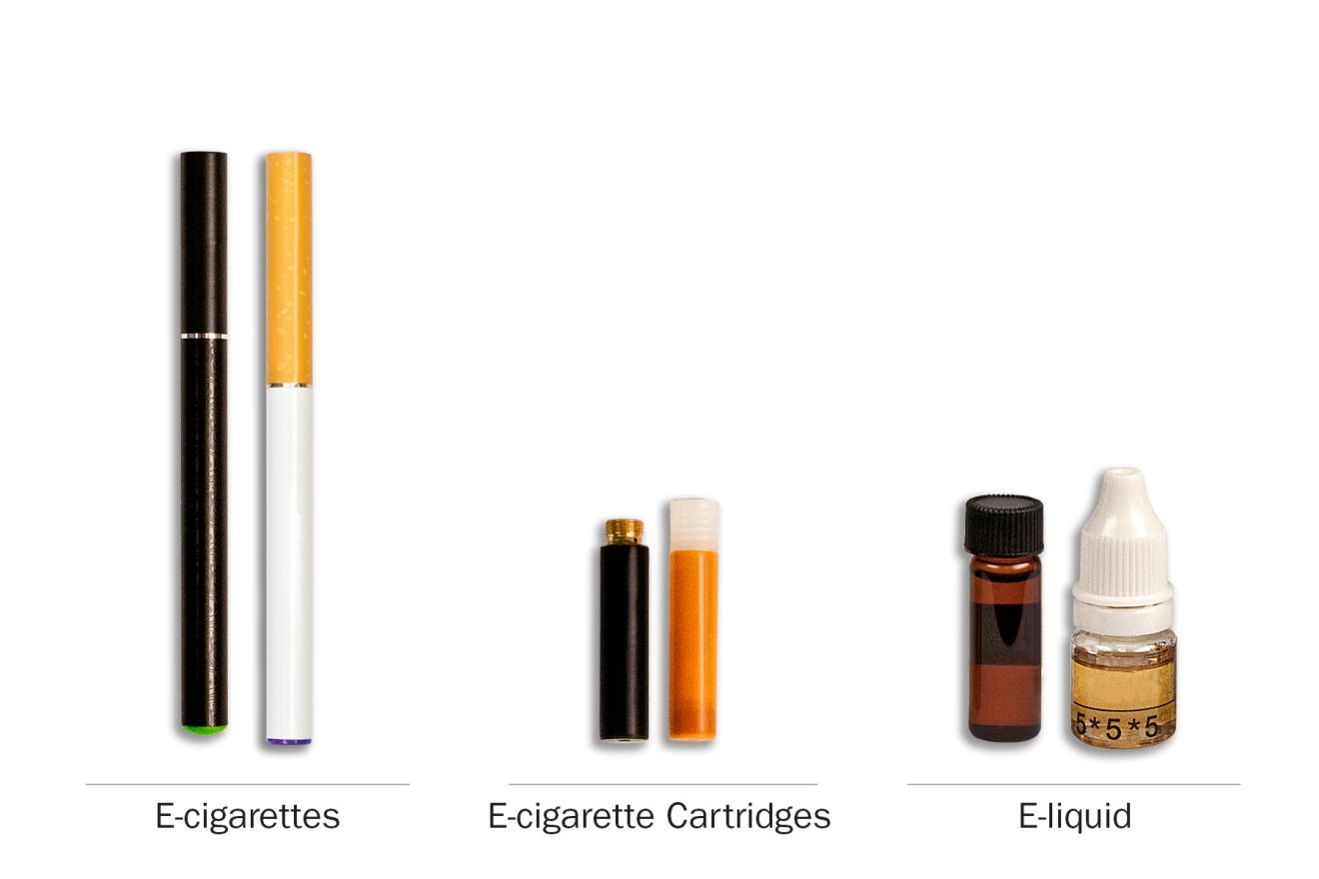
- Menos dañino
- Igual
- Más dañino
In your own words, what is this question asking?
Would your answer be the same or different if we included the words ‘Diría Ud. que’ OR ‘En su opinion”? Why or why not? Which wording would you prefer?
PATH ID: AG1099
- ¿Fumar puros tradicionales es menos dañino, es igual de dañino o es más dañino que fumar cigarrillos?
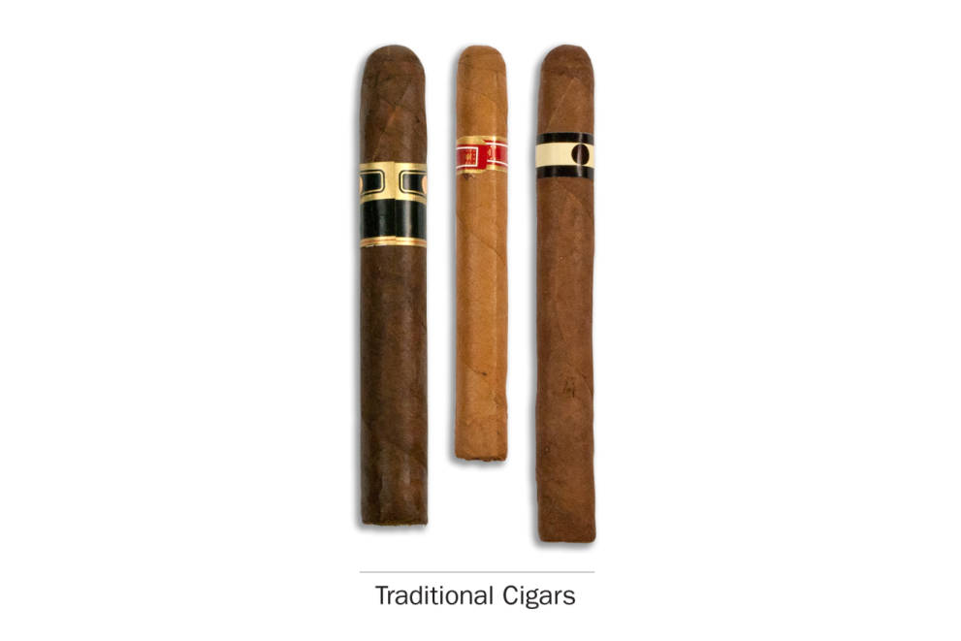
- Menos dañino
- Igual
- Más dañino
In your own words, what is this question asking?
Would your answer be the same or different if we included the words ‘Diría Ud. que’ OR ‘En su opinion”? Why or why not? Which wording would you prefer?

PATH ID: AG1106
- ¿Fumar puritos es menos dañino, es igual de dañino o es más dañino que fumar cigarrillos?
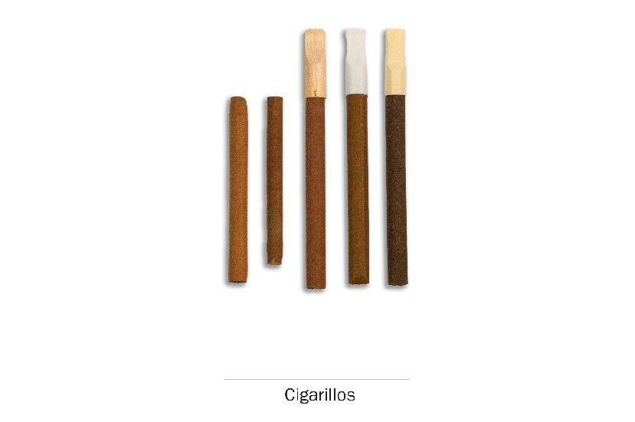

- Menos dañino
- Igual
- Más dañino
In your own words, what is this question asking?
Would your answer be the same or different if we included the words ‘Diría Ud. que’ OR ‘En su opinion”? Why or why not? Which wording would you prefer?

PATH ID: AG1107
- ¿Fumar puros con filtro es menos dañino, es igual de dañino o es más dañino que fumar cigarrillos?
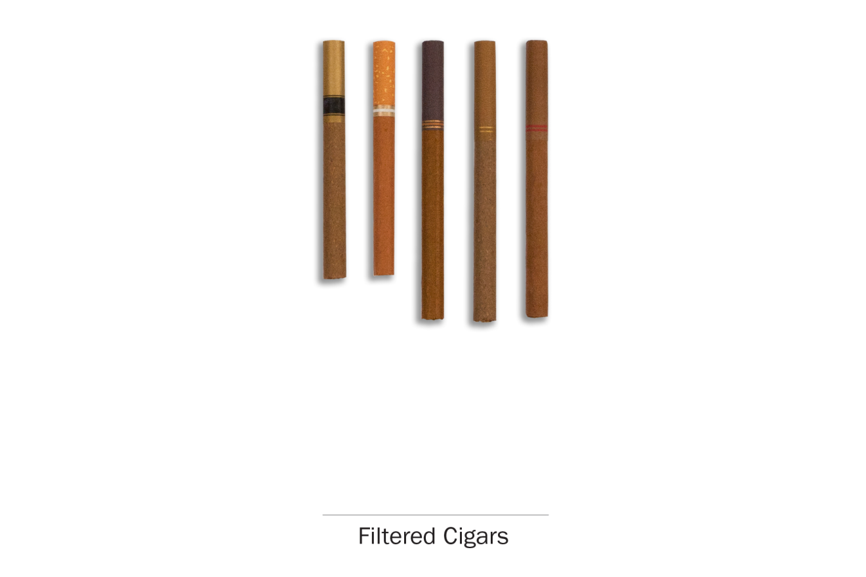
- Menos dañino
- Igual
- Más dañino
In your own words, what is this question asking?
Would your answer be the same or different if we included the words ‘Diría Ud. que’ OR ‘En su opinion”? Why or why not? Which wording would you prefer?

PATH ID: AP1099
- ¿Fumar tabaco en pipa es menos dañino, es igual de dañino o es más dañino que fumar cigarrillos?
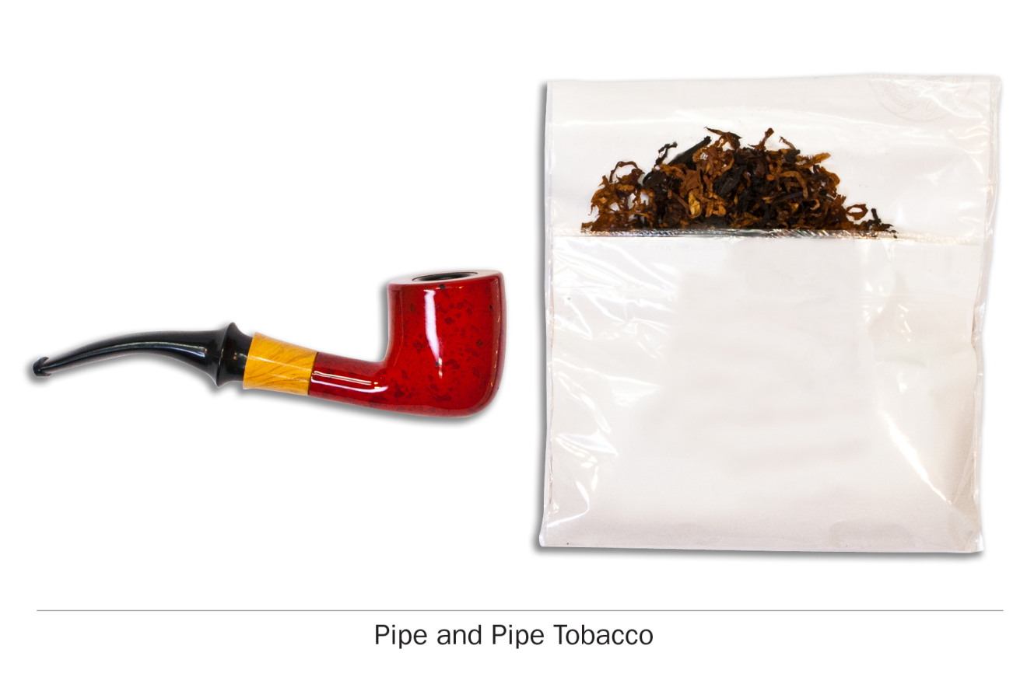
- Menos dañino
- Igual
- Más dañino
In your own words, what difference, if any, is there between “un poco” and “algo”?
Would your answer be the same or different if we included the words ‘Diría Ud. que’ OR ‘En su opinion”? Why or why not? Which wording would you prefer?

PATH ID: AH1099
- ¿Fumar tabaco en hookah es menos dañino, es igual de dañino o es más dañino que fumar cigarrillos?
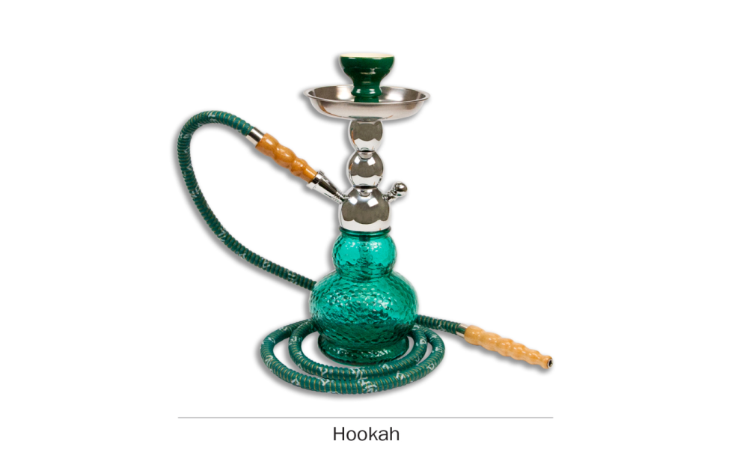
- Menos dañino
- Igual
- Más dañino
PROBE: What is the this question asking? How can it be made clearer?
Would your answer be the same or different if we included the words ‘Diría Ud. que’ OR ‘En su opinion”? Why or why not? Which wording would you prefer?

PATH ID: AS1105
- ¿Consumir tabaco que no se fuma es menos dañino, es igual de dañino o es más dañino que fumar cigarrillos?
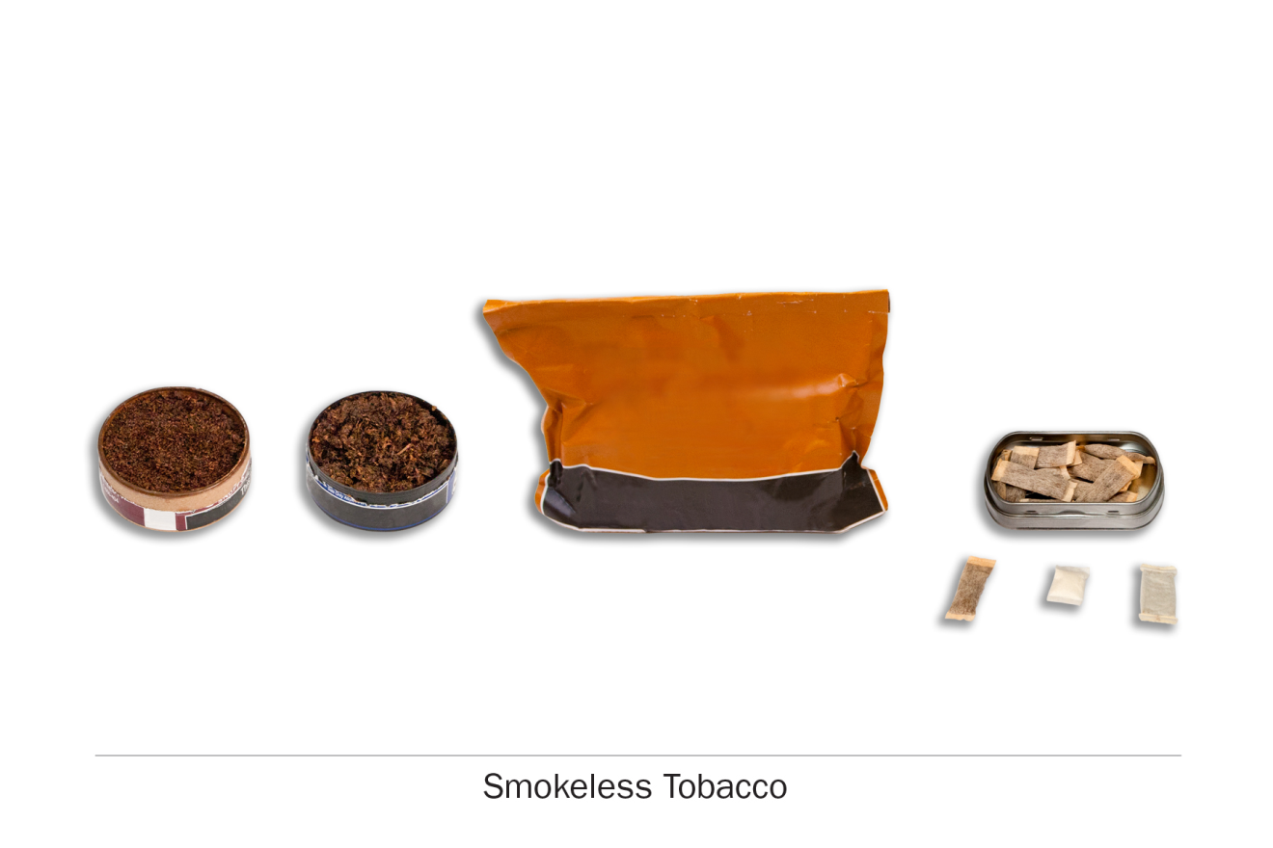
- Menos dañino
- Igual
- Más dañino
PROBE: What is the this question asking? How can it be made clearer?
Would your answer be the same or different if we included the words ‘Diría Ud. que’ OR ‘En su opinion”? Why or why not? Which wording would you prefer?

RESEACH QUESTION:
Also, test adding “en la boca” after “disuelve” as it is more descriptive and precise.
PATH ID: AD1099
- ¿Consumir tabaco que se disuelve es menos dañino, es igual de dañino o es más dañino que fumar cigarrillos?
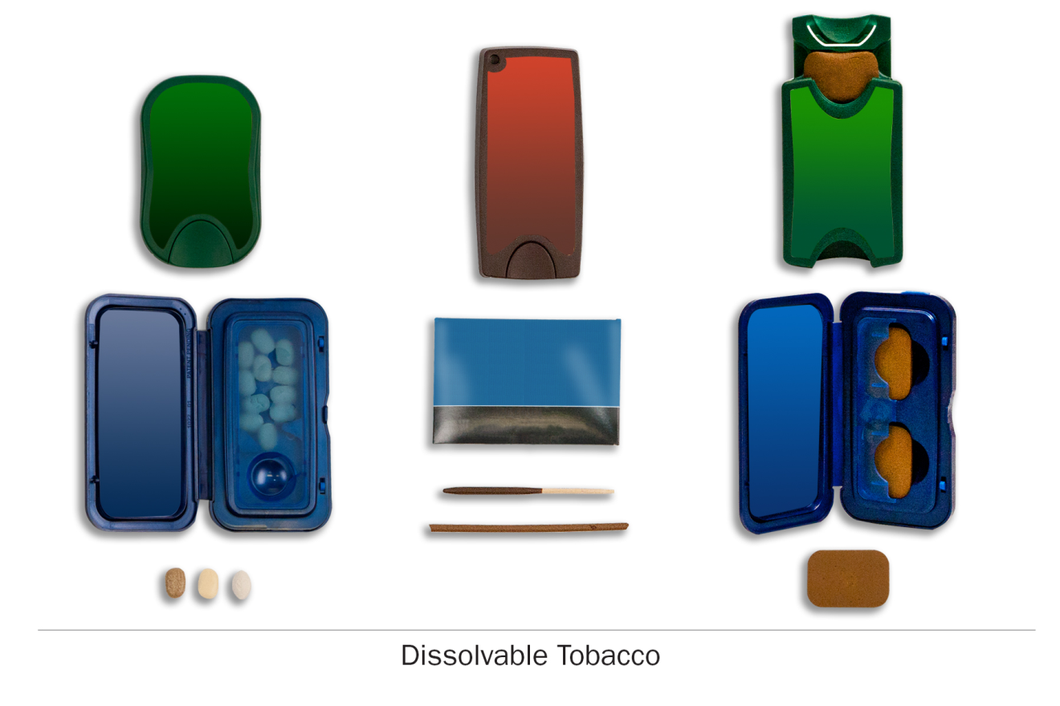
- Menos dañino
- Igual
- Más dañino
In your own words, what is this question asking?
What would your reaction be to adding “en la boca” after “se disuelve”? Would that make this question more clear, less clear, or wouldn’t make a difference?
Would your answer be the same or different if we included the words ‘Diría Ud. que’ OR ‘En su opinion”? Why or why not? Which wording would you prefer?

.

Spanish Health Module
ALL RESPONDENTS

Las siguientes preguntas son acerca de alguna información médica básica que es importante para el estudio.
RESEARCH QUESTION:
Respondents may define “consultorio médico” narrowly as going to a doctor’s office, excluding visits to a clinic or a mobile clinic. Test respondent interpretation.
PATH ID: AX0001
- En los últimos 12 meses, ¿ha ido a un consultorio médico?
- Sí
- No
How did you arrive at your answer?
The last time you saw a doctor, was it in a “consultorio médico”?
IF NO, Where did you see this doctor?
What other places might you receive medical care?
What term would you use to define all these places?
IF NEEDED, suppose you are at work and you saw a nurse in a mobile clinic, what term would you use instead of “consultorio médico”?
PATH ID: AX0002
- En los últimos 12 meses, ¿ha ido al dentista?
- Sí
- No
How did you arrive at your answer?
PATH ID: AX0302
- En los últimos 12 meses, ¿ha ido a la sala de emergencias o urgencias debido a un problema de salud que lo aquejaba?
- Sí
- No GO TO Q5
How did you arrive at your answer?
PATH ID: AX0155
- En los últimos 12 meses, ¿cuántas veces ha ido a la sala de emergencia o urgencias debido a un problema de salud que lo aquejaba?
___________________________________
How did you arrive at your answer?

PATH ID: AX0003
- En los últimos 12 meses, ¿le ha recomendado un médico, un dentista u otro profesional de la salud que deje de consumir tabaco [o cigarrillos electrónicos]?
- Sí
- No
How did you arrive at your answer?
RESEARCH QUESTION:
Determine how respondents differentiate between “un poco” and “algo”. These terms may be perceived as similar.
PATH ID: AX0104
- ¿Hasta qué punto ha dañado su salud, su [consumo de / consumo pasado de] productos de tabaco?
- Para nada
- Un poco
- Algo
- Mucho
How did you arrive at your answer?
In your own words, what difference, if any, is there between “un poco” and “algo”?

RESEARCH QUESTION:
Determine if any of the response options are difficult to use to gauge effort or distances, i.e., 3 blocks and 1 mile.
PATH ID: AX0097
- ¿Limita su salud alguna de las siguientes actividades? Escoja todas las opciones que correspondan.
- Levantar 10 libras
- Subir hasta 10 escalones
- Caminar 3 cuadras
- Caminar 1 milla
- Estar de pie por 20 minutos
- Agacharse o encorvarse
- Alzar el brazo por encima de la cabeza
- Usar los dedos para agarrar
- Ninguna de los anteriores
How easy or difficult was it to answer this question? What made it easy or difficult?
IF NEEDED, What did you think of these answer choices? Are there any that seemed odd or difficult to understand?
Is there a better way to ask this question?

RESEARCH QUESTION:
The wording is slightly awkward. The term “padece” (literally “suffers from”) is more commonly used with “having a condition or disease”(e.g., “she has diabetes” would translate to “ella padece de diabetes.”)
PATH ID: AX0111
- Alguna vez, ¿le ha dicho un médico u otro profesional de la salud que tenía alguno de los siguientes problemas del corazón? Escoja todas las opciones que correspondan.
- Hipertensión
- Colesterol alto
- Insuficiencia cardíaca congestiva
- Un derrame cerebral
- Un ataque al corazón (también llamado infarto de miocardio) o que necesitaba cirugía de bypass
- Otra enfermedad del corazón
- Ninguna de las anteriores Go to Q10
What reaction, if any, did you have to this question?
In your own words, what is this question asking?
I want to share alternative wording: “Alguna vez, ¿le ha dicho un médico u otro profesional de la salud que tenía ha tenido o padece de alguno de los siguientes problemas del corazón?” Which wording do you prefer? Why?

PATH ID: AX0219
- En los últimos 12 meses, ¿tomó algún medicamento para el corazón o la presión arterial de manera habitual? (De manera habitual quiere decir de acuerdo con las instrucciones de un profesional del cuidado de la salud.)
- Sí
- No
How did you arrive at your answer?

RESEARCH QUESTION:
It is unclear if respondents will understand “COPD” (and Enlish acronym) or if they prefer another term, such as “La Enfermedad Pulmonar Obstructiva Crónica o EPOC”. We’d also like to test if slightly modifying the question aids in clarity and makes it sound more culturally smooth/appropriate. The term “padece” (literally “suffers from”) is commonly used with “having a condition or disease”, such as “she has diabetes” would translate to “ella padece de diabetes.”
PATH ID: AX0119
- Alguna vez, ¿le ha dicho un médico u otro profesional de la salud que tenía alguno de los siguientes problemas pulmonares o respiratorios? Escoja todas las opciones que correspondan.
- COPD
- Bronquitis crónica GO TO Q16
- Enfisema GO TO Q16
- Asma
- Algún otro tipo de problema pulmonar o respiratorio GO TO Q16
- Ninguna de los anteriores GO TO Q16
PROBE: What is this question asking? How can it be stated more clearly?
I want to show you some alternte wording: “Alguna vez, ¿le ha dicho un médico u otro profesional de la salud que tenía ha tenido o padece de alguno de los siguientes problemas pulmonares o respiratorios?” Which wording do you prefer? Why?
PATH ID: AX0283
- En los últimos 12 meses, ¿tomó algún medicamento de manera habitual para COPD o el asma? (De manera habitual quiere decir de acuerdo con las instrucciones de un profesional del cuidado de la salud.)
- Sí
- No GO TO Q16
How did you arrive at your answer?
If R does not have asthma, skip to Q16
PATH ID: AX0125
- En los últimos 12 meses, ¿ha tenido un ataque de asma en el que se necesitó usar un medicamento esteroide por vía oral o en inyección en el momento del ataque? [Algunos ejemplos de medicamentos esteroides por vía oral o en inyección son la prednisona, la prednisolona (Orapred) y la dexametasona (Decadron).]
- Sí
- No GO TO 14
How did you arrive at your answer?
PATH ID: AX0126
- En los últimos 12 meses, ¿cuántos ataques asmáticos ha tenido en los que se necesitaba usar un medicamento esteroide oral o en inyección en el momento del ataque?
___________________________________
How did you arrive at your answer?

PATH ID: AX0127
- En los últimos 12 meses, ¿ha tenido que visitar una sala de urgencias o un centro de cuidado de urgencias debido al asma?
- Sí
- No GO TO 16
How did you arrive at your answer?
PATH ID: AX0282
- En los últimos 12 meses, ¿cuántas veces ha ido a la sala de emergencias o urgencias debido al asma?
___________________________________
How did you arrive at your answer?
PATH ID: AX0158
- ¿Toma alguno de los siguientes medicamentos? Escoja todas las opciones que correspondan.
- Aspirina
- Tylenol (acetaminofén o paracetamol) GO TO NEXT SECTION
- Inhibidores Cox-2, por ejemplo: Clebrex, Vioxx Celebrex GO TO NEXT SECTION
- Otro medicamento antiinflamatorio, por ejemplo: ibuprofeno, Motrin, Advil, Naprosyn, o Aleve GO TO NEXT SECTION

PATH ID: AX0156
- Aproximadamente, en los últimos 12 meses, ¿con qué frecuencia toma aspirina? No incluya a los analgésicos (calmantes para el dolor) tales como ibuprofeno o Tylenol.
- Nunca
- Menos de una vez al mes
- 1 a 3 días al mes
- 1 a 2 días a la semana
- 3 a 4 días a la semana
- 5 a 6 días a la semana
- A diario
How did you arrive at your answer?

Pregnancy
RESEARCH QUESTION:
Some of the terms used, while technically correct, may be unfamiliar to respondents. Test respondents’ understanding of the terms used and probe to see if there are other terms that may work better.
PATH ID: AX0134
- Las siguientes preguntas son acerca de su historial de embarazos.
Alguna vez, ¿ha estado embarazada? Por favor, incluya su embarazo actual, nacimientos vivos, pérdidas del embarazo, abortos, embarazos ectópicos o tubáricos (en las trompas) y embarazos en los que el bebé nació sin vida.
- Sí
- No GO TO NEXT MODULE
Whas this question easy or difficult to understand? What made it easy/difficult?
Were there any terms that you were unfamiliar with?
Do you usually use the term“nacimientos vivos” , or is there another term you use?
Do you usually use the term “pérdidas del embarazo”, or is there another term you use?
Do you usually use the term “y embarazos en los que el bebé nació sin vida”, or is there another term you use?

RESEARCH QUESTION:
In Spanish, “abortion” can be used to describe both a miscarriage and an intentional abortion (provoked miscarriage). It does not carry the same connotations as it does in English, nor is it necessarily sensitive when describing the term “miscarriage” (“aborto espontáneo”). Also, option #4 is usually described as “mortinato”. Determine which terms respondents prefer.
PATH ID: AX0135
- ¿Alguno de sus embarazos resultó en lo siguiente? Escoja todas las opciones que correspondan.
- Pérdida del embarazo
- Aborto GO TO NEXT MODULE
- Embarazo ectópico o tubárico (en las trompas) GO TO NEXT MODULE
- Embarazo en el que el bebé nació sin vida GO TO NEXT MODULE
- Ninguna de las anteriores GO TO NEXT MODULE
In your own words, what is the first answer choice, Pérdida del embarazo? Are those the words you usually use, or are there others?
In your own words, what is the second answer choice, Aborto? Is that the word you usually use, or are there others?
In your own words, what is the fourth answer choice, Embarazo en el que el bebé nació sin vida? Are those the the words you usually use, or are there others?
PATH ID: AX0308
- ¿Cuántos embarazos han resultado en nacimientos vivos?
___________________________________

PATH ID: AX0300
- Para esos nacimientos, ¿pasó algo de los siguiente? Escoja todas las opciones que correspondan.
- Nacimiento prematuro (el bebé nació antes de las 37 semanas de gestación)
- Bebé con bajo peso (menos de 5 libras 8 onzas)
- Bebé con defectos congénitos
- Placenta previa (cuando la placenta cubre el cuello uterino)
- Desprendimiento prematuro de la placenta
- Preeclampsia
- Ninguna de las anteriores
PROBE: How can this question be made clearer? Which terms, if
How easy or difficult was it to answer this question? What made it easy/difficult?
Were there any terms you were unfamiliar with?

Spanish Demographics Module
all respondents
Por último, tenemos algunas preguntas adicionales sobre usted y su trabajo.

Employment
RESEARCH QUESTION
Confirm respondents are comfortable with the usage of terminology surrounding employment.
PATH ID: AM0016
- ¿Cuál es su puesto de trabajo u ocupación principal?
___________________________________ go to Q3
- Not currently working
PATH ID: AM0017
- Actualmente:
- está buscando un trabajo pagado
- es un estudiante que no está buscando un trabajo pagado
- cuida del hogar o de otra persona y no está buscando un trabajo pagado
- está jubilado/retirado
- no puede trabajar debido a un problema físico o de salud mental
- no puede trabajar debido a otras razones
- ninguna de las anteriores
What reaction, if any, did you have to this question?
What words, if any, would you change?

Income
RESEARCH QUESTION:
Do respondents interpret the timeframe appropriately? Are they able to accurately repor their income with the given categories?
PATH ID: AM0015
- En los últimos 30 días, debido a la falta de dinero, ¿tuvo problemas para pagar las cuentas a tiempo, tales como el alquiler, la electricidad o el teléfono?
- Sí
- No
- No aplica
How did you arrive at your answer? IF NEEDED, What timeframe were you thinking about when you answered?
PATH ID: AM0030
- ¿Cuál de las siguientes categorías describe mejor el ingreso total de su hogar en los últimos 12 meses?
Esto es el ingreso total, antes de impuestos, de todas las personas de su hogar en conjunto. Incluya el dinero que recibió de trabajos, familiares, pensiones, dividendos, intereses, pagos del Seguro Social o pensiones de jubilación, ingresos netos de negocios, agricultura o alquiler y cualquier otro dinero recibido por los miembros del hogar.
- Menos de 10,000 dólares go to Q6
- 10,000 a 14,999 dólares go to Q6
- 15,000 a 24,999 dólares go to Q6
- 25,000 a 34,999 dólares go to Q6
- 35,000 a 49,999 dólares go to Q6
- 50,000 a 74,999 dólares go to Q6
- 75,000 a 99,999 dólares go to Q6
- 100,000 a 149,999 dólares go to Q6
- 150,000 a 199,999 dólares go to Q6
- 200,000 dólares o más go to Q6
- Don’t know
How did you arrive at your answer? IF NEEDED, What timeframe were you thinking about when you answered?
PATH ID: AM0031
- El ingreso total de su hogar en los últimos 12 meses, ¿es mayor o menor de 50,000 dólares?
- Mayor de 50,000 dólares
- Menor de 50,000 dólares
How did you arrive at your answer? How confident are you in your answer?

Sexuality
RESEARCH QUESTION:
Respondents may be unfamiliar with the some of the terms describing sexuality. In addition, many may be culturally uncomfortable answering this series questions
PATH ID: AM0021
- Las siguientes preguntas son sobre su nivel de atracción sexual a AMBOS sexos, hombres y mujeres. Por favor, responda las preguntas cuidadosamente, ya que es importante que las entienda y que sea lo más honesto(a) posible.
¿Por quién se ha sentido atraído sexualmente, incluso si no hizo nada al respecto?
- Solo por mujeres, nunca por hombres
- Mayormente por mujeres y por lo menos una vez por hombres
- Casi con la misma frecuencia por mujeres y hombres
- Mayormente por hombres y por lo menos una vez por mujeres
- Solo por hombres, nunca por mujeres
- Nunca me he sentido atraído sexualmente por nadie
In your own words, what is this question asking? Are there any answer choices that are unclear?
PATH ID: R02_AM0063
- ¿Se considera…
- Heterosexual
- Lesbiana o gay
- Bisexual
- Otra cosa

PATH ID: R02_AM0061
- Algunas personas se describen a sí mismas como transgéneros o transexuales cuando experimentan una identidad de género distinta a la de su sexo biológico al nacer. Por ejemplo, una persona transgénero o transexual sería alguien que nació varón, pero que se siente mujer o que vive como una mujer.
¿Se considera transgénero o transexual?
- Sí
- No GO TO NEXT MODULE
In your own words, what is this question asking?
PATH ID: R02_AM0062
- ¿Se considera a sí mismo o a sí misma hombre a mujer, mujer a hombre o de género no conforme?
- Sí, transgénero o transexual, hombre a mujer
- Sí, transgénero o transexual, mujer a hombre
- Sí, transgénero o transexual, de género no conforme
- No
- No está seguro
Are there any answer choices that are unclear?
How comfortable are you in answering this series of questions?
IF NEEDED, If the question stated “Your responses are confidential and will not be divulged,” would that change how you feel answering them?

