OMB Control No. 0648-0594
Expires 9/30/2012

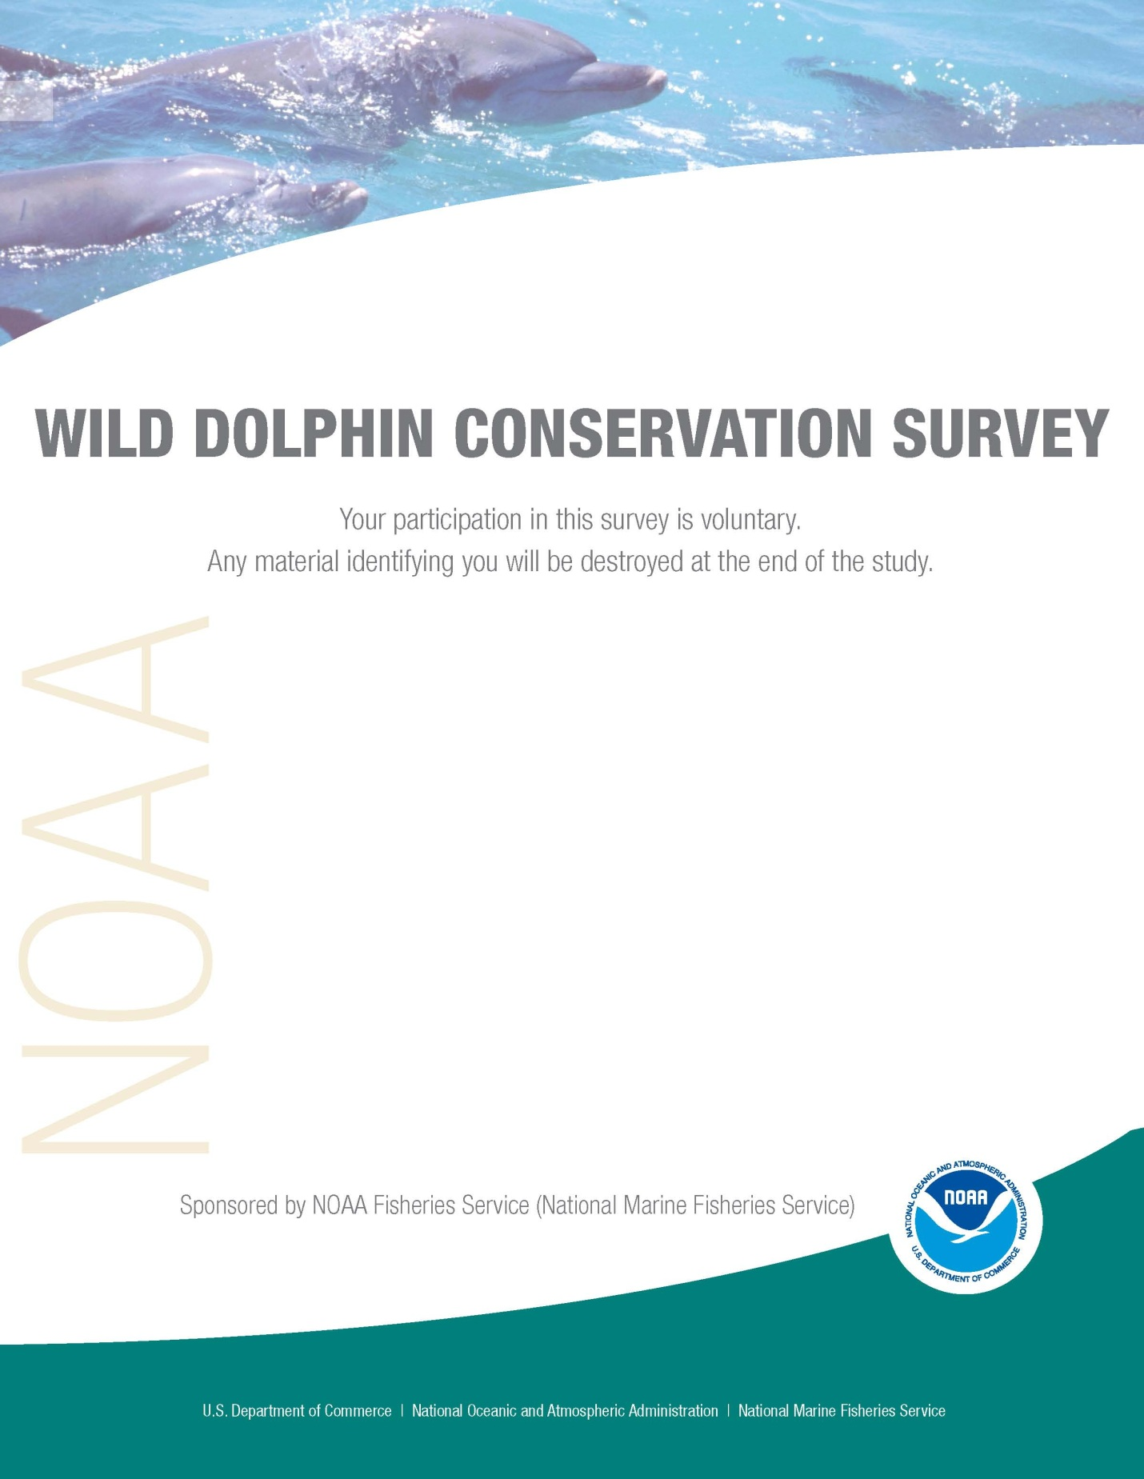
COMMERCIAL BUSINESS SURVEY

NOAA Fisheries Service (NMFS) is conducting a survey for more information on the public’s awareness and knowledge about wild dolphin conservation. The questions in this survey are about dolphins in the wild rather than dolphins in public display facilities (i.e., zoos and aquaria); therefore, any reference to the word “dolphin” means dolphins in the wild. The results of the survey will be used to help determine the effectiveness of NMFS’ public outreach efforts for wild dolphin conservation and guide future outreach activities.

Q1 How concerned are you, if at all, about protecting dolphins? (Please check one box)

Very concerned
Somewhat concerned
Not very concerned
Not at all concerned
Neutral

Q2 To the best of your knowledge, which statement is true? (Please check one box)

It is illegal but not harmful to feed dolphins in the wild please go to Q3
It is not illegal but harmful to feed dolphins in the wild please go to Q3
- It is illegal and harmful to feed dolphins in the wild please go to Q3
- It is not illegal nor harmful to feed dolphins in the wild please go to Q4

Q3 Please tell us where you heard or read the information about feeding dolphins in the wild. (Please check all that apply)

A. Posted signs on or at:
Docks or marinas
- Fishing Piers
- Visitor centers
- Other (please describe)__________________

B. Brochure from:
Visitor centers
- Hotel
- Boat rental company
- Zoo or aquarium
- Federal, state, or local government
- Other (please describe)__________________
C. Public Service Announcement (PSA) through:
- Animal related television channel/show
- Non-wildlife related television channel
- Radio station
- Newspaper
- Magazine

D. Zoological or nature center:
- Zoo, aquarium, or a wildlife theme park such as Gulf World or Sea World
- City, county, or state park
- Other (please describe)__________________

E Internet:
Florida Visitor Bureau or local tourism website
- Environmental conservation or non-profit organization website
- Federal, state, or local government website
- News related website
- Other (please describe)__________________

F. Television news:
Local
National
- Other (please describe)__________________
G. Newspaper article:
Local
National
- Other (please describe)__________________
H. Other:
Educational workshops
Nature/wildlife tour
- Word of mouth (i.e., friends and family)
- Billboard
- Other (please describe)__________________
- Cannot recall

Q4 Have you ever heard or read that it is all right to feed, pet, touch, or swim with dolphins in the wild? (Please check one box)

Yes please go to Q5
No please go to Q6
Don’t know please go to Q6

Q5 If you answered “Yes” to Q4, please tell us where you heard or read the information. (Please check all that apply)

- Television
- Newspaper

Magazines
- Radio
- Movies
- Advertisements
- Aquarium
- Zoos or wildlife parks
- Commercial tour operations
- Word of mouth (i.e., friends and family)
- Other (please describe)_______________________________________________
- Cannot recall

Q6 Which statement is true to the best of your knowledge? (Please check one box)

Swimming with, touching, or petting dolphins is potentially illegal but not harmful to you or dolphins please go to Q7
- Swimming with, touching, or petting dolphins is not illegal but harmful to both dolphins and you please go to Q7
- Swimming with, touching, or petting dolphins is potentially illegal and harmful to both you and dolphins please go to Q7
- Swimming with, touching, or petting dolphins is not illegal nor harmful to you or dolphins please go to Q8

Q7 Please tell us where you heard or read the information about swimming with, touching, or petting dolphins. (Please check all that apply)

A. Posted signs on or at:
Docks or marinas
- Fishing Piers
- Visitor centers
- Other (please describe)__________________

B. Brochure from:
Visitor centers
- Hotel
- Boat rental company
- Zoo or aquarium
- Federal, state, or local government
- Other (please describe)__________________
C. Public Service Announcement (PSA) through:
- Animal related television channel/show
- Non-wildlife related television channel
- Radio station
- Newspaper
- Magazine

D. Zoological or nature center:
- Zoo, aquarium, or a wildlife theme park such as Gulf World or Sea World
- City, county, or state park
- Other (please describe)__________________

E Internet:
Florida Visitor Bureau or local tourism website
- Environmental conservation or non-profit organization website
- Federal, state, or local government website
- News related website
- Other (please describe)__________________

F. Television news:
Local
National
- Other (please describe)__________________
G. Newspaper article:
Local
National
- Other (please describe)__________________
H. Other:
Educational workshops
Nature/wildlife tour
- Word of mouth (i.e., friends and family)
- Billboard
- Other (please describe)__________________
- Cannot recall

Q8 In your opinion, what are the best outreach methods for educating the public on safely viewing dolphins. (Please check one box for each category)

 | Very  effective | Somewhat effective | Not very effective | Not at all effective
Educational brochures and pamphlets…………
TV Public Service Announcements
Radio Public Service Announcements

Print Public Service Announcement

Internet……………
Signs………….…..
Billboards…………
Local newspaper articles……………
National magazine articles……………
Local television stories…………….
National television stories…………….
Boater training courses…………….
Workshops or town hall meetings………
Podcasts…………..
Other (please explain)

Q9 Which of the following best describes your business? (Please check all that apply)

  - Rental for:
Boat
Jet ski
Kayak
B. Chartered boat rentals:
- for fishing
- diving excursions
- Other (please describe)__________________
C. Other:
Public Display Facility (for example, zoo or aquarium)
Passenger ferry
Wildlife viewing
- Dolphin tour
- Marina
- Pier
- Other (please describe)__________________

Q10 How many years has this business been in operation? (Please describe) ________years

Q11 If your business is vessel-based, how many people is the vessel(s) designed to hold? (If your business includes more than one vessel, please provide the average vessel size)_____________

Q12 Does your business operate year-round? (Please check one box)

Yes
No

Q13 Is your commercial business primarily intended to take people to view dolphins or provide them with a way to view dolphins (i.e. boat or jet-skis rental)? (Please check one box)

Yes please go to Q14
No please go to Q16

Q14 If you answered “yes” to Q13, do you tell your guests how to view dolphins without disturbing them and why this is important? (Please check one box)

Yes please go to Q15
No please go to Q16

Q15 If you answered yes to Q14, what educational methods and/or materials do you provide? (Please check all that apply)

Educational brochures or pamphlets
Signs
Internet materials
Fact sheets
Onboard educational commentary
- Other (please describe)__________________

Q16 Would you be willing to participate in a one-time training/educational workshop on how to view dolphins without disturbing them?

(a) At no cost? (Please check one box)
Yes
No

(b) At low cost? (Please check one box)
- Yes please go to Q16(c)
- No please go to Q17

- If you answered “yes” to Q16(b), please indicate the most you are willing to pay? (Please check one box)
$5 maximum
- $10 maximum
- $15 maximum
- $20 maximum
- More than $20

Q17 Are you willing to provide, display, or play pre-recorded educational materials to guests if provided to you free of charge? (Please check one box)

Yes please go to Q18
No please go to Q19

Q18 If you answered “yes” to Q17, please tell us which educational materials you would be willing to distribute, display, or play if provided free of charge. (Please check all that apply)

Educational brochures or pamphlets
Fact Sheets
Signs
Scientific articles
Audio-visual Public Service Announcements
Podcasts
Internet materials
Posters
Stickers/vessel decals
- Other (please describe)__________________

Q19 Do you see the value in a program that provides incentives for businesses who voluntarily helping to enhance conservation of dolphins by promoting responsible viewing and advertising? (Please check one box)

Yes end
No please go to Q20

Q20 If you answered “no” to Q19, which reason(s) below best describes why? (Please check all that apply)

It may cost me money to participate.
I may lose businesses.
I don’t think that feeding or closely interacting with dolphins is harmful.
- Other (please describe)__________________

Thank you for taking the time to complete this survey. Your participation is greatly appreciated!

Public reporting burden for this information collection is estimated at 15 minutes, including time for reviewing instruction, gathering the information needed and completing and reviewing the collection of information. An additional 15 minutes is estimated for those respondents who choose to mail in their responses by the stamped and pre-addressed envelope provided. All responses will be handled as confidential in accordance with NOAA Administrative Order 216-100, Protection of Fishery Statistics. Notwithstanding any other provision of the law, no person is required to respond to, nor shall any person be subject to a penalty for failure to comply with, a collection of information subject to the requirements of the Paperwork Reduction Act, unless that collection of information displays a currently valid OMB Control Number.

