EPIC IHP/APR Screen Views

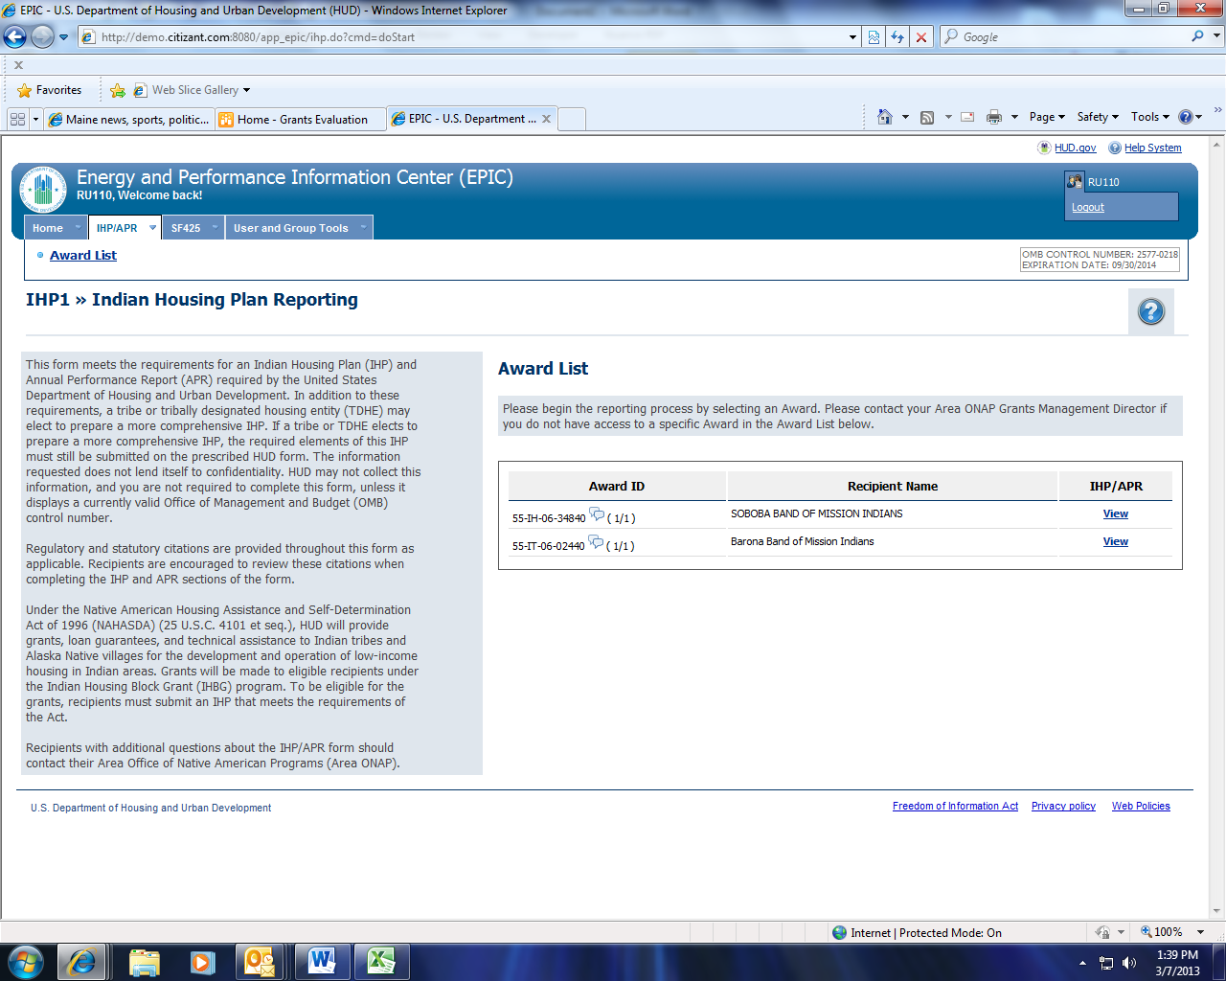
OMB Control Number, Expiation Date

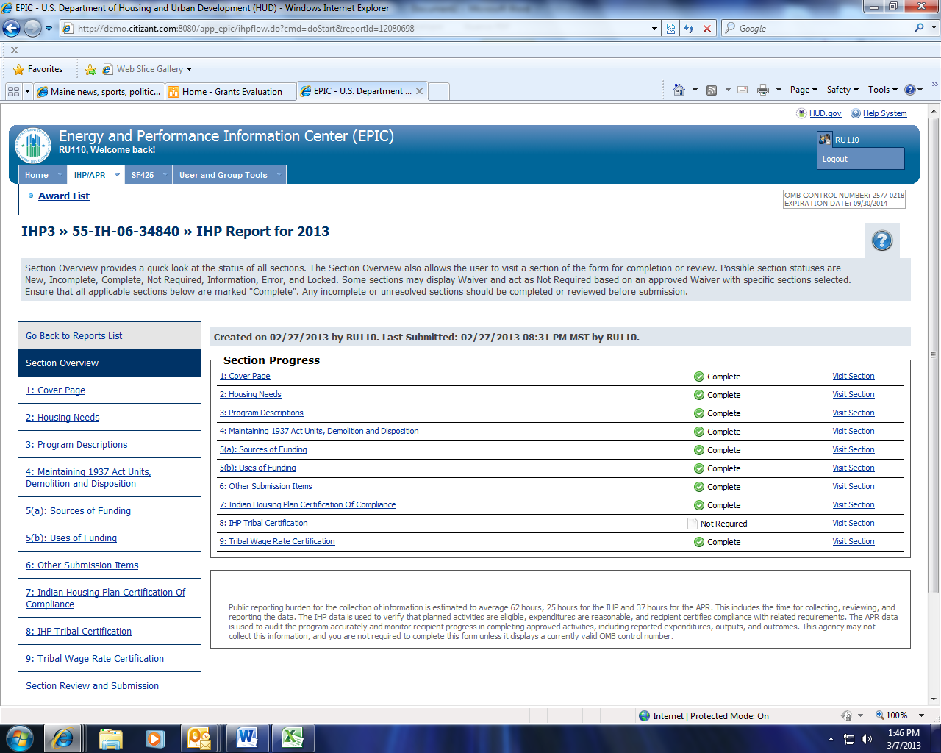
IHP Burden Statement

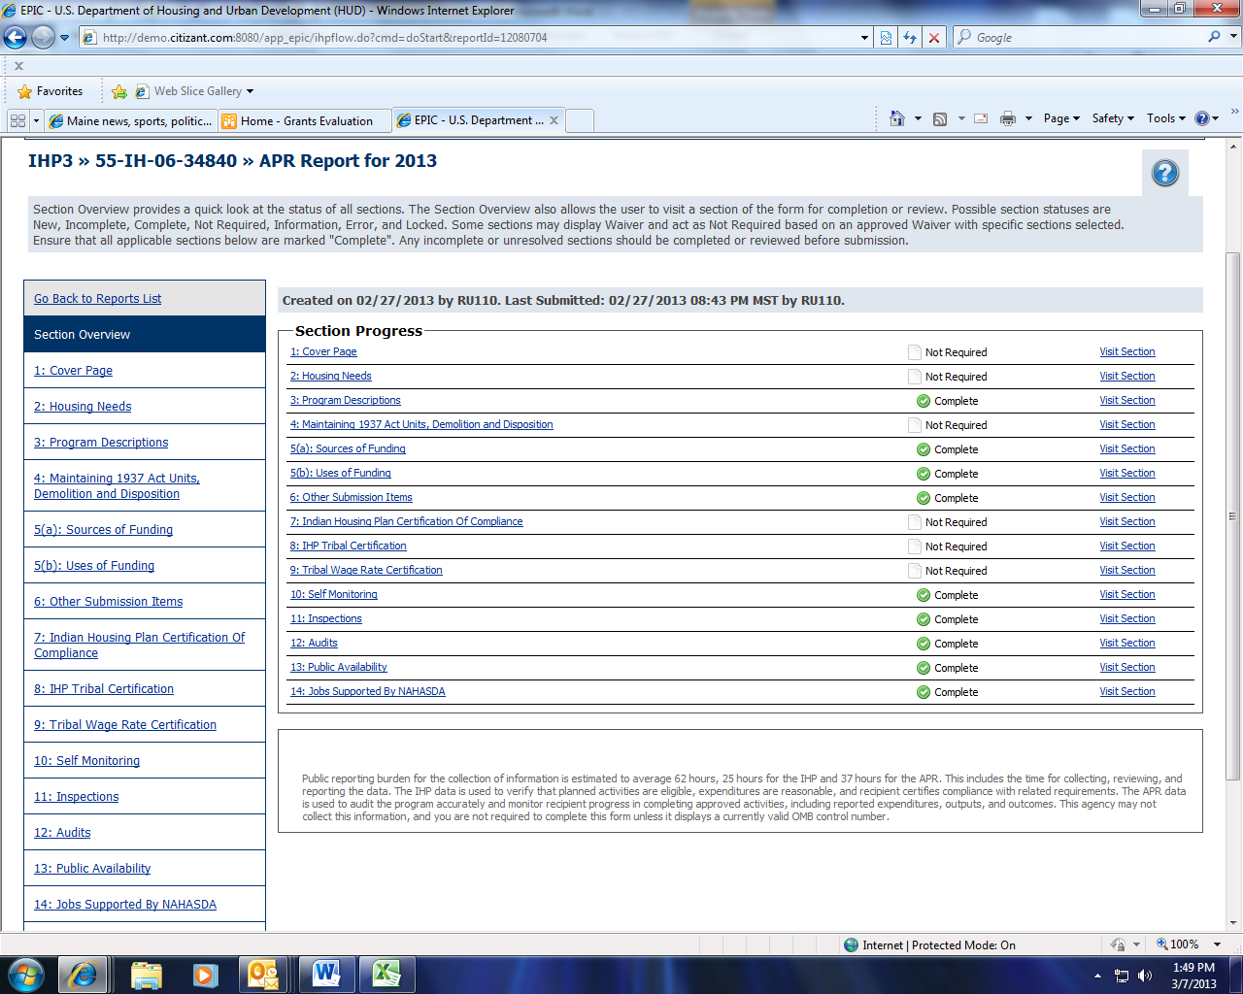
APR Burden Statement

