Name of test: Picture Vocabulary Test
Estimated time burden: 7 minutes
Estimated number of items: 25

Materials:
iPad

Description:
This measure of receptive vocabulary is administered in a computer-adaptive format. The respondent is presented with a recorded voice saying a word and with four pictures on the computer screen; the participant is instructed to touch the picture that most closely shows the meaning of the word. The test should take 5-7 minutes; which words are presented will depend on the participant’s performance.
Administration Instructions: The opening instructions are read to the participants.

Practice Items:
As an introduction, the examiner should say:
“Let’s look at some pictures. You’ll hear a word and see four pictures on the screen. Touch the picture that means the same as the word that was said. Some words will be easy and some will be harder. Answer as best you can.
If you need to hear a word again, I can play it again.
If you think you made a mistake and want to change your last answer, I can bring back that word and pictures. Are you ready to play?”
If a participant has difficulty touching the screen, he/she may point and the examiner may operate the iPad. The examiner should say something like the following to the participant: “You can point to your choice and then I will touch the screen for you.”
The examiner should touch the Touch-and-hold button to advance to the next screen.

Practice item 1:
The computer says: “Let’s try one for practice: Banana. Touch the picture of Banana.”
If correct, the computer says: “That’s right!” The computer will automatically go to the next practice item.
If incorrect, the Banana picture will light up and the computer will say: “This is a banana. Let’s try again.” The examiner should allow the child up to three chances to answer this practice item correctly. After three unsuccessful attempts by the participant, the examiner should touch the picture of the banana on the child’s screen and say: “This is a banana.” The computer will automatically go to the next practice item.

Practice item 2:
The computer says: “Let’s try another word: Spoon. Touch the picture of Spoon.”
If correct, the computer says: “That’s right!”
If incorrect, the Spoon picture will light up and the computer will say: “This is a spoon. Let’s try again.” The examiner should allow the participant up to three chances to correctly answer this practice item. After three unsuccessful attempts by the participant, the examiner should touch the picture of the spoon and say: “This is a spoon.”
Before going on, the examiner should review the task with the child, saying:
“Remember, you will hear a voice say a word and then you will see four pictures. One of the pictures will show what the word means. Touch the picture and you will hear a new word and see four more pictures. Again, touch the picture that shows what the word means. If you don’t know, make your best guess. Any questions?” The examiner should answer the questions.

Test items:
The examiner says: “Now, let’s try some more. Tell me when you are ready.” Examiner should touch the Touch-and-hold button to advance to the next screen.
The recording will say the words introduced with the following instructions: “Touch the picture of….” The items will continue in this format until the test is completed.

Sample screenshots: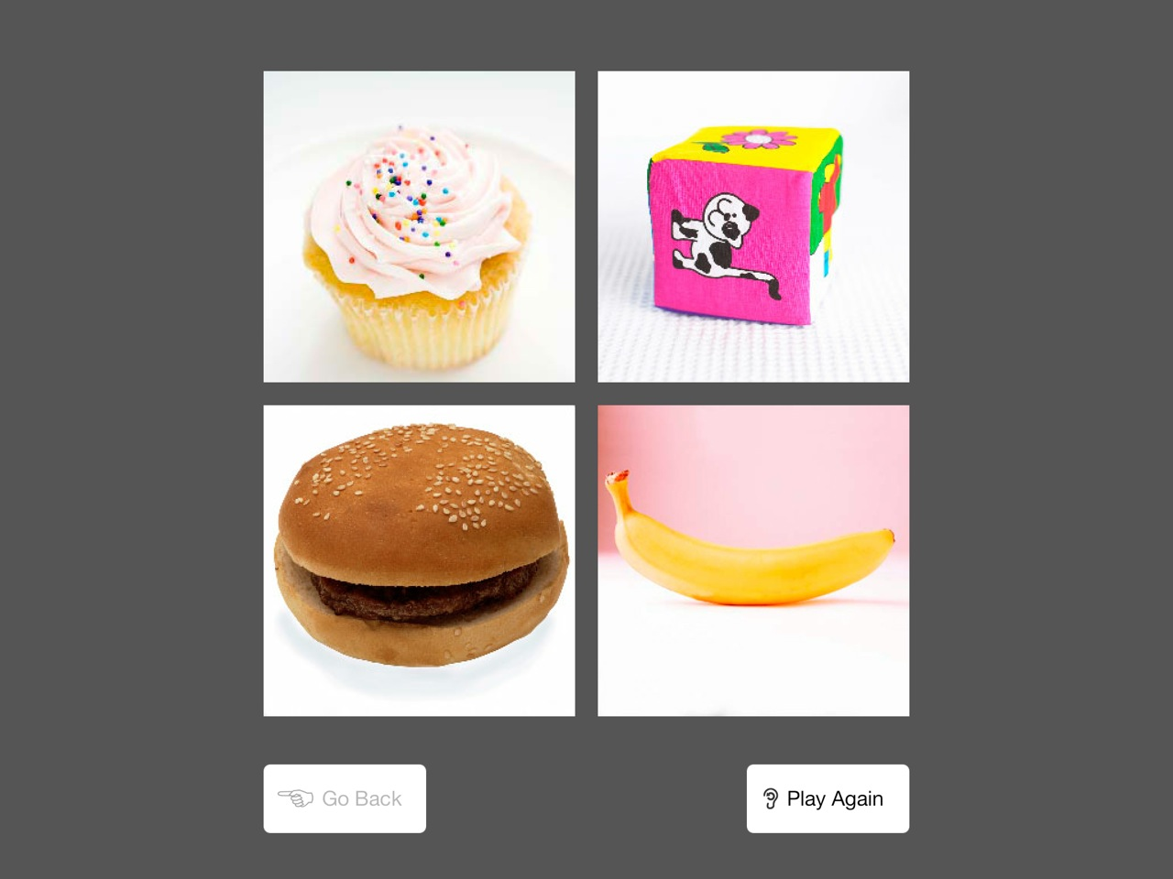
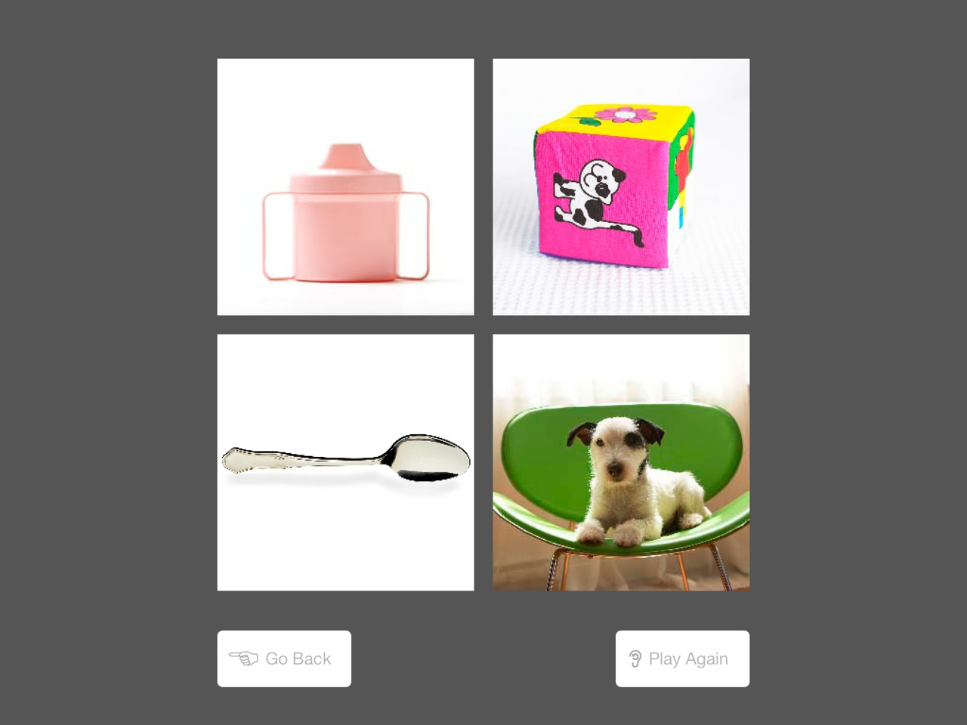

Complete bank of items (only a small selection of which are administered to any one participant; administered in either English and Spanish):

baby
money
flower
hat
foot
fish
train
bed
apple
cow
candy
egg
animal
house
door
book
child
paper
table
car
play
tree
eat
doctor
chair
dress
fireman
snake
mask
leaf
fly
guitar
bus
orange
sick
ride
party
airplane
star
balloon
tent
fun
rocket
wet
water
crayon
run
trash
stick
coat
ocean
back (of)
belt
big
crib
tractor
zoo
riding
nap
under
trophy
triangle
bucket
blanket
queen
angry
brush
shovel
log
diamond
yogurt
rose
open
pan
jewelry
railroad
roof
broom
jar
instrument
tricycle
porch
yard
castle
melted
stage
hive
lotion
tortoise
envelope
luggage
royal
wand
cut
gold
cactus
pyramid
hilarious
net
lighthouse
metal
cliff
shore
sculpture
carry
buy
plastic
boil
calm
carriage
palace
giggle
antenna
windmill
cottage
boulder
launch
spattered
ferocious
journal
tutor
crate
shatter
fancy
herd
camouflaged
arctic
dissolved
beside
exhibit
elastic
stubborn
acrobat
zodiac
scholar
cattle
cable
stampede
equation
unstable
festive
fellowship
engraved
blueprint
lounging
molten
drought
bouquet
souvenir
braid
voyage
transport
citrus
pamphlet
startled
utensil
tusk
snarl
weld
discouraged
monument
intersection
corroded
creek
quills
orchard
instruct
construct
ripple
barricade
trench
consume
lobby
port
broth
perch
swift
figurine
diagram
prohibit
gavel
absorb
decrepit
excavate
knickknack
fragment
hangar
debris
mine
pillars
tethered
boulevard
knead
residential
satchel
acoustic
offspring
cove
hedge
tattered
marsh
indicate
depot
fabricate
vortex
dune
ladle
judiciary
glum
slit
cascade
flimsy
transact
disarray
attire
transparent
tarnished
quartet
cubicle
tote
desolate
descend
summit
mend
confine
masonry
quarrel
brawny
irate
compress
celestial
frigid
minute
haul
distinguished
flamboyant
shimmer
tranquil
submerged
incinerate
bestow
noxious
vineyard
barren
pageantry
shabby
refurbish
labyrinth
lethargic
wallowing
rural
horizontal
cleave
oxidized
odometer
peak
ledger
jovial
panorama
morsel
thicket
melancholy
silhouette
quibble
ravine
congestion
sentry
receptacle
refuse
sumptuous
adhere
ensemble
trend
plumage
manger
bureau
plethora
striated
arid
burly
sapling
frothy
orifice
turbulent
fiery
abode
encumber
hodgepodge
perusal
trinket
idle
embellish
wilt
flaccid
luster
revel
comrade
scorched
glower
beacon
indisposed
amiable
helix
foal
concave
deluge
gregarious
inclement
opulent
cherubic
pachyderm
knoll
hovel
erode
cosmopolitan
coalesce
precipice
memento
feral
sustenance
domicile
malefactor
hydroponics
zenith
fissure
effervescent
infuse
spry
throng
disconsolate

monarch
obstreperous
jowl
tarpaulin
hurl
ellipse
wary
scintillating
surly
slat
verdant
quagmire
chaff
matron
buffoon
quadruped
parry
affable
anomalous
bolster
sinuous
resplendent
delineation
edifice
concomitant
ruminate
mirth
shorn
recess
reap
alms
iridescent
balustrade
atoll
gibe
islet
paucity
progeny
prone
detritus
didactic
lassitude
tractable
potable
repast
truculent
truncate
abrade
bucolic
baubles
pennant
jocular
onerous
trivet
redoubtable
munificence
egress
diadem
torpor
ebullience
histrionic
desiccated
buffet
disparate
pecuniary
firmament
cataract
fulminate
fecund
hirsute
natty
prodigious

