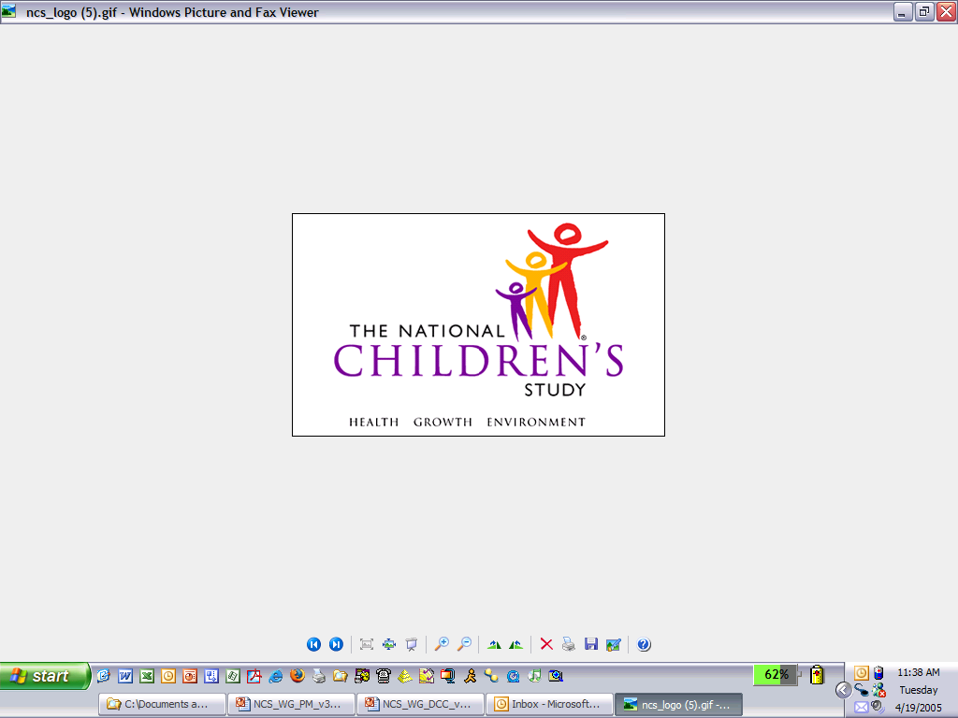

Children X months to XX months-old needed for The Bayley Child Development Study
Is your child between the ages of X months and XX months? Are you interested in learning about your child’s cognitive, motor, and language skills?

If so, we invite you to take part in a research study. We are interested in creating a short form of a measure called The Bayley that may be used in The National Children’s Study and other large scale studies. This study will be take place at your convenience at Westat on 1450 Research Boulevard in Rockville, Maryland.

We are looking for children from English-speaking households to take part in a 45-65 minute session. We are interested in observing such skills as crawling, reaching, understanding gestures and words, walking, etc. You will receive $25 and your child will receive a gift book for taking part in this study.

If you would like to participate or want more information, please call Carol Andreassen at 301-610-4838. You will be asked a few questions to see if your child can take part in this study.

