WASHOE COUNTY |  |  |  |  | 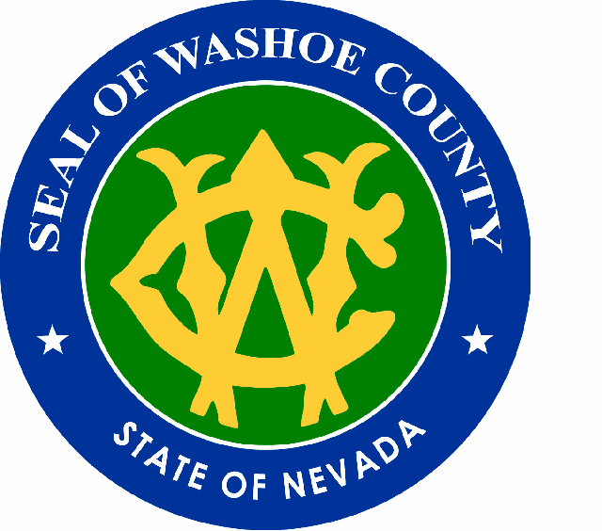
“Dedicated to Excellence in Public Service”
 |  |  |  | 350 S. CENTER STREET
DEPARTMENT OF SOCIAL SERVICES |  |  |  | POST OFFICE BOX 11130
Children’s Services |  |  |  | RENO, NEVADA 89520-0027
 |  |  |  | PHONE: |  | (775) 785-8600
 |  |  |  | FAX: |  | (775) 785-8648

Dear Prospective Participant,
You are asked to take part in a study going on with Washoe County Department of Social Services. The study is being done by Westat, a company hired by the U.S. Department of Health and Human Services. Before you decide to be in this study, it is important that you understand the purpose of the study and what it will involve. Please read the following information carefully.

What is the purpose of this study?
The purpose of this study is to find out which service programs in Washoe County help children stay out of foster care or leave foster care sooner. We need your help in finding out which services work better.

What am I being asked to do now?
At this time, we are asking you to agree to let Washoe County share your contact information with Westat. If you do not want Washoe County to give your contact information to Westat, please call the number below to tell the Washoe County not to share your contact information with Westat. If you do not call the number below by (insert date), Washoe County will share your contact information with Westat and a Westat researcher will call you to tell you more about the study. Your choice will not affect your case or the services that you and your family get.

What will I be asked to do if I agree to be in the study?
If you agree to let Washoe County share your contact information with Westat, a Westat researcher will call you and tell you more about the study. If you agree to be in the study, a Westat researcher will set up a time with you to come to your home and have you complete assessments about yourself and your family. The researcher will come to your home several times while your case is open in Washoe County. The questions will take no more than 90 minutes to answer. It will be done at a time that works best for you.

Do I have to take part in the study?
You can decide to be in the study or not. You can stop being in the study at any time. You can also decide later to be in the study. Your choice will not affect your case or the services that you and your family get. However, if you do not agree to participate, you may still be required to complete assessments about yourself and your family, depending on the services Washoe County assigns you. If required, your caseworker will gather this information from you and we will not use this information in the study.

What are the possible risks and discomforts?
We do not expect any risks from being in this study. If some of the questions make you feel upset or sad, you can talk with your caseworker. You can also skip questions you do not want to answer.

Are there any benefits from taking part in this study?
There are no direct benefits of taking part in this study. However, your participation will help the Washoe County develop better ways to serve families and children.

Who will see the information that I Share During the Study?
We will keep your information private according to the requirements of the Privacy Act of 1974 (Public Law 93-579). We will not include information that identifies you or your family in any reports. The study team will see your answers to individual questions. Your caseworker may see summary information from your answers. Washoe County Department of Social Services, including your caseworker, will not see your individual responses to questions except in situations where there is a need to prevent serious harm to yourself or others.

What if I do Not want Washoe County Department of Social Services to share my information?
If you do not want Washoe County Department of Social Services to share your contact information with Westat, please call Dena Negron at 775-785-8640 by (DATE TBD Pending OMB and IRB CLEARANCE).

What if I have questions about the study?
If you have questions about the study contact Allison Meisch of Westat at 1-800-937-8281 extension 2820.

Date of IRB approval of this letter: 5/29/12
Expiration date of IRB approval of this letter: 3/13
OMB NO:
EXPIRATION DATE:
THE PAPERWORK REDUCTION ACT OF 1995: Public reporting burden for this collection of information is estimated to average 90 minutes per response, including the time for reviewing instructions, gathering and maintaining the data needed, and reviewing the collection of information. An agency may not conduct or sponsor, and a person is not required to respond to, a collection of information unless it displays a currently valid OMB control number.

