Attachment K
Outpatient Department Patient Record form
Ambulatory Care Pretest, National Hospital Care Survey
OMB No. 0920-xxxx Exp. Date
Assurance of confidentiality – All information which would permit identification of an individual, a practice, or an establishment will be held confidential, will be used for statistical purposes only by NCHS staff, contractors, and agents only when required and with necessary controls, and will not be disclosed or released to other persons without the consent of the individual or establishment in accordance with section 308(d) of the Public Health Service Act (42 USC 242m) and the Confidential Information Protection and Statistical Efficiency Act (PL-107-347).

Patient’s name: ________________________________________________________
Patient’s address: ______________________________________________________ Street
____________________________ City _______ State
Patient’s Social Security number _____________________
Patient’s Control number ____________________________
Medicare health insurance benefit/claim number ___________________________
National Provider Identifier (NPI) - Attending _______________________________
National Provider Identifier (NPI) - Operating _______________________________

The current question on page 8 “Is patient allergic to any medication, e.g., bleeding from aspirin?” will be changed to the following:
Is the patient allergic to any medication?
Yes – Enter up to 3
No or no known allergies
Unknown
Has the patient had any adverse reaction to any medication (e.g., bleeding from aspirin)?
Yes – Enter up to 3
No or no known adverse reactions
Unknown

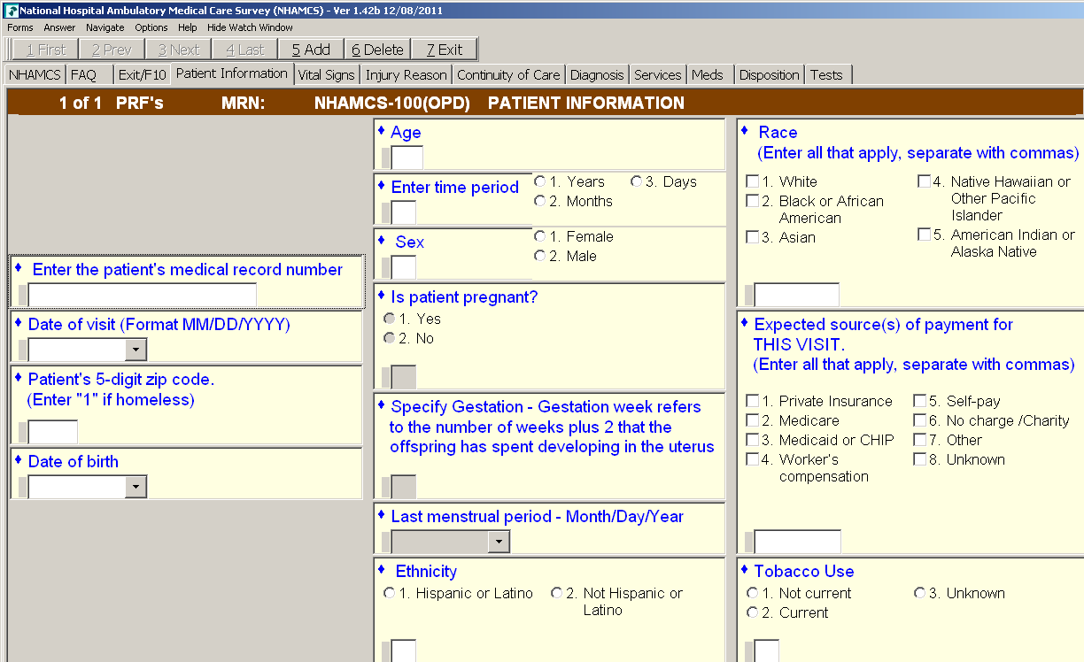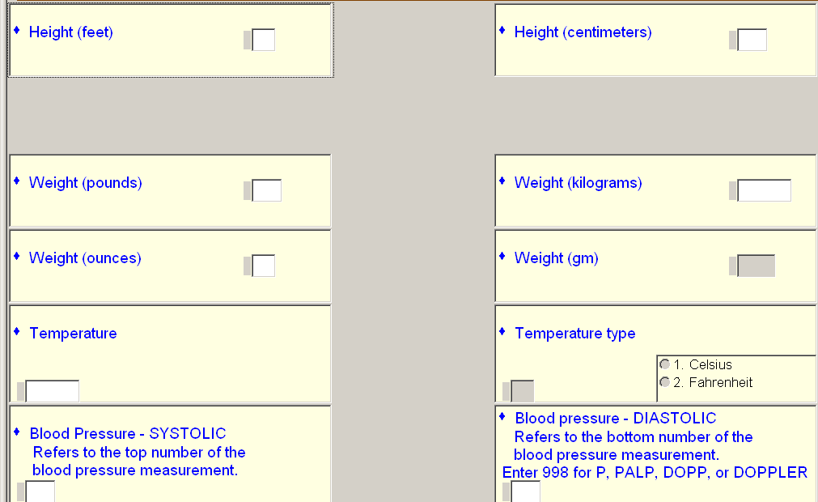
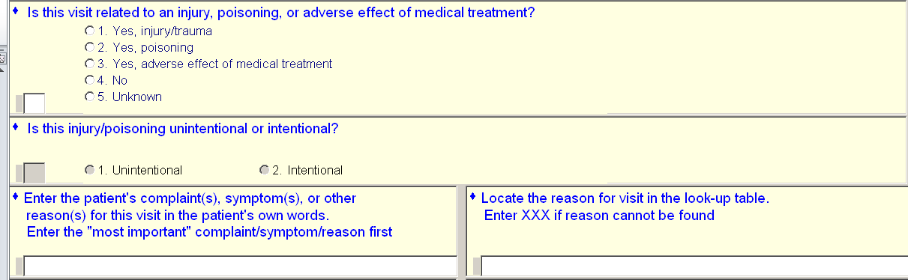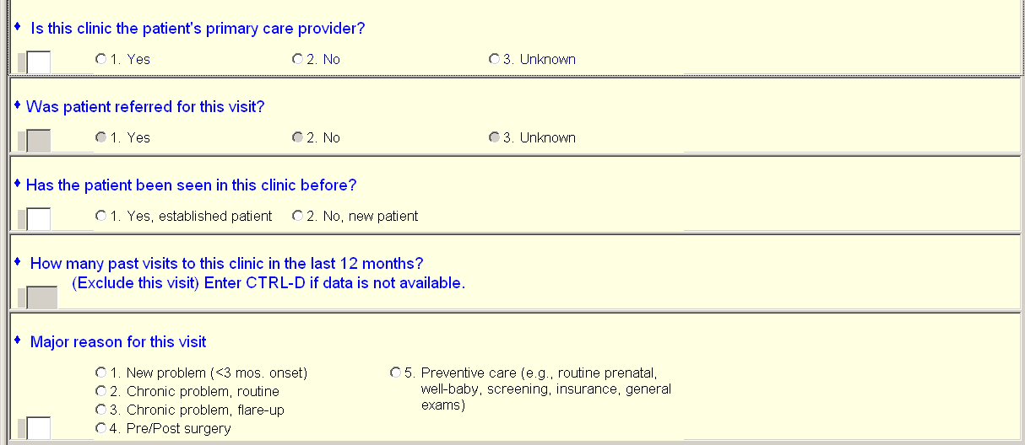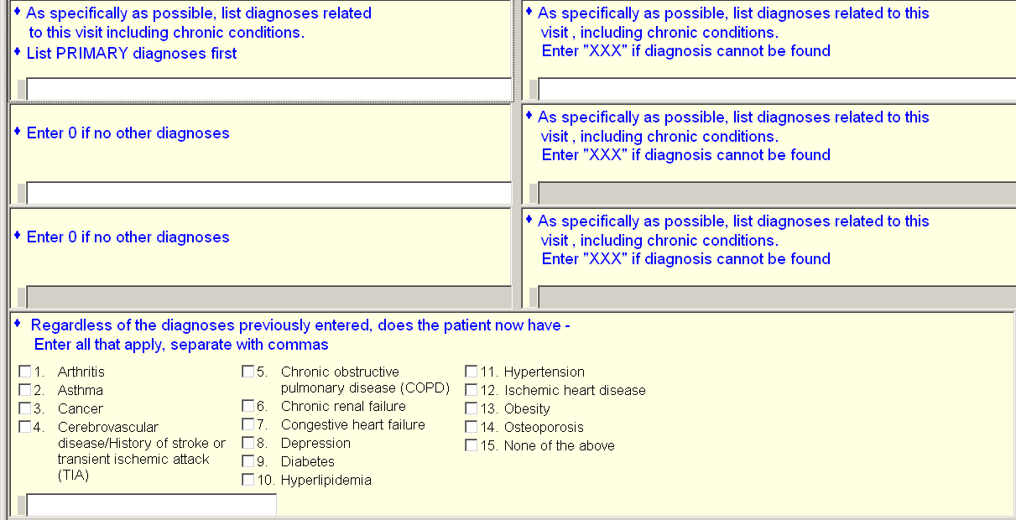
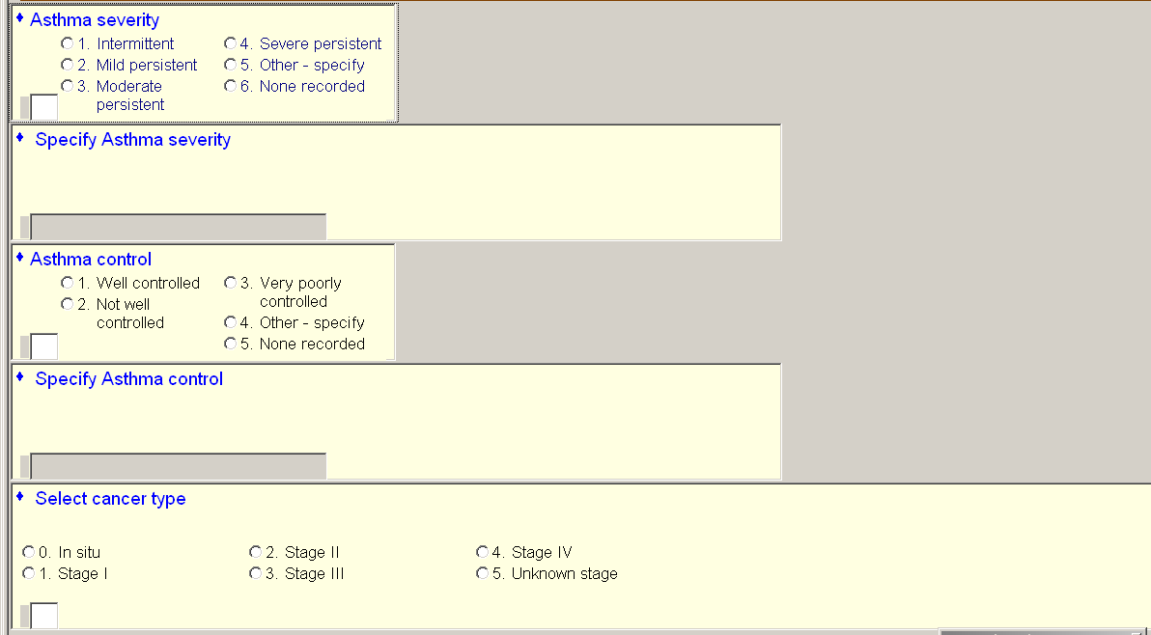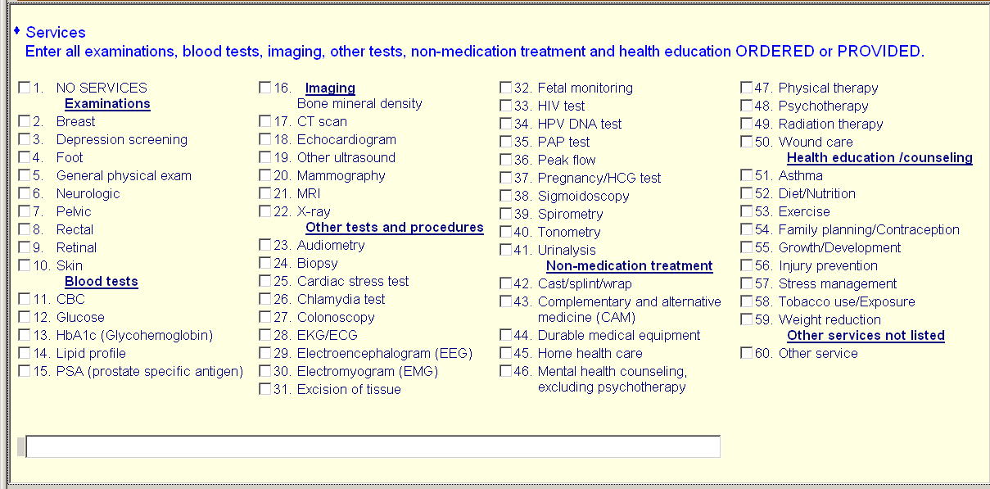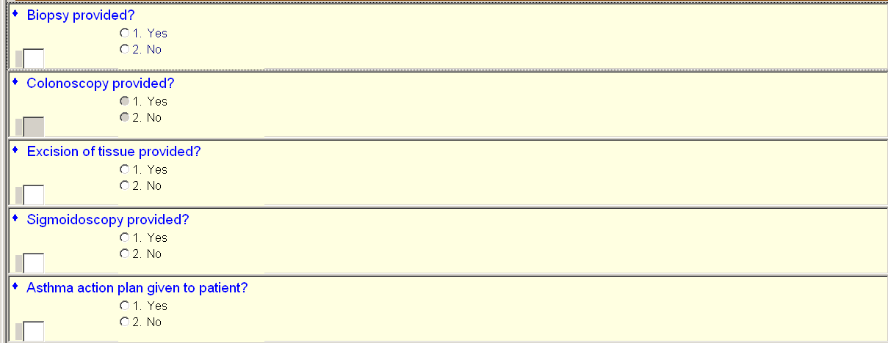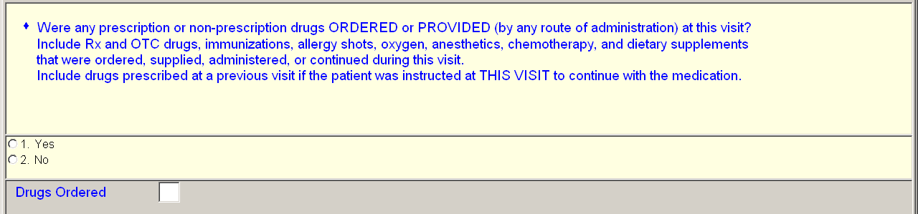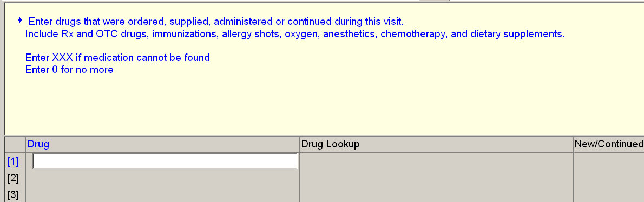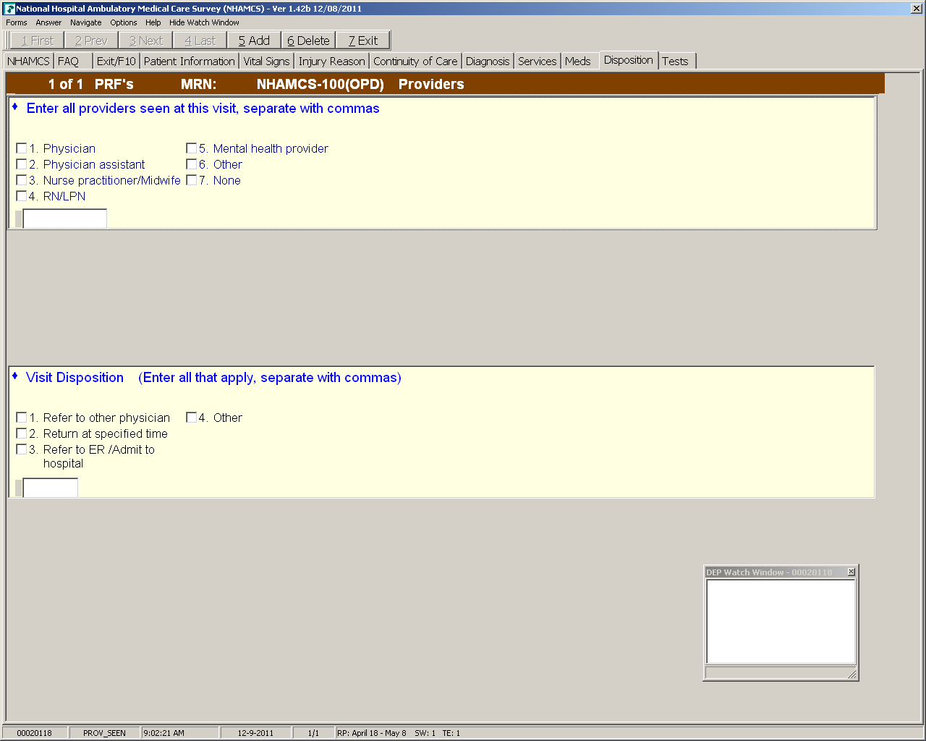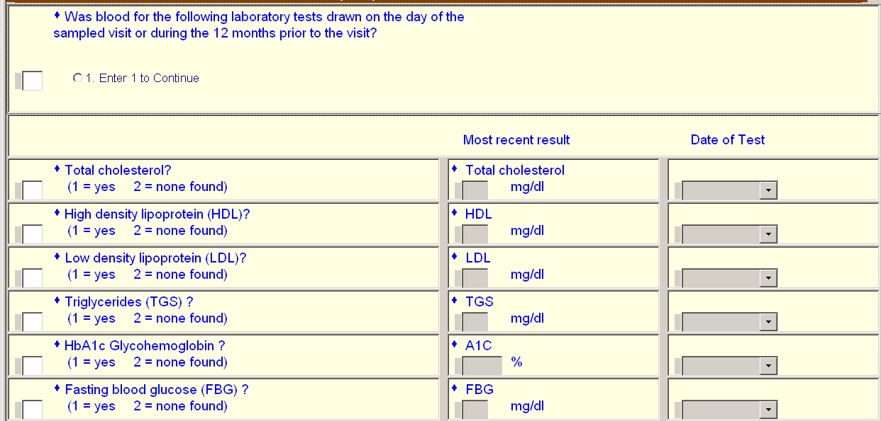
Lookback
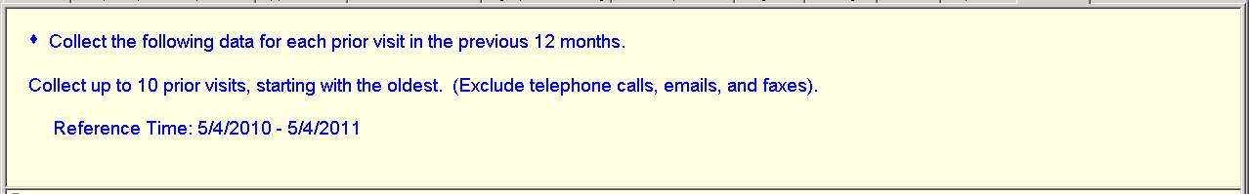
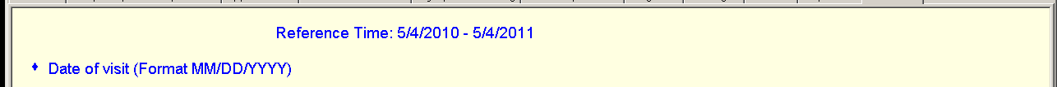
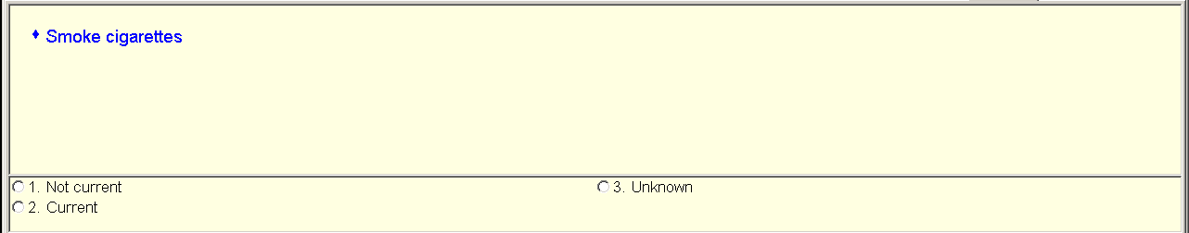
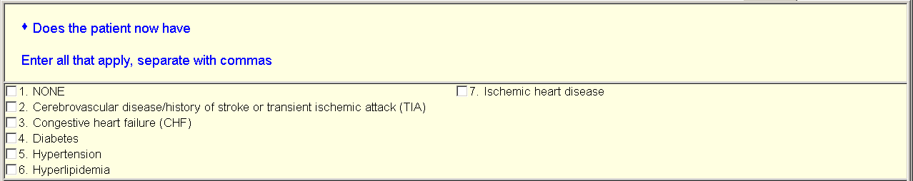
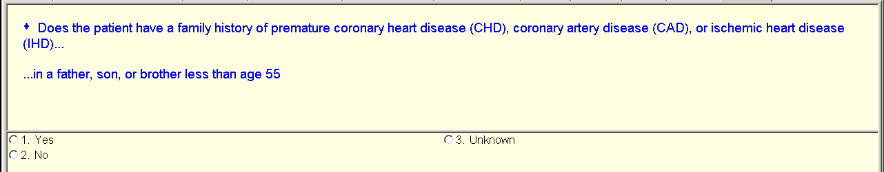
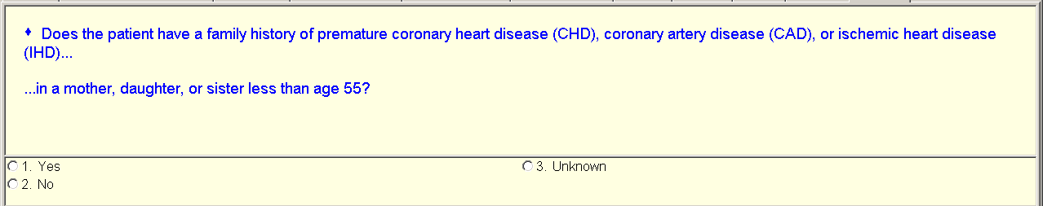
Skipping height through BP systolic screens- simply asks to fill in the number
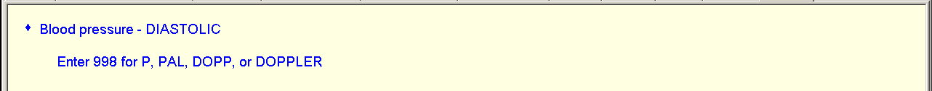
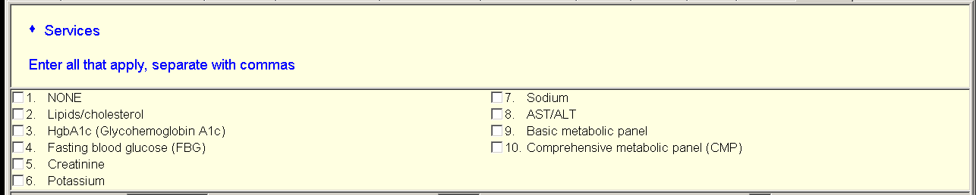
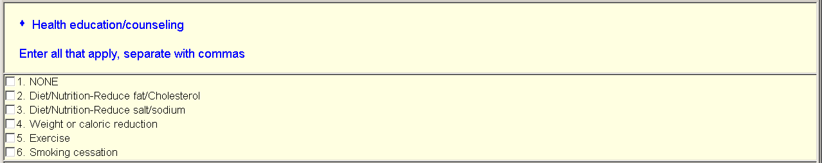
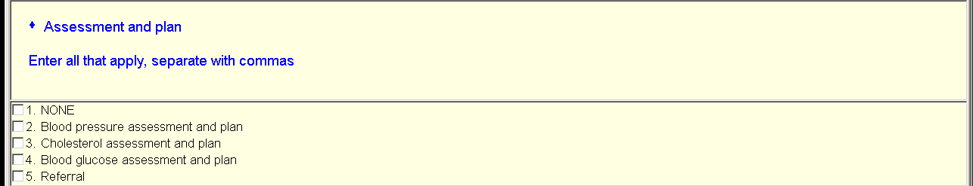
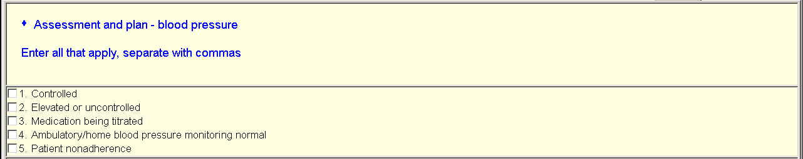
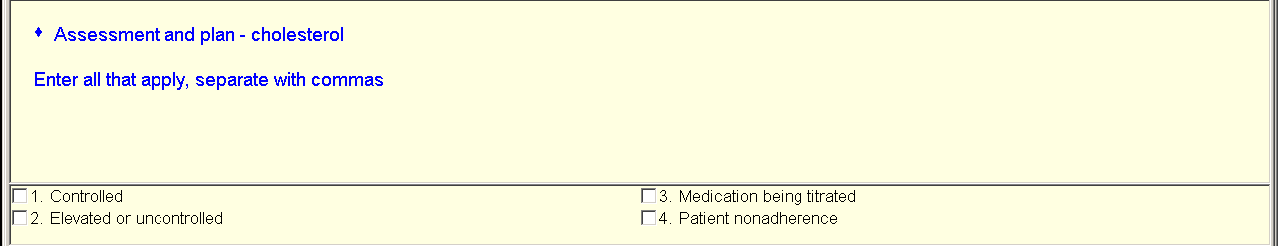
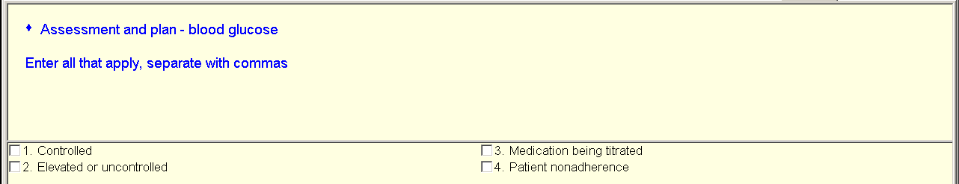
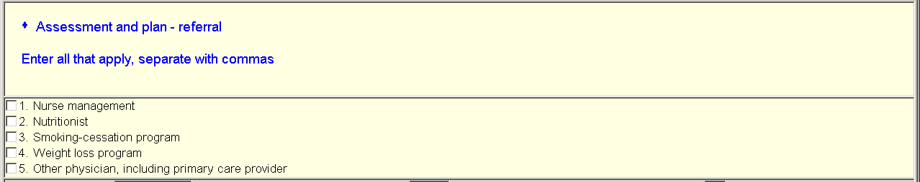
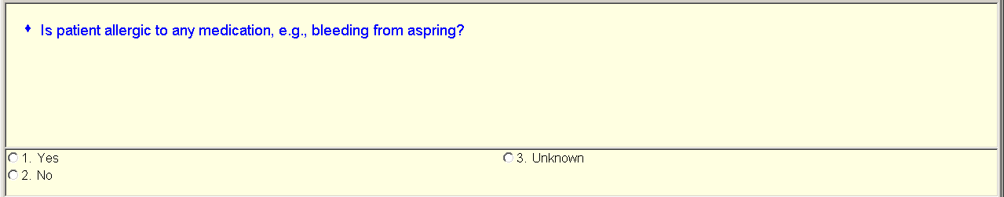
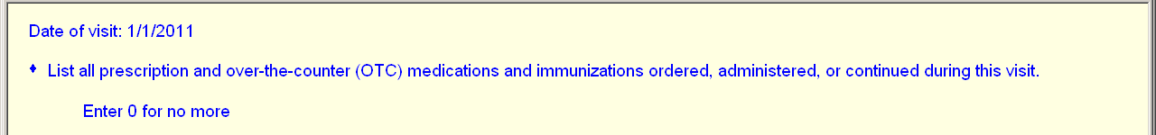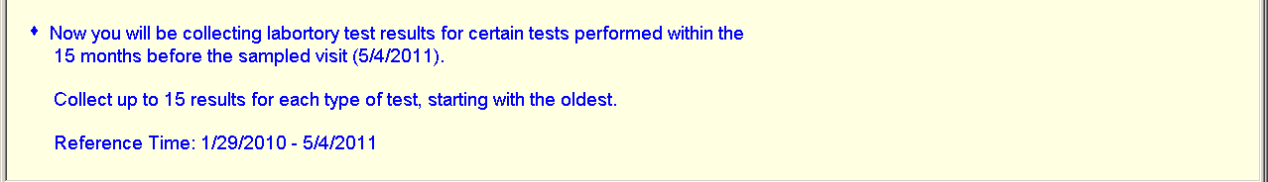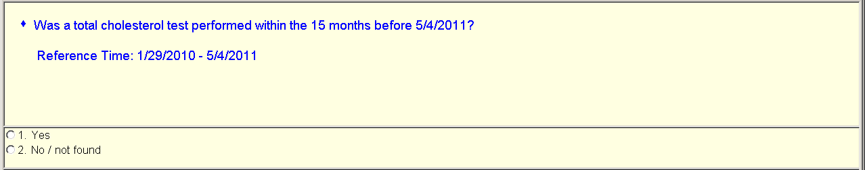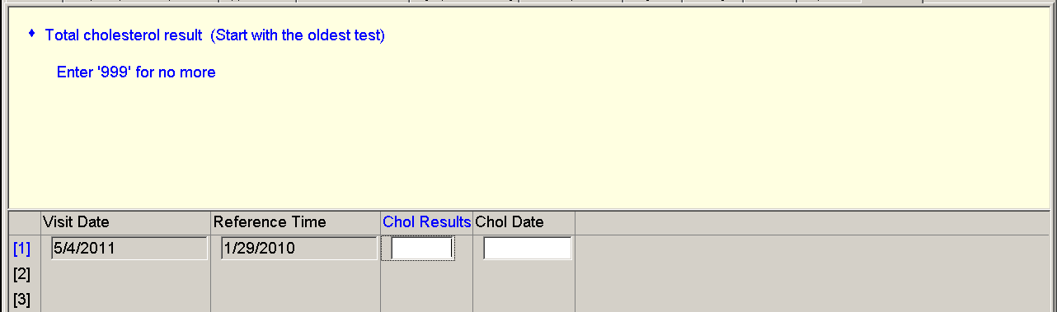
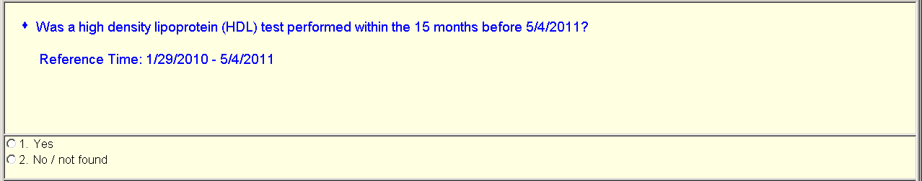
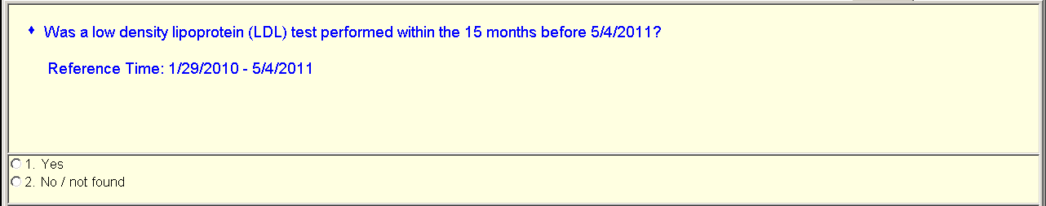
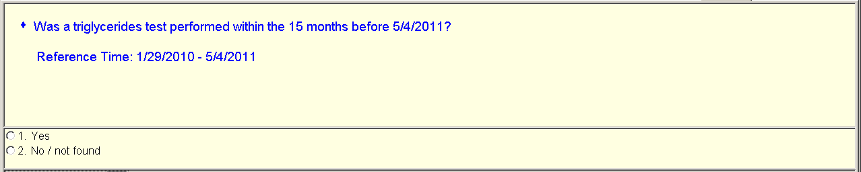
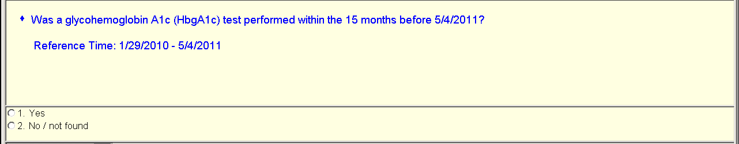
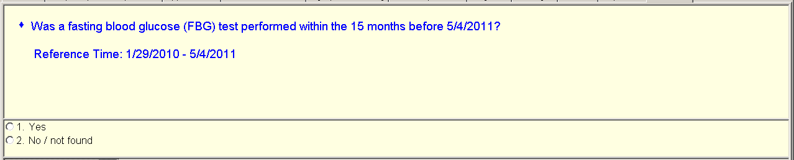

Total test result screens for each test is the same as cholesterol screen except with different wording to indicate the respective test, so did not copy those in.

