Head Start Health Managers Descriptive Study

Appendix G

Illustrative Screen Shots for MMICTM
(Multimode Interviewing Capability

March 6, 2012

This is an example of what the home page will look like for the Head Start Health Manager Survey. Respondents can access this page via a direct link in their recruitment email or through the RAND MMIC homepage using their unique MMIC-assigned user ID and password. The proposed text for the homepage can be found in Appendix B (Director Survey) and C (Health Manager Survey), and will be finalized upon OMB approval. Once a respondent clicks ‘next’ they will move to an informed consent screen.

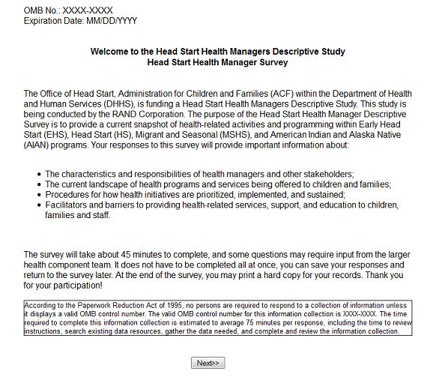

The following are screen shots of DEM02—DEM04 in the Head Start Health Manager Survey (see Appendix C). These are example and preliminary screen shots to provide the reviewer with a visual of the user interface.
