Occurrence Reporting & Processing System (ORPS)

Notification Report Data Entry – page 1

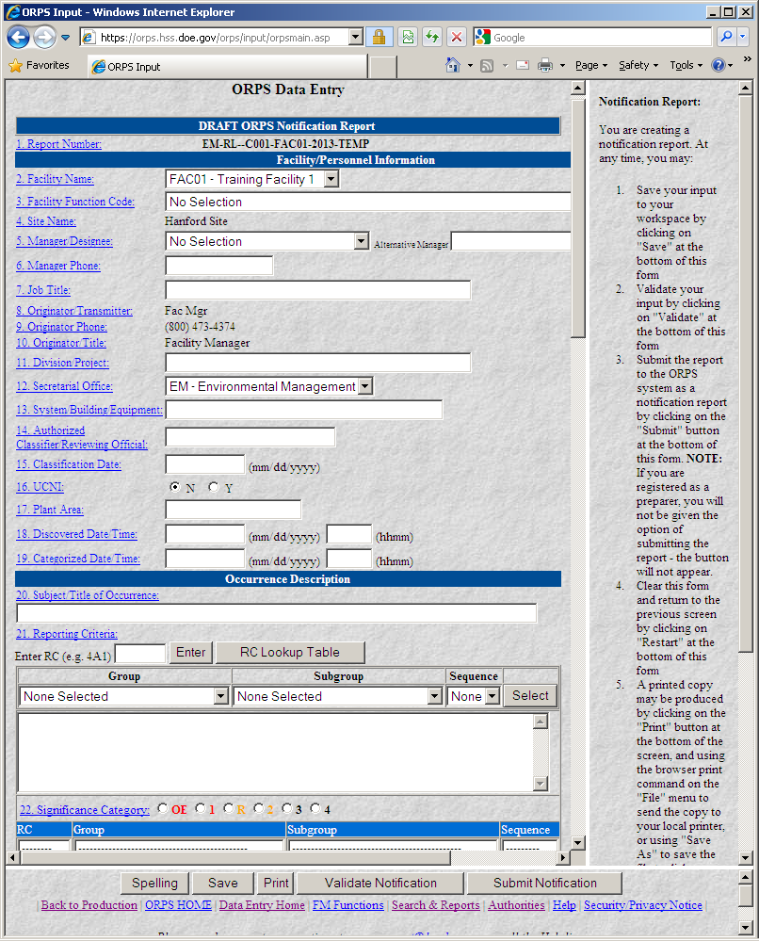

Notification Report Data Entry – page 2

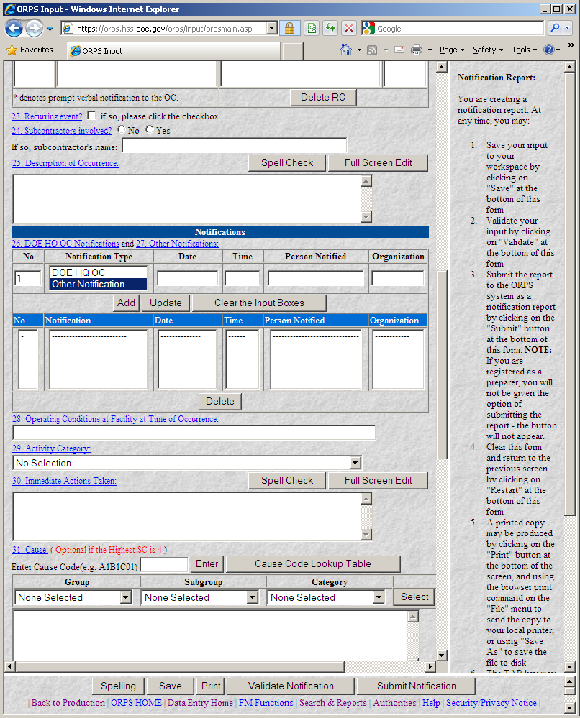

Notification Report Data Entry – page 3

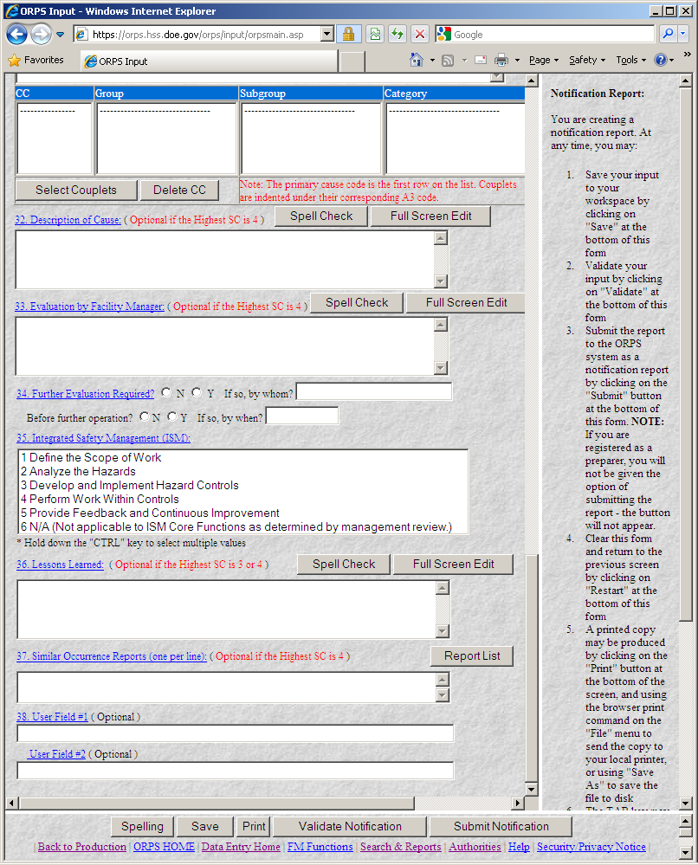

Update or Final Report Data Entry – page 1

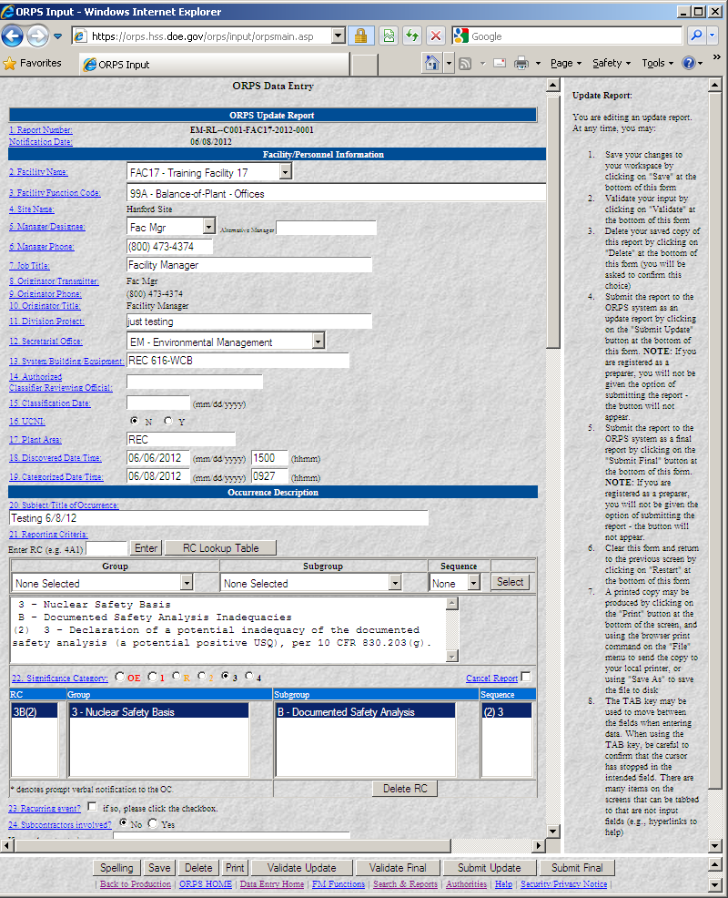

Update or Final Report Data Entry – page 2

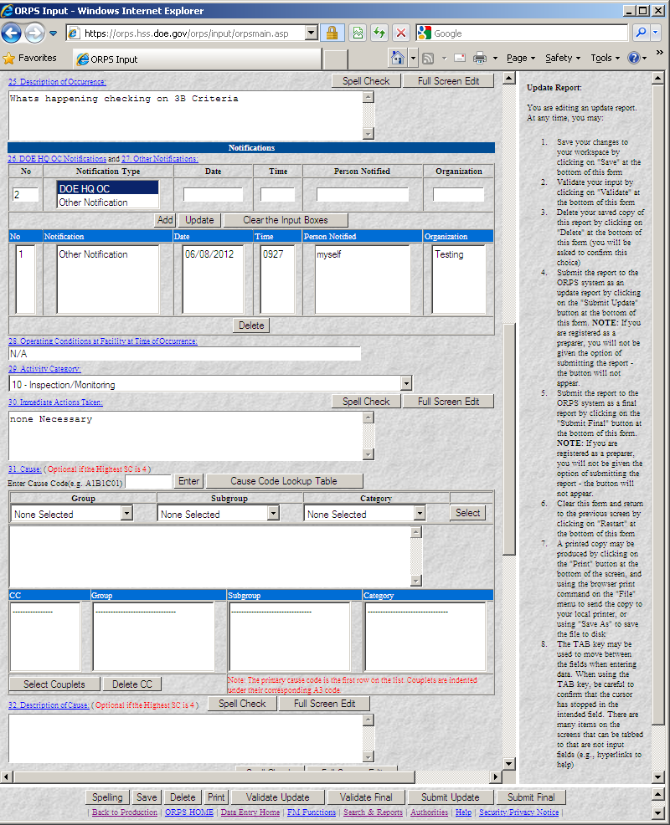

Update or Final Report Data Entry – page 3

