DOE Corporate Lessons Learned (LL)

Safety & Health Lesson Data Entry – Page 1

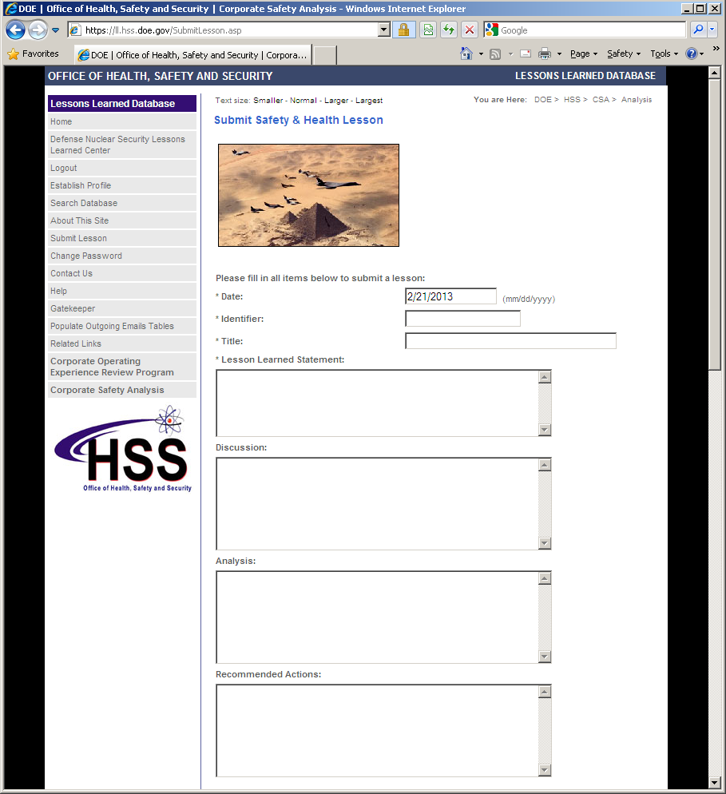

Safety & Health Lesson Data Entry – Page 2

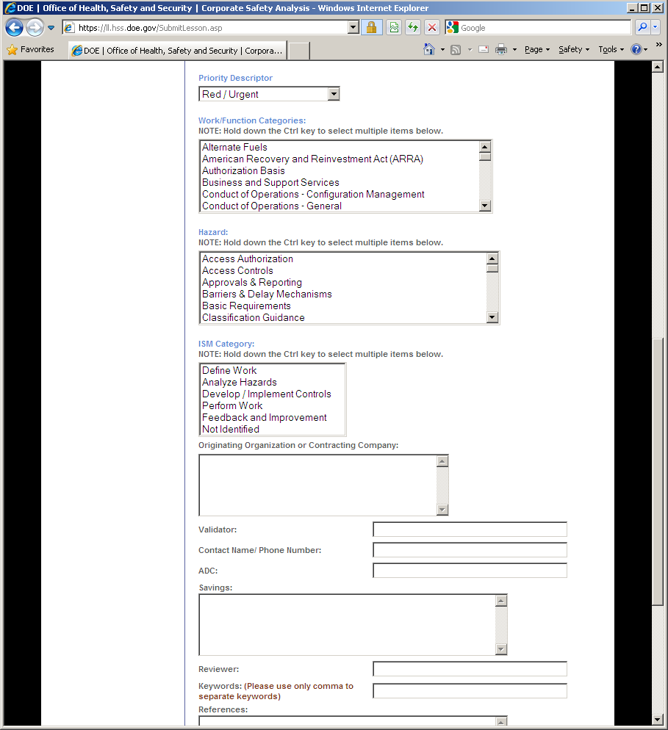

Safety & Health Lesson Data Entry – Page 3

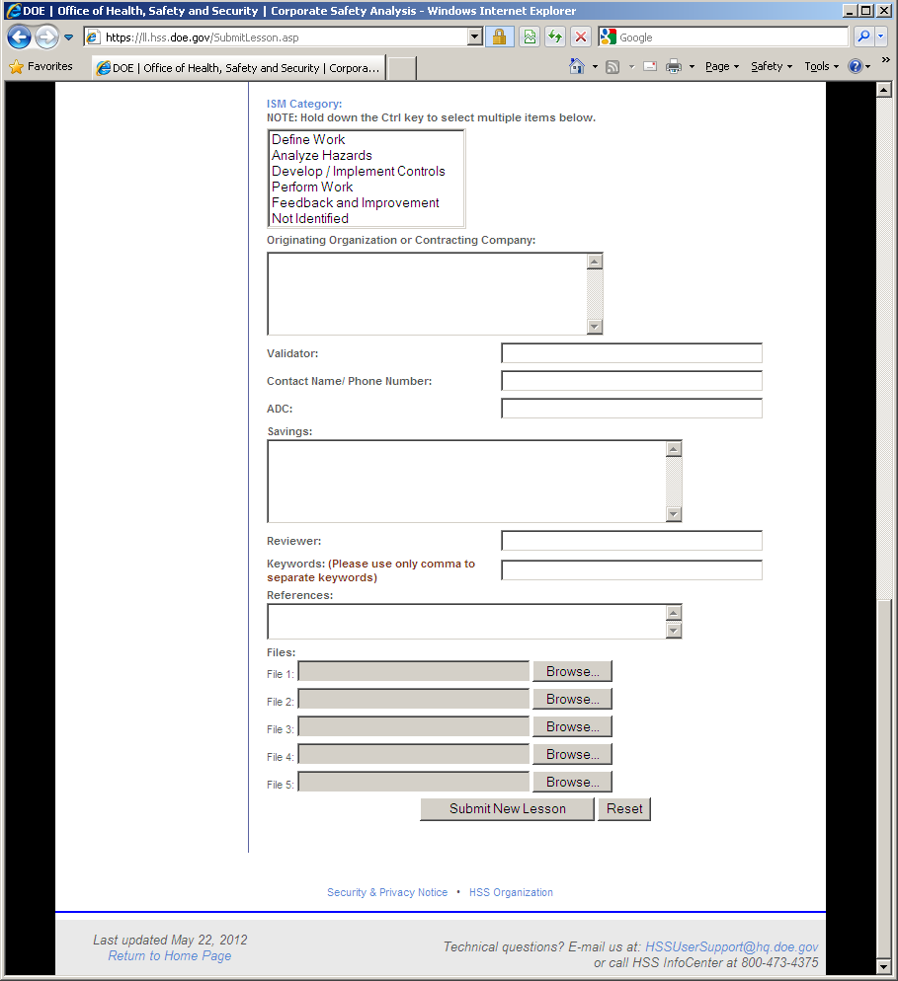
Security Lesson Data Entry – Page 1

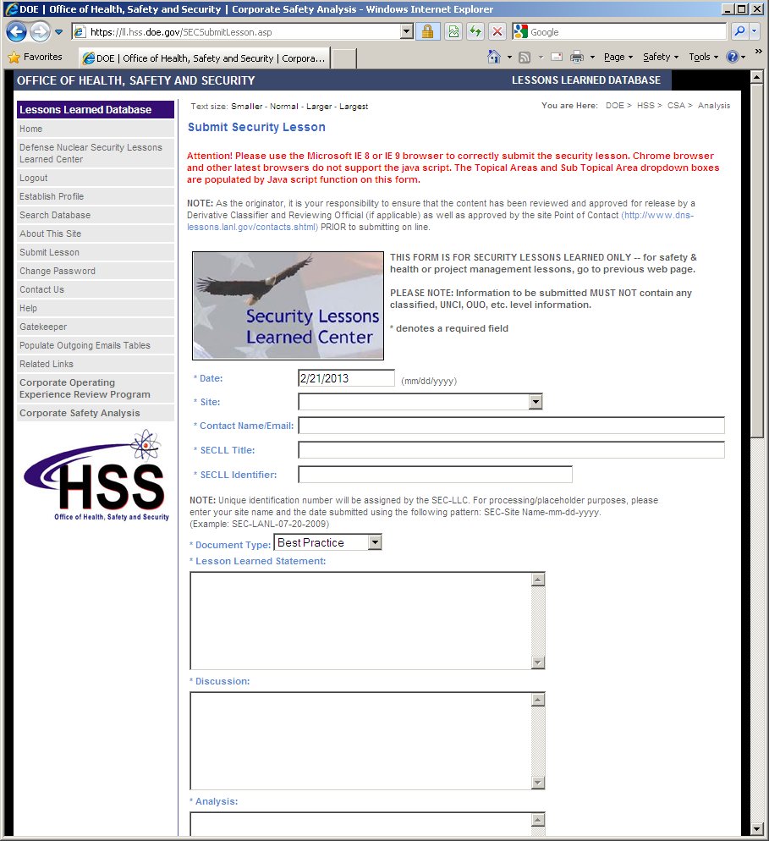

Security Lesson Data Entry – Page 2

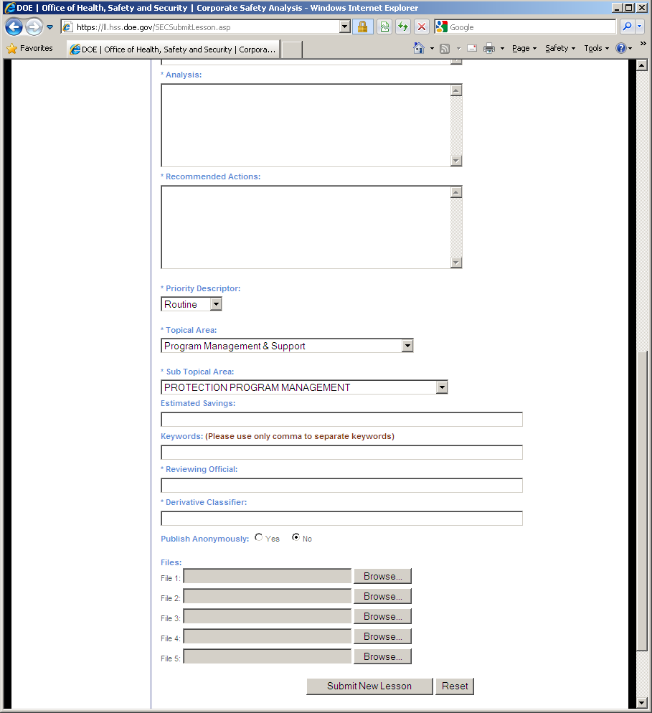

Project Management Lesson Data Entry – Page 1

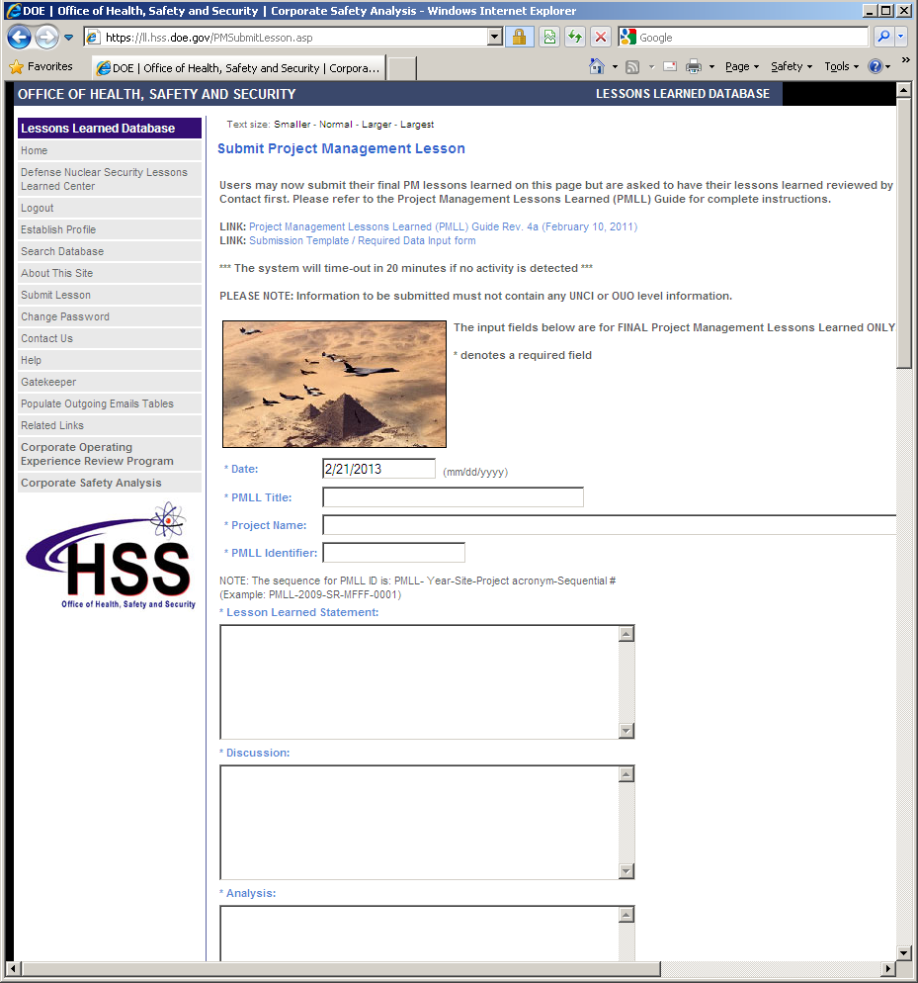

Project Management Lesson Data Entry – Page 2

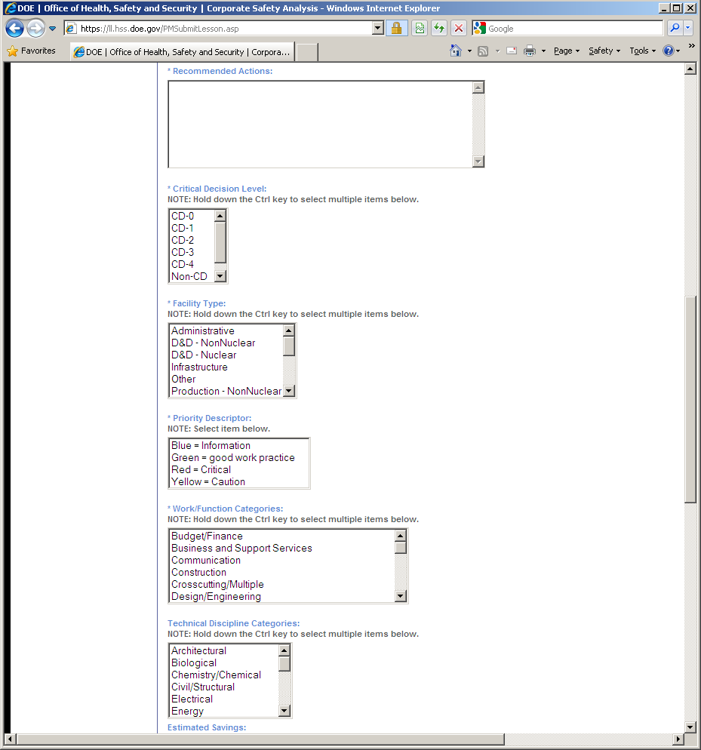

Project Management Lesson Data Entry – Page 3

