CAHPS Clinician and Group Data Submission Registration Form
Form Approved
OMB No. 0935-XXXX
Exp. Date XX/XX/20XX

Registration Step 1: Provide Contact Information
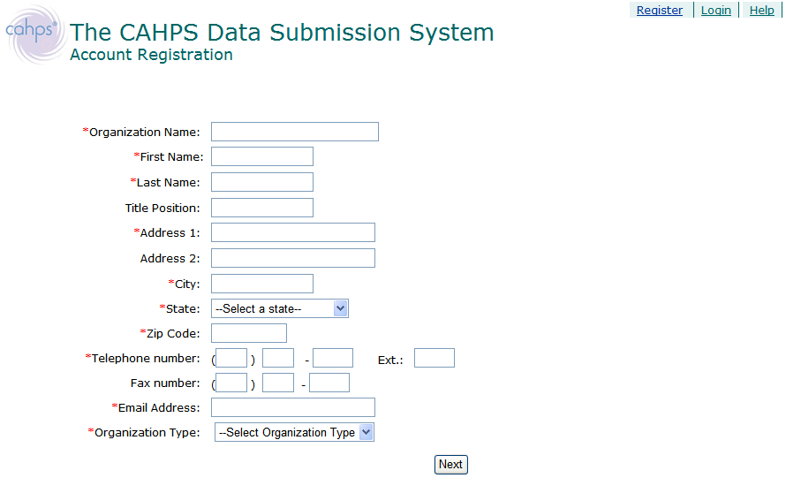

Registration Step 2: Create Username, Password and Security Question
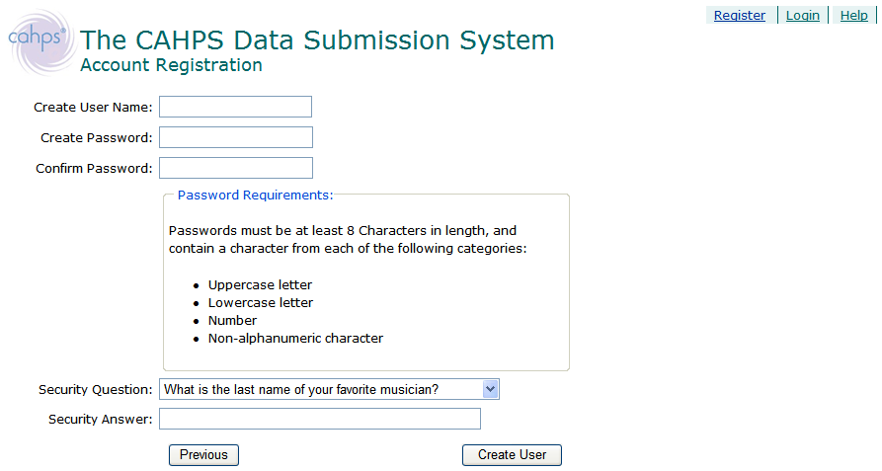

Public reporting burden for this collection of information is estimated to average 6 minutes per response, the estimated time required to complete the survey. An agency may not conduct or sponsor, and a person is not required to respond to, a collection of information unless it displays a currently valid OMB control number. Send comments regarding this burden estimate or any other aspect of this collection of information, including suggestions for reducing this burden, to: AHRQ Reports Clearance Officer Attention: PRA, Paperwork Reduction Project (0935-XXXX) AHRQ, 540 Gaither Road, Room # 5036, Rockville, MD 20850.

