Attachment J, Figure 1: Welcome Page

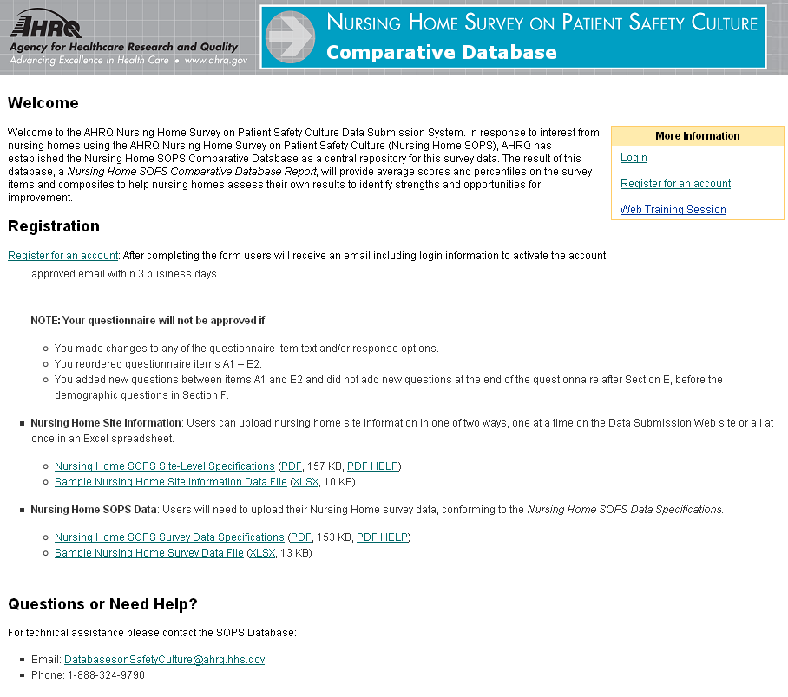

Attachment J, Figure 2: Login Page



