OMB No.: 0925-0648
Expiration Date: 1/31/2015
NOTIFICATION TO RESPONDENT OF ESTIMATED BURDEN
Public reporting burden for this collection of information is estimated to average 60 minutes per interview, including the time for reviewing instructions, searching existing data sources, gathering and maintaining the data needed, and completing and reviewing the collection of information. An agency may not conduct or sponsor, and a person is not required to respond to, a collection of information unless it displays a currently valid OMB control number. Send comments regarding this burden estimate or any other aspect of this collection of information, including suggestions for reducing this burden to: NIH, Project Clearance Branch, 6705 Rockledge Drive, MSC 7974, Bethesda, MD 20892-7974, ATTN: PRA (0925-0648). Do not return the completed form to this address.

Attachment 8: System Usability Scale

Strongly Strongly
disagree agree
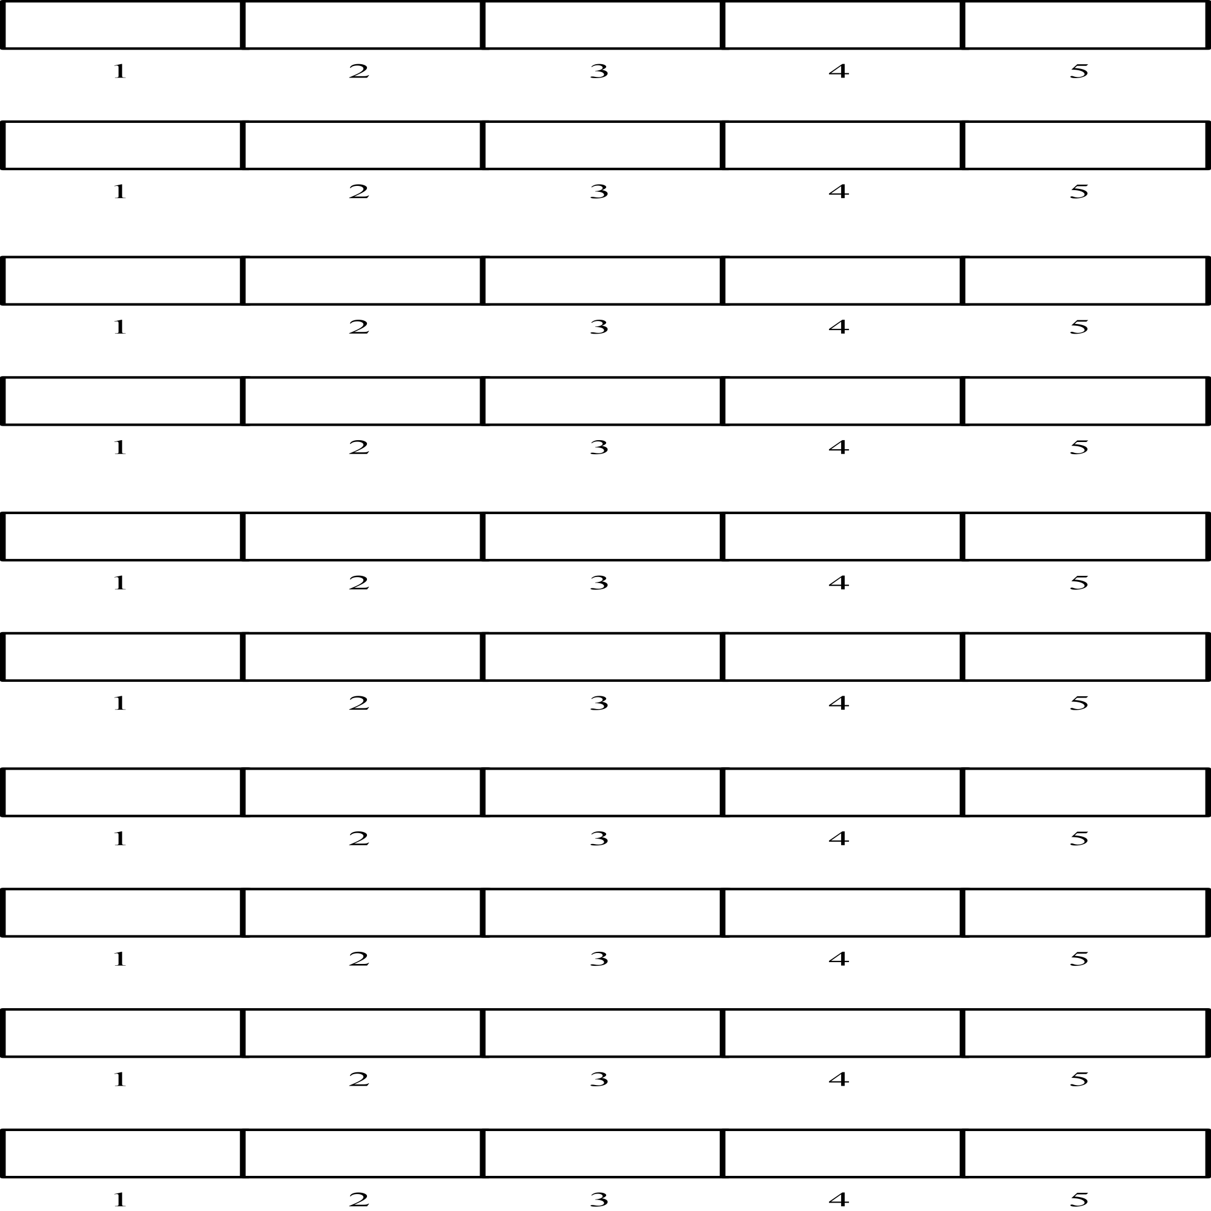

1. I think that I would like to
use this system frequently

2. I found the system unnecessarily
complex

3. I thought the system was easy
to use

4. I think that I would need the
support of a technical person to
be able to use this system

5. I found the various functions in
this system were well integrated

6. I thought there was too much
inconsistency in this system

7. I would imagine that most people
would learn to use this system
very quickly

8. I found the system very
cumbersome to use

9. I felt very confident using the
system

10. I needed to learn a lot of
things before I could get going
with this system

