Appendix A

Informal Caregiver Discussion Guide

Form Approved
OMB No. 0920-0572
Exp. Date: 2/28/2015

Public Reporting burden of this collection of information is estimated at 120 minutes per response, including the time for reviewing instructions, searching existing data sources, gathering and maintaining the data needed, and completing and reviewing the collection of information. An agency may not conduct or sponsor, and a person is not required to respond to a collection of information unless it displays a currently valid OMB control number. Send comments regarding this burden estimate or any other aspect of this collection of information, including suggestions for reducing this burden to CDC/ATSDR Reports Clearance Officer, 1600 Clifton Road NW, MS D-74, Atlanta, GA 30333; Attn: PRA (0920-0572).

Introduction 5 minutes
Sources of Health Information 10 minutes
Fall Prevention 20 minutes
Falls Materials 60 minutes
Compare Brochures 10 minutes
Getting Falls Information 6 minutes
Logo 7 minutes
Wrap up 2 minutes
TOTAL TIME ALLOCATED 120 minutes
Introductions 5 minutes
- Thank you for taking the time to come today. My name is ________, I’m from KRC Research. I’ll be the moderator.

Ground Rules:
- This discussion group is part of a project to learn how to help caregivers get the information they need to help keep the older adults they care for safe and healthy.

- This discussion will take about two hours. It’s not meant to be a question and answer session; we’d like it to be more of a discussion. There are no right or wrong answers. We want to hear your opinions and we expect there will be different points of view. So please share your thoughts and ideas, even if they are different from what others have said.

- None of the questions you will be asked are about private matters, but if any question makes you feel uncomfortable, you can choose not to answer.

- Please speak one at a time. It will be easier for everyone to hear each other that way. Also, we have a limited amount of time, so I may occasionally have to steer the discussion back to a particular topic.

- The discussion will be audio and video-taped so that I can write a summary report. However, your names won’t be included in the final report. There will be no link between the tape and the names of the people who participated. What you say will be kept private. Only people involved in this project will listen to the tapes, and once the project is finished, the information will be destroyed

- Any questions before we get started?

- Could I get each of you to briefly introduce yourself by first name only? Also, tell us a little about the person you care for—their age, their relationship to you (mother, father, neighbor, etc.), how long you’ve been caring for them, and in what ways you care for them.

Sources of Health Information and Health Concerns 10 minutes
- How often, if at all, do you look for information to help the person you care for?
  - What kind of information do you look for?
  - Are you usually looking for information directed at older adults or at caregivers?
  - Do you ever look for information about keeping the person you care for safe?
  - What are your biggest health concerns related to the person you care for?
  - IF FALLS NOT MENTIONED: Are falls a concern for you? How so? Have you ever looked for information related to falls?

- What are the sources you go to most often? PROBE FOR SOURCES SUCH AS MEDIA, FAMILY, FRIENDS, CHURCH, ONLINE

  - Do you go to doctor appointments with the person you care for?
  - Do you speak directly with the doctor about their health issues?
  - If you were looking for information about preventing falls, where would you look? PROBE: ROLE OF MEDIA, WORD OF MOUTH, WEBSITES, OTHER.

Fall Prevention 20 minutes
- Do you think falls among older adults are a problem? How big a problem is this?

  - How big of a problem is it compared to other health concerns for older adults?

- Are you ever concerned that the person you care for will fall?

  - IF SO: Is there anything you’ve done to try to minimize the possibility of the person you care for falling? What kinds of things have you done?

- Have you ever talked about how to prevent falls with the person you care for?

  - What have you discussed related to falls?

- Do you think the person you care for would be receptive to you talking with them about fall prevention?
Why or why not?

- Do you know if anyone else has talked about how to avoid falls with the person you care for? IF SO: Who discussed the issue with them?

  - PROBE: DOCTOR? RELATIVE? PHYSICAL THERAPIST? OTHER CAREGIVER?

- To your knowledge, has the person you care for ever fallen? [not necessarily while in your care]

  - Was the person injured?

- Do you think there is anything that can be done to prevent falls?

- Do you think there is anything that you as a caregiver can do to help prevent the older person you care for from falling?

  - What types of things could you do?

- Do you know of any fall prevention programs in your area?

Fall Prevention Materials 60 minutes

Now we are going to look at some information that was developed for older adults to tell them about falls and what they can do to prevent them. This information is intended for older adults, but we would like to get your impressions of these materials because you are caregivers of older adults. We are interested in knowing whether you would use these materials as is, or how you might change them.

DISTRIBUTE HANDOUT “STAY INDEPENDENT”

Take a few minutes to look over the brochure before we discuss it. As you read the brochure, CIRCLE anything that you think is particularly important and cross out anything that is unclear or that you have a question about.

Initial Impressions

- What are your first impressions? Would you pick up this brochure if you saw it?

- Do you think the person you care for would pick up this brochure if they saw it?

- Would you show it to the person you care for?

- Are you interested in this brochure’s topic? What is the most interesting information in this brochure?

- Do you like the way this brochure looks?

- Was it easy to read?

- Did you learn something new by reading this?

Comprehension

- If you were telling the person you care for what this brochure says and shows, what would you say? PROBE: What are the main ideas that this brochure is trying to get across, in your own words? LISTEN FOR… INSERT KEY POINT

  - PROBE: WHAT ADDITIONAL INFORMATION DOES THIS PROVIDE RELATED TO THE RISK OF FALLING? HOW CLEAR IS IT TO YOU?

  - PROBE: WHY IS THIS IMPORTANT TO YOU AND THE PERSON YOU CARE FOR? HOW WELL DOES THIS SHOW THE IMPORTANCE?

- How well do you think the main ideas come across?

- What action or actions, if any, would this brochure prompt you to take?

- Is there anything confusing, unclear, or hard to understand?

- Is there anything missing that should be included? IF SO: What is missing?

Internal Content: Check your Risk for Falling

- Would you work with the person you care for to complete the risk assessment? Why or why not?

  - PROBE: WOULD YOU HELP GO THROUGH AND SELECT A RESPONSE FOR EACH QUESTION?

  - PROBE: WOULD YOU HELP ADD UP A FINAL SCORE?

- Do you think the “Why it matters” information is useful? Why or why not?

- Would you discuss the brochure with the person you care for’s doctor? Why or why not?

- Would you have the person you care for discuss the brochure with his/her doctor? Why or why not?

Final Impressions

- Is there anything you especially liked about this brochure?

- Is there anything you would change about this brochure?

Persuasiveness

- After seeing this brochure, how likely are you to talk about preventing falls with the person you care for in the next week or so?

- What other comments would you like to make about this brochure?

DISTRIBUTE HANDOUT “WHAT YOU CAN DO TO PREVENT FALLS”

Take a few minutes to look over the brochure before we discuss it. As you read the brochure, CIRCLE anything that you think is particularly important and cross out anything that is unclear or that you have a question about.

Initial Impressions

- Would you pick up this brochure if you saw it?

- Do you think the person you care for would pick up this brochure if they saw it?

- Would you show it to the person you care for?

- Are you interested in this brochure’s topic?

- Do you like the way this brochure looks?

- Was it easy to read?

- Did you learn something new by reading this?

Comprehension

- What are the main ideas that this brochure is trying to get across, in your own words?

  - PROBE: WHAT SPECIFIC GUIDANCE DOES THIS PROVIDE YOU WITH?

- How well do you think the main ideas come across?

- Is it trying to get people to do something? What action would it prompt you to take?

- Is there anything confusing, unclear, or hard to understand?

Falls Recommendations

Now let’s discuss the recommendations that are in the brochure. We’ll talk about these one at a time.

- Begin a regular exercise program
- Have your health care provider review your medicines
- Have your vision checked
- Make your home safer [go through each check box]

- Have you heard this recommendation before today?

- What makes it difficult to follow this recommendation?

- What might make it easier for you to follow this recommendation?

- Do you think anyone in your household or the household of the person you care for would be against following this recommendation? Why?

- What would encourage or motivate you to follow this recommendation?

- In the next month, how likely are you to follow this recommendation with the person you care for?

Final Impressions

- Is there anything you especially liked about this brochure?

- Is there anything you would change about this brochure?

Persuasiveness

- After seeing this brochure, how likely are you to talk about preventing falls with the person you care for in the next week or so?

- After reading this brochure, how likely are you to follow the recommendations to prevent falls with the person you care for in the next week or so?

- Is there anything that could be changed to make it more likely you would follow the recommendations?

- What other comments would you like to make about this brochure?

DISTRIBUTE HANDOUT “CHECK FOR SAFETY”

Take a few minutes to look over the brochure before we discuss it. As you read the brochure, CIRCLE anything that you think is particularly important and cross out anything that is unclear or that you have a question about.

Initial Impressions

- Would you pick up this brochure if you saw it?

- Do you think the person you care for would pick up this brochure if they saw it?

- Would you show it to the person you care for?

- Are you interested in this brochure’s topic?

- Do you like the way this brochure looks?

- Was it easy to read?

- Did you learn something new by reading this?

Comprehension

- What are the main ideas that this brochure is trying to get across, in your own words?

  - PROBE: WHAT ROOMS AND PARTS OF A HOME SHOULD BE CHECKED TO PREVENT FALLS?

  - PROBE: WHAT ARE SOME THINGS YOU CAN DO IN CERTAIN ROOMS OR PARTS OF A HOME?

- How well do you think the main ideas come across?

- Is it trying to get people to do something? What action would it prompt you to take?

- Is there anything confusing, unclear, or hard to understand?

Internal Content: Home Fall Prevention Checklist

- Would you complete the fall prevention checklist at the home of the person you care for? Why or why not?

- Were there any recommendations that you would follow? Explain.

- Were there any recommendations that you would not follow? Explain.

Final Impressions

- Is there anything you especially liked about this brochure?

- Is there anything you would change about this brochure?

- After seeing this brochure, how likely are you to complete the fall prevention checklist with the person you care for in the next week or so?

- Is there anything that could be changed to make it more likely you would complete the fall prevention checklist with the person you care for?

- What other comments would you like to make about this brochure?

Compare Brochures 10 minutes
- Which brochure do you think would be most useful to the person you care for?

- Which brochure was more useful to you as a caregiver?

- Would it be useful to have any of the brochures specifically designed for you as a caregiver, or do you prefer information designed for an older adult?

- What changes would you make to any of these brochures to make them more useful to you as a caregiver?

- What information would be helpful to you that is not covered in the brochures we looked at?

Getting Falls Information 6 minutes

- What are some places where you might notice brochures like the ones you saw today?

- What [other] types of information would you like to get about preventing older adult falls?

- What would be the best way for you to get this information? PROBES: VIDEO, EDUCATIONAL PAMPHLETS, WEBCASTS, COMMUNITY/PUBLIC MEETINGS, INTERNET, WALL POSTER, POCKET GUIDE, BLOGS, SOCIAL MEDIA, TWITTER, FACEBOOK, OTHER.

- Do you feel you can help prevent the person you care for from falling?

Logo 7 minutes
I now want to show you a logo that we are thinking about adding to the brochures you just saw. I am interested in your impressions of the logo.

- What is your general reaction to this logo?

- Are there things about the logo that BOTHER you in any way?

  - PROBE: HOW DO YOU FEEL ABOUT THE WORDS USED IN THIS LOGO?

- If this logo were added to the brochures we looked at earlier, would it make you more likely or less likely to pick them?

- How do you think the person you care for would react to this logo?

- Are there things about the logo that might BOTHER the person you care for in any way?

  - PROBE: HOW DO YOU THINK THE PERSON YOU CARE FOR WOULD FEEL ABOUT THE WORDS USED IN THIS LOGO?

- Is there anything you would change about this logo? Why?

Wrap-up 2 minutes
That’s all the questions I have for you today. Is there anything else anyone would like to say related to our discussion today?

Thank you so much for joining our discussion. We really value your experiences as caregivers, and your ideas will make our brochures better. Please feel free to take the brochures with you when you leave and don’t forget to pick up your check on your way out.

###
REFERENCES

HANDOUT “STAY INDEPENDENT”
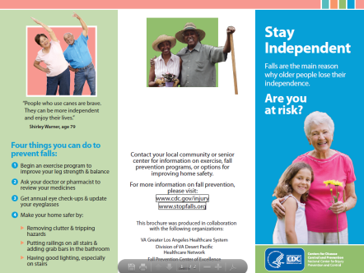

HANDOUT “WHAT YOU CAN DO TO PREVENT FALLS”
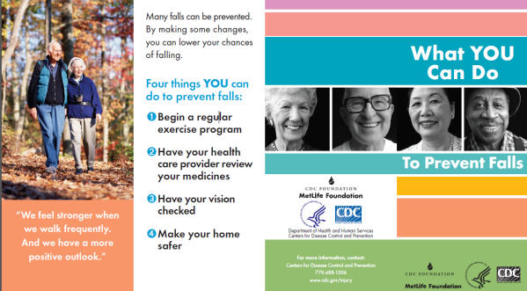

HANDOUT “CHECK FOR SAFETY”
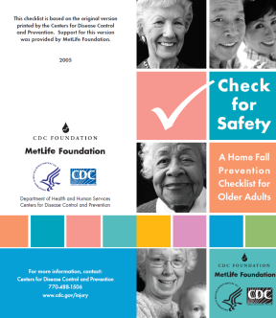

LOGO
