Form Approved: OMB No. 2133-0529
Expiration Date: 11/30/2011
This collection of information is required to obtain a waiver of the U.S.-build and other requirements of the Passenger Services Act (46 U.S.C. 55103) and will be used by the Maritime Administration to determine if the applicant is entitled to a waiver. Public reporting burden is estimated to average one hour per response, including the time for reviewing instructions, searching existing data sources, gathering and maintaining the data needed, and completing and reviewing the collection of information. No assurances of confidentiality are provided. Please note that an agency may not conduct or sponsor, and a person is not required to respond to, a collection of information unless it displays a currently valid OMB control number. The OMB control number for this collection is 2133-0529. Send comments regarding this burden estimate or any other aspect of this collection of information, including suggestions for reducing this burden to: Information Collection Clearance Officer, Maritime Administration, 1200 New Jersey Avenue, S.E., Washington, D.C. 20590.

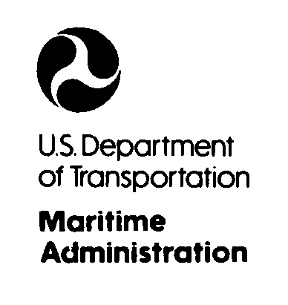
REQUEST FOR ADMINISTRATIVE WAIVER OF THE JONES ACT
46 U.S.C. 12121, 46 C.F.R. 388
1. Name of the Vessel:

2. Owner Information:

Name: ___________________________________ Telephone No: ________________________________
Address: _________________________________ Fax No: _____________________________________
_________________________________ Email: ______________________________________
3. Vessel Official Number (or Hull Identification No., or State No.):
4. Date of Vessel Construction:
5. Place of Construction:
6. Size, capacity and net tonnage of the vessel.

Size: ______________length ___________ net tonnage
Capacity: ______________ passengers
7. Intended commercial use of the vessel (attach pages if needed):

8. List all State(s) of intended operation and trade (“All States” is not acceptable):

9. A statement on the impact this waiver will have on other commercial passenger vessel operators, including a statement describing the operations of existing operators (attach pages as needed):

10. A statement on the impact this waiver will have on U.S. shipyards (attach pages as needed):

11. By submitting this information you are deemed to have certified that the above information is true and correct:  12. Submit your $500.00 payment via:  https://www.pay.gov/paygov/forms/formInstance.html?agencyFormId=1071542 website. | 13. Email to SmallVessels@dot.gov  or Mail to:  Small Vessel Waiver Program  Maritime Administration  MAR-730, MS #2 W23-454  1200 New Jersey Ave., SE  Washington, DC 20590
FORM MA-1023 (11-10)

