
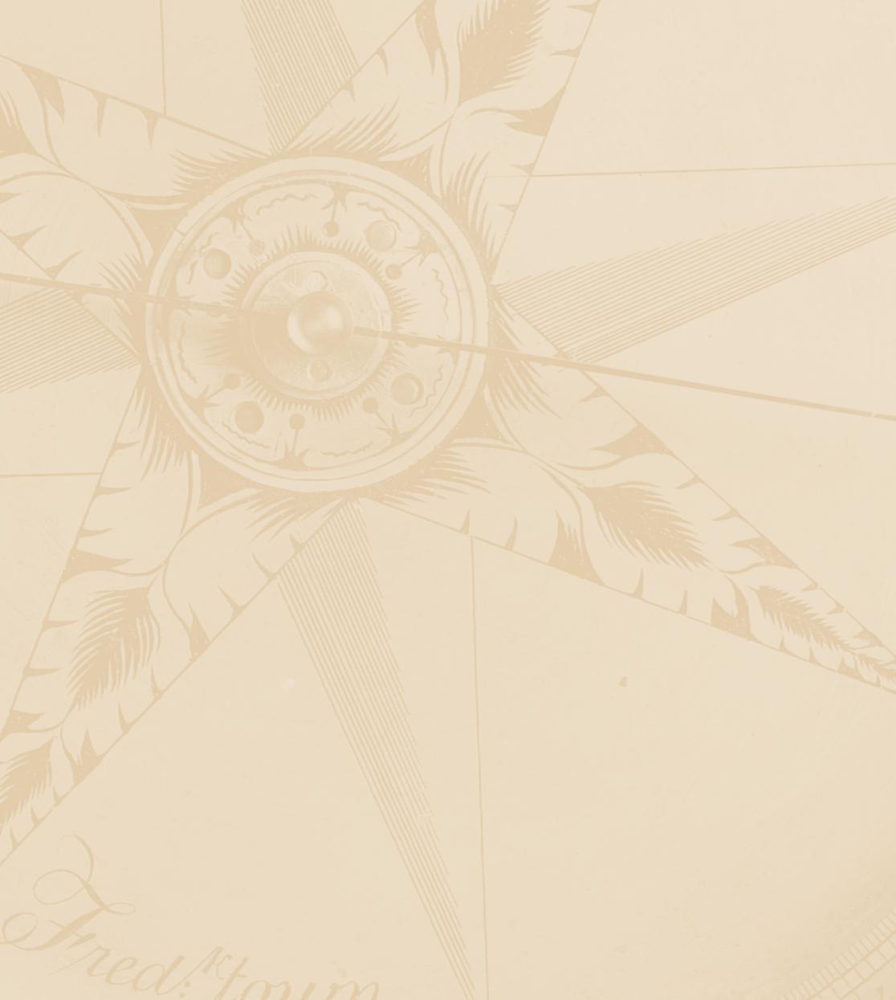
United States Mint

“S” Mint Mark Survey

June 27, 2012

Note to reader: Bold lines in between questions signify page/screen breaks.

Welcome to the United States Mint survey.

This survey is designed to help the United States Mint understand how it can improve the products and services it provides. According to the Paperwork Reduction Act of 1995, no persons are required to respond to a collection of information unless it displays a valid OMB number. The valid OMB control number for this information collection is 1535-0012-XXXX. Your participation in this survey is ENTIRELY VOLUNTARY and should require approximately 5-10 minutes of your time.

All of your responses are anonymous and will be kept completely confidential.

If you have any questions or problems while completing the survey, please call Eric Thomas weekdays from 9:00 AM to 5:00 PM EDT at 1-800-342-9102, or send an e-mail to ethomas@nationalanalysts.com

For more information about our privacy policy, please visit:

http://www.nationalanalysts.com/privacy/domestic-global.asp

Please click the Forward button to begin the survey.

To begin, we will first take a few minutes to familiarize you with our survey.

The survey will NOT ALLOW YOU TO SKIP A QUESTION. If you do not know an exact answer, then please give your best estimate.

You may click on the STOP button to pause the program to take a break. When you re-enter the survey you must use the same User ID and Password; the survey will return to the screen where you clicked Stop.

Please click the FORWARD button to begin.

SCREENING CRITERIA

Section S: Screening Criteria

S1. Have you purchased any coins or other merchandise from the United States Mint during the past 2 years?

Yes | ο
No | ο

Send to terminate screen if “No.”

S2. What is your age in years?

Age (in years)
_______

Send to terminate screen if under 18. Max. is 120

S3. In total, about how much have you spent on purchases from the United States Mint in
the past 2 years?

Please answer in whole dollars.

$_____________

S4. When was the very first time that you ever purchased coins or other merchandise directly from the United States Mint?

First time purchased coins directly from United States Mint
Within the past 12 months | ο
13 months to 23 months ago | ο
2 to 5 years ago | ο
6 to 10 years ago | ο
11 to 20 years ago | ο
More than 20 years ago | ο

Termination Screen

Based on what you know about the United States Mint, what are your impressions?

This is an open-end box to type in; do not force entry

Thank you very much for taking the time to complete this survey. Your feedback is very important to the United States Mint and greatly appreciated!

Q1. Which of the following items have you ever bought directly from the United States Mint?

Select all that apply.

Product Types | Ever Purchased from  the United States Mint
Annual Coin Sets
Annual Clad Proof Sets (Full set, Quarters, Presidential $1 Coin)
- Full set | □
- Quarters set | □
- Presidential $1 Coin set | □
Annual Silver Proof Sets (Full set, Quarters)
- Full set | □
- Quarters set | □
Uncirculated Sets | □
America the Beautiful Coins
Quarters Two-Roll Sets (Philadelphia and Denver) | □
Quarters 100-Coin Bags (Philadelphia or Denver) | □
Quarters Circulating Coin Set | □
Quarters Uncirculated Coin Set | □
5 oz. Silver Coins | □
American Eagle Coins
American Eagle Silver Coins | □
American Eagle Gold Coins | □
American Eagle Platinum Coins | □
American Buffalo Coins
American Buffalo 24K Gold Coins | □
First Spouse Coins
First Spouse 24K Gold Coins | □
Commemorative Coins
Gold Commemorative Coins or Commemorative Coin Sets | □
Silver Commemorative Coins or Commemorative Coin Sets | □
Clad Commemorative Coins or Commemorative Coin Sets | □
___________________________________________________________________

Q2. Which of the following items have you bought directly from the United States Mint in the past 2 years?

Select all that apply.

Product Types | Purchased from the United States Mint in the past 2 years
Annual Coin Sets
Annual Clad Proof Sets (Full set, Quarters, Presidential $1 Coin)
- Full set | □
- Quarters set | □
- Presidential $1 Coin set | □
Annual Silver Proof Sets (Full set, Quarters)
- Full set | □
- Quarters set | □
Uncirculated Sets | □
America the Beautiful Coins
Quarters Two-Roll Sets (Philadelphia and Denver) | □
Quarters 100-Coin Bags (Philadelphia or Denver) | □
Quarters Circulating Coin Set | □
Quarters Uncirculated Coin Set | □
5 oz. Silver Coins | □
American Eagle Coins
American Eagle Silver Coins | □
American Eagle Gold Coins | □
American Eagle Platinum Coins | □
American Buffalo Coins
American Buffalo 24K Gold Coins | □
First Spouse Coins
First Spouse 24K Gold Coins | □
Commemorative Coins
Gold Commemorative Coins or Commemorative Coin Sets | □
Silver Commemorative Coins or Commemorative Coin Sets | □
Clad Commemorative Coins or Commemorative Coin Sets | □

_____________________

Programming: Only show items selected in Q1.

Q3. What is your opinion regarding the breadth of different products currently available from the United States Mint? Please provide a low rating (of 1 or 2) if you feel the United States Mint does not offer enough products currently, a high rating (of 9 or 10) if you feel the United States Mint offers far too many products, or something in the middle if you feel the United States Mint offers about the right amount of products in each of the following categories.

Select one in each row.

 | Not Enough | About the Right Amount | Far too Many
 | 1 2 | 3 4 5 6 7 8 | 9 10
Overall | ο ο | ο ο ο ο ο ο | ο ο
America the Beautiful Coin Sets (Proof/Uncirculated Sets, Circulating Set, Bags, etc.) | ο ο | ο ο ο ο ο ο | ο ο
Gift Giving Products | ο ο | ο ο ο ο ο ο | ο ο

___________________________________________________________________

The United States Mint is introducing circulation-quality coins produced at the San Francisco Mint, as part of the America the Beautiful Quarters® Program. Traditionally, this mint has exclusively produced proof sets and uncirculated coinage, with the “S” Mint mark on them. Circulation-quality coins (specifically, the America the Beautiful Quarters®) will now be created with this mark.

The United States Mint currently offers coin rolls and bags of America the Beautiful Quarters®, part of a 56 quarter-dollar coin series featuring designs depicting national parks and other national sites. The “S” Mint mark coins will only be made available through direct orders to the United States Mint and will not be distributed through banks.

___________________________________________________________________

[IF Q4 IS SHOWN BEFORE Q6, OMIT “Another possible set of America the Beautiful Quarters®, instead of being sold as a single 3-roll set could be two separate coin rolls – 1 set of “P” and “D” rolls combined and 1 single “S” roll.”]

Q4. [ONLY SHOW IF Q6 IS SHOWN BEFORE Q4: With the introduction of the “S” mint mark, the United States Mint could produce the America the Beautiful Quarters® Coin Roll as two separate sets. Please answer the questions as if the two sets are separate purchases.

Please indicate the degree to which you would be likely to consider purchasing either of

these coin rolls for yourself, or as a gift for someone else, in the next 12 months.

Rate each item from 1-6, where 1 means “Not at All Likely” and 6 means “Extremely Likely”.

Not at Extremely
All Likely Likely
 | 1 2 3 4 5 6
a. America the Beautiful Quarters® Coin Rolls – “P” and “D”  Coin rolls are wrapped in custom designed roll wrap and contain coins minted on the main production floor at the mint(s) of origin. The wrap displays the coin type, mint of origin and face value of the roll. This two-roll set comes with 80 coins total, with one roll each of the “P” and “D” Mint marks with 40 coins.  Price: $32.95/set  Images not actual size (IMAGE: TWO ROLLS – “P” and “D” - bundled) | ο ο ο ο ο ο
b. America the Beautiful Quarters® Coin Rolls – “S”  This one-roll set comes with 40 coins total each with the “S” Mint Mark, the first circulation-quality coins to bear such a mark.  Price: $18.95/roll  Images not actual size (IMAGE: “S” ROLL) | ο ο ο ο ο ο

PROGRAMMING: HALF OF RESPONDENTS SEE Q4 AND Q5A/5B FIRST AND HALF SEE Q6 AND Q6a FIRST.

Q5a. How many sets of the “P” and “D” combination rolls would you be likely to purchase in the next twelve months?

_____________________

ALLOWABLE RANGE: 0-99

Q5b. How many sets of the “S” roll would you be likely to purchase in the next twelve months?

_____________________

ALLOWABLE RANGE: 0-99

PROGRAMMING: ALWAYS SHOW Q5a AND Q5B AFTER Q4.
___________________________________________________________________

[IF Q6 IS SHOWN BEFORE Q4, OMIT “Another possible set of America the Beautiful Quarters®, instead of being sold as two separate coin rolls, could be a single 3-roll set.”]

Q6. [ONLY SHOW IF Q6 IS SHOWN BEFORE Q4: With the introduction of the “S” mint mark, the United States Mint could produce the America the Beautiful Quarters® Coin Roll as a single set.]

Please answer the questions as if this is a single purchase. Please indicate the degree to which you would be likely to consider purchasing a coin set for yourself, or as a gift for someone else, in the next twelve months.

Rate each item from 1-6, where 1 means “Not at All Likely” and 6 means “Extremely Likely”.

Not at Extremely
All Likely Likely
 | 1 2 3 4 5 6
America the Beautiful Quarters® Coin Rolls – 3-roll Set “P” “D” and “S”  This three-roll set contains one roll from each mint location: “P” for Philadelphia, “D” for Denver, and “S” for San Francisco.  Price: $47.95/set  Images not actual size (IMAGE: THREE ROLLS) | ο ο ο ο ο ο

Q6a. How many sets of the “P,” “D,” and “S” combination roll would you be likely to purchase
in the next twelve months?

_____________________

ALLOWABLE RANGE: 0-99
___________________________________________________________________

Q7. In addition to the roll sets, the United States Mint also offers 100-coin bags of America the Beautiful Quarters®. The outside of the bag displays the coin type, mint of origin and face value of the bag. Each bag contains quarters from only one mint, each with the “P”, “D”, or “S” Mint mark.

Please indicate the degree to which you would be likely to consider purchasing either a

bag for yourself, or as a gift for someone else, in the next 12 months.

Rate each item from 1-6, where 1 means “Not at All Likely” and 6 means “Extremely Likely”.

Not at Extremely
All Likely Likely
 | 1 2 3 4 5 6
- “P” (Philadelphia) Mint mark 100-coin America the Beautiful Quarters® bag  Price: $34.95/bag  Images not actual size (IMAGE: P bag) | ο ο ο ο ο ο
- “D” (Denver) Mint mark 100-coin America the Beautiful Quarters® bag  Price: $34.95/bag  Images not actual size (IMAGE: D bag) | ο ο ο ο ο ο
- “S” (San Francisco) Mint mark 100-coin America the Beautiful Quarters® bag  Price: $34.95/bag  Images not actual size (IMAGE: S bag) | ο ο ο ο ο ο

Q7-1. How many of each type of America the Beautiful Quarters® bags would you be likely to purchase in the next twelve months?

- “P” (Philadelphia) _____________________

ALLOWABLE RANGE: 0-99

- “D” (Denver) _____________________

ALLOWABLE RANGE: 0-99

- “S” (San Francisco) _____________________

ALLOWABLE RANGE: 0-99

PROGRAMMING: Show Q7-1a if Q7 row a >1. Show Q7-1b if Q7 row b >1. Show Q7-1c if Q7 row c >1.
___________________________________________________________________

Q8a. Earlier you rated the overall breadth of products produced by the United States Mint a
[INSERT ANSWER TO Q3, Row 1]. After learning about the new production of the “S” Mint
Mark America the Beautiful Quarters®, how would you rate the overall breadth of United
States Mint products?

 | Not Enough | About the Right Amount | Far too Many
 | 1 2 | 3 4 5 6 7 8 | 9 10
Overall | ο ο | ο ο ο ο ο ο | ο ο

Q8b. Earlier you rated the breadth of products for gift giving produced by the United States
Mint a [INSERT ANSWER TO Q3, Row 3]. After learning about the new production of the
“S” Mint Mark America the Beautiful Quarters®, how would you rate the breadth of
United States Mint products that are produced for gift giving?

 | Not Enough | About the Right Amount | Far too Many
 | 1 2 | 3 4 5 6 7 8 | 9 10
Gift Giving Products | ο ο | ο ο ο ο ο ο | ο ο

PROGRAMMING: IF Q8a>8 FOR ROW 1, THEN ASK Q9a. IF Q8b>8, THEN ASK Q9b. OTHERWISE, SKIP TO Q10.

___________________________________________________________________

Q9a. You indicated that you feel the United States Mint is offering too many products overall.
Which of the following statements best describes how this affects you personally?

It doesn’t really create a problem for me personally, I just have a general concern that the range of products is too broad | ο
The wide range of products is too confusing, and makes it difficult for me to determine which products to buy | ο
There are too many products currently being offered by the U.S. Mint that I feel compelled to purchase, which forces me to choose between spending more than I would like to or not buying the products I really want | ο
Other (Specify_________________________________________) | ο

Q9b. You [INSERT “also” IF Q9a IS SHOWN BEFORE Q9b] indicated that you feel the United
States Mint is offering too many products for gift giving. Which of the following
statements best describes how this affects you personally?

It doesn’t really create a problem for me personally, I just have a general concern that the range of products is too broad | ο
The wide range of products is too confusing, and makes it difficult for me to determine which products to buy | ο
There are too many products currently being offered by the U.S. Mint that I feel compelled to purchase, which forces me to choose between spending more than I would like to or not buying the products I really want | ο
Other (Specify_________________________________________) | ο

___________________________________________________________________

Q10. If you were to purchase the “S” Mint Mark America the Beautiful Quarters® Coin Roll in

any of these arrangements or the Coin Bags, what would be your single, primary motivation for doing so?

I would purchase them because I want to or am excited to add them to my collection. | ο
I would purchase them because I feel compelled to buy them to complete my collection. | ο

Q11. Please rate your agreement with the following statements.

Rate each item from 1-6, where 1 means “Disagree Completely” and 6 means “Agree Completely”.

Disagree Agree
Completely Completely
 |  | 1 2 3 4 5 6
a. | The “S” Mint mark America the Beautiful Quarters® are an excellent way to commemorate the 75th anniversary of the San Francisco Mint. | ο ο ο ο ο ο
b. | The America the Beautiful Quarters® Coin Roll with the “S” Mint mark will be a valuable addition to the United States Mint’s product line. | ο ο ο ο ο ο
c. | The “S” Mint mark belongs on circulated coins. | ο ο ο ο ο ο
d. | The “S” Mint mark on circulated coins will make annual proof sets (which are exclusively made by the San Francisco Mint) less desirable as collectors’ items. | ο ο ο ο ο ο
e. | The introduction of America the Beautiful Quarters® with the “S” Mint mark will decrease the value of “S” Mint mark products. | ο ο ο ο ο ο
f. | New “S” Mint mark circulated coins should only be made if there is a shortage of circulated coins coming from the other mints. | ο ο ο ο ο ο
g. | I feel the introduction of the new “S” Mint mark circulating coins is just a way the United States Mint is trying to increase profits. | ο ο ο ο ο ο
h. | I feel the introduction of the new “S” Mint mark circulating coins is of little value to collectors. | ο ο ο ο ο ο
i. | The costs associated with the new “S” Mint mark quarters (new folders, albums, quarters themselves) are worth it because of the increase in value of my collection. | ο ο ο ο ο ο
j. | I feel the new “S” Mint mark quarters should be included in the uncirculated set. | ο ο ο ο ο ο

PROGRAMMING: RANDOMIZE ORDER
Q12. Based on what you now know about the “S” Mint Mark America the Beautiful Quarters®, what are your impressions?

This is an open-end box to type in; do not force entry

Section D: Demographic Information

QD1. What is the highest level of education you have attained?

Grade school (8th grade or less) | ο
Some high school | ο
High school graduate | ο
Some college, no degree | ο
Vocational training/2 –year college | ο
4-year college/bachelor’s degree | ο
Post-graduate training/degree | ο

___________________________________________________________________
QD2. Which of the following best describes your current employment status?

Full-time | ο
Part-time | ο
Retired | ο
Not employed or student | ο

___________________________________________________________________

QD3. Are you of Hispanic or Latino origin?

Yes | ο
No | ο

QD4. What is your race?

Please select one or more.
White? | ο
Black or African American? | ο
Asian? | ο
Native Hawaiian or other Pacific Islander? | ο
American Indian or Alaska Native? | ο

QD5. What is your gender?

Male | ο
Female | ο

___________________________________________________________________

PROGRAMMING: SKIP TO QD7 if QD2 IS ROW 3 OR 4

___________________________________________________________________

QD6. Which of the following best describes your occupation?

Managerial or professional | ο
Technical, sales, or administrative | ο
Service occupations | ο
Precision products, crafts or repairs | ο
Operators, fabricators, or laborers | ο
Farming, forestry, or fishing | ο
Other (Specify) _____________________________ | ο

___________________________________________________________________

QD7 Which of the following categories best describes your total household income before taxes in 2011? Your best estimate is fine.

Less than $10,000 | ο
Between $10,000 to $19,999 | ο
$20,000 to $29,999 | ο
$30,000 to $39,999 | ο
$40,000 to $49,999 | ο
$50,000 to $74,999 | ο
$75,000 to $99,999 | ο
$100,000 or more | ο

Thank you for participating in this survey.
Programmer: Add any necessary language for exiting the survey.

