SALIVA COLLECTION DO’S AND DON’TS
Enclosed are instructions and supplies to provide saliva samples. You will provide samples:
- First thing after waking up (before breakfast, before rinsing/brushing teeth)
- 30 minutes after waking up (also before breakfast, before rinsing/brushing teeth)
- Just before lunch*
- Right before dinner*
Store the vials in your freezer immediately after each one is filled.

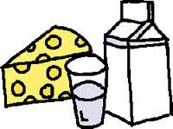 | *NO MILK OR OTHER DAIRY PRODUCTS FOR 20 MINUTES PRIOR TO  SAMPLE COLLECTION
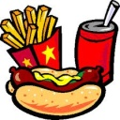 | *NO MAJOR MEALS FOR AT LEAST 1 HOUR BEFORE SAMPLE  COLLECTION. IF YOU SNACK, RINSE YOUR MOUTH WITH WATER  AT LEAST 10 MINUTES PRIOR TO SAMPLE COLLECTION.
 | *IF YOU ARE SICK, HAVE ACTIVE ALLERGIES, OR HAVE ORAL HEALTH  PROBLEMS, PLEASE DESCRIBE IN “COMMENTS” SECTION OF  COLLECTION FORM
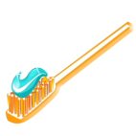
*NO TOOTH BRUSHING AT LEAST 45 MINUTES PRIOR TO SAMPLE COLLECTION,
NO MOUTH RINSING AT LEAST 10 MINUTES PRIOR TO SAMPLE COLLECTION.

Should any of these conditions occur, please make note in “comments” section of collection form
If you have any questions, please contact:

