Advance Email Text
Hello!
Thanks for agreeing to participate in our study! As we discussed on the phone, we are conducting this study to improve the Survey of Occupational Illnesses and Injuries, and the information you give us will be valuable in that process.
At _____, on ____, I will call you for the interview. Please have this email printed out and available at that time. You will need the information below to complete the study. You will not have to download any software to your computer, but will need to be able to access your email and internet.
When I call, I will a email with a link inviting you to a WebEx meeting, WebEx is the software that allows us to share an internet browser so I can see what you’re doing as you work on the survey.
Below is the information you’ll need to complete the tasks. Please do not click on the links before our interview, and remember to print it out and have it available when I call.
If you have any questions please email me or call me at 202-691-7528. I look forward to working with you!
Jennifer Edgar
Bureau of Labor Statistics

Task 1. Enter your own SOII information
Website: https://idcft.bls.gov/

Account Number:
Password:

Please complete the survey using your own SOII data.

Task 2: Enter fictitious SOII information
Website: https://idcft.bls.gov/

Account Number:
Password:

Add New Establishment ID(s) to Account
Have you received more than one survey to report for 2010? No

Select Company
Company Name

Section 1. Establishment Information
- Annual average number of employees for 2011? 10
- Total numbers of hours worked by all employees 1000
- Nothing unusual happened
- Did you have ANY work-related illnesses or injuries during 2011? Yes

Section 2. Summary of Work-Related Injuries and Illnesses, 2011
Number of Cases
Total number of deaths (G) | 0
Total number of cases with days away from work (H) | 1
Total number of cases with job transfer or restriction (I) | 1
Total number of other recordable cases (I) | 0

Number of Days
Total number of days away from work (K) | 4
Total number of days of job transfer or restriction (L) | 4

Injury and Illness Types (M)
Injuries | 0
Skin disorders | 0
Respiratory conditions | 0
Poisonings | 0
Hearing loss | 0
All other illness | 2

Section 3. Cases with Days Away from Work, Job Transfer, or Restriction
Enter data for cases with days away from work and/or job transfer or restriction.
- Please make up data for these fields.
- Remember you have reported 1 days away from work case and 1 days with job transfer or restriction case

Submit

Task 3: Provide feedback and answer questions about SOII survey pages
Website: https://idcft.bls.gov/

Account Number: 302150383900
Password: AnSU6446

Have you received more than one survey to report for 2010? No
Company Name: LOWES HOME CENTERS INC

Section 1. Establishment Information
- Annual average number of employees for 2011? 10
- Total numbers of hours worked by all employees 1000
- Nothing unusual happened
- Did you have ANY work-related illnesses or injuries during 2011? Yes

Section 2. Summary of Work-Related Injuries and Illnesses, 2011
Number of Cases
Total number of deaths (g) | 0
Total number of cases with days away from work (h) | 0
Total number of cases with job transfer or restriction (i) | 2
Total number of other recordable cases (j) | 0
Number of Days
Total number of days away from work (k) | 0
Total number of days of job transfer or restriction (l) | 5

Injury and Illness Types (M)
Injuries | 5
Skin disorders | 0
Respiratory conditions | 0
Poisonings | 0
Hearing loss | 0
All other illness | 0

Section 3. Cases with Days Away from Work, Job Transfer, or Restriction
- Please make up data for one case with days of job transfer.
- Again, you can make up whatever you want, this is not based on your own data
- After entering information about once case, click Continue

Testing Task Outline

Task 1: Log on, complete survey using own data
- The email I sent [date] has the website you will need, you’ll need to go to that site now. provide site and login information
- Remember to think aloud as you work

Task 2: Log on, complete the survey using the fictional data provided
- Now, please log out of the system and, using the email I sent, go back to the website. I’ll read you the account number and password to log in
- In my email I enclosed fictitious data OSHA form. I’d like you to use that form to complete the survey again
- Remember to think aloud as you work
Number of Cases
Total number of deaths (g) | 0
Total number of cases with days away from work (h) | 2
Total number of cases with job transfer or restriction (i) | 2
Total number of other recordable cases (j) | 0
Number of Days
Total number of days away from work (k) | 5
Total number of days of job transfer or restriction (l) | 10
Injury and Illness Types (M)
Injuries | 0
Skin disorders | 0
Respiratory conditions | 0
Poisonings | 0
Hearing loss | 0
All other illness | 4

Information about Cases with Days Away from Work, Job Transfer or Restriction
- Please make up data for these fields.
- Remember you have reported 2 days away from work cases and 2 days with job transfer or restriction cases
Task 3: Testing error message
- We have one more task to go through; you’re doing great so far!
- I want you to log out of the survey again, and log back in using the Task 3 information I emailed to you
- This time I’m going to tell you what to enter in each field. As we go, I’ll ask you some questions along the way.
- Let’s get started:
Section 3 page
- What do you think you’re supposed to do on this page?
- What do you think would happen if you clicked the ‘go back and correct’ button?
- What do you think would happen if you clicked the ‘enter data now’ button?
- What do you think would happen if you clicked the ‘continue’ button?
Enter Information about a Case page …
- What do you think you’re supposed to do on this page?
- What types of cases are you supposed to report on this page?
- DJTR: Would you enter your Days away from work cases or Days of job transfer or restriction cases first?
Number of Cases
Total number of deaths (g) | 0
Total number of cases with days away from work (h) | 0
Total number of cases with job transfer or restriction (i) | 2
Total number of other recordable cases (j) | 0
Number of Days
Total number of days away from work (k) | 0
Total number of days of job transfer or restriction (l) | 5
Injury and Illness Types (M)
Injuries | 5
Skin disorders | 0
Respiratory conditions | 0
Poisonings | 0
Hearing loss | 0
All other illness | 0

Information about Cases with Days Away from Work, Job Transfer or Restriction
- Please make up data for one case with days of job transfer.
- Again, you can make up whatever you want, this is not based on your own data
- After entering information about once case, click Continue

Section 4: Data review: ERROR
- What is the first thing you notice on this page?
- What do you think that error message means?
- What do you think you should do now? Please do that
“You have entered case information for fewer cases than reported in Section 2. Please enter case information for all Days Away from Work and Job Transfer or Restriction cases. Click the buttons above to return to a section to correct your entries”
- After corrected error, click continue again
- Now, tell me what you think you are supposed to do on this page?
- What would you next?
- What do you think happens when you click the submit button?

Debriefing questions
Now I have a few general questions to ask you about your experience completing the survey. Non-scripted questions will be added based on testing observations and additional post-testing questions will be added based on tasks.
- What would you say was the most difficult step involved in completing the survey? If you personally didn’t have a problem, do you think would be the most difficult step for others?
- BLS is now asking for respondents to tell us about both Days Away from work (Column H) and Days with Job Transfer or Restriction (Column I). What is your reaction to this?
- Did you have any trouble entering the Days with Job Transfer or Restriction information?
- Were there any places where the instructions could be improved or were needed?
- What are your general impressions of the online survey?

Thank you for helping us today! If you think of any other comments or suggestions, feel free to email them to me!

a30215035693 | AnSU4096

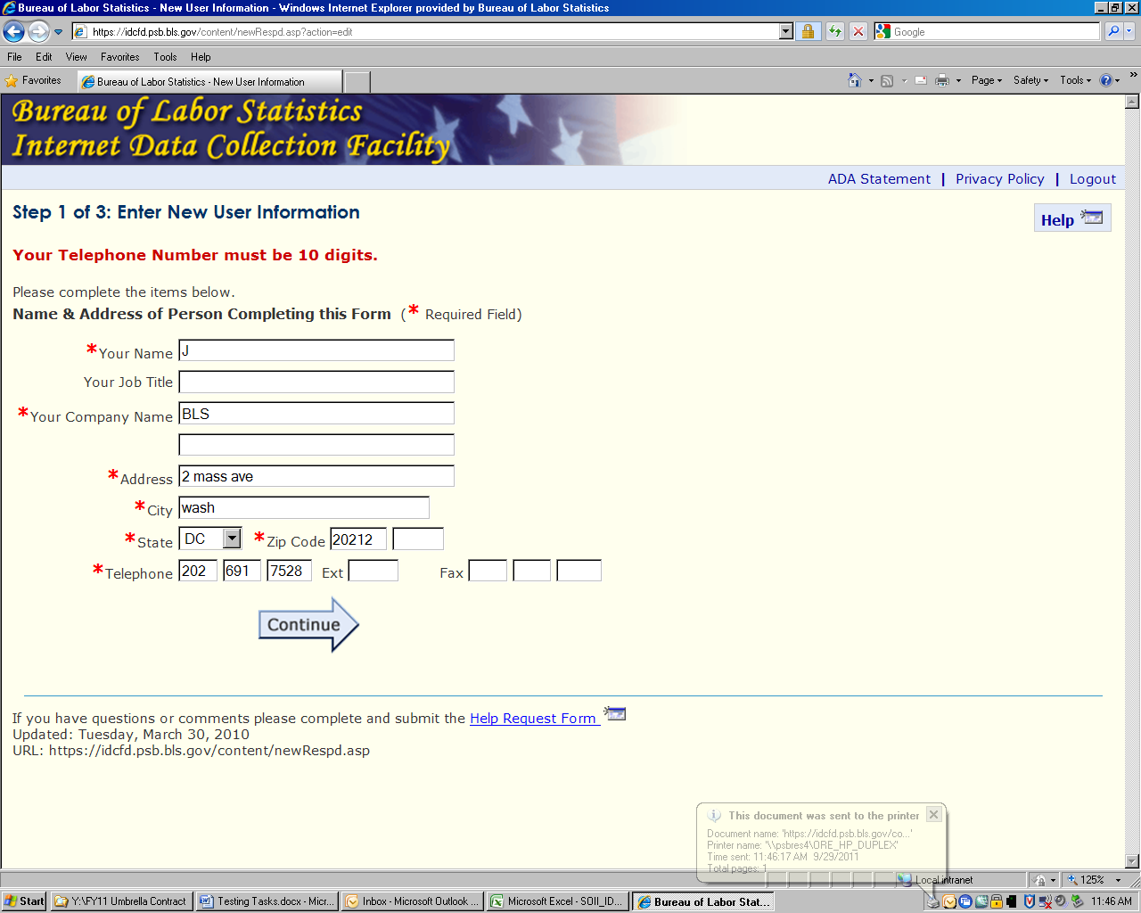

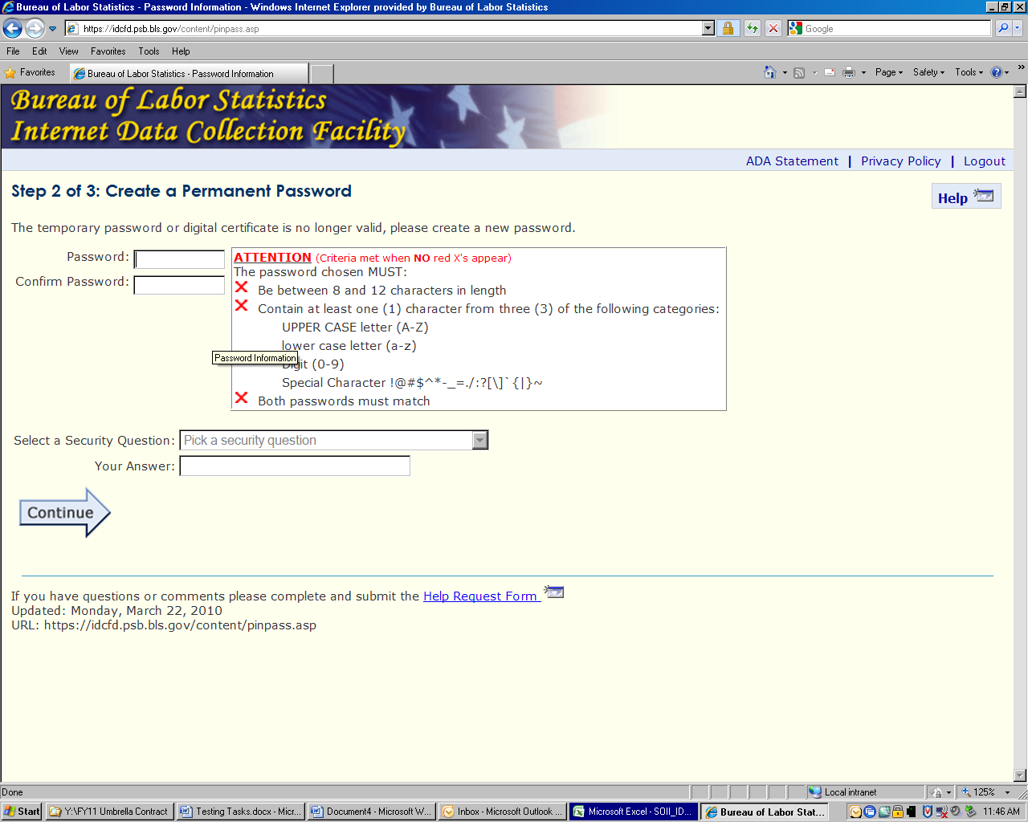

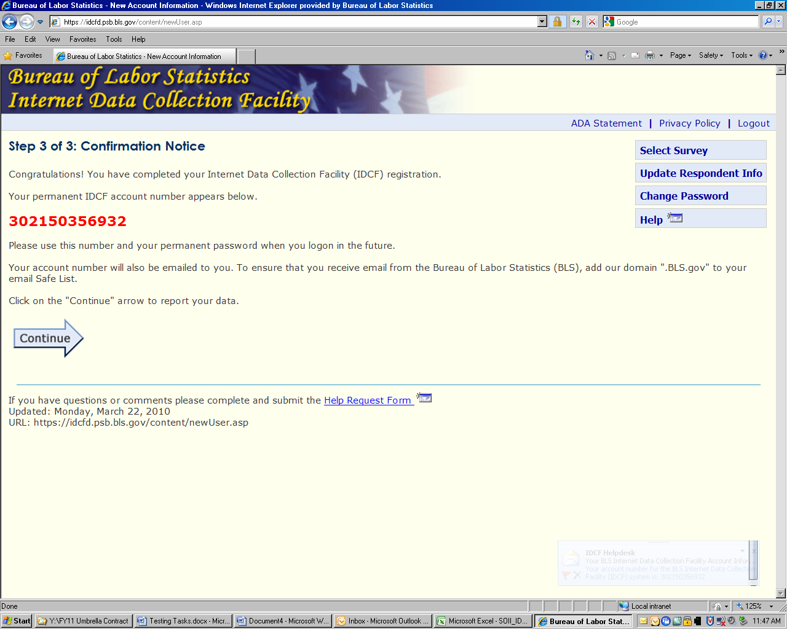

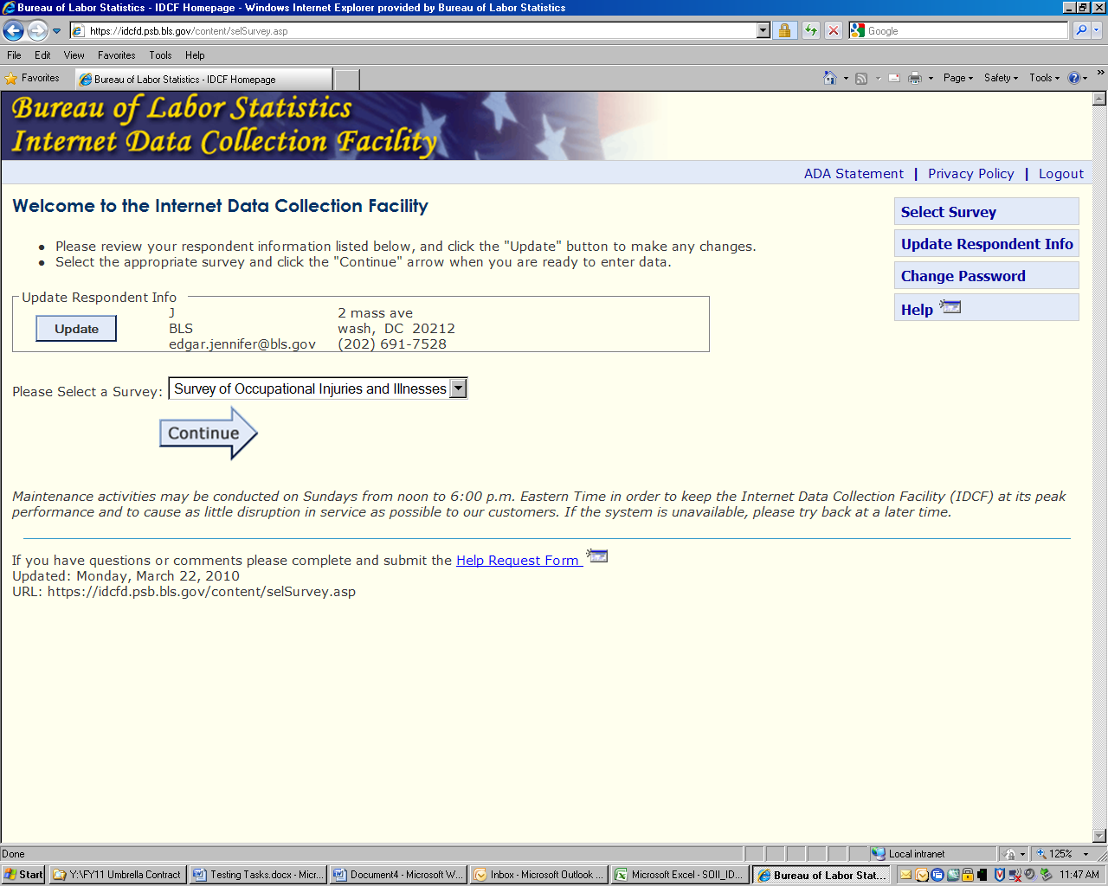

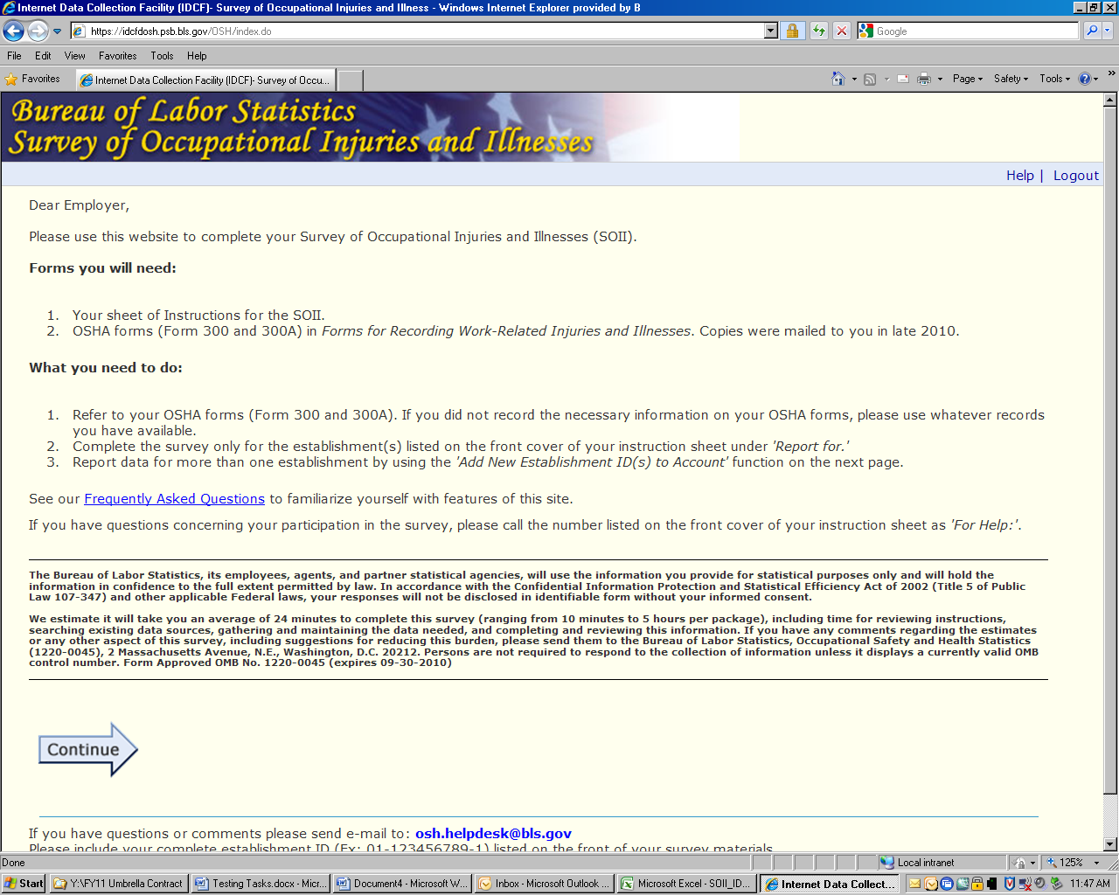

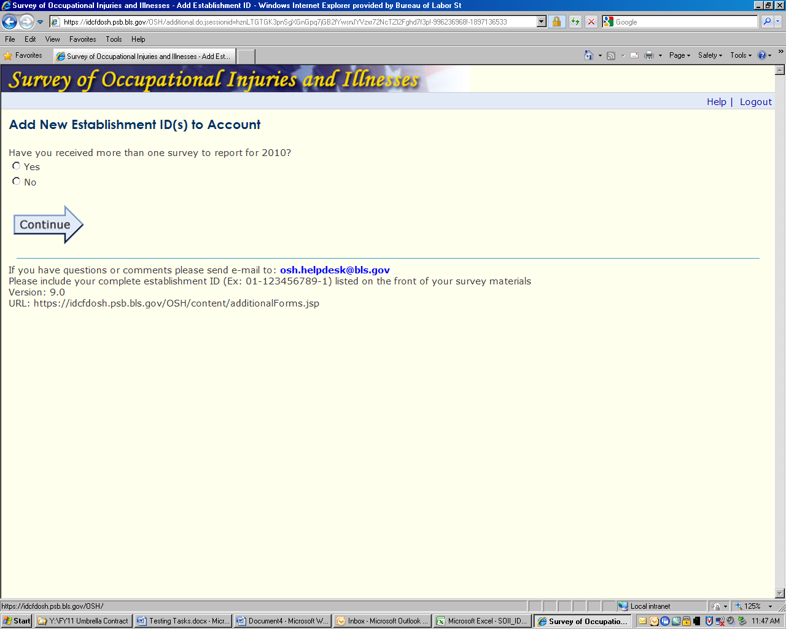

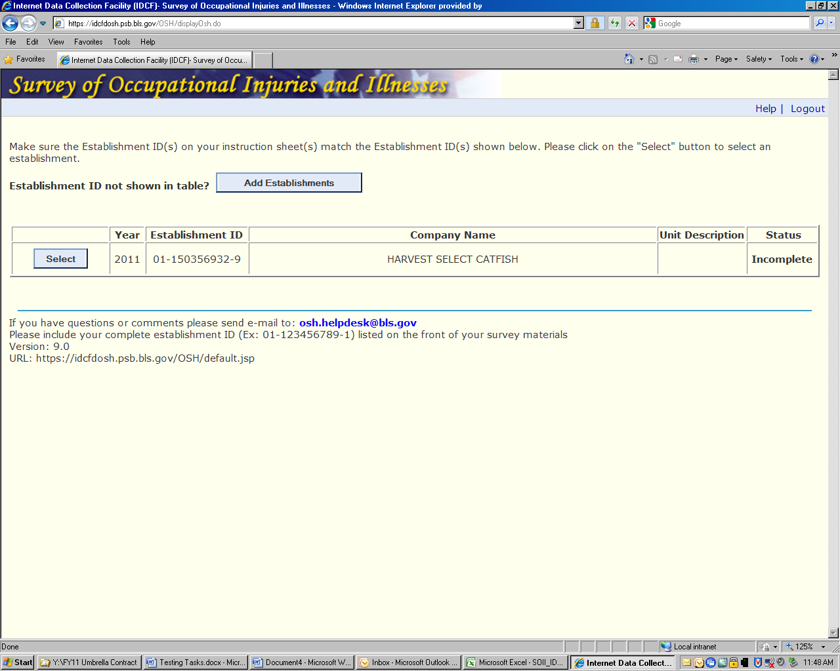

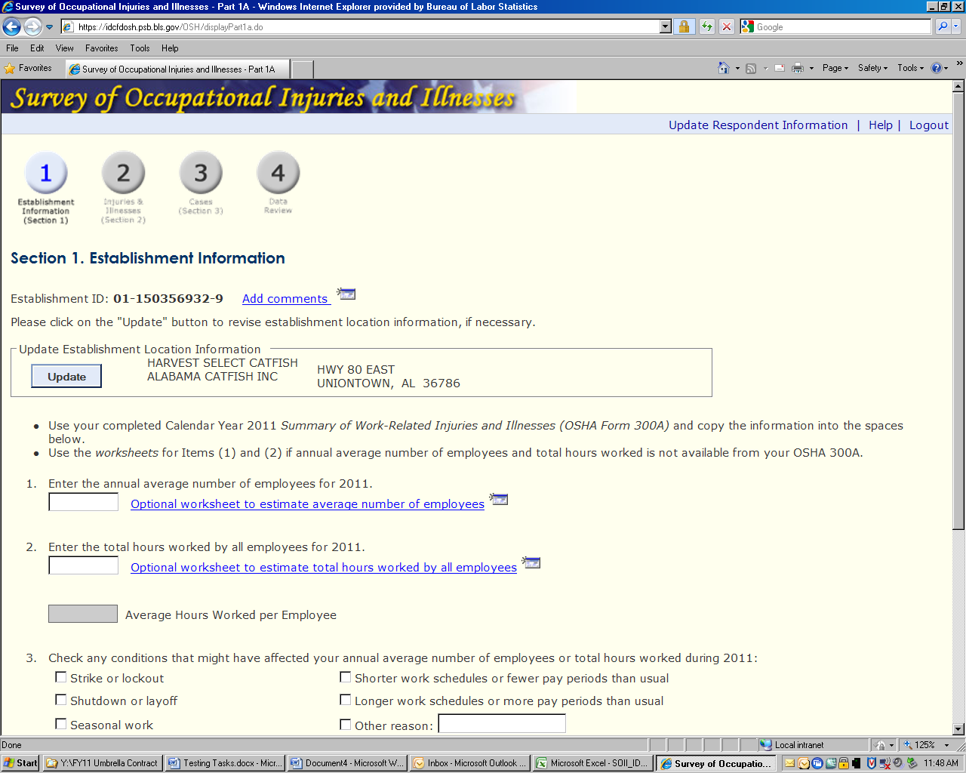

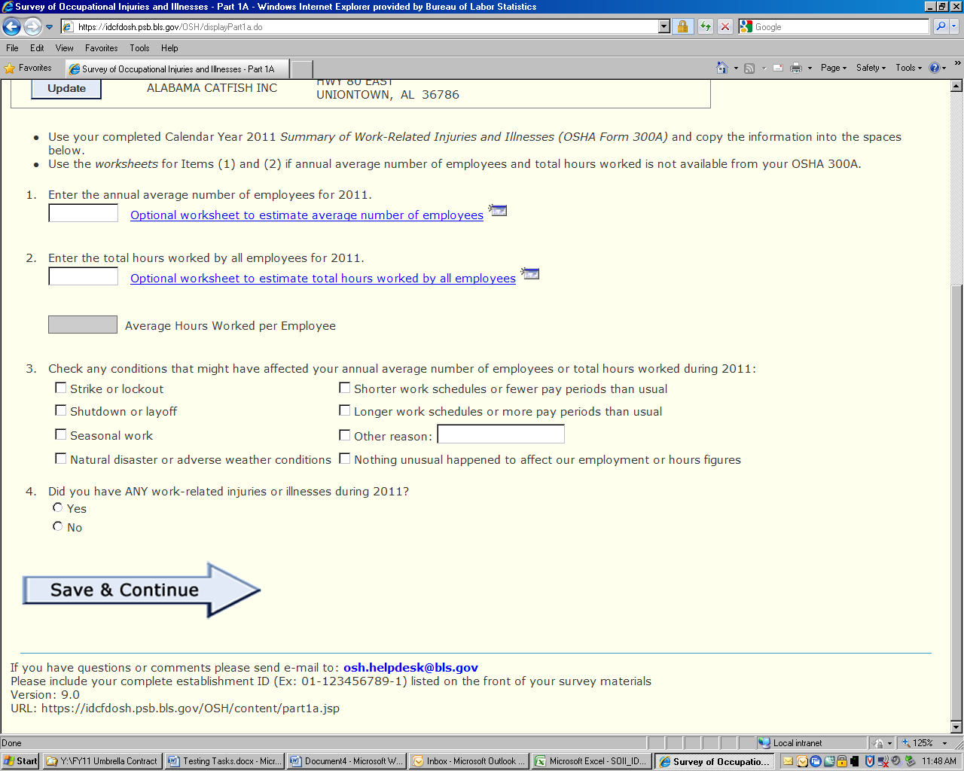

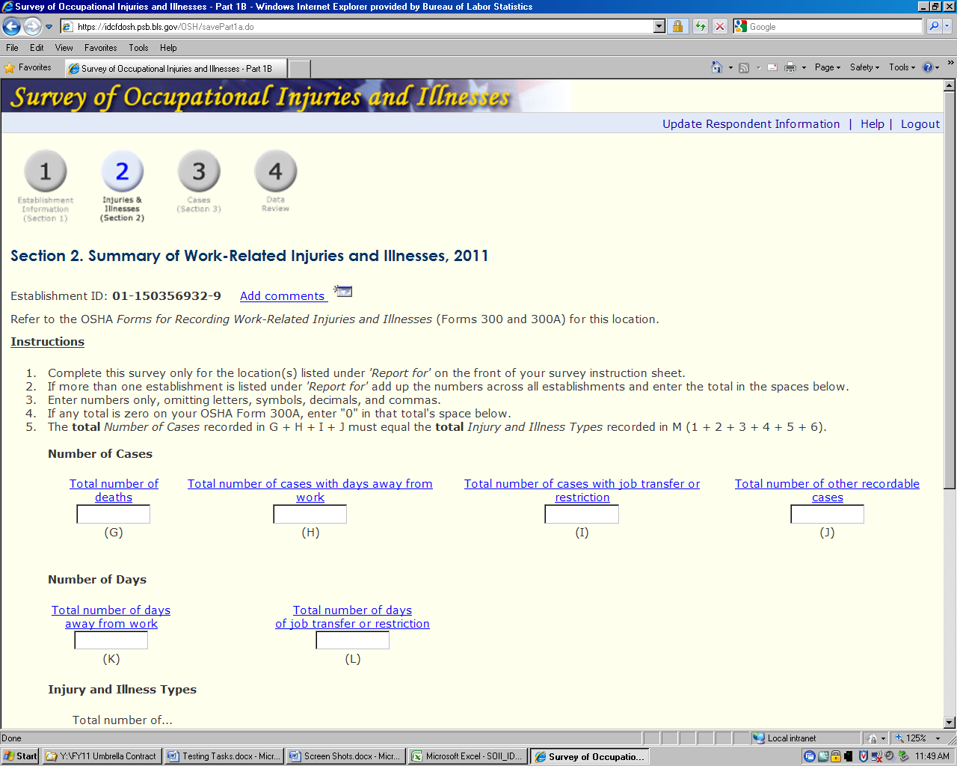

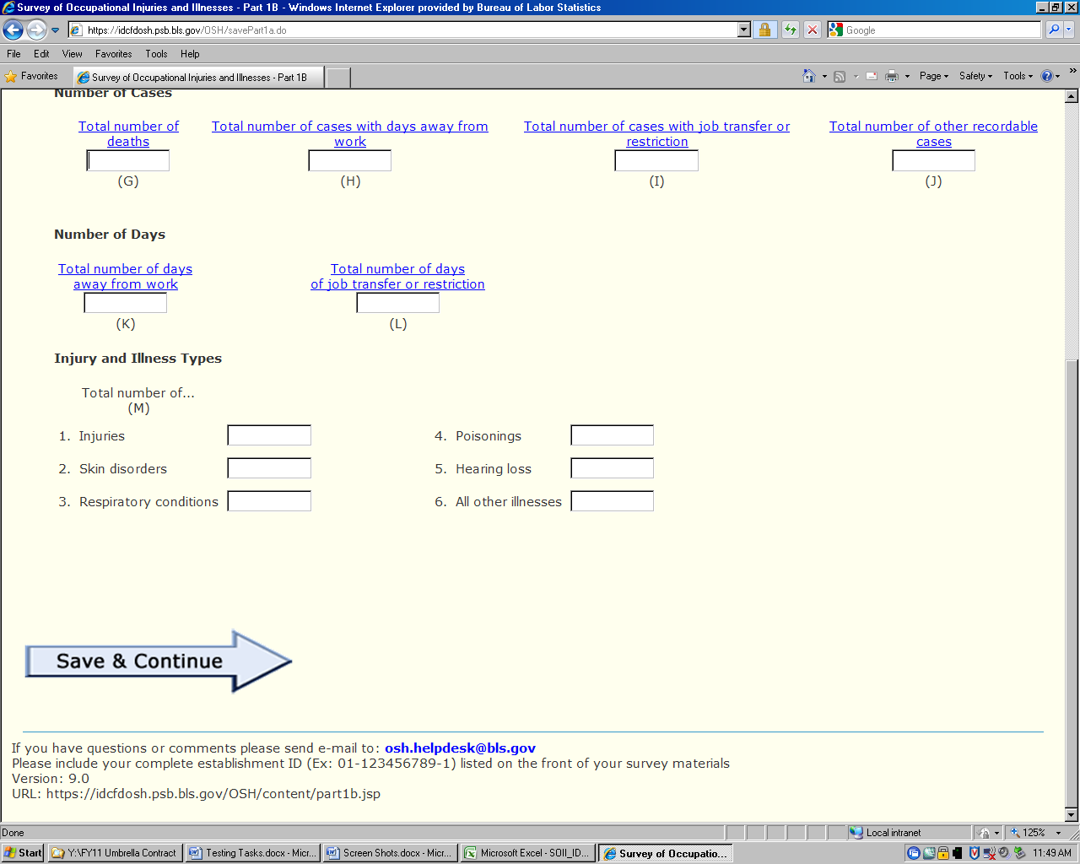

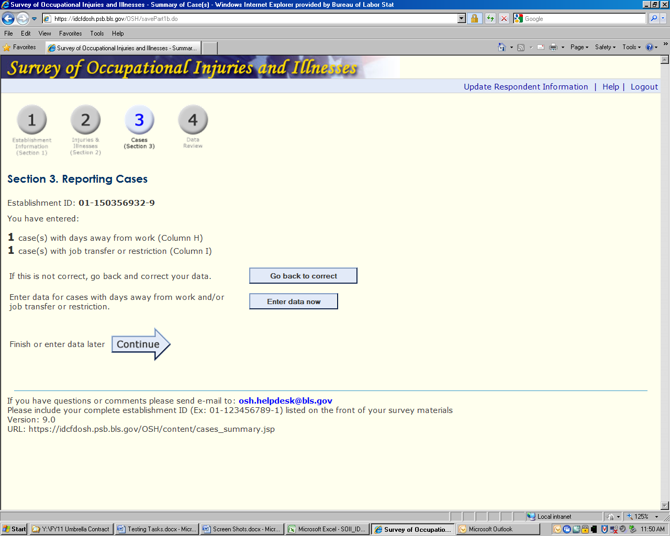

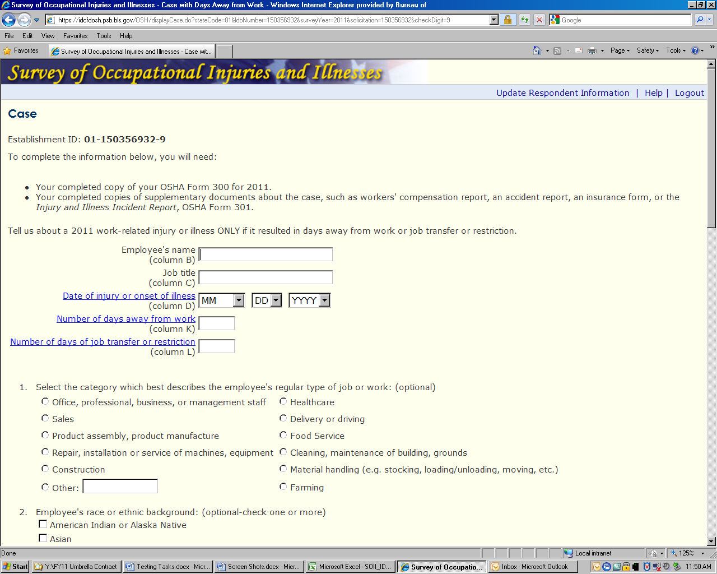

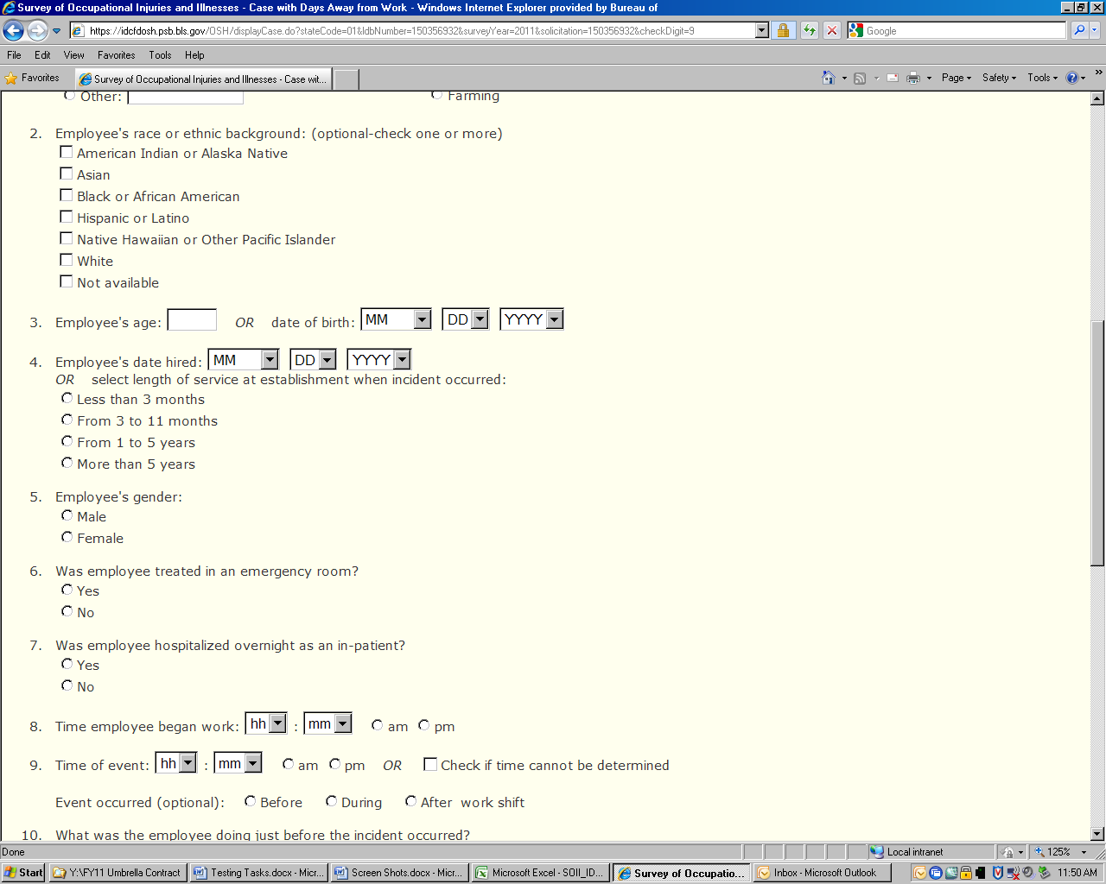

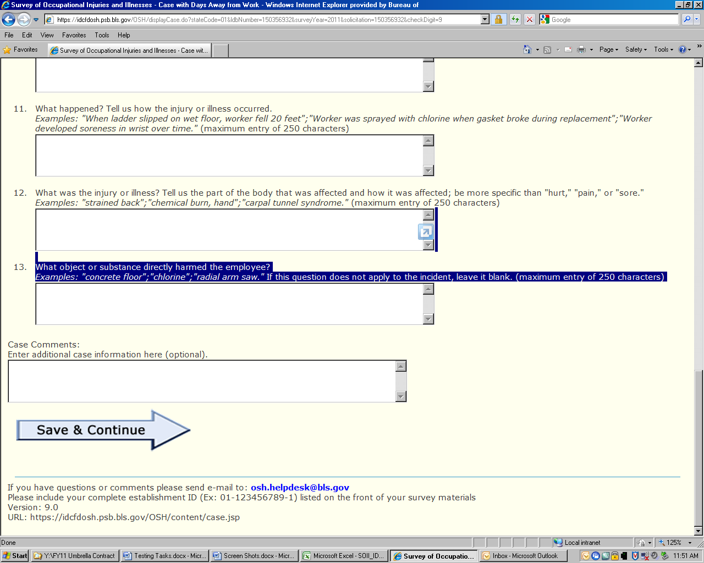

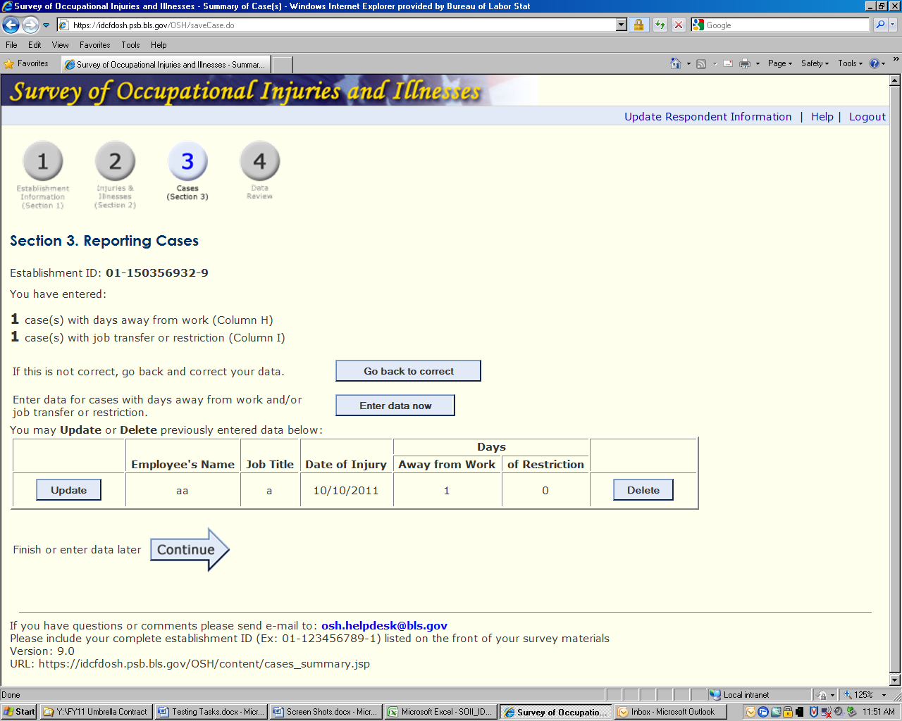

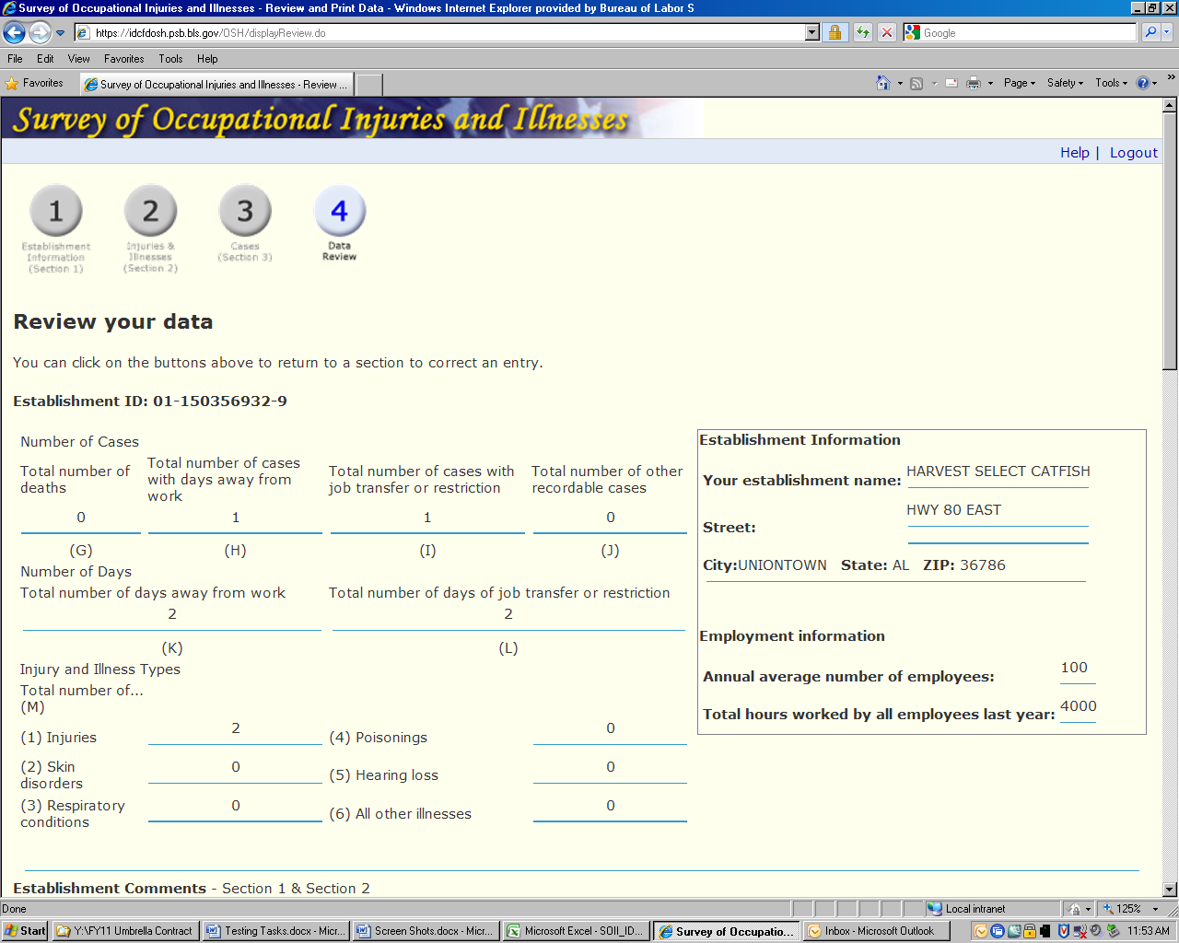

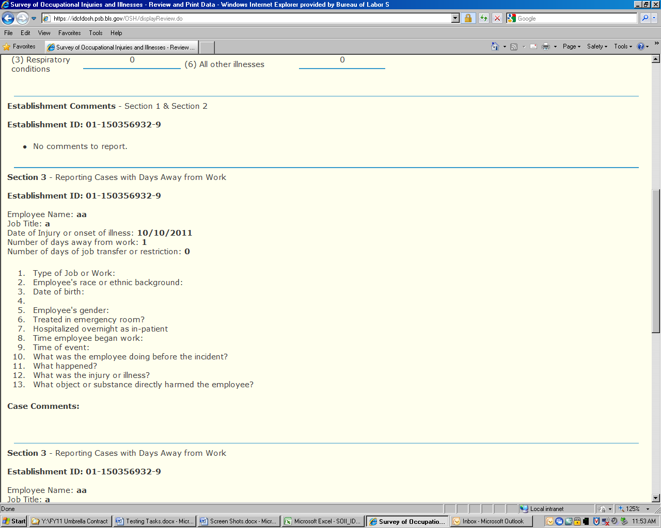

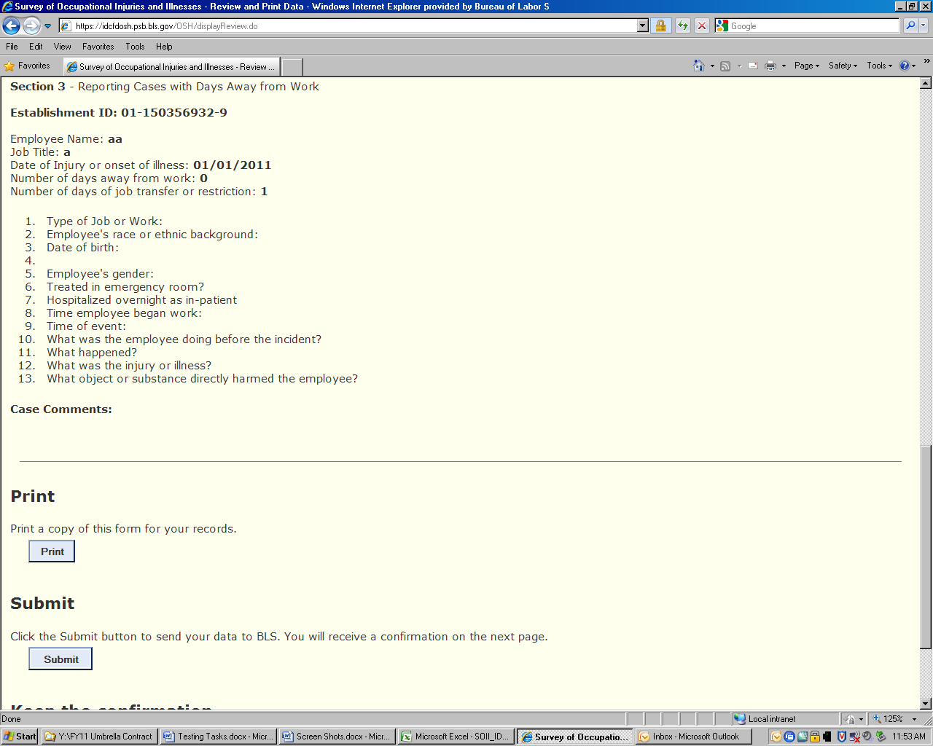

ERROR
