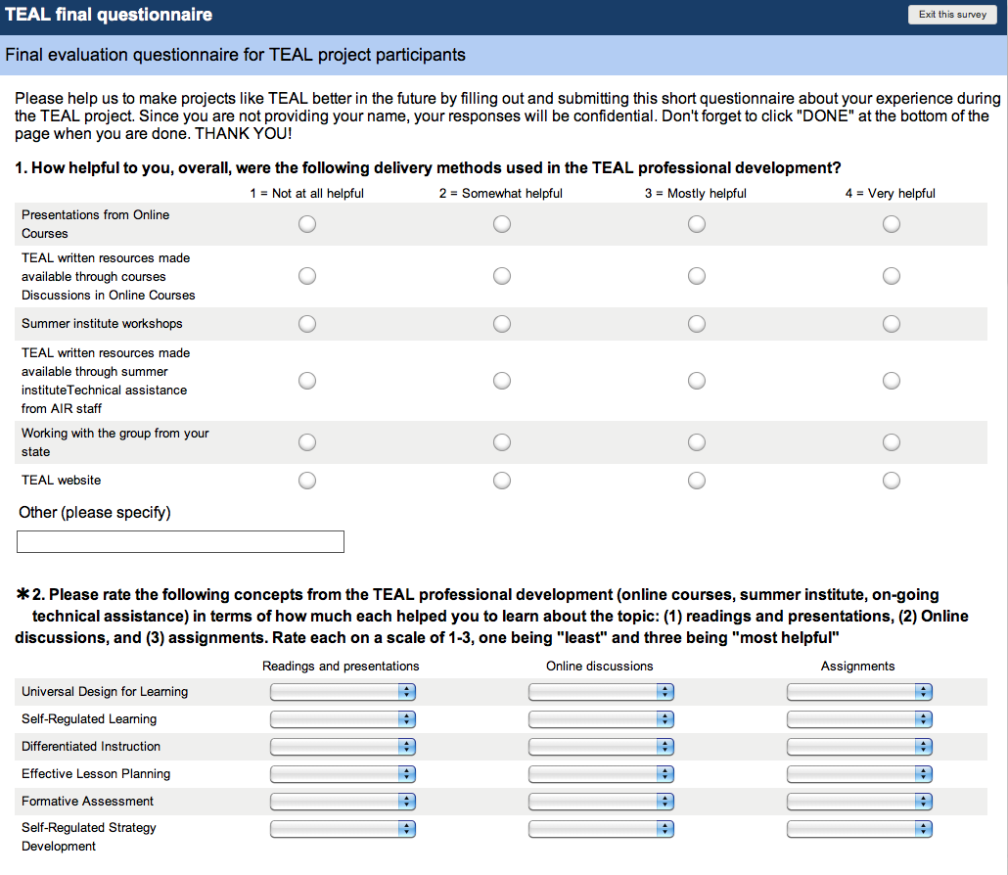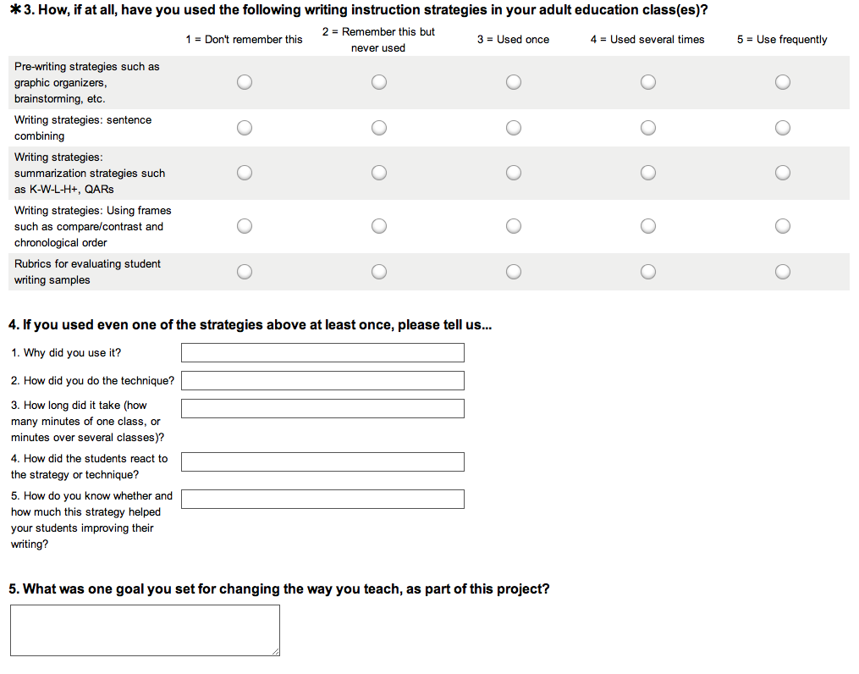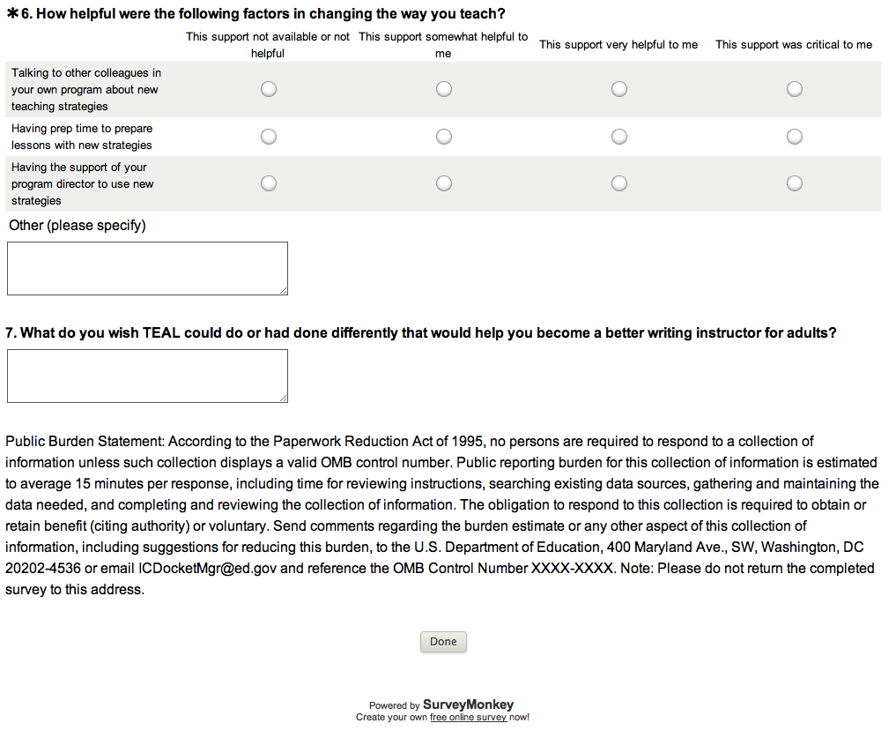
Public Burden Statement:

According to the Paperwork Reduction Act of 1995, no persons are required to respond to a collection of information unless such collection displays a valid OMB control number. Public reporting burden for this collection of information is estimated to average 10 minutes per response, including time for reviewing instructions, searching existing data sources, gathering and maintaining the data needed, and completing and reviewing the collection of information. The obligation to respond to this collection is voluntary. Send comments regarding the burden estimate or any other aspect of this collection of information, including suggestions for reducing this burden, to the U.S. Department of Education, 400 Maryland Ave., SW, Washington, DC 20210-4537 or email ICDocketMgr@ed.gov and reference the OMB Control Number 1880-0542. Note: Please do not return the completed Teaching Excellence in Adult Literacy survey to this address.

