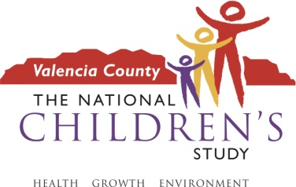

Dear Parent/Guardian:

The __________ school is working on a research study with the University of New Mexico and the National Children’s Study (NCS). The purpose of the study is to learn about parents’ and children’s thoughts about how to get permission from children who will be enrolled in the NCS. We would like opinions on how best to teach children 7-8 years of age about research participation using technology that is appropriate in this age group. You are being invited to participate in this study because you have a child in this age range. This study is being conducted in 2 parts.

First, we would invite you (without your child) to be part of a discussion group with 5-10 other parents of children ages 7-8 years old. This group discussion would be approximately 2 hours long. Refreshments and child-care will be provided and you will receive a $25 gift card to thank you for your time.

Then, at a later date, we would invite both you and your child to come back for a family interview. The interview will be approximately 1-2 hours long. We would like to have your permission for your child to be part of this interview and get his/her opinions on research participation. Refreshments and child-care will be provided and you will receive an additional $25 gift card to thank you for your time.

Both group sessions will take place at the University of New Mexico’s Valencia Campus in Tome, New Mexico. Both the group and family interview will be lead by a trained leader. It is important to know that we are not asking you to join an actual study where samples would be collected.

If you are interested in having both you and your child participate in this study, please contact our coordinator Donna Sedillo at 505-842-8932 or by e-mail at dsedillo@ori.org for more information. We would be more than happy to answer any questions you may have. Thank you for considering our study and we look forward to hearing from you soon.

If you have questions about the project, you may contact the school principal or study staff at _____________

Thank you for your cooperation.

Sincerely,

